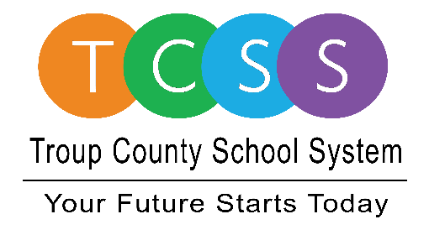
Yolanda Stephen, Director Public Relations
stephenyk@troup.org / troup.org
100 North Davis Rd, Building C / LaGrange, Georgia 30241
Office: 706.812.7900 / Fax: 706-812-7904

Story Release
FOR IMMEDIATE RELEASE

TCSS High Schools Receive Advanced Placement Recognition

LaGrange, Ga., March 1, 2021 – All three Troup County School System (TCSS) high schools were named in one or more areas on the Georgia Department of Education’s 2021 Advanced Placement Honor Schools listing.

The purpose of high school AP course offerings is to give students an opportunity to take college level coursework while still in high school. At the end of the course, students can voluntarily take an AP exam. If they pass the exam then they receive college credit for the course. Out of eight categories, TCSS high schools were named in four areas:

- 2021 AP Challenge Schools – Callaway High School
- 2021 AP Expansion School – Callaway High School
- 2021 AP Stem Schools – LaGrange High School and Troup High School
- 2021 AP Stem Achievement School – LaGrange High School

Callaway High moved from being named in one area to two. LaGrange High is one of only four (out of 16) high schools in the West Georgia RESA to be named both an AP STEM and an AP STEM Achievement School. Troup High was added to the 2021 honor listing.

Dr. Richard Woods, Superintendent of Schools for the state of Georgia, said, “I extend my heartfelt congratulations to this year’s AP Honor Schools,” Superintendent Woods said. “I commend them for their hard work to build strong Advanced Placement programs and, as a result, provide high-quality opportunities for Georgia students.”

According to ThoughtCo, a content creation website that provides education research-based articles for parents and students, says, “AP classes help students develop college-level academic skills that require the type of high-level calculating and critical thinking skills they will encounter their first year in college.”

AP Challenge Schools: Schools with enrollments of 900 or fewer students and students testing in English, math, science, and social studies

AP Expansion Schools: Schools with 25 percent growth in AP student participation from May 2019 to May 2020 and a minimum of 2t5 students testing in May 2019

AP STEM Schools: Schools with a minimum of five students testing in at least four AP STEM courses (AP Calculus AB, AP Calculus BC, AP Statistics, AP Biology, AP Chemistry, AP Environmental Science, AP Physics 1, AP Physics 2, AP Physics C, AP Computer Science A, AP Computer Science Principles)
AP STEM Achievement Schools: AP STEM schools (see above definition) with at least 50 percent of all AP STEM exams earning scores of 3 or higher

About Troup County School System
Troup County School System is an accredited educational system with over 12,100 students in grades K-12. TCSS does offer a free Pre-K program at each elementary school. The system is comprised of eleven elementary schools, three middle schools, three high schools, one college and career academy, and one alternative learning center. Students within the school system are taught a rigorous and relevant curriculum that helps them make college and career choices beyond graduation and succeed in life. The system 2020 graduation rate is 85.9 percent. To learn more about Troup County School System, visit troup.org and the Troup County School System Facebook page.

###

