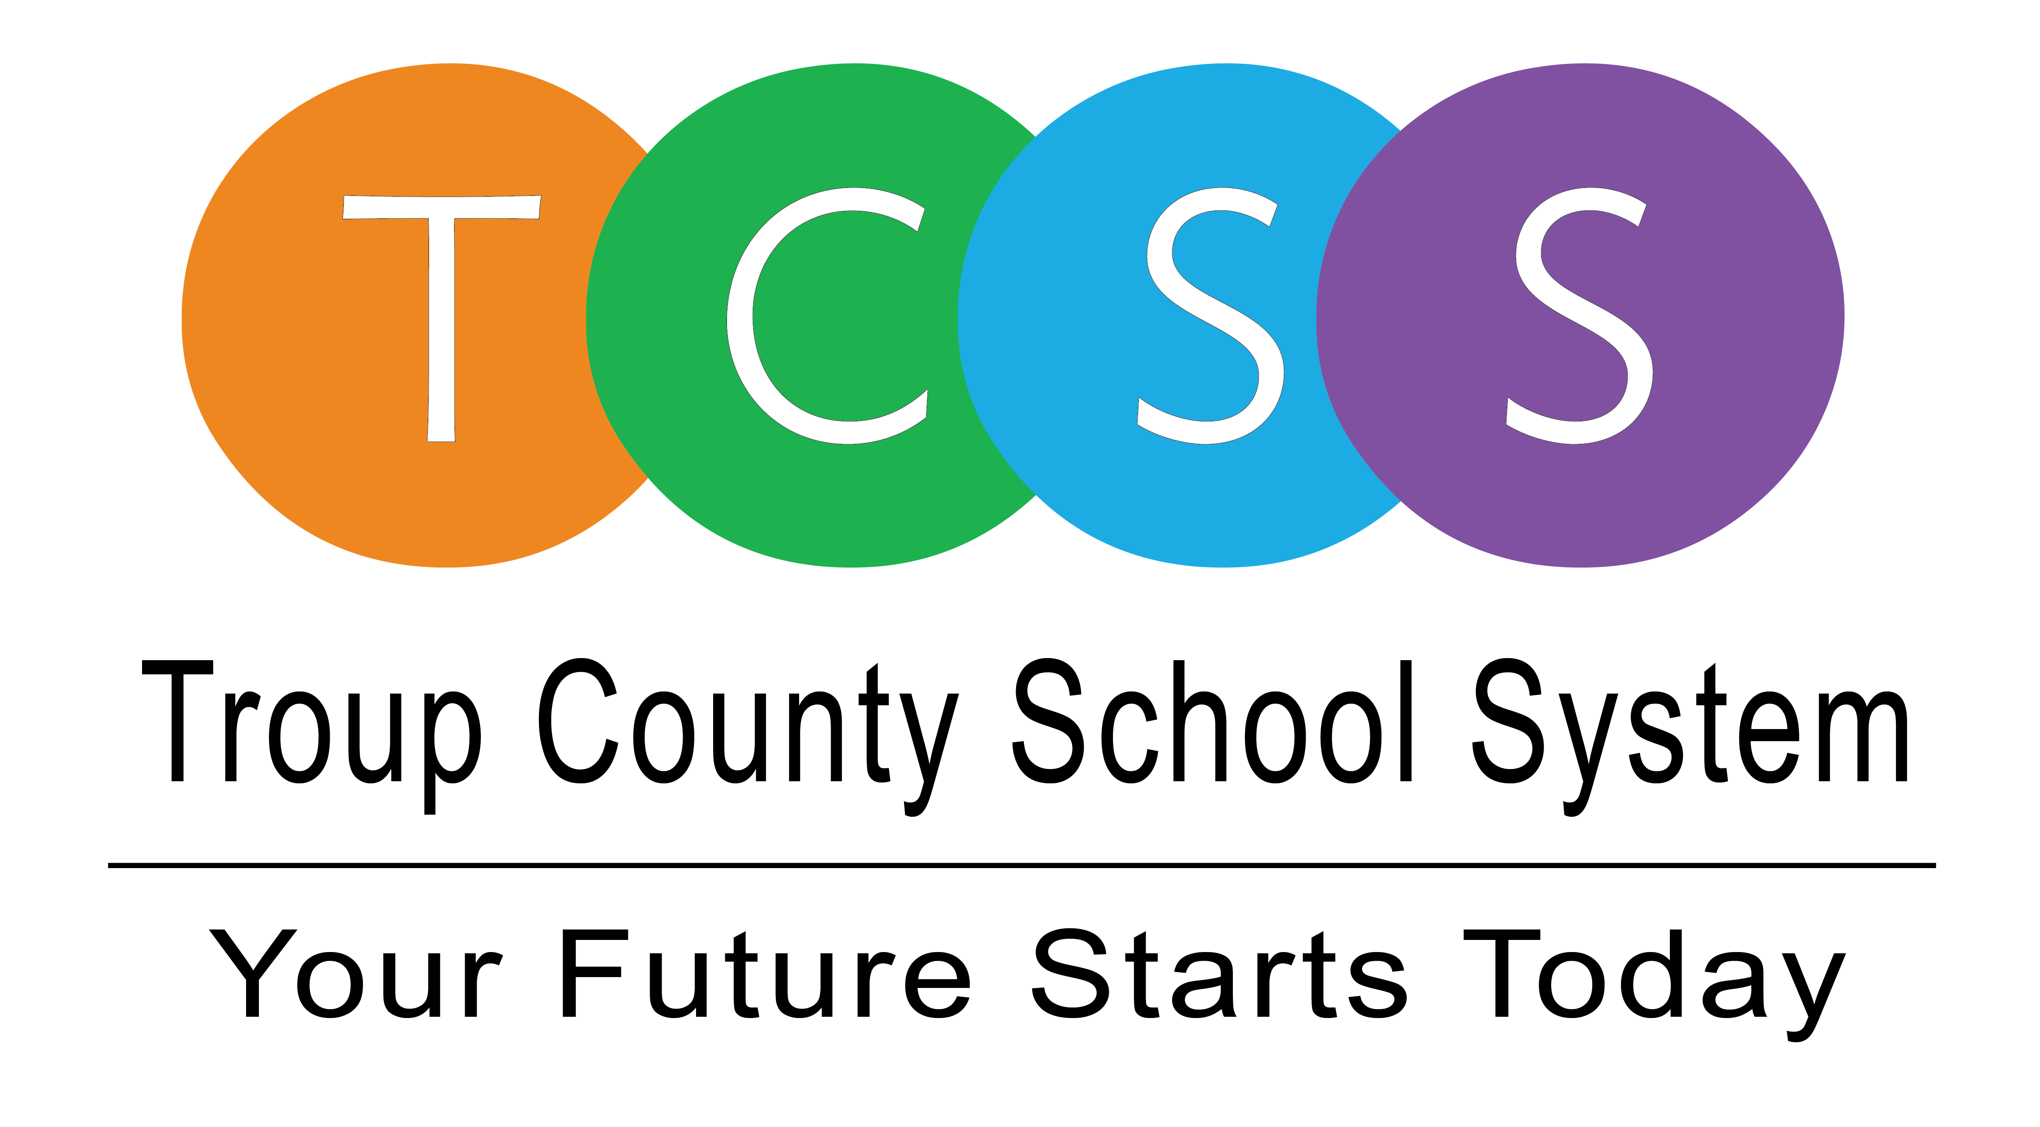
Yolanda Stephen, Director Public Relations
stephenyk@troup.org / troup.org
100 North Davis Rd, Building C / LaGrange, Georgia 30241
Office: 706.812.7900 / Fax: 706-812-7904

Story Release
FOR IMMEDIATE RELEASE

Troup County School System HB 251 School Choice Applications Now Available

LaGrange, Ga., June 4, 2021 – Troup County School System parents and legal guardians of kindergarten through twelfth grade students may request a transfer to another school in the district under House Bill 251. If granted, the transfer will be in effect for the 2021-2022 school year.

All applications and supporting documentation are available on www.troup.org and must be received by June 24, 2021. All mailed applications and supporting documentation must be postmarked by June 24, 2021. To apply or find out more information, go to troup.org where the following is available:
- Application for transfer
- Parent information sheet
- List of schools with available classroom space

Before a transfer is granted, classroom space must be available at the requested school, there must be appropriate teacher allocation at the requested school, and all assigned students must be enrolled and scheduled.

Upon approval to transfer a student to another school in the district, the law requires the parent or guardian assume all costs and responsibilities related to transportation as long as the student remains at the transferred school.

Information may also be obtained by calling the Troup County School System Office of Student Assignment at (706) 812-7900.

About Troup County School System
Troup County School System is an accredited educational system with over 12,100 students in grades K-12. TCSS does offer a free Pre-K program at each elementary school. The system is comprised of eleven elementary schools, three middle schools, three high schools, one college and career academy, and one alternative learning center. Students within the school system are taught a rigorous and relevant curriculum that helps them make college and career choices beyond graduation and succeed in life. The system 2019 graduation rate is 86.6 percent. To learn more about Troup County School System, visit troup.org and the Troup County School System Facebook page.
###

