

Yolanda Stephen, Director Public Relations
stephenyk@troup.org / troup.org
100 North Davis Rd, Building C / LaGrange, Georgia 30241
Office: 706.812.7900 / Fax: 706-812-7904

Story Release
FOR IMMEDIATE RELEASE

Georgia Deputy Commissioner for International Trade Stops By THINC to Learn About the International Business Pathway

LaGrange, GA., December 19, 2018 – Earlier this month Mary Waters, Deputy Commissioner of International Trade for the Georgia Department of Economic Development, visited THINC College & Career Academy (THINC) in LaGrange to hear more about the International Business (IB) Pathway offered exclusively at the academy. Students from all three Troup County high schools are enrolled in the pathway that helps them learn about business on a global scale.

Waters oversees the state's International Trade program which provides services that contribute to the expansion of Georgia's exports, retention of jobs in the field, and continued international reach of the state’s economy. During her visit at THINC, she received a tour of the school and heard first-hand about the IB pathway that started this year. What makes it unique is that it is the first of its kind in the state. The curriculum was developed by THINC educators in coordination with representatives from local businesses and LaGrange College’s IB program. While THINC is the only site in the state to offer this pathway, the curriculum is now available to all schools in Georgia.

THINC CEO, Kathy Carlisle, stated that, “…developing an understanding of the global market and our world, but also having a familiarity with local businesses is key for our students. The International Business pathway has been an important step in ensuring our students are engaged locally, yet connected globally, which is one of our main areas of focus.”

While in LaGrange, Waters also networked with a group of local business and economic development representatives from Kia Motor Manufacturing Company, Sewon America, Georgia Power, the City of West Point, and students that attend THINC.

In addition to Waters’ visit, THINC’s IB instructor, Frederick Neubert, met with the advisory committee to provide an update on the new program which includes the following courses: Introduction to International Business, Global Awareness & Cultural Competency, and International Business Concepts.

Neubert said, “Our goal is to prepare our students with critical thinking skills and help the students quickly contribute to their new employer's organization in innovative ways.”

During the status update, Neubert highlighted some of the main components of the program; one being a heavy focus on project-based learning. For this course, students are combined into teams that develop their own companies. While using an online business simulation, students are required to sell bikes in four regions of the world. To show success, they must present a balanced scorecard to determine the ranking of their company compared to their peers who also have a bike company. They must use research and the scorecard to make future business decisions that place them tops.

Students can also earn their Six Sigma White Belt certification at no cost to them. Currently, 63 percent of the students have completed the certification, which is the first level in the Six Sigma methodology used to improve business processes through statistical analysis.

Future plans for the International Business pathway include a possible educational tour to Eastern Europe in spring 2020.

About THINC
Located in LaGrange, Georgia, THINC College & Career Academy is a charter school designed for high school-aged students within Troup County. Combining critical thinking and business, THINC Academy creates an authentic workplace curriculum that extends learning beyond the traditional classroom. THINC students are highly desirable to businesses and colleges not only because they are equipped with technical and career-specific skills, but because they understand the soft skills of business – a firm handshake, a strong work ethic and critical thinking skills. Led by academic and corporate professionals and funded by local corporations, THINC officially opened its doors for learning in August 2015. For more information, visit www.thincacademy.net.

About Troup County School System
Troup County School System is an accredited educational system with over 11,900 students in grades K-12. The TCSS does offer a free Pre-K program at each elementary school. The system is comprised of eleven elementary schools, three middle schools, three high schools, one college and career academy, and one alternative learning center. Students within the school system are taught a rigorous and relevant curriculum that helps them make college and career choices beyond graduation and succeed in life. The system 2018 graduation rate rose 6.2 percentage points to 84.1 percent. To learn more about Troup County School System, visit troup.org and the Troup County School System Facebook page.

###

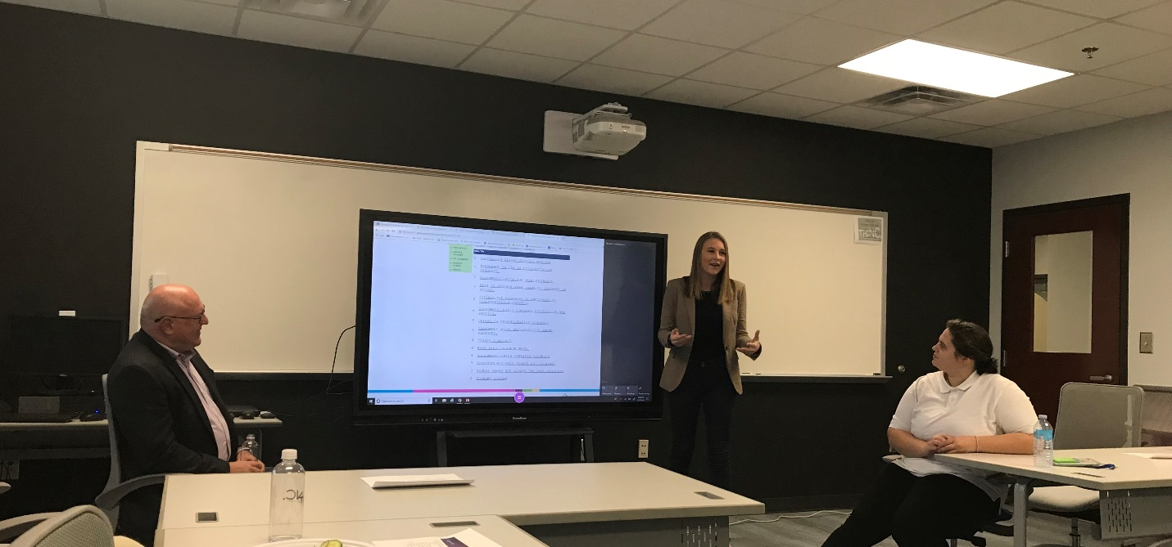
THINC student Ella Eiland presents her company to International Business advisory committee. Also pictured: Instructor Frederick Neubert and THINC Student Sharon Shelton.
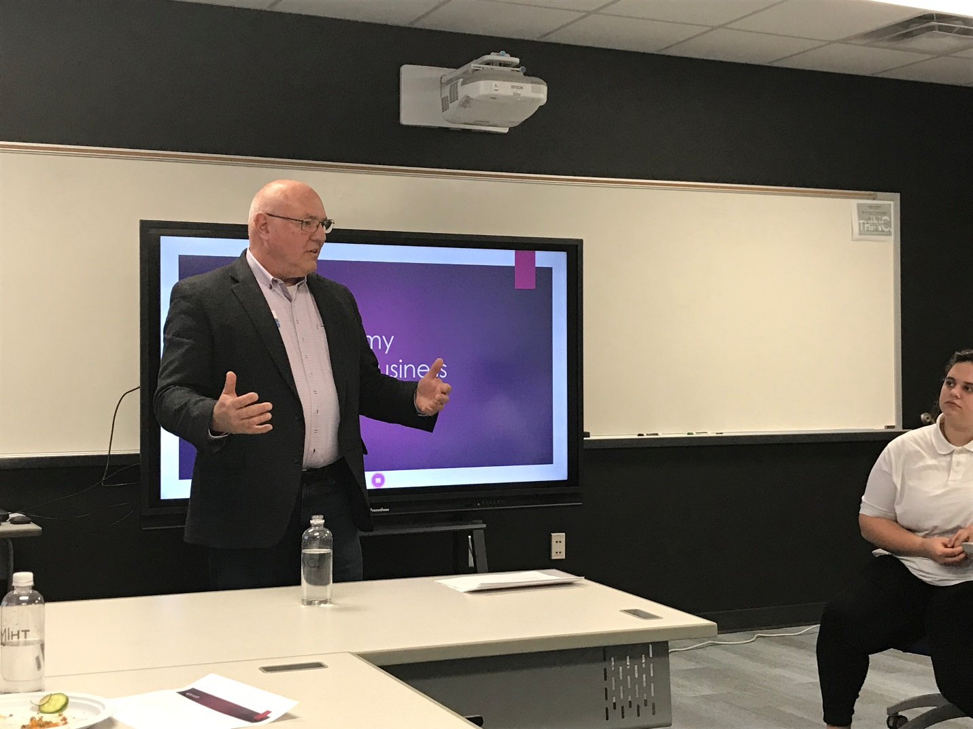
THINC International Business Instructor Frederick Neubert.
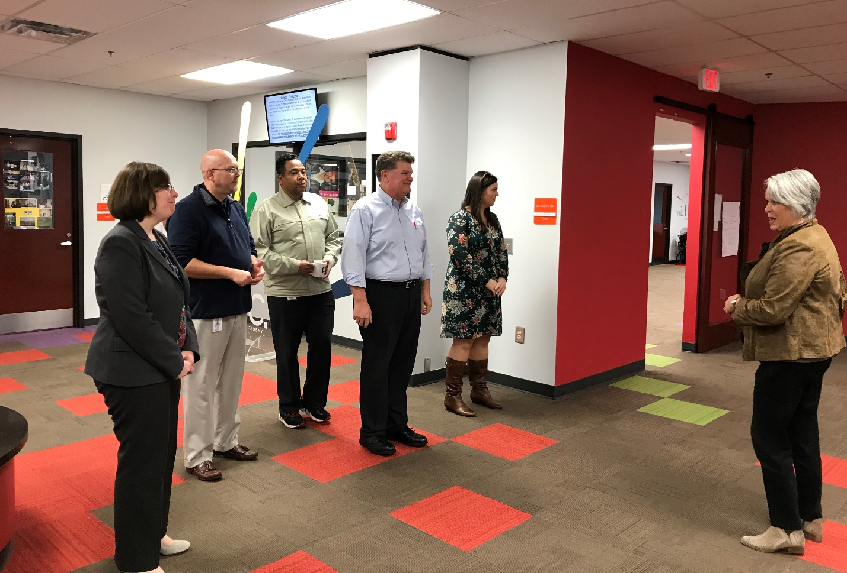
THINC CEO Kathy Carlisle conducts tour with Deputy Commissioner Mary Waters and representatives from Kia, Sewon and City of West Point.
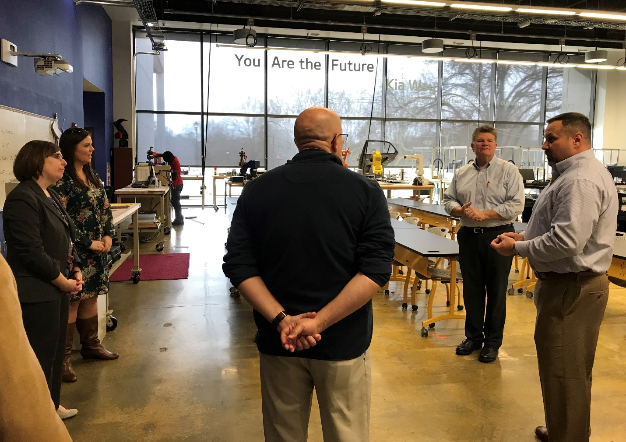
THINC Principal Chris Williams speaks to tour group in the THINC Mechatronics area.

