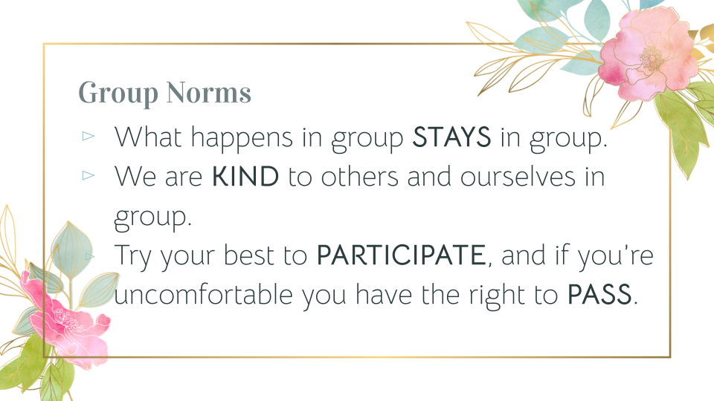

I agree to follow these norms, and I understand if I do not, I may be asked to leave the group.

_______________________________________________________ _______________________________________________________

_______________________________________________________ _______________________________________________________

_______________________________________________________ _______________________________________________________

_______________________________________________________ _______________________________________________________