Pocatello/Chubbuck
School District #25
WRITING HANDBOOK

“Writing is the most powerful means of discovery
accessible to all of us throughout life.”
-Peter Stillman

Pocatello/Chubbuck School District #25
3115 Pole Line Rd.
Pocatello, ID 83201
(208) 232-3563
www.sd25.us
Revised August 2019
“Putting words together in a way which is unique, to me is something I still think
is one of the most thrilling things that one can do in one’s life.”
-Seymour Simon
Table of Contents
Introduction 1
Writing Terminology 1
Six Stages of Writing 2
Graphic Organizers 3
Comparison/Contrast 4
Venn Diagram 4
Chronological Sequence 5
Five Paragraph Essay Format 8
Thesis Generator 9
Compare and Contrast Chart Graphic Organizer 10
MLA Format Requirements 12
Sample Pages of a Research Paper in MLA Style 14
Using Sources: MLA Format 15
Plagiarism 15
MLA Citation for Paraphrasing 15
Using Direct Quotations: MLA Formatting 17
Works Cited 18
Resources for evaluating websites: 18
Citation Building Websites: 18
Creating Works Cited Entries in MLA Format 19
Sample Works Cited Forms 19
Resources for MLA Formatting: 21
Root Words 24
Grade 7-8 “No Excuse” Spelling List 25
Suggested Sentence Beginnings 27
Some Suggested Transitions 28
Synonyms 29
Synonyms for SAID 32
Action Words/Verbs 33
Editing Symbols 34
Listening and Note-Taking Skills 36
Cornell Note Taking System 39
Works Cited 43

Introduction

We live in a technological society in which we rely more and more on computers and less on printed materials. Yet, our computer – the electronic office – is surrounded still by mounds of printed material. This provides justification that even if we throw away traditional pens and paper, the aim and method of becoming competent writers remains the same (Kennedy & Kennedy 1).

Reading and writing literacy is every person’s responsibility. One of the best ways of learning to write is to read. Reading enhances the vocabulary and sentence development of students. However, people do not learn only by reading but also by writing. Writing improves one’s ability to think, to process information, and to put information in perspective in every content area.

The goal of the Pocatello/Chubbuck School District is to graduate competent writers to the world of work or post-secondary pursuits. One measure of success will be students receiving a proficient or advanced score through standard testing. In addition, students will be required to complete a senior project which will serve as a culminating experience to their academic career. The senior project will include a research paper. To this end, the Writing Handbook will be a resource for students. Students will have access to this handbook throughout their academic career.

Writing Terminology

The following terms should be consistently used throughout Pocatello/Chubbuck School District #25 in all disciplines

Essay: A piece of writing that gives a writer’s thoughts (commentary) about a
subject.

Audience &
Purpose: Effective writing addresses the reader, or intended audience, and clearly
responds to the prompt and its purpose. Writers adapt their ideas,
structure, and style of writing to the audience, occasion, and purpose for
which they are writing.

First Draft: The first version of an essay. It is also called a rough draft.

Final Draft: The final version of an essay.

Peer Editing: Critiquing and proofreading a peer’s paper.

Writing Terminology

Six Stages of Writing

Brainstorming: Select a topic and use a graphic organizer (such as a spider graph)
appropriate to the specific writing assignment to extend supporting details.
See examples on following pages.

Pre-Writing: The process of getting concrete details down on paper before organizing a
new essay into paragraphs.
Grades 6-8: Create an outline with a thesis statement and three supporting topics.
Grades 9-12: Create an outline using the material from a graphic
organizer.

Drafting: Using information from the prewriting organizer(s), write a rough draft in
paragraph format that coincides with material from the outline. Compose
an introduction that includes a thesis statement; a body that includes
supporting detail sentences, explanations, details, and examples; and a
conclusion that ties all ideas together and restates the thesis statement.

Revising: The process of reconsidering and modifying a text. This includes adding,
deleting, and substituting or reformulating the essay. Revise the draft for
meaning, clarity and effective organization. Add an “attention-getter,”
interesting title, and transitional words/phrases. Delete unnecessary or
redundant information. Rearrange information as needed. Use a variety of
sentence structures to enhance writing style and improve sentence fluency.

Proofreading/
Editing: The process of reading and rereading in order to find errors while
preparing a manuscript for publication. Proofread the essay while
searching for errors in spelling, grammar, and punctuation. Correct writing
errors using editing symbols. Edit the errors to create the best possible
essay.

Publishing/
Present: Final copy should be typed using double spaced, 12 point, Times New
Roman font or written in black ink. After creating a final draft, publish or
present the essay to the audience (the teacher, a class, or possibly local
newspaper).

Graphic Organizers
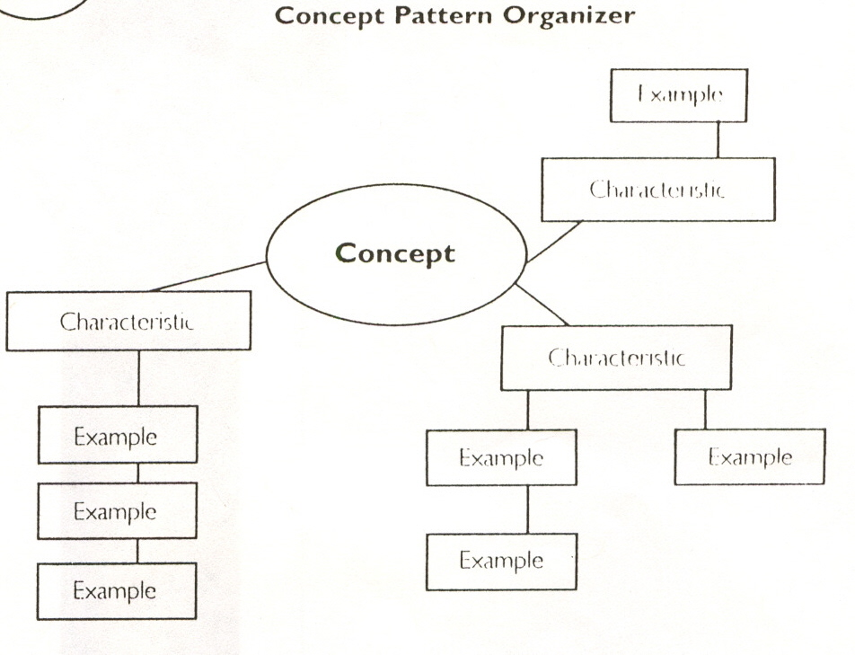

Example
Example
Example
Example
Example
Example
Example
Characteristic
Characteristic
Characteristic

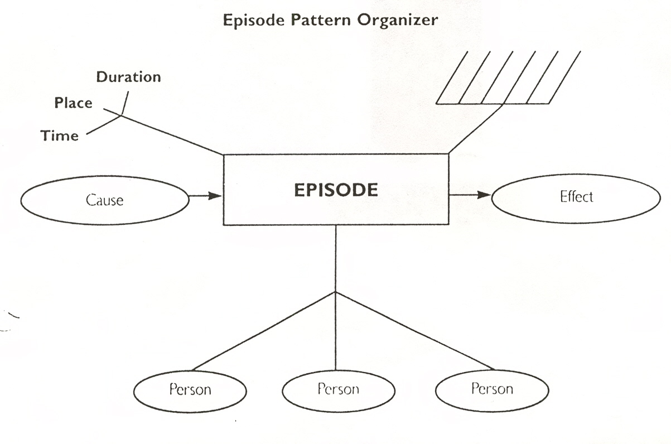
Cause
Effect
Person
Person
Person

Comparison/Contrast

Venn Diagram

Different
Different
Alike

Chronological Sequence
Topic:

Example:
Topic:
How to make a peanut butter & jelly sandwich

Spread jelly on top of peanut butter

Spread peanut butter on bread with knife

Open jars

Get stuff out

Clean up
the mess

Eat sandwich

Cut sandwich

Place both pieces of bread together

Writing Terminology
Introduction

Introductory
Paragraph: The first paragraph(s) in an essay introduces the topic and states the thesis.

Attention Getter: A statement/startling fact, quote, question, or anecdote that appears at the
beginning of the introduction and “hooks” or “grabs” the reader’s
attention.

Thesis Statement: The thesis is a sentence that makes a claim and summarizes the focus of
the paper in a fair and logical manner.

Body

Body Paragraphs: The paragraphs that develop logical points a writer wants to make to support the thesis. A strong body paragraph starts with a topic sentence that is supported with concrete detail and commentary and ends with a return to claim from the thesis.

Transition: To move from one part of writing to another, a good writer uses
transitional words, phrases, sentences, and paragraphs to assure
smoothness and continuity. See page 30 for examples.

Concrete Details: Specific details form the backbone or core of the body paragraphs.
Synonyms for concrete details include facts, specifics, examples,
descriptions, illustrations, support, proof, evidence, quotations,
paraphrasing, or plot references.

Commentary: The writer has a clear voice which may include insight, analysis, interpretation, inference, personal response, feelings, evaluation,
explication, or reflection. Commentary ties the concrete detail back to the thesis.
Conclusion

Concluding
Paragraph: The last paragraph in an essay sums up ideas, reflects on what has been
said in the essay, provides more analysis or clarification of voice about the subject, or gives a personal statement. The concluding paragraph subtly restates the thesis statement. An effective concluding paragraph will use techniques such as anecdotes, wit, strong images, or irony in order to give finality.

Six Traits of Writing

Ideas: Ideas are the focus of the essay that, with relevant supporting details, build
the reader’s understanding. The writer chooses details that are interesting, important, and informative. The ideas appropriately demonstrate an awareness of purpose and audience.

Organization: Organization, the internal structure of an essay, includes an introduction
with a clear thesis statement, body, and conclusion. Additionally,
transitions within the writing connect the ideas in a logical sequence.

Voice: Voice is the presence of the writer on the page. It is the sense that a real
person who cares about the message is speaking to the reader. When the writer is engaged personally with the topic, he/she imparts a personal tone and flavor to the piece that is unmistakably his/hers alone. All other traits contribute to the development of a strong voice.

Word Choice: The use of rich, colorful, precise language that moves and enlightens the
reader. It is the love of language, a passion for words, combined with a
skill in choosing words that creates just the right mood, impression, or
image in the heart and mind of the reader. Effective word choice includes
specific nouns, vivid verbs, and descriptive modifiers.

Sentence Fluency: Effective sentence construction creates an easy flow and rhythm to the
writing. The writing is free of word patterns that interfere with readability.
Students should be able to vary sentence structure, beginnings, and length.

Conventions: Conventions (grammar and usage, spelling, punctuation, capitalization,
and paragraphing) are the mechanical correctness of an essay.

Five Paragraph Essay Format
In accordance with Idaho Core Standards (ICS), this is a foundation to transition into more complex essays. This organization should be used as a starting point when an essay is assigned. Types of essays that would fit this format include expository and persuasive; both should include an introduction that introduces the subject and narrows it to a specific focus or thesis. The body paragraphs add support material to the thesis. Finally, the essay concludes with a closing paragraph that summarizes the thesis and supporting material.

This is a basic format that gives a strategy for organizing material for a variety of writing assignments. Once this strategy is familiar and comfortable, it becomes a foundation for creative experimentation and development of a more sophisticated writing style.
INTRODUCTION:
1. Use an attention getter to ‘hook’ the reader
such as anecdotes, dramatic facts, statistics,
impressive quotes, and/or a vivid description.
2. Follow with a broad topic sentence(s) that
introduces the topic.
3. Narrow to a limited subject or central point
(thesis.)
Opening Comments

Thesis Statement
Topic Sentence 3
Specific Details/Commentary
Topic Sentence 2
Specific Details/Commentary
Topic Sentence 1
Specific Details/Commentary
SUPPORT/EVIDENCE:
1. Give concrete details (examples, facts,
statistics, anecdotes, personal
observations/experiences, expert opinions,
quotations).
2. Acknowledge source of information (cite
references).
3. Add commentary (explanation of relevance of
detail to topic).
4. Use transitions.

CONCLUSION:
1. No new information can be introduced here.
2. Connect back to introduction.
3. Rephrase the thesis.
4. Summarize.
5. Give predictions, quotations, statistics,
recommendations or calls for action.

Rephrase Thesis

Closing Comments

Thesis Generator

Example
1. Identify the subject of your paper. | Growing up Native American
2. Turn your subject into a guiding question. | How is growing up Native American influenced by living in a primarily Caucasian community?
3. Answer your question with a statement. | As children grow up in white communities, they face challenges form both the white and Native worlds.
4. Refine this statement into a working thesis. | Growing up Native American in a primarily white community required teens to find ways to live in two different cultures while remaining true to their own identities.

1. Identify the subject of your paper.
2. Turn your subject into a guiding question.
3. Answer your question with a statement.
4. Refine this statement into a working thesis.
May be photocopied for classroom use. © 2010 by Jim Burke from What’s the Big Idea? Portsmouth, NH: Heinemann.

For additional information about Teaching with Questions visit:
http://www.englishcompanion.com/pdfDocs/BurkeHOutsTeachingwithQuestions.pdf

Electronic copy of Thesis Generator:
http://www.atech.org/faculty/burke/WRITING/thesisoutlinegenerator.html

Paper copy of Thesis Generator:
http://www.heinemann.com/shared/companionResources/E02157/BurkeWTBIChapter1/ThesisGenerator_Fig1.2.pdf

CCSS doesn’t focus on the narrative
Comparison and Contrast Essay Format

Compare and Contrast Chart Graphic Organizer
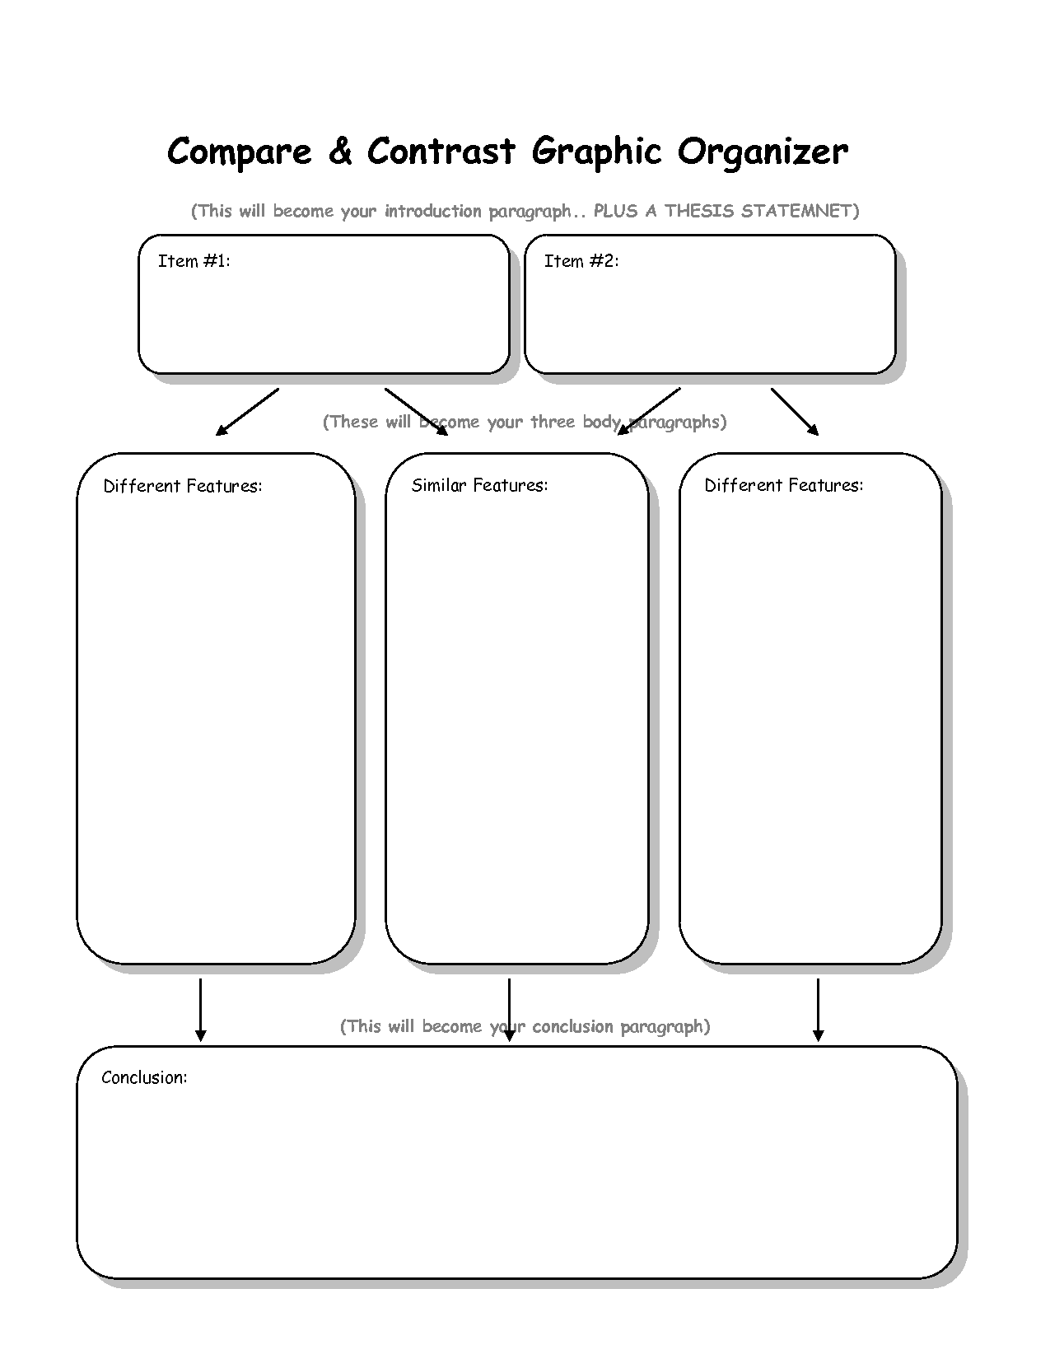

Another Resource for Compare/Contrast:
Teaching compare/contrast writing through modeling
http://www.readwritethink.org/classroom-resources/student-interactives/comparison-contrast-guide-30033.html
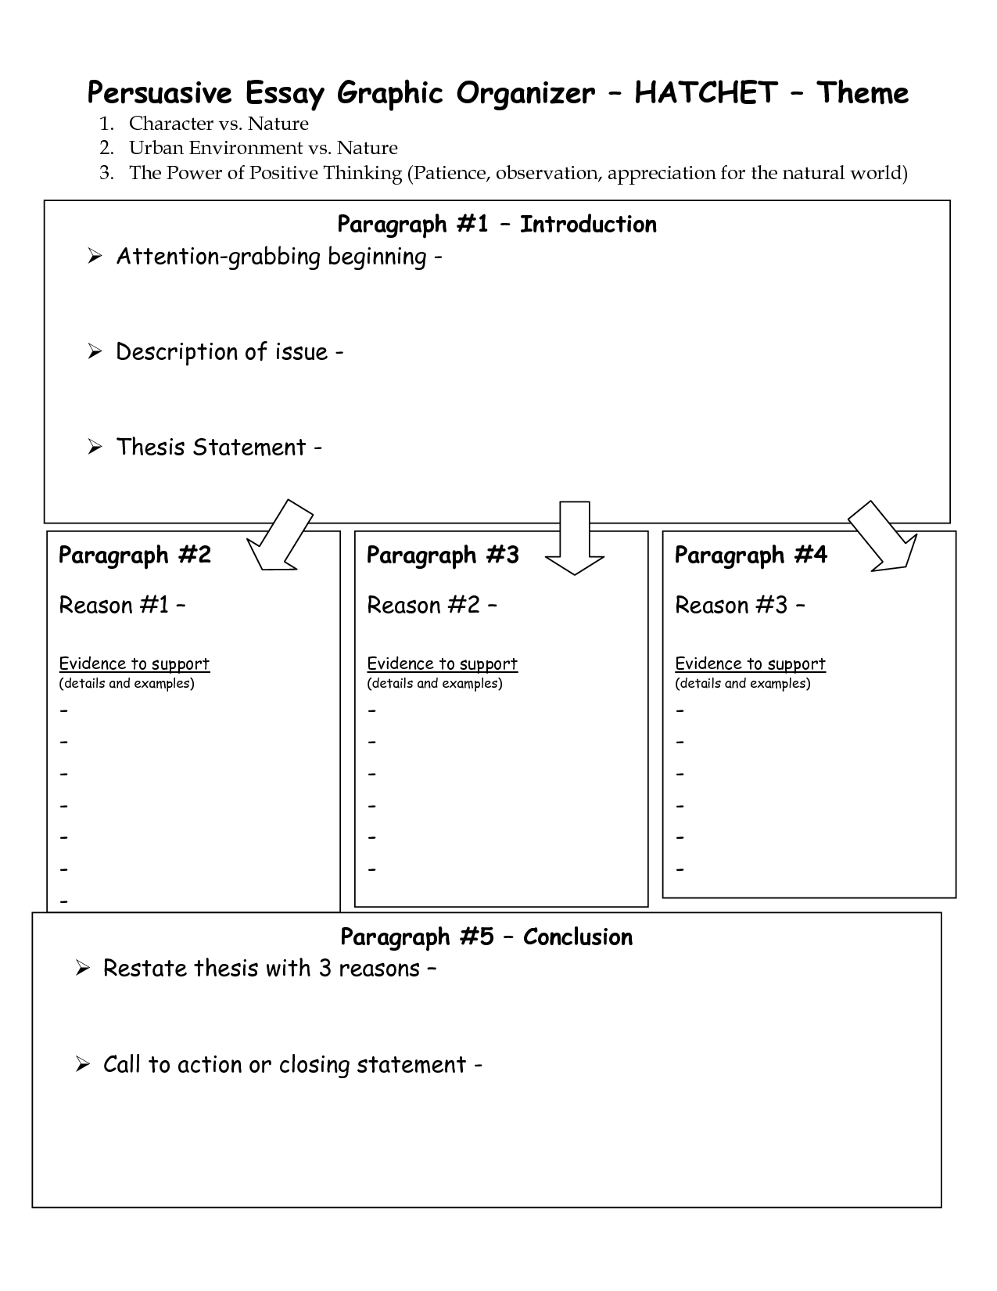

MLA Format Requirements
Essential Question for all grade levels: Why do we cite resources?

- We cite resources to give credit to the people who created these resources.

- We cite resources to allow other people who are interested in our projects to find out
more, so they can “track back” and look at our original source of information.

- We cite resources to add validity to our claims, arguments, and explanations.

- This is how scholarship works, from elementary school all the way through graduate research.

Definitions
Works Cited page - According to MLA style, you must have a Works Cited page at the end of your paper. All entries in the Works Cited page must correspond to the in-text citation.

In-text Citation - a reference to the source (either in the sentence itself or in parenthesis following the quotation or paraphrase) that guides the reader to the works cited page.

Signal Phrase - A method of referring to the works of others in your text by placing relevant source information in a phrase that introduces a quote or paraphrase.

Parenthetical Citation- a method of referring to the works of others in your text by placing relevant source information in parentheses after a quote or paraphrase.

MLA Format
Formatting is how words and symbols are placed on the page. All writing will conform to the Modern Language Association (MLA) format requirements. This format was chosen for its alignment with Common Core standards. These guidelines have been adapted for appropriateness at different grade levels yet still maintain standard format. See sample below.

1. Use standard sized 8 ½” x 11” plain white paper; 12 point font, Times New Roman.

2. Typed documents should be double spaced; use one side only.

3. Set margins to 1” on top, bottom, and sides.

4. Insert header which will include pages consecutively numbered in the upper right-hand
corner, ½” from the top with your last name before the page number on multiple-page
documents.

5. The essay should begin with a heading on the first page, beginning 1” from the top and
flush with the left margin. The heading should include these items in the following order:
student’s first and last name, teacher’s name, class name and period (or what teacher
prefers), and date (International Dating, see example). Write out the month of the year.
6. All documents need a title. The title follows the heading and is centered. The title’s font
should be the same as the rest of the paper. Do not bold, italicize, add quotation marks or
underline.

7. Paragraphs should be indented ½”.

1”
½”

Smith 1
1”

John Smith

Mr. Jones

English 10A, 3rd Period

03 February 2010

The Nursing Profession

Remember to indent your paragraphs and double-space your typed

papers.

Sample Pages of a Research Paper in MLA Style

First Page of a Research Paper

8 ½”
Double-space
½”

Josephson 1

Laura N. Josephson

Professor Bennett

Humanities 2710

8 May 1999

Ellington’s Adventures in Music and Geography

In studying the influence of Latin American, African, and Asian music on modern American

composers, music historians tend to discuss such figures as Aaron Copland, George Gershwin, Henry

Cowell, Alan Hovhaness, and John Cage (Brindle: Griffiths 104-39; Hitchcock 173-98). They usually

overlook Duke Ellington, whom Gunther Schuller rightly calls “one of America’s great composers” (318),

probably because they are familiar only with Ellington’s popular pieces, like “Sophisticated Lady,” “Mood

Indigo,” and “Solitude.” Still little known are the many ambitious orchestral suites Ellington composed,

several of which, such as Black, Brown, and Beige (originally entitled The African Suite), The Liberian

Suite, The Far East Suite, The Latin American Suite, and Afro-Eurasian Eclipse, explore his impressions of

the people, places, and music of other countries.

Not all music critics, however, have ignored Ellington’s excursions into longer musical forms.

In the 1950s, for example, while Ellington was still alive, Raymond Horricks compared him with Ravel,

Delius, and Debussy:

The continually enquiring mind of Ellington [. . .] has sought to extend steadily the

imaginative boundaries of the musical form on which it subsists. [. . .] Ellington

since the mid-1930s has been engaged upon extending both the imagery and the formal

construction of written jazz. (122-23)

Ellington’s earliest attempts to move beyond the three-minute limit

1”

Indent ½”

11”

Indent 1”
1”

Using Sources: MLA Format

Writers must document everything they borrow – not only direct quotations and paraphrases – but also information and ideas. Writers may paraphrase, summarize, borrow parts as fact, or directly quote, but all of this information must be documented. (See section on documentation.) The information in the format/documentation section comes from Gibaldi, Joseph. MLA Handbook for Writers of Research Papers. 7th ed. New York: MLA, 2009. Print.

Modified MLA for K-5 links

Plagiarism
What is plagiarism and how can it be avoided? Plagiarism is using someone else’s ideas and/or words and presenting them as your own without giving credit to the source (Gibaldi 30). Downloading or cutting and pasting papers from the Internet, copying information out of a book, and putting someone else’s information in your own words without giving proper credit to the source are all examples of plagiarism. To avoid plagiarism, always give credit whenever you use someone else’s ideas, opinions, or theories; use facts or statistics taken from published work; use quotations from someone else’s spoken or written words; or use paraphrased spoken or written words. In other words, give credit where credit is due. When in doubt, credit a source. It is better to err on the side of caution than to risk plagiarizing someone else’s words or ideas.

We take plagiarism very seriously in the Pocatello/Chubbuck School District. Plagiarism is treated the same as cheating and is subject to the rules of the classroom teacher or may be referred to an administrator for a major discipline referral.

Links for plagiarism tutorials:

http://www.lib.usm.edu/legacy/plag/plagiarismtutorial.php
https://plagiarism.duke.edu/def/

MLA Citation for Paraphrasing
The current recommended forms of citation are called Parenthetical and/or In-text Citation. Parenthetical citation directs the reader to the Works Cited page in order to verify reliability and lists the reference immediately following the information given in the text. Usually the author’s last name and a page number are enough to identify the source and location from which you have borrowed material.

1. When a source by one author is used, place the author’s name and page number right
after the quoted, paraphrased, or summarized material. Note that the parentheses go
before the end punctuation, and no punctuation goes between the author’s name
and page number.

Example:

Although pop art often resembles the comic strip, “it owes a debt to such painters as

Magritte, Matisse, and de Kooning” (Rose 184).

2. When using a source by one author and giving credit to that author by name within the
paper, only the page number and parentheses are needed.

Example:

According to critic Barbara Rose, pop art owes a large debt to such painters as Margritte, Matisse, and de Kooning (184).

3. When directly quoting material longer than five typed lines, follow the rules for blocked
quotations.

Example:

At the conclusion of Lord of the Flies, Ralph and the other boys realize the horror of their actions:
The tears began to flow and sobs shook him. He gave himself up to them

now for the first time on the island; great, shuddering spasms of grief that

seemed to wrench his whole body. His voice rose under the black smoke

before the burning wreckage of the island; and infected by that emotion,

the other little boys began to shake and sob too. (Golding 186)

4. When citing more than one work by the same author, include a short title in the parentheses.

Example:

Within 50 years the Inca and Aztec civilizations were defeated and overthrown by outside invaders (Thomas, Lost Cultures 198).

5. When citing a work by two authors, use both last names and the page number.

Example:

Prisons today are overcrowded to the point of emergency: conditions could not be worse, and the state budget for prison reform is at an all-time low (Smith and Jones 72).

6. When citing a work that has no author given, use the work’s title and the page number.

Example:

Each year 350,000 Americans will die of a heart attack before reaching a hospital (“First Aid for Heart Attacks” 88).

7. If the work you are citing appears in a series, include the volume and page number with the
author’s name.

Example:

The most common view camera format is 4” by 5”, though many sizes are available on
today’s market (Pursell 1:29).

Using Direct Quotations: MLA Formatting

1. Always quote accurately. Even minor mistakes in transcribing a passage damage a reader’s
confidence in the reliability of the writer.

2. Brief quotations. Quoted short passages and/or sentences woven into the text of paragraphs
should blend smoothly with the writer’s style tense used. The quotation must support some
point in the paper and not be “just thrown in.”

Quotations of four lines or less of prose or two lines of verse are placed between quotation marks and followed by documentation.

Example:

The Connecticut Yankee learns, “You can’t throw too much style into a miracle. It costs trouble, and work, and sometimes money, but it pays in the end” (Bailey 8).

3. Longer (blocked) quotations. Quotations of five lines or more of prose or three lines or
more of verse need to be blocked.

- Indent 10 spaces from the left-hand margin for each line of the blocked quotation.

b. Do not use quotation marks around the blocked passage since this special
typographical form indicates that you are quoting. However, if the material you are citing has quotation marks within, you do include those marks in your blocked passage. In other words, the punctuation in a blocked quoted passage looks exactly as it did in the source you used.

c. Documentation must follow the quote.

d. Be sure to relate the ideas in the blocked passage to the points the writer is making in the text of his/her paper.

Works Cited

The works cited page appearing at the end of the paper should include all of the sources actually cited in the paper.

1. Everything should be double spaced.

2. Citation-building websites are NOT completely reliable and OFTEN format incorrectly

3. The Works Cited page is the last SEPARATE page of your paper.

4. The entries are arranged alphabetically by author’s last name. In the MLA format, note
that the author’s last name is given first. If no author is given, use the first work in the
title omitting a, an, the.

5. The entries are not numbered or bulleted.

6. The punctuation on the Works Cited page needs to be exact.

7. Unlike prose, the second and the following lines are indented five spaces—hanging indent.

8. Titles of major works (books, magazines, websites, plays, CDs, movies, etc.) are
italicized when typed.

9. Titles of lesser works (magazine articles, news articles, essays, titles of poems) have
quotation marks around them.

Resources for evaluating websites:

http://www.ala.org/ala/mgrps/divs/rusa/sections/history/resources/pubs/usingprimarysources/index.cfm

http://www.lib.berkeley.edu/TeachingLib/Guides/Internet/Evaluate.html

http://library.acadiau.ca/tutorials/webevaluation/

http://www.library.cornell.edu/olinuris/ref/research/webeval.html

Citation Building Websites:
http://www.bibme.org/

http://citationmachine.net/

Creating Works Cited Entries in MLA Format

Instead of strict rules for format, MLA format now requires writers to identify core elements to create a citation. Core elements are those basic pieces of information that should be common to all sources, from books to articles, from lectures to tweets. The MLA core elements, which are assembled in a specific order, are as follows:
- Author.
- Title of Source.
- Title of Container,
- Other Contributors,
- Version,
- Number,
- Publisher,
- Publication Date,
- Location.

Sample Works Cited Forms
Books
Book by Single Author

Meriwether, Louise. Daddy Was a Number Runner. Prentice-Hall, 1970.

Book by Two Authors

Przeworski, Adam, and Henry Teune. The Logic of Comparative Social Inquiry. Wiley-Interscience, 1970.
Book by Three or More Authors

Glenn, Neal E., et al. Secondary School Music: Philosophy-Theory and Practice.
Prentice-Hall, 1970.

Corporate author

United Nations. Consequences of Rapid Population Growth in Developing Countries.
Taylor and Francis, 1991.

Anthologies or Compilations

Single Editor or Compiler

Nunberg, Geoffrey, editor. The Future of the Book. U of California P, 1996.

Multiple Editors or Compilers

Eastman, Arthur, et al., editors. The Norton Anthology of Poetry. Norton, 1970.

An essay/short story/poem in a Compilation or Anthology

Dewar, James A., and Peng Hwa Ang. “The Cultural Consequences of Printing and the Internet.” Agent of Change: Print Culture Studies after Elizabeth L. Eisenstein, edited by Sabrina Alcorn Baron et al., U of Massachusetts P / Center for the Book, Library of Congress, 2007, pp. 365-77.

Visual Media
Film and/or Television

“Hush.” Buffy the Vampire Slayer, created by Joss Whedon, performance by Sarah Michelle Gellar, season 4, episode 10, Mutant Enemy, 1999.
If the focus is on the performance of an Actor

Geller, Sarah Michelle, performer. Buffy the Vampire Slayer. Mutant Enemy, 1997-2003.
Film or Television viewed online

“Under the Gun.” Pretty Little Liars, season 4, episode 6, ABC Family, 16 July 2013. Hulu, www.hulu.com/watch/511318.

Tweet
@persiankiwi. “We have report of large street battles in east & west of Tehran now - #Iranelection.” Twitter, 23 June 2009, 11:15 a.m., twitter.com/persiankiwi/satus/2298106072.
Periodicals

Journal/ magazine/ newspaper

Baron, Naomi S. “Redefining Reading: The impact of Digital Communication Media.” PMLA, vol. 128, no. 1, Jan. 1023, pp. 193-200.

Electronic Sources

Website with Known Author

Hollmichel, Stefanie. “The Reading Brain: Differences Between Digital and Print.” So Many Books, 25 April 2013, somanybooksblog.com/2013/04/25/the-reading-brain-differences-between-digital-and-print/.

Resources for MLA Formatting:

https://owl.english.purdue.edu/owl/resource/747/01/

http://www.ipl.org/div/aplus/linkciting.htm

Citation Progression
Pocatello/Chubbuck School District

Grade Level | Expectation | Skills  Owl Purdue | Classroom Instruction Techniques
K | Awareness of Ownership | Cite author and/or title orally | Orally  Whole class
1 & 2 | Awareness of ownership and formatting | Cite author and/or title orally or in a works cited page | Orally  Whole Class
3rd | Introductory knowledge of formatting guidelines of in-text and works cited (up to Author, Title, and Container*). | Introduce basic in-text citations and signal phrases (e.g. last name, page number, “said”, etc.). Introduce formatting guidelines for following core MLA elements: Name of Author/Creator, Title, and Container. Title should be italicized in typed work, but can be underlined in handwritten work. | Whole Class
4th | Knowledge of formatting guidelines of in-text and works cited (up to Author, Title, Container*, and Location). | In-text citations, including parenthetical citations, and signal phrases. Formatting guidelines for following core MLA elements: Name of Author/Creator, Title, Container, and Location. (e.g., page number, URL). Title should be italicized in typed work, but can be underlined in handwritten work. | Whole Class
5th | Knowledge of formatting guidelines of in-text and works cited (up to Author, Title, Container*, and Location). | Continued development of in-text, including parenthetical citations, and signal phrases. Creation of complete entry on the Works Cited page. | Whole Class  Small Group
6th | Knowledge and use of formatting guidelines of in-text references as they connect to the works cited page. A complete works cited entry is as follows: Author, Title, Container, Other Contributors, Version, Number, Publisher, Publication date, and Location. | Continued development of in-text, parenthetical citations, and signal phrases. Creation of complete entry on the Works Cited page. | Whole Class  Small Group  Individual
7th | Knowledge and use of formatting guidelines of in-text references as they connect to the works cited page. A complete works cited entry is as follows: Author, Title, Container, Other Contributors, Version, Number, Publisher, Publication date, and Location. | Continued development of in-text, parenthetical citations, and signal phrases. Creation of complete entry on the Works Cited page.  Students should be able to cite a book and electronic sources. | Small Group  Individual
8th | Knowledge and use of formatting guidelines of in-text references as they connect to the works cited page. A complete works cited entry is as follows: Author, Title, Container, Other Contributors, Version, Number, Publisher, Publication date, and Location. | Continued development of in-text, parenthetical citations, and signal phrases. Creation of complete entry on the Works Cited page.  In addition to citing books and electronic sources, students will be able to cite other common sources such as interviews, film, and movies. | Small Group  Individual
9 & 10 | Mastery of MLA Format | Use of multiple and varied in-text citations, parenthetical citations, and signal phrases. Complete and accurate entries on a Works Cited page, paying special attention to the punctuation and formatting of names, titles, and containers. MLA format used throughout an entire paper. Students will also begin to independently evaluate sources as well as find formatting information. | Whole Class  Small Group  Individual
11 & 12 | Mastery of MLA Format | Use of multiple and varied in-text citations, parenthetical citations, and signal phrases. Complete and accurate entries on a Works Cited page. MLA format used throughout an entire and extended paper. Students can independently evaluate sources. | Small Group  Individual (Most of 12th grade work should be done independently).
*The container is where the material that you are looking for is housed. If the source that is documented is part of a larger whole, the larger whole is the container that holds the source. The title of the container is italicized and is followed by the comma since the information that follows describes the container.

Root Words

Common Latin Roots
audi: | auditory, audience, audit, auditorium, audible, inaudible, audition
dict: | dictate, predict, dictator, edict, contradict, dictation, indict, prediction
ject: | reject, inject, projection, interjection, eject, objection, dejection
port: | transport, transportation, import, export, porter, portable, report, support
rupt: | rupture, erupt, eruption, interrupt, interruption, disruption
scrib/  script: | scribe, describe, manuscript,  inscription, transcript, description, prescription
spect: | spectator, inspect, inspector, respect, spectacle, spectacular
struct: | structure, construct, construction, instruct, destruction, reconstruction
tract: | tractor, traction, attract, subtraction, extract, retract, attractive
vis: | vision, visual, visit, supervisor, invisible, vista, visualize, visionary

Common Greek Roots
auto: | automatic, autograph, autobiography, automobile, autocracy
bio: | biology, biosphere, biography, biochemistry, biometrics, biophysics
graph: | graphite, geography, graphic, photograph, phonograph
hydro: | anhydrous, dehydration, hydrogen, hydrant, hydrostatic, hydrophobia, hydrotherapy, hydroplane
meter: | speedometer, odometer, metronome, thermometer, chronometer, perimeter, hydrometer
ology: | geology, theology, zoology, meteorology, phonology
photo: | photography, photocopy, phototropism, photostat, photogenic
scope: | periscope, stethoscope, telescope, microscope, microscopic
tele: | telephone, telepathy, telegraph, television
therm: | thermos, thermodynamics, thermostat, thermophysics

Grade 7-8 “No Excuse” Spelling List

accept  except | to agree or take what is offered  leave out or exclude | emigrate  immigrate | exit country  into country
advice  advise | It is good advice to drive slowly on the ice.  To advise you must be wise. | ensure  insure | make certain of  business purposes (insurance)
affect  effect | v. to change or shape  n. result or outcome | everyday  every day | routine, daily  every single day
aid  aide | to help  the actual helper | foreword  forward | opening info in a book  move ahead
a lot  allot | a great number of  I want make a lot of money!  to allocate  I will allot $10.00 to this project. | its  it’s | possessive pronoun  it is
all ready  already | all is ready  past | lose  loose | not win, misplace  not tight
all right  alright | Not a word! | pair  pear | two  fruit
all together  altogether | all at once  entirely or whole | passed  past | v. to pass  preceding time
allusion  illusion | a reference; to refer or allude to  false impression | peak  peek  pique | high point (mountain peak)  try to see something  intrigue, interest (pique my interest)
altar  alter | in a church  to change | principle  principal | law or belief  major or head (principal of school); money that earns interest in a bank)
breath  breathe | single | quiet  quite | calm, silent  to a certain extent
Capital  Capitol | money/letters  The Capitol building in D.C. | stationery  stationary | paper to write a letter on  lacks motion, doesn’t move
karat  carat  caret  carrot | measurement of gold  measurement of diamond weight  symbol ^  vegetable | there  their  they’re | If you are not here you are over there!  Their new car is black.  They are
cite  sight  site | refer to sources  vision/view  location (web or building) | to  two  too | to the store  two (2) candy bars  also

Resources
Grade 7-8 “No Excuse” Spelling List

coarse  course | rough  path, class, ‘of course’ | whose  who’s | possessive of who  who is
complement  compliment | Complete ‘Those earrings complement your outfit.’  praise | your  you’re | possessive pronoun  you are
council  counsel | group/committee  to give advice
desert  dessert | dry, arid place; to leave  follows main course of meal
dual  duel | two  fight

Suggested Sentence Beginnings

1. Two adjectives
Tall, handsome lifeguards flirt…

2. An appositive
Sam, the tall, handsome lifeguard, flirts…

3. A parallel structure
Tall and handsome, Sam flirts…

4. A question
Who could that tall, handsome lifeguard be?

5. A prepositional phrase
On the high tower the tall, handsome lifeguard lounges…

6. An infinitive
To sit all day in the high tower is the job of the lifeguard.

7. A gerund
Sitting all day in the high tower, watching the pretty girls, is the lifeguard’s duty.

8. A perfect infinitive
To have sat in the burning sun all day was a challenge for the guards.

9. A perfect participle (past participle)
Having sat all day in the tower, the lifeguard left to find a cold drink.

10. A present participle
Smiling at the happy crowds, the lifeguard keeps watch.

11. A perfect gerund
Having sat there all day was a challenge for the guards.

12. A predicate adjective
Tall and handsome was the guard.

Some Suggested Transitions

To show time since during afterward
meanwhile later as time passed
eventually until soon
at last finally next
first, second soon after gradually

To show place here there elsewhere
beyond opposite in front of
nearby to the left next to
east far away on top of

To show result therefore as a result accordingly
or effect due to because of consequently
for this reason thus hence

To give an for example that is such as
example for instance specifically to illustrate

To add a point in addition furthermore also
moreover besides second

To compare similarly likewise also

To contrast however yet nevertheless
on the other hand in contrast but

To emphasize in particular most important note that

To conclude in conclusion to conclude finally

To summarize in other words in short to sum up

Synonyms

Synonyms are words that have similar meanings. Dictionaries often use synonyms in their definitions. There are whole books of synonyms and special reference works, such as the thesaurus, that have clusters of words or phrases, all with similar meanings. These are particularly useful in finding just the right word when writing. Caution: A synonym may be for only one meaning of a word with several meanings.

able – capable – competent
abrupt – sudden – hasty
achieve – accomplish – attain
add – total – sum up
after – following – subsequent
aim – purpose – goal
all – every – entire
allow – permit – grant
anger – rage – fury
answer – response – reply
arrive – reach – get to
ask – question – interrogate
astonish – surprise – amaze

back – rear – behind
bear – endure – tolerate
before – prior to – in front of
begin – start – initiate
below – under – beneath
birth – origin – genesis
border – edge – margin
bother – annoy – pester
boy – lad – youth
brave – courageous – daring
bulge – swell – protrude
busy – occupied – engaged

call – shout – yell
calm – composed – serene
car – auto – vehicle
carry – tote – lug
careful – cautious – prudent
change – vary – alter
charm – fascinate – enchant
cheat – deceive – swindle
children – youngsters – tots
city – borough – town
close – shut – seal
consent – agree – acquiesce
continue – persevere – persist
country – nation – state
cure – heal – restore

danger – peril – hazard
decrease – lessen – diminish
defect – flaw – blemish
delay – postpone – procrastinate
different – varied – diverse
disaster – calamity – catastrophe
divide – separate – split
during – while – at the same time
dwell – live – reside

eat – consume – devour
effort – exertion – endeavor
end – finish – complete
energy – power – strength
enough – adequate – sufficient
error – mistake – fallacy
explain – expound – elucidate

faith – trust – reliance
fat – plump – stout
fetch – bring – retrieve
find – locate – discover
fix – repair – mend
flat – level – flush
food – nourishment – sustenance
form – shape – make up
fragile – delicate – breakable
freedom – independence – liberty
frequent – often – many times

gay – lively – vivacious
gift – present – donation
give – grant – hand over
glum – morose – sullen
go – leave – depart
grateful – appreciative – thankful
great – grand – large
grow – mature – develop

happy – glad – joyous
hard – difficult – troublesome
hate – detest – despise
have – own – possess
heal – mend – cure
help – aid – assist
hide – conceal – secrete
high – tall – lofty
hold – grasp – clutch
hurry – rush – accelerate

idea – thought – concept
ill – sick – indisposed
income – revenue – earnings
injure – would – hurt

job – work – occupation
junk – rubbish – waste
just – fair – right

keep – hold – retain
key – answer – solution
kind – considerate – helpful
kill – slaughter – murder

large – big – enormous
last – endure – persist
late – tardy – delayed
learn – acquire – understand
leave – depart – go away
like – enjoy – be fond of
listen – hear – attend
little – small – petite
long – lengthy – drawn out
look – glance – see

mad – crazy – insane
make – build – construct
many – multitudinous – numerous
marvelous – wonderful – extraordinary
mean – stand for – denote
mend – repair – restore
method – way – manner
might – may – perhaps
mistake – error – blunder
move – transport – propel

name – title – designation
near – close by – in the vicinity
need – require – want
new – fresh – recent
noise – uproar – clamor
novice – beginner – learner

occur – happen – take place
often – frequently – repeatedly
old – aged – ancient
omit – delete – remove
one – single – unit
open – unlock – unseal
ornament – decoration – adornment
outlive – survive – outlast

page – sheet – leaf
pain – ache – hurt
pair – couple – duo
pardon – forgive – excuse
part – portion – piece
peak – summit – top
people – public – populace
play – frolic – romp
praise – acclaim – applaud
primary – chief – principal
prohibit – forbid – restrict
put – place – locate

raid – attack – invade
reckless – careless – rash
remote – distant – secluded
renew – restore – revive
respect – honor – revive
revise – alter – correct
right – correct – proper

say – state – remark
seem – appear – look
sell – vend – market
shame – humiliation – mortification
show – demonstrate – display
sorry – regretful – penitent
speed – haste – hurry
start – begin – commence
still – unmoving – silent
stop – halt – end
story – tale – account
strength – power – energy
supply – provide – furnish
surpass – exceed – outdo

take – grab – seize
tense – taut – rigid
terrify – frighten – alarm
thanks – gratitude – appreciation
thaw – melt – dissolve
thief – robber – crook
thin – slender – slim
think – reflect – contemplate
time – period – season
timid – fearful – cowardly
tiny – small – diminutive
trial – test – experiment
true – faithful – loyal
try – attempt – endeavor
turn – revolve – pivot

ugly – homely – plain
understand – comprehend – discern
unify – consolidate – combine
uproar – tumult – pandemonium
urge – press – exhort
use – operate – employ

vacant – empty – unoccupied
value – worth – price
vast – huge immense
verify – confirm – substantiate
victor – winner – champion

walk – stroll – saunter
want – desire – crave
waver – fluctuate – vacillate
weak – feeble – impotent
wealthy – riches – fortune
word – term – expression
work – labor – toil
world – globe – earth
write – record – draft

Bernard Fry, Ph.D., Edward, et al. The Reading Teacher’s Book of Lists. Paramus, NJ: Prentice-

Hall, 2000. Print.

Synonyms for SAID

addressed
advised
alleged
approved
assumed
avowed
began
commented
cried
disclosed
droned
entreated
explained
feared
grinned
indicated
laughed
mimicked
mused
noted
opined
pleaded
predicted
propounded
reassured
remonstrated
resumed
roared
scolded
snapped
specified
stated
suggested
told
vowed
acquiesced

described
advocated
allowed
argued
assured
babbled
boasted
complained
debated
disrupted
elaborated
enunciated
exposed
foretold
grunted
inferred
lectured
moaned
muttered
notified
orated
pled
proclaimed
publicized
reciprocated
repeated
retorted
ruled
screamed
sneered
spoke
stipulated
taunted
twitted
wailed
denied

admitted
affirmed
announced
assented
asked
bantered
called
confided
dictated
divulged
emphasized
estimated
expressed
fumed
held
instructed
maintained
mumbled
nagged
objected
ordered
pointed out
professed
quibbled
refuted
responded
returned
sanctioned
shouted
sobbed
sputtered
stormed
thought
urged
acknowledged
denounced

admonished
agreed
answered
asserted
attested
bargained
claimed
contradicted
directed
drawled
enjoined
exclaimed
faltered
giggled
implied
itemized
mentioned
murmured
narrated
observed
petitioned
prayed
prompted
ranted
related
restated
revealed
scoffed
shrieked
solicited
stammered
stressed
threatened
uttered
demurred
added

Action Words/Verbs

aching
bashing
bubbling
beeping
beaming
blistering
blinking
blaring
blinding
battering
bickering
babbling
crowing
clucking
creeping
crackling
coughing
clanking
chugging
chatting
crunching
cackling
chanting
crooning
dribbling
dazzling
drifting
dancing

engulfing
entertaining
flailing
fuming
floating
flowing
flapping
flaring
flittering
flopping
flickering
glistening
gunning
grinding
gliding
glaring
glowing
glittering
groaning
hooting
hissing
inviting
jumping
jerking
kissing
kicking
laughing
leaping

lighting
loaning
mumbling
mocking
moaning
munching
nailing
nicking
popping
pouncing
pattering
piling
pounding
plopping
peeping
quacking
reflecting
roaring
rattling
rumbling
shimmering
shrieking
sloshing
sputtering
sprinkling
slapping
sizzling
soaring

spinning
squawking
sparking
smoking
splashing
streaking
smashing
scolding
sailing
trilling
thumping
thundering
twinkling
whipping
whisking
whirring
wailing
winking
wheezing
whistling
yapping
yelling
zooming

Editing Symbols
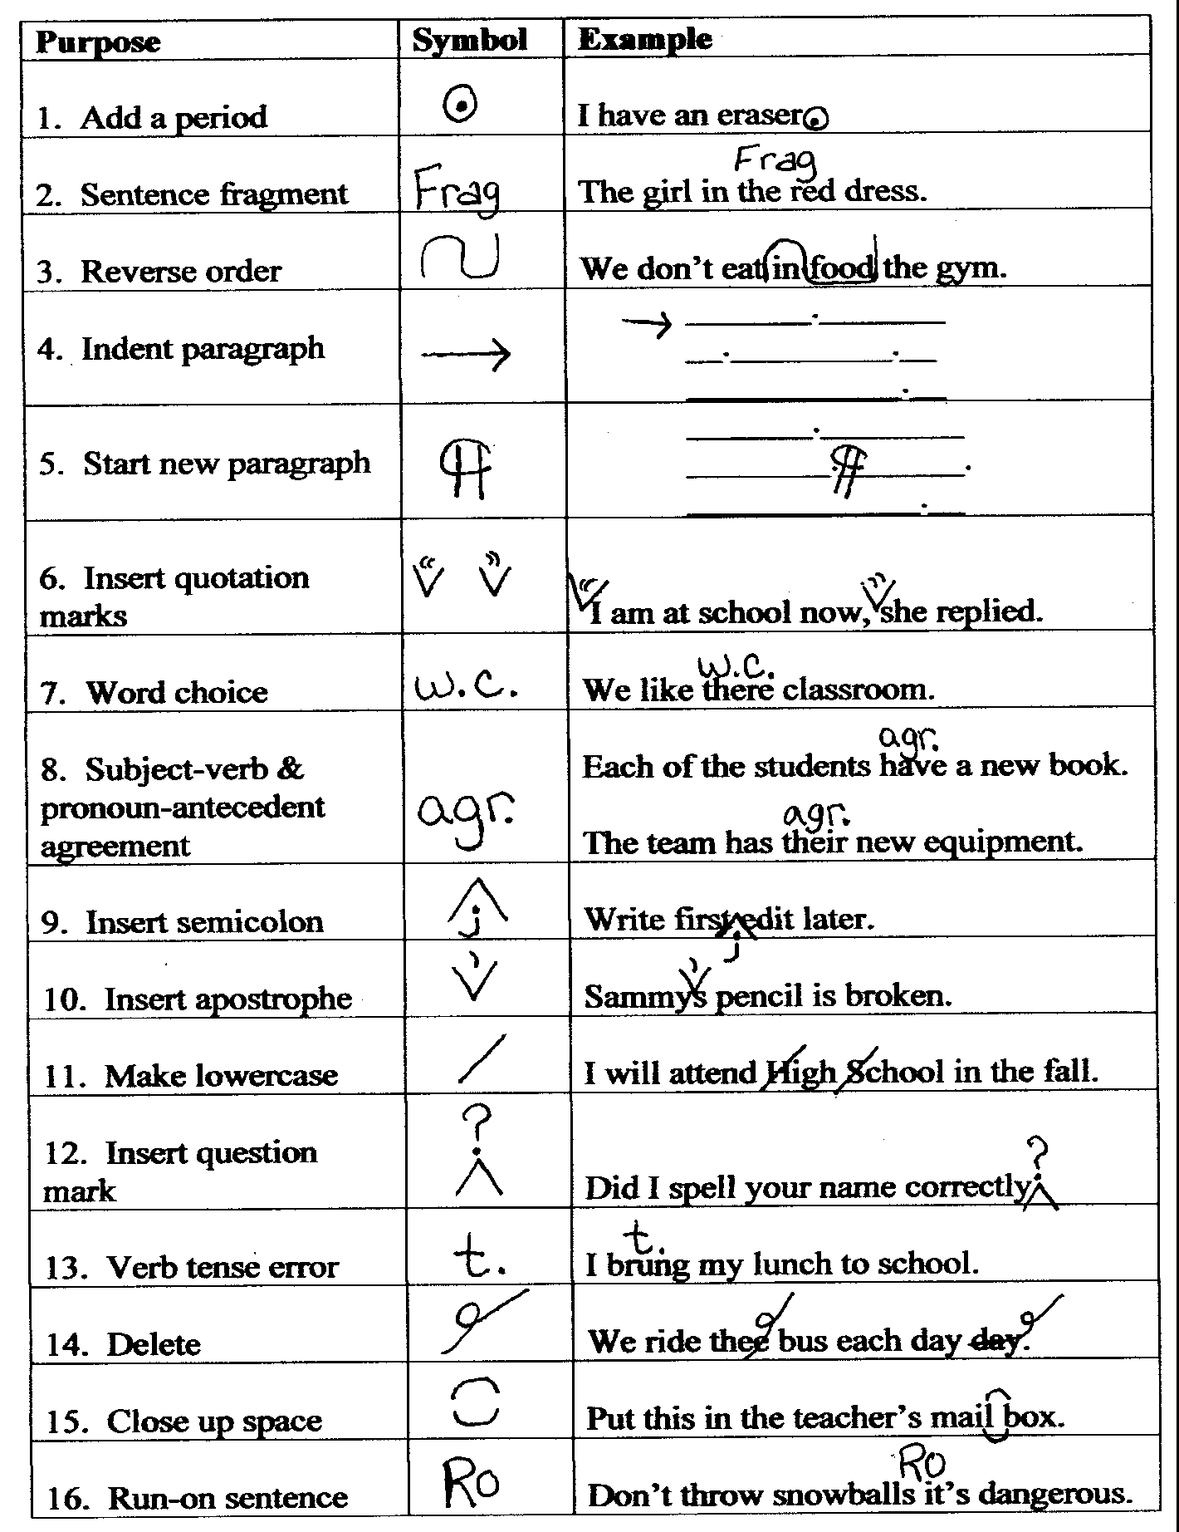

Editing Symbols

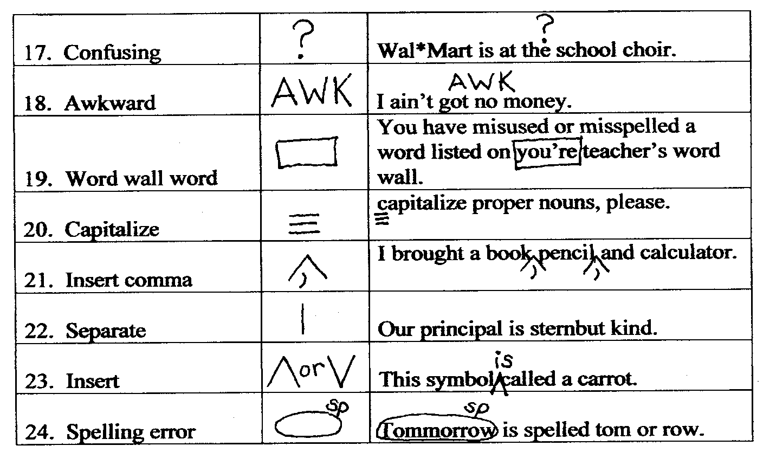

Listening and Note-Taking Skills

Creating a Shorthand System

You will be taking a lot of notes during your high school career. Start now to develop your own personal shorthand system. Here are some guidelines:

• Omit all articles (a, an, the).

• Use abbreviations without the periods.
meas max min p pp
prev approx etc esp incl
reg lg sm lbs st
pres Jan

• Use common mathematical and technical symbols.
+ - = X % # < > ÷ ↑ ↓ $ ║

• Eliminate vowels from words.
mdl for middle psbl for possible

• Use word beginnings.
intro for introduction psych for psychology

•Use your abbreviations consistently. Otherwise, you may end up wondering if psych
means psychology, psychiatry, or psychic.

• Create abbreviations for the most commonly used words in a particular course.
(Review your notes to find these words.) Write them and their abbreviations at the front
of your notebook.
PNS for parasympathetic nervous system
QE for quadratic equation

• Keep adding to your personal shorthand system. Here are some examples to get you
started:
w/ with w/o without
ex for example b/c because
b4 before SB should be
SNB should not be 2 two, to, too

Note-Taking Skills

Note taking is an active approach to learning, one that gets you personally involved in the learning process and helps you focus on and organize the information you need to study and learn.

The most important thing to understand about note taking is that you need to do more than simply listen and write. You need to listen, think, react, question, summarize, organize, label, and write.

Be Prepared . . .
- Do your assigned reading before you come to class. That way you can follow what is being discussed and don’t have to look at the floor every time your teacher asks a question.
- Have a separate notebook for each class and an extra pen or two.
- Label and date your notes at the beginning of each class period.

Be Attentive . . .
- Listen for any special instructions, rules, or guidelines your teacher may have regarding notebooks and note taking.
- Write your notes as neatly as time will allow; leave space in the margin for working with your notes later.
- Begin taking notes immediately. Don’t wait for something new or earthshaking before you begin taking notes.
- Relate the material to something in your life by writing a brief personal observation or reminder.
- Use your own words rather than copying exactly what you hear.

Be Concise . . .
- Summarize the main ideas, listing only the necessary details. Remember, taking good notes does not mean writing down everything.
- Condense information. Write your notes in phrases and lists rather than complete sentences.
- Use abbreviations, acronyms, and symbols (U.S., av., in., ea., lb., vs., @, #, $, %, &, +, =, w/o)
- Develop your own shorthand method.
- Draw simple illustrations, charts, or diagrams in your notes whenever they will make a point clearer.

Be Organized . . .
- Use a note-taking guide. Choose the guide that best fits your needs, or create a variation of your own.
- Write a title or heading for each new topic covered in your notes.
- Leave wide margins or skip a line or two between main ideas. When you’re reviewing later, you’ll have room to add study notes.
- Listen for transitions or signal words to help you organize your notes. Number all ideas and information presented in sequence or time order.
- Use a special system of marking your notes to emphasize important information (underline, highlight, star, check, indent).
- Label or mark information that is related by cause and effect, by comparison or contrast, or by any other special way.

Be Smart . . .
- Always copy down (or summarize) what the teacher puts on the board or projects on an overhead.
- Ask questions when you don’t understand something.
- Circle those words or ideas that you will need to look up later.
- Don’t let your notes sit until it is time to review for a test. Read over the notes you have taken within 24 hours and recopy, add details, highlight, or summarize as necessary.
- Jot down key words in the left-hand column. Cover your notes and try to restate what was said about each key word.
- Share your note-taking techniques, abbreviations, or special markings with others; then learn from what they share with you.

Tips for Remembering Your Notes
- Relate the material to your life.
- Recite ideas and facts out loud.
- Draw diagrams, illustrations, and clusters.
- Write about it, using your own words.
- Study it with someone or teach it to someone.
- Visualize it.
- Study your most difficult material first.
- Use acronyms, rhymes, raps, and flash cards.

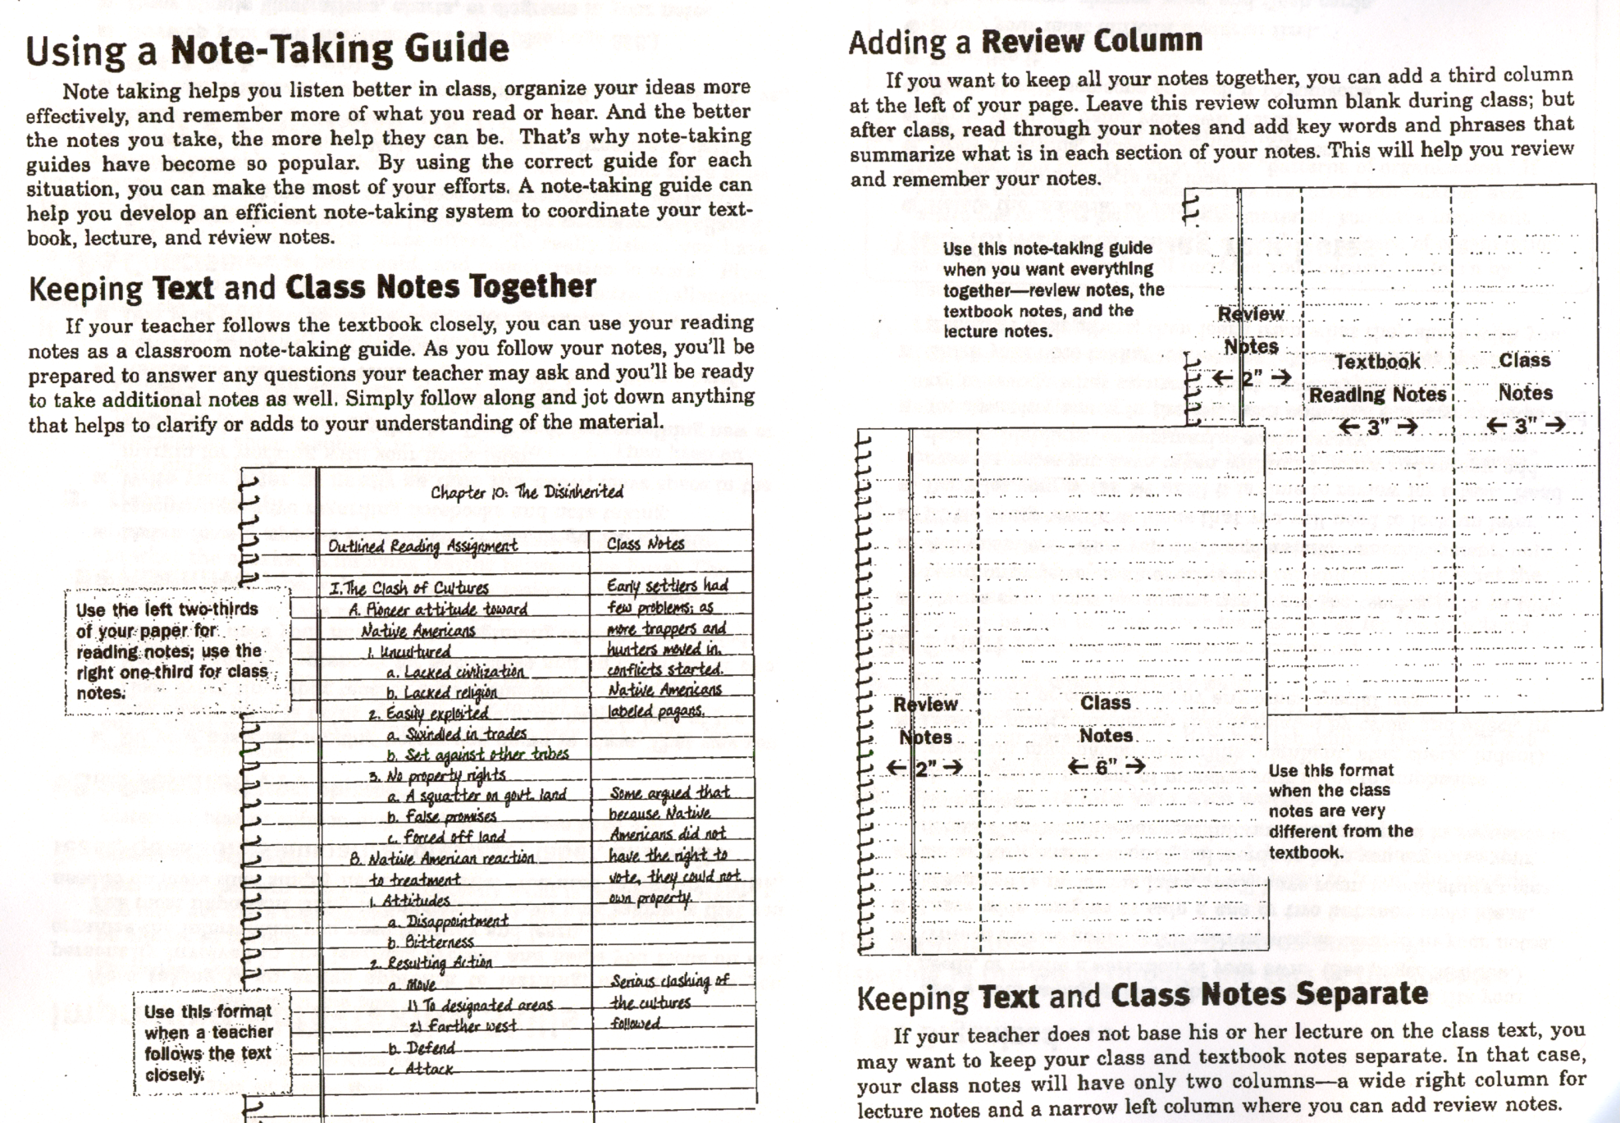

Cornell Note Taking System

Recall Clues & Questions

Preparing the system

Using the system

After the lecture or reading

Review method

Class: Date:
Notes: The Cornell Note Taking System

1. Use standard 3-hole paper.
2. Use one side of paper only.
3. Use a black or blue ball point pen.
4. Draw a line 1/3 from the left side of the paper.
5. Write ideas and facts on the right side of the line.
6. Skip lines between major ideas.

1. Record notes simply.
2. Write key phrases, not entire sentences.
3. Don’t make an elaborate outline.
4. Write down all key terms and definitions.
5. Include all relevant examples.
6. Use an abbreviation system.
7. Write as neatly as possible.
8. Leave blank space when you miss ideas, to add
information after asking the teacher or a classmate
for clarification.

1. Read through your notes as soon as possible after the
lecture or reading.
2. Rewrite illegible or abbreviated words that you may
forget.
3. Check the spelling of any uncertain words.
4. Improve the organization of the notes by
highlighting, numbering, and bulleting items.
5. Write key words or questions in the recall column
that prompt the information in the note taking
column.

1. Cover the right side of your notes with a piece of
paper.
2. Using the questions or key words in the recall
column, recite aloud the facts and ideas of the
lecture or reading in your own words.
3. Slide the paper down and check that portion of your
notes to see if you remembered all the critical
information.
4. Check off questions in the recall column that you
should continue to review more seriously.
(Kinsella, San Francisco State University, 10/00)
RUBRIC: Cornell Note Taking System

No Yes
Not Evident Very Evident
0 1 2 3 4
Fix-up

0 1 2 3 4 1. Is a complete heading included in the upper right-hand corner
(class name, date)?

0 1 2 3 4 2. Is the topic or title of the lecture written at the top of the note-
taking section?

0 1 2 3 4 3. Is the handwriting legibly written in blue or black ink?

0 1 2 3 4 4. Is sufficient space left between ideas, to add information if
necessary and to make review easier?

0 1 2 3 4 5. Are ideas indented to show the relationship between major or
minor points and supporting details?

0 1 2 3 4 6. Is the lecture primarily paraphrased rather than quoted?

0 1 2 3 4 7. Are the ideas primarily written in phrases rather than the
speaker’s or writer’s exact complete sentences?

0 1 2 3 4 8. Are abbreviations and symbols used when possible?

0 1 2 3 4 9. Are all of the most important points and adequate supporting
details included from the lecture?

0 1 2 3 4 10. Is the lecture information edited (with highlighting and
numbering or lettering) to make the main ideas and lecture
organization clear and easy to review?

0 1 2 3 4 11. Are sufficient questions and/or recall clues written in the recall
column to easily review all of the key points?

0 1 2 3 4 12. Are appropriate questions written in the recall column to
accurately and thoroughly review and quiz oneself?

Priorities for future note taking:
1.
2.
3.
(Kinsella, San Francisco State University, 10/00)

Cornell Note Taking Feedback Form

Note-taker _______________________ Evaluator _________________Grade ________

1. Date: Yes __________ No __________

2. Class name: Yes __________ No __________

3. Title: Yes __________ No __________

4. Written in ink: Yes __________ No __________

5. Handwriting is legible: Yes __________ No __________

6. Sufficient space between main ideas: Yes __________ No __________

7. Indentation to show the relationship Yes __________ No __________
between ideas:

8. Student used abbreviations or symbols Yes __________ No __________
when possible:

9. Student wrote down all of the most Yes __________ No __________
important points from the lecture.

10. Student created a 2” Recall margin. Yes __________ No __________

11. Student made enough clues in the margin Yes __________ No __________
to recall all the information to the right.

12. Student made up appropriate clues to Yes __________ No __________
recall the information to the right.

13. Student edited the lecture information to Yes __________ No __________
the right and made main ideas stand out
by highlighting, lettering, or numbering.

Suggestions for your next note taking effort:

1.

2.

3.

(Kinsella, San Francisco State University, 10/00)

Cornell Note Taking Format

Key Words,  Vocabulary,  or Student generated  questions | Notes
Doodle Zone | Summary

Works Cited

Fry, Bernard, Ph.D., Edward et al, The Reading Teacher’s Book of Lists. Paramus, NJ:

Prentice-Hall, 200. Print

Gibaldi, Joseph. Handbook for Writers of Research Papers. 7th ed. New York: The Modern

Language Association of America, 2009. Print.

Golding, William. Lord of the Flies. New York: Penguin Putnam. 1954. Print.

