  - COMPREHENSIVE Assessment Plan Template

LEA Comprehensive Assessment Plan

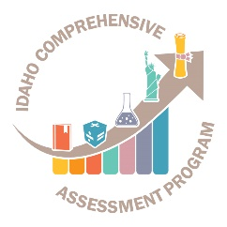
Idaho State Department of Education
Assessment & Accountability | Assessment monitoring

650 W State Street, 2nd Floor
Boise, IDaho 83702
208 332 6800 office
www.sde.idaho.gov

UPDATED 11/06/2018

TABLE OF CONTENTS
Instructions 3
Pocatello/Chubbuck School District 25 comprehensive assessment strategic plan 2019-2022 4
Philosophy & Purpose of the State Comprehensive Assessment Program: 4
Assessment in Public Schools - Philosophy - Idaho Code §08.02.03.111.01 4
Assessment in Public Schools - Purpose -Idaho Code §08.02.03.111.02 4
LEA Assessment Philosophy/Vision 4
LEA Assessment Purpose/Mission 4
Assessments: 6
State and LEA Assessments 6
Testing Procedures 12
Table 3 – State Assessments 12
Table 4 – LEA Assessments 15
Assessment of Students with Disabilities and ELL students: 18
Table 5 – State Assessments 18
Table 6 - LEA Assessments 23
Professional Development: 25
Test Security: 25
Technology Support/ Data Quality: 25
Appendix A: Glossary 26
Appendix B: Idaho Comprehensive Assessment Program Inventory 28
Appendix C: Resources 32

Instructions
The comprehensive assessment plan is a living document. It will guide the work of Local Education Agencies (LEAs) while also developing an excellent training tool for staff. This document will inform stakeholders (e.g. parents, administrative staff, etc.) the purpose of assessment, when and which assessments are administered, how results are used to improve instruction, and demonstrate how assessments will improve student learning. This document not only meets accountability compliance with the State Department of Education, but it helps guide LEA’s comprehensive assessment systems along with illustrating their tremendous efforts already accomplished.

This document serves as a template for the LEA’s Comprehensive Assessment Plan. Each section within this template is required upon submission. There are brackets [ ] throughout the document where the local LEA will insert relevant information in in template (e.g. [Insert LEA Name]). Tables are throughout the document. Please complete each table with the requested information. Finally, there are sections requiring narratives that should be completed with as much detail as possible.

Districts that already have a Comprehensive Assessment Plan may submit their document for assessment monitoring so long as all components in the template are included in the submission.

To submit comprehensive assessment plan, please visit District Assessment Monitoring Google Form. Complete the entire Google Form. Within the form, LEAs will upload their comprehensive assessment plans. There will be a confirmation email sent when the comprehensive assessment plan has been submitted. If there are any questions or concerns the Assessment & Accountability Department will contact the District Test Coordinator. Each LEA will receive feedback on their comprehensive assessment plan from the Assessment & Accountability Department.

LEAs must submit their comprehensive assessment plan by April 30, 2019.

If you have any questions or concerns, please contact:

Danielle Taylor
Assessment Program Specialist
(208) 332-6903
dtaylor@sde.idaho.gov

Pocatello/Chubbuck school district 25 comprehensive assessment strategic plan 2019-2022

The Pocatello/Chubbuck School District’s vision statement, mission statement, belief statements and learning goals provide the foundation for the Comprehensive Assessment System along with the District Strategic Plan and Idaho Content Standards.

Philosophy & Purpose of the State Comprehensive Assessment Program:

Assessment in Public Schools - Philosophy - Idaho Code §08.02.03.111.01
Acquiring the basic skills is essential to realization of full education, vocational and personal/social development. Since Idaho schools are responsible for instruction in the basic scholastic skills, the State Board of Education has a vested interest in regularly surveying student skill acquisition as an index of the effectiveness of the educational program. This information can best be secured through objective assessment of student growth. The State Board of Education will provide oversight for all components of the comprehensive assessment program.

Assessment in Public Schools - Purpose -Idaho Code §08.02.03.111.02
The purpose of assessment in the public schools is to:
- measure and improve student achievement;
- assist classroom teachers in designing lessons;
- identify areas needing intervention and remediation and acceleration;
- assist school districts in evaluating local curriculum and instructional practices in order to make needed curriculum adjustments;
- inform parents and guardians of their child’s progress;
- provide comparative local, state and national data regarding the achievement of students in essential skill areas;
- identify performance trends in student achievement across grade levels tested and student growth over time; and
- help determine technical assistance/consultation priorities for the State Department of Education.

LEA Assessment Philosophy/Vision
Advance excellence in teaching and learning using assessment strategies that yield dependable and actionable information about student achievement through a comprehensive, balanced assessment system.

LEA Assessment Purpose/Mission

The District’s Comprehensive Assessment System supports effective decision making and meets all key user needs by ensuring:
- Assessment literacy throughout the system.
- Assessment quality in all contexts.
- Learners become assessors of their own learning.
- Communication systems support and report student learning.

Assessments:

State and LEA Assessments
Table 1 – State Assessments has been completed. Please complete Table 2 – LEA Assessments with the following information for locally administered assessments:

- Assessment
  - For the LEA Assessments Section, enter assessments required by the LEA.
- Grade Level
  - Specify grade level(s) for which the assessment is administered.
- Test Schedule
  - Provide the test window for the assessment.
- Purpose of Assessment
  - Describe the purpose of the assessment.
- Reporting
  - How are test results reported?
- Administration Mode
  - Specify medium through which the assessment is administered (computer, on-on-one, paper/pencil, etc.).
- Test Vendor
  - Name the test vendor, if any.

Note: Assessment types and definitions see Appendix A.

Table 1 – State Assessments
1. Assessment | 2. Grade Level | 3. Test Schedule | 4. Purpose of Assessment | 5. Reporting | 6. Administration Mode | 7. Test Vendor
Civics | Grade 11 | Determined by LEA | Understand fundamentals of U.S. history & U.S. government | Transcript Required | District/School Decision | N/A
College Entrance Exam (PSAT) | Grade 10 | Determined by SDE; October of each year | Practice for SAT | Scores viewable off College Board Educator Portal | Paper/Pencil | The College Board
College Entrance Exam (SAT) | Grade 11 | Determined by SDE; April of each year | Graduation Requirement | Scores viewable off College Board Educator Portal | Paper/Pencil | The College Board
ISAT Science | Grades 11 | Determined by SDE; Spring of each year | Assessment Of Learning | Reports available in online reporting system (ORS) | Digitally Based Assessment | American Institutes for Research
Idaho Alternate Assessment | Grades 3-8 and 10 and 11 | Determined by SDE; Spring of each year | Assessment Of Learning | Reports available in online reporting system (ORS) | Digitally Based Assessment | American Institutes for Research
Idaho English Language Assessment (WIDA’s ACCESS 2.0) | Grades K-12 | Determined by SDE | English language proficiency for program eligible English language learners | Score reports are in WIDA-AMS/DRC system | Digitally Based Assessment  *Paper/Pencil available | Data Recognition Corporation
Idaho Reading Indicator (IRI/ISIP) | Grades K-3 | Fall: September  Spring: May | Screener for early literacy skills | Reports available in Istation’s online reporting system | Digitally Based Assessment | Istation
Idaho Standards Achievement Test (ISAT) | Grades 3-8 and 10 | Determined by SDE; Spring of each year | Assessment of Learning –  Accountability  Student Growth | Reports available in online reporting system (ORS) | Digitally Based Assessment | American Institutes for Research
Interim Assessment | 3-5 Required  6-10 Optional | Determined by SDE | Assessment for learning | Reports available in online reporting system (ORS) | Digitally Based Assessment | American Institutes for Research
The National Assessment of Educational Progress (NAEP) | Grades 4, 8, & 12 | Determined by SDE | National Trend | State reporting in odd years  National reporting in even years | Digitally Based Assessment | NCES

Table 2 – LEA Assessments
Please complete this table for locally administered assessments not included in the state comprehensive assessment system.
1. Assessment | 2. Grade Level | 3. Test Schedule | 4. Purpose of Assessment | 5. Reporting | 6. Administration Mode | 7. Test Vendor
iReady Diagnostic | 6-8 | Beginning of each trimester: August, November, February | Monitor progress of students identified for intervention | Diagnostic reports available online | Digitally based assessment | Curriculum Associates
Quick Write | K-5 | Three times per year: September, December, April | Identify students for possible intervention/further diagnostic assessment | Probe scores are kept on individual school spreadsheets and student progress is recorded in Mileposts | Classroom teacher/assessment team | District developed
Grade Level Math Screeners | 1-5 | Three times per year: September, December, April | Identify students for possible intervention/further diagnostic assessment | Same as above | Classroom teacher/assessment team | District developed
Kindergarten Screener | 1-2 | Twice per month | Monitor progress of students identified for intervention | Same as above | One on one by teacher providing intervention | District developed
Addition Subtraction Probes | 2-5 | Twice per month | Monitor progress of students identified for intervention | Same as above | One on one by teacher providing intervention | District developed
Place Value Probes | 3-5 | Twice per month | Monitor progress of students identified for intervention | Same as above | One on one by teacher providing intervention | District developed
Multiplication and Division Probes | 4-5 | Twice per month | Monitor progress of students identified for intervention | Same as above | One on one by teacher providing intervention | District developed
ISIP | K-5 | Monthly | Monitor student progress | Diagnostic reports available online | Digitally Based Assessment | Istation

Testing Procedures

Table 3 – State Assessments
In this table, identify the staff (by position) responsible and/or describe the processes for the following:
Assessment | Establishing test schedules | Ordering materials or uploading pre-identification file(s) | Identifies and trains proctors | Handling printed materials, including ordering, storing and returning.
Civics | *District teacher teams determined the most appropriate time to administer the assessment is during the student’s Junior year at the end of the US History II course  *Administered by the US History II teacher | *Administered online via Moodle  *students use an access code to join the test (separate access codes for regular and accommodated version of test)  *2019-2020 test will be administered via Google | *US History II teachers administer the assessment;  *District Instructional Technology Coaches provide training/support for Moodle/Google | *Administered online; no material ordering/storage required
College Entrance Exam (PSAT) | Follow State assessment window | *Tests are ordered by the Testing and Assessment Specialist via a bulk district upload pulled from a query from district’s student information system (SIS) | *A high school counselor is assigned as the PSAT Site Coordinator  *The site coordinator identifies and trains all building test proctors | *Test materials are sent directly to the high schools  *The PSAT Site Coordinator keeps the materials secured before testing and is also responsible for returning tests/directions
College Entrance Exam (SAT) | Follow State assessment window | Same as PSAT | *A high school counselor is assigned as the SAT Site Coordinator  *The school coordinator identifies and trains all building test proctors | *Test materials are sent directly to the high schools  *The SAT Site Coordinator keeps the materials secured before testing and is also responsible for returning tests/directions
ISAT Science | *Each school assigns a Building Test Coordinator (BTC) who is paid a leadership stipend to attend district-sponsored training and facilitate testing in the building  *The principal and BTC determine test dates within the state’s designated test window | Rosters are uploaded from district’s SIS into TIDE at the beginning of each trimester by the Testing and Assessment Specialist | *The District Test Coordinator (DTC) trains a Building Test Coordinator (BTC) at each school who receives a leadership stipend for identifying/training all proctors and monitoring test security | *Administered online; no material ordering/storage required  *Any staff member involved in testing is required to attend/view test security training and sign the state’s Test Security Agreement; these are kept on file at the district for three years
Idaho Alternate Assessment | *The Special Education teacher determines test dates within the state’s designated test window | Teachers are entered into TIDE and Rosters are uploaded from SIS into TIDE by Testing and Assessment Specialists | *District Test Coordinator and the Special Education Teacher Consultant provide annual training regarding test administration/security | *Administered online  *Teachers view test directions on a separate computer to read to students  *If a teacher needs to print materials they are responsible for keeping them secure/shredding  *Any staff member involved in testing is required to sign the state’s Test Security Agreement; these are kept on file at the district for three years
Idaho English Language Assessment (WIDA’s ACCESS 2.0) | *The Federal Programs Coordinator and EL teachers determine test dates within the state’s designated test window | Students are uploaded by via a bulk upload into WIDA DRC via query pulled from the district’s SIS/ELMs by the Federal Programs Coordinator | The Federal Programs Coordinator ensures LEP teachers/paras/proctors complete all required training and sign test security agreements | *The DTC ensures printed material is stored in a district testing room until it is checked out to individual proctors. *Proctors sign test security agreement and keep material secure between test sessions  *Material is returned to DTC, inventoried, and returned to DRC
Idaho Reading Indicator (IRI/ISIP) | Follow State assessment window: K-3 students take the assessment the 1st time they log on each month September and May | Students are entered by the Network Specialist via an upload from the district’s SIS; the upload refreshes nightly | Each school sent an intervention/classroom teacher to training. The interventionist/teacher is responsible for training all classroom teachers/paraprofessionals | *Administered online; no material ordering/storage required
Idaho Standards Achievement Test (ISAT) | *Each school assigns a Building Test Coordinator (BTC) who is paid a leadership stipend to attend district-sponsored training and facilitate testing in the building  *The principal and BTC determine test dates within the state’s designated test window | Rosters are uploaded from district’s SIS into TIDE at the beginning of each trimester by the Testing and Assessment Specialist | *The District Test Coordinator (DTC) trains a Building Test Coordinator at each school (BTC) who receives a leadership stipend for identifying/training all proctors and monitoring test security | *Administered online; no material ordering/storage required  *Any staff member involved in testing is required to attend/view test security training and sign the state’s Test Security Agreement; these are kept on file at the district for three years
Interim Assessment | *The DTC established the test window  *Classroom teachers decide when to administer in the classroom | Rosters are uploaded from district’s SIS into TIDE at the beginning of each trimester by the Testing and Assessment Specialist | Classroom teachers are provided training via District Writing and Math Coaches and optional, after-school Instruction CAMPs | *Administered online; no material ordering/storage required
The National Assessment of Educational Progress (NAEP) | As assigned by State | Completed by State Coordinator | Completed by State Coordinator | Completed by State Coordinator

Table 4 – LEA Assessments
In this table, identify the staff (by position) responsible and/or describe the processes for the following:
Assessment | Establishing test schedules | Ordering materials or uploading pre-identification file(s) | Identifies and trains proctors | Handling printed materials, including ordering, storing and returning.
ISAT Alt, Science | Building principal/Building Test Coordinator establish the test window and submit to the District Test Coordinator within the state’s designated test window | District Testing and Assessment Specialist completes upload | District Test Coordinator and the Special Ed Teacher Consultant provide training to teachers  All test administrators submit test security agreements to DTC and ensure secure test environments throughout the test window | *Administered online  *All printed test materials are kept in a secure location and shredded upon completion of the test
PSAT/SAT | State Established Dates | District Testing and Assessment Specialist complete a bulk upload | Each high school identifies a counselor to serve as a P/SAT Site Coordinator who trains all proctors and ensures a secure test environment | P/SAT Site Coordinator keeps all materials secure and is responsible for returning materials
Istation (ISIP) | First time the student logs on each month | Network Assistant completes upload and manages rosters | Each school identifies an interventionist to attend training and train all classroom teachers and paraprofessionals | *Administered online; no material ordering/storage required
WIDA | Federal Programs Coordinator and EL teachers/para establish a test schedule that is within the state’s designated test window | Federal Programs Coordinator oversees the upload into WIDA DRC | Federal Programs Coordinator identifies and trains all proctors | Materials are sent to the district office and are stored in a secure location until they are inventoried and picked up by proctors. Proctors secure materials between test sessions and return materials to district office. DTC inventories and returns material

Assessment of Students with Disabilities and ELL students:

Table 5 – State Assessments
Briefly describe each State assessment with the following information below:
Assessment | Procedures for the LEA has in place to ensure the inclusion of students with disabilities in the state assessment system | Procedures for the LEA has in place to ensure the inclusion of all English learners in the assessment system | The process for determining whether to  assess a student on the general assessment  without accommodation(s), the general  assessment with accommodation(s), or an alternate assessment | The process for ensuring the appropriate accommodations are available for Students with disabilities or English learners
Civics | *All Juniors are required to participate unless otherwise indicated in the IEP  *Scores are recorded in Moodle/Google and uploaded to the districts SIS  *Participation is monitored every six weeks by the District Testing and Assessment Specialist; a list of students who have not participated is sent to high school registrars | *All Juniors are required to participate, including those who qualify for EL services  *Scores are recorded in Moodle/Google and uploaded to the districts SIS  *Participation is monitored every six weeks by the District Testing and Assessment Specialist; a list of students who have not participated is sent to high school registrars | *IEP teams determine if a student will take the assessment with or without accommodations  *Students requiring an accommodations take an adapted version of the test  *There is not an alternate Civics test | *Classroom teachers monitor student’s IEPs and administer the assessment with accommodations, if required  *EL students may have the test read aloud if the teacher determines appropriate
College Entrance Exams (P/SAT) | *All Sophomores are required to participate on the P/SAT School Test Day unless otherwise indicated in the IEP  *Each school assigns a PSAT Site Coordinator who monitors test participation | *All Sophomores, including those who qualify for EL services, are required to participate  *Scores are recorded in Moodle/Google and uploaded to the district’s SIS  *Participation is monitored by the PSAT Site Coordinator | *IEP teams determine if a student will take assessments with or without accommodations  *Each high school assigns a P/SAT site coordinator who works with Special Education teachers to ensure accommodations are submitted to the College Board and provided during the test  *The DTC monitors State Newsletters/Webinars, etc. to ensure communication reaches teachers/site coordinators | *Each high school assigns a P/SAT site coordinator who works with Special Education/ EL teachers to ensure accommodations are submitted to the College Board and provided during the test
College Entrance Exam (SAT) | *All Juniors are required to participate on the PSAT School Test Day unless otherwise indicated in the IEP  *Each school assigns an SAT Site Coordinator who monitors test participation and requires students to come to on the make-up day  *Participation is also monitored every six weeks by the District Testing and Assessment Specialist; a list of students who have not participated is sent to high school registrars | *All Juniors, included those who qualify for LEP services, are required to participate  *Scores are recorded in Moodle and uploaded to the districts SIS  *Participation is monitored by the SAT Site Coordinator  *Participation is also monitored every six weeks by the District Testing and Assessment Specialist; a list of students who have not participated is sent to high school registrars | Same as PSAT | Same as PSAT
ISAT Science | *All Sophomores are required to participate on the EOC unless otherwise indicated in the IEP  *Participation is monitored by BTC/DTC | *All Sophomores are, including those who qualify for EL services, are required to participate on the EOC  *Participation is monitored by BTC/DTC | *IEP teams determine if a student will take assessments with or without accommodations | *Required accommodations are entered into Mileposts by the Special Education/EL teacher; an upload from Mileposts into TIDE is completed on the first Monday of each month  *BTC and test proctors ensure that required non-embedded accommodations are provided during testing
Idaho Alternate Assessment (IDAA) | *Students who qualify for the IAA are coded in the district’s SIS for inclusion in the ISEE uploads  *The district Special Education Teacher Consultant monitors test participation | *IEP Teams, in cooperation with EL teachers/Federal Programs Coordinator determine if a student qualifies for the IAA | *The default in TIDE for students who qualify for the IAA is for students to have all allowable accommodations  *IEP teams determine if an accommodation is not allowable | *Test administrators ensure all required/allowable accommodations are provided during testing
Idaho English Language Assessment (WIDA’s ACCESS 2.0) | *Students who qualify for the EL/Special Education are coded in the district SIS for inclusion in the ISEE uploads  *The Federal Programs Coordinator and EL teachers monitor participation | *The Federal Programs Coordinator and EL teachers monitor EL student participation | IEP Teams, in coordination with EL teachers, determine allowable accommodations | EL teachers ensure allowable accommodations are provided during the assessment
Idaho Reading Indicator (IRI/ISIP) | All K-3 students take the IRI/ISIP unless they qualify for the IAA  *Participation is monitored by the classroom teacher/building interventionist or BTC | All K-3 students take the IRI/ISIP including those identified and coded EL | *IEP teams determine if a student will take assessments with or without accommodations | EL and Special Education teachers ensure students are provided allowable accommodations
Idaho Standards Achievement Test (ISAT) | *All students in grades 3-8 and 10 are required to participate unless they qualify for the IAA  *Participation is monitored by the BTC and DTC | *Students who have been attending a US school for one year or less are not required to take the ISAT ELA  *Students who qualify for EL programming are coded as such in the district’s SIS  *Participation is monitored by the BTC/DTC | *IEP teams determine if students will take the ISAT with or without accommodations  *Allowable accommodations/designated supports are entered into Mileposts by the Special Education  *An upload from Mileposts into TIDE is complete on the first Monday of every month to ensure students have access to accommodations/designated for IABs and the summative assessment | *The EL teachers/Federal Programs Coordinator determine allowable accommodations/designated supports for students who qualify for EL services  *Allowable designated supports are entered into Mileposts by an interventionist or RtI Coach  *An upload from Mileposts into TIDE is complete on the first Monday of every month to ensure students have access to designated for IABs and the summative assessment
Interim Assessment | *IABs are used extensively to provide data to inform instruction and to support student achievement on the ISAT  *Same as ISAT above | *Same as ISAT above | *Same as ISAT above | *Same as ISAT above
The National Assessment of Educational Progress (NAEP) | Monitored by the State | Monitored by the State | Monitored by the State | Monitored by the State

Table 6 - LEA Assessments
Briefly describe each LEA assessment with the following information below:
Assessment | The LEA ensures the inclusion of students with disabilities in the LEA assessment system | Procedures for the LEA has in place to ensure the inclusion of all English Learners in LEA assessment system | The process for determining whether to  assess a student on the general assessment  without accommodation(s), the general  assessment with accommodation(s), or an alternate assessment | The process for ensuring the appropriate accommodations are available for Students with disabilities or English learners
iReady Diagnostic | 6-8 | All K-3 students take the IRI/ISIP including those identified and coded EL | An alternate assessment is not available. If the assessment is not appropriate for a student with disabilities, an alternate assessment is administered. | Students are provided supports or accommodations as indicated on the student’s ELP or IEP
Quick Write | K-5 | Same as above | Same as above | Same as above
Grade Level Math Screeners | 1-5 | Same as above | Same as above | Same as above
Number Sense Probes | 1-2 | Same as above | Same as above | Same as above
Addition Subtraction Probes | 2-5 | Same as above | Same as above | Same as above
Place Value Probes | 3-5 | Same as above | Same as above | Same as above
Multiplication and Division Probes | 4-5 | Same as above | Same as above | Same as above

Professional Development:
- Describe the process your district uses to train staff who interact with each of the State and LEA’s assessments. Provide as much detail as possible.
  - IRI/ISIP – Each building assigns a teacher or an interventionist to attend training. The district instructional coach, who attends state-sponsored training, provides test security/test administration training to building representatives. Building representatives are responsible for training building staff. All K-3 teachers/administrators/related staff sign test security agreements which are kept on file in the Curriculum Office for three years. All K-3 teachers attend iStation Data Analysis Training.
  - ISAT – Each building assigns a Building Test Coordinator (BTC), who receives a leadership stipend using state funds, to oversee test administration. The District Test Coordinator (DTC) provides annual test security/test administration training. All test administrators (TA)/test observers (TO) are required to view a test security video that summarizes the information from the SDE’s Assessment Integrity Guide. All TAs/TOs also sign test security agreements which are kept on file in the Curriculum Office for three years. The DTC/BTC monitor test security and participation during the test window. The DTC reports all test incidents to the SDE via the Test Incident Log Application.
  - NAEP – All training is provided by the SDE.
  - PSAT/SAT – Each building assigns a PSAT and an SAT site coordinator who completes all required training, provides training to all test administrators and ensures material security.
  - WIDA – The Federal Programs Coordinator works with the DTC to ensure all EL staff complete required WIDA training and that all materials are kept secure. All TAs complete Test Security Agreements which are kept on file in the Curriculum Office for three years.
- Describe the process your district uses to train staff supporting students with disabilities and English learners on selection of and the appropriate use of accommodations and/or designated supports.
  - Staff who support students with disabilities are provided training by the DTC on the available designated supports (DS) and accommodations prior to ISAT test administration. The Special Education Teacher Consultant works with teachers to ensure students are coded correctly in the student information system and in Mileposts. The district Testing and Assessment Specialist completes monthly uploads from Mileposts into TIDE to ensure students receive DS/accommodations on the ISAT.
  - Staff who support English learners review all available DS/accommodations for WIDA and the ISAT. The DTC marks EL supports in Mileposts. The district Testing and Assessment Specialist completes monthly uploads from Mileposts into TIDE to ensure students receive DS/accommodations on the ISAT. Classroom teachers are encouraged to administer IABs to provide students with practice using the EL DS.
  - Each high school assigns a PSAT/SAT site coordinator who works with staff who support students with disabilities to ensure accommodations are submitted to College Board and provided during assessments.

- Describe how assessment results for each state and LEA assessment are used, including the audience for the results.
  - Each fall K-12 administrators convene at an annual Building Leadership Team (BLT) meeting. During this meeting BLTs analyze state assessment data and set continuous learning plans. This data includes, but is not limited to: IRI/ISIP, ISAT, PSAT, and SAT.

- Describe how testing schedules are developed, who is responsible for developing testing schedules, who is responsible for communicating the testing schedule to the district and school and parents.
  - Test schedules are developed at the building level in coordination with the DTC. Test schedules are submitted to the DTC who ensure all testing is completed within the test window and that all required students participate. Parents are informed of testing schedules via school and teacher newsletters.

Test Security:
- Explain process to ensure students do not have calculators, alphabet strips, recordings, books, walls are free from instructional materials, etc. during any state testing unless items are specifically approved as accommodations.
  - The BTC assigned to each building attends annual district-sponsored training. The training includes specific information about what is/is not allowable in the test environment.
  - BTC provide building level training to all test administrator and observers.
- Describe the process used to ensure students are appropriately monitored when they are in the testing room, or leave the testing room for a break.
  - The BTC assigned to each building attends annual district-sponsored training. The training includes specific information about how TAs are required to actively monitor students during testing and that students must be monitored outside of the testing area if a break is shorter than 20 minutes.
  - BTC provide building level training to all test administrator and observers.
- Explain the process for ensuring all paper assessments and other assessment materials are handled appropriately. Include how materials are transported, stored, returned, or destroyed.
  - For each state test administered, the staff member identified to coordinate training (BTC for ISAT, PSAT/SAT, WIDA) attends district or state sponsored training which includes specific information about how to transport, store, destroy or return test materials.
- Provide any local policies established related to test security.
  - The DTC ensures all state-developed test securities policies/procedures are followed.

For additional information on test security, please review the Assessment Integrity Guide.

Technology Support/ Data Quality:
- Describe the responsibilities of District Technology Coordinators in supporting the state and LEA assessments.
  - The Technology Coordinator works closely with the DTC to ensure that the infrastructure is ready for testing. That may include device and network setup.
- Describe how the LEA ensures that student information is accurate in ISEE reports.
  - The Technology Coordinator continues to analyze, refine and improve our student information ISEE reporting to improve upon accuracy.

Appendix A: Glossary
- Assessment – The process of quantifying, describing, or gathering information about skills, knowledge or performance.
- Benchmarks – Benchmarks describe the knowledge and skills that all students should know and be able to do, in selected content areas, by the time they reach certain grade levels. Benchmarks are yardsticks or targets, because they specify the knowledge and skills within a content area’s continuum that a student must possess to demonstrate a level of progress toward mastery or proficiency of a standard. States may refer to benchmarks as competencies, anchors, etc.
- Curriculum-Embedded Assessment – Curriculum-embedded assessments are those that have been deliberately incorporated in the instructional material being used by learners or in the instructional activities routinely taking place. Examples include: Quizzes, End of Chapter Tests, and Common Assessments.
- Decode – To analyze spoken or graphic symbols of a familiar language to ascertain their intended meaning and to change communication signals into messages, as to decode body language.
- Diagnostic Assessment – Pre-assessment that allows a teacher to determine students’ individual strengths, weaknesses, knowledge, and skills prior to instruction. It is primarily used to diagnose student difficulties and to guide lesson and curriculum.
- Formative Assessment – Refers to a process that includes the following attributes: Clarify Intended Learning, Elicit Evidence, Interpret Evidence, and Act on Evidence. The formative assessment process helps teachers identify where students are in their learning so that adjustments can be made to curriculum, instructional methods, and academic support. Formative assessment activities are not graded. These activities are integrated into daily instruction and are not quite teaching, but not traditionally what we call assessment. This evidence helps both learner and teacher decide what to do next.
- Growth Targets – A state or district level target, which is set to define progress and track change in individual student achievement scores over multiple years. Used for accountability purposes.
- Interim Assessment – Assessment that educators use to (1) periodically evaluate where students are in their learning progress and (2) determine whether they are on track to master standards within a given time period. Interim assessments are usually administered strategically during a course or school year (for example, every three to six weeks) and separately from the process of instructing students. They are not graded and not used for accountability purposes.
- Norm-Reference Assessment – Comparing a student’s performance or test result to performance of other similar groups of students; (e.g., he typed better than eighty percent (80%) of his classmates.
- On-Demand Assessment – Assessment that takes place at a predetermined time and place. Quizzes, state tests, SATs, and most final exams are examples of on-demand assessment.
- Performance Assessment – Direct observation of student performance or student work and professional judgment of the quality of that performance. Good quality performance assessment has pre-established performance criteria.
- Portfolio-Based Assessment – Collections of academic work that are compiled by students and assessed by teachers in a consistent ways. For example: assignments, lab results, writing samples, speeches, student-created films, or art projects.
- Proficiency – Having or demonstrating a high degree of knowledge or skill in a particular area to the extent that standards are met.
- Progress Monitoring – Progress monitoring probes are administered weekly or biweekly to gauge student growth toward mastery of a targeted skill.
- Screening – Assessment used to determine whether students may need specialized assistance or service, or whether they are ready to begin a course, grade level, or academic program. Screening assessments may take a wide variety of forms, they may be developmental, physical, cognitive or academic.
- Summative Assessment – Summative assessments provide information regarding the level of student, program, or school success at an endpoint in time. Results are used to evaluate student achievement toward grade level standards, determine program effectiveness, and meet accountability requirements. Examples include: End of Course Assessments, ISAT Assessment.
- Universal Screening – Universal Screeners are administered one to two times per year to identify learners who may be at risk of not meeting grade level standards. Examples include: Idaho Reading Indicator, CORE MAZE, CORE Vocabulary.

Appendix B: Idaho Comprehensive Assessment Program Inventory
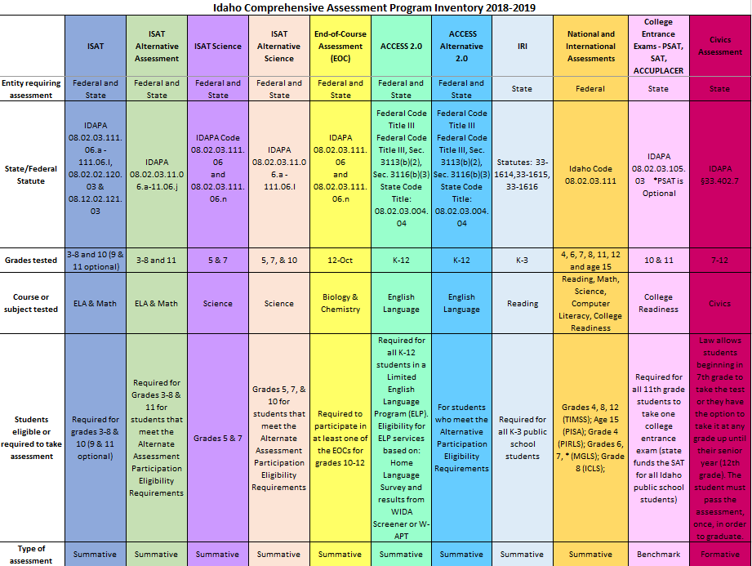

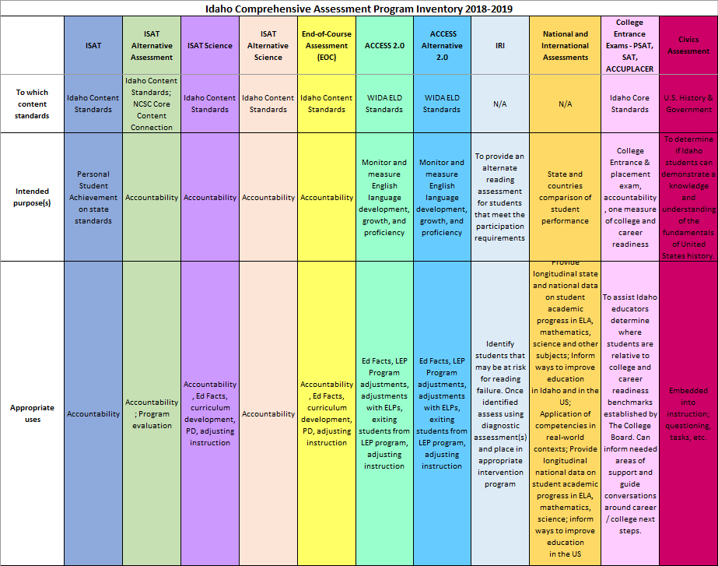

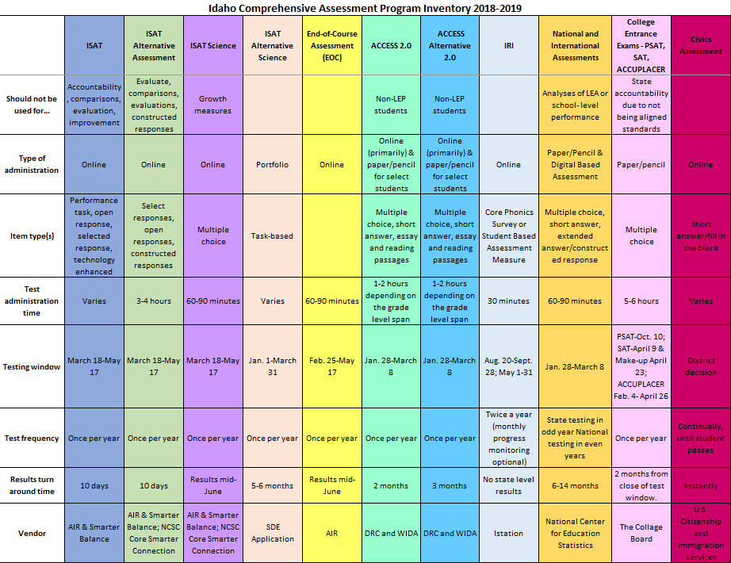

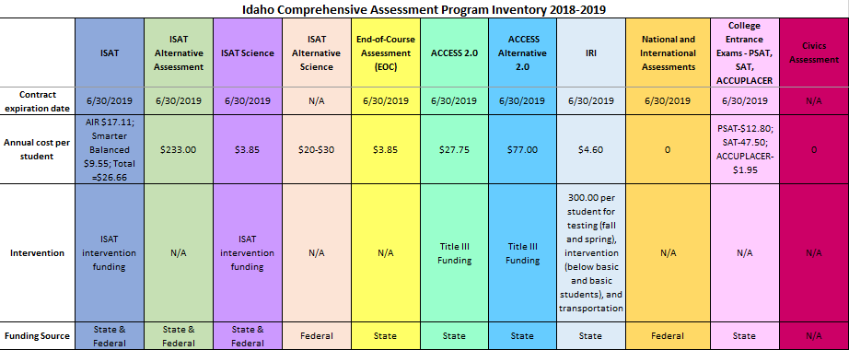

Appendix C: Resources
This list provides links to frequently accessed sites. Links to specific assessment portals or external websites are also included.
- Idaho State Department of Education Assessment and Accountability:
  - Assessment Main Page
    - Main page to navigate to each state assessment, calendar of events, resource center, and pending rule changes
  - Resource Center
    - Archived monthly webinars and newsletters; portals for ADEA, Assessment Monitoring, Incident Log, I-Pass, IRI, ISAT, Participation Appeals, WIDA AMS; resource files, FAQs, trainings and links for each of the portals
      - Edmodo
        - Annual Test Coordinators User Group - To subscribe, contact the Assessment and Accountability department for the current code
  - Pending Rule Changes
    - Keep up-to-date with any SDE pending rule changes
  - Civics Assessment
  - College Entrance Exams
    - College Board:
      - Main Webpage
      - SAT
      - PSAT
      - ACCUPLACER
      - ACCUPLACER Portal
  - English Language Proficiency Assessment
    - WIDA
      - WIDA Main Page
      - WIDA AMS
  - Idaho Reading Indicator
    - Istation Idaho Webpage
  - ISAT Comprehensive Assessment System
    - Digital Library
    - ISAT ELA
    - ISAT Math
  - Idaho System for Educational Excellence (ISEE)
  - National and International Assessments
    - National Assessment of Educational Progress (NAEP):
      - General Information
        - Previous reports, data tools, news releases, and sample questions
      - MyNAEP
  - Science
  - Special Education

