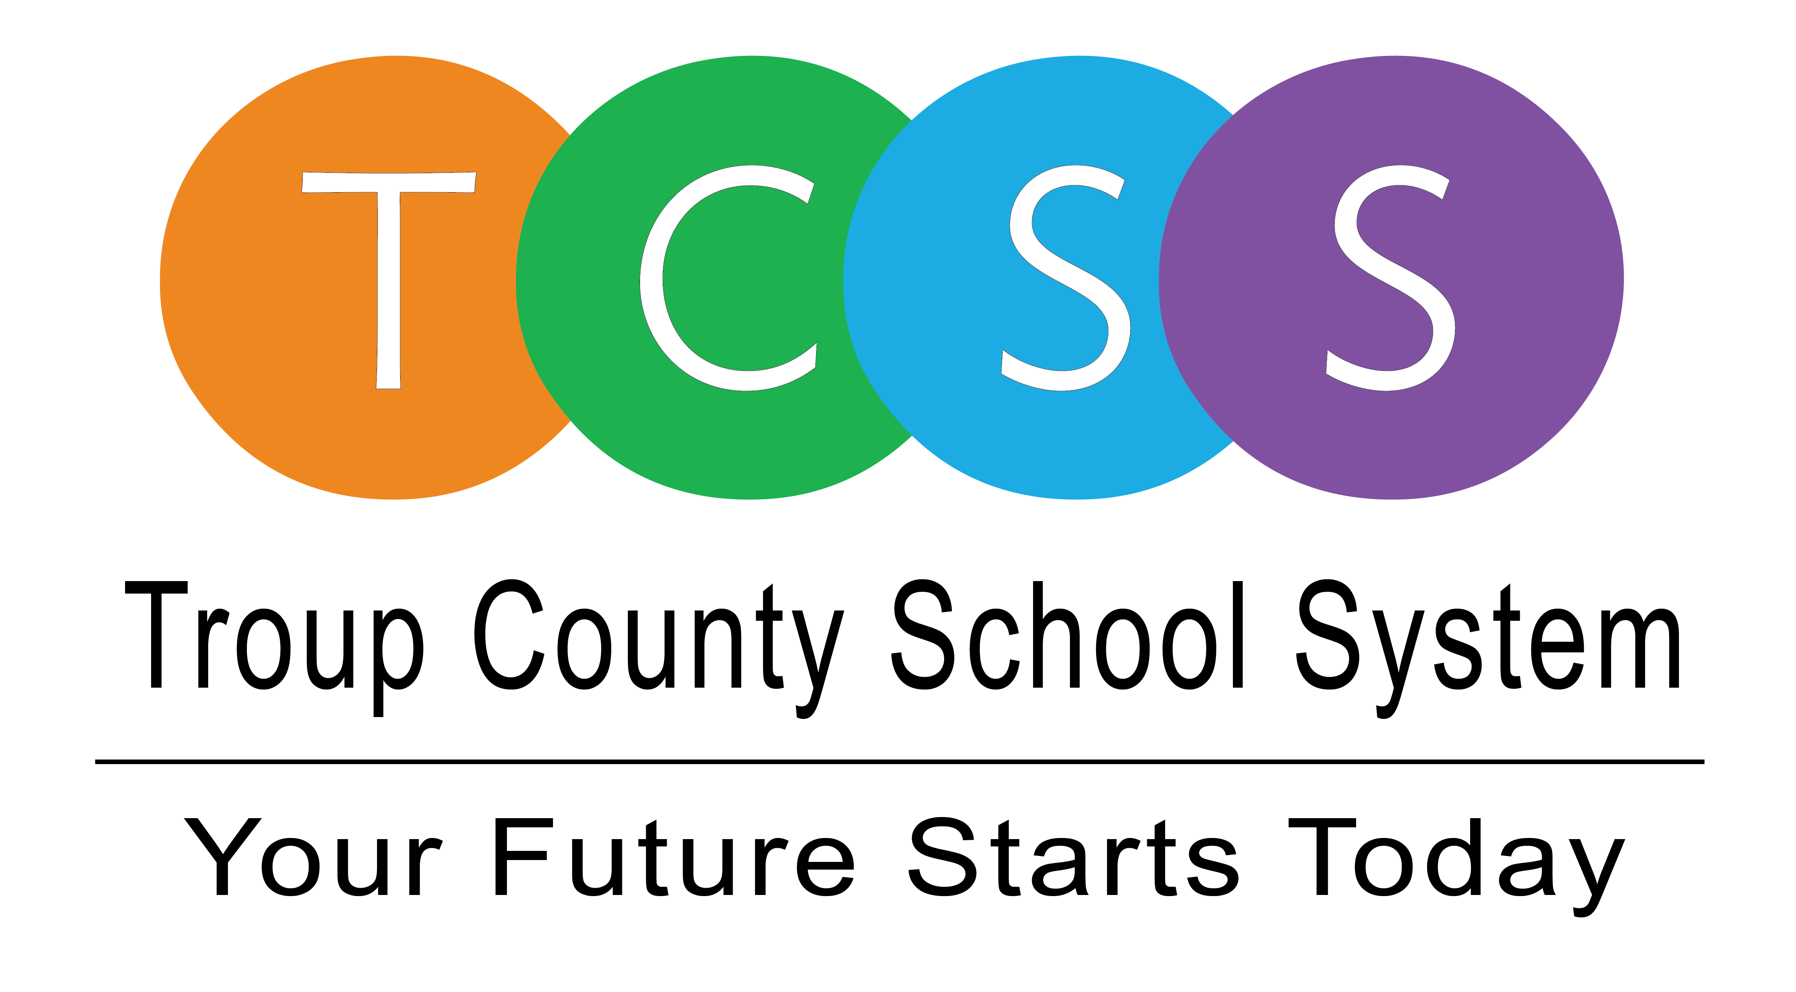
Yolanda Stephen, Director Public Relations
stephenyk@troup.org / troup.org
100 North Davis Rd, Building C / LaGrange, Georgia 30241
Office: 706.812.7900 / Fax: 706-812-7904

Story Release
FOR IMMEDIATE RELEASE

Zyshonn Morris, II is prepping for college and working for scholarships

LaGrange, Ga., June 15, 2020 – Zyshonn Morris just graduated from Troup High School and is excited about the possibilities of attending Kennesaw State University in August. He’s also excited about scholarships he has received to stifle the financial burden. Morris said, “I am going to be the first generation college student. Some people in my family didn’t graduate high school so that’s a big accomplishment for me within itself. I not only want to go to college, I want to complete college. I don’t want to have to worry about the finances and I don’t want finances to stop me from really meeting my goal.”

The future business owner now works at Chick-fil-A on Commerce Avenue where he is learning customer service and business skills. He also learned some of those skills as a student at THINC College & Career Academy. He completed the Mechatronics pathway and was on his way into the business courses. While in high school he was a manager for sports teams at Troup and a member of the THINC Robotics team, Student Ambassadors, and a student member on the THINC Board.

In October, Morris won the J. Randy Jackson Scholarship Award which funded a study abroad trip to Scandinavia with some of his International Business classmates but coronavirus halted the trip. The scholarship would have covered his flight, hotel, meals, and transportation. He said it would have been his first trip out of the country and he was looking forward to learning about how companies do business internationally.

“I want to own a business that revolves around teaching young children about opportunities. I plan to do that by using technology and my own personal experiences,” stated Morris. He thanks Mr. Paul Hammock who was his 10th grade English instructor at Troup. He said Mr. Hammock had a group for young men called SHARP. The program was for young men that possessed the talent to be successful in college but lacked the monetary resources. Morris said Mr. Hammock helped him stay on track and he is grateful for his persistence and belief in him.

He also said that he will be a Troup Tiger for life, “My principal, Ms. Niki Watts, is big on respect. Even with the students who may have had discipline issues – she believes you can bring out the best in them. That same culture that I learned at THS is something that I have transferred over to my job. She’s amazing and a good mentor. I often see myself bringing my inner Watts out,” Morris laughed.

Good luck Zyshonn!
About Troup County School System
Troup County School System is an accredited educational system with over 12,100 students in grades K-12. TCSS does offer a free Pre-K program at each elementary school. The system is comprised of eleven elementary schools, three middle schools, three high schools, one college and career academy, and one alternative learning center. Students within the school system are taught a rigorous and relevant curriculum that helps them make college and career choices beyond graduation and succeed in life. The system 2019 graduation rate is 86.6 percent. To learn more about Troup County School System, visit troup.org and the Troup County School System Facebook page.
###

Photo: Zyshonn Morris is ready for Kennesaw
Photo: Morris will be first generation college student.

