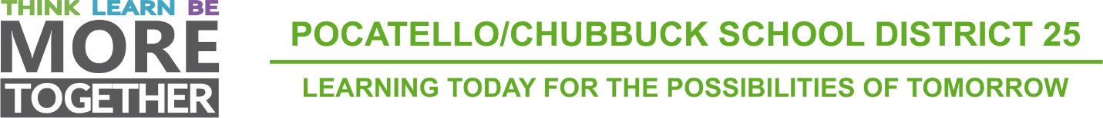

SCHOOL DISTRICT NO. 25
INVITATION TO BID

Sealed bids will be received by Representatives of the Board of Trustees of School District No. 25, Bannock County, Pocatello, Idaho, at 3115 Pole Line Road, Pocatello, Idaho 83201, until March 9, 2021 at 10:00 A.M.

Bids are being called for the following:

Six (6) 77 Passenger Conventional Style School Buses

One (1) 54 Passenger Conventional School Bus with Wheelchair Lift.

Specifications or additional details may be secured at 3115 Pole Line Road, Pocatello, Idaho 83201 or by calling (208) 235-3270. All bids must be completed on the furnished forms. All blank spaces must be filled in and signed with the name and address of the Bidder. No unqualified bids will be read.

Each bid shall be accompanied by a certified check, cashier’s check, or a bidder’s bond (executed by a qualified surety company with the power to do business in the State of Idaho) in the sum of not less than five percent (5%) of the total bid, made payable to School District No. 25, Bannock County, Pocatello, Idaho. This surety shall be forfeited by the bidder in the event of failure to fulfill provisions of bid on which purchase order award is based. Personal or company checks will not be accepted.

All bids shall be in a sealed envelope and clearly marked: 2021 School Bus, to be opened at 10:00 AM on March 9, 2021.

The Board of Trustees reserves the right to reject any or all bids or to waive any formalities, or to accept the bid or bids deemed best for Pocatello/Chubbuck School District No. 25.

Renae Johnson, Clerk
School District No. 25

Publication Dates:
February 14, 2021
February 21, 2021

Idaho State Journal

