0BMedical Assisting

1BStudent Guidebook
Last revised June 29, 2021

Introduction to Medical Assisting

Medical Assisting Program Description
The medical assistants are multi-skilled health professionals specifically educated to work in ambulatory settings performing administrative and clinical duties. The practice of medical assisting directly influences the public’s health and well-being, and requires mastery of complex body of knowledge and specialized skills requiring both formal education and practical experience that serve as standards for entry into the profession. Medical Assisting continues to be one of the fastest growing occupations.
The Metro Technology Centers Medical Assisting program is a comprehensive program that combines classroom, laboratory and clinical experiences to ensure achievement of the entry-level competencies for the medical assistant. The curriculum includes courses in Anatomy and Physiology, Medical Terminology, Medical Law and Ethics, Human Relations, Clinical Procedures, Administrative Skills, Pharmacology, Clinical Laboratory and Professional Development. Students will participate in a clinical/administrative externship.
The program is 10 months in length and approximately 1115 clock hours. Total approximate cost of the program is $5063.50, which includes the admission fee, student fee, book/curriculum fee, uniform fee and graduation fee. Classes begin each year in August student could be accepted in October and January as seats come available.

Vision Statement of Medical Assisting
In the rapidly changing health care industry, one versatile professional stands out, the Certified Medical Assistant. The Metro Tech Medical Assistant program is fully accredited by the Commission on Accreditation of Allied Health Education Programs (CAAHEP) and through Prior Learning Assessment (PLA), upon completion of a recognized, national certification along with 12-credit hours of resident credits at OCCC, students are eligible to receive college credit to apply toward an Associate of Applied Science Degree in Medical Assistant. Our vision is to develop quality program completers who will successfully complete the American Association of Medical Assistants (AAMA) National Certification examination.

Metro Technology Centers believes in the worth of all individuals and is committed to equal opportunity for employees, students and any person visiting a District campus. Metro Technology Centers does not discriminate on the basis of race, color, national origin, sex, gender, gender expression or identity, sexual orientation, age, veteran status, religion, pregnancy, or genetic information or disability in its programs, services, activities and employment.
Table of Contents

Introduction to Medical Assisting 2
Medical Assisting Program Description 2
Vision Statement of Medical Assisting 2
School Calendar 5
Message from Instructor 6
Health Careers Center Organizational Chart 7
Administration and HCC Staff 7
Medical Assisting Organizational Chart 8
Mission, Vision and Core Values 9
Philosophy of Medical Assisting 10
CMA (AAMA) Core Values 11
Program Goals and Objectives 17

Course Descriptions 19
Curriculum Outline 22
Book List 26
Progress Chart 27
MAERB Core Curriculum for Medical Assistant 28
Student Expectations and Grading Systems 33
Medical Emergencies 33
Insurance 33
Internet Access 33
Transportation – Parking and Grounds 33
General Admission Criteria 33
Admission with Transfer Credit 34
Admission of Person with Arrest/Conviction Record 35
Readmission Procedure 35
Attendance 36
Communication 37
Grading/Promotion/Retention 38
Assignment Procedure 39
Student Class Information 39
Professional Appearance 40
Student & Teacher Conferences 42
Career Major Completion 42
Tuition and Career Major Costs 43
Student Services, Assistance & Information 44
Student Work/Employment 44
Testing and Assessment 44
Career Counseling Services 44
College and Career Services 44
Employment Services 44
Academic Centers 44
Child Care 44
Disability Services 45
Student Organizations 46
Student of the Year 47
Procedures for Success in the Class 49
Conflict Resolution 54
Discipline Procedure 54
Wireless Communication Devices 56
Complaint/Appeal Process 56
Student Records 57
Emergency Closing Policy 58
Harassment, Intimidation, Bullying, and/or Threatening Behavior 59
Drug Screening Procedure Statement 61
Student Health Requirements 64
HCC Library Information 66
Financial Aid 68
Refunds 70
Skill Lab and Testing Procedures 73
LED Individual Study Learning Contract 76
Student Affirmation Form 77
Statement of Understanding of Clinical Requirements 78
Drug Screening Statement Understanding 79
Faculty Report of Reasonable Suspicion of Drug/Alcohol Use 80
Statement of Employment Understanding 81
Student Confirmation and Consent Form 82

School Calendar

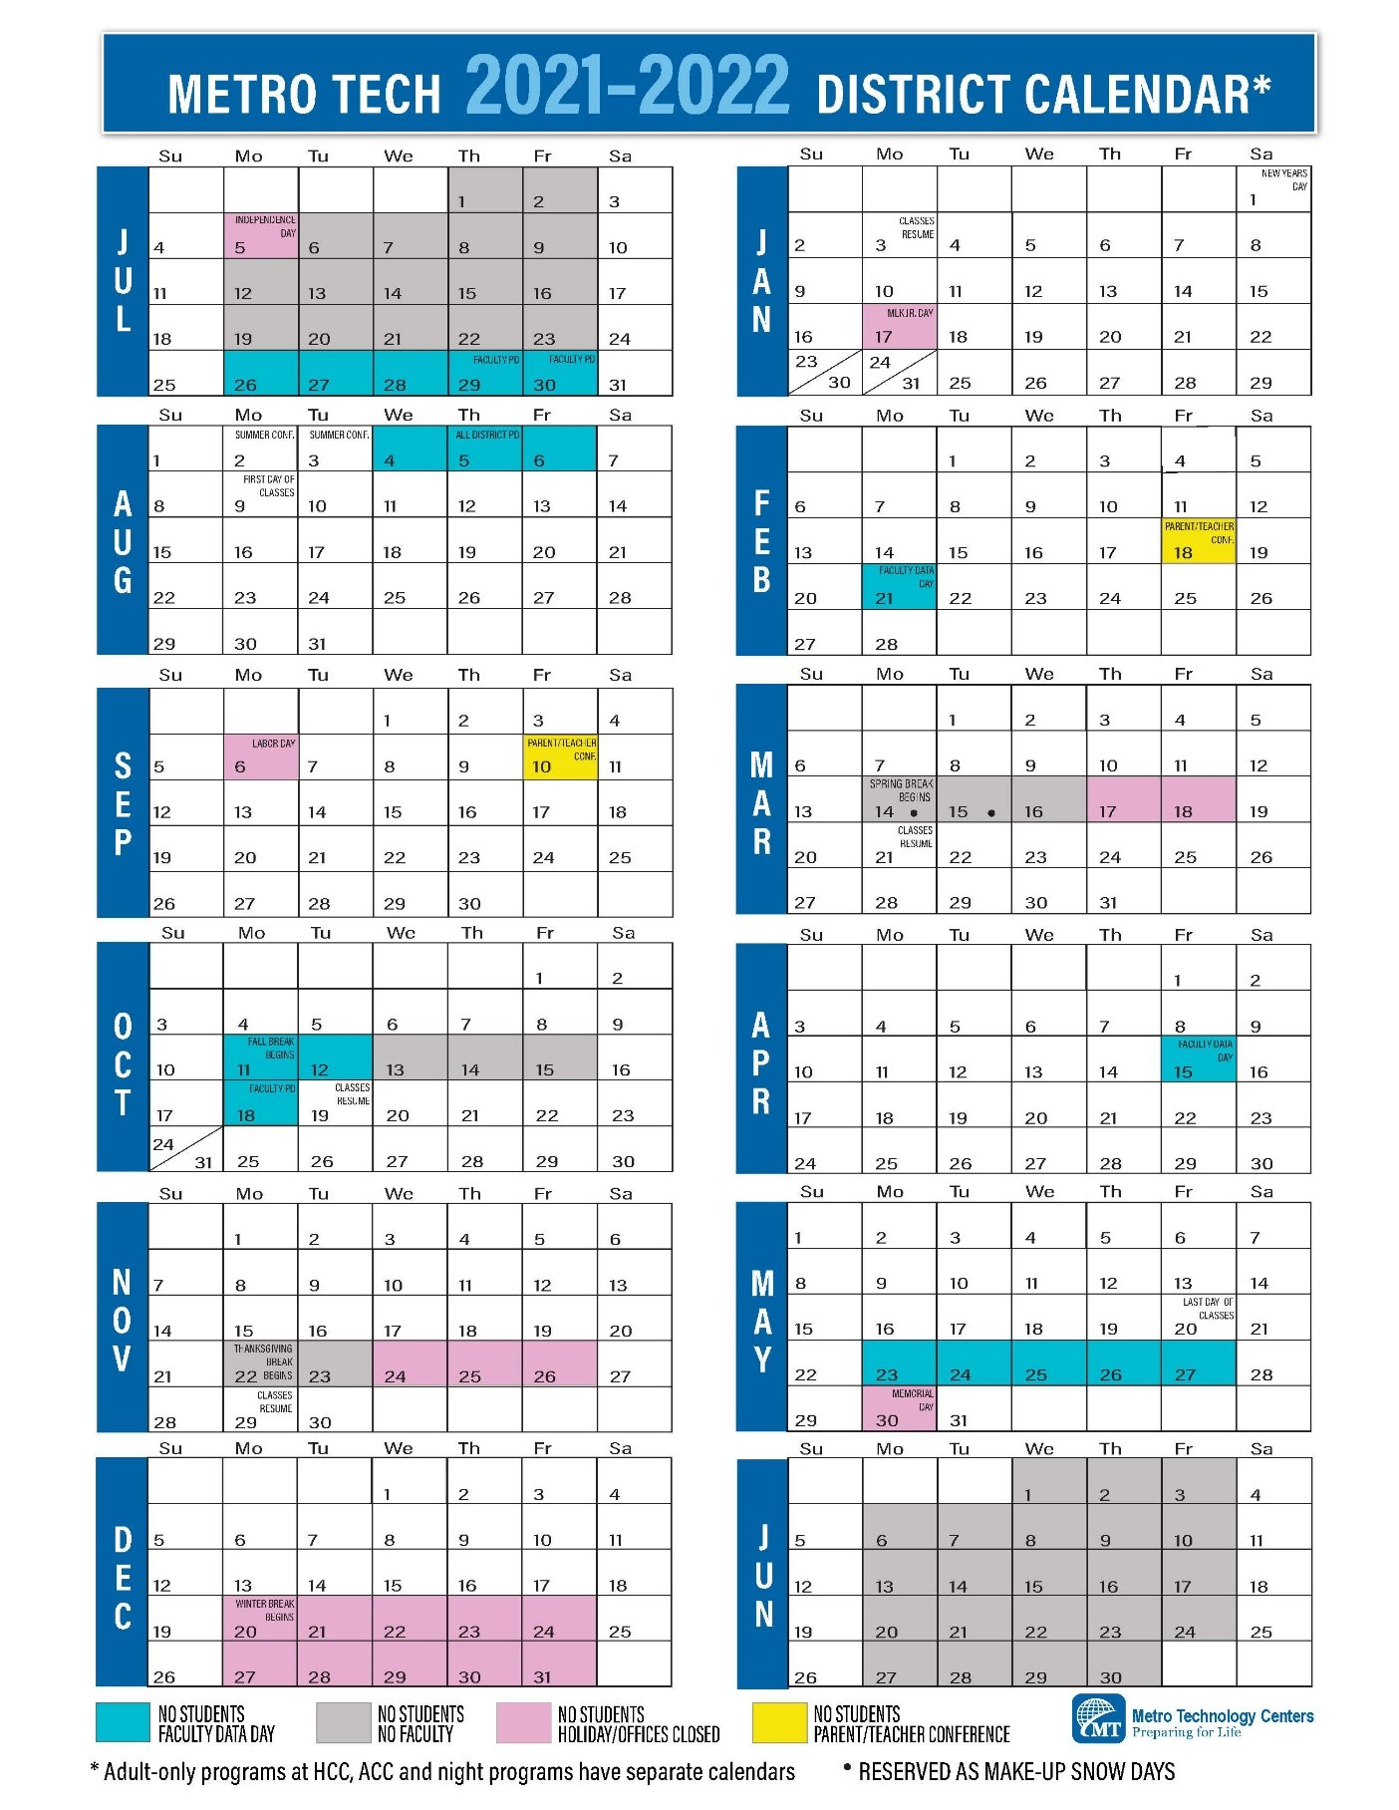
Message from Instructor
Welcome
The faculty of Metro Technology Centers (aka Metro Tech) Medical Assistant program wishes to congratulate you for being accepted in the program. A career in medical assisting is challenging and offers variety, job satisfaction, opportunity for service, and possibility for advancement. The skills acquired by the medical assistant can be carried all through life, and employment is readily available anywhere in the world that medicine is practiced. Although the medical assisting field will make many demands on you, the Metro Tech Medical Assisting program will prepare you to accept those demands. We hope you are ready to accept the challenge of hard work in learning about your chosen profession.
The rules and regulations found in this information guide have been made to encourage self-discipline and to maintain high standards of the school from which you will graduate. It is the desire of the faculty that all students will succeed in this program. We are aware that there are times when things do not always go as we would like. If this happens with you, and if we can be of help please call on us.
Faculty Members
Tammy Kersey AAS, CMA (AAMA) – Instructor Shawna Blackburn RN-MSN - Site Director

The Medical Assistant Program is accredited by:
National Commission on Accreditation of Allied Health Education Programs (CAAHEP)
9355-113th St. N, #7709
Seminole, FL 33775
Phone: 727-210-2350
Fax: 727-210-2354
www.caahep.org
Medical Assisting Education Review Board (MAERB) 20 N. Wacker Drive, Suite 1575
Chicago, IL 60606
1-800-228-2262
www.maerb.org\
Oklahoma Board of Career and Technology Education (OBCTE) 1500 West Seventh Ave.
Stillwater, OK 74074
phone (405) 377-2000, 1-800-522-5810
fax (405) 743-6809
Health Careers Center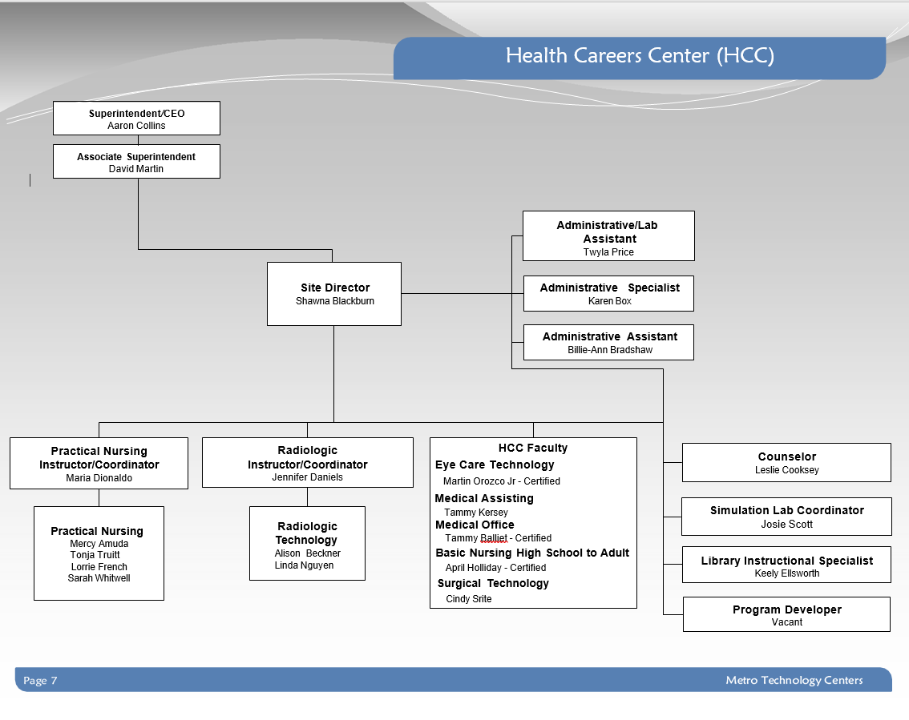

Administration & Staff
Aaron Collins, Superintendent
David Martin, Assistant Superintendent, Instruction
Shawna Blackburn, Health Careers Center Site Director
Tammy Kersey, Medical Assistant Director
Twyla Price-Kelly, Administrative/Lab Assistant (HCC)
Leslie Cooksey, Health Careers Center Site Counselor
Keely Ellsworth, Resource Room/Computer Lab Instructional Assistant (HCC)
Karen Box, Administrative Specialist (HCC)
Billie- Ann Bradshaw, Administrative Assistant (HCC)
Medical Assisting Organizational
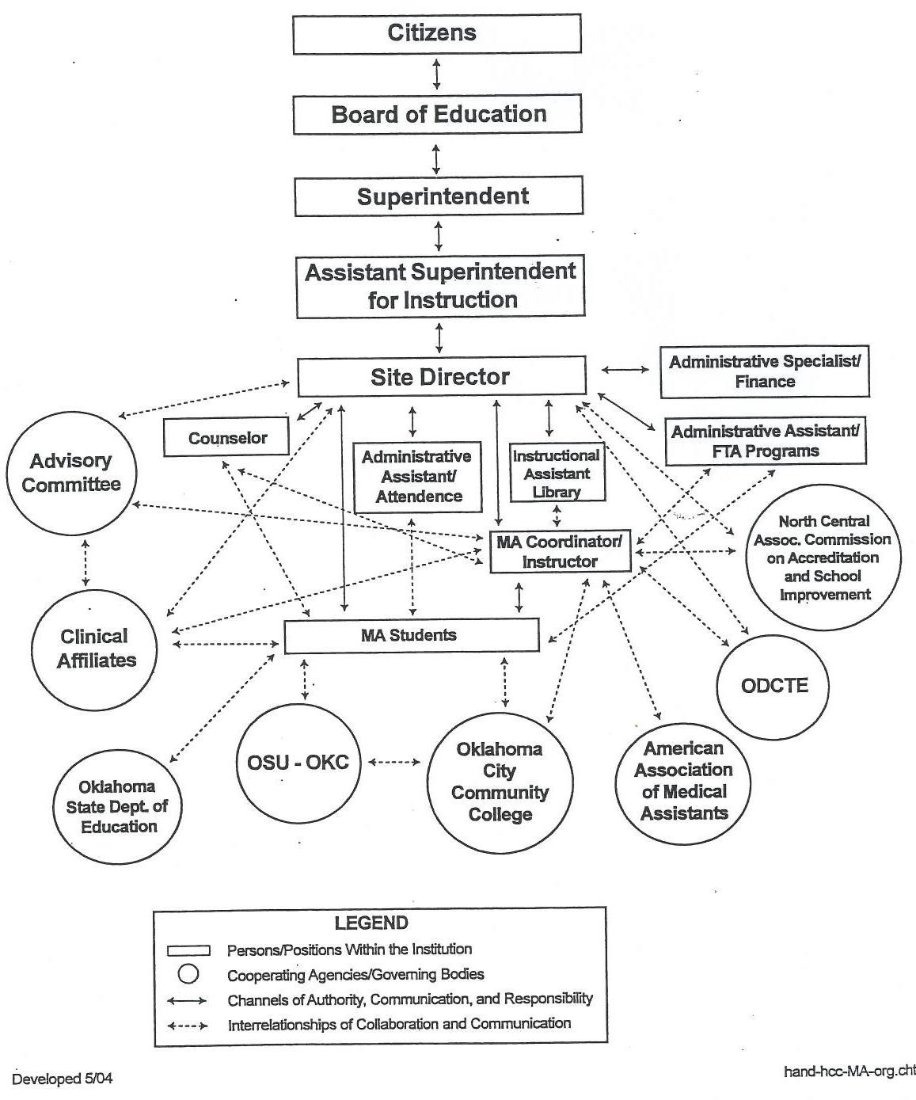

Mission, Vision, and Core Values

MISSION
Metro Technology Centers prepares people for successful employment and life in a global society.

OUR VISION
Metro Technology Centers will be recognized as a strategic partner in economic development by preparing a high-quality workforce.

OUR COMMITMENT
Metro Technology Centers provides the highest quality programs and services enabling students to succeed in their chosen career field. (Board Policy BP-1007)

OUR CORE VALUES
- Customer-focused
- Learning-center
- Accountable and ethical
- Innovative
- Nurturing, sensitive and supportive
- Dedicated to continuous quality improvement
- Agile and flexible

Philosophy of Medical Assisting

The Medical Assisting program functions within the Metro Technology Centers, and reflects the mission statement, vision statement and core values developed by the employees of the district.
The purpose of the Medical Assisting program is to focus on producing a cross-trained, multi-skilled employee to meet the ever-changing needs of industry. The delivery of health care has changed dramatically in the last two decades. Increasing health care costs have created a trend away from hospital-based treatment toward the delivery of care in physicians' offices and in outpatient centers. Although doctors have employed assistants in their practices for many years, computerization and technologic advances have created more opportunities for qualified medical assistants and increased their responsibilities; as a result, the need for those trained in this profession has grown.1
The Medical Assisting program provides quality instruction. The curriculum is based on the minimum standards outlined by the American Association of Medical Assistants' Endowment and the American Medical Association Essentials for an accredited program. The program maintains a strong relationship with industry. It strives to include all entry- level competencies necessary for each student to successfully complete the program.
The Medical Assisting program promotes the belief that flexibility is a key factor in achieving success in the world of work. With the redesign of health care delivery and more limitations of resources, we believe a proactive approach to preparing students for a successful career in Medical Assisting is essential.
The Medical Assisting program provides a progressive environment, which is imperative in meeting the current technology of the health care industry. The Medical Assisting Advisory Committee provides input to ensure that the program is reflective of industry's advanced technology.
The Medical Assisting program faculty promotes the development of a strong work ethic by enforcing regular attendance, promptness, dependability, and initiative. All Career and Technology Educational programs stress values, attitudes, and skills necessary to meet the client's needs. Our program strives to prepare diverse populations for successful employment in a competitive, global economy.
The strength of all Health Occupations Education programs is in the clinical component, which enhances the classroom and laboratory learning experiences. The Medical Assisting program provides extensive externships in clinical and administrative areas of training. The opportunity for training in a specialty area is also provided. The Medical Assisting philosophy promotes the belief that students be prepared for a variety of job options when they have completed the program.

1Mary E. Kinn, The Administrative Medical Assistant (Philadelphia: W.B. Saunders Company, 1993)
CMA (AAMA) Core Values

Actively participate in the delivery of quality health care.
Promote patient safety and well-being.

Contribute to a positive health care experience for patients.
Demonstrate integrity and respect, and protect patient confidentiality.

Advocate the essential value of certification and continuing education.
Embrace change, growth, and learning.
Medical Assisting Code of Ethics | The Medical Assisting Code of Ethics of the AAMA sets forth principles of ethical and moral conduct as they relate to the medical profession and the particular practice of medical assisting.
Members of AAMA dedicated to the conscientious pursuit of their profession, and thus desiring to merit the high regard of the entire medical profession and the respect of the general public which they serve, do pledge themselves to strive always to:
  - Render service with full respect for the dignity of humanity.
  - Respect confidential information obtained through employment unless legally authorized or required by responsible performance of duty to divulge such information.
  - Uphold the honor and high principles of the profession and accept its disciplines.
  - Seek to continually improve the knowledge and skills of medical assistants for the benefit of patients and professional colleagues.
  - Participate in additional service activities aimed toward improving the health and well-being of the community.
Medical Assisting Creed
The Medical Assisting Creed of the AAMA sets forth medical assisting statements of belief:
- I believe in the principles and purposes of the profession of medical assisting.
- I endeavor to be more effective.
- I aspire to render greater service.
- I protect the confidence entrusted to me.
- I am dedicated to the care and well-being of all people.
- I am loyal to my employer.
- I am true to the ethics of my profession.
- I am strengthened by compassion, courage and faith.
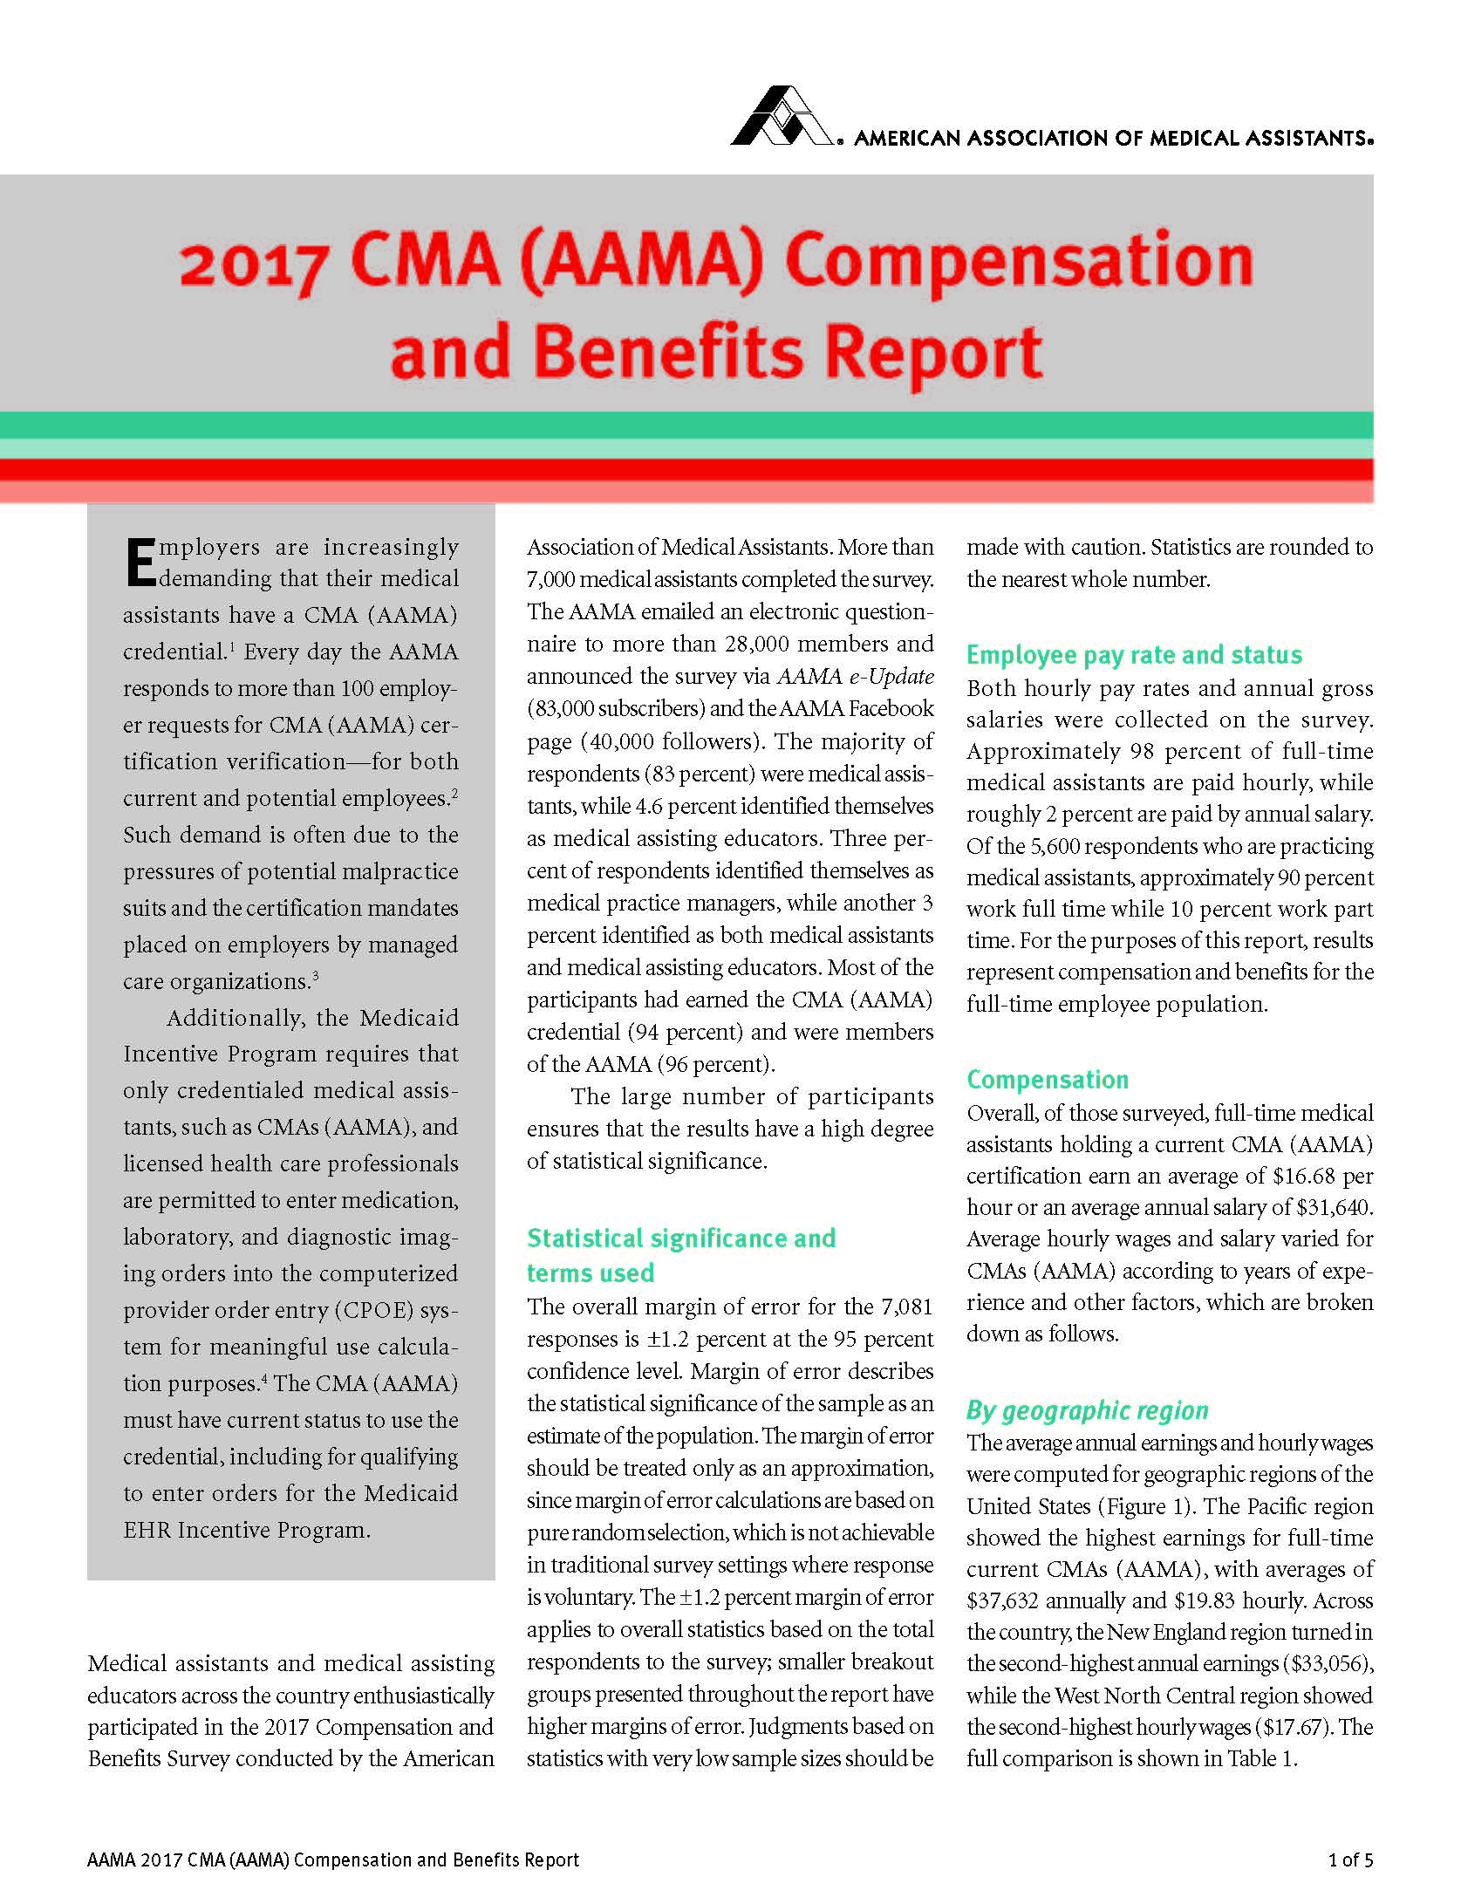

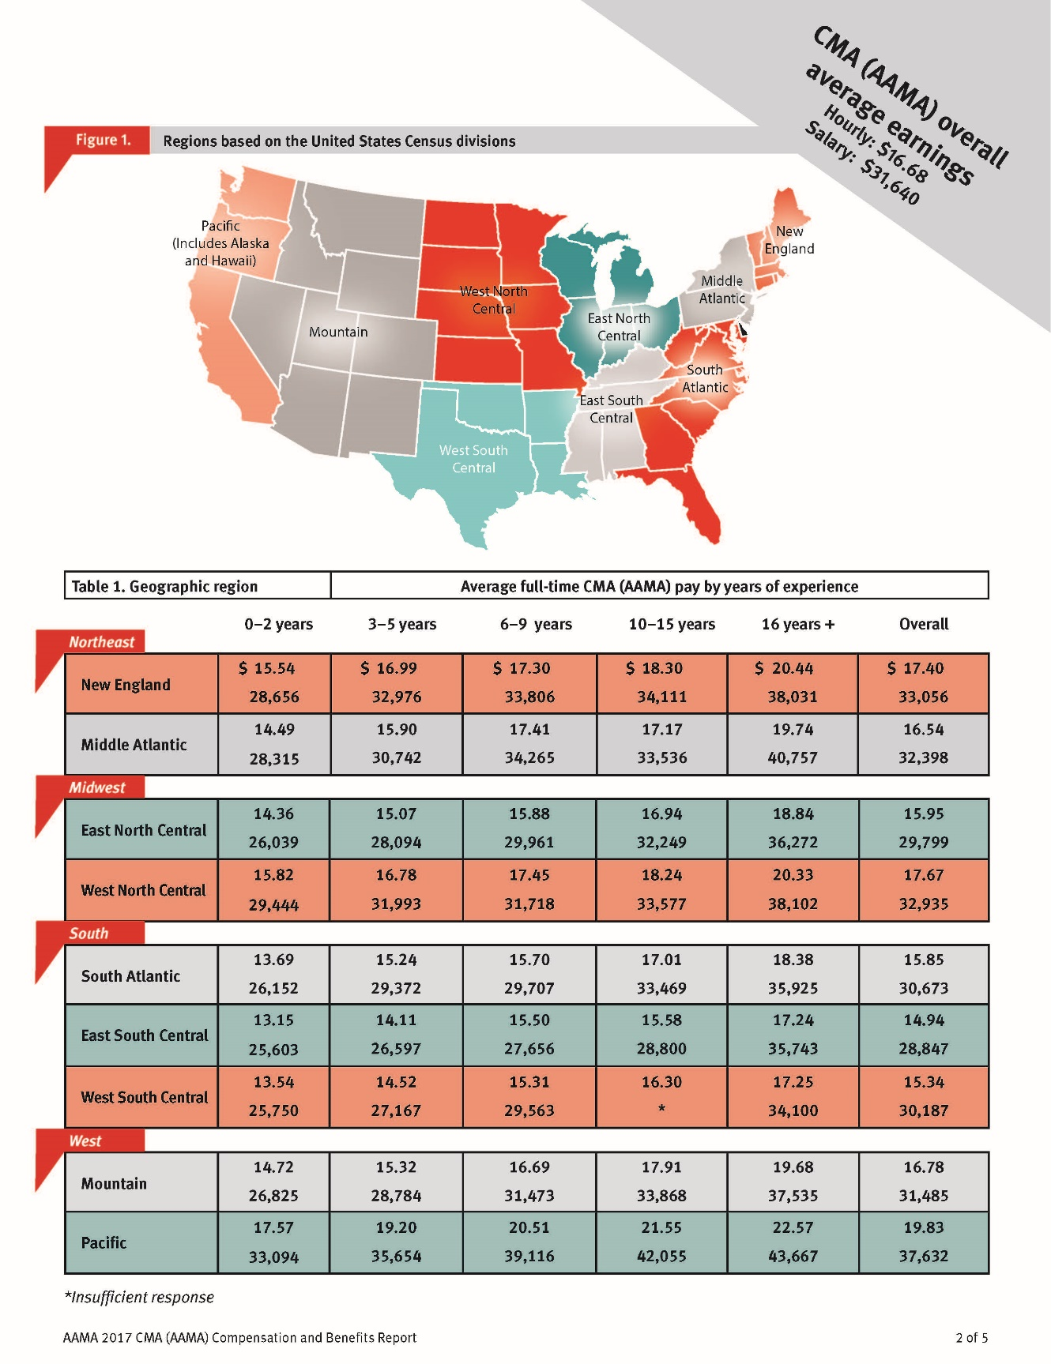

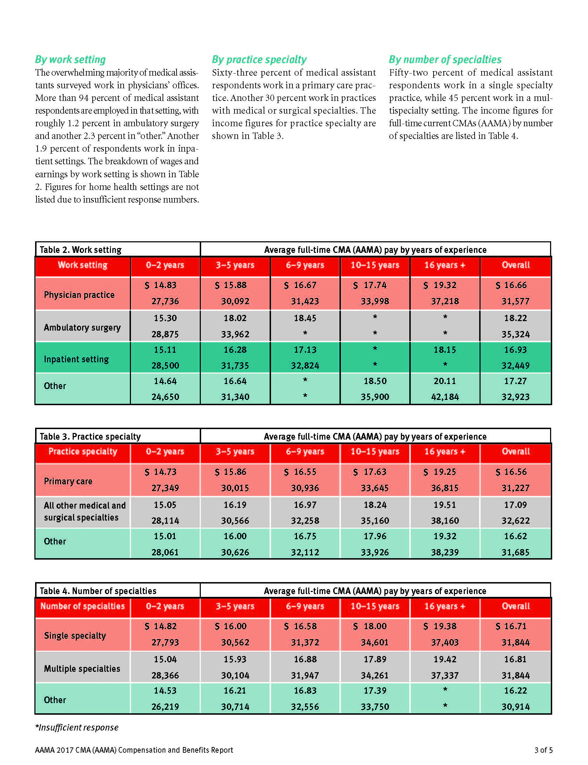

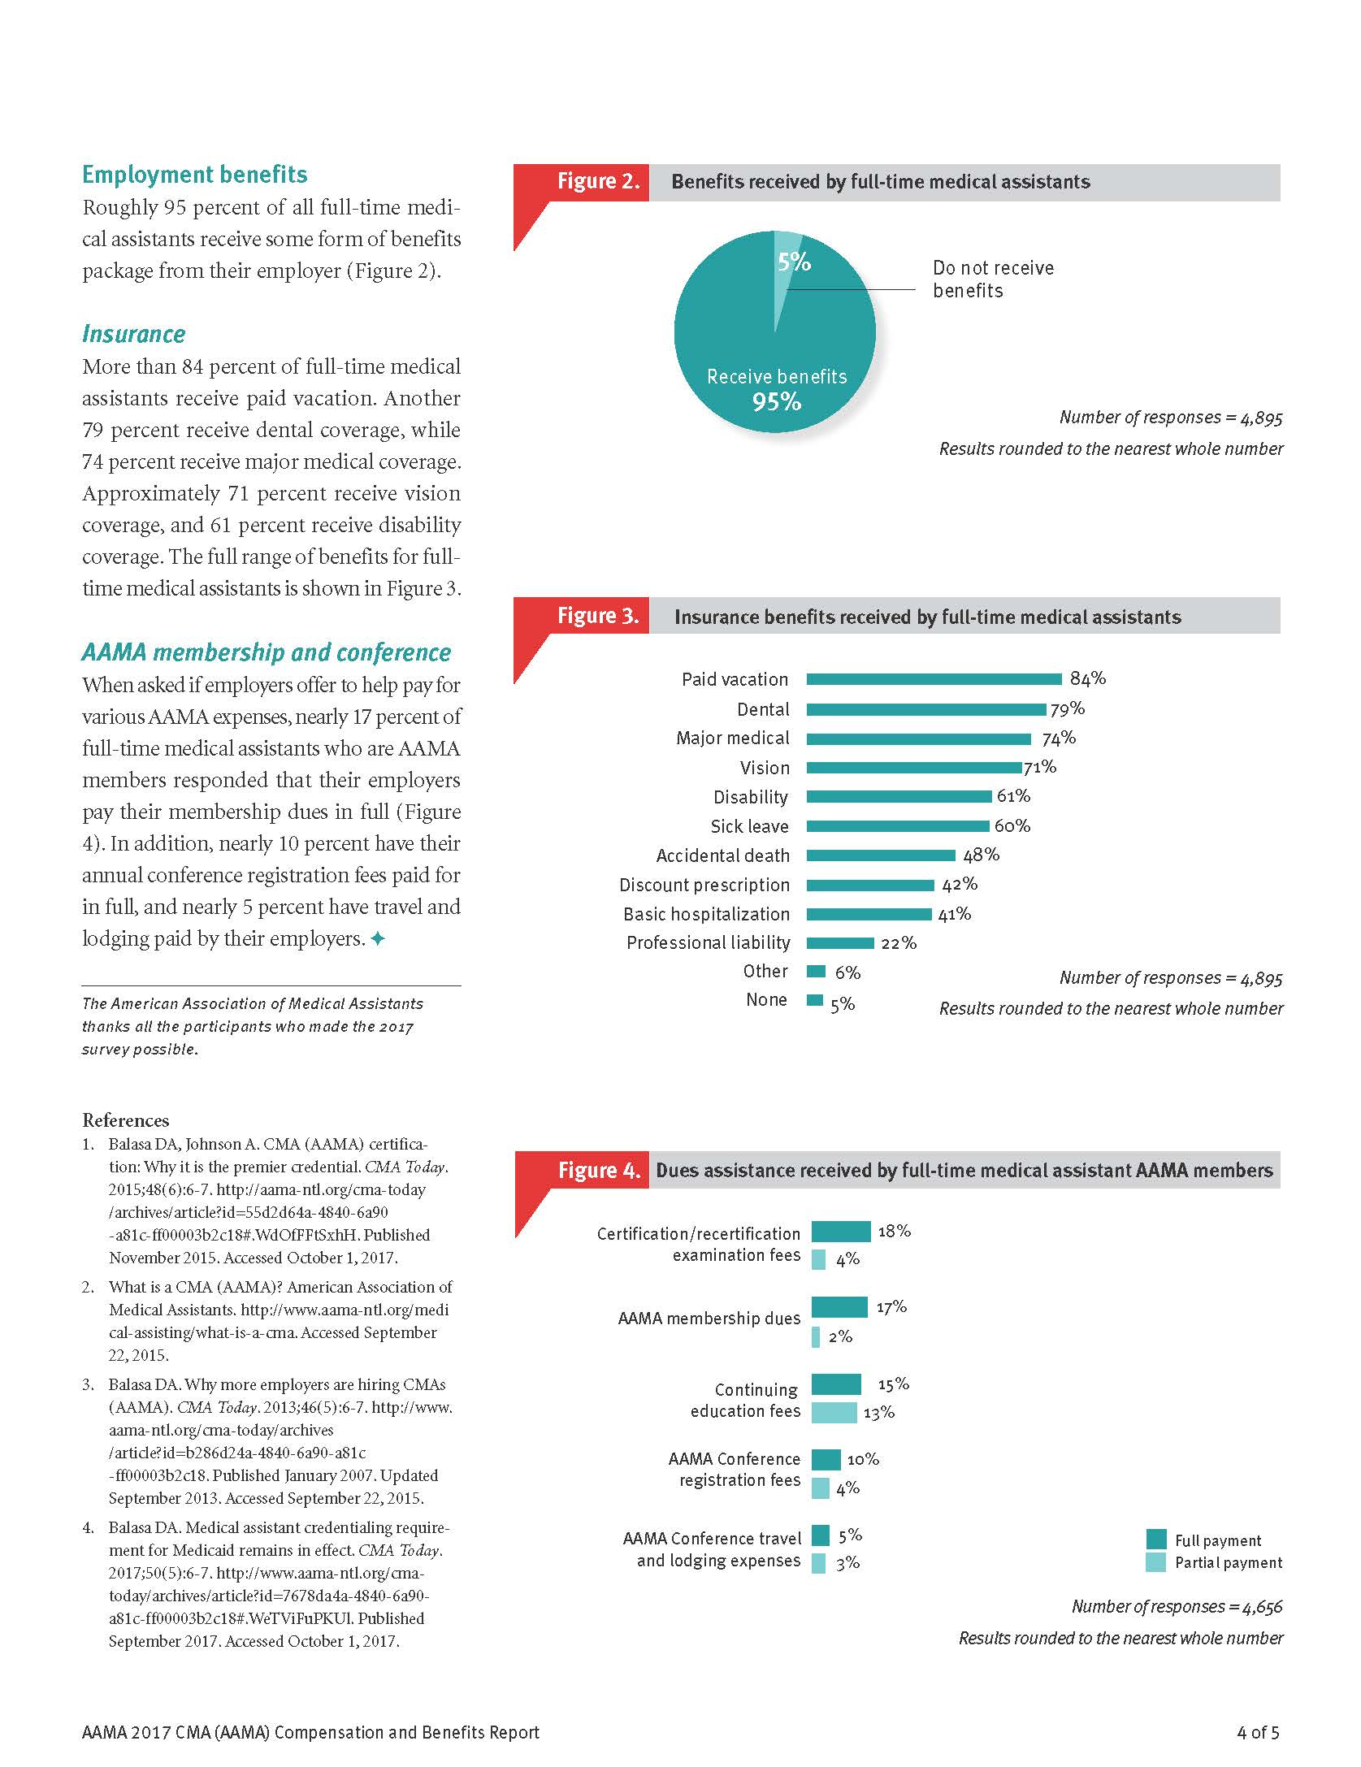

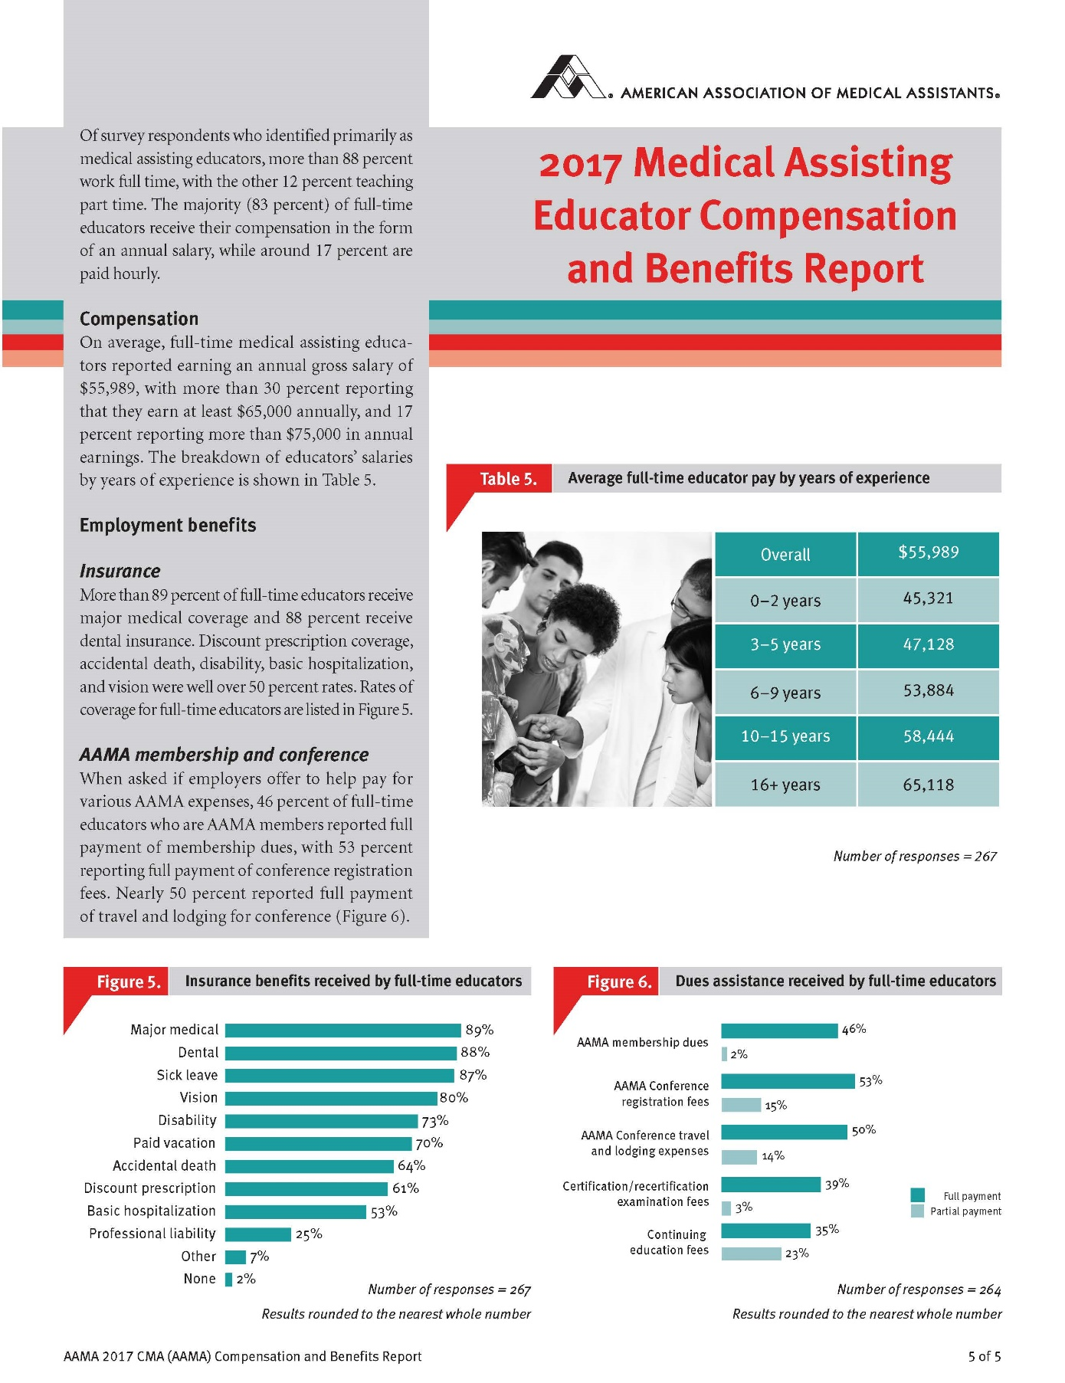

Program Goals and Objectives
- Provide classroom instruction and externship experiences which promote professionalism.
  - State the importance in understanding the scope of practice for the Medical Assistant
  - Discuss the role of the Medical Assistant as a member of the health care team.
  - Demonstrate the personal attributes that are required of a Medical Assistant.
  - Explain accreditation, certification, and continuing education as they pertain to the professional medical assistant.

- Provide opportunities for the development of effective communication skills.
  - Explain the importance of effective communication skills.
  - Transmit information using the communication cycle and channels of communication.
  - Demonstrate the role of the Medical Assistant in producing written communications.
  - Demonstrate proper telephone technique using listening and communication skills.

- Provide classroom instruction, laboratory experiences, and externships to develop entry-level competencies in Administrative Medical Assisting.
  - Manage ambulatory care offices files.
  - Schedule appointments using computer application and manual methods.
  - Demonstrate database management concepts used in an ambulatory care setting.
  - Function as a Medical Assistant in all areas of administration.

- Provide classroom instruction, laboratory experiences, and externship to develop entry-level competencies in Clinical Medical Assisting.
  - Adhere to OSHA Blood borne Pathogens Standards.
  - Respond accurately to emergency situations in the ambulatory care setting.
  - Assist the physician with all clinical procedures.
  - Perform laboratory procedures in a medical office.
  - Operate all clinical equipment in the medical office.

- Provide learning experiences which allow the student to develop an awareness of legal responsibilities and ethical behavior of a medical assistant.
- Demonstrate the characteristics that are important for a professional Medical Assistant.
- Practice confidentiality and right to privacy as they relate to medical records.
- Define the Medical Assistant’s role in legal issues.

- Provide classroom instruction and externships for achievement of entry-level competencies in managing the Medical Office.
  - Develop an office procedures manual.
  - Supervise medical office personnel.
  - Assist in improving work flow and office efficiencies.
  - Supervise the purchase and storage of office supplies.
  - Complete an inventory of supplies.

- Provide classroom instruction and externship which promote the role of the Medical Assistant as a health educator.
  - Prepare patient education materials.
  - Present patient education materials.
  - Explain physician orders to the patient.
  - Arrange patient/community education workshops as needed.
  - Train new personnel as outlined in the office procedures manual.

- Provide classroom instruction in accounting billing, and bookkeeping procedures which are necessary for effective management of office finance.
  - Manage office practice insurance.
  - Develop office staff salary schedules.
  - Implement the ICD-10-CM and CPT coding system during the billing process.
  - Process accounts payable and accounts receivable during the billing cycle.

Course Descriptions

Academic Life Skills 15 hours
This course is designed to provide adult students the foundation needed for success in school while preparing for certification or licensure in the chosen healthcare field. Topics of instruction include time management, resource management, study techniques, test taking skills, communication, cultural diversity, ethics and professionalism.
Medical Terminology 45 hours
Medical Terminology course is designed to develop in the students a working knowledge of the language of medicine. Students acquire word building skills by learning prefixes, suffixes, roots and abbreviations. By relating terms to body systems, students identify proper uses of words in a medical environment. Knowledge of medical terminology enhances students’ ability to successfully secure employment or pursue advanced education in healthcare.
Clinical Procedures I 120 hours
The student will receive an overview of the Medical Assistant career. An emphasis will be placed on professionalism, history of the profession, human relations, OSHA guidelines, medical asepsis, vital signs, routine medical office procedures, emergency procedures, law, ethics, communication and documentation.
Prerequisite: Acceptance to the Medical Assistant major or focus
Clinical Procedures II 120 hours
The student will demonstrate an understanding of such skills as maintaining the examination area, performing clinical lab tests, twelve lead electrocardiograph (ECG), patient instruction and minor office surgery. An emphasis is placed on the patient's physical examination and treatment procedures that are performed in a medical office setting.
Prerequisite: Acceptance to the Medical Assistant major or focus
Pharmacology for Medical Assistants 60 hours
The student will identify sources, schedules and classes of drugs. The student will identify and interpret actions of drugs commonly used in a physician's office, accurately calculate drug dosage and identify appropriate medication routes. The student will follow the written, verbal and standing physician orders and properly prepare and administer using aseptic technique as required.
Prerequisite: Acceptance to the Medical Assistant major
Anatomy & Physiology 120 hours
Anatomy/Physiology is the study of the structural complexity of the human body and its intricate functional mechanisms. This course is taught as a laboratory science. Students will conduct scientific investigations and fieldwork using scientific knowledge and methodology that will enable them to make educated conclusions based on higher-level critical thinking and problem solving skills. The areas studied will be an integration of biology and chemistry and will include, but are not limited to: organization of the body, chemical basis for life, cells & tissues, integumentary system, skeletal system, muscular system, nervous system, endocrine system, blood, circulatory system, lymphatic & immune systems, respiratory systems, digestive system & metabolism, urinary system, and reproductive system. An emphasis should be placed on real-world applications, and active-learning exercises should be included along with laboratory experiences.
Medical Insurance and Coding 54 hours
This course presents information necessary to understand medical insurance form preparation as it is used in a medical clinic office. Students will demonstrate an understanding of legal issues regarding insurance claims, procedural and diagnostic coding, delinquent claims, problem solving, managed care systems, proper form preparation and several major types of insurance forms.
Prerequisite: Acceptance to the Medical Assistant major
Medical Assisting Applications 75 hours
Students will use computer and word processing software to create, modify, store, retrieve and print documents. Word processing features include create, edit, print, format, spell check, thesaurus, file management, styles, merge and sort tables and graphics. This course is an introduction and overview with emphasis on learning and applying the mechanics of the software.
Prerequisite: Acceptance to the Medical Assistant major
Medical Law and Ethics 40 hours
This course covers information necessary to understand the legal and ethical standards of the medical assisting practice. Students will demonstrate a knowledge of ethical issues, contracts, healthcare worker liability, medical litigation, drug regulations, discrimination issues, OSHA rules, bioethical issues, medical records, acceptable fees, and laws that may affect the health care professional. Emphasis is placed upon the settings that employ medical assistants.
Prerequisite: Acceptance to the Medical Assistant major or focus
Administrative Medical Office Procedures 105 hours
Students will apply the basic concepts and principles of medical office practices and procedures with entry-level proficiency in the performance of duties in the administrative medical office.
Prerequisite: Acceptance to the Medical Assistant major
Medical Informatics 45 hours
The student will gain an understanding of the automated medical office by using a computerized medical office package. Included in this software package are billing, charge slips, scheduling, insurance form preparation and patient data storage. The student will demonstrate familiarity with methods and techniques used in literary research for medical professionals. The student will further be exposed to advanced Internet research. Prerequisite: Acceptance to the Medical Assistant major
Medical Assisting Simulation 90 hours
This course is designed to build upon previous knowledge from medical assistant course. The student will apply critical thinking skills for medical assistants to include the process of planning, managing and delivering care to patients. During this course, the student will schedule, prepare and assist in the care of a group of virtual patients' health care needs.
An emphasis will be placed on communication skills in relation to patients and their families. The student will manage a simulated clinic including patient charts, inventories, billing, scheduling, insurance form preparation, coding and other administrative and clinical duties. A variety of teaching methods, learning activities, and computer research and practical simulations are utilized.
Prerequisite: Acceptance to the Medical Assistant major or focus
Medical Office Laboratory Procedures 75 hours
This course is designed to introduce, prepare and ensure student competency in clinical lab skills required at an entry level position for a medical assistant. Students learn aseptic techniques, minor office procedures, basic diagnostic testing techniques, phlebotomy, patient assessment techniques and applications, along with various other techniques involving assisting a physician within the parameters of a medical office.
Medical Assisting Externship 171 hours
This course is designed to apply the knowledge and skills acquired in previous medical assistant courses to the clinical site. Externship assignments are scheduled to provide students with adjunct faculty and supervised experience in performing the skills and competencies of a medical assistant in a physician's office. Students will accept accountability and responsibility for their own behavior while in the learning environment and will practice within the clinical and legal framework of the profession of medical assistant.
Prerequisite: Acceptance to the Medical Assistant major.

Curriculum Outline

MDL 1000 ACADEMIC LIFE SKILLS
Time Management Resource Management Study Techniques
Test Taking Skills Communication Cultural Diversity
Ethics and Professionalism Problem Solving
Resume

MDL 1010 MEDICAL TERMINOLOGY
MT-1 Basic Elements of a Medical Word MT-2 Suffixes and Combining Forms
MT-3 Prefixes
MT-4 Diagnostic Procedures and Therapeutic Interventions
MT-5 The Body as a Whole MT-6 Musculoskeletal
MT-7 Circulatory System MT-8 Respiratory System
MT-9 Digestive System
MT-10 Urinary System
MT-11 Reproductive System
MT-12 Integumentary System
MT-13 Nervous & Psychologic Disorders
MT-14 Special Senses & Peripheral Nervous
MT-15 Endocrine
Comprehensive Medical Terminology Review/Final

MDL 1060 ANATOMY & PHYSIOLOGY
AP- 1 Organization of the Human Body
AP-2 Tissues and Skin
AP-3 Skeletal Tissue, Bones, Joints and Muscular System
AP-4 Nervous System
AP-5 Sense Organs & Endocrine
AP-6 Blood and Cardiovascular System
AP-7 Lymphatic, Immune & Respiratory System
AP-8 Digestive, Urinary and Fluid Balance
AP-9 Reproductive & Growth and Development
AP-10 Comprehensive Check

MDL 1020 CLINICAL PROCEDURES 1
CP1-1Safety
CP1-2 The Health Care System
CP1-3The Professional Medical Assistant
CP1-4 Interacting with Patients
CP1-5 Medical Asepsis and OSHA Standard
CP1-6 Sterilization and Disinfection
CP1-7 The Medical Record
CP1-8 Emergency Preparedness
CP1-9 Vital Signs
CP1-10 The Physical Examination
CP1-11 Nutrition

MDL- 1030 CLINICAL PROCEDURES II
CPII-1 The Gynecologic Examination/Prenatal Care CPII- 2 The Pediatric Examination
CP11-3 Eye and Ear Assessment and Procedures
CPII-4 Minor Office Surgery
CPII-5 Physical Agent to Promote Tissue Healing
CPII-6 Administration of Medication and Intravenous Therapy CPII-7 Cardiopulmonary Procedures
CPII-8 Specialty Examinations and Procedures: Colon Procedure, Male Reproductive and Radiology Diagnostic Imaging

MDL- 1150 MEDICAL OFFICE LABORATORY PROCEDURES
MOLP-1 Medical Lab Office Safety
MOLP-2 Medical Office Lab Documentation & Reports
MOLP-3 Medical Office Lab General Collection & Transportation MOLP-4 Microscopic Testing
MOLP-5 Urinary Testing
MOLP- 6 Hematological Testing
MOLP- 7 Microbiological Testing
MOLP-8 Phlebotomy
MOLP-9 Gastrointestinal Testing

MDL-1040 PHARMACOLOGY
Pharm-1 Intro to Pharmacology and its Legal and Ethical Aspects
Pharm-2 Basic Pharmacology
Pharm-3 Drug Information and Forms
Pharm-4 Understanding Drug Dosages for Special Populations
Pharm-5 Reading & Interpreting Medication Labels, Orders & Documenting Properly
Pharm-6 Math Review
Pharm-7 Measurement Systems and Their Equivalents
Pharm -8 Converting Between Measurement Systems
Pharm- 9 Calculating Doses of Nonparenteral Medications
Pharm -10 Calculating Does of Parenteral Medications
Pharm-11 Medication Administration
Pharm- 12 Pharmacology for Multisystem Application
Pharm- 13 Medications Related to Body Systems

MDL 1100 ADMINISTRATIVE MEDICAL OFFICE PROCEDURES
AMOP-1 Patient Reception
AMOP-2 Scheduling Appointments
AMOP-3 Written Communications
AMOP-4 Mail
AMOP-5 Managing Practice Finances
AMOP-6 The Medical Assistant as Office Manager
AMOP-7 Obtaining Employment

MDL 1160 MEDICAL INSURANCE AND CODING
MIC-1 Medical Coding
MIC-2 Medical Insurance
MIC-3 Billing and Collections

MDL 1090 MEDICAL LAW AND ETHICS
MLE-1 The US Legal System
MLE- 2 The Basics of Ethics
MLE-3 Ethical and Bioethical Issues
MLE-3 Ethical and Bioethical Issues
MLE-4 Workplace Issues
MLE-5 Code and Standard Infractions
MLE- 6 The Medical Malpractice Lawsuit and the Trial Process
MLE-7 Intentional and Quasi-Intentional Torts MLE-8 Statutory Reporting and Public Duties
MLE-9 Professional Liability Insurance
MLE-10 Death and Dying Issues
MLE-11 Conflict Management
MLE-12 Business Aspects of Healthcare

MDL 1170 MEDICAL ASSISTANT APPLICATIONS
MAAPP-1 Getting Started with MS Office MAAPP-2 Creating Documents
MAAPP-3 Editing Documents
MAAPP-4 Formatting Text and Paragraphs MAAPP-5 Creating and Formatting Tables MAAPP-6 Formatting Documents
MAAPP-7 Merging Word Documents
MAAPP-8 Developing Multipage Documents MAAPP-9 Working with Styles and Templates
MAAPP-10 Building Forms

MDL 1120 MEDICAL INFORMATICS
Using Computerized EMR and Electronic Billing to simulate electronic: Maintaining Patient Records
Managing Appointments Written Communication
Encounter. Allergies and Medications
Problem List, Vital Sign, Progress Notes, and Immunizations Patient Assessment Health History and Preventative Services Patient Education & Order Entry
Superbills, Ledger and Day Sheets with Billing and Coding and Claims

MDL 1130 MEDICAL ASSISTING SIMULATION
Scenario based Clinical Assessment
Scenario based Administrative Assessment

MDL 1140 MEDICAL ASSISTING EXTERNSHIP
Site based hands on Clinical & Administrative Assessment and Training.

Book List

BOOK TITLE | EDITION | ISBN | AUTHOR | PUBLISHER | FORMAT
Today's Medical Assistant, 4th Edition book and workbook with SimChart for the Medical Office 2021 package | 4th/2021 | 9780323824019 | Bonewit-West | Elsevier | print
HIPAA Online (access card) | 5th | 9780323792820 | Elsevier | Elsevier | online
Medical Terminology Online with Quick & Easy Medical Terminology (acces code/textbook pkg) | 9th | 9780323554114 | Leonard | Elsevier | print/online
Legal and Ethical Issues for Health Professions, ebook | 4th | 9780323550352 | Elsevier | Elsevier | ebook
Pharmacology Principles and Applications (text/workbook pkg) | 3rd | 9781455711420 | Fulcher | Elsevier | print
Illustrated Microsoft Office 365 and Word 2016 for Medical Professionals package | 1st | 9781305878594 | Duffy, Cram | Cengage | print
MA Notes | 4th | 9781719640329 | Brassington | FA Davis | print
Lab Notes | 3rd | 9780803644014 | Hopkins | FA Davis | print
Medical Assistant (CCMA) Certification online study guide and practice test |  |  | National Healthcareer Association (NHA) | National Healthcareer Association (NHA) | online
PersonAbility |  |  | National Healthcareer Association (NHA) | National Healthcareer Association (NHA) | online
The Human Body in Health & Disease | 7th | 9780323402118 | Patton, Thibodeau | Elsevier | print

Progress Chart

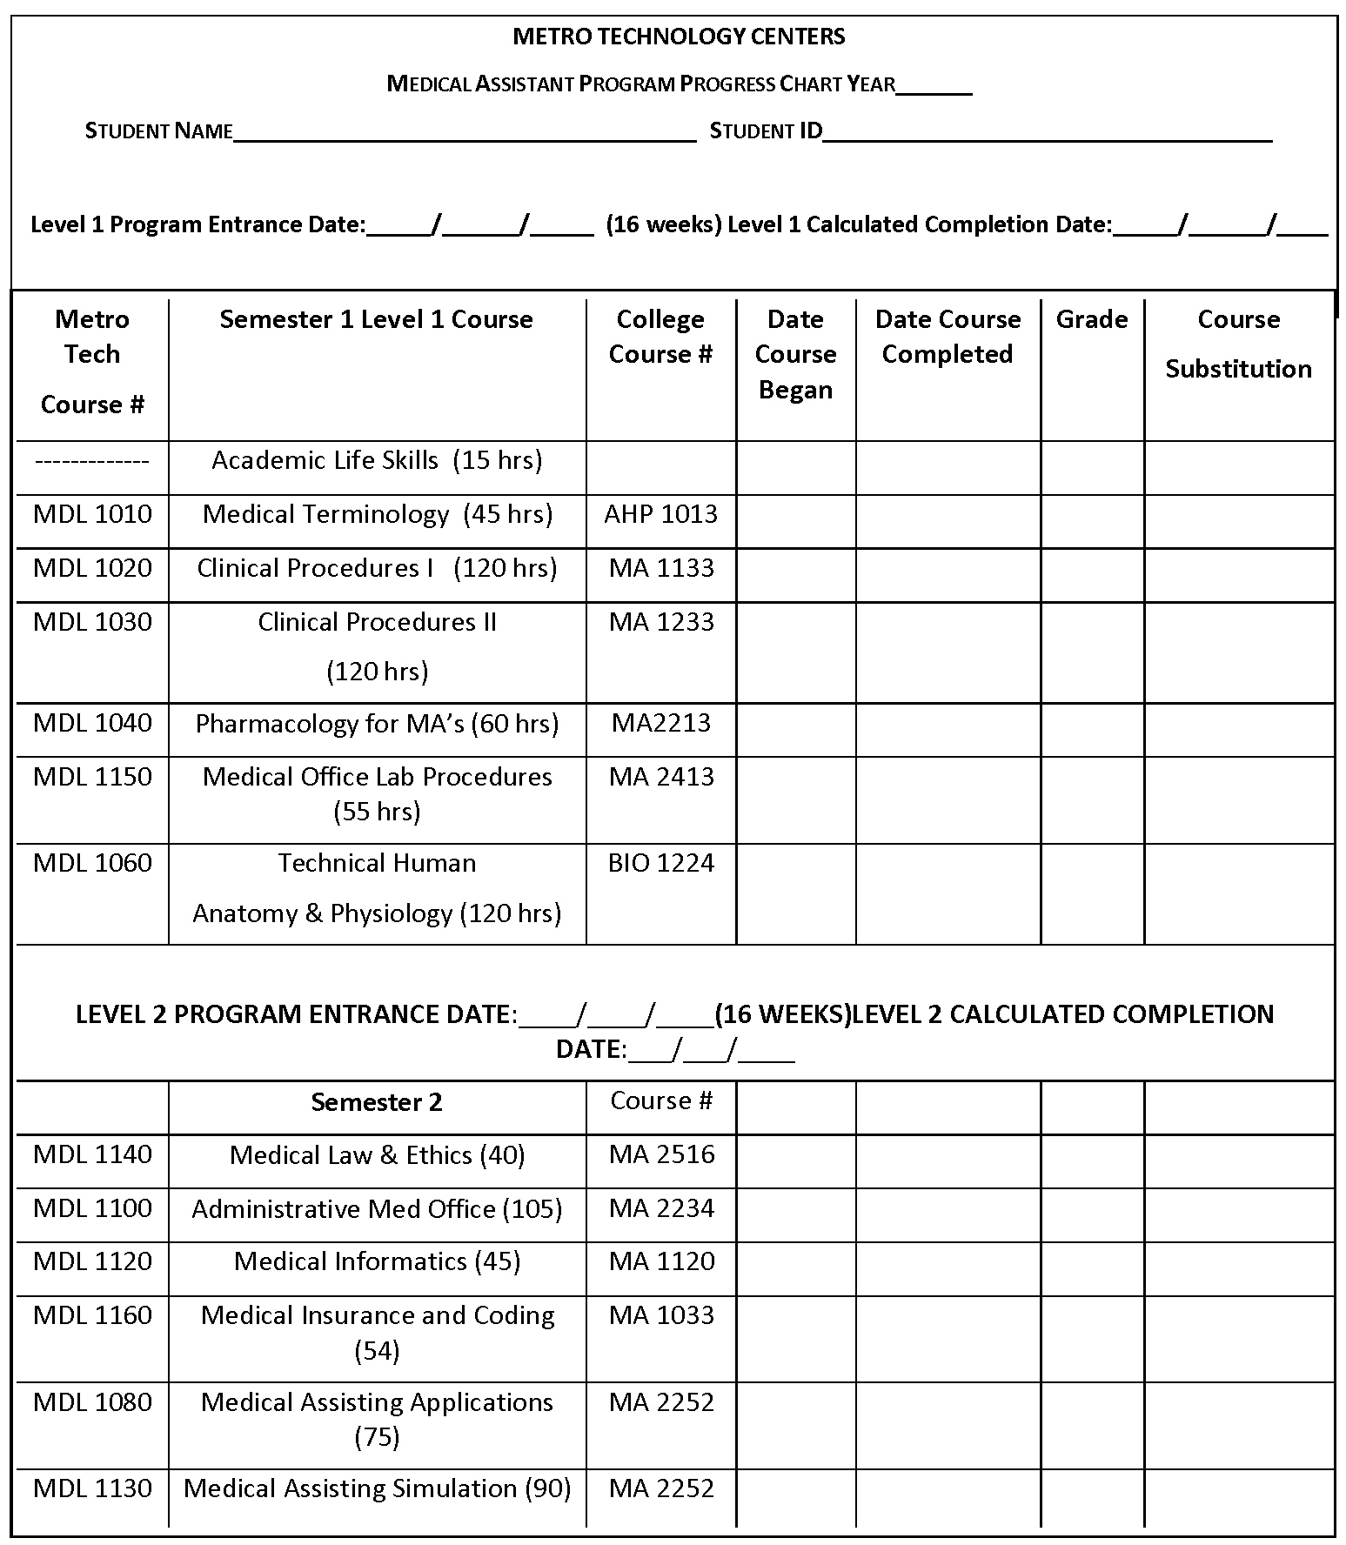

MAERB Core Curriculum for Medical

Core Curriculum for Medical Assistants Medical Assisting Education Review Board (MAERB) Foundations for Clinical Practice: Medical assistants graduating from programs accredited by the Commission on Accreditation of Allied Health Education Programs (CAAHEP) will demonstrate critical thinking based on knowledge of academic subject matter required for competence in the profession. They will incorporate the cognitive knowledge in performance of the psychomotor and affective domains in their practice as medical assistants in providing patient care.
Psychomotor & Affective Competencies
FOUNDATIONS FOR CLINICAL PRACTICE
Anatomy & Physiology
I.P.1 Measure and record:
a. blood pressure
b. temperature
c. pulse
d. respirations
e. height
f. weight
g. length (infant)
h. head circumference (infant)
i. pulse oximetry
I.P.2 Perform
a. electrocardiography
b. venipuncture
c. capillary puncture
d. pulmonary function testing
I.P.3 Perform Patient Screening using established protocols
I.P.4 Verify the rules of medication administration
a. right patient
b. right medication
c. right dose
d. right route
e. right time
f. right documentation
I.P.5 Select proper sites for administering parenteral medication
I.P.6 Administer oral medications
I.P.7 Administer parenteral (excluding IV) medications
I.P.8 Instruct and prepare a patient for a procedure or a treatment
I.P.9 Assist provider with a patient exam
I.P.10 Perform a quality control measure
I.P.11 Obtain specimens and perform:
a. CLIA waived hematology test
b. CLIA waived chemistry test
c. CLIA waived immunology test
d. CLIA waived microbiology test
I.P.12 Produce up-to-date documentation of provider/professional level CPR
I.P.13 Perform first aid procedures for:
a. bleeding
b. diabetic coma or insulin shock
c. fractures
d. seizures
e. shock
f. syncope
I.A.1 Incorporate critical thinking skills when performing patient assessment
I.A.2 Incorporate critical thinking skills when performing patient assessment
I.A.3 Show awareness of patient’s concerns related to the procedure being performed

- Applied Mathematics
II.P1. Calculate proper dosages of medication for administration
II.P.2 Differentiate between normal and abnormal test results
II.P.3 Maintain lab test results using flow sheets
II.P.4 Document on a growth chart
II.A 1 Reassure a patient of the accuracy of the test results

III. Infection Control
III.P.1. Participate in blood borne pathogen training
III.P.2. Select appropriate barrier/personal protective equipment (PPE)
III.P.3. Perform handwashing
III.P.4 Prepare items for autoclaving
III.P.5 Perform sterilizations procedures
III.P.6 Prepare a sterile field
III.P.7 Perform a sterile field
III.P.8 Perform wound care
III.P.9 Perform dressing change
III.P.10 Demonstrate proper disposal of biohazardous material
- sharps
- regulated wastes
III.A. Recognize the implications for failure to comply with Center for Disease Control
(CDC) regulations in healthcare settings

IV.P Nutrition
IV.P.1 Instruct a patient according to patient’s special dietary needs
IV.A.1 Show awareness of patient’s concerns regarding a dietary change

APPLIED COMMUNICATIONS

V.P Concepts of Effective Communication
V.P.1 Use feedback techniques to obtain patient information including:
a. reflection
b. restatement
c. clarification
V.P.2 Respond to nonverbal communication
V.P.3 Use medical terminology correctly and pronounce accurately to
Communicate information to providers and patients
V.P.4 Coach patients regarding:
a. office policies
b. health maintenance
c. disease prevention
d. treatment plan
V.P.5 Coach patients appropriately considering:
a. diversity
b. developmental life stages
c. communication barriers
V.P.6 Demonstrate professional telephone techniques
V.P.7 Document telephone messages accurately
V.P.8 Compose professional correspondence utilizing electronic technology
V.P.9 Develop a current list of community resources related to patients’
Navigator
V.P.10 Facilitate referrals to community resources in the role of patient
Navigator
V.P.11 Report relevant information concisely and accurately
V.A.1 Demonstrate:
a. empathy
b. active listening
c. nonverbal communication
V.A.2 Demonstrate the principles of self-boundaries
V.A.3 Demonstrate respect for individual diversity including:
a. gender
b. race
c. religion
d. age
e. economic status
f. appearance
V.A.4 Explain to a patient the rationale for performance of a procedure.

MEDICAL BUSINESS PRACTICES

VI.P Administrative Functions
VI.P.1 Manage appointment schedule using established priorities
VI.P.2 Schedule a patient procedure
VI.P.3 Create a patient procedure
VI.P.4 Organize a patient’s medical record
VI.P.5 File patient medical records
VI.P.6 Utilize an EMR
VI.P.7 Input patient data utilizing a practice management system
VI.P.8 Perform routine maintenance administrative or clinical equipment
VI.P.9 Perform and inventory with documentation
VI.A.1 Display sensitivity when managing appointments

VII.P Basic Practice Finance
VII.P.1 Perform accounts receivable procedures to patient accounts including
Posting:
- charges
- payments
- adjustments
VII.P.2 Prepare a bank deposit
VII.P.3 Obtain accurate patient billing information
VII.P.4 Inform a patient of financial obligations for services rendered
VII.A.1 Demonstrate professionalism when discussing patient’s billing record
VII.A.2 Display sensitivity when requesting payment for services rendered

VIII.P Third Party Reimbursement
VIII.P.1 Interpret information on an insurance card
VIII.P.2 Verify eligibility for services including documentation
VIII.P.3 Obtain precertification or preauthorization including documentation
VIII.P.4 Complete an insurance claim form
VIII.A.1 Interact professionally with third party representatives
VIII.A.2 Display tactful behavior when communicating with medical providers
Regarding third party requirements
VIII.A.3 Show sensitivity when communicating with patients regarding third
Party requirements

IX.P Procedural and Diagnostic Coding
IX.P.1 Perform procedural coding
IX.P.2 Perform diagnostic coding
IX.P.3 Utilize medical necessity guidelines
IX.A.1 Utilize tactful communication skills with medical providers to ensure
Accurate code selection

MEDICAL LAW AND ETHICS

X.P Legal Implications
X.P.1 Locate a state’s legal scope of practice for medical assistants
X.P.2 Apply HIPAA rules in regard to:
a. privacy
b. release of information
X.P.3 Document patient care accurately in the medical record
X.P.4 Apply the Patient’s Bill of Rights as it relates to:
a. choice of treatment
b. consent for treatment
c. refusal of treatment
X.P.5 Perform compliance reporting based on public health statutes
X.P.6 Report an illegal activity in the healthcare setting following proper Protocol
X.P.7 Complete an incident report related to an incident report related to an
Error in patient care
XA.1 Demonstrate sensitivity to patient rights
XA.2 Protect the integrity of the medical record

XI.P Ethical Considerations
XI.P.1 Develop a plan for separation of personal and professional ethics
XI.P.2 Demonstrate appropriate response (s) to ethical issues
XI.A.1 Recognize the impact personal ethics and morals have on the delivery of
Of healthcare

SAFETY AND EMERGENCY PRACTICES

XII.P Protective Practices
XII.P.1 Comply with:
- safety signs
- symbols
- labels
XII.P.2 Demonstrate proper use of:
- eyewash equipment
- fire extinguishers
- sharps disposal containers
XII.P.3 Use proper body mechanics
XII.P.4 Participate in a mock exposure even with documentation of specific
steps
XII.P.5 Evaluate the work environment to identify unsafe working conditions
XII.A.1 Recognize the physical and emotional effects on persons involved in an
Emergency situation
XII.A.2 Demonstrate self-awareness in responding to an emergency situation

Student Expectations and Grading

Medical Emergencies
If a student has an injury or sudden illness while at Metro Tech, he/she should notify the instructor immediately for further direction. Students who are ill must sign-out in the attendance office before leaving the campus. Staff will contact a parent/guardian before secondary students are allowed to leave school. Metro Tech staff will not issue medication or perform medical treatments on any student, minor or adult.

Insurance
Students are responsible for their own accident and health insurance. The school does not carry insurance on students. High school students may get information on school accident insurance at their home high school.

Internet Access
Guidelines for Use of Metro Tech’s Information Technology Resources, Including Internet Access
Metro Technology Centers provides a system of information technology resources, including access to the Internet, to its students. The system has a limited educational purpose. The term “educational purpose” includes use of the system for learning activities and for professional or career development.
Use of the system by students will be governed by this policy, by related District policy and regulations and by all applicable laws.
The District makes no warranties of any kind, either express or implied, that the functions or the services provided by or through the District system will be error-free or without defect. The District will not be responsible for any damage students may suffer, including but not limited to, loss of data or interruptions of service.

Transportation – Parking and Grounds
Since some of the classes are held at the Health Careers Center and others in various health agencies, the student is responsible for furnishing his/her own transportation to the clinical facilities and/or on field trips. Students are encouraged to form car pools.
However, student assignment in the clinical area cannot be scheduled on the basis of car pools. Students are expected to drive with care and caution in the parking lot and on the Springlake campus. The campus speed limit is fifteen (15) miles per hour. Students who exceed the speed limit or drive recklessly on campus will lose campus driving privileges. Students should park in the student parking lot. Parking is not permitted in handicapped, faculty, staff or visitor parking spaces.

General Admission Criteria
It is Metro Technology Center’s Board policy that consideration should be given to all individuals desiring to attend Metro Tech. Applicants are considered for admission according to the following criteria. Applicants are ranked according to a point system based upon their H.S GPA/GED score, Post-Secondary Education, and pre-entrance exams.
The applicant must:
- Be a high school graduate or have a GED certificate or equivalent.
- Be 18 prior to clinical assignment.
- Complete orientation session and pre-entrance tests.
- Complete American Heart Association BLS for health care providers.
- Submit all required documentation to the administration office by the announced deadline.

Required documentation includes:
- Completed application for admission.
- Official copy of all transcripts – high school, college, career tech, GED scores (official equivalency interpretation required of all foreign transcripts).
- ACCUPLACER scores in Reading, Writing, and Algebra
- TOEFL scores for English second language students.
- Upon acceptance into the career major, a physical examination must be completed by a physician.
- Required CPR, immunizations and background check for clinical assignments.
- Required random drug screen
- Approved Background check after acceptance

Admission with Transfer Credit
The definition of admission with advanced standing is: “The evaluation of an individual’s previous educational experience and the application of such experience to the requirements of specific instruction areas within a program of study.”
Admission with advanced standing will be considered on an individual basis. An applicant seeking admission with advanced standing will be evaluated according to the following criteria:
  - Meet all general admission requirements. Students already attending Metro Tech must be sure all required application documents are turn in by deadline.
  - Apply within two years of withdrawal from the equivalent program of study. Credit will be granted only for courses taken within the last two years.
  - Applicants may request to take challenge exams (theory &/or skill) for courses completed beyond the 2 years. This will be at the student’s expense.
  - Apply within two years of successful completion of nurse pre or equivalent career major.
  - Submit the following documentation:
    - Letter of recommendation from the previous institution.
    - Statement of good standing at the time of withdrawal/completion from the previous institution.
    - Official transcript of all work completed at the previous institution.
    - Course syllabus for each course for consideration for advance standing.
    - Documentation of laboratory/clinical competencies.
    - Documentation of required immunizations
  - No credit will be granted for courses taken through in-service education or “on- the-job training.”
  - Former students seeking readmission with advanced standing must meet and follow the readmission procedure see below.
  - Admission into the career major shall be in accordance with the scheduled course offerings. Admission will be contingent upon available space and/or admission ranking.
  - Applicants must complete at least 50% of the career major at this institution in order to receive a certificate of completion from Metro Technology Centers.
  - Applicants may be required to successfully complete a clinical competency skills check.

Admission of Person with Arrest/Conviction Record
Most clinic sites will not allow a student that has a criminal history to participate in the clinical experience. If the student is not eligible for clinical placement, the student will not be able to meet the requirements of the career major.
If the student is able to secure a clinical opportunity, that does not guarantee the sponsoring licensure body for the national testing will allow student to take licensure examination or guarantee employment. Metro Tech does not guarantee any student employment upon completion of the career major. Student Background checks will be shared with clinical sites.

Readmission Procedure
Student who withdraws from the Career Major for any reason may be eligible for re-entry
one time if the following requirements are met:
- Written statement from student of intention to withdraw from program and request to be considered for re-entry into career major.
- Student was in good standing at the time of withdrawal.
- Financial and other student obligations met.
- Attendance maintained in accordance with current attendance policy.
- Re-entry into the career major within one year of withdrawal date.
- Space availability.
- Students must show competency of pharmacology skills prior to attending clinical due to patient safety.
- A new application must be submitted.
- Recommendation from Admission Committee.
- A student that withdraws with grades below passing must submit supporting documentation that previous problems or obstacles have been resolved.

ATTENDANCE GUIDELINES
Regular class attendance for adult and secondary students is an essential component of academic success and is required for all MTC students. No student may miss more than one (1) day per month, except as noted below under Activity Absences or Financial Aid requirements. Violation of the attendance policy will result in the student receiving no academic credit and will result in withdrawal from school. Students who violate the attendance policy will not be allowed to enroll for the following regular semester, including summer school if the violation occurs during the spring semester.
Absences a day are defined as the class period a student is enrolled each day. Students who miss over one hour per class will be counted absent for the class.
• A new student who has never attended MTC and misses three (3) consecutive days with no contact will be withdrawn.
• Students starting after the first day of classes will have less than the ten (10) days of allowed absences.
• Students who miss 5 consecutive days during the school year without contacting the school will be withdrawn.
• Accredited programs shall meet the attendance requirements established by the accrediting agency, and such requirements will supersede this ten (10) day rule.
• Tardies: Students can accrue a tardy by either arriving late to class or leaving class early.
• Three tardies will equal one (1) absence.
Please be aware this policy does not preclude being dismissed from the program due to course grades below the benchmark as a result of absences.
- Absences will not be considered as “excused” or “unexcused.” Students will be counseled per the following schedule:
  - Instructor/Faculty Advisor when absent hours reach 25 percent
  - HCC Counselor when absent hours reach 50 percent
  - MA Coordinator when absent hours reach 60 percent
  - HCC Director when absent hours reach 72 percent
- Students are expected to make up work missed while they are absent. It is the responsibility of the students to contact the instructor and arrange to complete the work missed in the required time frame. The normal time frame is one (1) school day for each day missed.
- If students are absent three (3) consecutive days due to personal illness, they must present written releases from physicians before they can return to class or participate in clinical experience.
- Clinical Attendance is mandatory. Students are given 3 days (24 hours) in which they are able to be absent and make up the clinical days for points. Any additional days absent will be required to be made up after their completion date and are based upon clinical availability at the instructor discretion and availability. Students’ clinical grades will not be adjusted for clinical days made up after the completion date. Students completing make up clinical hours after their completion date must receive passing grade for each clinical day to have the days count towards their completion of the program.
- Students must contact the clinical site and instructor if they are unable to attend their clinical.
- Students must have turned in proof of all immunizations, American Heart Association CPR card for HealthCare Providers, Group 1 background check and completed Drug screen and remain current on TB and CPR card to be able to attend clinical experience. Students who are not current or are missing any of the above documentation will receive zero points for each clinical day they are unable to attend. This could result in a student not passing a clinical course.
- Students are expected to be on time. Each tardy will be recorded at no less than 15 minutes absence as in 15-minute intervals up to 1.5 hours. Tardies in excess of 1.5 hours will equal 3 hours (1/2) day absence. Leaving class early will be recorded at no less than 15 minutes absence by 15-minute intervals up to 1.5 hours.
- Prior to being absent or tardy, students must notify the instructor. If students do not do so, they may be placed on attendance probation. Failure to follow this policy is grounds for dismissal.
- Students may apply for a “Leave of Absence” for a minimum of five (5) days, and a maximum of fifteen (15) days. All arrangements for a leave of absence must be recommended by the instructor or counselor, and approved by the site director. If a leave of absence is granted, the student is allowed to cease to attend the class for the specified period. When students return from the leave of absence, they will be allowed the same amount of time absent to make up work missed. The period of absence will not be counted toward accumulated hours of absence, and no grades will be kept during the leave. Requests for Leave of Absence will be made on a form designated by the superintendent. Students will be allowed only one (1) Leave of Absence per year. Agency students will not be paid during the Leave of Absence.
- Any exception to the attendance procedure will be dealt with on an individual basis. The site director may consider extenuating circumstances and emergencies. Documentation of an extenuating circumstance or emergency must be presented to the site director within five (5) days after the student returns to school. The site director will select a three-member committee made up of the site director, site counselor, and an outside member. The committee will review the documentation and make a determination within five (5) days.
- Students may appeal decisions as provided for by Board Policy 10.6.8.

Communication
The Discussion board is an important means of communication in the classroom. Students will be held responsible for all new information that is posted on the Discussion boards located on eLearn.
The Medical Assisting classroom Data Centers will provide the student with classroom progress. Students are expected to assist in posting outcomes on their "Data Center".

Grading/Promotion/Retention
The following grading procedure will be enforced:

Letter Grade | Percentage
A | 94-100
B | 87-93
C | 80-86
Minimum passing grade is 80%
Grades are earned based on the competencies demonstrated during assessments. Clinical grades are based on the student’s achievement of objectives while in the clinical assignment.

General Information

- Progress reports will be issued to students at the end of each grading period. At any point the instructor deems necessary, he/she will request a conference with any student who is having difficulty with his/her grades. Students shall be responsible for tracking their own progress.
- In order to progress students must successfully complete each course by maintaining satisfactory attendance and a minimum of 80% average in each course.
- Any fraction of a grade point will be rounded off as follows:
  - or above will be rounded up to the next whole number:
    - Example: 79.5 = 80%
0.4 or below will be rounded down to the next whole number:
    - Example: 79.2 = 79
- Students are required to maintain all course averages at a minimum of 80% in each course. Students failing to maintain minimum course averages of 80% may be placed on academic and/or clinical probation and required to develop and implement a plan for improvement.
- Courses with clinical components, students must achieve a final minimum passing grade of 80% in both the theory and clinical components in order to receive credit for the courses and continue in the career major. Students not achieving minimum of 80% final course grade in the theory component must repeat both the theory and the clinical component of the course.
- Cheating will result in written warnings and zeros for the first offense. Students will be dismissed from the career major for second cheating offense of any kind.
- Students are required to pass ODCTE Competency Exams for 1 Clinical and 1 Administrative with at least a 70% prior to completion.
- Student must protect the privacy of faculty, peers, patients and family members of patients by not inappropriately disclosing confidential information about faculty, peers, patients or their family members that is disclosed to them during their capacity as a Metro Technology Centers student. Students must also agree to HIPAA guidelines. Students breaking confidentiality or HIPAA guidelines may be dismissed from the career major.
- Students will not discuss or post any information about faculty, peers, patients, family members, or any clinical facility on any electronic venue ( i.e. My Space, Facebook, Twitter, cell phones, etc.). Nor will students leave/save any patient, family, faculty, clinical facility or student information on any open access desktop or hard-drive. Students posting/discussing inappropriate information may be dismissed from career major.
- Students are encouraged to participate in HOSA throughout their career major. Students who have signed up to attend a HOSA event and decide not to attend/participate will be required to reimburse Metro Tech for registration of event.

Assignment Procedure
- Assignments are due at the beginning of class on the scheduled due date to receive credit.
- Assignment points are all or nothing. All assignments must provide completed at 100% with answers that are evidence-based otherwise zero points are awarded.
- Students who turn in incomplete assignments or assignments that were completed inaccurately or fraudulently will forfeit their assignment points. (Students who copy other students assignments will be written up for cheating)
- Late assignments will NOT be accepted.
- There are no makeup opportunities for quizzes or assignments that are to be completed in class. Failure to submit a quiz or assignment that was done in class will result in a zero for the quiz/assignment.
- Research Papers are to be in APA Format with title page (no abstract page needed). Information on APA format can be found at www.apastyle.org. All papers will be graded on grammar and format. One revision may be allowed.
- Tests are not open book tests unless the instructor has directed you as so.

Student Class Information
Class Schedule
Class schedules will be provided to each student on the first day of each level. It is the responsibility of each student to know the schedule. Generally, class hours will be 7:45
  - – 2:45 p.m. with a lunch break provided. Breaks in the morning and afternoon will also be provided.
Classroom
- The classroom area is for study and not for conversations.
- Disruptive (loud talk) student will be asked to talk outside the classroom and dock their attendance appropriately.
- Study quietly with MA students is acceptable. Studying with other health majors is not recommended.
- English will be spoken in the classroom at all times.
Food & Drink
- Food and drink is not allowed in the lab. Food and drink are allowed in the classroom as long as there is a lid on your drink and you are not using an electronic device. This can be changed if it is abuse or problems arise.
Smoking
- Tobacco products are widely recognized as a public health concern. The Board of Education believes that a safe and healthful environment should be provided for all students and employees.
- The use of all tobacco products, which includes cigarettes, cigars, pipes, snuff, chewing tobacco or any other form of tobacco product, is prohibited in the buildings. State statute prohibits high school students from tobacco use on campus.
- This prohibition extends to all campuses, facilities, vehicles, and environs. In addition, this prohibition extends to district-sponsored events and activities such as, but not limited to, Career Technical Student Organization (CTSO) activities and National Technical Honor Society (NTHS) events. The superintendent will ensure appropriate procedures are developed to enforce this policy.

Professional Appearance
Professional Appearance/Behavior
Appropriate standards of dress for persons in the health care profession are taken into consideration in the Medical Assistant career major. Our career major is preparing students for the workplace; therefore, each student is expected to dress and behave in a professional manner (follow Metro Tech dress policy during classroom hours).
The student uniform has been designed to provide neat, comfortable attire which identifies you with our school. The school uniform is to be worn only when participating in school activities. Instructors will counsel students when they are inappropriately dressed. Students may return to the clinical area upon conforming to the clinical dress code. Points will be deducted for not meeting professional appearance.
The complete uniform includes:
    - scrub jacket
    - scrub pants & top
    - tennis/nursing shoes (no canvas or crocks, open heels)
    - white hosiery/socks
    - school patch
    - ID badge
    - plain white or flesh colored under garments

In the clinical facility and laboratory setting, the student should have:
- watch with second hand
- pen with black ink
- small notebook
- drug handbook when applicable
- stethoscope
- competency notebook
The student is expected to maintain an appearance which is clean, neat, and appropriate at all times and is expected to adhere to dress code of clinical facilities.
Please adhere to the following guidelines while in laboratory and clinical settings:
  - bathe regularly and use deodorant/antiperspirant. (No perfumes/colognes or strong lotions are allowed.)
  - maintain good oral hygiene
  - wear hair pulled back so it is not in student’s face and it does not touch the patient. (Hair ornaments must be inconspicuous) No head wear to be worn.
  - jewelry should not be worn during clinical or laboratory experience.
  - No visible body piercing with exception to 1 pair of stud earrings and cannot be distracting. (No gauged piercings)
    - No facial piercing or tongue piercing.
    - Only wedding or engagement rings may be worn, although caution should be used when wearing exam gloves.
  - no visible body tattoos
  - keep beards neatly trimmed
  - keep fingernails short and clean (clear non-chipped polish only and no artificial nails)
  - use cosmetics with discretion

Laboratory practice is designed to prepare students for the clinical experience. To aid in preparing for the clinical experience, students must wear scrubs during scheduled laboratory practice. Scrubs during laboratory practice may be any color and must not have any institution or facility markings.

Class Days: Follow Metro Tech Dress Code to include the following:
- Scrub bottoms and scrub top or appropriate t-shirt is required
- No gang wear.
- No halter tops, strapless tops, or spaghetti straps.
- No midriffs showing.
- No T-shirts with references to alcohol, drugs, sexual inferences, or generally crude statements, slogans or phrases.
- No hats/ball caps, head coverings of any kind.
Close-toed shoes MUST be worn in the lab.

Professional Attire: Medical Assistant students are expected to dress professionally for out-of-school meetings, workshops, field trips, and student organization conferences. ID badge must be worn when representing the school. Inappropriate attire is not acceptable and will result in a student conference or the student may be sent home.

Uniform and Appearance in Externship: The Uniform and Appearance Policy for Medical Assisting is outlined in the medical Assisting Externship Handbook. Also see above.

Student & Teacher Conferences
Teacher-student conferences are scheduled as needed. The purpose of individual student conferences is to provide an opportunity to review progress, discuss grades and attendance, and to discuss any problems or needs of the student. This may include one- on-one tutoring; discussion of the individual’s learning style, motivation and special needs. Students will receive frequent feedback and reinforcement of learning for classroom, laboratory and externship instruction. Student conferences may be schedule before or after class or as the instructor’s office time permits.

Career Major Completion
Completion ceremonies will be held in May for all eligible students. Students with incomplete grades may be allowed to participate in completion ceremonies, if it is the opinion of the faculty that the students will have met completion requirements in a designated period of time.
In order to complete a full-time adult Health Careers Education career major, students must meet the following criteria:
  - Successfully complete all course requirements with a minimum final grade of a C
  - Maintain attendance in accordance with current attendance policy
  - Successfully perform all required competencies
  - All course work completed and submitted within 60 days of the scheduled completion date
  - All missed clinical days are made up
  - Upon successful completion of the career major and payment of all school obligations students will receive certificates of completion, transcripts, and program/school pins. Completers are then entitled to take national certification or licensure examinations.
Tuition and Career Major Cost

TUITION BOOKS SUPPLIES CERTIFICATION CHROMEBOOK TOTAL
2,787.50 883.00 717.00 155.00 283.00 4,824.50
Program supply costs include, but are not limited to:
- Membership in professional and /or student organizations
- Uniform (2 sets scrubs and lab jacket)
- Chromebook
- Diploma and cover
- Liability insurance
- Identification badge
- NHA national testing fee
- Drug screening and lab supplies

This program is eligible for Financial Aid
MISCELLANEOUS COSTS NOT INCLUDED IN TUITION
Prices may vary and are subject to change without notice.
Background Check............................................................................$100.00 – up
Stethoscope .......................................................................................$20.00 – up
Leather Tennis shoes.........................................................................$45.00 – up
Wristwatch with second hand ...........................................................$25.00 – up White Socks ......................................................................................$6.00 – up
Additional Scrubs..............................................................................$30.00 – up
Immunizations...................................................................................$150.00 – up
Physical .............................................................................................$50.00 – up
CPR for Health Care providers (American Heart)............................$45.00 – up Ear phones for computer or iPad ......................................................$10.00 – up
External Memory Card .....................................................................$20.00 – up

Student Work/Employment
The services are: All student activities associated with the career major curriculum, particularly clinical experience, must be educational. Students will not receive pay while participating in clinical experience.
Facilities may offer students employment; however, students may not apply any paid work experience toward clinical requirements of the career major. Students may not wear the school uniform during any paid work experience.

Testing and Assessment
The assessment staff administers achievement tests, aptitude assessments, interest inventories and personality indicators. The staff also provides guidance and counseling to assist students in career choices.

Career Counseling Services
Our counseling staff is available to assist individuals in finding their career and technical aptitudes and interests.

College and Career Services
Through Prior Learning Assessment (PLA), upon completion of a recognized, national certification along with 12-credit hours of resident credits at OCCC, you will be eligible to use that certification to receive college credit to apply toward an Associate of Applied Science Degree in Medical Assisting.

Employment Services
These services are available to both current and former students of Metro Tech. Employment Services work closely with business and industries to keep lists of job openings. Financial aid, scholarships and tuition waiver programs are available for qualified persons enrolled in full-time career majors.

Child Care
Program Features include:
- Hours 7:00 am-6:00 pm (week days)
- DHS approved, NAEYC guidelines
- Experienced, qualified staff
- Ages 6 weeks through 5 years
- After school program for K-6th grade. Transportation from schools provided in northeast area. (Call 405- 427-1034 for more information.)
- Affordable rates, VISA/MasterCard/American Express accepted
- Financial assistance available
- Breakfast, lunch and snack included
- No registration fee
- Priority enrollment given to Metro Technology Centers’ students and staff
For more information or to enroll your child in the Child Care Training Center, please call (405) 595-4751.

Disability Services
Metro Tech provides reasonable accommodations and support for students with disabilities and special education needs covered by the Americans with Disabilities Act (ADA), Section 504 of the Rehabilitation Act of 1973, and Individuals with Disabilities Education Act (IDEA).
Disability Services Accommodation Request
If you have a physical or mental impairment that substantially limits a major life activity you may be eligible for accommodations in the assessment process and/or classroom accommodations that will ensure the assessment and/or classroom work accurately reflects your skills, knowledge and abilities. Attempts will be made to provide reasonable accommodations that will allow you to demonstrate your abilities. You will need to go to www.metrotech.edu/disability_request.html and complete Steps 1-3 and submit the form to Metro Tech.
Step 1: Contact Information
You will be requested to give contact information in Step 1. The information in Step 1 and any documentation regarding your disability or need for accommodation to attend career objectives in a program or assessment will be considered strictly confidential and will not be furnished to any outside source without your permission to provide reasonable accommodations that will allow you to demonstrate your abilities.
Step 2: Disability Documentation
You will be requested to give what Metro Tech Program/class activity you are asking for accommodation. You will also be asked what accommodation you are requesting. Step 2 also involves obtaining Disability Documentation.
Disability Documentation
Prior to receiving accommodations all students identified as being disabled must have the proper documentation on file in order to receive accommodations. Your request for accommodation must be certified by an appropriate professional (licensed physician, licensed psychologist, approved agency, etc.)
Metro Technology Centers does not discriminate on the basis of race, color, national origin, sex/gender, age, marital or veteran status, religion, pregnancy or qualified disability.
You are to submit your documentation by fax, US Mail, E-mail or in person to: Title IX Coordinator
Metro Technology Centers 1900 Springlake Drive Oklahoma City, OK 73111 405.595.4418

Step 3: Approval and Plan Development
Once documentation is submitted you will be contacted and a accommodation plan will be developed. Persons included in development of plan can include Director of Disabilities Services, student, instructor, and others whom student invites. Plan may be developed face to face or in some cases as a conference call. Plan development should be in place prior to first day of class or ASAP after that date. All documentation is confidential.

Student Organizations
Health Occupations Students of America
The Medical Assistant career major supports the concept that the career-tech student organization is an integral part of the vocational program. Health Occupations Students of America (HOSA) is the recognized vocational student organization serving Health Occupations Education students. HOSA’s mission is to enhance the delivery of compassionate, quality health care to all people.
The coordinator/instructor serves as the advisor for the student organization. The advisor works closely with the student members in planning the chapter’s program of work, which includes a balance of community/civic projects, fund-raising projects, professional activities and social functions.
Through participation in HOSA, students develop leadership skills which enhance technical skills and prepare them for participation in professional organizations. Students will be required to attend the Fall Leadership Conference in October and all students will be required to participate during Spring Leadership Conference. Each student will select a competitive event to participate in during Spring Conference. Competing and placing in any events demonstrates to future employers your level of expertise and commitment to professionalism. If a student(s) place 1st at SLC they have the option to compete at National Leadership Conference (out of state). Metro Technology Centers will provide the student with registration, transportation, hotel and stipend for food. Student must participate in all required events during the conference.
AAMA/OKLAHOMA MEDICAL ASSISTANT SOCIETY
Students are expected to participate in at least one meeting in the school year. The cost is $5.00 for students. There is one meeting held in September typically held in Tulsa and one in Oklahoma City in April. This is part of your professional development grade.
National Technical Honor Society
The National Technical Honor Society (NTHS) is non-profit organization established to honor excellence in workforce education for academically outstanding students enrolled in vocational programs. The purposes of the Society are to promote characteristics in the following areas:
- Leadership
- Scholastic achievement
- Service
- Honesty/Integrity
- Skill development
- Citizenship
- Individual responsibility
Honor Society membership develops individual self-esteem and pride. Candidates for membership in the NTHS must be approved by the local school administration and must meet local and national membership standards.
Metro Technology Centers National Technical Honor Society Membership Requirements
The requirements for membership in the Health Career Center NTHS are:
- 3.5 cumulative GPA in career and technology education program
- No more than 30 hours of absence per program year (Adult Programs)*
- Career and Technology Student Organization participation
Demonstrates good character of Leadership, Scholastic Achievement, Service, Honesty/Integrity, Skill Development, Citizenship, Individual Responsibility and demonstration of a positive attitude with Instructors, Staff, Students, and Clinical Preceptors.
- Faculty Recommendation
Members of the NTHS are provided certificates and a membership pin at the conclusion of the Medical Assisting program if all requirements have been maintained throughout the program year. Membership fees are a one-time charge of $20.00. Membership fees are paid by Metro Tech Health Careers Center as a reward for academic achievement and demonstrating positive character and leadership qualities.
Metro Technology Centers students that achieved membership in the NTHS are honored at an “Induction Ceremony” held in March.
*Leave of Absences and/or make up time will not be allowed to qualify for NTHS.

Student of the Year
The Medical Assisting “Student of the Year” should demonstrate the following:
- Attendance:
  - Attend class and the clinical setting a minimum of 95% of the program hours.
  - Notify the instructor prior to being tardy or absent from class or clinical practicum. Not through a friend and must be each day of absence unless prior arrangements.
  - Complete all assignments and missed work following an absence within an acceptable time line.
  - Return promptly from lunch and breaks during class, laboratory, and in the clinical practicum.

- Academic Excellence:
  - Maintain a minimum of 3.0 GPA in all course work.
  - Arrive to class prepared with books and completed assignments.
  - Demonstrate learning readiness each day by remaining on task.
  - Prepare in advance for lectures and lab by reading assignments.
  - Receive positive clinical evaluations.

- Professionalism:
  - Work well with assigned group(s), peers, preceptors, and instructional staff.
  - Participate willingly and enthusiastically in class activities and discussions.
  - Display a positive outlook.
  - Demonstrate flexibility in adapting to unavoidable changes throughout the year.
  - Listen and follow directions.
  - Demonstrate appropriate language and positive communication skills
  - Leave work and lab area clean and neat by putting away supplies and equipment.
  - Seek employment in the Dental Assisting profession.
  - Attend the Oklahoma County Dental Assistant meetings and/or the Annual Oklahoma Dental Association Convention

- Leadership:
  - Provide assistance and support to others.
  - Develop leadership skills
  - Accept responsibility and follow through with assignments.
  - Participate willingly and actively in HOSA activities (fundraising, committees, competitions, etc.)

- Ethical Conduct and Character Qualities:
  - Maintain the highest level of ethical conduct in personal and professional actions.
  - Demonstrate positive character qualities in personal and professional actions.

- Portfolio Documentation:
  - Grade verification
  - Attendance verification
  - CTSO Involvement
    - Committee
    - Membership
    - Activities
  - Functional resume
  - Work examples
  - Certificates of Achievement
    - CPR card (copy)
    - ODCTE certificates (copy)
    - Attendance certificate (gold, silver or bronze)
    - Student of the Quarter
    - National Technical Honor Society
  - Personal Mission Statement
  - Personal Goals
  - Character First! Documentation
  - Clinical Documentation

NOTE: All students are required to develop a portfolio and keep it up-to-date.
Procedures for Success in the Class
Personal Matters:
- Please take care of personal matters before entering the classroom.
- Don’t share all of your personal matters to classmates.

Entering the Classroom:
- Enter the classroom quietly and begin your warm-up activity.
- Disinfect with a wipe or spray provided for your desk/lab area.
- Tardies are entered for those not in the classroom door when prior to the assigned class time.
- Cell phones turned off and checked at break time
- Wear uniform and name tag

Being Prepared for Class:
- Have your books, supplies, assignments, etc., with you when you enter the classroom.
- Be prepared for class before the assigned time. This includes sharpening your pencil, getting a tissue, turning in work, turning on computer, etc.

Turning in Work:
- Place all assigned work in the appropriate basket for your class.
- Heading on Papers:
- The first page of all handwritten or computer uploaded assignments is headed as follows in the upper right-hand corner:
- Last name, First name
- Date
- The course name, unit of study, and title of assignment is centered on the paper below personal information.
- Subsequent pages are headed by your last name and page number (Smith 2, Fisher 3, etc.)

An acceptable paper:
- Has NO paper torn out of a spiral notebook
- Is written in blue or black ink only.
- Is neat and legible. If I cannot read it, I cannot grade it.
- Is properly labeled. Five points will be taken off any paper that is not correctly labeled.

After an Absence:
Please check on eLearn or with a classmate what information was covered. Any handouts for the week are in the tray located by the mailboxes. Homework is posted on eLearn within each course and is up to the student to be sure all assignments are complete. Any work that was completed as part of participation or review quiz is not eligible to be made up.

Dismissal of Class:
Prepare for the end of class when you are instructed to do so. At the end of class, remain quietly seated and wait to be dismissed. Please make sure your work area is clean and throw away all trash on your way out of the classroom.

Extra Help:
You are encouraged to schedule a conference with me if you do not understand a concept in class.

Entering the classroom
- Greet the instructor by name
- Enter the room quietly
- Get your materials
- Go directly to your seat
- Begin work immediately
Entering the classroom during class:
- Knock on the door
- Wait to be let into the classroom by the instructor or a classmate (if during a test you will need to wait until completed)
- Enter quietly
- Go directly to your seat
- Get to work immediately
When you are absent:
- You are responsible for missed information/work
- You will have 2 days to complete any missing lab assignments
- If you are planning on being absent, notify the instructor ASAP in order to make arrangement beforehand.
- Instructor must be notified directly if you are not going to be in attendance either by text or phone call to the class. Not a notification by your peers
Getting to work immediately
- Have all your materials (notes, pens, highlighters, etc.)
- Read the assignment that is on the board
- Begin working on the assignment
- If you don’t understand, quietly ask your neighbor for help
Coming to attention:
- Look at instructor
- Stop talking
- Listen for instructions
- Continue work when instructed

Asking a question during a discussion:
- Raise your hand
- Wait to be called on
- When called on, ask your question

Participating in class discussions:
- Raise your hand
- Wait to be called on
- If you don’t get called on, wait quietly for your turn
- When it is your turn, speak loudly, clearly, and discuss

Conferencing with instructor:
- Give the instructor your full attention
- Follow directions
- When conferencing is completed, return to your work

Getting materials without disturbing others:
- Quietly walk directly to where the materials are located
- Get your materials
- Return directly to your seat
- Continue working

When you need a writing utensil or paper
- Ask for paper from the instructor at the beginning of class
- Borrow paper from a classmate during class

If you finish early:
- Read your textbook
- Read a journal article
- Finish any missing assignments
- Practice a lab skill
- Work on data center

When given assignment:
- Enter into your appointment book/agenda, or your “In Class” app
- Ask questions if you have any

End of class dismissal:
- The instructor dismisses the class/lab/clinical, not the clock or the students
- Push you chair under your desk
- Put your materials neatly away
- Say goodbye to the instructor(s) and other students
- Exit quietly

When visitors are in the classroom:
- Continue with your work
- Be polite to the guest, answer questions if asked
- Maintain work if the instructor is called away
- If appropriate, engage in conversation with the visitor

If the instructor is out of the classroom:
- Continue with your work
- Be quiet, responsible, and mature

When a school-wide announcement or classroom page is made:
- Stop talking
- Listen to the announcement
- Then continue working quietly

Saying “thank you”
- Look the person in the eye who you are thanking
- Say “thank you” following by the person’s name
- Explain why you are thanking them.
- Smile
- Thank you should be said whenever someone does something for you (gift, help, etc.)

If you are suddenly ill
- If time, notified the instructor
- If no time, go directly to the restroom
- If you cannot make it the restroom, please grab the waste basket on your way out
- Report back when you are done

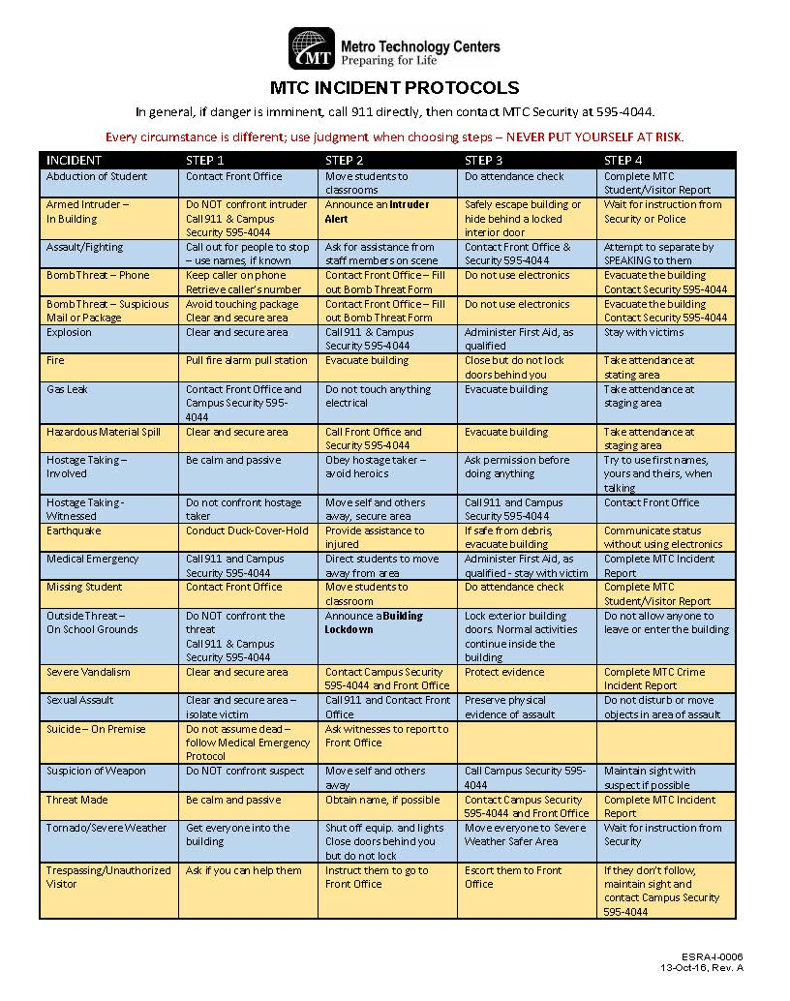

Conflict Resolution
In any organization with a variety of jobs and many people, different point of view will develop. Recognizing this fact, Metro Technology Centers has developed a procedure for resolving conflicts in an orderly and fair manner. If you have a disagreement or dispute with another person, follow these steps:
- Discuss the complaint informally with the person involved, and try to resolve the problem. Be sure to explain how you perceived the situation and try not to blame the other person. Often disagreements are simply miscommunications.
- If you cannot solve the problem with the person involved, invite your site counselor to serve as a liaison between the two of you.
- If these methods do not work, submit your complaint in writing to your Site Director and request a meeting about the issue. The Site Director will make a decision and put it in writing.
- If the issue has still not been resolved to your satisfaction, you may appeal in writing to the Assistant Superintendent for Instruction. The Assistant Superintendent will call a meeting of the parties involved and make a final decision. This final decision will be put in writing.
Reference: Metro Technology Centers Board Policy, BP-10015

Discipline Procedure
Our career major behavior expectations are similar to those governing the Licensed Practical Nurse.
Disciplinary action may be initiated for failure to adjust to the student role, unsafe medical assisting, or unprofessional conduct.
The first time a student’s behavior warrants disciplinary action, a conference will be held with the student and a warning issued. The student will be given an opportunity to correct the behavior. If the student’s behavior is not corrected or another offense occurs, the student will be placed on probation or suspension. A student can be suspended from clinical only, or from classes and clinical together. Suspensions will occur for an appropriate period of time to determine by the program faculty. Suspensions will likely result in a delay of career major completion and/or licensure for the student. If the behavior continues or additional offenses occur, the student will be terminated from the career major.

The following definitions are offered for the purpose of clarification of terms:
- Lack of adjustment to the student role includes, but is not limited to:
  - resorting to fraud, misrepresentation or deceit in taking examinations or completing assigned work
  - aiding or abetting other students in taking examinations or completing assigned work
  - failure to turn in assigned work
  - excessive absences or tardiness
  - sleeping in class and/or clinical
  - showing disrespect toward instructors, administrative staff, guest speakers, nursing personnel in the clinical area or peers
  - confronting clinical staff or instructors inappropriately regarding evaluations or behavioral reports
  - confronting instructors regarding classroom or academic issues.
  - failure to adhere to the code of ethics for medical assistants.
  - failure to be in complete appropriate attire as described in the professional appearance policy
  - failure to notify instructors in case of unavoidable absence or tardy
  - habitual intemperance or addiction to habit-forming drugs
  - wearing the school badge while employed by another health agency

- Unsafe medical assistant practice shall include but is not limited to:
  - Incompetence by reason of negligence, i.e. failure to possess and use that degree of learning and skill ordinarily possessed and used by other medical assistant students under similar circumstances.
  - Performance of any deliberate act that jeopardizes a patient’s life, health, or safety. “Conduct which jeopardizes a patient’s life, health or safety shall include but is not limited to the following:
    - Delegating or accepting the delegation of a medical assistant function or a prescribed health care function when the delegation or acceptance could reasonably be expected to result in unsafe or ineffective patient care; or
    - Unauthorized alterations of medication; or
    - Failure to utilize appropriate judgment in administering safe medical assistant practice or patient care assignment based upon the level of training for which the individual is licensed or recognized; or
    - Performing new techniques, procedures, or patient care activities without proper education and preparation; or
    - Failure to report through the proper channels the unsafe or illegal practice of any person who is providing patient care.

- Unprofessional Conduct
Activities generally prevailing in the State of Oklahoma and which could jeopardize the health and welfare of the people which shall include but not be limited to the following:
- inaccurate recording, falsifying or altering patient records; or
- verbally or physically abusing patients; or
- falsely manipulating drug supplies, narcotics or patient records; or
- appropriating without authority medications, supplies or personal items of the patient or agency; or
- falsifying documents
- leaving an assignment or patient care assignment without properly advising appropriate personnel; or
- violating the confidentiality of information or knowledge concerning the patient; or
- conduct detrimental to the public interest; or
- discriminating in the rendering of medical services or patient care assignment; or
- impersonating any applicant or acting as proxy for the applicant in any examination required for the issuance of a license or certificate; or
- impersonating another licensed or certified practitioner, or permitting another person to use his/her license, certificate, or certificate of recognition for any purpose; or
- aiding, abetting or assisting any other person to violate or circumvent any law or rule or regulation intended to guide the conduct of a nurse or advanced unlicensed assistive person; or
- forging a prescription for medication/drugs; or
- presenting a forged prescription; or
- selling or attempting to sell a controlled dangerous substance or otherwise making such drugs available without authority to self, friends, or family member; or
- while caring for a patient, engaging in conduct with a patient that is sexual or may reasonably be interpreted as sexual, or in any verbal behavior that is seductive or sexually demeaning to a patient, or engaging in sexual exploitation of a patient; or
- obtaining money, property or services from a patient, other than reasonable fees for service provided to the patient, through the use of undue influence, harassment, duress, deception or fraud; or
- engaging in fraudulent billing practices, including violations of federal Medicare and Medicaid laws or state medical assistance laws.

Wireless Communication Devices
(Cell phone, PDA’s, iPads, personal computers)
In order to maintain an environment conducive to learning, Metro Tech requests that student employees turn “off” all cell phones during class. Students with cell phones or ear pieces accessible during testing will receive zero on exams. Students are not to be texting or answer phones during class. Student should wait until breaks to check phone messages or missed calls.
Any misuse of the device shall act to forfeit the right to carry such wireless communication device, at the discretion of the site director. Misuse shall be defined as any operation, including ringing or sounding, which disrupts school activities. Criminal use of the device shall also be considered misuse. Prior permission for emergency purposes with your instructor allows for you to carry the phone but not to answer or use during class.

Complaint/Appeal Process
Students are to discuss their complaint informally with the person against whom the complaint is directed. It is the hope of all that most complaints can be resolved via meaningful dialogue. The counselor may serve as a liaison in attempting to bring the parties together. If this proves inadequate, the student may:
  - Submit his/her complaint in writing to the Campus Director within five days. The Campus Director shall call a meeting of the student (who may bring counsel) and the parties concerned. The Campus Director’s decision shall be in writing.
  - If the complaint is not resolved to the student’s satisfaction, he/she may appeal to the appropriate Associate Superintendent within five days. The Associate Superintendent’s decision shall be final.
  - If the complaint involves the Campus Director, it shall go to the appropriate Associate/Assistant Superintendent within five school days. The Associate Superintendent shall call a meeting of the student and the parties concerned. The Associate Superintendent’s decision shall be in writing. The Associate Superintendent shall make every effort to resolve the matter equitably and as quickly as possible.
References: Metro Tech School Board Policy, 10.6.8 and BP 1001

Student Records
The Family Educational Rights and Privacy Act of 1974 (FERPA) is a federal law designed to protect the privacy of a student’s education records. The law applies to all schools which receive funds under an applicable program from the U.S. Department of Education.
DEFINITIONS
Eligible student - a student who has reached 18 years of age or is attending Metro Tech as a postsecondary student.
Parent - a parent of a student, who is not an eligible student as defined above, including a natural parent, a legal guardian, or an individual acting as a court-appointed surrogate parent.
FERPA affords parents and eligible students certain rights with respect to the student’s education records. They are:
- Inspect and review information contained in the student’s education records;
- Request the correction of records to ensure that they are accurate, not misleading, or otherwise in violation of the student’s privacy or other rights;
- Have a hearing if the outcome of the request for correction is unsatisfactory;
- Submit an explanatory statement for inclusion in the education records if the outcome of the hearing is unsatisfactory;
- Prevent disclosure, with certain exceptions, of personally identifiable information from their education records;
- Secure a copy of the Metro Tech policy, which includes the location of education records; and,
- File complaints with the U.S. Department of Education alleging failure of Metro Tech to comply with the requirements of FERPA.
A copy of Metro Tech Board Policy 10.6.7, Student Records, can be obtained from the Site Director at each campus. (See BP-10014)

Emergency Closing Policy
The superintendent or designee is empowered to close one or more of the District’s centers, to delay opening them, or to dismiss them early in the event of hazardous weather or other emergencies which threaten the health or safety of students and personnel.
The following factors shall be considered in making these decisions:
- Weather conditions, both existing and predicted.
- Driving, traffic and parking conditions affecting public and private transportation facilities.
- Actual occurrence or possibility of any emergency condition which would make the operation of schools difficult or dangerous.
- Inability of teaching personnel to report for duty, which might result in inadequate supervision of students.
Students, parents, and staff shall be informed early in each school year of the procedures which will be used to notify them in case of emergency closing. (See BP-5005)

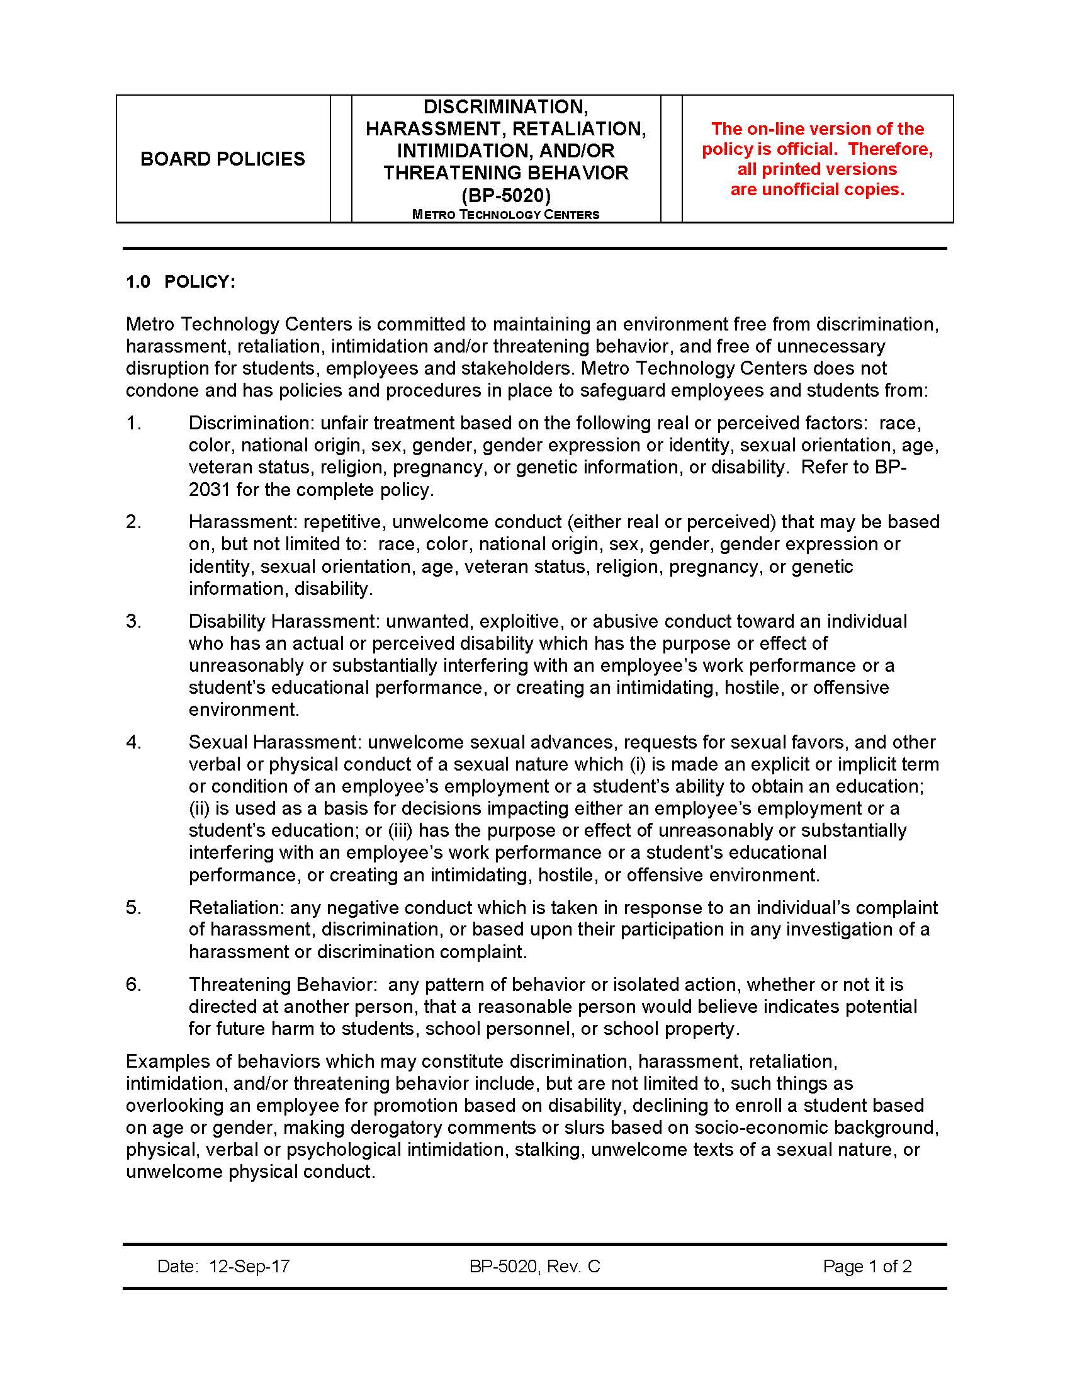
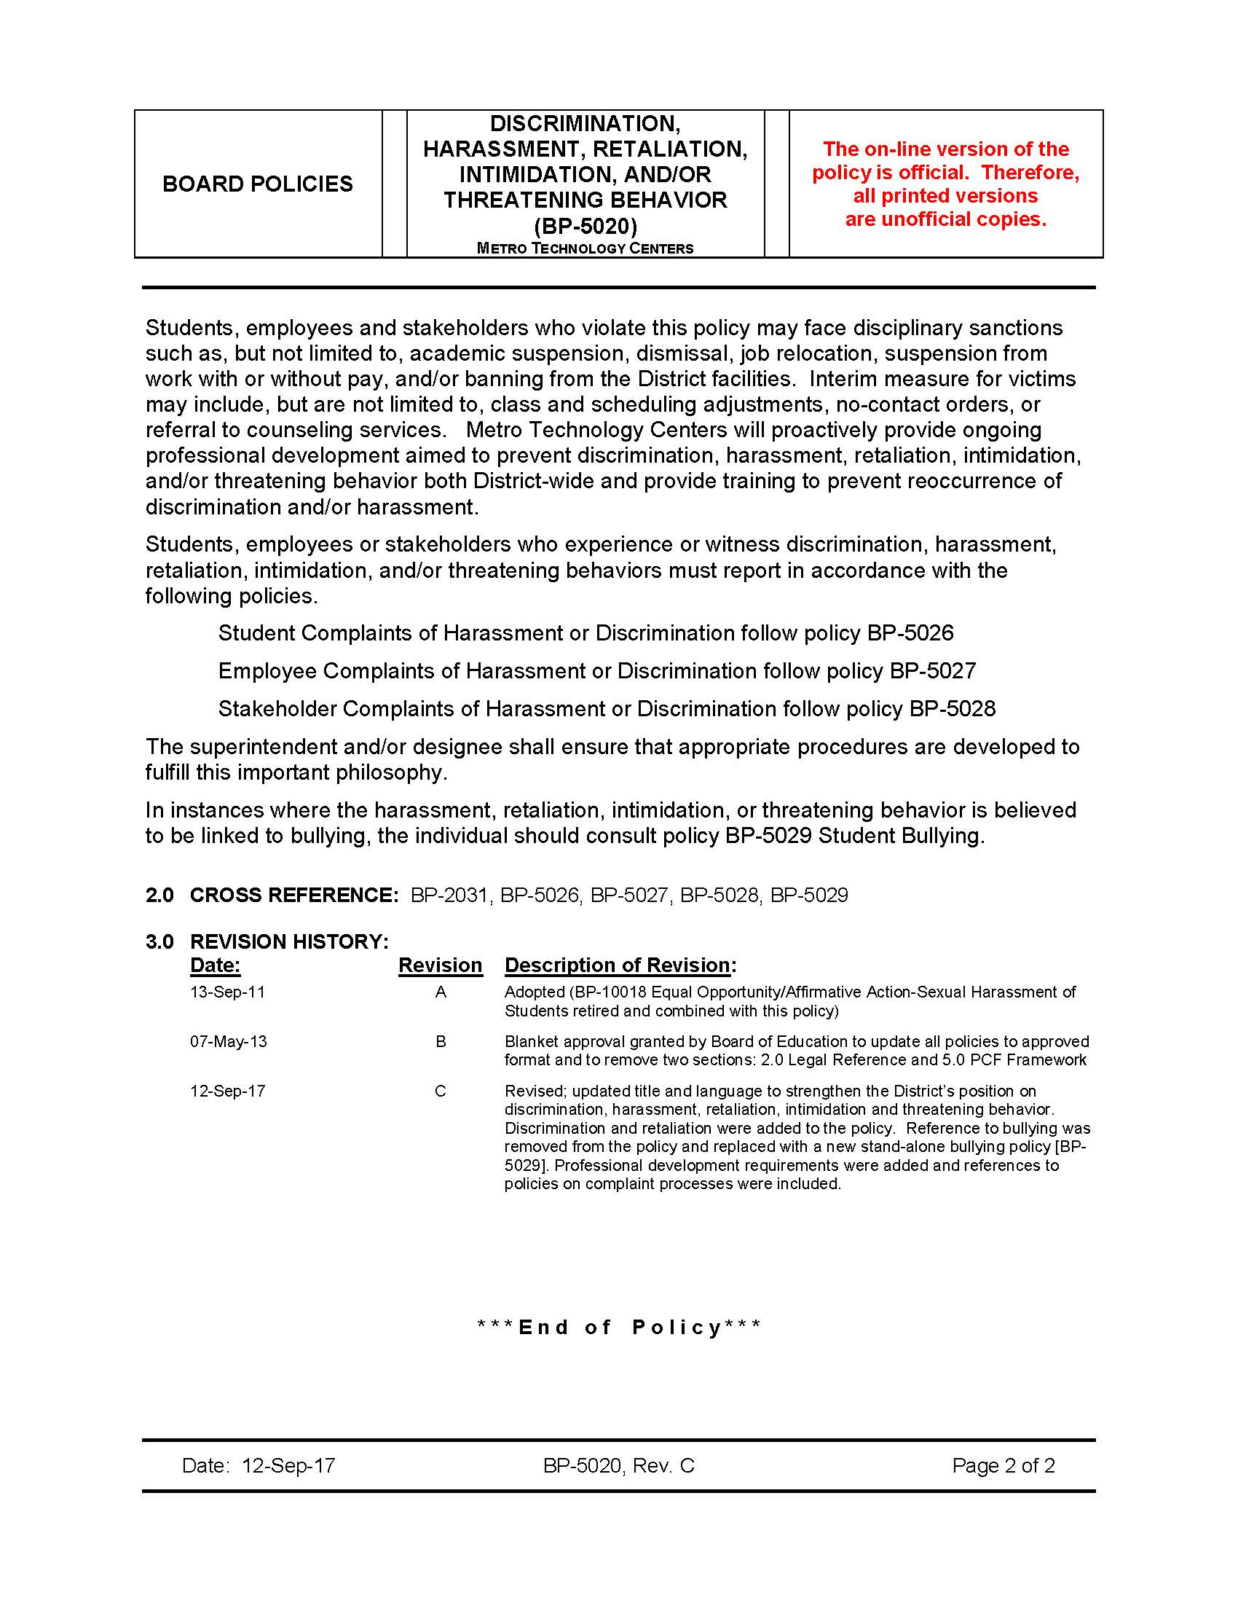

Drug Screening Procedure Statement
The mission of Metro Technology Centers is to prepare people for successful employment and life in a global society. We accomplish this by providing a caring, engaging environment for the empowerment of student learning potential. Therefore, in order to uphold the highest standards for student success, Metro Technology Centers has adopted a drug-free policy (Metro Tech School Board Policy, BP-10007 – refer to student handbook). As a condition of enrollment in applicable programs, students may be required to submit to a drug screen. Students in ALL applicable programs will sign a statement of understanding to be kept on file throughout the length of the program.

Oklahoma Medical Marijuana and Patient Protection Act Paragraph H(2)(c) of Section 427.8 states:
H (2) No employer may refuse to hire, discipline, discharge or otherwise penalize an applicant or employee solely on the basis of a positive test for marijuana components or metabolites, unless:
(c) the position is one involving safety-sensitive job duties, as such term is defined in subsection K of this section.
K (1) “Safety-Sensitive” means any job that includes task or duties that the employer reasonable believes could affect the safety and health of the employee performing the task or others including but not limited to, any of the following:
(g)(i) Dispensing pharmaceuticals, direct patient care
Therefore, students who come up positive on the drug screen for marijuana will not be able to attend healthcare clinicals. A student not able to attend clinical will not meet the clinical requirements and/or objectives of their program, therefore will not be able to continue in the program.
Notification
Initial notification of drug screening will be included in application and in the acceptance letters sent to those enrolling in applicable programs. Specific details of the procedure will be announced during the first day of class.
Procedure
Drug screenings will be conducted on-site by an independent testing agency responsible for the testing, as well as notifying individual students and faculty of results. Students may be selected for testing any time on a random basis throughout the program. If a student is absent on the day of screening, upon return to class, they will immediately report to the assigned clinic for screening.
- A “negative” report will allow the student to continue enrollment.
- A “positive” report will result in dismissal from the program.
If at any time, there is reasonable suspicion of a student being under the influence of drugs or alcohol the student will be directed to submit to a drug screening within 24 hours at the student’s expense.
Reasonable suspicion is defined as the belief that a student is using or is under the influence of alcohol or drugs based on observable phenomena including but not necessarily limited to:
- Physical signs/manifestations of substance use and/or the direct observation of such use
- Evidence that a student has tampered with a drug screening test
- Evidence that a student is involved in the possession, use, sale, solicitation or transfer of alcohol or drugs while on Metro Technology Centers premises or while participating in any activity associated with or sponsored by Metro Technology Center.
Students who are dismissed from the program for positive drug screen test may reapply to the program during the following enrollment/application period. Students who reapply and receive a second positive drug screen test will not be considered for enrollment into health programs.
Students may request an evidentiary hearing within 10 school days of the initial day of the interim suspension/dismissal by submitting Student Hearing Rights Appeal/Waiver (INST-F-0332).
Faculty Procedure for Reasonable Suspicion of Drug/Alcohol Use by Students
Metro Technology Centers maintains a drug-free environment. Random drug and alcohol testing may be conducted. Additionally, any student who demonstrates behavioral changes suspected to be related to the use of drugs or alcohol will be subjected to testing. The faculty member’s decision to refer a student for drug testing will be based on, but not limited to:
- Observable phenomena such as direct observation of drug use and or physical symptoms or manifestations of being under the influence of a drug
- Erratic behavior, slurred speech, staggered gait, flushed face, dilated/pinpoint pupils, wide mood swings, and deterioration of work performance
- Evidence that a student has tampered with a drug screening test
- Evidence that a student is involved in the possession, use, sale, solicitation or transfer of alcohol or drugs while on Metro Technology Centers premises or while participating in any activity associated with or sponsored by Metro Technology Centers

Testing will be conducted using the following procedure:
1. The faculty member will notify the program coordinator (if applicable) then have another faculty member or coordinator confirm the suspicious behavior. If a preceptor reports behavioral changes, the preceptor will notify the site manager and remove the student from patient contact. The program coordinator and site director will be notified.
2. The discussion will be documented, and a decision whether to refer for drug testing will be made. In the case of a work-based learning environment, faculty may visit the site or confer by phone with the student. A witness should be included during the phone conference.
3. The faculty member will complete the Faculty Report of Reasonable Suspicion of Drug/Alcohol Use form and submit the form to the site director’s office as soon as possible.
4. If a decision is made to refer the student for drug testing, the student should be instructed on where and when to report for testing:
a. Provide the student with a Request for Random Drug Screen form (available in the site director’s office).
b. Provide the student with the name and address of the collection site (available in the site director’s office).
c. Instruct the student to report for testing immediately, if possible, or if this is not reasonable, provide a time frame not to exceed 24 hours.
5. The site director will then submit the Dismissal-Suspension of Adult Student Procedure (INST-TP-0010) or Dismissal-suspension of Secondary Student Procedure (INST-TP-0009) to appropriate administrators.
6. The student will be suspended from clinical participation until the screening results have been reviewed by the administration. If the drug/alcohol screen is negative, the site director will notify administration, and instruct faculty to readmit the student to the course without penalty.
7. If the screen is positive, administration will be notified and the student will continue with the Dismissal-Suspension procedure currently in progress. Student’s 10 days for appeal will start at this point.
8. All referred drug screenings will be at the student’s expense.

Student Health Requirements

MEDICAL ASSISTANT STUDENTS
Student must provide evidence of good health, by submitting a completed Medical History and Physical Examination Form, which has been completed by their personal physician.
- Must submit evidence of current immunizations.
- Must be able to stand for extended periods of time.
- Who have a history of drug abuse, must submit proof that they have remained drug-free for one year. The students also must show that they are members of a substance abuse support group.
- Must be willing to submit to a random drug testing prior to clinical rotations. A non-negative test will cause the student to be ineligible for externship/ practicum, and without the completion of clinicals the student is unable to successfully complete program requirements.
- Must provide a physician’s statement of release regarding any physical limitations.
- Must be able to meet the following physical demands: bends, walks, stands, lifts, carries, pushes, and handles equipment, supplies, or patients exceeding (25) pounds.
- Must submit to a physical examination as deemed advisable by the faculty at any time during the student’s enrollment in the program.
- Must receive the Hepatitis B Vaccine series. The Medical Assistant works in a “high risk” area and needs to protect himself/herself and family. This is required by many of the clinical sites to meet contract requirements.

GUIDELINES FOR PREVENTION OF DISEASE
- Since we may not always know when a patient is infected with a communicable disease, treat all patients as being potentially infected.
- Routine use of appropriate barrier protection to prevent skin and mucous membrane exposure when in contact with blood or other body fluids of any patient is expected.
  - Gloves should be worn for touching blood and body fluids, mucous membranes, or non-intact skin of all patients, for handling items or surfaces soiled with blood or body fluids.
  - Gloves should be changed after contact with each patient.
  - Should gloves be torn through needle sticks or other such injuries, the glove should be removed and a new glove used as promptly as patient safety permits.
  - Masks and protective eyewear or face shields should be worn during procedures that are likely to generate droplets of blood or other body fluids to prevent exposure of mucous membranes of the mouth, nose, and eyes.
  - Gowns, lab coats and/or aprons should be worn during procedures that are likely to generated splashes of blood or other body fluids.
  - Hair should be restrained away from the face and off the shoulder.
This includes bangs and whispys.
- Hands and other skin surface should be washed immediately and thoroughly if contaminated with blood or other body fluids. Hands should be washed immediately after gloves are removed.
- All health-care workers should take precautions to prevent injuries caused by needles, scalpels, and other sharp instruments or devices during procedures; when cleaning used instruments; during disposal of used needles; and when handling sharp instruments after procedures. To prevent needle sticks injuries, needles should not be recapped, purposely bent or broken by hand, removed from disposable syringes or otherwise manipulated by hand.
- After they are used, disposable syringes, and needles, scalpel blades, and other sharp items should be place in puncture resistant container should be located as close as practical to the use area. Large-bore reusable needles should be place in a puncture resistant container for transport to the reprocessing area.
- Health care workers who have exudative lesions or weeping dermatitis should refrain from all direct patient care and from handling patient-care equipment until the condition resolves.
- Should you have any suspected or known communicable disease(s), please report the condition to the Director of the Health Careers Center and the Career Major Instructor. This information will be shared with the Superintendent of Schools and representatives of the appropriate clinical facilities.
- Adhere to the clinical facility’s policies on communicable disease.

HCC Resource Room Information

WELCOME TO THE HEALTH CAREERS CENTER COMPUTER LAB/RESOURCE ROOM!

Hours: 7:30 AM – 4:00 PM Monday – Friday Phone: 595-4604

***Check the monthly calendar posted near the door for changes and availability***

NO food or drink allowed on computer desks

- Leave food/drinks (even water) in the Resource Room or on the monitor desk
- Liquids – even “just water” don’t mix well with keyboards or pages of books

Quiet
- Total silence in the Computer Lab/Resource Room is not always possible (earplugs may be helpful)
- Courtesy to others studying
- Often testing occurs during the day (indicated by a sign on the door). Computers may or may not be available depending on the nature of the test and number of those testing
- No cell phone use

**TURN CELL phones to silent or off**
Resources
- Check out time is 2 weeks for books, may renew provided there is no reserve
- CDs/DVDs/VHS tapes for viewing in the computer lab, but may not be removed from the area
- Magazines – educational as well as entertainment/current events
- Copier/Printer – 10 pages at no charge, per student per day; additional pages are 10¢ per sheet
- Recycle bin for unwanted papers (proceeds benefit the Metro Tech Foundation)
- Pencil sharpener, stapler, calculator, markers
- TV/VCR/DVD player for viewing videos
- EBSCO journal database online (must use school computers)
- Access to EBSCOhost database: digitalprairieok.net/discover

Computers – for educational purposes

- Do NOT log off the stations in the Computer Lab and attempt to log into your student account
- No online social networking such as Facebook, Twitter, Instagram, etc.
- No streaming audio or video files (listening to online music/watching online videos) unrelated to coursework
  - Uses a large amount of server space
- Dropbox is not available; Google Drive is recommended – elearn accounts are already integrated into Google Apps
- Sites with inappropriate content and those not for educational purposes such as gaming, shopping, etc. should not be accessed at school. (Most likely access to inappropriate sites will be blocked anyway.)
- If a legitimate site is blocked that you need, let me know and I’ll attempt to get you access
- What you are accessing can be seen by Metro Tech staff at any given time
- Heed any warnings that may come across the screen
- Files may be saved to flash drives – don’t save files to computers hoping to access them later

Printing
- Print power points as ‘handouts’ with 6 slides to a page

Other Items as Needed

- I’m here to help during your time at Metro Tech and beyond….

Revised 8/20

Financial Aid

Financial aid, scholarships, and monetary support programs are available for qualified individuals enrolled in most full-time programs at metro Technology Centers. Federal financial aid is available for adult students enrolled in approved programs that are at least 600 clock hours in length. Once you have taken out a loan and entered school, you must go through loan entrance counseling and learn about the terms and conditions of your loans.
You must reapply each year for federal student aid. Fortunately, it’s now easy to annually renew your Free Application for Federal Student Aid (FAFSA) online
Apply for your financial aid online!
The Metro Technology Centers Federal Pell Code is- 016140
Complete Your Student Loan Counseling Online
Entrance Counseling
The Metro Technology Centers OPEID number is 00533900
Exit Loan Counseling
The Metro Technology Centers OPEID number is 00533900
Metro Technology Centers is approved for the following aid programs:
- Federal Pell Grant
- Federal Subsidized Stafford Loan (formerly GSL)
- Federal Unsubsidized Stafford Loan
- PLUS Loan
- Oklahoma Tuition Aid Grant
To qualify for Federal Student aid, you must:
- Have a high school diploma, a GED, or have the ability-to-benefit
- Be enrolled as a regular student in an eligible program
- Be a U.S. Citizen or eligible non-citizen
- Be enrolled at least half-time at Metro Tech
- Make satisfactory academic progress
- Sign a statement of updated information
- Sign a statement of registration status, if required
- Show financial need
- Have a social security number

Metro Technology Centers programs approved for financial aid
Most of the Metro Technology Centers full-time day programs are approved for financial aid. Some of the Metro Technology Centers full-time evening programs are approved for financial aid.

Metro Technology Centers is also approved for Veteran Benefits
All of the full-time day programs are approved for veteran benefits except Health Science Technology and Hospitality/Intergenerational Services. The practical Nursing evening program is also approved for veteran benefits.
For more information:

Call the Financial Aid/veteran Coordinator’s office at (405) 605-4437 or (405) 595-4446

Contact the Metro Technology Centers Financial Aid Department,
(405) 595-4446 or aid@metrotech.org.

Refunds

If a student employee drops a program before completion, tuition refunds will apply as follows:
- No tuition obligation if the student has dropped before 5 days.
- No tuition refund will be given for program courses that the student employee has completed.
- A full tuition refund will be given for program courses that the student employee has enrolled in but has not yet begun.
- A partial tuition refund may be given for courses that the student employee has begun but not yet completed, depending upon how far the student employee progressed into the course. These refunds will be based on the scheduled hours for each course as follows:

Students completing up to: | Will receive:
25% of scheduled hours | A 75% refund
50% of scheduled hours | A 50% refund
75% of scheduled hours | A 25% refund
100% of | No refund

No refunds will be given for books, supplies, fees, or any other non-tuition costs.
If a student’s tuition is paid through financial aid assistance or an agency, refunds will be handled according to the rules and policies of the tuition source.
Deferment
- Students approved for financial aid, vocational rehabilitation, etc. shall eligible for tuition deferments by the Financial Aid Officer/Specialist only.
- Students will sign a deferment form outlining the amount of tuition obligation and due dates for payment(s).
- Students who do not make tuition payments in accordance with District policies will be dropped from attendance and will be withdrawn from the program.
- Financial aid, vocational rehabilitation or other forms of assistance will be handled by the Financial Aid officer.

Voluntary Withdrawal
A student withdrawing from school shall state in writing his/her intent to withdraw and include the date the withdrawal becomes effective. An exit interview with the Health Careers Center director, site counselor, or coordinator of the Medical Assisting program will be conducted. The student will return his/her name tag, film badge, and any other property of the Metro Technology Centers or the clinical site(s) which may be in the student’s possession. The coordinator of the Medical Assisting Career Major shall notify the counselor, the attendance clerk, and the designated secretary of the student’s withdrawal/ dismissal.
The student will be counseled regarding his/her options for returning at a later date.
A final transcript will be completed up to the last day of attendance and will be kept in the student’s file. The student may receive a copy of the transcript upon request through student services.
Dismissal
The student will be notified of their dismissal during a counseling session/exit interview with the coordinator, the director of the Health Careers Center, and any other involved instructor, if necessary.
The student will receive written documentation of the school’s decision to terminate them. The student’s name tags, film badge, library books and any other property of Metro Technology Centers or the clinical site(s) which may be in the student’s possession must be returned when a student is dismissed from the program.

Skill Lab and Testing Procedures

SKILL LAB PRACTICE
All students must meet competency in medical assisting skills prior to completing skills in the clinical setting.
Laboratory practice is designed to prepare students for the clinical experience. To aid in preparing for the clinical experience, students must wear scrubs during scheduled laboratory practice. Scrubs during laboratory practice may be any color and must not have any institution or facility markings. Students must follow professional appearance guidelines.
All students need to practice a skill a minimum of two times with a peer prior to their scheduled competency check. Competency checks are important to provide patient safety in the clinical setting. Students who are unable to meet competency in any skill will not be allowed to attend clinical until competency is met. Students who do not meet competency after 3 attempts will be required to meet with Lab Coordinator/Instructor for additional practice.
For a few skills, students serve as the “patients” for one another for non-invasive procedures. Students will demonstrate invasive procedures on the mannequins.
Any student who has major difficulty (ex. breaking sterile field) with skills at clinical will be required to schedule time with their instructor/coordinator to complete another competency check in the laboratory setting prior to continuing clinical for patient safety.

SKILLS LAB/SAFETY RULES
(See Simulation Lab Guidelines)
Students must follow laboratory procedures and instructor instructions at all times to provide a safe environment in the lab. Students who do not act professional in the lab setting will be counseled for unprofessional behavior.
The following safety rules apply to all students while practicing in the skills lab:
- Be attentive to the task at hand. The skills lab is not a place to play. Concentrate on the skill being practiced.
- Follow instructor’s instructions at all time.
- No cell phones allowed in lab, no ink pens.
- Students must wear shoes.
- Observe instructor demonstrate a skill prior to practicing the skill.
- Syringes and needles are to be used under direct supervision of an instructor. Needles are not to be recapped. Immediately dispose of sharps in the sharps containers in the skills lab.
- Apply universal precautions.
- Wash hands when indicated.
- Discard used gloves. Notify instructor of latex allergy.
- Walk; never run, while in the building.
- In case of fire, leave the building immediately, but do not run.
- Carefully check water temperatures to avoid injury.
- Promptly wipe-up spills
- Do not sit on the beds.
- Keep all aisles open and clear.
- Bed should be in the low position after completing a skill.
- Do not allow the linen to touch the floor.
- Use good body mechanics when pulling, lifting, or pushing an object.
- Lock wheels of any equipment being used.
- Use care when moving beds or over-bed tables.
- Handle mannequins with caution.
- Know proper use of equipment and supplies before using.
- Observe electrical wires, plugs and outlets and report any problems to an instructor.
- All equipment should be held so as not to cause injury to self or others.
- Report any equipment problems, or accidents regardless of how minor, to an instructor.

TEST PROCEDURE
Students in the Facilitator-led Individual Study class have the flexibility of choosing when to take a test according to the posted schedule.
A student must score 100% on the Safety Test in Clinical Procedures I before progression to the next module will be permitted. A delay in progression could result in probation. Sharing information of test content with other students who have not taken test is considered cheating and could result in dismissal from program.
Students are required to take exams at the scheduled time. Students who do not take an exam at the scheduled time will be given option B test form. Students who are tardy for exam will not be allowed to enter and will given option B test form.
Students must take missed exams upon return to class/clinical. Students who fail to make up exams in the allotted time frame may receive zeros for the exam.
Test grades will be calculated according to the Grading Policy as stated in this handbook.
All students should record their grades on their grade forms to track their progress.

TEST ITEM CHALLENGE
If a student desires to challenge a test item, the student must:
- Use the appropriate test question challenge form and make the appeal in writing at the time of recapturing test question items. Test items may not be challenged after the turned-in recapture form and test are turned in.
- Test Question Challenge Form must be filled out completely for consideration.
- Site sources (text name, page number, and answer written out) providing documentable evidence the answer on the test key is incorrect.
The student will be notified of the outcome of the challenge. Only the student who challenged the test item will receive credit, if applicable.

RECAPTURE PROCEDURE
It is important to identify why a question is missed on your exams. Students are encouraged to make appointments with their instructor to review the questions they missed. Students must refrain from discussing or sharing test questions with other students. Probation or dismissal from the program may result if either a test is removed from classroom or instructor office, or if a student is observed by faculty to be discussing or sharing test questions with another student. (This also applies to whoever is involved in the discussion of tests.)

REMEDIATION
If a student scores below 80% on a test, he/she is required to complete a remediation assignment as given by his/her assigned instructor. Remediation assignments are to be completed within 2 weeks of the original exam date. Courses are incomplete until all remediation’s are done.

LED Individual Study Learning

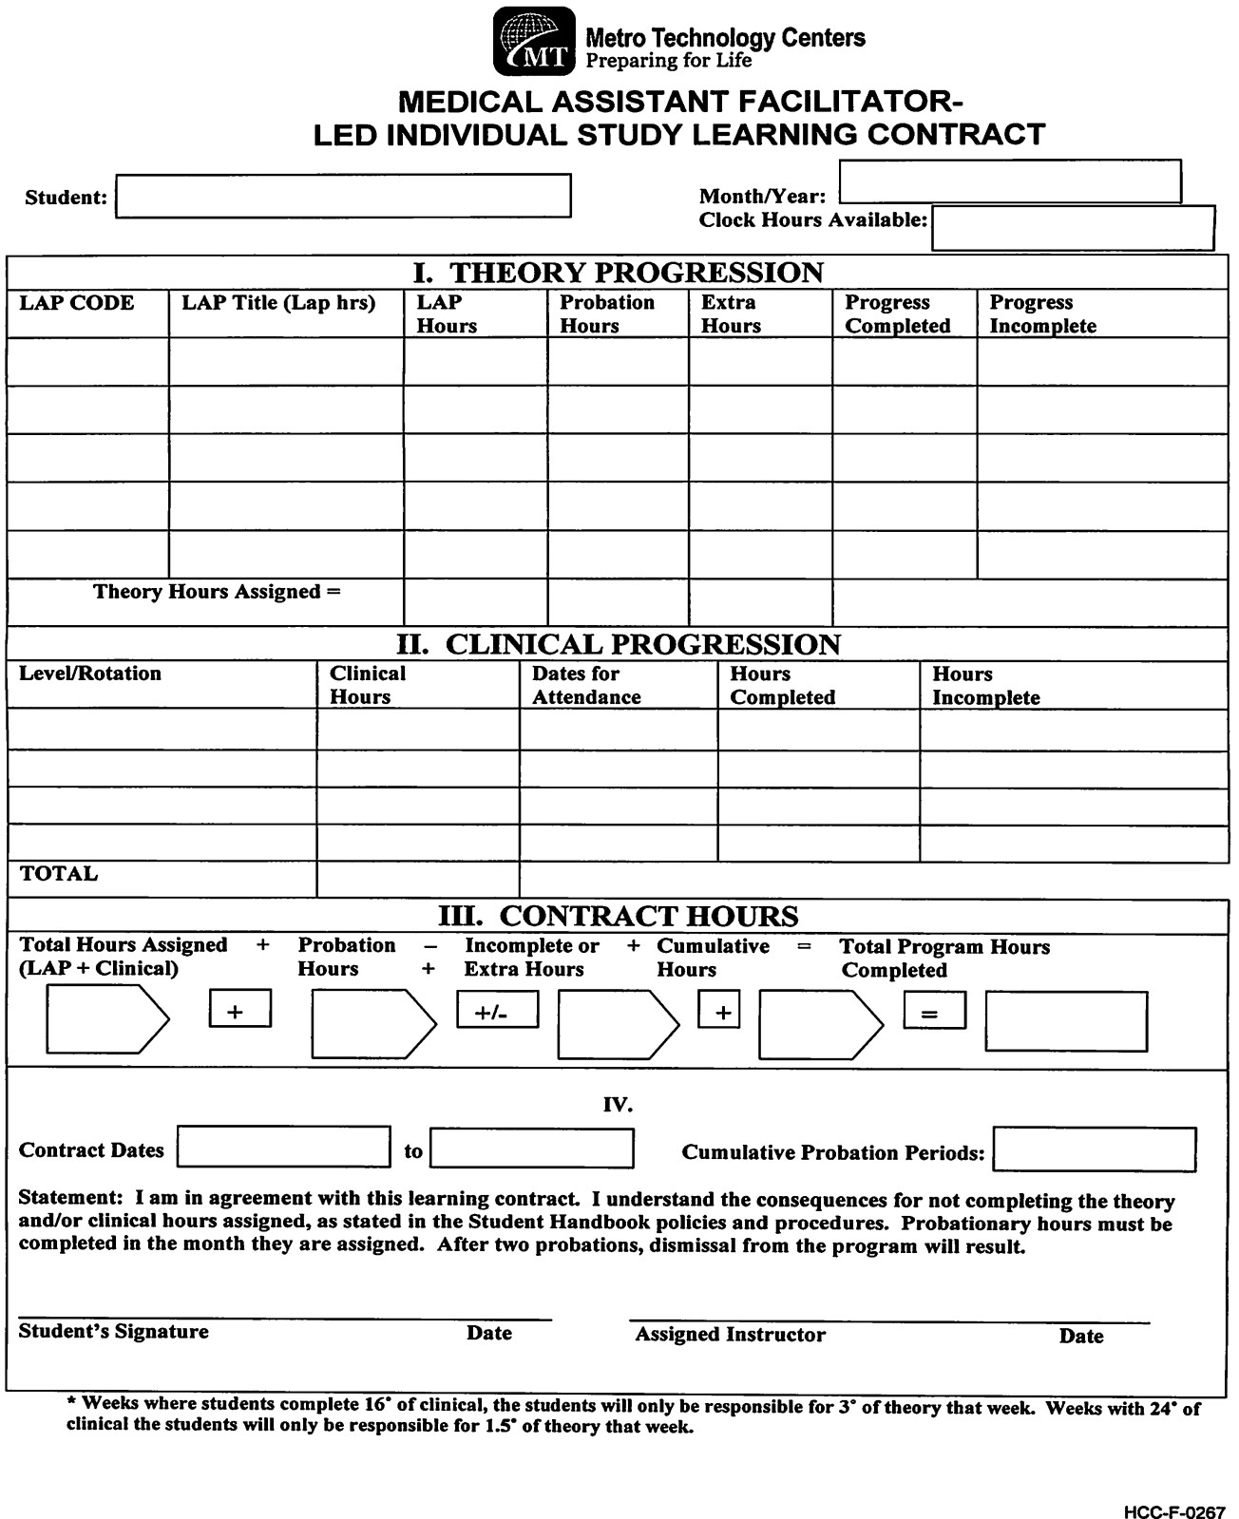

Student Affirmation Form

I understand that I am a member of a profession which requires the utmost discretion and professionalism. I acknowledge that I have a responsibility to act in a matter consistent with a professional. In this regard:
_I agree to protect the privacy of faculty, peers, patients and family members of patients by not inappropriately disclosing confidential information about faculty, peers, patients or their family members that is disclosed to me in my capacity as a Metro Technology Centers student. In addition, I agree not to inappropriately disclose confidential information about my agency or institution that is disclosed to me in my capacity as a Metro Technology Centers student. I will adhere to HIPAA guidelines.
_I will not discuss or post any information about faculty, peers, patients, family members, or any clinical facility on any electronic venue (i.e. My Space, Facebook, Twitter, cell phones, etc.). Nor will I leave/save any patient, family, faculty, clinical facility or student information on any open access desktop or hard-drive.
_I have/will read the student handbook and syllabus for each of the courses in this Career Major and I understand the criteria established for grading my course work. I understand that my average on exams and/or course assignments must be 80 or higher in order to pass the course and remain in the Career Major with the exception of Anatomy & Physiology and Medical Terminology.
_I agree that I will conduct myself in a manner that exhibits professional values in accordance with my professional Code of Ethics.
_I will maintain and uphold the academic integrity of Metro Technology Centers and will not condone or participate in any activities of academic dishonesty including, but not limited to, plagiarism, cheating, stealing or copying another’s assigned work, or lying about any situation.
_I will not recreate or copy any items or portions of any course exam for my own use, or for use by others during my enrollment at Metro Technology Centers.
_I will not accept or access any unauthorized information related to any exam administered during my enrollment at Metro Technology Centers.
_I will sign my own papers and other documents and will not sign any other student’s name to anything, including class rolls.
_I will not allow any student access to any of my course work for the purpose of copying.
_I understand that violating any of the above can result in termination from the Career Major.

Student’s Signature Date

Student’s Printed Name Career Major
Statement of Understanding of Clinical

MEDICAL ASSISTING
I have been notified and understand the following requirements must be completed prior to participation in any clinical assignments. Students unable to attend clinical due to these requirements not being met will receive grades/points each day absent from clinical.
- Submit completed background check according to Metro Tech HCC requirements.
- Submit a Statement of Good Health completed by a physician.
- Submit all required Immunization documentation.
- Submit to Drug Screening as required by the program.
- Submit documentation of current certification of an American Heart Association CPR course for healthcare professionals.
- Register on the Clinical Portal which includes student cost of $39.50/yearly (if applicable)

I understand that any adverse background check information or a “positive” drug screen may result in one or more of the following consequences:
- Inability to participate in clinical assignments.
- Inability to complete the program.
- Dismissal from the program.
- Forfeiture of tuition and related program costs.
- Notification of law enforcement officials.

I give permission for each clinical site to have a copy of my immunization records, background check, and/or drug screen results if requested by them.

Print Student Name

Student’s Signature Date

Medical Assistant Career Major

Drug Screening Statement Understanding
I understand that as a requirement for enrollment in applicable programs, I must submit to a drug screen. I further understand that I may be subject to additional random drug screening while enrolled at Metro Technology Centers. In addition, refusing to submit to a required drug screen will result in dismissal from the program. The result of the test will be provided to the assigned site director and shared with required clinical sites. I understand that if the test result is positive, I will be dismissed from the program.
BY SIGNING THIS DOCUMENT, I INDICATE THAT I HAVE READ, UNDERSTAND, AND AGREE TO METRO TECHNOLOGY CENTERS’ DRUG POLICY AND PROCEDURE. I UNDERSTAND THAT A NEGATIVE DRUG TEST IS REQUIRED FOR CONTINUED ENROLLMENT. THIS SIGNED DOCUMENT CONSTITUTES MY CONSENT FOR DRUG SCREENING BY A METRO TECHNOLOGY CENTERS DESIGNATED LABORATORY. IT ALSO CONSTITUTES CONSENT FOR THE LABORATORY TO RELEASE THE RESULT OF MY DRUG SCREEN TO THE ASSIGNED SITE DIRECTOR AND CLINICAL SITES.

Student’s Signature Date Faculty Signature Date

Student’s Printed Name Faculty Signature (if more than one faculty) Date

Medical Assistant Career Major

Faculty Report of Reasonable Suspicion of Drug/Alcohol Use

Please use the space below to provide a detailed description of the student’s behavior. All information is to be kept confidential. Please return the form in a sealed envelope to the site director’s office as soon as possible. Notify the site director’s office by phone immediately to request a drug test.
1. Name of Student:

2: Date of Incident:

- Time of Incident:

- Location of Incident:

- Detailed description: Include any behavioral, visual, olfactory or auditory observations.
  - Speech (normal, incoherent, confused, change in speech, slurred, rambling, shouting, using profanity, slow)
  - Coordination (normal, swaying, staggering, lack of coordination, grasping for support)
  - Performance (unsafe practices, unsatisfactory work)
  - Alertness (change in alertness, sleepy, confused)
  - Demeanor (change in personality, fighting, excited, combative, aggressive, violent, argumentative, agitated, indifferent, threatening, antagonistic)
  - Eyes (bloodshot, dilated)
  - Clothing (dirty, disheveled)
  - Odor of alcohol on breath
  - Other observed actions or behaviors (list below)
  - Complaints of student behavior from personnel or other students (list below)
  - Unexplained absences or tardiness (list below)

_______________________________ ______________________________
Faculty Signature Date

Medical Assistant Career Major

Statement of Employment Understanding
I , understand that neither the instructor nor the institution will guarantee me a job upon graduation/completion from the Metro Technology Centers Medical Assistant career major. I know that I can increase my chances of employment by:
- Preparing an employment portfolio
- Practicing interview techniques
- Passing all certification exams
- Participating in professional organization for networking
- Demonstrating excellent employability skills during clinical practicum experience
- Maintaining excellent attendance at school and clinical assignments

I am also aware that I can check the local newspaper, online, healthcare placement agencies and professional journals listing job opportunities. I understand that securing employment is my responsibility and that the training I have received at Metro Tech will enable me to meet the qualifications for an entry level position as a Medical Assistant.

______________________________ ___________________________

Student’s Signature Date

Student Confirmation and Consent Form
You must complete this form and return to your teacher.

POLICIES AND PROCEDURES
I have been given and I agree to abide by the policies, procedures, and statements presented in the Medical Assisting student guidebook.

If you are under the age of 18, your parent or guardian must sign.

Student Full Name (please print) Parent/Guardian Name (please print)

Student Signature Parent/Guardian Signature

Date Date

After completing, please return this form to your teacher.

