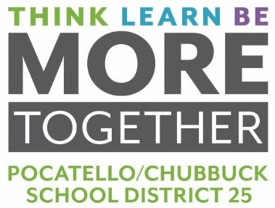
MEMORANDUM

To: Dr. Douglas Howell, Superintendent

From: Bart J. Reed, Director of Business Operations

Date: May 19, 2020

RE: BID FOR MILK FOR 2020-2021 SCHOOL YEAR

On April 15, 2020, bids were opened for milk supply for the 2020-2021 school year to include the summer feed program. The bid invitation requested a total daily delivery of approximately 10,000 half pints of milk, to be delivered to twenty-three (23) various locations throughout the District. This year’s bid also included delivery of half pints of milk daily during the summer months.

Specifications were sent to one (1) vendor. We received a response from one (1) vendor. The summary below is for your review.
Half-Pints
Vendor | Paper Cartons |  |  |  |  |  | Plastic Bottles
 | Skim (Fat Free) | Grade A 1% Low Fat White | Chocolate (must be Skim) |  | Strawberry (Skim if available) |  | Skim (Fat Free) | Grade A 1% Low Fat White | Chocolate (must be Skim) | Strawberry (Skim if available)
Meadow Gold  Pocatello, ID | $0.2321 | $0.2627 | $0.2723 |  | $0.2639 |  | $0.2874 | $0.2958 | $0.3138 | $0.3135

Board Action Requested: Motion to award bid to Meadow Gold Dairy for $496,708 for 2020-2021 school year which includes the 2021 Summer Food Service Program.

