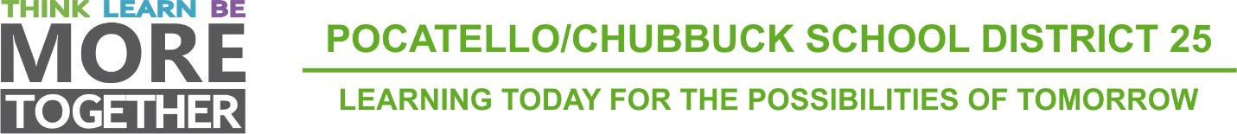

Administration Offices
3115 Pole Line Road
Pocatello, Idaho

INVITATION TO BID

GASOLINE AND DIESEL FUEL SUPPLY

Sealed bids for Gasoline and Diesel Fuel will be received by a representative of the Board of Trustees of School District No. 25, Bannock County, Pocatello, Idaho, 3115 Pole Line Road, Pocatello, Idaho, 83201, until 10:30 AM on April 8, 2020.
Specifications or additional details (including bid forms) may be secured at 3115 Pole Line Road, Pocatello, Idaho.
Each bid shall be accompanied by a certified check, cashier's check, or a bid bond in the sum of not less than five percent (5%) of the total bid, made payable to School District No. 25, Bannock County, Pocatello, Idaho. This surety shall be forfeited by the bidder in the event of failure to fulfill provisions of bid on which purchase order award is based. No personal or company checks will be accepted.
Bids not delivered by vendor at the time of bid opening must be received in mail no later than 4:00 PM on April 7, 2020, the day before the bid opening.
The Board of Trustees reserves the right to reject any or all bids; likewise, to reject any item or items in any such bid, and the right to waive any technicality.

