**ExamView**

Making a test from Scratch

On your desktop you should see three Examview icons:

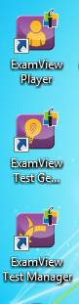

We will be working with Examview Test Generator.

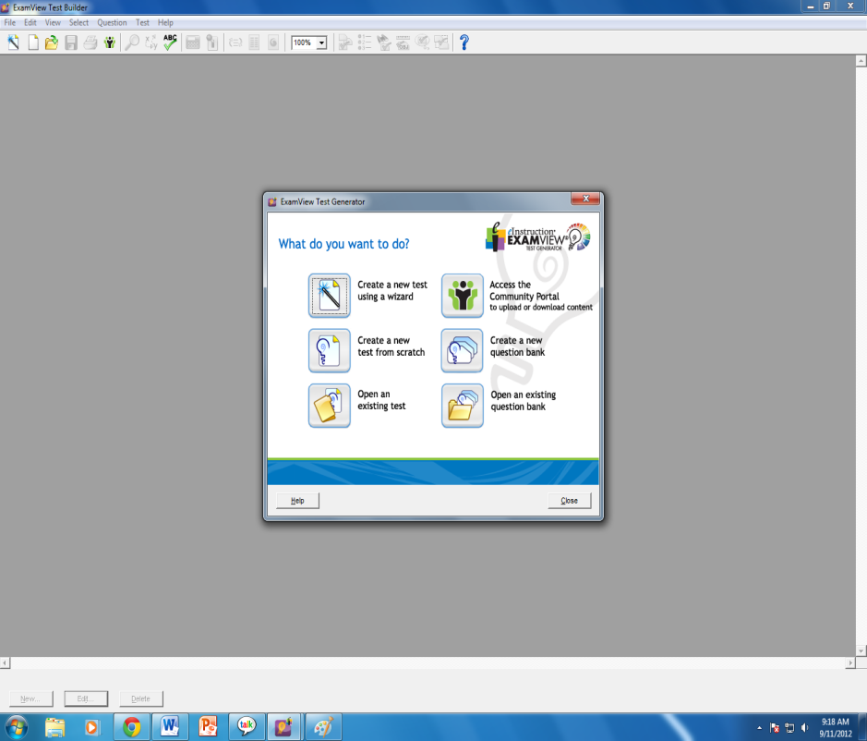

When you open Examview Test Generator you will get this window.

You have two choices when it comes to making a test:

Test **Wizard** allows you to choose the test bank and number of questions.

Making one from **scratch** allows you to choose the test bank then you may select your questions while viewing them.

You may also open an existing test from this menu.

The next screen you will get will look like this: You will name your test.

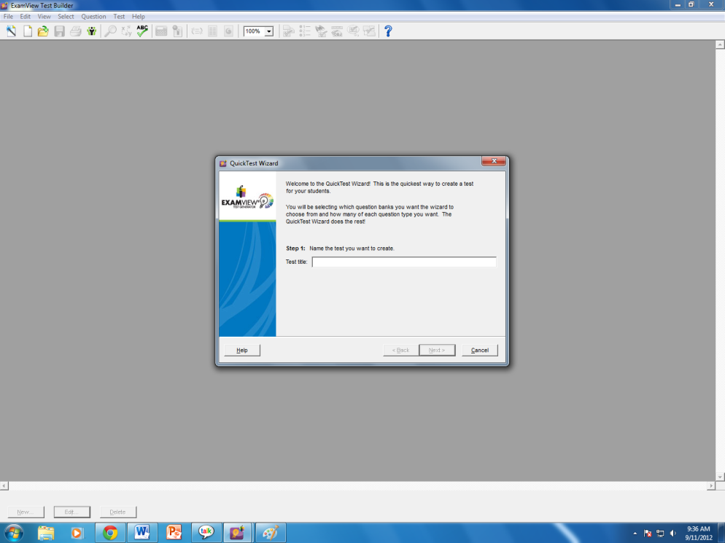

Next you have the option of selecting the bank of questions you want to use. It will automatically look on your c drive.

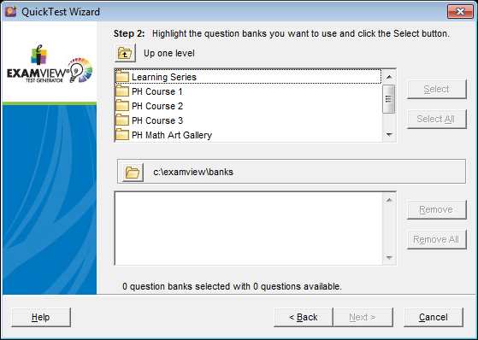

Click on the test bank you want to use then click select. Once you have all the test banks you want, click next.

At this point you will see a document full of test questions like this:

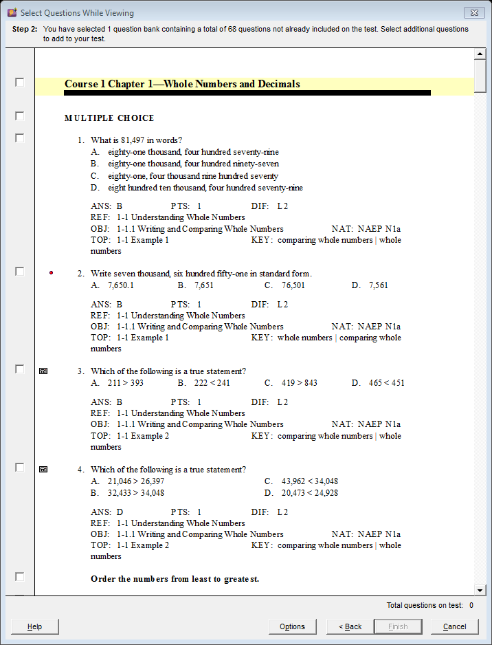

As you add questions Examview will keep a total on the bottom right corner.

Notice the white boxes to the left of the questions.

Click the box next to questions you want to use. A black check will appear.

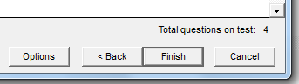

When you have all the questions you want, click Finish.

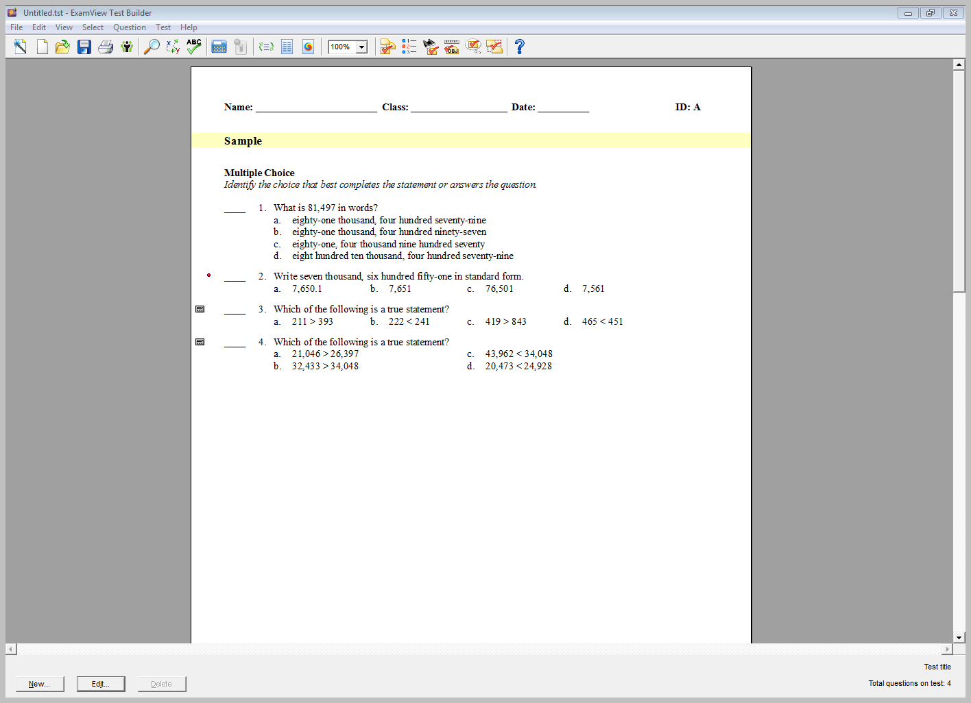

To print:

Click “File”, then “print test.” You can then print multiple versions with the option to scramble answers and or sections.

