**Suggested Supply List for Second Grade**

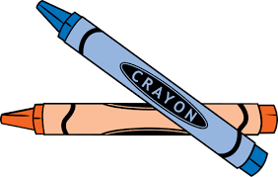

1 set of headphones

1 pair of gym shoes to be kept at school

1 art shirt

1 pencil box (5” x 8” plastic or metal)

12 sharpened yellow pencils *Please send Dixon Ticondergoa brand, do not send mechanical or fancy pencils

4 glue sticks

1 box of Crayola crayons (24 count)

1 box of Crayola colored pencils (10 or 12 count)

1 box of fat Crayola markers (10 or 12 count)

1 box of skinny Crayola markers (10 or 12 count)

1 pair of scissors

1 spiral notebook, wide ruled, 70 pages

1 two-pocket folder

1 hand-held pencil sharpener with receptacle for shavings

1 one-inch 3-ring binder with clear-view front

1 roll of scotch tape

1 pack of 3x3 sticky notes

3 dry erase markers (black chisel point)

1 box of Kleenex

1 canister of disinfecting wipes

1 face mask

Please label everything with your child’s name/initials.