Farm2School
REQUEST FOR PROPOSALS FOR THE 2022-2023 FARM2SCHOOL LUNCH PROGRAM
Mesabi East School District ISD #2711
601 North 1st Street W.
Aurora, MN 55705
FARM FRESH GROWN FOOD
PROPOSALS DUE: NOT LATER THAN 1:00 PM, March 18, 2022 LATE PROPOSALS WILL NOT BE ACCEPTED
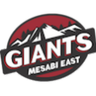
1
1 OVERVIEW
1.1 INTRODUCTION
Mesabi East School District ISD #2711 seeks proposals from farmers and growers and producers for food as part of the Farm2School Lunch Program. 1.2 TERM OF CONTRACT
The contract term shall be the 2022-2023 school year with products being procured for the once a month Farm2School Lunch Program [F2S]. Months include September through May.
1.3 CONTRACT PROVISIONS & TIMELINES
Proposers are advised to read and become familiar with ISD #2711 standard terms and conditions provided in section 5.
TIMELINES
ACTIVITY DATE
Issue and Advertise RFP Feb 8, 2022
Deadline for Questions March 4, 2022
Proposals Due March 18, 2022
Procurement Committee Meeting March 28, 2022
Anticipated Contract Award April 1, 2022

NOTE: The Procurement Committee reserves the right to deviate from this schedule.
1.4 PROCUREMENT COMMITTEE MEMBERS
Rachel Doherty, ISD #2711 Greenhouse Manager
Dr. Jeff Burgess, Superintendent, ISD # 2711
Walt Hautala, School Board Member, ISD # 2711
Demetri Johnson, Food Service Director, ISD # 2711
Pam Zahn, Finance Officer, ISD # 2711
Selina Layman, RN CLC
Heather Mahoney, Rutabaga Project, Non-Voting Member
2
2 SCOPE OF WORK
2.1 STATEMENT OF WORK
The selected Contractors/Farmers/Ranchers will provide and deliver farm fresh produce, protein and eggs. Individual product specifications are listed on ATTACHMENT D, Cost Proposal. Mesabi East Public School District ISD #2711 implemented the Farm2School Lunch Program in September 2019. The program provides lunch once a month which introduces farm fresh grown food to students. The Farm2School Lunch Program promotes healthy eating habits, supports neighboring small and mid-sized farmers and helps build the local economy, the program offers important learning opportunities for students, staff and guests. The school cafeteria is a model for health, wellness and food system sustainability. At ISD #2711, the cafeteria is viewed as a learning laboratory to introduce students to locally sourced food. ISD #2711 is interested in purchasing products from farmers whose production practices support environmental sustainability goals, such as, [but not restricted to], reduced use or elimination of chemical pesticides and fertilizers, use of organic fertilizers, fewer transport miles between farm and ISD #2711, and environmentally friendly packaging. Featured ISD #2711 products will be promoted through the Food Service Department. In addition, ISD #2711 may choose to provide supplemental educational activities during the Farm2School lunches. ISD #2711 used the following in determining which products to feature in the 2020-2021 Farm2School Program.
1. Availability of the item in the area where students live such that the featured items are more likely to also be offered outside the school environment.
2. Consideration was given to children’s food preferences and how much children generally like each item selected for Farm2School.
3. Foods were selected to represent the diverse bio-cultural landscape and food economy in which ISD #2711 is located. Considerations included foods both associated with traditional farming and those that honor the local hunting traditions and cultural diversity
4. To promote school and home garden connections, foods were selected that are also likely to be grown in local gardens.
5. Nutrient dense foods were selected.
6. So that kitchens may incorporate the F2S products into a variety of dishes, the versatility of the selected item was considered.
3
Product Quality of Produce
Fresh fruit and vegetables shall be:
● Cool to the touch
● Of reasonably uniform color
● Free from foreign flavor and odor
● Normally developed
● Free from objectionable matter
● Clean and free from foreign material
Fresh fruit and vegetables shall be reasonably free from:
● Extraneous vegetable material
● Stem ends
● Rot
● Damage by insects or disease
● Insect infestation
● Mechanically damaged units
● Moderate amount of bruising
● Fibrous units and stems
Food Safety Requirements for Produce
Farmers Shall have a written on-farm food safety plan, which shall address:
● Handwashing in field and packing area
● Health and hygiene training for workers
● Management of manure and compost as fertilizer
● Limiting animals in fields and packing areas
● Cleaning of equipment, storage containers, and tools
● Testing of well water
● Do not need to have a gap audit. Template included.
● Resources and FAQs listed under Attachment A
Product Quality and Requirement of Eggs
A retail egg license is required if a farmer distributes eggs from other farms, not their own; or have more than 3,000 hens in production. Otherwise, farmers need to register with the MDA using the form found on the next page. Farmers selling eggs from their small flocks need to follow the grading, candling, packing and labeling requirements. This fact sheet lays out the rules for food facilities accepting locally grown eggs from farmers: https://www.mda.state.mn.us/egg-handling-and-sales-shell-eggs
4
Sales to Grocery Stores, Farmers Markets, Restaurants, Schools, etc.
Producers must meet the requirements of Minnesota Statutes 29 and Minnesota Rules 1520. Basic compliance with these requirements include the following:
● CLEANING: The eggs must be cleaned by approved methods. ● CANDLED AND GRADED: All eggs must be candled and graded. ● REFRIGERATION: Eggs must be refrigerated at 45°F or less after grading and be maintained at that temperature during storage.
● PACKAGING: Containers (cartons, flats, and cases) of eggs must be labeled with the following mandatory information:
○ Grade and size of the eggs.
○ Your name, address and zip code.
○ The statement, "Perishable. Keep Refrigerated."
○ A pack date in the Julian calendar (day of the year). For example: The labeling of a grade A egg packed on June 1 will have a pack date of 152. ○ A freshness date not to exceed 30 days from the date of pack. The freshness date must also have an explanation such as "exp." best if used by or similar explanation. In the above example using June 1 as the pack date, the freshness date is July 1.
○ The safe handling instructions: "To prevent illness from bacteria: keep eggs refrigerated, cook eggs until yolks are firm, and cook foods
containing eggs thoroughly."
Sales Direct to Consumer from Farm Premise
● Allowed by the MDA and farmers are exempt from licensing and inspection ● Must own less than 3,000 layers
Cleaning of Eggs
● Wet cleaning using rags, sponges or other devices to scrub or wipe by hand is prohibited
● Dry cleaning with abrasive material (sandpaper) reasonably free of bacterial contamination is permitted
● To use washing equipment for cleaning of eggs, you must meet requirements outlined in MN Rule 1520.0500
Cartons
● Cartons may be reused for selling eggs
● Must be clean
● Maintained in a sanitary manner
● Include labeling information pertaining to the eggs stored in the cartons ● Any claims or information not pertaining to your eggs must be covered or blackened out
What Type of Eggs Can Be Sold in Minnesota
~Chicken ~Turkey ~Duck ~Goose ~Any domesticated fowl 5
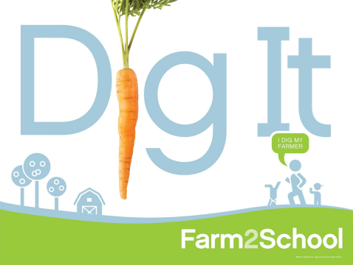6
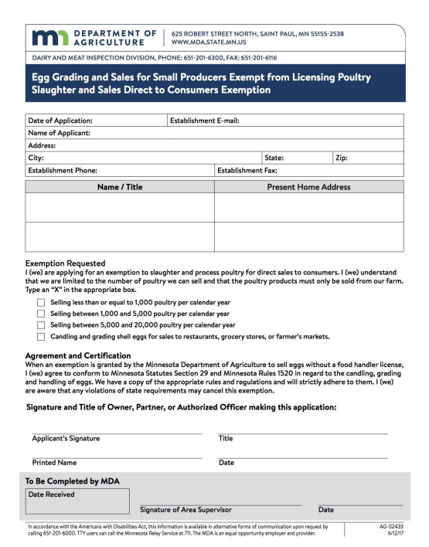7
3 PROPOSAL FORMAT, EVALUATION AND SELECTION
3.1 All proposals will be uniform by completing the RFP. [ATTACHMENT A]
3.2 The proposals shall be evaluated by the Procurement Committee. The Committee will assign scores to each proposal described under the Evaluation Criteria below.
CATEGORY MAXIMUM SCORE
1. Meets Product Specification 20
2. Sourcing 20
3. Experience & Capacity of Proposer 10
4. Cost 40
5. Additional information for consideration 10

TOTAL POSSIBLE SCORE 100
1. Category: Meets Product Specification
Information required: Meets products-processing receipt of “Equal to” Produce meets product quality specifications
Evaluation criteria: Can provide amount and form of product requested Can complete 100% of requested amount 20 points
Can complete 80% of requested amount 15 points
Can complete 60% of requested amount 10 points
2. Category: Sourcing
Information required: Address of farm
Evaluation criteria: Farm located 75 miles 20 points Farm located 150 miles 15 points
Farm located >150 but in Minnesota 10 points
3. Category: Experience & Capacity of Proposer
Evaluation criteria: Met obligation of past contracts 10 points New to the Farm2School Program 5 points
8
4. Category: Cost
Information required: Cost of products offered
Evaluation criteria: Lowest Bidder 40 points
Second Lowest 30 points
Third Lowest 20 points
5. Category: Ability to meet proposals as stated.
Information required: [checks from list below on RFP]
Free-range
GMO free
No antibiotics
No grain ration
No hormones
No pesticides
No herbicides
OTHER:
Evaluation criteria: Category 5 items will be discussed by the procurement committee and assigned points from 0 to 10
9
4 PURCHASING REQUIREMENTS
4.1 PROPOSAL SUBMISSION
Farmers must submit the proposal electronically or in paper form to: Rachel Doherty , Farm2School Coordinator
ELECTRONICALLY: rdoherty@isd2711.org
PAPER FORM: Mesabi East School District ISD #2711
601 North 1st Street W.
Aurora, MN 55705
PROPOSALS MUST BE RECEIVED ON OR BEFORE 1 PM ON March 18, 2022
4.2 REJECTION OF PROPOSALS
ISD #2711 reserves the right to reject any or all responses to this RFP.
4.3 CLARIFICATION OF RESPONSES
Mesabi East ISD #2711 reserves the right to request clarification of any item in a farmer’s proposal or to request additional information necessary to properly evaluate a particular proposal.
4.4 PUBLICITY
News releases pertaining to the Farm2School Program will share the awarded contracts and profiles of each farm.
4.5 COLLUSION
A Proposer submitting a proposal hereby certifies that no employee of ISD #2711 has a pecuniary interest in this proposal; that the proposal is made in good faith without fraud, collusion or connection of any kind with any other Proposer and that the Proposer is competing solely in its own behalf without connection with, or obligation, to, any undisclosed person or firm.
10
5 CONTRACT TERMS AND CONDITIONS
5.1 Mesabi East, ISD #2711 SCHOOL FARM2SCHOOL STANDARD CONTRACT Farmers awarded a contract will be notified and a Procurement Contract will be drawn up and sent to the Farmer. See ATTACHMENT B for a sample contract. Farmers will have 10 business days to sign and return the contract to Mesabi East ISD #2711 Rachel Doherty, Farm2School Coordinator.
5.2 PAYMENT OF INVOICES
Dr. Jeff Burgess, Rachel Doherty and Demetri Johnson will sign each contract and submit for payment to the District Business Office. Copies of the completed contract will be mailed or emailed to the awarded farmers with instructions for delivery and payment of invoices. Please invoice Mesabi East Schools: Attention, Pam Zahn. Farmers will receive payment after the product is delivered per awarded contract via the district office Financial Officer.
5.3 DELIVERY OF PRODUCT
The 2022-2023 Farm2School Lunches will be assigned on the third week monthly beginning in September and ending in May. Products must be delivered to Mesabi East ISD #2711 School kitchen. Deliveries shall be coordinated with the Food Service Director.
5.4 DELAYS
If delivery delays are foreseen: Mesabi East ISD #2711 Food Service must be notified within 24 hours of the contractor's knowledge of such delay. Contractor shall keep the school advised of the status of deliveries. Two failures to meet delivery dates will constitute a breach of contract by contractor which may subject the contractor to termination under terms and conditions of the resultant contract, and may further jeopardize future bidding opportunities with Mesabi East ISD #2711 Public School District. In the event of default by the contractor of their obligations, ISD #2711 reserves the right to obtain the required products elsewhere.
Frequently Asked Questions:
1. Do I have to deliver during a certain time?
a. Morning delivery times are preferred. Please call the Food Director Demeteri Johnson for scheduling your delivery times.
2. If I can not fulfill the amount of produce I bid, what then?
a. We understand that crops can fail. Please notify the Farm2School Coordinator as soon as possible so that other arrangements to procure the food can be made.
11

ATTACHMENT A

REQUEST FOR PROPOSAL
Farm Name:___________________________________________________________ Farmer’s Full Name:____________________________________________________ Address:____________________________________________________________________________________________________________________________________ Which county is your farm located?_______________________________________ Miles from Farm to Mesabi East:__________________________________________
Phone/cell #:__________________________________________________________ Email:________________________________________________________________ Website:______________________________________________________________

DIRECTIONS:

Indicate which product/s you can provide by completing the minimum weight, month and price per pound columns. If handwriting the information, please write legibly.
The examples of produce, meats, and other products are listed in Appendix D. Along with a sample of how to indicate what items you are able to provide.

Questions regarding the RFP must be submitted via email on or before noon on March 4, 2022 to Rachel Doherty at rdoherty@isd2711.org
Questions submitted after the aforementioned time will not be answered.
Additional Resources -
Rachel Doherty Farm2School Coordinator/Greenhouse Manager
rdoherty@isd2711.org or 218-229-5318
Heather Mahoney
heather.mahoney@aeoa.org or 218-404-8466

Following is a list of product examples that the Mesabi East School District would be interested in. Please use this as a guideline and add any items you feel you may be able to provide. Please do not hesitate to contact one of the resources listed above.

Attachment D
Requested product  Please indicate variety if applicable | Minimum Weight  Example | Which month can you provide the product? | Price per  unit
*Example* Carrots - rainbow mix | 20 lbs | Sept., Oct. | $0.10/lb
Apples
Beets
Broccoli
Cabbage
Carrots
Cauliflower
Celery
Corn
Cucumbers
Green Beans
Kohlrabi
Lettuce
Melon
Onions
Onions/Green
Peas
Peppers
Potatoes
Pumpkins - pie
Radish
Rhubarb
Rutabaga
Spinach
Squash
Tomatoes - Cherry
Tomatoes - Grape
Tomatoes - Slicers
Turnips
Watermelon
Zucchini
Wild Rice (MN originated)
Honey
Maple Syrup
Noodles local
Additional Products | Minimum Quantity Needed
Bread types made with local ingredients
breadsticks | 36 doz.
Rolls | 50 doz.
Buns | 55 doz.
Bread (loaves) | 40 loaves
Bread (Italian) | 40 loaves
USDA Inspected Meats | Minimum Quantity Needed
Ground Beef | 130#
Ham
Chicken
Turkey, Breast
Pork (ground or sausage)
Eggs
Farm2School
- I affirm that I can meet product specifications for produce.
One-Page Summary of Written On-Farm Food Safety Plan for Fruit & Vegetable Production: Briefly describe how you address each of the following food safety practices on your farm.

1. Handwashing station(s) in the field and/or packing area.

2. Clean and stocked restroom facilities available to workers.

3. Hygiene, illness, injury and safety training for workers.

4. Regular cleaning/sanitizing for equipment, tools, storage, and transport containers.

5. Manure and/or compost management plan.

6. Measures to keep wild and domestic animals out of fields and packing areas.

7. Annual well water testing for generic E. coli and nitrites/nitrates. (or uses city water)

Check all that apply to your RFP for Egg products.

- Free-range
- GMO free
- Grass-fed
- No antibiotics
- No grain ration
- No hormones
- Pasture-raised
- OTHER:

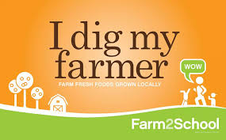

Is there anything else you’d like the 2022-2023 Farm2School Procurement Committee to know about your RFP?

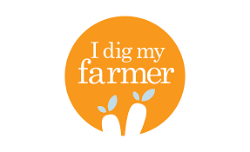

The undersigned has read the Overview, Scope of Work, Proposal Format, Evaluation and Selection, Purchasing Requirements, and the Contract Terms and Conditions, is familiar with and understands the information contained herein and agrees to furnish
and deliver the goods in accordance with the aforementioned.

______________________________________________________________________Signature Date

ATTACHMENT A
must be completed and submitted to
Mesabi East School District ISD #2711
601 North 1st Street W.
Aurora, MN 55705
Attention: Rachel Doherty
before 1:00 PM March 18, 2022

ATTACHMENT B SAMPLE CONTRACT

Farm2School
It is the intention of Mesabi East Schools ISD #2711 [name of person coordinating] to purchase EGGS from ABC123 FARMS.

It is the intention of ABC123 FARMS to provide and sell the following product to Mesabi East Schools ISD #2711 Lunch Program [name 1].

Product Name: EGGS

The total estimated quantity to be delivered: 8 Dozen

When it will be delivered to Mesabi East Schools ISD #2711: September 15, October 15, November 15, 2023

Cost per unit paid: $3.50 per dozen

Total cost for product: $28.00

___________________________ ___________________________ [Name 1] Farmer Dick and Jane
ABC123 Farms

