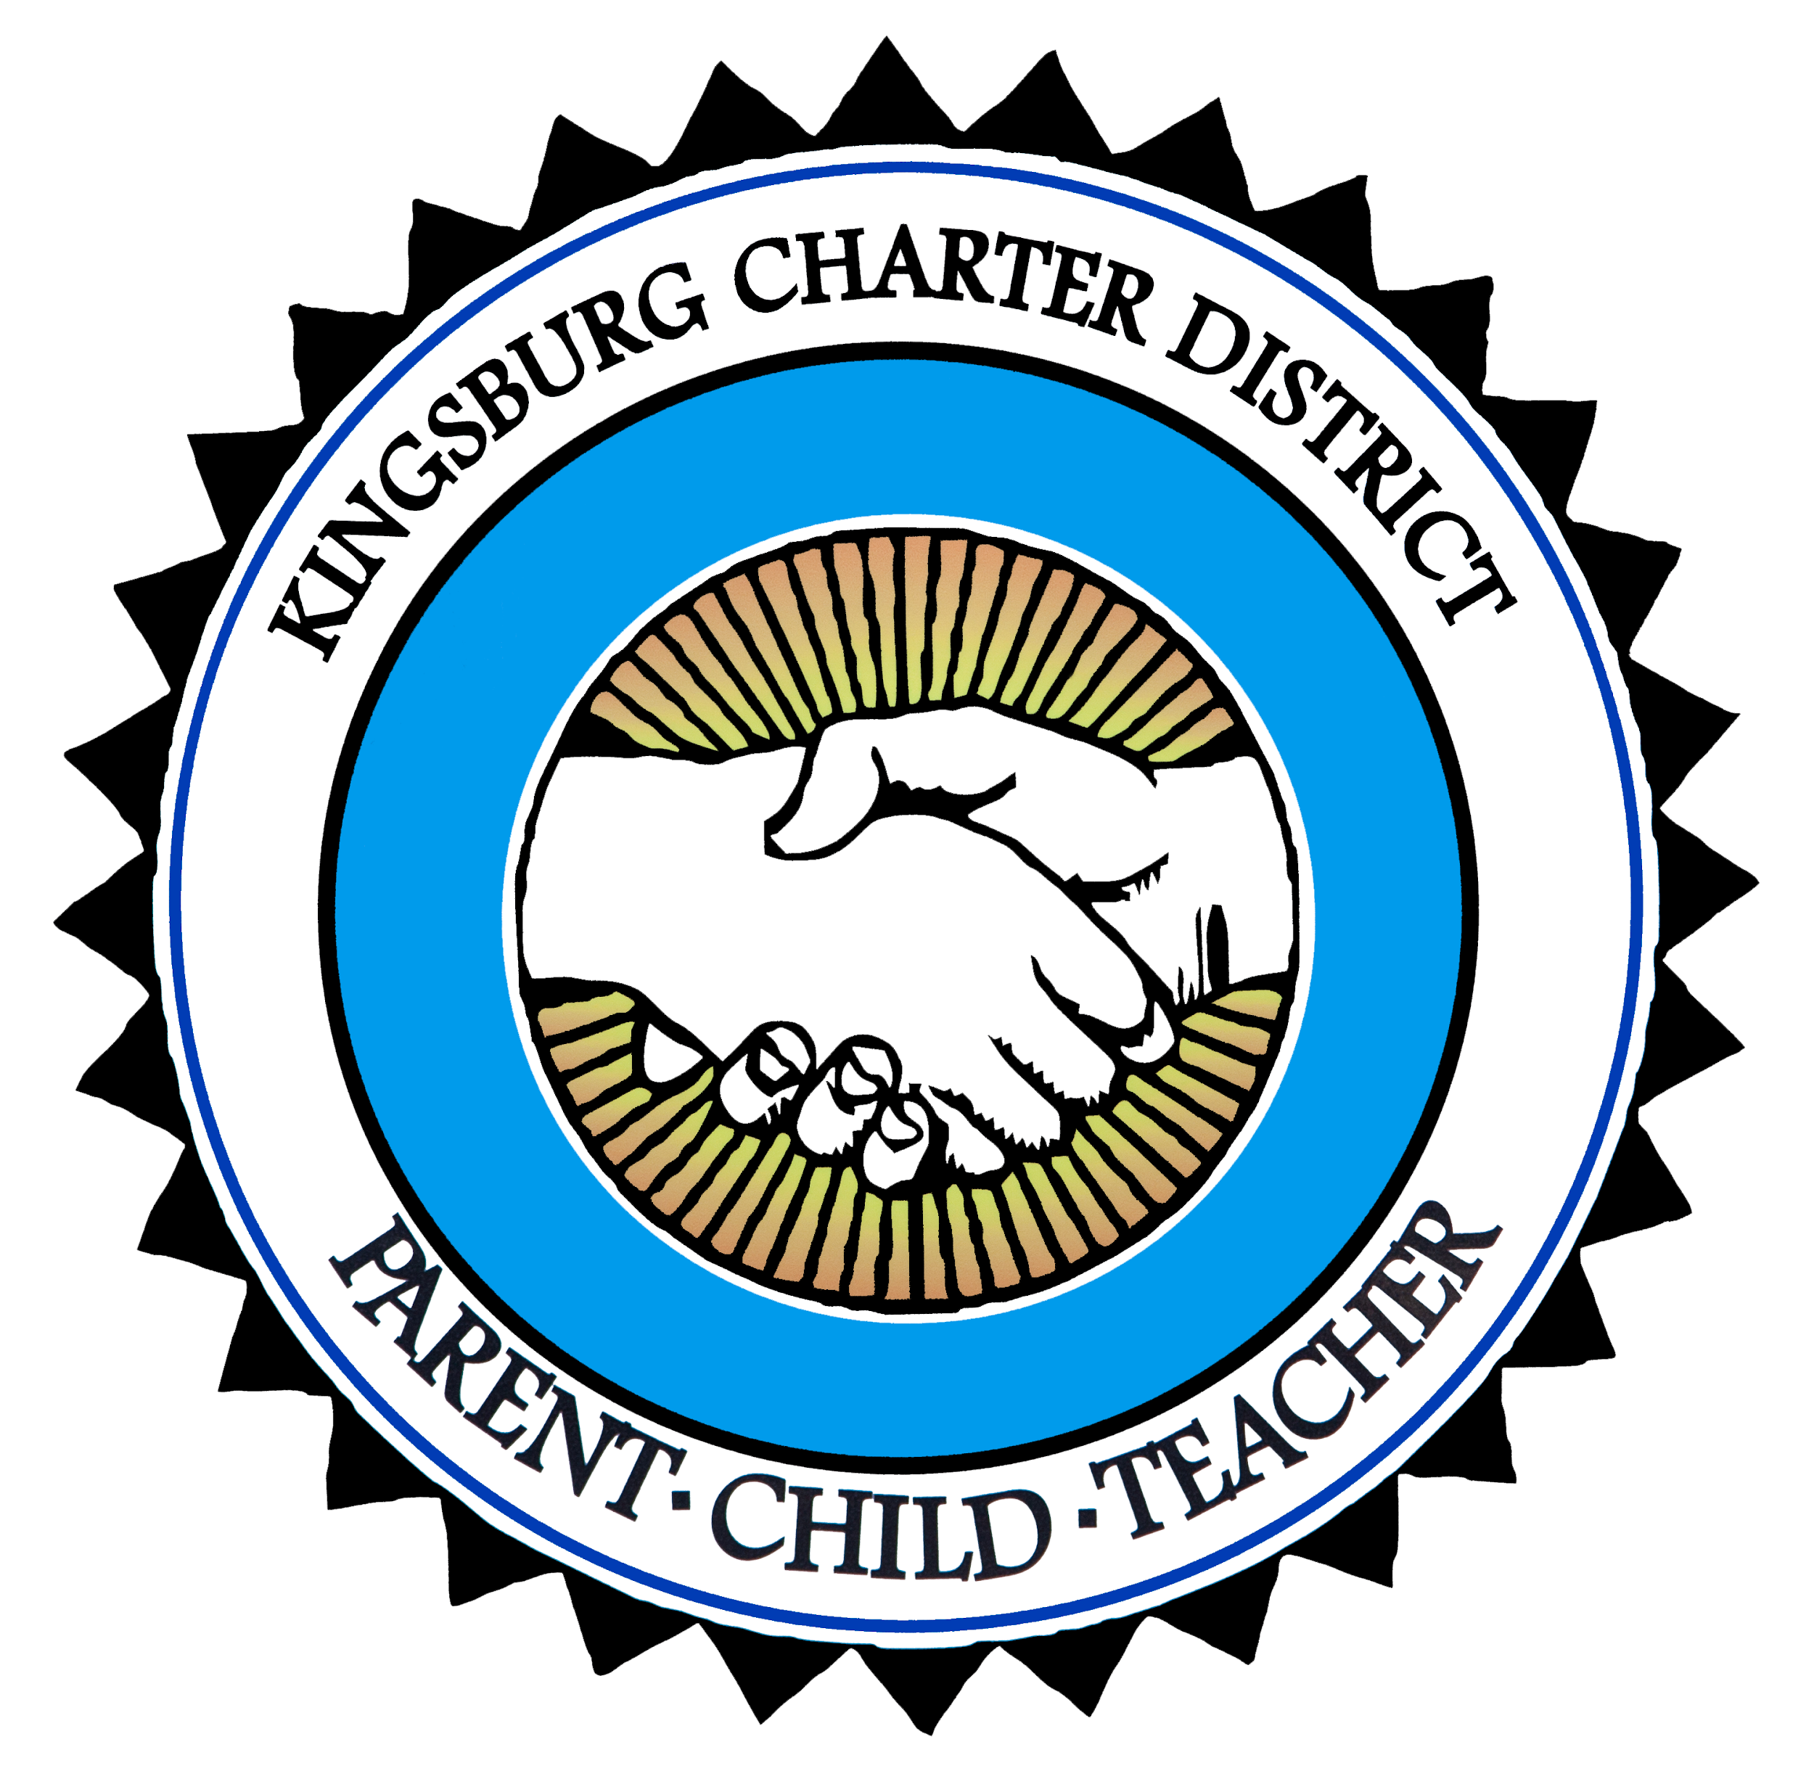**District English Learner Advisory Committee Meeting (DELAC)**

**Date: Friday, Feb 18, 2022**

**Time: 3:30 pm**

**Place: KESD Board Room**

**(Adjacent to the District Office - 1310 Stroud Avenue)**

**Agenda**

1. Welcome
   1. The meeting was called to order at 3:35 pm.
2. Checking in
   1. Present: Anna Hernandez, Ana Lizarraga, Maria Gutierrez and Melanie Sembritzki
   2. The committee welcomed Ana Lizarraga to the DELAC. Mrs. Lizarraga is representing Lincoln School. Mrs. Lizarraga is representing Lincoln School.
3. English Learner Master Plan
   1. Identification
      1. Mrs. Sembritzki explained that districts must identify in a timely manner EL students in need of language assistance services. The home language survey (HLS) is a questionnaire given to parents or guardians that helps schools and LEAs identify which students are potential ELs and who will require assessment of their English language proficiency (ELP) to determine whether they are eligible for language assistance services. Mrs. shared a flowchart illustrating the English Learner identification process and the path students follow once identified as in need of English language support and the criteria for reclassification.
   2. Reclassification
      1. Mrs. Sembritzki explained that Reclassification is the process whereby a student is reclassified from English learner status to Fluent English Proficient status. Reclassification can take place at any time during the academic year, immediately upon the student meeting all the criteria. She also discussed the district’s criteria for reclassification, as per the EL Master Plan.
      2. Mrs. Hernandez had concerns regarding her child when he gets to high school. She asked about the possibility of missing out on electives in high school because of being identified as “EL” and instead attending designated ELD class. Mrs. Sembritzki said she would contact Kingsburg High School and ask for information on how English Learner students are supported at KHS.
   3. Support
      1. Mrs. Sembritzki talked about how teachers support English Learners in the classroom.
      2. She also shared some different resources, such as the district’s adopted model of instruction, SIOP, Imagine Learning and ELLevation.
4. Kingsburg Reads One Book
   1. This year’s book selection is, The Mouse and the Motorcycle - By, Beverly Cleary.
   2. Students will begin reading on March 14 - 30
   3. There will be a lot of fun activities for families to participate all centered around the book.
5. Cultural Responsive Literature
   1. In response to the DELAC’s concerns in regards to culture and the need to educate the school community on the importance of the many great cultures and ethnic groups that make up our community, the district has been purchasing culturally responsive literature to bring awareness to students and their families. The DELAC perused through the books on display and were invited to take books home to share with their families.
   2. The DELAC will continue this discussion continue to review different pieces of literature at our next meeting.
6. District Calendar and Important Events

**Junta del Comité Asesor de Aprendices de Inglés del Distrito (DELAC)**

**Fecha: Viernes, 18 de febrero, 2022**

**Hora: 3:30 pm**

**Lugar: Salón de Reuniones de KESD**

**(Adyacente a la Oficina del Distrito - 1310 Stroud Avenue)**

**Agenda**

1. Bienvenida
2. Lista de Asistencia
3. Plan Maestro de Aprendices del Inglés

a. Identificación

b. Reclasificación

c. Apoyo

1. Kingsburg Lee Un Libro
2. Respuesta de Literatura Cultural
3. Calendario del Distrito y Eventos Importantes