How is the strategy of shifting the tax burden away from residential and towards commercial going?
1) It is probably best to compare 2018 to 2021 as there were staggered revals in 2019 and 2020 (commercial was first followed by residential). Our value added to residential in the four years was approx 600MM while commercial was 300MM.

2) As this is the assessor’s data, multifamily is considered commercial. 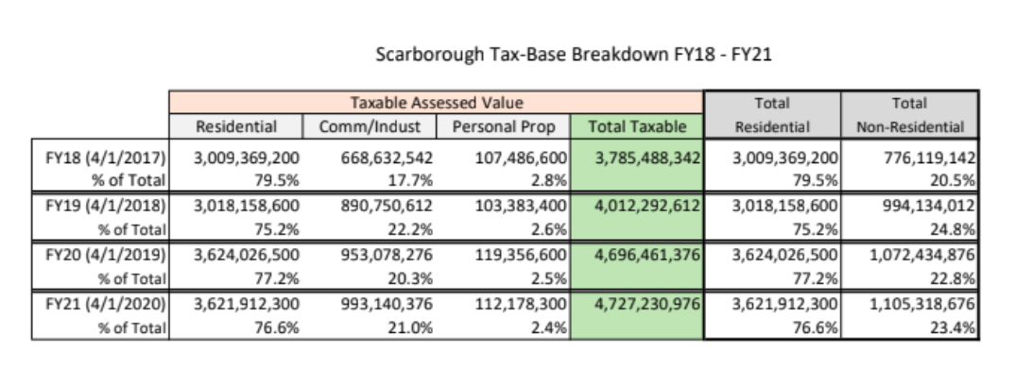
What is the breakdown of the growth permits issued this year?
- This is from the planning department.

. 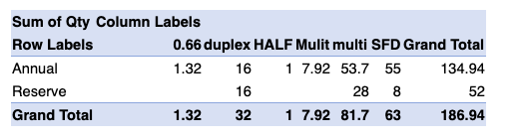

What is the running average number of UNITS built in the past 5-years? What about 10-years?
- This is “all in”. Beacon, Piper, Hillcrest, Etc (very important distinction as Hillcrest is already exempt from our GMO, so these are more than just the units resulting from growth permits)
- This is from the planning department. 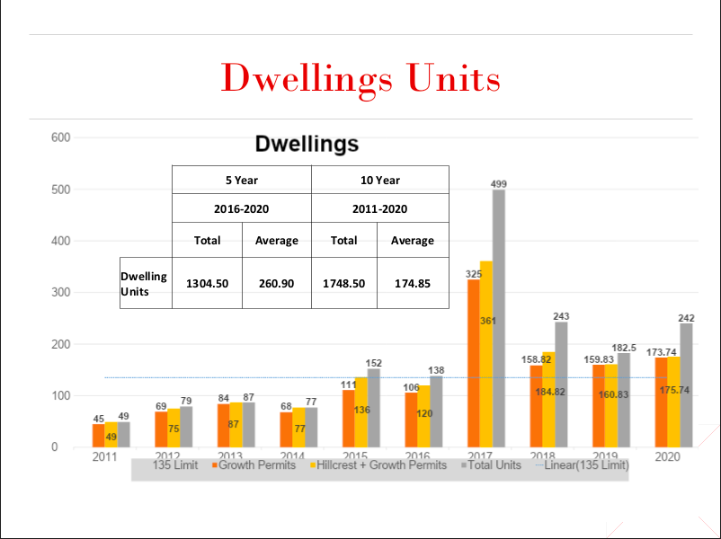

If we exempted all one-bedroom units and everything else one-to-one, what is the running average number of UNITS that would be issued under this assumption in the past 5-years? What about 10-years?
- This is “all in”. Beacon, Piper, Hillcrest, Etc (very important distinction as Hillcrest is already exempt from our GMO, so these are more than just the units resulting from growth permits)
- This is from the planning department.

 | 5-year (tot) 5-year (avg) | 10-year (tot) 10-year (avg)
All units 1 GP | 1305 261 | 1749 175
1 bedroom exempt | 833 167 | 1259 126

What is currently proposed: exempting one-bedroom, contract zones, and affordable housing (including Hillcrest). Using this premise, and all other units being 1 growth permit, what would the past averages look like?

 | 5-year (tot) 5-year (avg) | 10-year (tot) 10-year (avg)
All units 1 GP | 1305 261 | 1749 175
1 bedroom exempt, contract zones, affordable, Hillcrest | 477.5 95.5 | 832 83.2

That seems like a lot of exemptions. Why not continue with the reserve pool or actually create “council” permits?
It is nuanced. By exempting certaining scenarios, we keep our actual permits issued low. This means our five and ten year averages will actually decrease and always leave the door open to more restrictive measures.

What about the overcrowding of schools that is happening? How is school enrollment trending?
- This data is compiled by JC. His dashboard is probably one of the most informative tools we have. If you haven’t clicked on this or you haven’t spent real time on it, you are doing yourself a disservice. FYI...in the top left, there are 10 different pages with all the common data requests.
- This data is pulled from official sources that I will let JC defend if anyone would like to probe further.
- In case you can’t see the small font (click on the dashboard!), the top blue is high school, then middle school, etc...

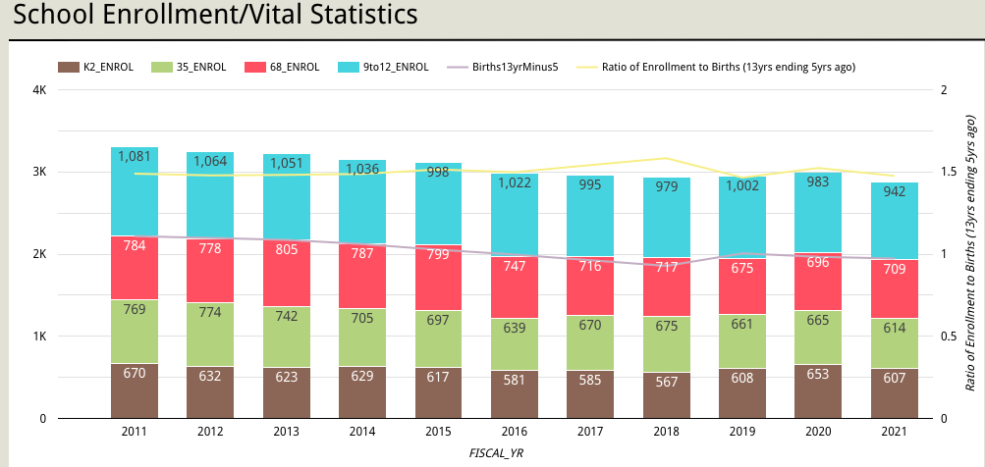
Wait, wait. Before we move on. Where are the projections for The Downs project for the next 30 years and what are the assumptions? I know this is a bit off topic, but I’m always looking for it.
You can find them here. I suggest you download and then read it - much easier on the eyes. BTW, this is the updated version after the recent reval.

I feel like there is more floating around out there. Where is it all?
I agree. Here are some other resources:

Workshop powerpoint from 2019.
The Downs specific growth management questions for SEDCO

Feel free to add to this list. And, don’t forget to check out the dashboard.

