PTA Meeting February 17, 2022
Meeting began at 7:05 PM

Attendance: Nicole R., Jamie D., Megan C., Dr. Recker, Lindsey L., Cheryl B., Jamie D., Angela H., Patty J., Weiwei Zong, Angie L., Colleen, Jimin Y, Garette B.

- Updates
  - Volunteers needed – Staff Appreciation Breakfast
  - Family picnic in the spring
    - DJ from-a-thon
    - Food wagon
    - Kona
    - Hot dogs
    - Nicole is sending out sign-up genius soon to pin-point exactly what we need done
  - Board positions leaving
    - Opportunities to open
    - Contact Nicole R. if interested
    - Applications due in April
    - Vote in May
- Ways to support Hamilton
  - Mabel’s labels
  - Kroger rewards
  - Bags
  - Box tops
  - Spirit wear
  - Restaurant night
- Upcoming events
  - School sledding TBD
    - Joseph D. – Long Lake/Ryan
    - Pavilion
    - Tim Horton’s hot chocolate
    - Flier tomorrow
  - Mid-Winter recess 2/21-2/22
  - Report cards End 3/3
  - No school ¾
  - School skating on Thursday 3/10 at Skate World of Troy 6:15-8:15 PM
  - Next PTA meeting 3/15 at 7:00 PM
  - ½ day of school on 3/17
  - Spring Break begins Friday 3/25-4/1
  - School resumes

- School updates
  - Faculty Breakfast
  - New Bathroom revision and faculty lounge (some items already purchased)
    - Stocked K-cups
    - Trash can right outside the bathroom to throw away paper towels
    - Paint
    - Hanger hooks
    - Door Pulls
    - New flooring
  - Purchasing new furniture for the common centrum areas
  - Grant money/PTA support
    - Rewarded grant money for seating outside
    - Small tables
  - Continuing the discussion on big school project
      - Gathering input from the students this month or next
      - Waiting to hear on future school improvements/grants to see where our money can be best spent
      - Gathering input from students this month
- Budget
  - 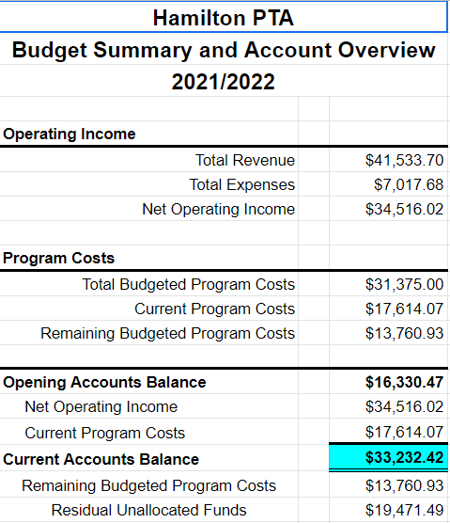
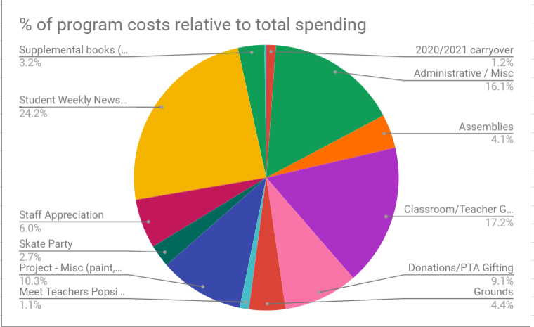

- Principal Update
  - School is in great position with the Covid numbers
  - Numbers are down
  - Schools have been doing great on charity projects and/or helping out at schools
  - Midst of typical winter activities
  - Getting ready for teacher month
  - Troy Community Coalition does projects
  - Facilities approvements hopefully covered by TSD instead of PTA
  - Centrum furniture would be money well spent
  - Lots of celebrations
    - Many teachers had accolades
    - Five teachers were nominated for Troy School of the Year!
    - A few teachers received around $3,000 for reading month
    - Mrs. McNally has a wonderful Social Studies program! Consultants from Oakland County watched the presentation and after seeing it, they told Dr. Recker that “they have hope for the future of education.”
  - Students had an opportunity to speak with 5th graders about what would they like:
    - Kindness
    - Respectful
    - Empathy
- Faculty update
  - Faculty lounge is more inviting and very much appreciated
  - Also the improvements in the restroom has been noticed and appreciated
  - Money for Reading month benefits all of the children
  - Loves the idea of new outside centrums
  - PTA would like grants to be in by the end of April
  - Hamilton book contest
    - Would need volunteers to judge
    - Mrs. Buxton has a list of former winners
    - She would love a plaque every year
- VP shoutouts
  - Gina Patel organized our restaurant night
  - The “Angies” put together the staff breakfast
  - Nicole – 100 days at first term as President who is doing a PHENOMINAL job! You are so appreciated by everyone!
- Nicole
  - She wants to thank everyone for their support
  - Putting deposit down Jimmy Johns game for families in June

SNOW DAY CONFIRMED DURING MEETING!!! HAPPY SNOW DAY!!!

Meeting ended at 8:00 PM

Respectfully submitted by M. Cyrulewski

