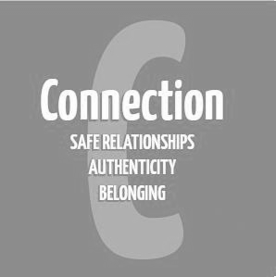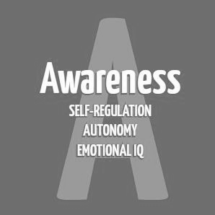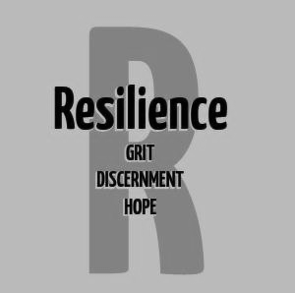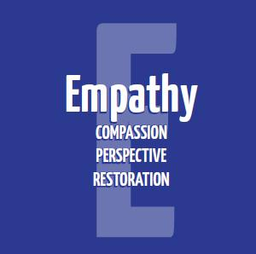
Secondary Guidance Lesson
Conflict Resolution
Objective: To help students understand what conflict resolution is and how to implement healthy, positive conflict resolution.
Video: https://youtu.be/DX4as9Fdoec
Activity:
● Show video
● Group Discussion
○ What were some differences in the first disagreement (negative way) and the second disagreement (positive way)?
● Individual Activity
○ Think of a recent disagreement you may have had recently.
○ Do you feel you handled the conflict in a positive or negative way? ○ What were some ways you handled the conflict in a positive, healthy way? ○ What were some actions you did/words you said that did not help resolve the conflict?
○ What are some things you would do differently in handling your next conflict?
Follow-up/Closing:
● By resolving conflicts in a healthy, positive way each person involved benefits and stronger relationships are built.
● When looking at movies/television/social media where conflict is shown, think about whether the conflict is being handled in a healthy way or negative way. If the conflict is being handled in a negative way, think about some things that could be done for it to be handled in a positive way.

