Secondary Guidance Lesson
Holiday Blues Lesson #2

Objective: To help students recognize, avoid and/or cope with the holiday blues.

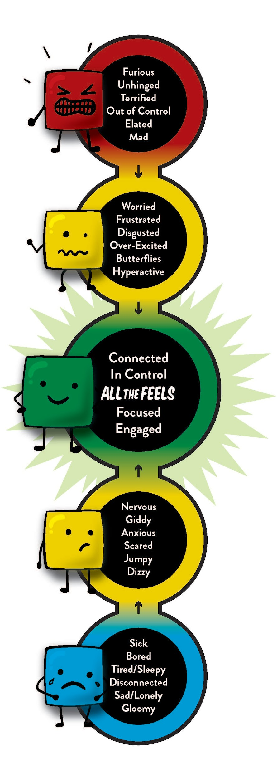
Video: https://www.youtube.com/watch?v=M4EPpAsiZqc

Activity:
Group Discussion Questions:
- Discuss the tips from the video:
- Intentionality, Gratitude, Exercise, Schedule Something Fun, Start a Post Holiday Tradition, Change up routine
- How would you describe having the holiday blues?
- What are some other reasons someone might get into the blue zone?
- How would you know if a friend or family member was suffering from the holiday blues?
- What could you do if a friend or family member was suffering from the holiday blues?
Sometimes doing things for others can help us appreciate what we have. Brainstorm some things you do for others during the holiday season.
- Donate
- Volunteer
- Make homemade gifts
- Holiday get together with family and friends

Follow-up/Closing:
Feeling blue can happen anytime. But, feeling blue around the holidays can be especially difficult because you may or may not have access to help. We want you to have a plan if you are feeling blue. Make a list of people you trust and are available if you need help or if you need to help someone you know. Make a list of some things you would like to do this holiday season to help you stay in the green zone.

Extra Video: https://www.youtube.com/watch?v=bjESBOlOTkw

