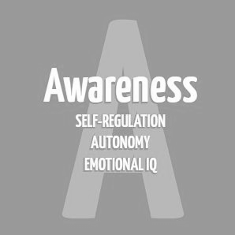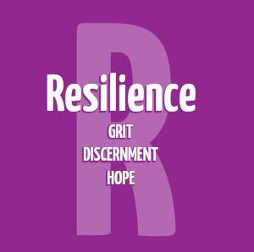

Secondary Guidance Lesson
Suicide Prevention: Stay Here Pt. 2

Objective: Suicide prevention. To ensure that students know when to talk to a safe adult about big feelings. To help students identify safe adults in their lives.

Background/Caution: Be aware that some of our students are struggling and this topic may bring some emotions to the surface. If a student becomes emotional during the video, stay calm and supportive and do not send the student out of the room alone to the restroom or to the counselor. Call first and make sure the student has adult support. There may be an increase in risk screeners around this time, but that’s ok. We want students to share with us.

Materials:
- Paper and pen/pencil for each student

Opening/Review:
- Review “Get To Green” using poster Get to Green Poster
- Allow opportunity for students to share a time this week when they practiced this. Share when you did as well (connection).

Activity:
- Have students write down the names of safe adults they can talk to if they or a friend needs help. Keep this list in a safe place.
  - Help students brainstorm some options.
- On the same piece of paper have students write themselves a positive note to reach for when they’re feeling discouraged. (For those who struggle to do this, a classmate or teacher can write a positive message for them.)
- As a group, discuss how you would help a friend if they reached out to you and said they were struggling.
  - Example: Find a trusted adult, tell someone, get them help, don’t leave them alone.

Closing:
Remind students that no matter how hard things get or what they’re going through, they’re NEVER truly alone and they don’t have to feel this way forever. Say something and stay here with us.

