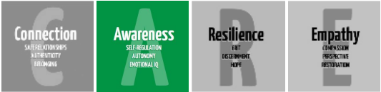

Secondary Guidance Lesson
Breathing Techniques Lesson #2: 4-7-8 Breathing

Objective: To practice a breathing exercise that students can use to self-regulate and to help themselves get to green.

Google Slides Presentation (Video Embedded): https://docs.google.com/presentation/d/11t7kJI2dHG0VIVEkL-UM8iT5pvElpW5BVRKxoW3m9Rw/edit?usp=sharing

Activity:
- Go through the slides in the presentation.
- Watch the video in the presentation and encourage students to practice 4-7-8 breathing.
- Share the following article with additional relaxation exercises that students can learn about.

https://kidshealth.org/en/teens/relax-breathing.html

Discussion Questions:
- The presentation suggested using 4-7-8 breathing before taking a test or quiz you may feel nervous about. When else do you think a breathing technique like 4-7-8 breathing or box breathing would be helpful?
- What are other healthy ways you can use to help yourself get to green when you are overwhelmed or stressed?

Follow-up/Closing: The 4-7-8 breathing exercise is an option to try when you are feeling anxious or on alert. As we learned in the presentation however, it has also been suggested to use when you are not on alert and to practice regularly as a part of your day. We encourage you to practice breathing techniques and other coping skills to see what is most helpful for you in taking care of your body.

