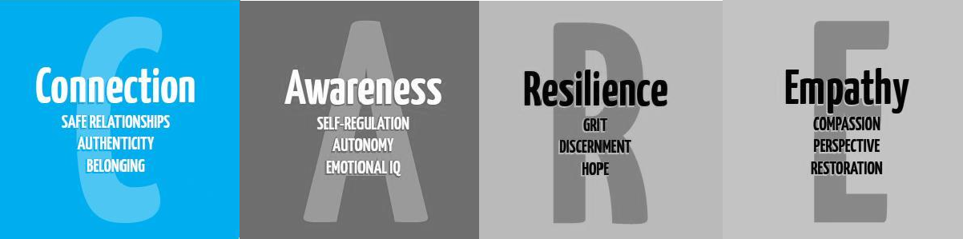

Secondary Guidance Lesson
Back to School - Mental Health

Objective: To help students and staff recognize emotions they may be having about coming back to school, understand that they are not alone, and encourage connectedness.

Video: https://video.link/w/JCc6c

Activity: Discuss and reflect

Use best practices to facilitate a discussion among students.

- Before school started this school year, how were you feeling about coming back and why?
- How are you feeling now and why?
- When we say, “We are in this together, what do we mean?”
- How can we support each other here at school?

Follow-up/Closing:

- What is something you will do to support a friend this year.
- How do you like to receive support?

Extension:

Create a visual (drawing, video, etc.) that illustrates that we are “In this together”.

