Secondary Guidance Lesson
Healthy vs Unhealthy Relationships
Objective: The student will identify the characteristics of healthy and unhealthy relationships.
Video: District “Love is Respect Video”
Activity: Raise your Hand
Instructions - read the list of relationship situations. After each one, raise your hand if you think the behavior is concerning in any way. 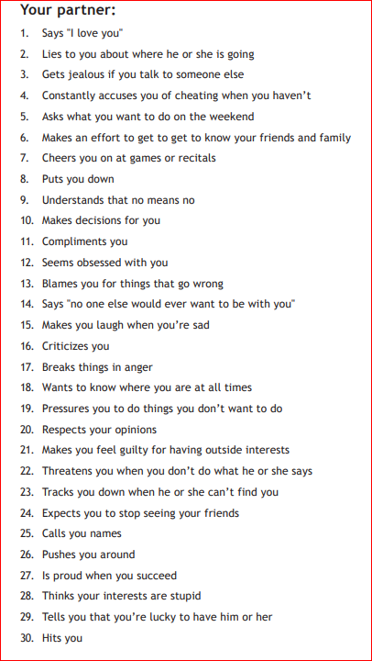
Follow-up/Closing: Students work in pairs to brain-storm ideas on how to plan for or work towards healthy relationships.

