Secondary Guidance Lesson
“Healthy Relationships” (Connection)

Objective: Students will be able to compare and contrast healthy behaviors and unhealthy behaviors in relationships.
Video: https://youtu.be/Uuvc2fjz0NA
Activity:
- Ask students to have a device available for an activity during the presentation
- Show video
- Open Google Slides presentation to facilitate discussion with students: https://docs.google.com/presentation/d/15qolJ0xRch4iTyUucLn7pbFAvK0oLvlB/edit?usp=sharing&ouid=114124613430526330831&rtpof=true&sd=true (NOTE: There is an interactive survey/assessment for students to do from their own devices in this presentation, and because the site focuses on teen dating violence and related topics, they will see a popup that looks like below with a warning that browser history can be monitored -- this warning is part of the website and does not present any security threat/problem. Students may click on “OK” to proceed to the interactive survey/assessment.)
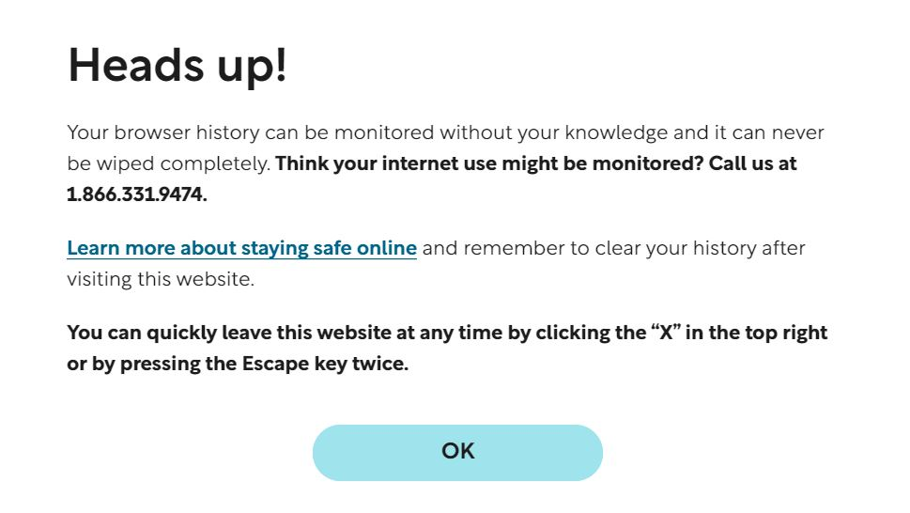

Follow-up/Closing:
Group discussion, if time allows:
- Who are some people you know that have a “healthy relationship” based on the characteristics you have heard about today?
- Do most teenagers you know have healthy relationships?

Remind students that they can talk to a trusted adult if they have concerns about their relationship or that of a friend.

