Accessing Office 365 and Teams [Grades K-5]
What is Teams?
Teams is a digital platform within Office 365 that brings conversations, content, and apps together in one place. It enables teachers to create collaborative, paperless classrooms and also can be used to create professional learning communities.
You already have access to the tools through ISD’s Office 365 account.

Accessing Office 365 and Teams from Clever
You can access your Office 365 account from Clever. You will only need to log in one time from your Clever account to save your Office username and password. The first time you log in you will use the following:
Username: Clever username as an email address (e.g. – moorjos25@issaquah.wednet.edu)
Password: Clever password (Student ID#)

Accessing Teams from Office.com
Visit Teams by logging into Office.com and then clicking on the Teams icon at the top of the dashboard or download the app (android || iOS)
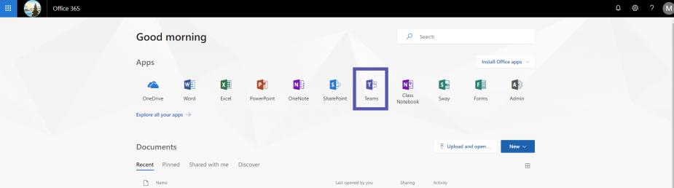
You can also install the Teams desktop application to your computer.

Logging into Teams
Use the following credentials:
Username: ISD username as an email address (e.g. – moorjos25@issaquah.wednet.edu)
Password: ISD network password (what you log onto a computer at school with)

Getting to Your Teams
Once you’ve logged into Office and clicked on the Teams icon, you will your Class Teams. Click on the Team you want to interact with. This will open your team. On the left, you will see a list of channels for your class. Each of these channels has a space to have conversations called Posts and a place to share files, called Files.
Each teacher will have slightly different set-up and expectations for how and where to interact in teams. It is important to pay attention to these expectations and norms in order to support a rich and collaborative environment.

A Few Things to Keep in Mind
- Make sure you are where you want to be. Look for team icon at the top to make sure you are in the right team. Then also check the name of the channel next to the icon.

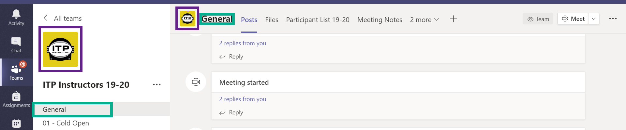
- Use the Reply button carefully. Conversation threads in teams can get busy and if you are not careful you might end up replying to the wrong conversation or worse, starting a whole new conversation.

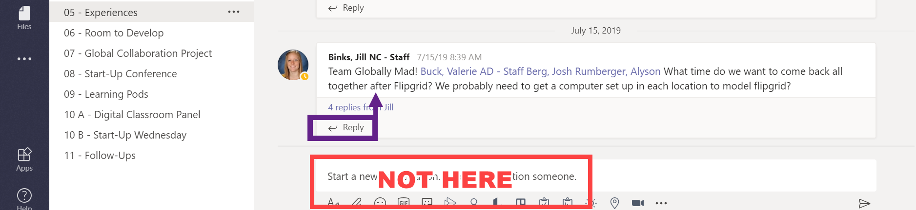

- Any Microsoft document you upload to a conversation or the files tab is editable by all members of the team. This is great for collaboration, but makes it really important that you pay attention to where you are and where you are putting stuff.

Joining a Meeting in Teams
- Log into Teams and click into the Team where the meeting is being held.
- Then go to the Channel where the meeting is being held.
- Once in that join the video chat 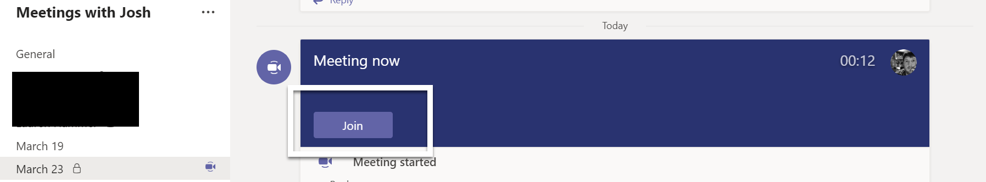

- To join the video chat, you should see a big purple bar with a Join button. Click that button and then make the following choices
  - Camera toggled off
  - Microphone toggled off
  - Then click Join

