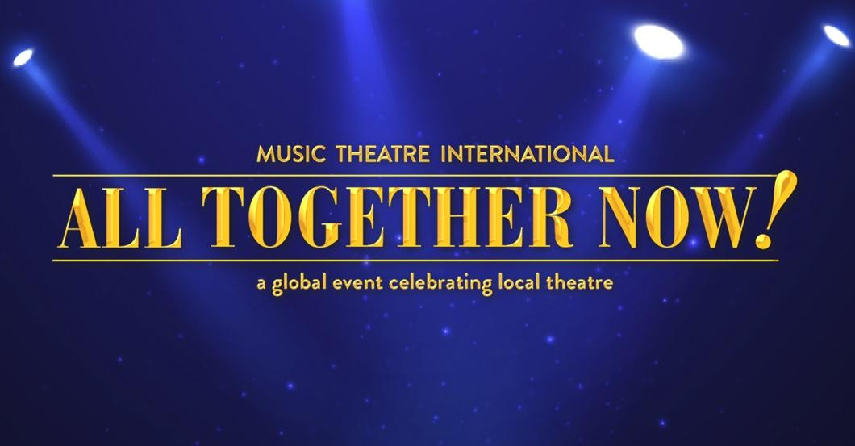

Fred T Foard Theatre Announces an Upcoming Production of

Music Theatre International’s
All Together Now!: A Global Event Celebrating Local Theatre

Performances to take place November 12 – 13, 2021

A fantastic selection of songs are featured in this brand new musical revue from shows including Rent, Into the Woods, Disney’s Beauty and the Beast, Fiddler on the Roof, Once on This Island, Godspell, Guys and Dolls, and many more!

Fred T Foard High School, (October 21, 2021) – Fred T Foard Theatre announced that they will be joining thousands of theatrical organizations around the globe by producing their own local production of Music Theatre International’s All Together Now!: A Global Event Celebrating Local Theatre. Theatrical licensor Music Theatre International (MTI) created this revue for theatres across the globe to use as a local fundraising event performed over the same weekend of November 12, 2021. FTF Theatre’s performances are scheduled for November 12th 7:00pm, November 13th 3:00pm and 7:00pm.

All Together Now! features songs from MTI’s beloved catalogue of musicals including Come From Away, Disney’s Beauty and the Beast, Fiddler on the Roof, Godspell, Guys and Dolls, Into the Woods, Rent, Waitress and many more!

OPTIONAL QUOTE TO INCLUDE FROM MTI:
- MTI’s President and CEO, Drew Cohen stated, “MTI’s All Together Now! is about bringing people back to the theatre, whether as audience members or cast, crew and musicians. The revue features songs from the world’s most iconic musicals, so there is definitely something for everyone to enjoy. Our goal with this worldwide event is for organizations to provide hope, inspiration and excitement to their communities through the transformative power of musical theatre.

- Tickets are $8 in advance or $10 at the door. Because of our social distancing efforts, seating is extremely limited. Tickets can be purchased from any cast member or by emailing Kelly Hutchinson at Kelly_Hutchinson@catawbaschools.net

