Revised: 12/02/15 TO
PROCESSING A REQUISITION FOR MASTERCARD
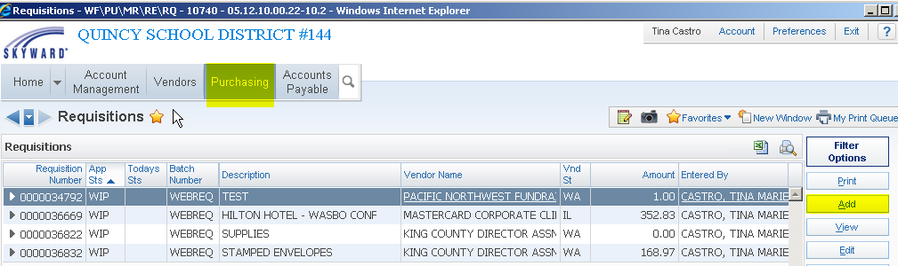

- Requisition Group – Select the appropriate requisition group
- Requisition Information – under Description –
  - PLEASE MAKE SURE TO PUT THE VENDOR NAME IN THE BOARD DESCRIPTION
Vendor name (vendor you are purchasing items from)
&
a brief description of items (i.e. Barnes & Noble - books).
If the requisition is for a hotel or conference please add the conference name just as you do for a hotel or conference.

- Vendor name - MasterCard Corporate Clients (use the PO Box address – Vendor Key – MASTERCA000).
- Ship to – if needed
- Attention – your name
- Tax/Other
- Save & Add Detail
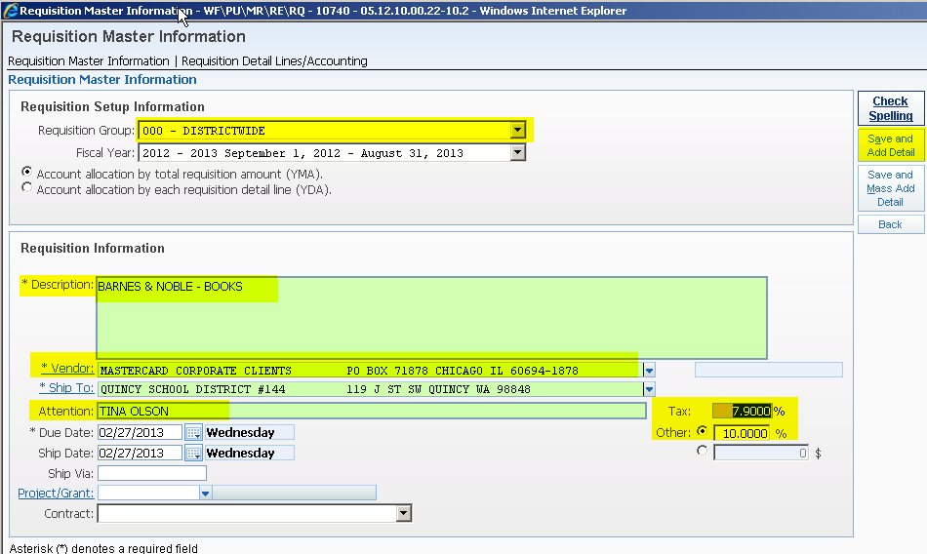

- Select Narrative – under Description
  - Enter the vendor name (vendor you are purchasing your items from) as a narrative line item. This narrative line must be the first line BEFORE you begin entering your LINE items. The reason for listing the vendor name for a second time is that it prints on different reports.
  - If requisition is for a conference or hotel please follow the instructions for entering a requisition for a hotel or conference.

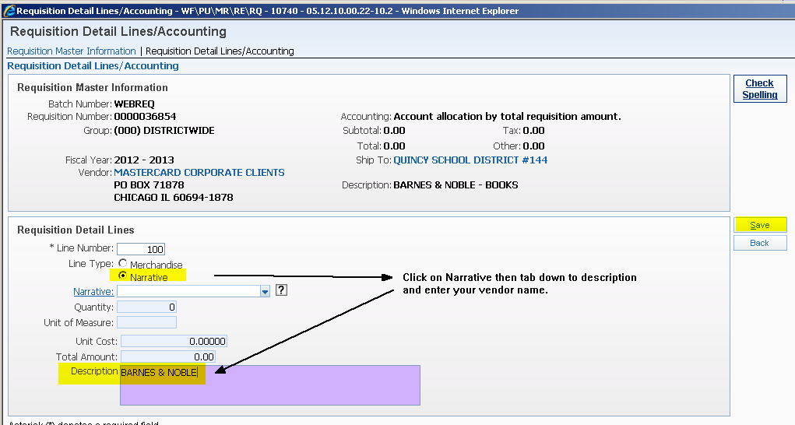

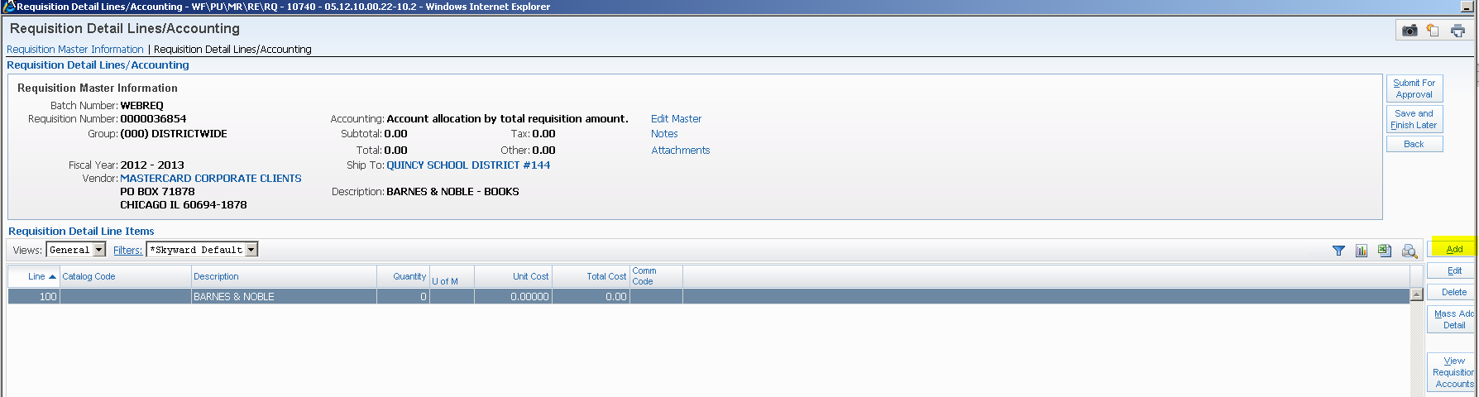

- Enter Quantity, Unit of Measure, and Unit Cost. If entering a hotel or conference follow the same guidelines.
- Description (Detail Lines) - Add merchandise line item(s). Use this section to go into detail of your purchases.
- Save
