PROCESSING A REQUISITION FOR VISA-WA TRUST/COSTCO
Skyward: Purchasing/Requisitions

Add

Requisition Group – Select the appropriate requisition group

Requisition Information
Description - Vendor name & a brief description of items (i.e. COSTCO - Classroom Supplies).
Vendor name - WA TRUST Spokane address – USE WA TRUST004
Ship to – your building
Attention – your name
Tax
Other
Save & Add Detail

Detail Lines
Line Type: Select Narrative - must be the first line BEFORE you begin entering your LINE items
Description: Enter COSTCO/SUPPLIES
The reason for listing the vendor name for a second time is that it prints on different reports.

SAVE

ADD
Enter Quantity
Unit of Measure
Unit Cost
Description (brief description of items you are purchasing
SAVE

ADD REQUISTIONS ACCOUNTS
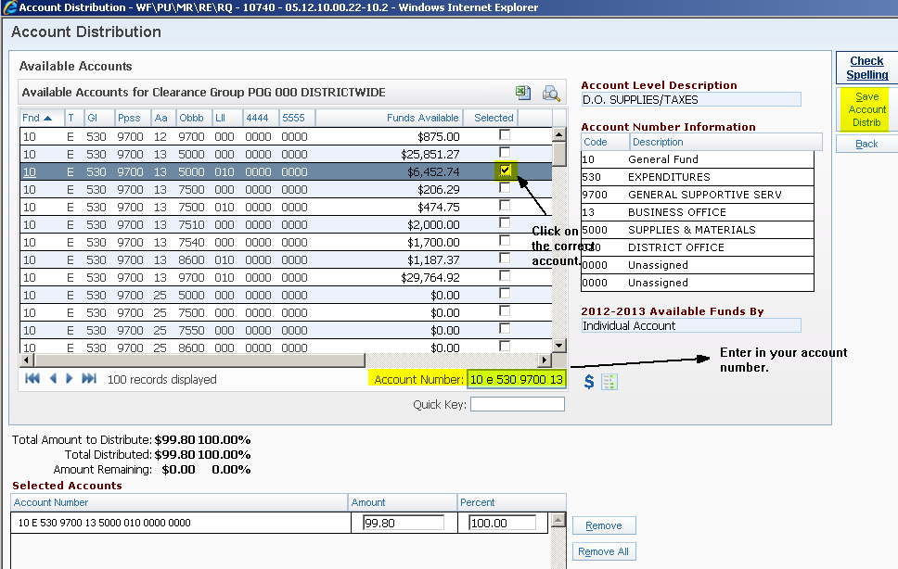

SUBMIT FOR APPROVAL

