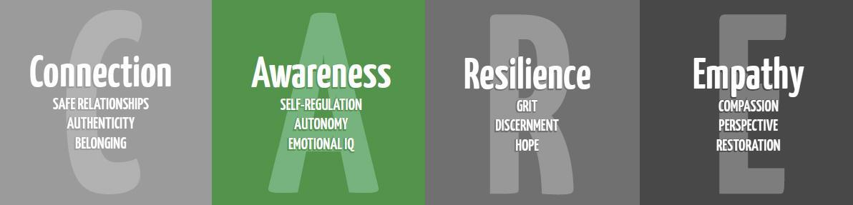
Safety Lesson
1st Grade
Purpose: To teach safety strategies and how the student can stay safe.
Materials: Speech bubble Handout (See attached)
Time: 20-30 minutes
Focus:
Tell students that today we are going to talk about different ways to practice staying safe. Some of these you may know and some may be new to you. Allow a minute or two for a “turn and talk” to tell a neighbor one way they can think of how they are practicing staying safe.
Lesson:
Discuss the following.
Who is a stranger?
- What if someone came up to you and told you they were supposed to take you home. They said they had talked to your parent(s)/guardian and that your parent(s)/guardian said it was ok. What would you do? If this happened to you, who would you tell?

Hurts:
Let’s talk about some different types of hurt that you may feel sometimes. .

- If someone falls down and scrapes their knee, or gets punched in the arm. This hurts, but it probably passes pretty quickly.

- If someone has bruises or scratches, or broken bones, those are serious kinds of hurts. The hurt usually doesn’t stop after a short time.
- Emotional hurt - Is when we hurt on the inside, like your feelings getting hurt.

- Who can you talk to about those hurts?
- If someone is hurting you in any of these ways, what can you do? (Answer) tell that person to stop, that I don’t like it and then tell someone what happened.

Secrets-
What’s the difference between a secret and a surprise?
A secret is a promise to never tell something and a surprise is waiting to tell something like a birthday wish or good test grade.

Now a very important question: Tell me why some kids feel that if someone hurts them, they have to keep it a secret? –(Answer): The person who is doing the hurting scares them or tricks them into keeping a secret.

- If someone does something that makes you feel scared, hurt, confused or icky, should you keep it a secret if that person tells you to? - (Answer) No, tell a parent, counselor, or someone you trust!

Touches-

- One more thing to talk about is touches- The good, the bad and the confusing. A good touch is like a hug from your mom for doing a good job. A bad touch is like getting hit or tickled until you can’t breathe. A confusing touch is when you’re not sure if it's good or bad.

- What are 3 things to do if there is a touching problem? (Say) You could say, “Please don’t do that” or “I don’t like that”, and then tell an adult you know and trust.

Closing:
Give students a speech bubble (see below) that says “One way I can practice staying safe is…” and allow them to write on it.

Name:

One way I can practice staying safe is...

