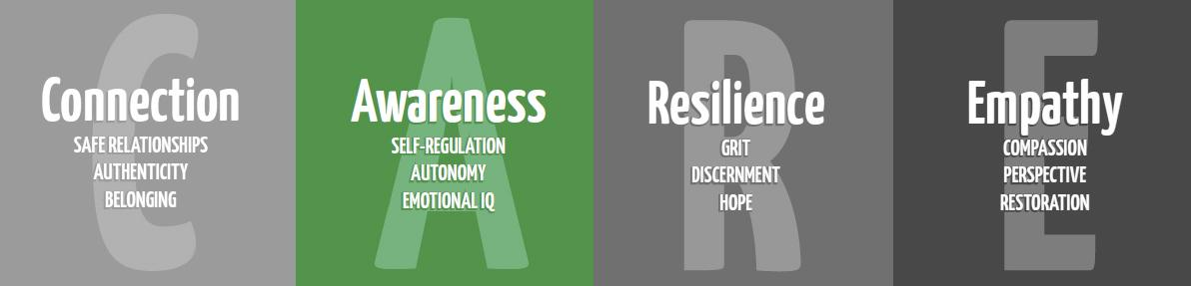

Hands are Not for Hitting

A Feelings/Friendship Lesson

Purpose: To educate students on acceptable ways to use their hands.

Materials:
Hands are Not for Hitting by Martine Aggasi
Die cut hands or the following resource from Teachers pay Teachers https://www.teacherspayteachers.com/Product/Hands-are-not-for-hitting-2425734

Time:
Approximately 30 minutes

Focus:
Hold up your hand palm to palm with a student’s hand, and ask the class, “Who has the bigger hand?” Explain to students that even though our hands are different sizes, we all use our hands every day.
Have students copy you in making a butterfly/dog/thumbs up with your hand.
Ask students, “What else do our hands do?” Allow a moment for students to share answers.

Lesson:
Say, “We are going to read a book (or watch the youtube link of the read aloud) about our hands.”
Read students the book, Hands are Not for Hitting. Pause to talk about positive hand uses and practice (handshakes, waving, high-fives, hugs). Pause to talk about negative hand uses (hitting, slap, grab) and ask if students have ever had someone do something negative to them like that before. Ask students to reflect, “How did that person doing that to you make you feel?”

Closure:
Have students turn and talk to a neighbor and share with their partner one positive way they can use their hands. Have students share their answers with the group. Distribute the die cut hands and have students draw a picture of a positive choice they can make with their hands. This resource through Teacher Pay Teachers is also another example.
https://www.teacherspayteachers.com/Product/Hands-are-not-for-hitting-2425734

