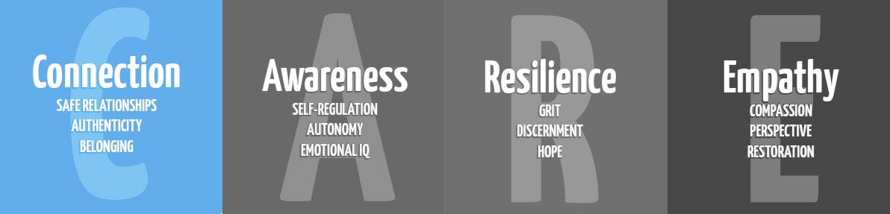
Choices
5th Grade
Materials
Circle map poster over choices
PowerPoint
“I will” worksheets
Time
20-30 minutes
Focus
“Today we are going to talk about choices and what is in our control.”
Have the inside circle of the circle map already labeled “Things in my control”
In the outer circle, fill out in things students say they have control over. Then follow up by adding in what they don’t say:
Control things may be: Words, Actions, Ideas, Effort, Mistakes, Behavior, Who I’m friends with
Outside of the circle have it labeled “Things outside of my control” and allow students to share. Some things you can add in if they don’t share could be: other people’s words, other people’s actions, other’s behavior, other’s effort, other’s behavior, other’s mistakes
“Do you see a pattern with what’s in the outside circle?” They should notice the “other” included in most of those.
“Why do you think that is?” Give them a moment to share out and then have a brief conversation about it.
Lesson
Students will need to be in groups once you start the PowerPoint. If they are sitting by tables, then you can have them complete the lesson this way. If they are in rows, have a way to randomly pair or group them together.
“We need to talk about choices. I’m going to show you a list of words and with each word I show you, I want you to answer 2 questions. #1: What does the word mean and #2 How would it affect you based on your choices when you deal with it.”
Show PPT- Pull up each slide and let them discuss the word. Then, have them discuss how it will affect them based on choices. (You will probably have to remind them before the first couple of slides what the 2 questions are they need to be answering at their table or group). Allow time after each one for groups to share out what they said to discuss.
“I hope you see how much the choices you make can make a big impact on the things we talked about. With thinking about your choices, I want you to take a minute to yourself, not with your partner, and think about when you make your choices. How do you see yourself? In 1 year? In 2 years? In 5 years? Past that, even later on in your life, when you think about yourself, how do you want to be remembered? What kind of person do you want to be? Take a minute to come up with some words that you want to be used to describe you.”
Give students about a minute of think time and then allow students to individually share out or list them out. Next, discuss self-Image posters: “We talked about words that describe us. Share with me some words that you used.”

Close: Make the “character traits” poster.
Have a discussion with the words that the students chose for themselves. “So if I chose the words trustworthy, how would I behave or what actions would show someone that I am trustworthy?”
“IF I chose the word honest, what would I need to do to show someone that I am honest? IF I want to exhibit these things, I have to look at what choices I make to show that type of character. What is character?”
Show students the character traits paper and use one to model. Explain to students that they are going to use the words that they want to be used to portray what kind of person they want to be to build the face of themselves on a poster. Use some of the words they shared to model on the poster. (I usually use about 11-12 words to build the face: eyebrows (1 word each), eyes (2 words each), nose (2 words), and mouth (3-4 words). Once they create the face, encourage them to color and make it look like a portrait of themselves. This is a great thing for them to look back on and remind themselves of what character they are working to exhibit by either being hung outside their room or kept in their binders.

