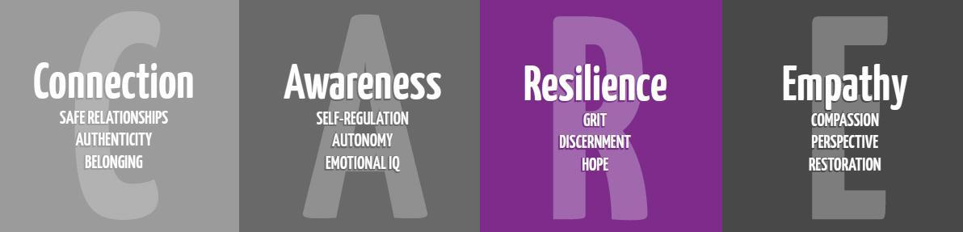

Anxiety & Stress

5th Grade

Purpose: To teach anxiety reducing strategies

Materials:
Anxiety and Stress Reducing Steps Cards
Stress in the Body Google Slide (linked below)
Circles of Control Google Slide (linked below)

Time:
Approximately 20-30 minutes

Focus:
See how many words you can make from the letters in STRESSED. Give students one minute to make as many words as they can, then list what words they come up with on chart paper, or on the board.

Discuss words and then point out the word “stress”.

Lesson
What is stress? Anxiety?
Discuss what each of these are. Explain to students that we feel these physically in our body, too. You might have a stomach ache, headache, or feel tension in your shoulders or neck.
A little bit of stress can help you do your best, but a lot of stress can feel like a crushing weight.

Where do you feel stress?
Use the google slide and consider where you feel stress in your body and the physical impact.

Stress in Your Body

What do you stress about?
Allow for answers. STAAR test too?
Use the Circles of Control Google Slide to discuss what we can control and what is outside our sphere of control. Recognizing both areas of influence can help us reduce or eliminate some of our stressors.

Circles of Control

How can you make stress go away?
Too much stress can feel awful inside. There are four powerful steps that you can use if you feel too much stress. You can use these steps to help you to relax and to make better decisions. We calm our bodies, minds, and heart.

Youtube Resources:
Butterfly Body Scan
https://youtu.be/56_8aK3cLEA

Teachers Pay Teachers Resources:
Relax Your World Mindfulness Wheel

Extension:
Tell students: We use many different strategies to cope with stress and motivate ourselves. Another coping skill many people love is through art. Share with them that we would love to post some positive words of encouragement out in the halls for students to see and think about as we prepare for an important task. They can use the coloring as a relaxing coping skill on a tough day and then when they are finished, the school counselor will collect them to display for others to see. Give students several options to choose from. Some examples are below, but there are a lot online.

Anxiety and Stress Reducing Steps  - Slow down and relax.  - Take some S L O W DEEP breaths.  - Close your eyes and think of something happy.  - Smile and say or think “I’ve got this!” | Anxiety and Stress Reducing Steps  - Slow down and relax.  - Take some S L O W DEEP breaths.  - Close your eyes and think of something happy.  - Smile and say or think “I’ve got this!”
Anxiety and Stress Reducing Steps  - Slow down and relax.  - Take some S L O W DEEP breaths.  - Close your eyes and think of something happy.  - Smile and say or think “I’ve got this!” | Anxiety and Stress Reducing Steps  - Slow down and relax.  - Take some S L O W DEEP breaths.  - Close your eyes and think of something happy.  - Smile and say or think “I’ve got this!”
Anxiety and Stress Reducing Steps  - Slow down and relax.  - Take some S L O W DEEP breaths.  - Close your eyes and think of something happy.  - Smile and say or think “I’ve got this!” | Anxiety and Stress Reducing Steps  - Slow down and relax.  - Take some S L O W DEEP breaths.  - Close your eyes and think of something happy.  - Smile and say or think “I’ve got this!”
Anxiety and Stress Reducing Steps  - Slow down and relax.  - Take some S L O W DEEP breaths.  - Close your eyes and think of something happy.  - Smile and say or think “I’ve got this!” | Anxiety and Stress Reducing Steps  - Slow down and relax.  - Take some S L O W DEEP breaths.  - Close your eyes and think of something happy.  - Smile and say or think “I’ve got this!”

