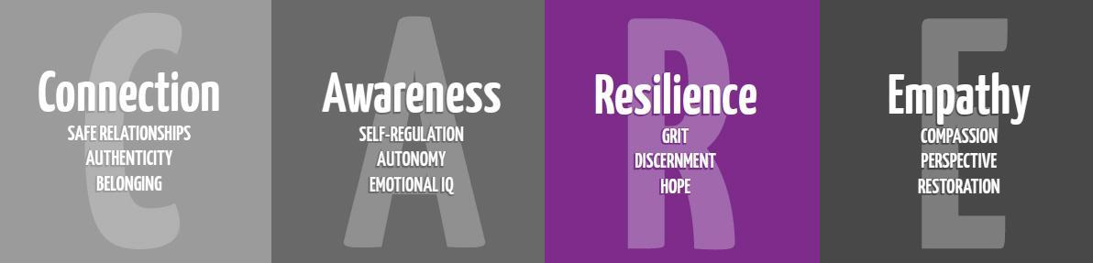

Anxiety & Stress Lesson
4th Grade

Purpose: To teach anxiety reducing strategies.

Materials:

Wilma Jean Worry Machine by Julia Cook
OR Ruby Finds a Worry by Tom Percival
OR Wemberly Worried by Kevin Hankes
OR Worry Says What? by Allison Edwards
Anxiety and Stress Reducing Steps Cards
Relaxation/mindfulness exercise (Spaghetti Toes-included at bottom of page or Yoga Pretzels for kids card)
Flocabulary Video: Managing Worry and Anxiety for Kids https://www.youtube.com/watch?v=l7g8Atv27Q8

Time:
Approximately 20-30 minutes

Focus:
Rush in the room looking stressed and frantic. Ask students to identify what they think you’re feeling. How did they know?

Lesson:
What is stress? Anxiety?
Discuss what each of these are. Explain to students that we feel these physically in our body, too. You might have a stomach ache, headache, or feel tension in your shoulders or neck.
A little bit of stress can help you do your best, but a lot of stress can feel like a crushing weight.

What do you stress about?
Allow for answers. STAAR test too?

Read Book
Wilma Jean Worry Machine by Julia Cook
How did Wilma Jean beat her worries?

How can you make stress go away?
Too much stress can feel awful inside. There are four powerful steps that you can use if you feel too much stress. You can use these steps to help you to relax and to make better decisions. We calm our bodies, minds, and heart. Pass out Anxiety and Stress Reducing Cards.
Step 1: Slow down and relax. Tell yourself that you need to take a little time to get comfortable and relax for a moment.
Step 2: Take some slow deep breaths. Slowly breathe in as deeply as you can through your nose. Then quietly and peacefully let the air all the way out. Do this about three or four times.
Step 3: Do yoga pretzel card or do this: Close your eyes and think about something happy. Keep breathing slowly and close your eyes. Picture in your mind something peaceful and happy.
Step 4: Motivate yourself, because stress can lie to you! Say “I’ve got this!”

Closure:
Relaxation/mindfulness exercise (Spaghetti Toes or Yoga Pretzels for kids card or other)
AND Watch Managing Worry and Anxiety for Kids (Flocabulary)
https://www.youtube.com/watch?v=l7g8Atv27Q8

Additional Resources to Consider:
Ruby Finds a Worry by Tom Percival
Wemberly Worried by Kevin Hankes
Worry Says What? by Allison Edwards

Stress Cards
Pretzel Yoga Cards (for purchase)

Anxiety and Stress Reducing Steps  - Slow down and relax.  - Take some S L O W DEEP breaths.  - Close your eyes and think of something happy.  - Smile and say or think “I’ve got this!” | Anxiety and Stress Reducing Steps  - Slow down and relax.  - Take some S L O W DEEP breaths.  - Close your eyes and think of something happy.  - Smile and say or think “I’ve got this!”
Anxiety and Stress Reducing Steps  - Slow down and relax.  - Take some S L O W DEEP breaths.  - Close your eyes and think of something happy.  - Smile and say or think “I’ve got this!” | Anxiety and Stress Reducing Steps  - Slow down and relax.  - Take some S L O W DEEP breaths.  - Close your eyes and think of something happy.  - Smile and say or think “I’ve got this!”
Anxiety and Stress Reducing Steps  - Slow down and relax.  - Take some S L O W DEEP breaths.  - Close your eyes and think of something happy.  - Smile and say or think “I’ve got this!” | Anxiety and Stress Reducing Steps  - Slow down and relax.  - Take some S L O W DEEP breaths.  - Close your eyes and think of something happy.  - Smile and say or think “I’ve got this!”
Anxiety and Stress Reducing Steps  - Slow down and relax.  - Take some S L O W DEEP breaths.  - Close your eyes and think of something happy.  - Smile and say or think “I’ve got this!” | Anxiety and Stress Reducing Steps  - Slow down and relax.  - Take some S L O W DEEP breaths.  - Close your eyes and think of something happy.  - Smile and say or think “I’ve got this!”
