Purpose: To educate students about accepting differences. Students will become aware of how people work in a group together.

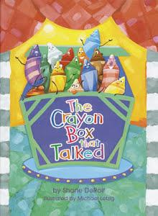
Materials:
The Crayon Box that Talked book
Box of crayons
2 copies of any coloring page
Kinder-First The Crayon Box That Talked- Favorite color handout
Second The Crayon Box That Talked- Writing handout
Crayon Bulletin Board Extension

Time:
Approximately 30 minutes

Focus:
Show students a box of crayons. Discuss how each color is different and unique.

Lesson/Discussion:
Read the book “The Crayon Box That Talked”. Discuss how the feelings of the crayons changed and what they learned about each other. Talk about what the world would be like if everyone were the same.
Hang up two identical pictures on the board. Tell the class that you are going to color one picture using a box of crayons and color the other using just one color. Let students take turns coming up and coloring the picture. After all or some of the picture is colored, discuss which picture looks best and why.

Extension:
Students will complete the application pieces. “Kinder-First The Crayon box that talked” Favorite color handout or the “The Crayon box that talked” writing page.

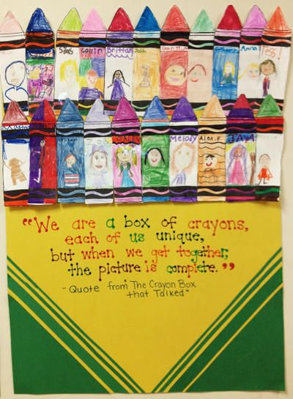
Another extension option would be to give each student one crayon from the blank crayon handout. Guide students to write their name on the center of the crayon handout rather than a color. Direct students to color the crayon however they would like using whatever colors that they would like. When students are finished, collect each crayon and create a crayon box visual (see photo).
