Conflict Resolution K-1

Purpose: Students will learn 4 steps to resolve conflict on their own.
Materials: Buddy Bee & Lucky Lady Bug Puppet
Blocks or other items for building
4 Keys Steps Song- from Social Studies Alive- https://www.youtube.com/watch?v=ROS-g9iBL_s
Visual with steps listed (see attached handouts)
Optional extension (The Great Lego Challenge) See Below
Time: 20 minutes
Lesson: Tell a story about the day that Lucky and Buddy had a problem that they handled the wrong way. This leads to consequences and it doesn’t solve the problem. Act out the problem, Situation 1, with puppets, using blocks. (see suggested skit) Freeze the puppets at the point just after Buddy the Bee yells at and punches Lucky the Ladybug. Talk about what just happened. Someone got hurt, someone will be in trouble, they might not stay friends, and the problem still isn’t solved.
Next, teach the “4 Key Steps to Solving a Problem”, using visuals, and singing the steps to the tune of the song.
- I stop, calm down.
- I talk, and listen.
- I think of ways to solve the problem.
- I agree on a plan and try it.
Once you’ve taught the steps, allow students to sing the song with the CD.
Next, “rewind” and begin the story again, Situation 2. This time, allow the students to help Lucky and Buddy navigate through the problem using the problem solving steps. The story ends on a happy note,the problem is solved, and the two remain friends.

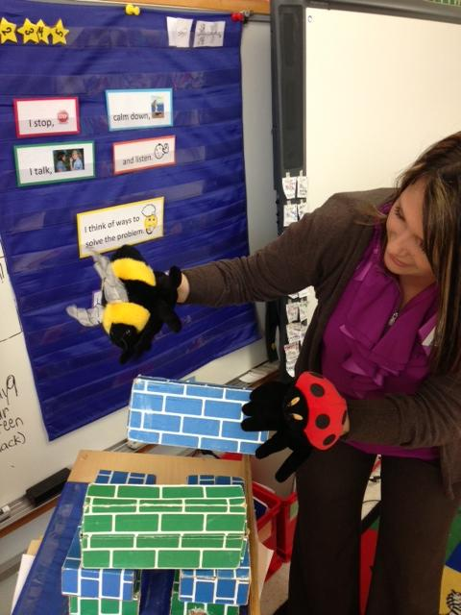
Possible Script
Situation 1
Narrator: One day, Lucky the Ladybug was building a tower with blocks.
Lucky: Do-de-do-de-do-de-do…I’m building a tower! I’ve worked so hard on my tower. These blocks are so heavy and I’m being very careful (straining).
Narrator: Along came Buddy the Bee.
Buddy: Hey Lucky! Whatcha doin’?
Lucky: Oh hey Buddy! I’m building a tower. I’ve worked so hard on this tower and I’m really proud of it.
Buddy: Cool! Can I help?
Lucky: Uh, uh, well, you are my friend…and I know it’s nice to share…uh, ok, you can help…but be careful!
Narrator: Buddy was so excited that Lucky let him help.
Buddy: (picking up a block and putting it on top) Oh wow, this is fun! (accidently knocks the tower down)
Lucky: Buddy!!! You knocked down my tower!!! I hate you! (punches Buddy and he falls to the ground)
(Freeze scene. Talk about what happened, then teach steps.)

Situation 2
Narrator: One day, Lucky the Ladybug was building a tower with blocks.
Lucky: Do-de-do-de-do-de-do…I’m building a tower! I’ve worked so hard on my tower. These blocks are so heavy and I’m being very careful (straining).
Narrator: Along came Buddy the Bee.
Buddy: Hey Lucky! Whatcha doin’?
Lucky: Oh hey Buddy! I’m building a tower. I’ve worked so hard on this tower and I’m really proud of it.
Buddy: Cool! Can I help?
Lucky: Uh, uh, well, you are my friend…and I know it’s nice to share…uh, ok, you can help…but be careful!
Narrator: Buddy was so excited that Lucky let him help.
Buddy: (picking up a block and putting it on top) Oh wow, this is fun! (accidently knocks the tower down)
(Freeze scene. Allow students to walk Buddy and Lucky through the problem solving steps.)
Might go like this…
Lucky: (taking slow, deep breaths to calm herself down) Buddy, I’m really upset because you knocked down my tower.
Buddy: Oh Lucky. I’m so sorry. I didn’t do it on purpose. (Lucky listens to him.)
Lucky: Well, that’s ok. How are we going to fix it?
Buddy: I know! We can leave it here and go play something else!
Lucky: I don’t think that’s a good idea because someone else would have to clean it up.
Buddy: What do you think about taking turns picking up the blocks and taking turns rebuilding the tower?
Lucky: That’s a great plan! Let’s try it!

(Talk about the fact that in this scenario, neither got hurt, neither got in trouble, and they both remained friends. ☺)
Stand up and sing the song together again!

Extension:
In a couple of weeks, return to classes to review the steps. Review singing the song, then give students the steps for them to put in order. We then practice different scenarios where the kids use the steps to solve problems. We talk about issues that have come up in their classrooms. I let students use the puppets to act out the scenarios. They love this!

I stop,

calm down.

I talk,

and listen.

I think of ways to solve the problem.

I agree on a plan and try it.

“The Great Lego Challenge”
(Teamwork/Problem Solving Challenge)

Divide class into groups of 2-5, depending on class size and the amount of Legos you have.
Give each group a container of Legos and instruct them not to touch the Legos until you tell them to begin.

Mission: Each group will work as a team to build ONE thing together. This can be done in several ways to increase the level of the challenge.

Students will utilize the interpersonal skills (i.e. taking turns, sharing, solving a problem, asking what the other person would like to do, calming one-self down when frustrated). This can be done in rounds, each time adding increasing the amount of verbal communication you allow and giving time for processing and reflection.
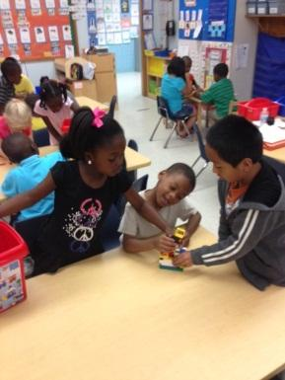
Options…
- Can talk while building
- NO talking
- Timed build
- Students can only use one hand

During processing, students often report how frustrating it is when they know what they want to build but they can’t verbally communicate with their teammates. On the rounds when they’re allowed to talk, it’s fun to witness the various ways in which students come to an agreement on what to build. There’s usually at least one child who gets frustrated during the process. During these times, you may see a classmate use reassuring friendship skills, offer suggestions, etc. You can encourage them to sing the “4 Key Steps to Solving a Problem” song.
