Kindergarten: Tattlin’ Madeline

Purpose: The student will decide whether they should report in given situations.
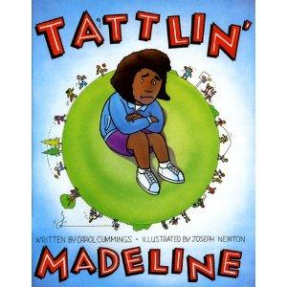
Materials:
- Tattlin’ Madeline by Carol Cummings
- Blindfold
- Scenario slips (w/hat or bucket)
- Happy & sad faces

Time:
Approximately 30-40 minutes

Focus:
- Ask and discuss these questions
  - What do you know about tattletales?
  - What comes to mind when you hear that word?
  - Have you ever been called a tattletale? How did you feel?
  - Look at the cover of the book. How do you think Madeline feels about being called a tattletale?

Lesson:
- Read Tattlin’ Madeline. As you read, incorporate the following questions:
  - What is Madeline’s problem?
  - How did the teacher help her solve the problem?
  - What happened to Madeline because of her tattling all of the time?
  - Does tattling interrupt your teacher and classroom activities?
  - What is the difference between tattling and reporting?
  - When is it important to report?
  - Who should you worry about? Whose behavior can you control?
- Remind students:
  - If you’re trying to get someone else in trouble🡪 that’s tattling
  - If you are trying to prevent someone from getting hurt🡪 reporting.

Closure:
Draw a circle on the board. Have students draw their scenario, read it to them. Have them decide if it is tattling or reporting and choose the appropriate face (happy face for reporting, sad face for tattling). If they say it is tattling have them come up with another way to handle the situation (ignore, use I feel ____ when you ____ language, walk away). Blindfold the student and have them put the face on the board as close as they can to the circle.

Tattling Scenarios

Sandy fell down on the playground.

Danny won’t play with me.

Julie is trying to trip me.

Joey ran out into the street.

Noah dropped his pencil.

Charlie said he was going to beat up Landon afterschool.

Maureen didn’t do her homework.

Glen is throwing rocks.

Ashley is throwing leaves.

Maria is crying in the restroom.
Johnnie cut in line.

Jessica is touching my paper.

Colton took my red crayon.

Andy stayed home from school, and she wasn’t really sick.

Lucy keeps playing with her hair.

Greg is chewing gum.

Jared scratched me and now I’m bleeding.

Eric is playing by the danger sign.

Maureen didn’t do her homework.

Hailey stole money from the teacher’s desk.

Raven slapped me really hard.

Justin said my shoes were ugly.

