Peer Pressure
Session One

Purpose: To educate students about peer pressure, bullying, ways to deal with both, and decision making.

Materials:
Candy jar
Sticky notes for guessing
Scenario Cards (see below)

Time: Approximately 45 minutes

Focus: Candy Jar Activity: Jar of candy; paper
- Have students guess how many candies are in the jar and write the number on their paper
- Have them pair up with someone next to them and come up with a number that they both agree on.
- Have each pair get with another pair and decide on one number.
- Have those 4 get with another group of 4 and decide on a number.
- Have those 8 add one more group of 4 and decide on a number.

Discussion:
- Was it easier to come up with a number on your own, or with help?
- How many of you felt it was difficult with the more people that were added to your group?
- Did you feel pressured by others to choose a certain number?

Lesson
We are going to talk about peer pressure today. Everybody makes decisions everyday.

What are some decisions you might make in a day? (Elicit student responses)

* Which friends to interact with
* Which feelings to share/keep
* Which games to play?
* What books to read?
* How to settle disagreements

Some of those decisions are easy to make (what TV show to watch) and some of them are more difficult (what to spend money on).

Some decisions we make are good and some are bad and both have consequences. The good decisions we make usually have positive consequences, whereas the bad decisions bring negative consequences.

Have you ever made a poor decision because a friend or sibling “suggested” the idea? Sometimes we want to blame those other people for the poor decisions we make. It is important to remember that we are in charge of the decisions we make. Although a friend or sibling may suggest or encourage us to do something that will get us in trouble, it is up to us to decide if the idea is good or bad.

How many of you have heard the word PEER? Who can give me a definition for the word peer? (Elicit student response)

* A PEER is someone near your age

Children who are in the surrounding grades are your peers, but someone in middle school or high school is not considered your peer. Your peers share certain experiences and have certain things in common.

How many of you have heard the word PRESSURE? Who can give me a definition for the word pressure? (Elicit student response)

* To PRESSURE means to persuade someone to do something

Let’s think of some synonyms for the word pressure:
* persuade
* convince
* encourage
* talk into
* suggest

Thus, PEER PRESSURE is when someone near your own age tries to convince, persuade, encourage, talk you into doing something. Deciding what to do would be a peer pressure decision.

Peer pressure can be both positive and negative. (Can use handout over this.)

Positive Peer Pressure Situations:

* cheering on teammates in a sport or game
* encouraging someone to try harder or not to quit
* modeling good listening by not talking with friends during class time
* suggesting to a friend to include everyone in a game or on a team
* encouraging a classmate to read a book you enjoyed

Negative Peer Pressure Situations:

* teasing someone into breaking a rule
* persuading a friend to steal candy from the store with you
* convincing a classmate to be mean to another classmate
* begging a friend to share his/her homework answers with you

Let’s talk about some of the warning signs of negative peer pressure. They include:

* teasing
* name-calling
* daring
* whispering
* looking to see if anyone is watching
* acting cool
* you’re a sissy, baby, chicken, etc.
* it’s okay, everyone does it
* come on, we won’t get in trouble

So we can see that peer pressure can be both positive and negative.
Peer pressure is really about making good decisions and looking at consequences. Peer pressure is nothing but words that peers use to try to encourage, persuade, or convince others to do something. Remember, no one can make you do something you do not want to do. You are in charge of making your own decisions.

I want to share with you a wonderful tool that you can use that will help you to make good decisions. It is called the IF .................THEN guide. If you can remember to use the IF .................. THEN guide before making decisions, you will almost always make good, positive choices. Let’s do some IF .............. THEN situations together. Remember you are providing the consequences to the decisions.

IF I shoplift candy with my friend THEN ..............

IF I do all my homework every night, THEN ..........

IF I save my allowance every week, THEN ...............

IF I often decide not to do my homework, THEN ............

IF I practice my favorite sport daily, THEN .............

IF I do not brush my teeth regularly, THEN ..........

Closure: Scenario Cards-turn and talk, then share

It’s Halloween and the kids you’re with are smashing pumpkins? Would you?

You’re spending the night with a friend and his/her family rented an R-rated movie and everyone's watching it together. Would you watch it too?

You’re at a sleepover and everyone is up past midnight telling scary stories. You have to get up early for a ball game. Would you stay up late too?

Your group of friends is making fun of a little guy in the class who wears glasses, is poor at sports, and always has his head in a book. Will you join in the teasing?

Peer Pressure
Session Two

Purpose: To educate students about peer pressure, bullying, ways to deal with both, and decision making.

Materials:
Scenarios (see below)
Do the Bright Thing Video https://www.youtube.com/watch?v=h6DoISdFawc

Note about the video: the dad mentions praying about a problem. Before watching the video say to students, “The dad in the video mentions prayer. This is a personal belief. It’s okay if you do, and it’s okay if you don’t.”

2-sided handout: How to Stand Up to Negative Peer Pressure/Thinking Map

Time:
Approximately 45 minutes

Focus
Last week we discussed what peer pressure is and talked about using the “if, then” method to decide the consequences of our choices. Give me an “if, then” example you’ve experienced since our last lesson.
Today we are going to discuss the things we can do to stand up to negative peer pressure.

Lesson
Now, sometimes we have trouble saying no to negative peer pressure. What are some situations where you may have trouble saying no to negative peer pressure? (Elicit student response)

* wanting to impress other kids, especially older ones
* not wanting to look like a baby
* wanting to be cool
* wanting to stop the teasing
* don’t know what to say or do when they won’t take no for an answer
* wanting to have friends

We are going to talk about some ways to stand up to negative peer pressure.

Distribute Handout
Discuss each strategy on Distribute the handout called How to Stand Up to Negative Peer Pressure. Go over the corresponding handout called Teaching Outline for Exercise 7 to discuss each technique.

It is so important to make your decision quickly and act quickly. The longer you stand there uncertain, the more your friend will try to convince you. The longer you take to decide, the more likely you are to fall for the negative peer pressure tricks or get into an argument.

Scenarios- Discuss as a Class
Your parents aren’t home and it is close to dinnertime. A friend who is visiting is trying to persuade you to call in a pizza order.

Your friend encourages you not to talk to another one of your friends because he/she was mean to them today at PE.

You are at Six Flags with some friends who are really cool. They are trying to convince you to go for a ride on a really big roller coaster. They all love roller coasters, but you hate them. In fact, last time you went on one, you threw up.

You and a friend are exploring the Internet on your home computer. You find a cool website where you can order a sports magazine and get a free T-shirt and poster. Your friend suggests ordering it in your dad’s name. You would really like to have the poster.

Video: Do the Bright Thing
He had lots of choices to make, and lots of people telling him what to do, but the decision he made was up to him.
* Did he always make the best decisions? ----- No, and you won’t either. You need to remember though, that when you do something you cannot blame your actions on someone else. People will always be telling us to do things, but it is up to us whether we do them or not! We learn from our mistakes.

* When he thought things through and made decisions for himself, they were usually good ones!

Closure: Distribute Do the Bright Thing Thinking Map handout
Have students fill out the bubble map in groups, then discuss.

Remember, peer pressure will always be around, but it is up to you to make good choices that show respect for yourself and others!

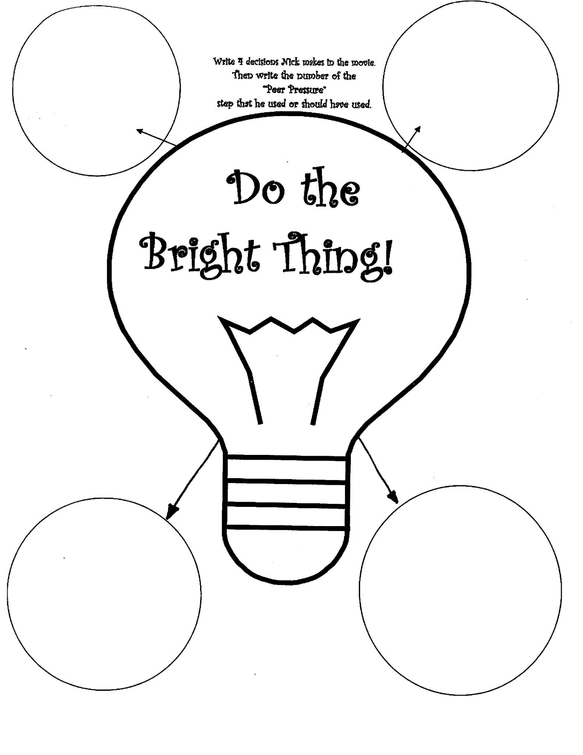
How To Stand Up To Negative Peer Pressure

      - Say “No!”
      - Make a joke.
      - Act shocked.
      - Leave.
      - Ignore it. Or change the subject.
      - Dare them back (in a good way).
      - Get help from an adult.

