Mesquite Independent School District
2021‐2022 Oﬃcial Budget
3819 Towne Crossing Blvd.
Mesquite, Texas 75150 Dallas County

Issued by:

Dr. David Vroonland Superintendent
Pete D. Pape Assistant Superintendent
Finance & Operations

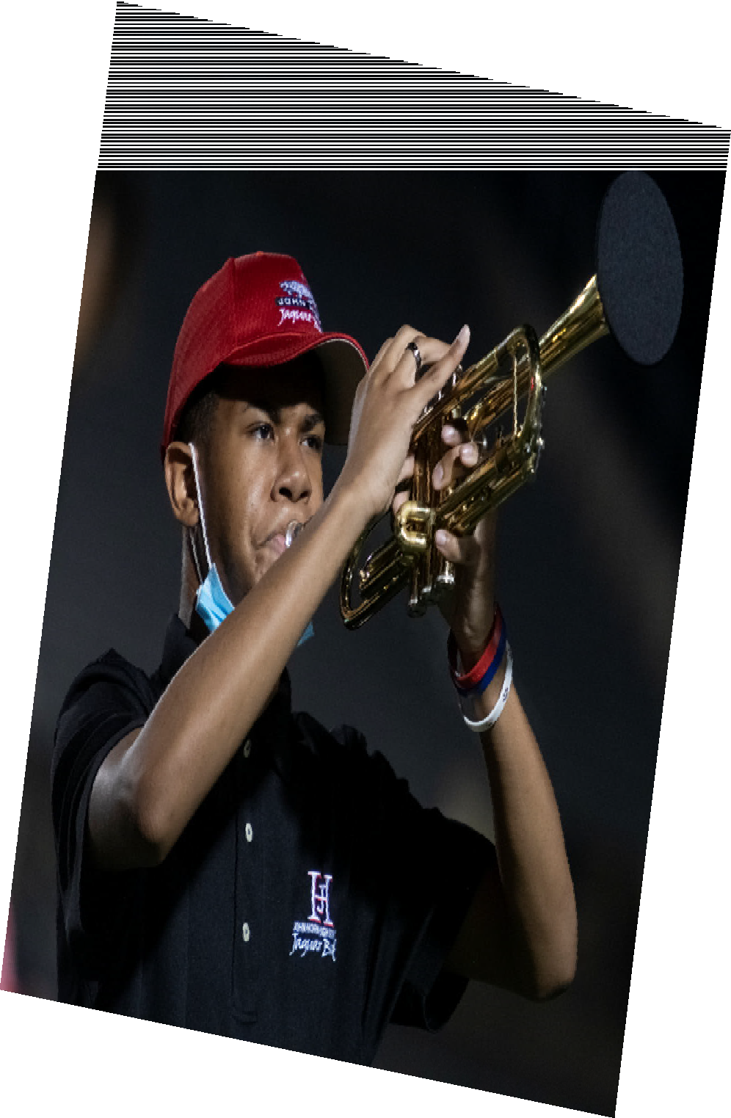

Available online at www.mesquiteisd.org

Table of Contents

Executive Summary 1
Executive Summary Table of Contents 2
Board of Trustees/Administrative Oﬃcials 3
Consultants and Advisors 4
Executive Summary 5‐6
District Details 7‐9
Mission Statement 10
Budget Process 11‐12
Budget Timeline 13
Budget Highlights 14
General Fund 15
Estimated Revenues 16
Expenditures 17
General Fund 18
Student Nutrition Fund 19‐20
Debt Service Fund 21
General Obligation Debt 22
General Obligation Bonds 23
Capital Projects 24
Internal Service Funds 25
Taxable Values and Tax Rate 26‐28
Enrollment Growth 29
Student Enrollment Summary 30
Student Enrollment by Campus 31‐32
Staﬃng 33
Graduation Rates 34
2021 Accountability 35
Financial Integrity Rating System of Texas (FIRST) and Future Budget Years 36
Future Budget Years 37
Revenue and Budget 5 Year Estimations 38‐39
Budget Contact 40
Organizational Section 41
Organizational Section Table of Contents 42
Significant Facts about Mesquite Independent School District 43
Mesquite ISD Attendance Zones 2021‐22 44
Enrollment Growth 45
Student Enrollment Summary 46
Student Enrollment by Campus 47‐48
Student Ethnicity Percentages 49
Mesquite ISD Contact Information 50‐52
Mesquite ISD School Calendar 2021‐22 53
Organizational Chart 54
Board of Trustees 55‐57
MISD Vision 58
Strategic Roadmap 59‐66
Financial Policies/Basis of Accounting 67‐76
Account Code Structure/Basic System Expenditure Code Structure 77‐78
Function Codes 79‐83
Account Code Structure 84‐88
Budget Policies 89‐99
Budget Timeline 100
Financial Section 101
Financial Section Table of Contents 102
Introduction 103
Funding Public Education 104‐105
Property Tax Levies & Collections 106
Comparison of Combined M&O and I&S Tax Rates 107
Long Range Assumptions 108
Budget Administration & Management Process 109‐111
Assumptions & Priorities for the 2021‐22 Budget 112‐113
Financial Section Overview 114
2021‐22 General /Debt Service/Student Nutrition Funds 115
General/Debt Service/Student Nutrition Funds—Revenues by Object 116‐117
General/Debt Service/Student Nutrition Funds—Expenditures by Object 118‐121
General Fund 122
Revenues & Expenditures 123‐124
Revenues by Object 125‐126
Expenditures by Object 127‐130
Student Nutrition Fund 131‐133
Revenues by Object 134
Expenditures by Object 135‐136
Debt Service Fund 137‐139
Revenues by Object 140
Expenditures by Object 141
Bond Debt Service 142
Outstanding Debt 143
Capital Projects Fund Overview 144
Capital Projects—Expenditures by Object 145
2018 Bond Package 146‐150
Internal Service Funds 151
Department Budgets 152
Budget Trends 153
Revenue and Budget 5 Year Estimation 154‐155
Future Budget Years 156
MISD Buildings. 157‐160
Defined Benefit Pension Plan. 161‐162
OPED Liability 163
Informational Section 164
Informational Section Table of Contents 165‐166
Taxable Value Information 167
Assess Value History 2000‐2022 168
Taxable Value History and Future Projections 169
Property Tax Levies & Collections 170
Top Ten Taxpayers 2021 171
Tax Rate Impact to District’s Taxpayers 172
Taxable Values & Tax Rate History 173‐174
Student & Enrollment by Campus 175
Student Enrollment & Projected Student Enrollment 176
Student Enrollment by Campus 177‐178
Enrollment 179
Staﬃng 180
Debt Service Fund 181‐182
Principal Outstanding 183
Bond Debt Service 184
Capital Improvement Program Impact on Tax Rate (Outstanding Debt Only) 185
Dropout Rate 186
2021 Accountability 187
MISD 2020‐21 Accomplishments 188‐192
Graduation Rates 193
ISIP‐Early Reading 194
Free/Reduced Lunch Numbers 195
Campus Budget and Performance Information
Achziger Elementary School 196
Austin Elementary School 197
Beasley Elementary School 198
Black Elementary School 199
Cannaday Elementary School 200
Florence Elementary School 201
Floyd Elementary School 202
Galloway Elementary School 203
Gentry Elementary School 204
Gray Elementary School 205
Hanby Elementary School 206
Henrie Elementary School 207
Hodges Elementary School 208
Kimball Elementary School 209
Lawrence Elementary School 210
Mackey Elementary School 211
McKenzie Elementary School 212
McWhorter Elementary School 213
Moss Elementary School 214
Motley Elementary School 215
Pirrung Elementary School 216
Porter Elementary School 217
Price Elementary School 218
Range Elementary School 219
Rugel Elementary School 220
Rutherford Elementary School 221
Seabourn Elementary School 222
Shands Elementary School 223
Shaw Elementary School 224
Smith Elementary School 225
Thompson Elementary School 226
Tisinger Elementary School 227
Tosch Elementary School 228
Agnew Middle School 229
Berry Middle School 230
Fraiser Middle School 231
Kimbrough Middle School 232
McDonald Middle School 233
New Middle School 234
Terry Middle School 235
Vanston Middle School 236
Wilkinson Middle School 237
Woolley Middle School 238
Horn High School 239
Mesquite High School 240
North Mesquite High School 241
Poteet High School 242
Vanguard High School 243
West Mesquite High School. 244
Mesquite Academy 245
Learning Center 246
Athletics 247

Glossary of Terms 248‐257

List of Tables

Executive Summary
Table 1: General Fund Revenues 16
Table 2: General Fund Expenditures 17
Table 3: General Funds 18
Table 4: Student Nutrition Fund – Statement of Revenues and Expenditures 19‐20
Table 5: Student Nutrition ‐ Fund Balance 20
Table 6: Debt Service Fund 21
Table 7: General Obligation Bonds 23
Table 8: Taxable Value Projections 26
Table 9: Tax Rate History 27
Table 10: Tax Rate Impact to District’s Taxpayers 28
Table 11: Property Tax Due 28
Table 12: Actual Student Enrollment Summary 30
Table 13: Demographers Projected Student Enrollment 31‐32
Table 14: Staﬃng History 33
Table 15: Graduation Rates 34
Table 16: 2019 Accountability 35
Table 17: Future Budget Years 37
Table 18: Revenue and Budget 5 Year Estimations 38‐39

Organizational Section
Table 19: Student Enrollment Summary 46
Table 20: Student Enrollment by Campus 47‐48
Table 21: Student Ethnicity Percentages 49

Financial Section
Table 22: Funding Public Education 105
Table 23: Property Tax Levies & Collections 106
Table 24: Comparison of Combined M&O and I&S Tax Rates 107
Table 25: General/Debt Service/Student Nutrition Funds 115
Table 26: General/Debt Service/Student Nutrition Funds—Revenues by Object 116‐117
Table 27: General/Debt Service/Student Nutrition Funds—Expenditures by Object 118‐121
Table 28: General Fund—Revenues & Expenditures 123
Table 29: General Fund ‐ Revenues & Expenditures 124
Table 30: General Fund ‐ Revenues by Object 125‐126
Table 31: General Fund—Expenditures by Object 127‐130
Table 32: Student Nutrition Fund 132‐133
Table 33: Fund Balance for Student Nutrition 133
Table 34: Student Nutrition ‐ Revenues by Object. 134
Table 35: Student Nutrition ‐ Expenditures by Object 135‐136
Table 36: Debt Service Fund 139

Financial Section (cont.)
Table 37: Debt Service Fund ‐ Revenues by Object 140
Table 38: Debt Service Fund ‐ Expenditures by Object 141
Table 39: Debt Service Fund ‐ Bond Debt Service 142
Table 40: Capital Improvement Program Impact on Tax Rate (Outstanding Debt Only) 143
Table 41: Capital Projects ‐ Expenditures by Object 145
Table 42: 2018 Bond Package 146‐150
Table 43: Department Budgets 152
Table 44: Revenue Budget 5 Year Estimations 154‐155
Table 45: Future Budget Years 156
Table 46: Buildings 157‐160

Informational Section
Table 47: Assessed Value History 168
Table 48: Taxable Value History and Future Projections 169
Table 49: Property Tax Levies and Collections 170
Table 50: 2021 Top Ten Taxpayers 171
Table 51: Tax Rate Impact to District’s Taxpayers 172
Table 52: Taxable Value Projections 173
Table 53: Tax Rate History 174
Table 54: Student Enrollment 176
Table 55: Projected Student Enrollment 176
Table 56: Student Enrollment by Campus 177‐178
Table 57: Enrollment 179
Table 58: Staﬃng History 180
Table 59: Principal Outstanding 183
Table 60: Debt Service ‐ Bond Debt Service 184
Table 61: Capital Improvement Program Impact on Tax Rate (Outstanding Debt Only) 185
Table 62: Dropout Rate 186
Table 63: 2019 Accountability 187
Table 64: Graduation Rates 193
Table 65: Overall English & Spanish ISIP Totals 194
Table 66: Free/Reduced Lunch Numbers 195

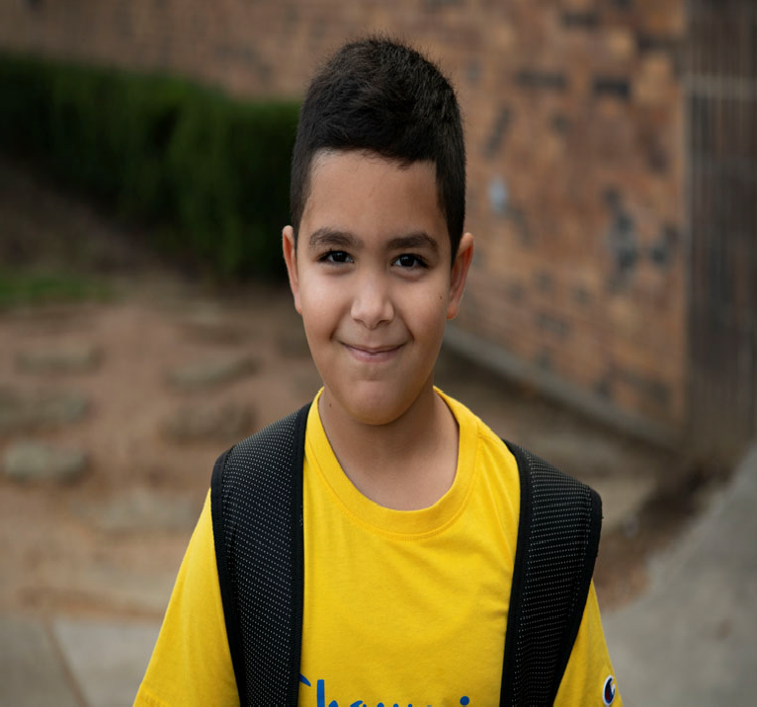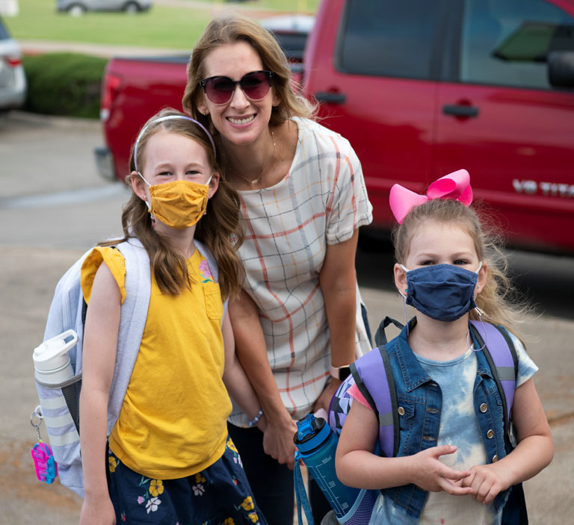
Mesquite Independent School District


Executive Summary

Executive Summary 1
Table of Contents 2
Board of Trustees/Administrative Oﬃcials 3
Consultants and Advisors 4
Executive Summary 5‐6
District Details 7‐9
Mission Statement 10
Budget Process 11‐12
Budget Timeline 13
Budget Highlights 14
General Fund 15
Estimated Revenues 16
Expenditures 17
General Fund 18
Student Nutrition Fund 19‐20
Debt Service Fund 21
General Obligation Debt 22
General Obligation Bonds 23
Capital Projects 24
Internal Service Funds 25
Taxable Values and Tax Rate 26‐28
Enrollment Growth 29
Student Enrollment Summary 30
Student Enrollment by Campus 31‐32
Staﬃng 33
Graduation Rates 34
2021 Accountability 35
Financial Integrity Rating System of Texas (FIRST) and Future Budget Years 36
Future Budget Years 37
Revenue and Budget 5 Year Estimations 38‐39
Budget Contact 40

3819 Towne Crossing Blvd.
Mesquite, TX 75150

Board of Trustees

Eddie Rose, President Greg Everett, Vice President Elaine Whitlock, Secretary
Teia Collier, Member Gary Bingham, Member Robert Seward, Member Kevin Carbo, Member

Administrative Oﬃcials

Dr. David Vroonland, Superintendent of Schools Dr. Angel Rivera, Deputy Superintendent
Pete D. Pape, Assistant Superintendent for Finance & Operations Mike Jasso, Assistant Superintendent for Administrative Services
Dr. Jennifer Hammett, Assistant Superintendent for Teaching & Learning Mary Randall, Assistant Superintendent for Personnel Services
Dr. Leslie Feinglas, Assistant Superintendent for Leadership & Strategic Initiatives Laura Jobe, Chief Information Oﬃcer

Consultants and Advisors

General Counsel Gary Grimes Mesquite, TX

Auditors Weaver and Tidwell, L.L.P. Dallas, Texas

Financial Advisor First Southwest, a Division of Hilltop Securities, Inc.
Dallas, Texas

Bond Counsel Norton Rose Fulbright US LLP Dallas, Texas

Depository Bank Prosperity Bank Balch Springs, Texas

Executive Summary

We are pleased to present the 2021‐22 Budget Book for Mesquite Independent School District. This budget represents the revenue and spending plan for the District for the 2021‐22 fiscal year which be‐ gins July 1, 2021, and ends June 30, 2022. It has been prepared in accordance with state regulations and local policies. The budget includes the three major funds requiring Board approval for the fiscal year – General Fund, Student Nutrition Fund, and Debt Service Fund. Also included, are the Capital Projects Funds and the Internal Service Funds, both types of funds do not require board adoption.

The budget is developed per the Board policies CE (Legal and Local) which stipulate that the “Superintendent shall prepare, or cause to be prepared, a proposed budget covering all estimated revenue and expenditures of the District for the following fiscal year.” The Texas Education Agency, which exercises oversight of Texas School District financial aﬀairs, requires a legally adopted budget for the General Fund, Food Services Fund, and the Debt Service Fund.

The 2021‐22 budget presentation for Mesquite ISD is designed to provide quality, useful information to its citizens concerning the District’s financial plan for education programs and services for the coming 2021‐22 fiscal year. It is prepared in a manner to help our citizens, staﬀ, and Board of Trustees under‐ stand how resources are allocated and the goals the District desires to achieve.

The budget book is organized to present the information in a user‐friendly format that meets the crite‐ ria set forth in the Meritorious Budget Award program administered by the Association of School Busi‐ ness Oﬃcials (ASBO) organization. The budget book contains the following sections:

- Executive Summary – reflects the key, important information within the budget book. This section gives the reader an insight to the remainder of the budget book. This section high‐ lights and summarizes the key components within the budget book.

- Organizational Section – provides the framework for the budget development as well as the District’s organizational and financial structure. Contains detail information on the budget process and policies, account code structure, and District financial policies and procedures.

Executive Summary (cont.)

- Financial Section – presents the financial information and budgetary projections for the com‐ ing fiscal year. The schedules highlight the three governmental funds requiring legally‐ adopted budgets as well as capital project funds. These schedules reflect historical, current, and future financial data.

- Informational Section – provides additional financial, staﬃng, and student information. This section provides actual budget data, tax values information, enrollment data, and other schedules to highlight useful budget information for the District’s citizens.

Facts about Mesquite Independent School District

The Mesquite Independent School District is an independent public educational agency operating un‐ der applicable laws and regulations of the State of Texas. The Mesquite ISD Board of Trustees (“Board”) is the level of government which has oversight responsibility and control over all activities related to public school education within the District. The District receives funding from local, state, and federal government sources and must comply with all the requirements of these funding source entities. However, the District is not included in any other governmental “reporting entity” as defined in generally accepted accounting principles.

Mesquite ISD encompasses Mesquite, Balch Springs, Garland and Dallas. The district has nearly 38,000 students and operates 33 elementary schools, 10 middle schools, and 6 high schools.

Mesquite Independent School District District Details

Excellence Always

Mesquite ISD’s 5,000+ employees work in unison for Excellence Always. They seek new heights of achievement while ensuring the best educational experience for every student, preparing him or her for continued success beyond graduation. Each school day, nearly 38,000 students on 50 quality campuses are exposed to caring, highly qualified teachers and the most current technological learning innovations.
Five belief statements guide all daily decisions and interactions aﬀecting students and their families:
- Each student holds unique value and infinite promise.
- Experiences that foster collaboration, communication, curiosity, and contextual learning prepare students for a competitive workforce.
- Our democracy depends on educational experiences that develop responsible citizens.
- MISD employees form a passionate learning family committed to professional growth.
- A diverse and involved community positively impacts our students.

A Great Place to Work

MISD is a dynamic, diverse district with a family‐like, close‐knit atmosphere often associated with districts much smaller in size. In the 2020‐21 school year, MISD’s new hires included 57 proud graduates of our schools. MISD boasts a lower‐than‐average turnover rate. Mesquite ISD’s Board of Trustees strives to keep salaries and benefits competitive so that the district can attract and retain the best educators and other staﬀ members.

We also value our teachers who are called to make a diﬀerence. In 2016, Mesquite ISD launched a groundbreaking program that allows teachers to grow professionally and financially – all while staying in the classroom. Under the Excellence in Teaching Incentive Program, Mesquite ISD teachers can add up to $12,000 to their annual salary in just six years by completing advanced training and other requirements. No other district in the country is making this type of investment in its staﬀ.

Early Literacy Initiative

We know learning doesn’t begin when students start school. A child’s learning begins the moment he or she enters the world. For that reason, Mesquite ISD and our community are committed to creating bookworms from birth through an early literacy initiative we call ReadPlayTalk. Our families are

encouraged to read, play, and talk with their children every single day. Our goal is for every student in Mesquite ISD to be reading on grade level by the third grade. Why? Because early literacy is the greatest single predictor of high school graduation and success into adulthood. Partnerships with local businesses, organizations and city services are helping to spread the message of Read Play Talk and making this simple model a part of our community’s culture.

Rich Academic Oﬀerings

A focus on college and career readiness is a hallmark of the district’s academic programs. Last year, students earned 13,584 dual credit hours and Advanced Placement students earned 966 college cred‐ its. The district has also launched an elementary honors program designed to encourage elementary students to take higher‐level classes; the goal is to have 80 percent of 8th‐graders taking at least one pre‐AP or honors class.

This school year, the district opened a choice career high school named Vanguard High School where students can streamline and focus their education on their chosen careers in high‐demand, high‐ paying fields. In addition, the district will oﬀer four‐year academies at each of its traditional high schools, giving students the opportunity to attend a high school outside their attendance zone if they choose to enroll in an academy oﬀered at a specific campus.

Career and Technical Education (CTE) in MISD provides a kaleidoscope of opportunities for students to explore and plan for future success. CTE courses oﬀer opportunities for students to learn skills they may use in high school, in a career after graduation, or as a financial means to help pursue higher education. In high school, our students enjoy options to earn multiple professional certifications and advanced training in even more industries.

Mesquite ISD oﬀers the AVID program on selected campuses. AVID (Advancement Via Individual Determination) is a rigorous program that transforms average students into high performers. This proven program uses mentoring and special learning opportunities to teach skills and instill attitudes that foster success in high school and college.

Programs to Address Diﬀerent Needs
Mesquite Academy serves secondary students who are not on track to graduate from high school in four years. The Academy oﬀers a flexible learning environment driven by the case‐by‐case needs of individual students. The Academy oﬀers an eﬃcient environment for acceleration by limiting class loads. Blended learning utilizes teacher‐driven lessons accompanied by online curriculum, promoting a focused approach for course completion. Customized interventions and weekly meetings monitor students’ individual progress for meeting the requirements for graduation. After catching up to their

cohort, students may choose to return to their home campus or to complete high school at the Academy.

Approximately 29 percent of Mesquite ISD students are limited in their English proficiency (LEP). LEP students are served by MISD’s elementary 50/50 enrichment bilingual program – with instruction in both English and Spanish – as well as English as a Second Language (ESL) programs at elementary and secondary levels.

The MISD Gifted and Talented Program serves students in all grade levels. Gifted students have diﬀerent needs, and their needs must be met through a diﬀerentiated curriculum. Teachers who have completed additional specialized training—enabling them to lead these classes in exciting, motivating ways—teach these programs. The district has also launched an advanced academics initiative de‐ signed to give all elementary students an honors program experience and ensure that 80% of eighth‐ graders will be enrolled in at least one pre‐AP course.

Broad Extra‐Curricular Options
MISD’s numerous extra‐curricular programs give students opportunities to develop relationships with peers through a team environment, an awareness of health and fitness, and the ability to sharpen leadership skills while working with others. Extra‐curricular programs include athletics, academic com‐ petitions, fine arts and a variety of clubs and organizations. Because students who are involved at school tend to stay in school, one of the district's objectives is to ensure that every student takes part in a school organization or extra‐curricular program.

Studying the fine arts is a great way to get involved in a lifelong activity. Classes such as band, choir, orchestra, art, and theater provide students the ability to realize their talents and the opportunity for individual and team recognition. On the elementary campuses, general music classes and fine arts field trips are part of the curriculum and expose students to a variety of cultural experiences. For eight consecutive years, MISD has been selected as one of the Best Communities for Music Education by the National Association of Music Merchants.

Safety First
School safety is a top priority for families and Mesquite ISD. Our campuses warmly welcome visitors while maintaining strict security standards. School Resource Oﬃcers are trusted role models and staﬀ members at middle and high schools, building relationships that keep students on the right track and making good choices. All visitors must be buzzed into the school building by a secretary.

Mesquite Independent School District Mission Statement

The mission of Mesquite ISD is to develop an inspiring and innovative learning community that educates and empowers students to pursue excellence.

At MISD, we believe:
  - Each student holds unique value and infinite promise.
  - Experiences that foster collaboration, communication, curiosity, and contextual learning prepare students for a competitive workforce.
  - Our democracy depends on educational experiences that develop responsible citizens.
  - MISD employees form a passionate learning family committed to professional growth.
  - A diverse and involved community positively impacts our students.

Our Vision: Excellence Always

Mesquite ISD developed a 5‐year Strategic Plan in 2017. In 2021 Mesquite ISD developed a 3‐year ’Strategic Roadmap’. We have developed the budget to help implement each of these categories:

  - Leading Through Ownership (LTO)
  - Facility Upgrades
  - AYO
  - Accreditation
  - LET
  - Literacy Lens
  - Vanguard

The members of the cabinet place in the budget request any strategies that require funds. We work to fund all needs of the campuses to implement these goals. The M&O has paid for the building of sever‐ al wings and buildings, and professional development to meet these goals.

Mesquite Independent School District Budget Process

The overall budget process has rules and laws that must be met as set by the State of Texas. The Texas Education Code Sections 44.002‐44.006 establish the legal basis for school district budget development. Along with these legal requirements, the District also follows a standard process to develop each fiscal year’s budget. The budgeting process is comprised of five major phases: planning, preparation, adoption, implementation, and evaluation. The budgetary process begins with sound planning. Planning defines the goals and objectives of campuses and the school district and develops programs to attain those goals and objectives. Campuses are allocated budgetary resources based on their unique student demographics. Each campus uses a committee to allocate their resources to best ad‐ here to their goals, which are laid out in the Campus Improvement Plan which is developed annually and submitted to the Texas Education Agency (TEA). The District plan specifies district goals and re‐ sources are allocated in the budget to help achieve these goals. Budgetary resource allocations are the preparation phase of budgeting. The allocations cannot be made until plans and programs have been established.

The adoption stage of the budget process occurs in the month of June each year, prior to the start of the fiscal year on July 1st. The Board of Trustees has the responsibility of adopting the budget before setting the tax rate to support the budget. A public hearing for the budget and the proposed tax rate must occur before oﬃcial legal adoption by the Board of Trustees. After adoption, the implementation of the budget is performed by the Business Oﬃce, with the cooperation of other District administrators. Implementation also includes establishing controls over revenues and expenditures, budget amendments, and informational reporting on the budget.

Finally, the budget is evaluated for its eﬀectiveness in attaining goals and objectives. Evaluation typically involves an examination of how funds were expended, what outcomes resulted from the expenditure of funds, and to what degree these outcomes achieved the objectives stated during the planning phase. This evaluation phase is important in determining the following year’s budgetary allocations. The evaluation culminates in the performance of the annual audit performed by an independent CPA Firm. The audit results must be reviewed and approved by the Board and sent to the State by the end of January each year.

In summary, budget preparation is not a one‐time exercise to determine how a school district will allocate funds. Rather, school district budget preparation is part of a continuous cycle of planning and evaluation to achieve district goals.

Budget Process (cont.)

The preparation, adoption and revision of the budget are the result of a process covering the entire year. The following is the budget calendar for the 2021‐22 fiscal year.

    - Budget Planning November‐January
    - Budget Preparation February‐April
    - Board Adoption June (includes Board of Trustee review in May & June)
    - Budget Evaluation May‐June
    - Audited Financial Statements November

A comprehensive budget calendar is included in the Executive Summary and the Organizational Section.

There are two significant changes aﬀecting the 2021‐22 budget. The first significant change aﬀecting the 2021‐22 budget is the district changing from a September 1 to a July 1 fiscal year. This change aﬀected the budget development timeline and will create a one year only larger than normal in‐ crease to fund balance in both the General & Debt Service funds.

The second significant change in the 2021‐22 budget is the opening of Vanguard HS. Vanguard HS is MISD’s first ‘choice' campus and will oﬀer students a comprehensive career focus and non‐ traditional learning environment. Students can choose from 16 diﬀerent programs of study and earn multiple industry certifications, as well as dual credit. The campus will open with grades 9‐10 and add a grade each year. The decision was made to staﬀ Vanguard HS as if it housed grades 9‐12 in order to have the proper programs and to help juniors and seniors at the Districts remaining five high schools continue to take the needed courses due to many programs moving from their campus to Vanguard HS.

Staﬃng was allocated to best serve students and the MISD community. MISD received approximately $37M in ESSER II funds and $83M in ESSER III funds. These funds have been allocated to pro‐ vide additional services to help with learning loss and to provide accelerated instructional ser‐
vices. These funds will be used for these purposes for the next three years (or longer).

Budget Timeline

      - Budget Priorities 11‐9‐2020
      - Workshop with Board 12‐14‐2020
      - Campus Allocation & Development Input 1‐31‐2021
      - Comptroller Values (for 2021‐22 state funding) 2‐1‐2021
      - Board Sets Workshop Priorities 3‐8‐2021
      - Board Approves Priorities 3‐8‐2021
      - Preliminary 2021 Values 4‐22‐2021
      - Board Update on Status of Budget Development 4‐12‐2021
      - Final Property Values 7‐2021
      - Board Approves Preliminary Budget 5‐10‐2021
      - Publish Public Notice 6‐3‐2021
      - Amend 2020‐21 Budget 6‐14‐2021
      - Hold Public Meeting 6‐14‐2021
      - Approve 2021‐22 Budget 6‐14‐2021
      - Adopt Tax Rate 9‐13‐2021

Each year the District Cabinet meets to discuss and set the budget priorities. A board workshop is held in November/December to discuss the national/state economic outlooks and review priorities. The Board’s Administration discuss and set the priorities at the March workshop/board meeting. The Board is updated on the budget development in April or May. The fund budget is presented to the Board and adopted in June.

Beginning July 1, 2021, the District changed its fiscal year from September 1 to July 1. Texas districts are permitted by the state to have either a September 1 or July 1 fiscal year. This change will better align the District's fiscal year with the academic year and will add approximately $20M to fund balance since only ten
- months of expenditures are in fiscal year 2021.

2021‐22 Budget Highlights

The Annual Budget was developed to align to the Districts’ Strategic Roadmap. The district is developing a transition plan by continuing to monitor and adjust priorities and district goals. For 2021‐22, employees received a 2.5% compensation increase.

  - Salary increases of 2.5% for all MISD employees
  - One‐time payment of $1,000 for all Professional Personnel
  - One‐time payment of $750 for all Paraprofessional and Auxiliary Support Personnel
- Provides funds for Xello, AED Replacements, JROTC‐Robotics, Employer‐Paid LTD, Website Software, Increase Substitute Pay, Technology/Facility Upgrades
  - Provides funds for Leadership Coaching
  - Provides Computer/Computer Program Upgrades
  - Continues seatbelts for buses
  - Provides funds for Soft Serve AI Project
  - Provides funds for phase II of the KEOM project

General Fund

The General Fund is commonly referred to as the “Operating Fund” or “Local Maintenance Fund”. State aid and local tax revenue make up the bulk of revenues received by this fund. This fund is used to pay general operating expenses such as salaries, utilities, supplies, and contracted services throughout the District.

The General Fund for 2021‐22 revenue is budgeted to decrease $7 million from the state and increase $1 million from local taxes. The General Fund Balance is estimated to be 135,000,000 for 2020‐21 and projected to remain unchanged for the 2021‐22 school year due to lower enrollment, student attendance, and COVID‐19 federal funds.

2021‐22 General Fund Estimated Revenues

    - Local Revenue $ 104,090,000
    - State Revenue $ 277,280,090
    - Federal Revenue $ 6,050,000
    - Other Sources $ 550,000

Total Estimated Revenues $ 387,970,090

Table 1
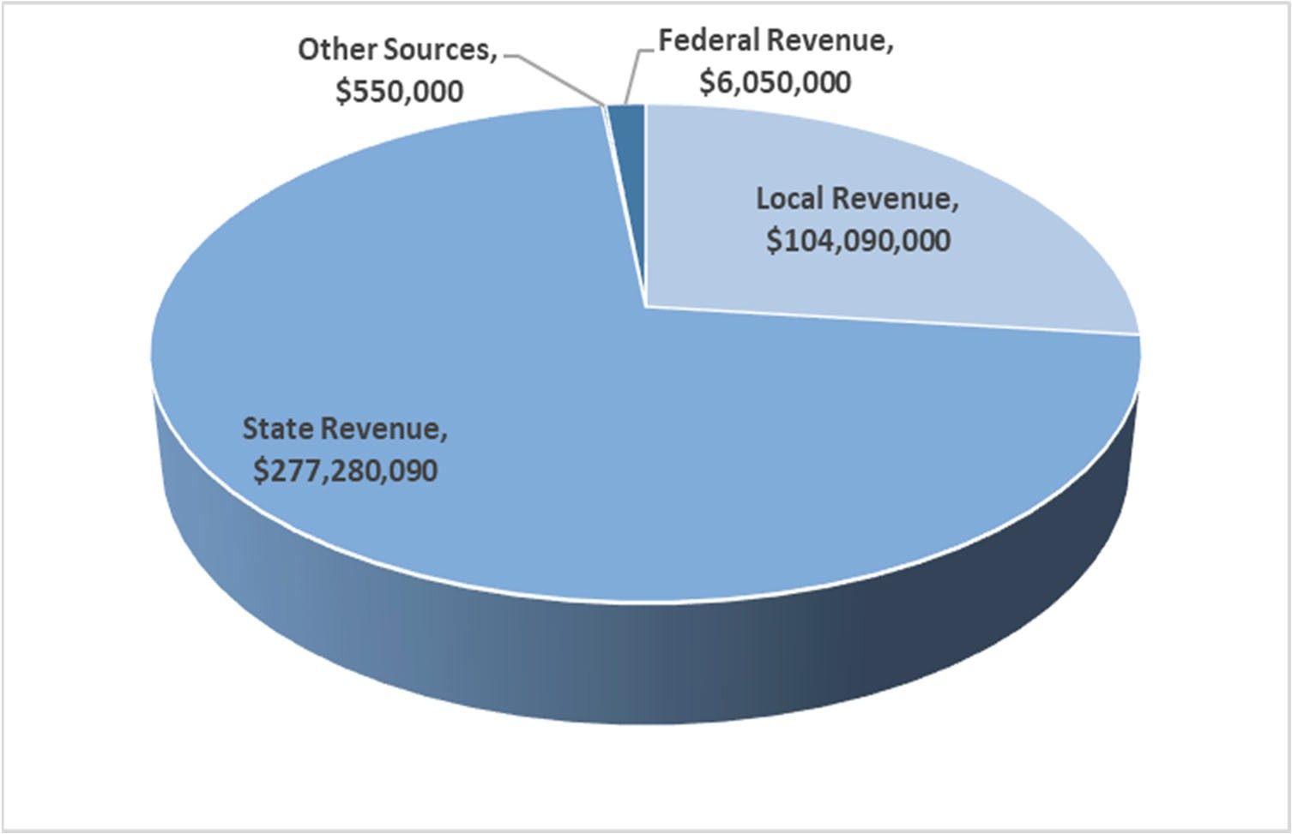
MISD Adopted Budget

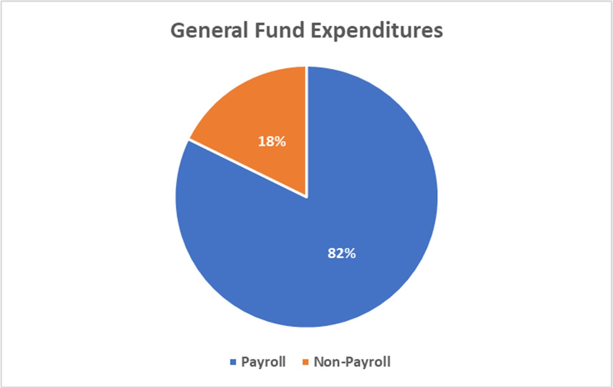
2021‐22 General Fund Expenditures Table 2

MISD Adopted Budget

General Fund

 | 2018 AUDITED |  | 2019 AUDITED |  | 2020 AUDITED |  | 2021 UNAUDITED |  | 2022 BUDGET
Revenue
Local Revenue | $ 90,177,275 |  | $ 96,682,292 |  | $ 96,941,792 |  | $ 101,203,370 |  | $ 104,090,000
State Revenue | $ 264,513,649 |  | $ 260,207,642 |  | $ 275,692,363 |  | $ 277,559,621 |  | $ 277,280,090
Federal Revenue | $ 3,448,413 |  | $ 5,471,042 |  | $ 3,974,706 |  | $ 2,725,372 |  | $ 6,050,000
Other Sources | $ 563,534 |  | $ 3,522,350 |  | $ 431,602 |  | $ 433,671 |  | $ 550,000
Total Revenue | $ 358,702,871 |  | $ 365,883,325 |  | $ 377,040,463 |  | $ 381,922,034 |  | $ 387,970,090
Expenditures
General | $ 814,256 |  | $ 742,684 |  | $ 7,010,724 |  | $ 621,522 |  | $ 1,000,000
Instruction | $ 210,892,298 |  | $ 209,438,154 |  | $ 211,537,349 |  | $ 199,902,568 |  | $ 244,738,283
Instructional Resource & Media | $ 6,000,597 |  | $ 5,882,019 |  | $ 6,231,567 |  | $ 5,710,879 |  | $ 6,051,440
Curriculum & Staﬀ Dev. | $ 3,482,493 |  | $ 3,701,145 |  | $ 3,829,566 |  | $ 3,387,228 |  | $ 5,432,811
Instructional Leadership | $ 6,953,162 |  | $ 6,677,436 |  | $ 6,889,245 |  | $ 6,493,162 |  | $ 7,680,033
School Administration | $ 18,898,998 |  | $ 19,250,135 |  | $ 19,744,667 |  | $ 16,858,513 |  | $ 21,948,080
Guidance & Counseling | $ 15,099,774 |  | $ 15,162,939 |  | $ 16,426,436 |  | $ 15,106,612 |  | $ 18,731,150
Social Work Services | $ 238,317 |  | $ 215,054 |  | $ 220,715 |  | $ 195,621 |  | $ 259,100
Health Services | $ 3,837,759 |  | $ 3,896,096 |  | $ 3,994,529 |  | $ 3,791,494 |  | $ 4,521,650
Student Transportation | $ 5,317,301 |  | $ 6,599,516 |  | $ 6,623,511 |  | $ 5,340,216 |  | $ 7,322,600
Food Services | $ 1,138,656 |  | $ 1,262,468 |  | $ 1,228,215 |  | $ 1,140,450 |  | $ 1,531,500
CoCurricular/Extra Curricular | $ 9,921,683 |  | $ 11,241,040 |  | $ 9,224,421 |  | $ 7,311,956 |  | $ 9,026,500
General Administration | $ 8,269,954 |  | $ 8,481,423 |  | $ 9,190,688 |  | $ 8,369,318 |  | $ 10,636,900
Plant Maintenance & Operating | $ 33,567,139 |  | $ 34,940,324 |  | $ 35,540,863 |  | $ 33,099,076 |  | $ 38,106,250
Security & Monitoring Services | $ 3,305,098 |  | $ 3,786,211 |  | $ 4,166,518 |  | $ 3,543,564 |  | $ 4,259,450
Data Processing Services | $ 7,101,943 |  | $ 8,220,691 |  | $ 10,569,719 |  | $ 11,032,104 |  | $ 12,988,350
Community Services | $ 261,669 |  | $ 268,666 |  | $ 264,579 |  | $ 213,923 |  | $ 254,650
Debt Services | $ | ‐ | $ | ‐ | $ | ‐ | $ | ‐ | $ | ‐
FAC Acquisition/Construction | $ 27,593,017 |  | $ 15,326,000 |  | $ 13,871,132 |  | $ 1,707,456 |  | $ 4,940,950
Juvenile Justice Alternative | $ 63,762 |  | $ 50,424 |  | $ 23,484 |  | $ 25,488 |  | $ 130,000
Tax Increment Fund | $ 3,627,332 |  | $ 3,216,776 |  | $ 3,183,867 |  | $ ‐ |  | $ ‐
Other Intergovernmental | $ 368,753 |  | $ 406,205 |  | $ 419,493 |  | $ 436,161 |  | $ 420,000
Total Expenditures | $ 366,753,962 |  | $ 358,765,407 |  | $ 370,191,287 |  | $ 324,287,311 |  | $ 399,979,697
Beginning Fund Balance | $ 120,343,707 |  | $ 112,292,616 |  | $ 119,410,534 |  | $ 126,259,710 |  | $ 183,894,433
Ending Fund Balance | $ 112,292,616 |  | $ 119,410,534 |  | $ 126,259,710 |  | $ 183,894,433 |  | $ 171,884,826

Student Nutrition Fund

 | 2018 AUDITED | 2019 AUDITED | 2020 AUDITED | 2021 UNAUDITED |  | 2022 BUDGET
Local Revenue
Earnings From Investments | $ 91,664 | $ 193,850 | $ 115,455 | $ 38,841 |  | $ 115,000
Gifts & Bequests | $ ‐ | $ ‐ | $ 60,000 | $ 7,413 |  | $ 60,000
Misc/Fines, Wellness, & Etc. | $ 69,285 | $ 46,476 | $ 53,689 | $ 15,818 |  | $ 53,000
Food Services Activity | $ 3,325,457 | $ 3,130,188 | $ 2,126,072 | $ 1,081,727 |  | $ 2,119,000
Extra/Cocurricular Activity | $ ‐ | $ ‐ | $ ‐ | $ ‐ |  | $ ‐
Activity Fund | $ ‐ | $ 462 |  |  |  | $ ‐
Transfer In | $ 64,224 | $ 41,329 | $ 32,058 | $ |  | $ 75,000
Other/Non‐Revenue | $ ‐ | $ ‐ | $ ‐ | $ ‐ |  | $ ‐
Grand Total | $ 3,550,630 | $ 3,412,304 | $ 2,387,274 | $ 1,143,799 |  | $ 2,422,000
State Revenue | 2018 AUDITED | 2019 AUDITED | 2020 AUDITED | 2021 | UNAUDITED | 2022 BUDGET
Miscellaneous State Programs | $ 127,614 | $ 124,976 | $ 121,564 | $ | ‐ | $ 110,700
Other State Agencies | $ 146,059 | $ 183,608 | $ 1,728,776 | $ | ‐ | $ 1,115,000
Grand Total | $ 273,673 | $ 308,585 | $ 1,850,340 | $ | ‐ | $ 1,225,700
Federal Revenue | 2018 AUDITED | 2019 AUDITED | 2020 AUDITED | 2021 UNAUDITED |  | 2022 BUDGET
School Breakfast Program | $ 3,423,909 | $ 3,450,297 | $ 3,075,166 | $ 1,664,133 |  | $ 2,706,000
National School Lunch | $ 14,013,847 | $ 13,939,615 | $ 10,501,651 | $ 7,475,345 |  | $ 11,016,000
USDA Donated Commodities | $ 1,717,639 | $ 1,675,144 | $ 1,699,613 | $ 1,841,360 |  | $ 2,143,000
Other Federal Revenues  Direct Federal Revenue | $ ‐  $ ‐ | $ ‐ | $ ‐ | $ ‐  $ ‐ |  | $ ‐  $ ‐
Grand Total | $ 19,155,395 | $ 19,065,056 | $ 15,276,430 | $ 10,980,838 |  | $ 15,865,000

Table 4 (cont.)

2018 AUDITED 2019 AUDITED 2020 AUDITED 2021 UNAUDITED 2022 BUDGET
Expenditures

Payroll Costs | $ 8,701,961 | $ 8,430,241 | $ 8,469,165 | $ 6,927,615 | $ ‐
Contracted Services | $ 154,950 | $ 127,701 | $ 90,190 | $ 27,947 | $ 420,400
Supplies & Materials | $ 11,378,993 | $ 11,490,337 | $ 10,107,110 | $ 7,683,983 | $ 15,113,698
Other Operating Cost | $ 37,839 | $ 28,724 | $ 24,307 | $ 74,829 | $ 77,500
Fixed Assets | $ 1,156,370 | $ 2,217,303 | $ 918,259 | $ 58,098 | $ 1,592,000
Other Uses | $ 391,200 | $ 391,200 | $ 391,200 | $ ‐ | $ ‐
Grand Total | $ 21,821,313 | $ 22,685,506 | $ 20,000,230 | $ 14,772,472 | $ 17,203,598
Beginning Fund Balance | $ 5,995,589 | $ 7,153,974 | $ 7,254,412 | $ 6,768,226 | $ 4,120,391
Ending Fund Balance | $ 7,153,974 | $ 7,254,412 | $ 6,768,226 | $ 4,120,391 | $ 6,429,493

Table 5
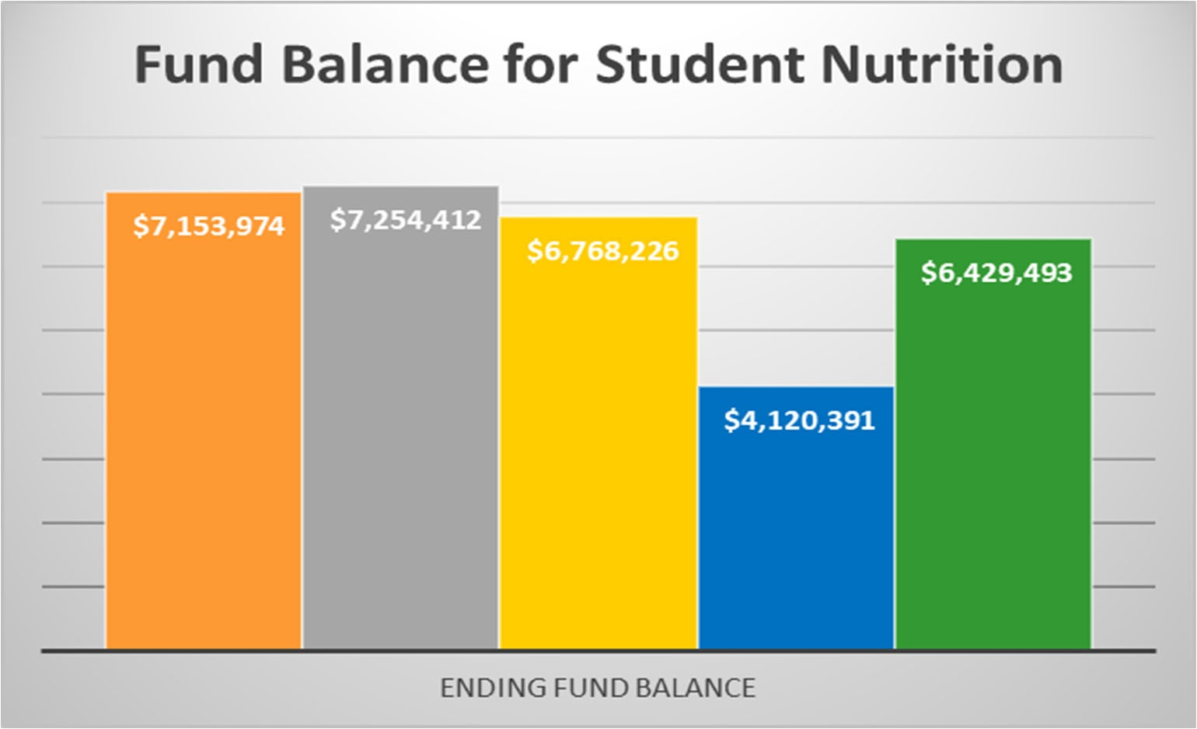
MISD 2020‐21 Financial Unaudited

Table 6
Mesquite Independent School District Debt Service Fund

2018 AUDITED 2019 AUDITED 2020 AUDITED 2021 UNAUDITED 2022 BUDGET

Local Revenue
Taxes, Current Year Levy | $ 31,305,319 |  | $ 39,049,957 |  | $ 42,681,897 |  | $ 45,985,189 |  | $ 47,050,000
Taxes Prior Year | $ 257,984 |  | $ 173,028 |  | $ 322,890 |  | $ 291,891 |  | $ ‐
Penalties, Interest & Other TA | $ 347,748 |  | $ 452,931 |  | $ 460,346 |  | $ 506,989 |  | $ ‐
Earnings From Investments | $ 895,547 |  | $ 1,336,037 |  | $ 783,387 |  | $ 15,833 |  | $ 50,000
Grand Total | $ 32,806,598 |  | $ 41,011,953 |  | $ 44,248,520 |  | $ 46,799,902 |  | $ 47,100,000
State Revenue  Misc. State Programs | $ 24,619,635 |  | $ 24,037,151 |  | $ 20,376,022 |  | $ 17,274,832 |  | $ 10,500,000
Grand Total | $ 24,619,635 |  | $ 24,037,151 |  | $ 20,376,022 |  | $ 17,274,832 |  | $ 10,500,000
Expenditures
Bond Principal | $ 26,395,260 |  | $ 28,778,582 |  | $ 24,405,378 |  | $ ‐ |  | $ 19,400,000
Interest on Bonds | $ 25,708,508 |  | $ 33,776,656 |  | $ 35,627,559 |  | $ 16,445,815 |  | $ 37,600,000
Debt Service Fees | $ 206,547 |  | $ 197,868 |  | $ 394,629 |  | $ 249,902 |  | $ 600,000
Grand Total | $ 52,310,315 |  | $ 62,753,106 |  | $ 60,427,565 |  | $ 16,695,716 |  | $ 57,600,000
Other Financing Sources
Refunding Bond Issuance | $ | ‐ | $ | ‐ | $ | (11,940,000) | $ | (14,780,000) | $ | ‐
Sale of Bonds | $ | ‐ | $ ‐ |  | $ | ‐ | $ | ‐ | $ ‐
Transfer In | $ | ‐ | $ ‐ |  | $ | ‐ | $ | ‐ | $ ‐
Premium/Discount | $ | ‐ | $ ‐ |  | $ (2,001,805) |  | $ (1,633,143) |  | $ ‐
Other Resources | $ | ‐ | $ ‐ |  | $ ‐ |  | $ ‐ |  | $ ‐
Other Uses | $ | ‐ | $ ‐ |  | $ 14,137,135 |  | $ 16,364,219 |  | $ ‐
Grand Total | $ | ‐ | $ ‐ |  | $ 195,330 |  | $ (48,924) |  | $ ‐
Beginning Fund Balance | $ 17,088,628 |  | $ 22,204,546 |  | $ 24,500,544 |  | $ 28,892,851 |  | $ 76,222,945
Ending Fund Balance | $ 22,204,546 |  | $ 24,500,544 |  | $ 28,892,851 |  | $ 76,222,945 |  | $ 76,222,945

General Obligation Debt

For the past decade and the foreseeable future, the District has and will continue to experience bond elections authorizing new bonds an a continual issuance of bonds. In the past, the District has received a primary bond rating of AAA through the State of Texas Permanent School Fund (PSF). The District’s underlying rating from Fitch was an AA+ and S&P rating was AA.

The state funding formula provides for two types of debt service support—the Instructional Facility Allotment (IFA) and the Existing Debt Allotment (EDA). These allotments are both weighted to take into consideration the property wealth per student of the receiving districts.

The Legislature’s practice of rolling forward new debt into EDA ensures that MISD’s debt is equalized to the highest levels.

IFA funds target debt repayment for new construction, and due to limited funding at the state level, Mesquite ISD continues to receive funds from the IFA. The District expects to receive approximately
$2.1 million.

The EDA funding, created in 1999 supports the repayment of debt that is already outstanding. The District expects to receive $9.8 million.

For 2021‐22, the Debt Service Fund has budgeted revenues for $57,600,000. The debt service tax rate is estimated to be $0.44.

The major growth in enrollment over the past ten years has caused the District to call for several bond elections to authorize construction of new school facilities. The District’s financial advisor, Jason Hughes with First Southwest, works with the District to eﬀectively structure its debt capacity.

General Obligation Bonds

The primary type of bond debt instrument is the General Obligation Bond. This debt instrument re‐ quires voter approval. Mesquite ISD’s rating as stated below by Fitch and Standard & Poor is due to excellent financial and administrative practices.

The following table depicts bonded debt facts:

Table 7
The Districts AA from S&P:
“Sustained very strong finance with available reserves averaging slightly more than 30% of expenditures during the past four fiscal years.”
The District’s AA+ rating from Fitch:
“The district has demonstrated a strong commitment to supporting financial flexibility. Budgeting is conservative and typically includes capital projects and management has been proactive in maintaining operational balance throughout economic cycles”
AAA
AA+Fitch AAStandards & Poor
Bond Rate (Texas Permanent School Guaranteed)
Bond Rate (underlying)
$748,039,388.90
Outstanding Bonded Debt as of 6‐30‐21.
MISD Debt Book‐Hilltop Securities

* The Bond Debt Service schedule is located in Table 39 on page 142.

Capital Projects

This governmental fund budgeted at $ 37,342,800 for 2021‐22 is established to account for proceeds on the modified accrual basis from the sale of bonds and other resources to be used for Board authorized acquisition, construction, or renovation as well as furnishing and equipping of major capital facilities.

The last bond package was approved in May 2018. The bond included Woolley Middle School, Elementary School #34, Vanguard High School, athletic updates, roofs, and expansions to several of our facilities, technology infrastructure updates, and additional school buses.

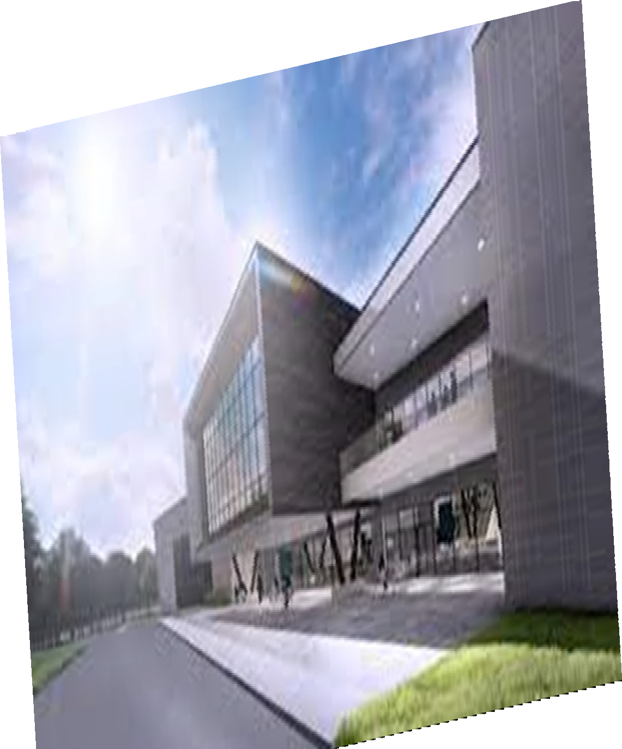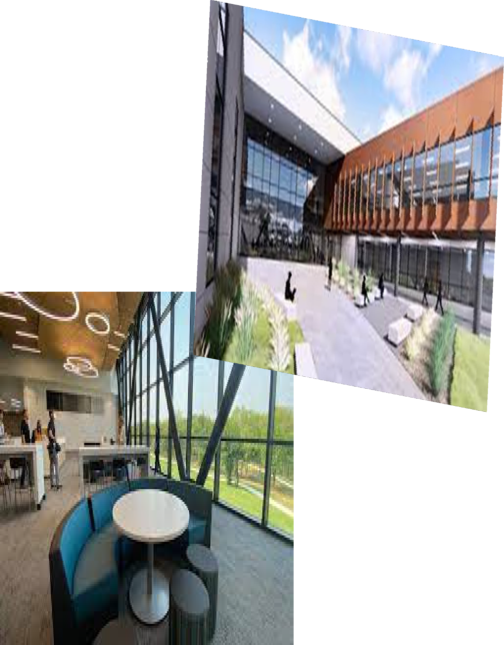

Mesquite Independent School District Internal Service Funds
Executive Summary
Mesquite ISD Oﬃcial Budget 2021‐2022
25

 |  | Employee Health Center Fund |  |  | Workers Compensation Fund
 | 2019 AUDITED | 2020 AUDITED | 2021 UNAUDITED | 2019 AUDITED | 2020 AUDITED | 2021 UNAUDITED
Revenue
Charges for services | $ 3,725,105 | $ 3,654,953 | $ 3,148,558 | $ 1,100,000 | $ 1,100,000 | $ 1,329,148
Earnings | $ 7,248 | $ 1,447 | $ 37 | $ 159 | $ 158 | $ ‐
Grand Total | $ 3,732,353 | $ 3,656,400 | $ 3,148,595 | $ 1,100,159 | $ 1,100,158 | $ 1,329,148
Expenditures
Personal services | $ 1,286,152 | $ 1,374,728 | $ 1,209,410 | $ 236,486 | $ 251,194 | $ 216,864
Professional and contractual services | $ 87,661 | $ 61,791 | $ 45,400 | $ 15,221 | $ 13,913 | $ 14,040
Supplies and materials | $ 2,986,890 | $ 2,728,529 | $ 2,324,738 | $ 10,396 | $ 9,694 | $ 5,169
Insurance claims and expenses | $ 33,608 | $ 40,600 | $ 40,987 | $ 1,198,568 | $ 948,058 | $ 558,876
Other operating costs | $ 4,156 | $ 3,409 | $ 13,100 | $ 16,721 | $ 12,930 | $ 12,930
Grand Total | $ 4,398,467 | $ 4,209,057 | $ 3,633,635 | $ 1,477,392 | $ 1,235,789 | $ 807,879
Loss before transfers | $ (666,114) | $ (552,657) | $ (485,040) | $ (377,233) | $ (135,631) | $ 521,269
Transfers in | $ 261,985 | $ 311,998 | $ 588,573 | $ ‐ | $ ‐ | $ ‐
Change in net position | $ (404,129) | $ (240,659) | $ 103,533 | $ (377,233) | $ (135,631) | $ 521,269
Net position‐beginning | $ 827,885 | $ 423,756 | $ 183,097 | $ 1,629,014 | $ 1,251,781 | $ 1,116,150
Net position ‐ending | $ 423,756 | $ 183,097 | $ 286,630 | $ 1,251,781 | $ 1,116,150 | $ 1,637,419

Mesquite Independent School District Taxable Values and Tax Rate

The appraisal process is conducted by the Dallas County Appraisal District (DCAD). Properties are re‐ quired to be appraised at 100% of market value as of January 1. A ten percent appraisal cap controls runaway property value growth. The DCAD submits preliminary values to the school district by May 1. These values are usually a conservative estimate of the final certified values that are provided by July 25th. The preliminary values are good estimates upon which to base the tax levies for the operating and debt service budgets. Once the certified values are received by the district, the tax rate adoption and budgeting process can be completed for the new fiscal year. The tax year 2021 value we use for the 2021‐22 budget.

Table 8
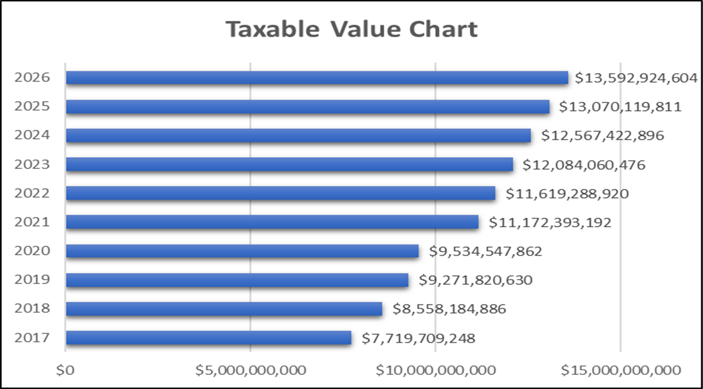
Taxable Value Projections
Dallas County Appraisal District

For budget purposes, the tax levy is computed from the New Taxable Value at a 99% collection rate. The actual taxes to be collected on the Freeze Taxable Values are added back. The Freeze Taxable Val‐ ue is the property values of citizens over 65 years old. When a taxpayer on a homesteaded property turns 65, the taxes are frozen and can only increase if the home is enlarged. The combination of the Net Taxable Value levy on Frozen Values the Total Levy for the year.

The Maintenance and Operations tax rate supports the major educational and operational programs of the District for such expenses as staﬀ salaries, utilities, supplies, materials, equipment, etc. The M&O rate for 2021‐22 is $ 0.8720.

The Debt Service rate tax rate supports payments of principal and interest for the debt authorized by the voters. The total amount of debt service payable each year less any state aid is divided by the taxable property values to determine the rate. For the 2021‐22, the debt service rate is $0.44 which is a four cent decrease from the 202‐21 year.

Table 9

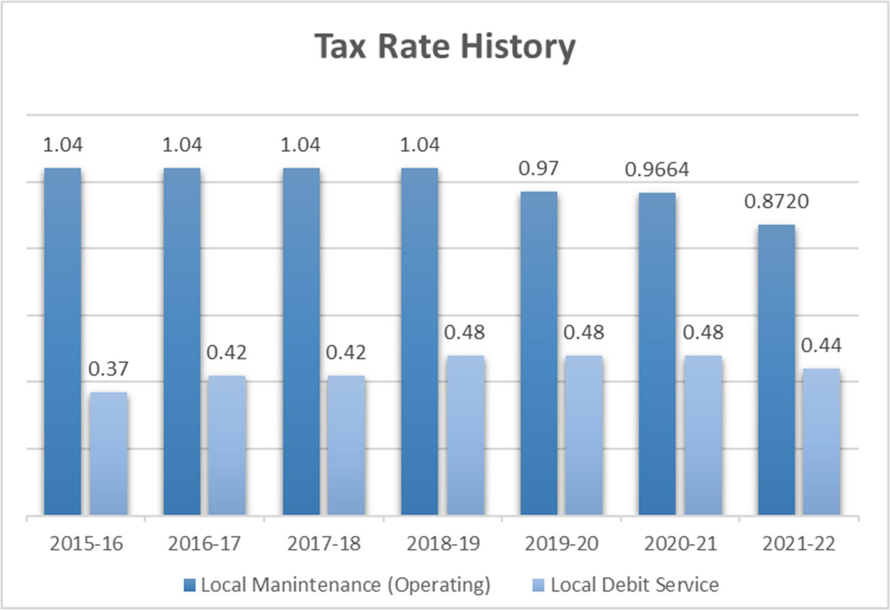

The yearly impact of the M&O tax rate and the Debt Service (Interest & Sinking or I&S) tax rate for the District’s taxpayers is shown in Table 8. The numbers show the eﬀect of the total tax rate along with the increases in property values over the past several years. The table uses the average home value in the District over the past 8 years to reflect the tax increase trend.

Table 10
Tax Rate Impact to District’s Taxpayers

 | 2017‐18 | 2018‐19 | 2019‐20 | 2020‐21 | 2021‐22
Assessed/Market Value of a Home | $ 128,823 | $ 146,319 | $ 147,608 | $ 169,135 | $ 173,364
Average Taxable Value | $ 99,152 | $ 113,294 | $ 115,607 | $ 138,608 | $ 143,468
Total Property Tax Rate | $ 1.46 | $ 1.52 | $ 1.45 | $ 1.4464 | $ 1.312
Property Tax Due | $ 1,447.62 | $ 1,722.06 | $ 1,676.30 | $ 2,004.83 | $ 1,882.30
Increase in Taxes | $ 193.76 | $ 274.44 | $ (45.76) | $ 328.53 | $ (122.53)
Property Tax Percent Increase from Prior Year | 15.5% | 19.0% | ‐2.7% | 19.6 % | ‐6.1%

This schedule shows the trends in property values and tax rates. Each year the Dallas County Appraisal District appraises property based on market conditions such as sales in the surrounding areas. The above schedules show how market conditions have aﬀected the assessed value through 2021‐22 based on the overall appraisal value trends in the District. As shown above, the average value of a residence in the District continues to rise annually.

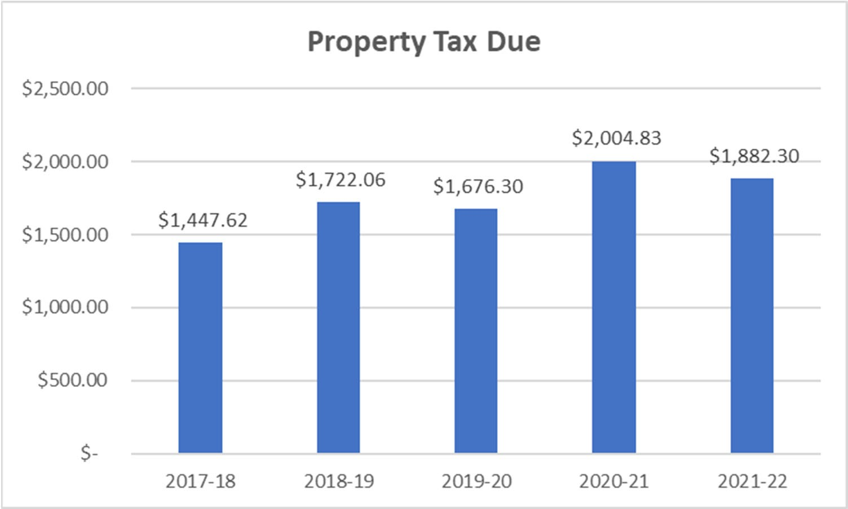
Table 11

Mesquite Independent School District Enrollment Growth

Student enrollment numbers for Mesquite Independent School District are declining. Total K‐12 enrollment was 38,381 in 2020 to 37,735 in 2021.

The 2021‐22 school year will see a minimal decrease in enrollment from the prior year.

The previous enrollment growth along with a demographers estimate that the District will continue to experience some annual growth starting in the next 35 years.

As subdivisions identified by the demographers begin to build homes and apartments, the District expects to experience annual growth beginning in school year 2022‐23 through 2029‐30.

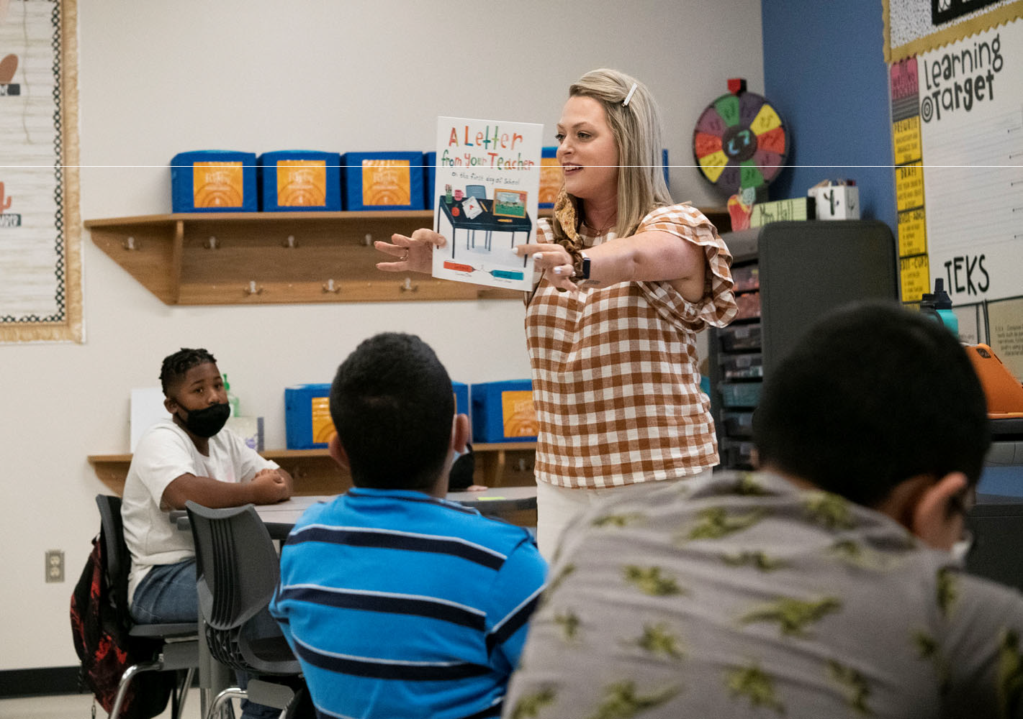

Table 12
Executive Summary
Mesquite ISD Oﬃcial Budget 2021‐2022
30

Mesquite ISD Student Enrollment Summary

Campus Type | Actual 2017‐18 | Actual 2018‐19 | Actual 2019‐20 | Actual 2020‐21 | Current Year 2021‐22 | Projected 2021‐22 | Projected 2022‐23 | Projected 2023‐24 | Projected 2024‐25
High Schools | 12,023 | 12,367 | 12,029 | 12,105 | 12,279 | 12,192 | 12,571 | 12,737 | 12,720
Middle Schools | 7,163 | 9,973 | 9,907 | 9,570 | 9,189 | 9,440 | 9,174 | 8,701 | 8,456
Elementary Schools | 21,643 | 18,497 | 17,695 | 16,701 | 16,266 | 16,518 | 16,444 | 16,533 | 16,684
Mesquite Academy | 187 | 280 | * | * | *
JJAEP |  |  | 7 | 5 | 1 | 4 | 4 | 4 | 4
Total Enrollment | 41,016 | 41,117 | 39,638 | 38,381 | 37,735 | 38,154 | 38,193 | 37,975 | 37,864

* Student enrollment included in high school count.
Student Information System (as of September 3, 2021)

Table 13
Executive Summary
Mesquite ISD Oﬃcial Budget 2021‐2022
31
Mesquite ISD Student Enrollment by Campus

Campus | Actual 2017‐18 | Actual 2018‐19 | Actual 2019‐20 | Actual 2020‐21 | Current Year 2021‐22 | Projected 2021‐22 | Projected 2022‐23 | Projected 2023‐24 | Projected 2024‐25
Mesquite High School | 2,904 | 2,829 | 2,625 | 2,561 | 2345 | 2,574 | 2,660 | 2,724 | 2,648
North Mesquite High School | 2,808 | 2,864 | 2,522 | 2,415 | 2169 | 2,346 | 2,358 | 2,358 | 2,328
West Mesquite High School | 2,077 | 2,137 | 2,162 | 2,280 | 2223 | 2,422 | 2,549 | 2,545 | 2,490
Poteet High School | 1,848 | 1,853 | 1,822 | 1,750 | 1651 | 1,730 | 1,729 | 1,687 | 1,700
Horn High School | 2,386 | 2,684 | 2,898 | 3,099 | 3089 | 3,120 | 3,275 | 3,423 | 3,554
Vanguard High School | 0 | 0 | 0 | 0 | 802
Agnew Middle School | 831 | 1,280 | 1,228 | 1,227 | 1153 | 1,147 | 1,114 | 1019 | 1066
Vanston Middle School | 805 | 969 | 923 | 847 | 856 | 878 | 837 | 798 | 714
Wilkinson Middle School | 974 | 926 | 790 | 797 | 724 | 768 | 733 | 659 | 633
McDonald Middle School | 1,002 | 909 | 908 | 923 | 840 | 876 | 829 | 798 | 798
New Middle School | 926 | 931 | 935 | 831 | 797 | 852 | 800 | 737 | 697
Kimbrough Middle School | 825 | 1,222 | 1,357 | 1,260 | 1188 | 1,243 | 1,249 | 1,232 | 1,167
Berry Middle School | 904 | 1,116 | 1,103 | 613 | 601 | 636 | 635 | 699 | 704
Terry Middle School | 896 | 1,440 | 1,463 | 1,039 | 1056 | 1,061 | 1,015 | 916 | 869
Fraiser Middle School | 0 | 1,180 | 1,200 | 1,126 | 1087 | 1,076 | 1,001 | 929 | 877
Woolley Middle School | 0 | 0 | 0 | 907 | 887 | 903 | 961 | 914 | 931
Black Elementary School | 639 | 606 | 656 | 626 | 634 | 621 | 610 | 622 | 617
Florence Elementary School | 654 | 543 | 548 | 467 | 482 | 458 | 450 | 441 | 428
Galloway Elementary School | 732 | 489 | 461 | 420 | 418 | 394 | 382 | 374 | 374
Hanby Elementary School | 929 | 835 | 838 | 740 | 689 | 749 | 740 | 750 | 757
Hodges Elementary School | 767 | 610 | 545 | 514 | 512 | 498 | 500 | 491 | 489
McWhorter Elementary School | 870 | 719 | 633 | 549 | 496 | 516 | 481 | 477 | 477
Motley Elementary School | 455 | 370 | 338 | 276 | 250 | 253 | 243 | 241 | 250
Range Elementary School | 763 | 653 | 601 | 580 | 572 | 571 | 562 | 553 | 532
Rugel Elementary School | 458 | 355 | 355 | 321 | 293 | 302 | 308 | 308 | 305
Rutherford Elementary School | 474 | 645 | 659 | 648 | 657 | 659 | 658 | 652 | 631
Shands Elementary School | 825 | 655 | 629 | 622 | 544 | 596 | 600 | 582 | 580
Tisinger Elementary School | 824 | 819 | 660 | 631 | 648 | 614 | 624 | 621 | 621
Tosch Elementary School | 872 | 658 | 594 | 617 | 585 | 626 | 621 | 626 | 644
Seabourn Elementary School | 724 | 700 | 661 | 578 | 608 | 594 | 592 | 600 | 606
Lawrence Elementary School | 440 | 368 | 334 | 283 | 261 | 255 | 248 | 243 | 254
Floyd Elementary School | 798 | 579 | 604 | 455 | 428 | 452 | 466 | 480 | 477
Porter Elementary School | 605 | 427 | 421 | 389 | 374 | 368 | 375 | 356 | 354

Table 13 (cont.)
Executive Summary
Mesquite ISD Oﬃcial Budget 2021‐2022
32

Mesquite ISD Student Enrollment by Campus (cont.)

Campus | Actual 2017‐18 | Actual 2018‐19 | Actual 2019‐20 | Actual 2020‐21 | Current Year 2021‐22 | Projected 2021‐22 | Projected 2022‐23 | Projected 2023‐24 | Projected 2024‐25
McKenzie Elementary School | 538 | 493 | 454 | 414 | 390 | 415 | 412 | 401 | 403
Beasley Elementary School | 467 | 378 | 374 | 359 | 369 | 355 | 341 | 345 | 346
Price Elementary School | 451 | 359 | 348 | 299 | 311 | 298 | 298 | 304 | 312
Shaw Elementary School | 884 | 582 | 577 | 555 | 514 | 548 | 533 | 537 | 530
Kimball Elementary School | 242 | 192 | 188 | 211 | 214 | 224 | 225 | 247 | 252
Pirrung Elementary School | 434 | 438 | 392 | 396 | 388 | 392 | 383 | 377 | 375
Cannaday Elementary School | 564 | 575 | 590 | 582 | 570 | 580 | 569 | 563 | 574
Austin Elementary School | 471 | 471 | 390 | 343 | 323 | 345 | 345 | 349 | 358
Moss Elementary School | 434 | 391 | 380 | 323 | 317 | 322 | 316 | 318 | 311
Thompson Elementary School | 565 | 529 | 523 | 566 | 566 | 571 | 563 | 557 | 562
Gray Elementary School | 634 | 512 | 450 | 431 | 412 | 431 | 431 | 436 | 450
Smith Elementary School | 494 | 425 | 437 | 545 | 541 | 564 | 583 | 594 | 613
Gentry Elementary School | 916 | 654 | 617 | 624 | 595 | 613 | 633 | 667 | 722
Mackey Elementary School | 788 | 678 | 615 | 650 | 663 | 639 | 633 | 644 | 649
Achziger Elementary School | 971 | 854 | 912 | 827 | 816 | 847 | 903 | 963 | 1,015
Henrie Elementary School | 961 | 935 | 911 | 860 | 826 | 848 | 816 | 814 | 816
Mesquite Academy | 187 | 280 | * | * | *
JJAEP |  |  | 7 | 5 | 1 | 4 | 4 | 4 | 4
TOTAL | 41,016 | 41,117 | 39,638 | 38,381 | 37,735 | 38,154 | 38,193 | 37,975 | 37,864

* Student enrollment included in high school count.
District Demographic Report‐2021

Mesquite Independent School District Staﬃng

The data below shows the 5‐year history of the Districts staﬃng by employee group, student enrollment and teaching and total staﬀ‐to‐student ratios. Starting in the 2019‐20 school year there were increases in the professional support, school leadership, and central administration categories due to the following three factors: 1) the Texas state legislature passed HB‐3 which increased funding for Texas school districts, 2) HB‐3 added three new allotments (Dyslexia, Early Childhood, and College, Career and Military Readiness Allotments, and 3) MISD added teachers, professional supports, school leadership, and central administration positions to focus on building and enhancing leadership development throughout the district.

The teaching staﬀ and total staﬀ‐to‐student ratios have decreased over the past two‐years mainly due to a temporary drop in enrollment due to the COVID‐19 pandemic in the 2020‐21 school year, coupled with the additional positions which have been provided to help Mesquite ISD meet its goals as stated in the ‘Strategic Roadmap’.

Table 14
Mesquite Independent School District Staﬃng History

School Years  Teachers  (Classroom, Interventionists, Special Programs) | 17‐18  2,738 | 18‐19  2,748 | 19‐20  2,751 | 20‐21  2,789 | 21‐22  2,870
Professional Support | 532 | 546 | 566 | 585 | 591
(Directors, Counselors, Librarians, Campus Oﬃce Staﬀ,
Central Oﬃce Staﬀ)
School Leadership (Principals, Asst. Principals) | 132 | 133 | 141 | 145 | 148
Central Administration | 11 | 9 | 28 | 30 | 32
(Superintendent, Asst. Superintendents, Cabinet‐Level Positions)
Paraprofessional | 802 | 807 | 810 | 837 | 842
Auxiliary | 1,156 | 1,138 | 1,135 | 1,101 | 1,122
Total Staﬀ | 5,371 | 5.381 | 5,431 | 5,489 | 5,605
Student Enrollment (as of September 3, 2021**) | 41,025 | 41,022 | 39,638 | 38,381 | 37,735*
Staﬃng Ratios
Mesquite ISD | 15.1 | 15.1 | 15.1 | NA | NA
Teaching Staﬀ | 14.98 | 14.93 | 14.41 | 13.76 | 13.15
Total Staﬀ | 7.64 | 7.62 | 7.30 | 6.99 | 6.73
State | 7.57 | 7.53 | 7.46 | NA | NA
*Does not include 466 students who have opted for virtual learning for the first 9‐weeks of the 2021‐22 school year.
**For years 2017‐18 through 2020‐21 the enrollment was based on the District ‘Snapshot Date’ which is the last Friday of October. However, due to MISD changing its fiscal year from September 1 to July 1 the enrollment is as of the first Friday in September for 2021‐22.
TAPR

Mesquite Independent School District Graduation Rates

Table 15
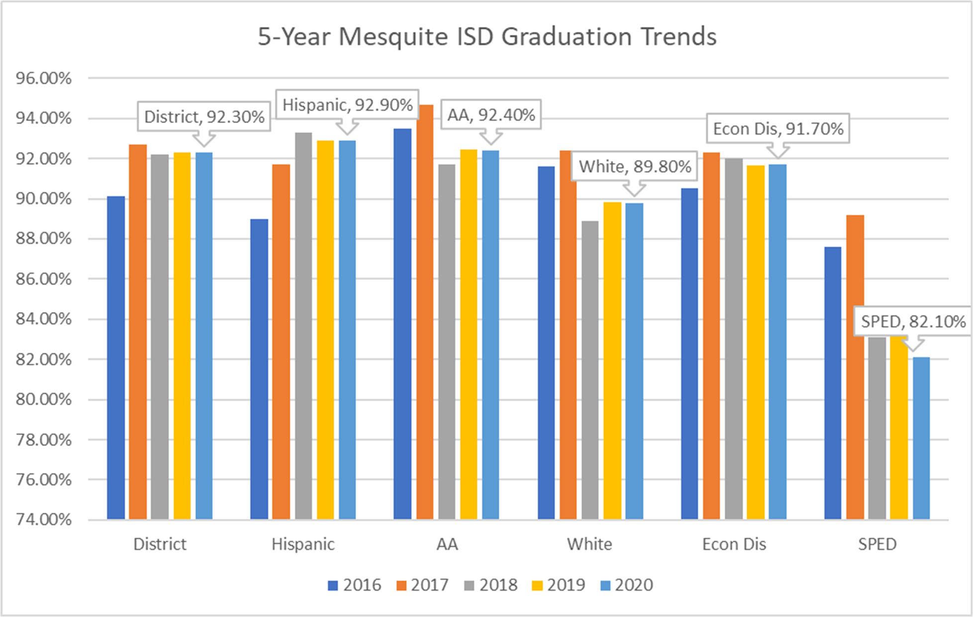
Texas Education Agency‐District TAPER Report

Mesquite ISD maintains one of the highest graduation rates for districts that are similar in demographic makeup and size. Graduation rates remain consistently above the region and the state rates.

Mesquite Independent School District 2021 Accountability Ratings
The STAAR test was administered in 2021 for the first time since 2019. However, due to COVID, new accountability ratings were not given. All campuses retained their “Not Rated” status and 2019 ratings remain in eﬀect. The district retained an 87‐B. All campuses retained their 2019 overall ratings.

Table 16
2019 Accountability Ratings
CAMPUS | OVERALL PERFORMANCE  GRADE
Elementary Schools
Achziger | C
Austin | B
Beasley | B
Black | C
Cannaday | C
Florence | B
Floyd | C
Galloway | B
Gentry | B
Gray | B
Hanby | B
Henrie | B
Hodges | C
Kimball | A
Lawrence | B
Mackey | B
McKenzie | B
McWhorter | C
Moss | B
Motley | A
Pirrung | B
Porter | A
Price | C
Range | C
Rugel | B

CAMPUS | OVERALL PERFORMANCE  GRADE
Rutherford | B
Seabourn | C
Shands | B
Shaw | C
Smith | B
Thompson | C
Tisinger | C
Tosch | C
Middle Schools
Agnew | C
Berry | B
Frasier | C
Kimbrough | C
McDonald | C
New | C
Terry | C
Vanston | C
Wilkinson | A
High Schools
HHS | B
MHS | B
NMHS | B
PHS | B
WMHS | B
Mesquite Academy | Not Rated
Texas Education Agency‐District TAPER Report

Financial Integrity Rating System of Texas (FIRST)

Senate Bill 218 of the 77th Legislature (2001) authorized the implementation of a financial accountability rating system, which is oﬃcially referred to as School FIRST. The primary goal of School FIRST is to improve the management of school district financial resources. School FIRST was developed in consultation with the Comptroller of Public Accounts, and its development also benefited from the many comments that were received from school district and regional education service center personnel. The School FIRST rating is based upon an analysis of staﬀ and student data reported for the school year and actual financial data.

Mesquite ISD received a rating of Superior and a letter grade of A with a score of 96 for 2021.

Each school district must hold an announced public meeting to distribute the financial management report that explains the district’s performance under each of the 20 indicators and the district’s rating. Each district is encouraged to provide additional information in the financial management performance report that is beneficial to taxpayers by noting special circumstance.

Future Budget Years

Budgeted revenue for local taxes and state aid in 2021‐22 are based on the funding laws enacted by the 86th Texas Legislature. All projections for future revenue are based on these laws staying in place.

Enrollment numbers reflect the projections shown by our demographer’s report at the moderate growth rate. The attendance rate of 96% reflects the history of attendance in the district and is used to calculate the Average Daily Attendance (ADA). The ADA is the major driver in determining the amount of state funding for each fiscal year.

The Maintenance and Operations tax rate is decreasing from $0.9664 to $0.8720 per $100 of taxable value due to the M&O tax rate being compressed due to property value growth.

Salary increases were 2.5% and are assumed to be 2% per year along with non‐payroll expenditure increases each year.

Table 17
Mesquite Independent School District Future Budget Years

General Fund | 2021‐2022 | 2022‐2023 | 2023‐2024 | 2024‐2025 | 2025‐2026
Revenues | $ 387,970,090 | $ 387,607,646 | $ 387,837,821 | $ 386,837,821 | $ 387,237,821
Expenditures | $ 399,979,697 | $ 394,979,697 | $ 394,979,697 | $ 394,979,697 | $ 394,979,697
Net | $ (12,009,607) | $ (7,372,051) | $ (7,141,876) | $ (8,141,876) | $ (7,741,876)
Beginning Fund Balance | $ 151,000,000 | $ 138,990,393 | $ 131,618,342 | $ 124,476,466 | $ 116,334,590
Ending Fund Balance | $ 138,990,393 | $ 131,618,342 | $ 124,476,466 | $ 116,334,590 | $ 108,592,714
Debt Service Fund
Revenues | $ 57,600,000 | $ 56,600,000 | $ 56,000,000 | $ 56,000,000 | $ 55,000,000
Expenditures | $ 61,100,000 | $ 56,600,000 | $ 56,000,000 | $ 56,000,000 | $ 55,050,000
Net | $ (3,500,000) | $ ‐ | $ ‐ | $ ‐ | $ (50,000)
Beginning Fund Balance | $ 59,162,208 | $ 62,662,208 | $ 62,662,208 | $ 62,662,208 | $ 62,662,208
Ending Fund Balance | $ 62,662,208 | $ 62,662,208 | $ 62,662,208 | $ 62,662,208 | $ 62,712,208
Student Nutrition Fund
Revenues | $ 19,512,700 | $ 24,000,000 | $ 24,250,000 | $ 24,700,000 | $ 25,000,000
Expenditures | $ 17,203,598 | $ 24,000,000 | $ 24,250,000 | $ 24,700,000 | $ 25,000,000
Net | $ 2,309,102 | $ ‐ | $ ‐ | $ ‐ | $ | ‐
Beginning Fund Balance | $ 6,768,227 | $ 9,077,329 | $ 9,077,329 | $ 9,077,329 | $ 9,077,329
Ending Fund Balance | $ 9,077,329 | $ 9,077,329 | $ 9,077,329 | $ 9,077,329 | $ 9,077,329
Capital Projects Fund
Revenues | $ 3,000,000 | $ 125,000 | $ 50,000
Expenditures | $ 37,342,800 | $ 49,750,000 | $ 17,174,366
Net | $ (34,342,800) | $ (49,625,000) | $ (17,124,366)
Beginning Fund Balance | $ 173,753,366 | $ 139,410,566 | $ 17,124,366
Ending Fund Balance | $ 139,410,566 | $ 89,785,566 | $ ‐

*The District has sold its last authorized amount and the remainder of the Capital Projects Funds will be expended on bond projects.

Table 18
Mesquite ISD Oﬃcial Budget 2021‐2022
38
Mesquite Independent School District Revenue and Budget 5 Year Estimations
Executive Summary

Property Growth Prediction |  |  | 10% |  | 10% |  | 4% |  | 4% |  | 4% |  | 4% |  | 4% |  | 4% |  | 4%
Student Enrollment | 2016‐2017 |  | 2017‐2018 |  | 2018‐2019 |  | 2019‐2020 |  | 2020‐2021 |  | 2021‐2022 |  | 2022‐2023 |  | 2023‐2024 |  | 2024‐25 |  | 2025‐26
Growth Factor Projected‐Demographer (Low) | 40,886 |  | 40,923 |  | 40,888 |  | 40,965 |  | 40,996 |  | 37,816 |  | 37,640 |  | 37,248 |  | 37,005 |  | 36,957
Growth Factor Projected‐Demographer (Moderate) | 40,886 |  | 40,923 |  | 41,053 |  | 41,249 |  | 41,401 |  | 38,152 |  | 38,190 |  | 37,976 |  | 37,864 |  | 37,963
Growth Factor Used for Revenue Planning |  |  | 269 |  | 0 |  | 125 |  | 100 |  | ‐268 |  | 38 |  | ‐213 |  | ‐112 |  | 99
Refined ADA‐Formula | 38,786 |  | 38,530 |  | 38,530 |  | 38,655 |  | 38,755 |  | 36,696 |  | 36,734 |  | 36,521 |  | 36,409 |  | 36,508
Summary of Total State/Local M&O | Audited |  | Audited |  | Audited |  | Audited |  | Budgeted |  | Budgeted |  | Budgeted |  | Budgeted |  | Budgeted |  | Budgeted
Revenue | Revenue |  | Revenue |  | Revenue |  | Revenue |  | Revenue |  | Revenue |  | Revenue |  | Revenue |  | Revenue |  | Revenue
 | 2016‐2017 |  | 2017‐2018 |  | 2018‐2019 |  | 2019‐2020 |  | 2020‐2021 |  | 2021‐2022 |  | 2022‐2023 |  | 2023‐2024 |  | 2024‐25 |  | 2025‐26
State Revenue | $ 264,460,611 |  | $ 264,513,649 |  | $ 260,207,642 |  | $ 275,692,362 |  | $ 283,775,600 |  | $ 277,280,090 |  | $ 275,280,090 |  | $ 273,903,690 |  | $ 271,507,032 |  | $ 271,846,416
Local Revenue | $ 81,681,577 |  | $ 90,177,275 |  | $ 96,682,294 |  | $ 96,941,793 |  | $ 102,936,700 |  | $ 104,090,000 |  | $ 105,727,556 |  | $ 107,334,131 |  | $ 108,730,789 |  | $ 108,791,405
Federal Revenue | $ 3,720,967 |  | $ 3,448,413 |  | $ 5,471,041 |  | $ 3,974,706 |  | $ 6,050,000 |  | $ 6,050,000 |  | $ 6,050,000 |  | $ 6,050,000 |  | $ 6,050,000 |  | $ 6,050,000
Other Sources | $ 425,291 |  | $ 563,534 |  | $ 2,779,666 |  | $ ‐ |  | $ 550,000 |  | $ 550,000 |  | $ 550,000 |  | $ 550,000 |  | $ 550,000 |  | $ 550,000
Total M&O Revenue | $ | 350,288,446 | $ | 358,702,871 | $ | 365,140,643 | $ | 376,608,861 | $ | 393,312,300 | $ | 387,970,090 | $ | 387,607,646 | $ | 387,837,821 | $ | 386,837,821 | $ | 387,237,821
 |  | Audited |  | Audited |  | Audited |  | Audited |  | Budgeted |  | Budgeted |  | Budgeted |  | Budgeted |  | Budgeted |  | Budgeted
 |  | Expenditures |  | Expenditures |  | Expenditures |  | Expenditures |  | Expenditures |  | Expenditures |  | Expenditures |  | Expenditures |  | Revenue |  | Revenue
 |  | 2016‐2017 |  | 2017‐2018 |  | 2018‐2019 |  | 2019‐2020 |  | 2020‐2021 |  | 2021‐2022 |  | 2022‐2023 |  | 2023‐2024 |  | 2024‐25 |  | 2025‐26
Expenditures
General | $ 766,611 |  | $ 814,256 |  | $ |  |  | 6,579,122 | $ 1,000,000 |  | $ 1,000,000 |  | $ 600,000 |  | $ 600,000 |  | $ 600,000 |  | $ 600,000
Instruction | $ 203,626,505 |  | $ 210,892,298 |  | $ 209,440,357 $ |  |  | 211,559,530 | $ 234,546,500 |  | $ 244,738,283 |  | $ 245,764,147 |  | $ 245,764,147 |  | $ 245,764,147 |  | $ 245,764,147
Instructional Resources | $ 5,808,045 |  | $ 6,000,597 |  | $ 5,882,019 $ |  |  | 6,208,669 | $ 6,601,550 |  | $ 6,051,440 |  | $ 6,495,950 |  | $ 6,495,950 |  | $ 6,495,950 |  | $ 6,495,950
Staﬀ Development | $ 3,434,673 |  | $ 3,482,493 |  | $ 3,701,139 $ |  |  | 3,829,566 | $ 5,895,850 |  | $ 5,432,811 |  | $ 5,005,000 |  | $ 5,005,000 |  | $ 5,005,000 |  | $ 5,005,000
Instructional Leadership | $ 6,031,666 |  | $ 6,953,162 |  | $ 6,677,436 $ |  |  | 6,889,245 | $ 8,040,600 |  | $ 7,680,033 |  | $ 7,200,000 |  | $ 7,200,000 |  | $ 7,200,000 |  | $ 7,200,000
School Administration | $ 17,824,237 |  | $ 18,898,998 |  | $ 19,250,145 $ |  |  | 19,745,382 | $ 21,033,450 |  | $ 21,948,080 |  | $ 21,300,000 |  | $ 21,000,000 |  | $ 21,000,000 |  | $ 21,000,000
Guidance & Counseling Services | $ 13,958,037 |  | $ 15,099,774 |  | $ 15,162,952 $ |  |  | 16,426,443 | $ 18,504,900 |  | $ 18,731,150 |  | $ 17,000,000 |  | $ 17,000,000 |  | $ 17,000,000 |  | $ 17,000,000
Social Work Services | $ 217,139 |  | $ 238,317 |  | $ 215,053 $ |  |  | 220,715 | $ 221,500 |  | $ 259,100 |  | $ 220,000 |  | $ 220,000 |  | $ 220,000 |  | $ 220,000
Health Services | $ 3,633,255 |  | $ 3,837,759 |  | $ 3,896,097 $ |  |  | 3,994,527 | $ 4,265,800 |  | $ 4,521,650 |  | $ 4,405,000 |  | $ 4,405,000 |  | $ 4,405,000 |  | $ 4,405,000
Transportation Services | $ 5,533,277 |  | $ 5,317,301 |  | $ 6,599,519 $ |  |  | 6,623,511 | $ 7,683,200 |  | $ 7,322,600 |  | $ 6,850,000 |  | $ 6,850,000 |  | $ 6,850,000 |  | $ 6,850,000
Food Service | $ 1,220,182 |  | $ 1,138,656 |  | $ 1,262,470 $ |  |  | 1,228,214 | $ 1,433,700 |  | $ 1,531,500 |  | $ 1,600,000 |  | $ 1,600,000 |  | $ 1,600,000 |  | $ 1,600,000
Extra Curricular Services | $ 9,705,576 |  | $ 9,921,683 |  | $ 11,241,059 $ |  |  | 9,224,421 | $ 10,075,000 |  | $ 9,026,500 |  | $ 9,250,000 |  | $ 9,250,000 |  | $ 9,250,000 |  | $ 9,250,000
General Administration | $ 7,907,330 |  | $ 8,269,954 |  | $ 8,481,425 $ |  |  | 9,190,689 | $ 9,765,800 |  | $ 10,636,900 |  | $ 9,600,000 |  | $ 9,600,000 |  | $ 9,600,000 |  | $ 9,600,000

Table 18 (cont.)
Executive Summary
Mesquite ISD Oﬃcial Budget 2021‐2022
39

 | Audited  Expenditures | Audited  Expenditures | Audited  Expenditures | Audited  Expenditures | Budgeted  Expenditures | Budgeted  Expenditures | Budgeted  Expenditures | Budgeted  Expenditures | Budgeted  Revenue | Budgeted  Revenue
 | 2016‐2017 | 2017‐2018 | 2018‐2019 | 2019‐2020 | 2020‐2021 | 2021‐2022 | 2022‐2023 | 2023‐2024 | 2024‐25 | 2025‐26
Expenditures
Maintenance | $ 33,739,387 | $ 33,567,139 | $ 34,940,328 | $ 35,540,859 | $ 37,700,950 | $ 38,106,250 | $ 38,000,000 | $ 38,000,000 | $ 38,000,000 | $ 38,000,000
Security | $ 3,408,242 | $ 3,305,098 | $ 3,786,216 | $ 4,166,516 | $ 4,026,400 | $ 4,259,450 | $ 3,850,000 | $ 3,850,000 | $ 3,850,000 | $ 3,850,000
Data Processing | $ 8,230,436 | $ 7,101,943 | $ 8,220,692 | $ 10,569,718 | $ 11,947,000 | $ 12,988,350 | $ 12,000,000 | $ 12,000,000 | $ 12,000,000 | $ 12,000,000
Community Services | $ 112,286 | $ 261,669 | $ 268,672 | $ 264,579 | $ 284,700 | $ 254,650 | $ 279,600 | $ 279,600 | $ 279,600 | $ 279,600
Juvenile Justice Alternative | $ 85,308 | $ 63,762 | $ 15,325,998 | $ 13,871,130 | $ 4,895,200 | $ 130,000 | $ 130,000 | $ 130,000 | $ 130,000 | $ 130,000
Tax Increment Zones | $ 3,416,856 | $ 3,627,332 | $ 50,424 | $ 23,484 | $ 130,000 | $ ‐
FAC Acquisition/Construction | $ 13,343,955 | $ 27,593,017 | $ 3,216,624 | $ 3,183,867 | $ 3,600,000 | $ 4,940,950 | $ 5,000,000 | $ 5,000,000 | $ 5,000,000 | $ 5,000,000
Intergovernmental Charges | $ 344,842 | $ 368,753 | $ 406,205 | $ 419,493 | $ 420,000 | $ 420,000 | $ 430,000 | $ 430,000 | $ 430,000 | $ 430,000

TOTAL EXPENDITURES | $ 342,347,846 | $ 366,753,962 | $ 358,024,830 | $ 369,759,680 | $ 392,072,100 | $ 399,979,697 | $ 394,979,697 | $ 394,679,697 | $ 394,679,697 | $ 394,679,697

Current Fund Balance $ 112,402,842 $ 120,343,442 $ 112,296,013 $ 119,411,826 $ 126,261,007 $ 127,501,207 $ 115,491,600 $ 108,119,549 $ 101,277,673 $ 93,435,796

Revenues ‐ Expenditures $ 7,940,600 | $ (8,051,091) | $ 7,115,813 $ | 6,849,181 | $ 1,240,200 | $ (12,009,607) | $ (7,372,051) | $ (6,841,876) | $ (7,841,876) | $ (7,441,876)
Predicted Fund Balance $ 120,343,442 | $ 112,292,351 | $ 119,411,826 $ | 126,261,007 | $ 127,501,207 | $ 115,491,600 | $ 108,119,549 | $ 101,277,673 | $ 93,435,796 | $ 85,993,921
Board Policy ‐ 22% Fund Balance $ 75,316,526 | $ 80,685,872 | $ 80,330,941 $ | 82,853,949 | $ 86,528,706 | $ 85,353,420 | $ 85,273,682 | $ 85,324,321 | $ 85,104,321 | $ 85,192,321

MISD Internal Data
Black is audited and red is unaudited/forecast budget



Mesquite Independent School District Budget Contact

Individuals who have questions regarding this budget document should contact Pete Pape, Asst. Superintendent for Finance & Operations at 972‐882‐7409 or ppape@mesquiteisd.org. They may also contact Dr. Faith Cheek, Executive Director of Business Services at 972‐882‐7319 or fcheek@mesquiteisd.org.

Budgeting a school district’s revenues and expenditures is a challenging process, especially in times of reduced funding from the state. However, we believe the budget document demonstrates reasonable and prudent eﬀort to provide the needs of the students, families, and community members. It is our goal to provide the best possible education for our students, while being food stewards of the tax‐ payers’ dollars.

We appreciate the support from the Mesquite Independent School Board of Trustees for developing, implementing, and maintaining an excellent education program for the children of our school district.

Dr. David Vroonland Pete D. Pape
Superintendent Assistant Superintendent Finance & Operations

Executive Summary
40 Mesquite ISD Oﬃcial Budget 2021‐2022

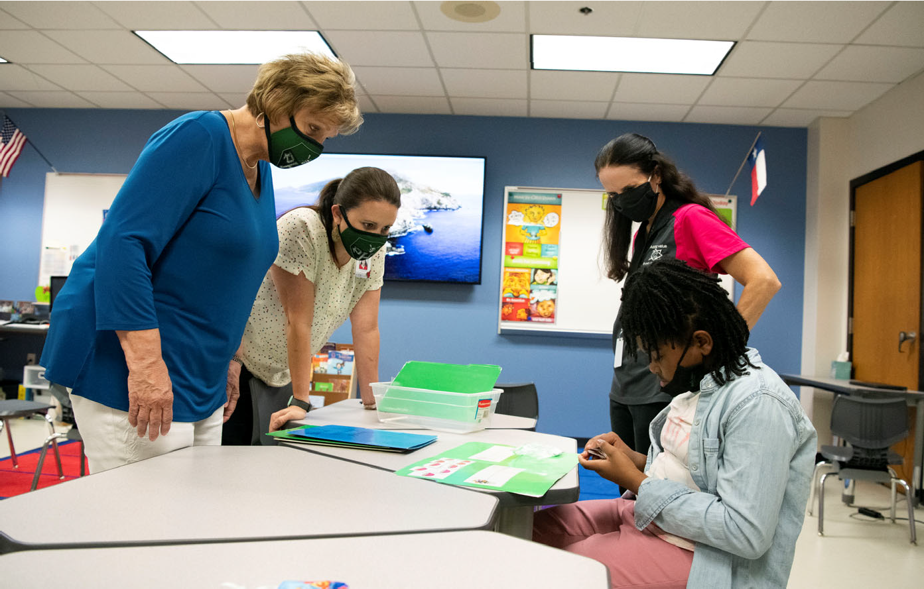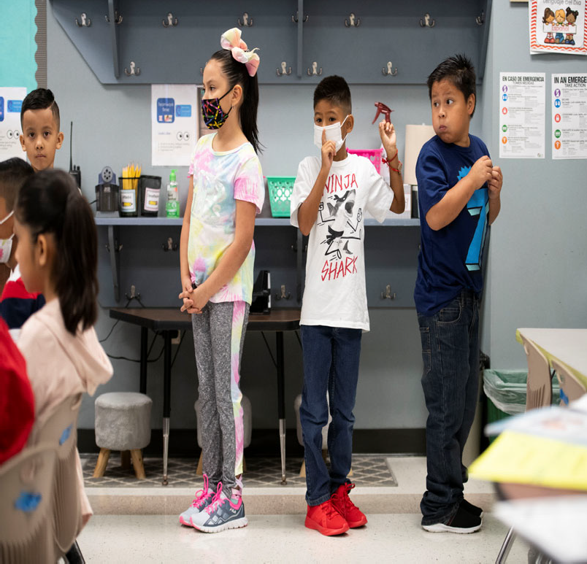

Mesquite Independent School District

Organizational Section

Organizational Section 41
Table of Contents 42
Significant Facts about Mesquite Independent School District 43
Mesquite ISD Attendance Zones 2021‐22 44
Enrollment Growth 45
Student Enrollment Summary 46
Student Enrollment by Campus 47‐48
Student Ethnicity Percentages 49
Mesquite ISD Contact Information 50‐52
Mesquite ISD School Calendar 2021‐22 53
Organizational Chart 54
Board of Trustees 55‐57
MISD Vision 58
Strategic Roadmap 59‐66
Financial Policies/Basis of Accounting 67‐76
Account Code Structure/Basic System Expenditure Code Structure 77‐78
Function Codes 79‐83
Account Code Structure 84‐88
Budget Policies 89‐99
Budget Timeline 100



Significant Facts about Mesquite Independent School District

The District provides education services to all children with in is designated boundaries. These services include qualifying infants through 12th grade. For the 2021‐22 school year, the District is composed of 33 elementary schools, 10 middle schools, 6 high schools, 1 academy and 1 discipline alternative education program. We also oﬀer a bilingual elementary school program for students who speak Spanish as their first language.

The projected enrollment for the 2021‐22 school year is 38,154 students.

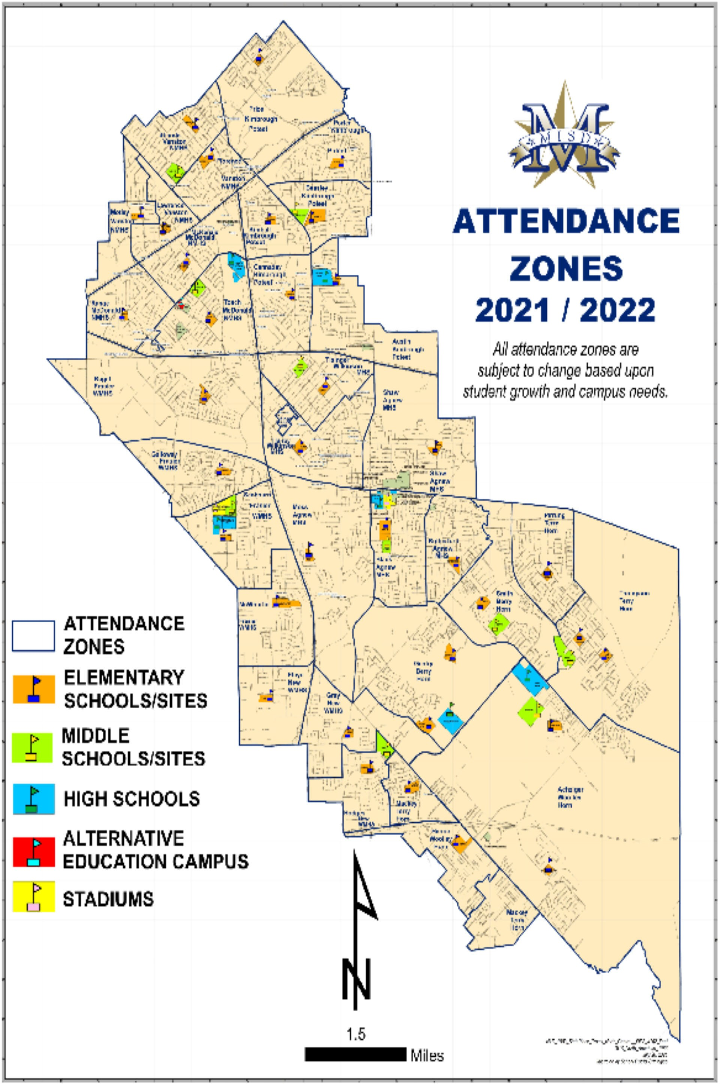

Mesquite Independent School District Enrollment Growth

Student enrollment numbers for Mesquite Independent School District remain steady. Total K‐12 enrollment was 38,381 in 2020‐21 and enrollment for 2021‐22 (as of 9/3/2021) was 37,735 which does not include 466 students who have opted for virtual learning for the first 9‐weeks of the school year. MISD uses the ‘moderate scenario’ from the demographer report and this enrollment number is in line with the demographer estimated enrollment for the 2021‐22 school year (38,154). The District’s enrollment is expected to decrease in four of the next five years followed by enrollment growth beginning in the 2028‐29 school year and beyond.

The District has begun the early stages of planning for elementary #34 with an expected opening date of August 2023. Other than adding some classrooms at a couple of schools the District will be pre‐ pared for the upcoming enrollment growth. The District continues its emphasis on decreasing the use of portable buildings throughout the district. In 2015 the District used over 400 portables and at the start of the 2021‐22 school year the District is using approximately 100 portables with many of these being used for storage.

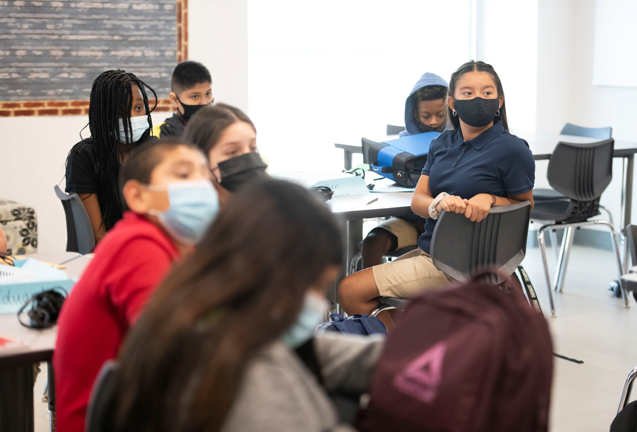

Table 19
Organizational Section
46
Mesquite ISD Oﬃcial Budget 2021‐2022

Mesquite ISD Student Enrollment Summary

Campus Type | Actual  2017‐18 | Actual  2018‐19 | Actual  2019‐20 | Actual  2020‐21 | Current Year  2021‐22 | Projected  2021‐22 | Projected  2022‐23 | Projected  2023‐24 | Projected  2024‐25
High Schools | 12,023 | 12,367 | 12,029 | 12,105 | 12,279 | 12,192 | 12,571 | 12,737 | 12,720
Middle Schools | 7,163 | 9,973 | 9,907 | 9,570 | 9,189 | 9,440 | 9,174 | 8,701 | 8,456
Elementary Schools | 21,643 | 18,497 | 17,695 | 16,701 | 16,266 | 16,518 | 16,444 | 16,533 | 16,684
Mesquite Academy | 187 | 280 | * | * | *
JJAEP |  |  | 7 | 5 | 1 | 4 | 4 | 4 | 4
Total Enrollment | 41,016 | 41,117 | 39,638 | 38,381 | 37,735 | 38,154 | 38,193 | 37,975 | 37,864

* Student enrollment included in high school count.
Student Information System (as of September 3, 2021)

Table 20
Organizational Section
Mesquite ISD Oﬃcial Budget 2021‐2022
47
Mesquite ISD Student Enrollment by Campus

Campus | Actual  2017‐18 | Actual  2018‐19 | Actual  2019‐20 | Actual  2020‐21 | Current Year  2021‐22 | Projected  2021‐22 | Projected  2022‐23 | Projected  2023‐24 | Projected  2024‐25
Mesquite High School | 2,904 | 2,829 | 2,625 | 2,561 | 2345 | 2,574 | 2,660 | 2,724 | 2,648
North Mesquite High School | 2,808 | 2,864 | 2,522 | 2,415 | 2169 | 2,346 | 2,358 | 2,358 | 2,328
West Mesquite High School | 2,077 | 2,137 | 2,162 | 2,280 | 2223 | 2,422 | 2,549 | 2,545 | 2,490
Poteet High School | 1,848 | 1,853 | 1,822 | 1,750 | 1651 | 1,730 | 1,729 | 1,687 | 1,700
Horn High School | 2,386 | 2,684 | 2,898 | 3,099 | 3089 | 3,120 | 3,275 | 3,423 | 3,554
Vanguard High School | 0 | 0 | 0 | 0 | 802
Agnew Middle School | 831 | 1,280 | 1,228 | 1,227 | 1153 | 1,147 | 1,114 | 1019 | 1066
Vanston Middle School | 805 | 969 | 923 | 847 | 856 | 878 | 837 | 798 | 714
Wilkinson Middle School | 974 | 926 | 790 | 797 | 724 | 768 | 733 | 659 | 633
McDonald Middle School | 1,002 | 909 | 908 | 923 | 840 | 876 | 829 | 798 | 798
New Middle School | 926 | 931 | 935 | 831 | 797 | 852 | 800 | 737 | 697
Kimbrough Middle School | 825 | 1,222 | 1,357 | 1,260 | 1188 | 1,243 | 1,249 | 1,232 | 1,167
Berry Middle School | 904 | 1,116 | 1,103 | 613 | 601 | 636 | 635 | 699 | 704
Terry Middle School | 896 | 1,440 | 1,463 | 1,039 | 1056 | 1,061 | 1,015 | 916 | 869
Fraiser Middle School | 0 | 1,180 | 1,200 | 1,126 | 1087 | 1,076 | 1,001 | 929 | 877
Woolley Middle School | 0 | 0 | 0 | 907 | 887 | 903 | 961 | 914 | 931
Black Elementary School | 639 | 606 | 656 | 626 | 634 | 621 | 610 | 622 | 617
Florence Elementary School | 654 | 543 | 548 | 467 | 482 | 458 | 450 | 441 | 428
Galloway Elementary School | 732 | 489 | 461 | 420 | 418 | 394 | 382 | 374 | 374
Hanby Elementary School | 929 | 835 | 838 | 740 | 689 | 749 | 740 | 750 | 757
Hodges Elementary School | 767 | 610 | 545 | 514 | 512 | 498 | 500 | 491 | 489
McWhorter Elementary School | 870 | 719 | 633 | 549 | 496 | 516 | 481 | 477 | 477
Motley Elementary School | 455 | 370 | 338 | 276 | 250 | 253 | 243 | 241 | 250
Range Elementary School | 763 | 653 | 601 | 580 | 572 | 571 | 562 | 553 | 532
Rugel Elementary School | 458 | 355 | 355 | 321 | 293 | 302 | 308 | 308 | 305
Rutherford Elementary School | 474 | 645 | 659 | 648 | 657 | 659 | 658 | 652 | 631
Shands Elementary School | 825 | 655 | 629 | 622 | 544 | 596 | 600 | 582 | 580
Tisinger Elementary School | 824 | 819 | 660 | 631 | 648 | 614 | 624 | 621 | 621
Tosch Elementary School | 872 | 658 | 594 | 617 | 585 | 626 | 621 | 626 | 644
Seabourn Elementary School | 724 | 700 | 661 | 578 | 608 | 594 | 592 | 600 | 606
Lawrence Elementary School | 440 | 368 | 334 | 283 | 261 | 255 | 248 | 243 | 254
Floyd Elementary School | 798 | 579 | 604 | 455 | 428 | 452 | 466 | 480 | 477
Porter Elementary School | 605 | 427 | 421 | 389 | 374 | 368 | 375 | 356 | 354

Table 20 (cont.)
Organizational Section
Mesquite ISD Oﬃcial Budget 2021‐2022
48

Mesquite ISD Student Enrollment by Campus (cont.)

Campus | Actual 2017‐18 | Actual 2018‐19 | Actual 2019‐20 | Actual 2020‐21 | Current Year 2021‐22 | Projected 2021‐22 | Projected 2022‐23 | Projected 2023‐24 | Projected 2024‐25
McKenzie Elementary School | 538 | 493 | 454 | 414 | 390 | 415 | 412 | 401 | 403
Beasley Elementary School | 467 | 378 | 374 | 359 | 369 | 355 | 341 | 345 | 346
Price Elementary School | 451 | 359 | 348 | 299 | 311 | 298 | 298 | 304 | 312
Shaw Elementary School | 884 | 582 | 577 | 555 | 514 | 548 | 533 | 537 | 530
Kimball Elementary School | 242 | 192 | 188 | 211 | 214 | 224 | 225 | 247 | 252
Pirrung Elementary School | 434 | 438 | 392 | 396 | 388 | 392 | 383 | 377 | 375
Cannaday Elementary School | 564 | 575 | 590 | 582 | 570 | 580 | 569 | 563 | 574
Austin Elementary School | 471 | 471 | 390 | 343 | 323 | 345 | 345 | 349 | 358
Moss Elementary School | 434 | 391 | 380 | 323 | 317 | 322 | 316 | 318 | 311
Thompson Elementary School | 565 | 529 | 523 | 566 | 566 | 571 | 563 | 557 | 562
Gray Elementary School | 634 | 512 | 450 | 431 | 412 | 431 | 431 | 436 | 450
Smith Elementary School | 494 | 425 | 437 | 545 | 541 | 564 | 583 | 594 | 613
Gentry Elementary School | 916 | 654 | 617 | 624 | 595 | 613 | 633 | 667 | 722
Mackey Elementary School | 788 | 678 | 615 | 650 | 663 | 639 | 633 | 644 | 649
Achziger Elementary School | 971 | 854 | 912 | 827 | 816 | 847 | 903 | 963 | 1,015
Henrie Elementary School | 961 | 935 | 911 | 860 | 826 | 848 | 816 | 814 | 816
Mesquite Academy | 187 | 280 | * | * | *
JJAEP |  |  | 7 | 5 | 1 | 4 | 4 | 4 | 4
TOTAL | 41,016 | 41,117 | 39,638 | 38,381 | 37,735 | 38,154 | 38,193 | 37,975 | 37,864

* Student enrollment included in high school count.
District Demographic Report‐2021

Table 21
Mesquite Independent School District Student Ethnicity Percentages

Federal Race | 2016‐17 | 2017‐18 | 2018‐19 | 2019‐20 | 2020‐21
Hispanic/Latino | 56.1 | 58.08 | 59.44 | 59.02 | 61.38
American Indian or Alaska Native | 0.7 | 0.49 | 0.45 | 0.76 | 0.40
Asian | 1.6 | 1.52 | 1.38 | 1.27 | 1.28
Native Hawaiian or Pacific Islander | 0.1 | 0.07 | 0.08 | 0.07 | 0.0
Black or African American | 24.7 | 24.83 | 24.54 | 24.67 | 24.48
White | 14.9 | 13.03 | 12.08 | 12.07 | 10.26
Two or more races | 2 | 1.99 | 2.03 | 2.14 | 2.13

Elementary Schools
Mesquite ISD Contact Information

Achziger Elementary 3300 Ridgeranch Road
Mesquite, TX 75181 972‐290‐4180

Austin Elementary 3020 Poteet Drive
Mesquite, TX 75150 972‐882‐7220

Beasley Elementary 919 Green Canyon
Mesquite, TX 75150 972‐882‐5160

Black Elementary 328 E. Newsom Road Mesquite, TX 75149 972‐882‐7240

Cannaday Elementary 2701 Chisolm Trail
Mesquite, TX 75150 972‐882‐5060

Florence Elementary 4600 Ashwood Drive
Mesquite, TX 75150 972‐290‐4080

Floyd Elementary
3025 Hickory Tree Road Balch Springs, TX 75180 972‐882‐7100

Galloway Elementary 200 Clary Drive
Mesquite, TX 75149 972‐882‐5101

Gentry Elementary 1901 Twin Oaks Dr. Mesquite, TX 75181 972‐290‐4140
Gray Elementary 3500 Pioneer Road
Balch Springs, TX 75180 972‐882‐7280

Hanby Elementary 480 Gross Road
Mesquite, TX 75149 972‐882‐5040

Henrie Elementary
253 West Lawson Road Dallas, TX 75253 972‐290‐4200

Hodges Elementary 14401 Spring Oaks Balch Springs, TX 75180 972‐290‐4040

Kimball Elementary 4010 Coryell
Mesquite, TX 75150 972‐290‐4120

Lawrence Elementary 3811 Richman
Mesquite, TX 75150 972‐882‐7000

Mackey Elementary 14900 N. Spring Ranch Balch Springs, TX 75180 972‐290‐4160

McKenzie Elementary 3535 Stephens Green
Mesquite, TX 75150 972‐882‐5140

McWhorter Elementary 1700 Hickory Tree
Mesquite, TX 75149 972‐882‐7020
Moss Elementary 1208 New Market
Mesquite, TX 75149 972‐882‐7130

Motley Elementary 3719 Moon Drive
Mesquite, TX 75150 972‐882‐5080

Pirrung Elementary 1500 Valley Creek
Mesquite, TX 75181 972‐882‐7170

Porter Elementary 517 Via Avenida
Mesquite, TX 75150 972‐290‐4000

Price Elementary 630 Stroud Lane
Garland, TX 75043 972‐290‐4100

Range Elementary 4060 Emerald Dr.
Mesquite, TX 75150 972‐882‐5180

Rugel Elementary 2701 Sybil
Mesquite, TX 75149 972‐882‐7260

Rutherford Elementary 1100 Rutherford Drive
Mesquite, TX 75149 972‐290‐4060

Seabourn Elementary 2249 Picadilly Blvd.
Mesquite, TX 75149 972‐882‐7040
Shands Elementary 4836 Shands
Mesquite, TX 75150 972‐290‐4020

Shaw Elementary 707 Purple Sage
Mesquite, TX 75149 972‐882‐7060

Smith Elementary
2300 Mesquite Valley Rd. Mesquite, TX 75149 972‐882‐7080

Thompson Elementary 2525 Helen Lane
Mesquite, TX 75181 972‐882‐7190

Tisinger Elementary 1701 Hillcrest
Mesquite, TX 75149 972‐882‐5120

Tosch Elementary 2424 Larchmont
Mesquite, TX 75150 972‐882‐5000

Middle Schools
Agnew Middle School 729 Wilkinson
Mesquite, TX 75149 972‐882‐5750

Berry Middle School 2675 Bear Dr.
Mesquite, TX 75181 972‐882‐5850

Fraiser Middle School 2250 W. Scyene Road Mesquite, TX 75149 972‐290‐4300

Kimbrough Middle School 3900 North Galloway
Mesquite, TX 75150 972‐882‐5900

McDonald Middle School 2930 Town East
Mesquite, TX 75150 972‐882‐5700

New Middle School 3700 South Beltline
Mesquite, TX 75181 972‐882‐5600

Terry Middle School
2351 Edwards Church Road Mesquite, TX 75181 972‐882‐5650

Vanston Middle School 3230 Karla
Mesquite, TX 75150 972‐882‐5801

Wilkinson Middle School 2100 Crest Park
Mesquite, TX 75149 972‐882‐5950

Woolley Middle School 3200 Blue Sky Road Mesquite, TX 75181 972‐290‐4350

High Schools
Horn High School
3300 E. Cartwright Road Mesquite, TX 75181 972‐882‐5200

Mesquite High School 300 East Davis
Mesquite, TX 75149 972‐882‐7800

North Mesquite High School 18201 LBJ Freeway
Mesquite, TX 75150 972‐882‐7900

Poteet High School 3300 Poteet Drive
Mesquite, TX 75150 972‐882‐5300

Vanguard High School
4201 Faithon P. Lucas Sr. Blvd. Mesquite, TX 75181 972‐882‐8768

West Mesquite High School 2500 Memorial Blvd.
Mesquite, TX 75149 972‐882‐7600

Mesquite Academy 2704 Motley
Mesquite, TX 75150 972‐882‐7570

Facilities
Administration Building 3819 Towne Crossing Blvd. Mesquite, TX 75150 972‐288‐6411

Administrative Annex 329 East Davis Street Mesquite, TX 75149 972‐882‐7400

L.A. Berry Support Complex 2133 North Belt Line Road Mesquite, TX 75149 972‐882‐5402

Florence Annex 105 Florence Street
Mesquite, TX 75149
Food & Nutrition Services Building 405 E. Davis Street
Mesquite, TX 75149 972‐882‐5500

Learning Center 230 Pioneer
Mesquite, TX 75149 972‐882‐7150

Professional Development Center 3819 Towne Crossing Blvd.
Mesquite, TX 75150 972‐882‐7393

Russell Planetarium 2501 Memorial
Mesquite, TX 75149 972‐882‐7750

Service Center 800 East Kearney
Mesquite, TX 75149 972‐882‐5551

Student Support Center 714 E. Kimbrough St.
Mesquite, TX 75149 972‐882‐7700

Teacher Center 200 Pioneer Road
Mesquite, TX 75149

Technology Excellence Center 612 East Davis
Mesquite, TX 75149

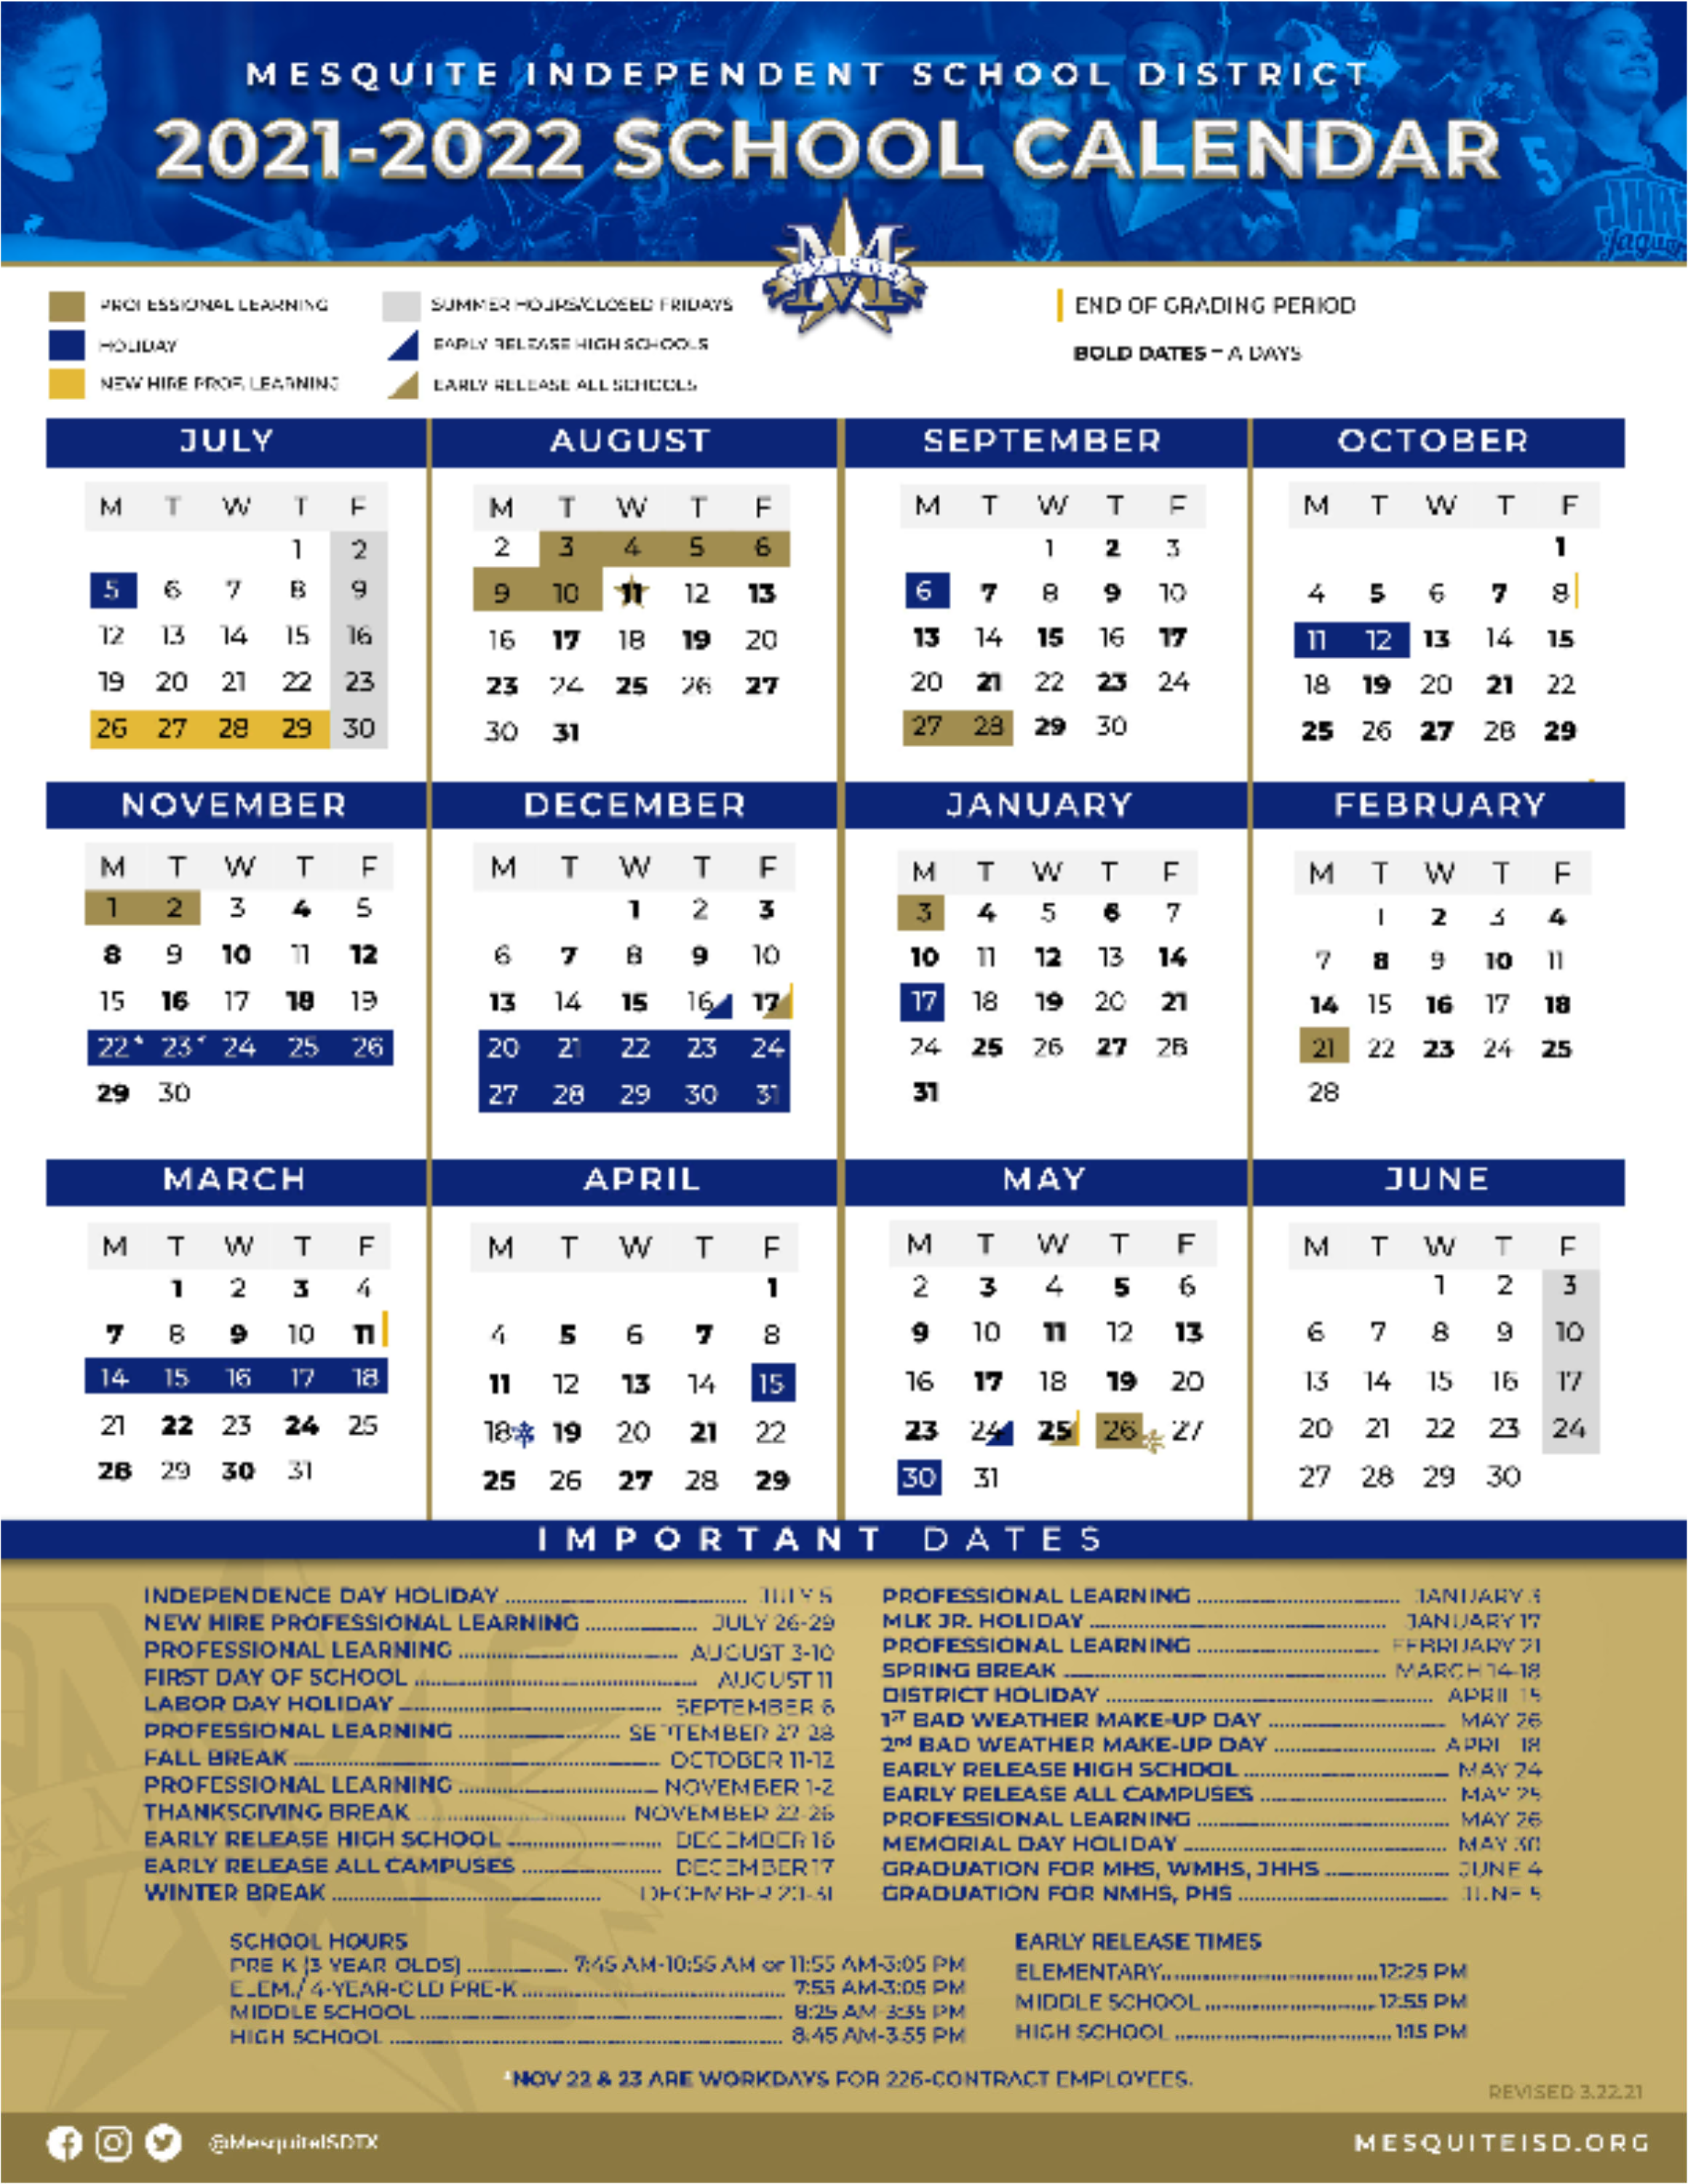



Mesquite Independent School District Organizational Chart

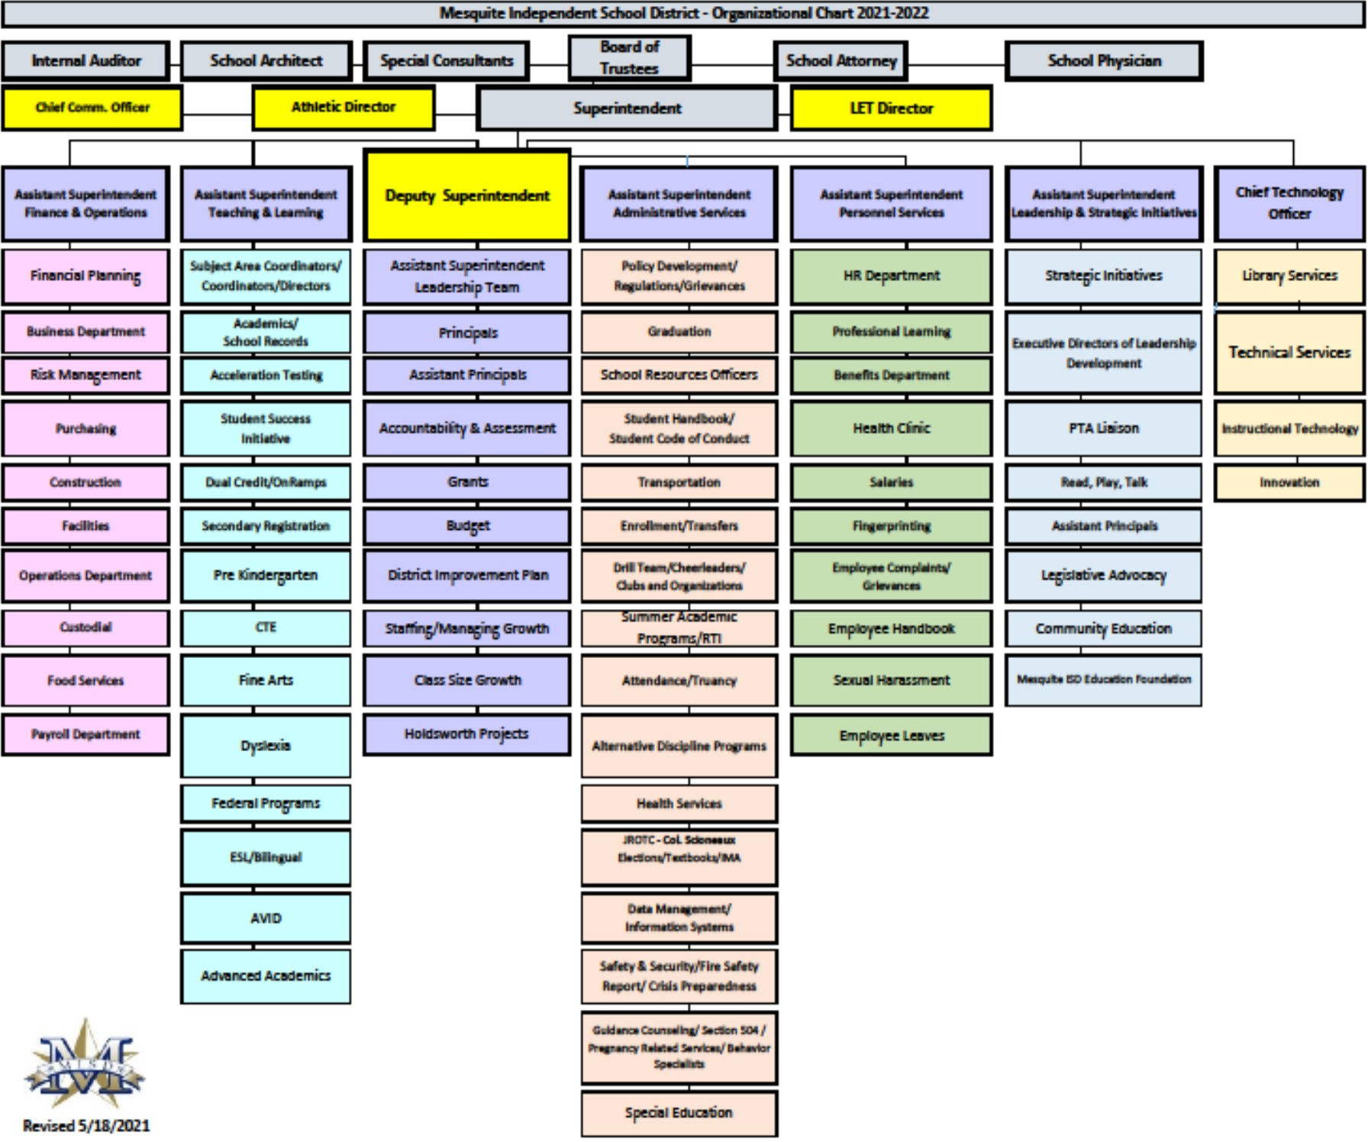

Dr. David Vroonland, Superintendent of Schools Dr Angel Rivera, Deputy Superintendent
Pete D. Pape, Assistant Superintendent for Finance & Operations Mike Jasso, Assistant Superintendent for Administrative Services
Dr. Jennifer Hammett, Assistant Superintendent for Teaching &Learning Mary Randall, Assistant Superintendent for Personnel Services
Dr. Leslie Feinglas, Assistant Superintendent for Leadership & Strategic Initiatives Laura Jobe, Chief Information Oﬃcer

Eddie Rose, President – Place 2—Elected to the board in 2016. He graduated from Stephen F. Austin State University; he earned his BA degree (criminal justice) in 1991. He is the Arson Investigator with the Mesquite Fire Department and has been with them since 1985. Eddie is married to Misty, an Assistant Principal for Mesquite ISD; they have three children: Reed, who is a senior at Sam Houston State, Hayden, a freshman at Texas A&M, and Gracie, a fourth grader at Kimball Elementary.

Greg Everett, Vice President – Place 4 – He served on the board for an 18‐year period, from 1991‐2009, and was re‐elected in May 2014. He graduated from North Mesquite HS in 1974 and attended Eastfield College. He is department manager for Levy and Son in Dallas. He and his wife Ramona have three children, Matthew, Daniel, and Emily and three grandchildren.

Elaine Whitlock, Secretary ‐ Place 6 ‐ Elected to the Board in 2015. She is a 1964 Mesquite High School graduate and a graduate of Texas Tech University. She received her master’s degree from Texas A&M ‐ Commerce and Mid‐Management Certification from Texas Women’s University. She retired in 2011 as an elementary principal after serving 38 years in education, with 37 in MISD. She is married to Larry, and they have four daughters, Leslie, Kelly, Laura, and Amanda and four grandchildren.

Teia Collier ‐ Place 1 ‐ Appointed to the Board in June of 2021 to complete the unexpired term of Archimedes Faulkner, who resigned due to illness. She is now the CEO/publisher at Teia Collier Brands but previously served as an educator at West Mesquite High School and Cesar Chavez Public Charter Schools. She also served as a corporate health coach for major insurance companies while becoming a lifestyle blogger and auto‐ motive journalist. In 2017, she re‐launched the digital media site Dallas Single {Mom} Parents for families across the country. A graduate of North Mesquite High School and long‐time resident of Mesquite, Collier is an education, historic preservation, and quality of life advocate. She is the mother of three school‐aged children: Zenora, 15; Soloman, 13; and Noah, 7.

Gary Bingham ‐ Place 3 – Elected to the board in 1996. A 1975 Mesquite High School graduate; Gary earned his Bachelor of Business of Administration in 1979 from Stephen F. Austin. He owns Gary Bingham & Associates Insurance Agency. He and his wife Cecelia have two children, Samantha and Adam and two grandchildren.

Robert Seward – Place 5 ‐ Elected to the board in 1993. A 1968 Mesquite High School graduate, Seward earned his Bachelor of Business Administration in accounting in 1976 from North Texas State University. He is retired from Luminant. Robert was elected as the 2008‐09 Texas Association of School Boards (TASB) President. He and his wife Marjorie have two children, Craig, and Christy and three grandchildren.

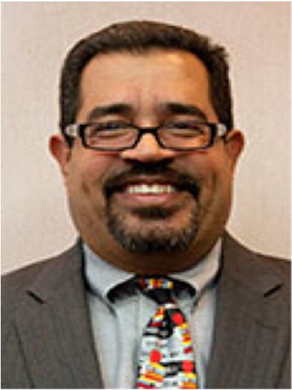Kevin Carbo– Place 7 – Elected to the Board in 1996 and served till 2014. He was re‐elected in November of 2015. He graduated from “Colegio San Antonio” in Puerto Rico. Kevin earned his BBA –
Finance from Dallas Baptist University in 1995 and received his MBA from University of Dallas in 1999. He is employed at City of Dallas in the Aviation Dept. as Business Operations Analysis. He and his wife Jossie have two children, Jessica and Kevin, Jr. and three grandchildren. Jessi‐ ca and Kevin, Jr. attended Mesquite schools K‐12, and graduated from Mesquite High School. His involvement with MISD started in the 80’s as a member of several PTA’s and he was 1st. Vice‐President of the Mesquite Council of PTA’s.

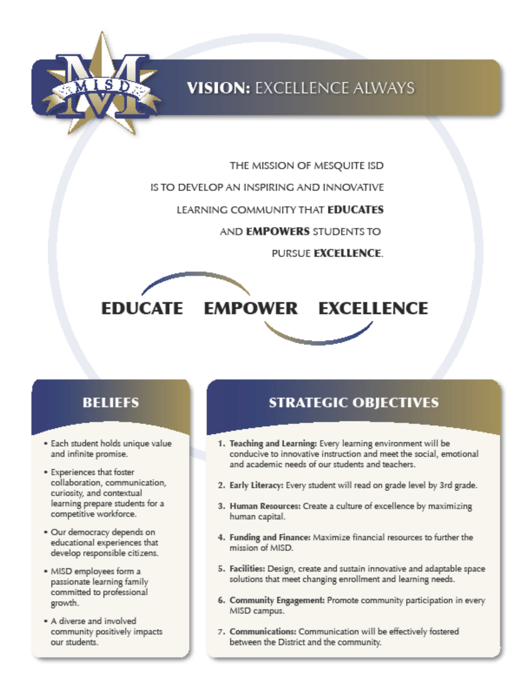

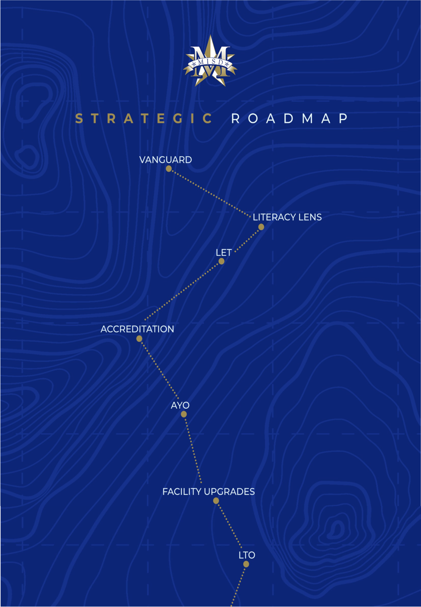

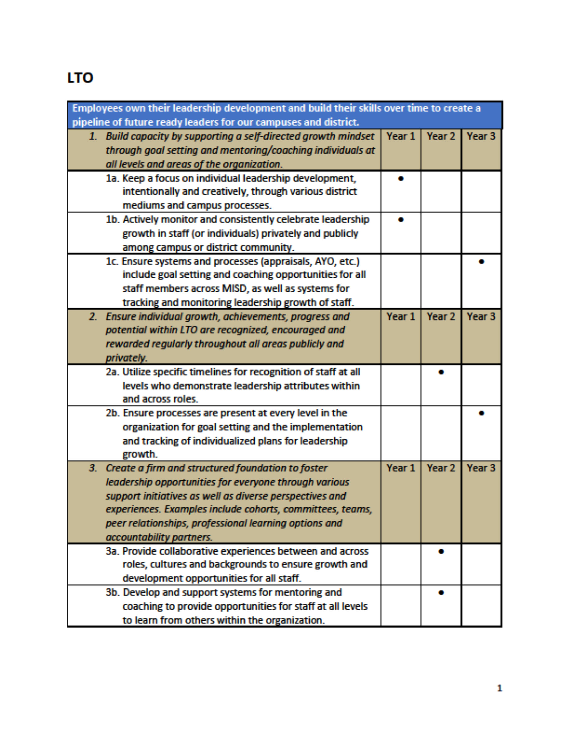

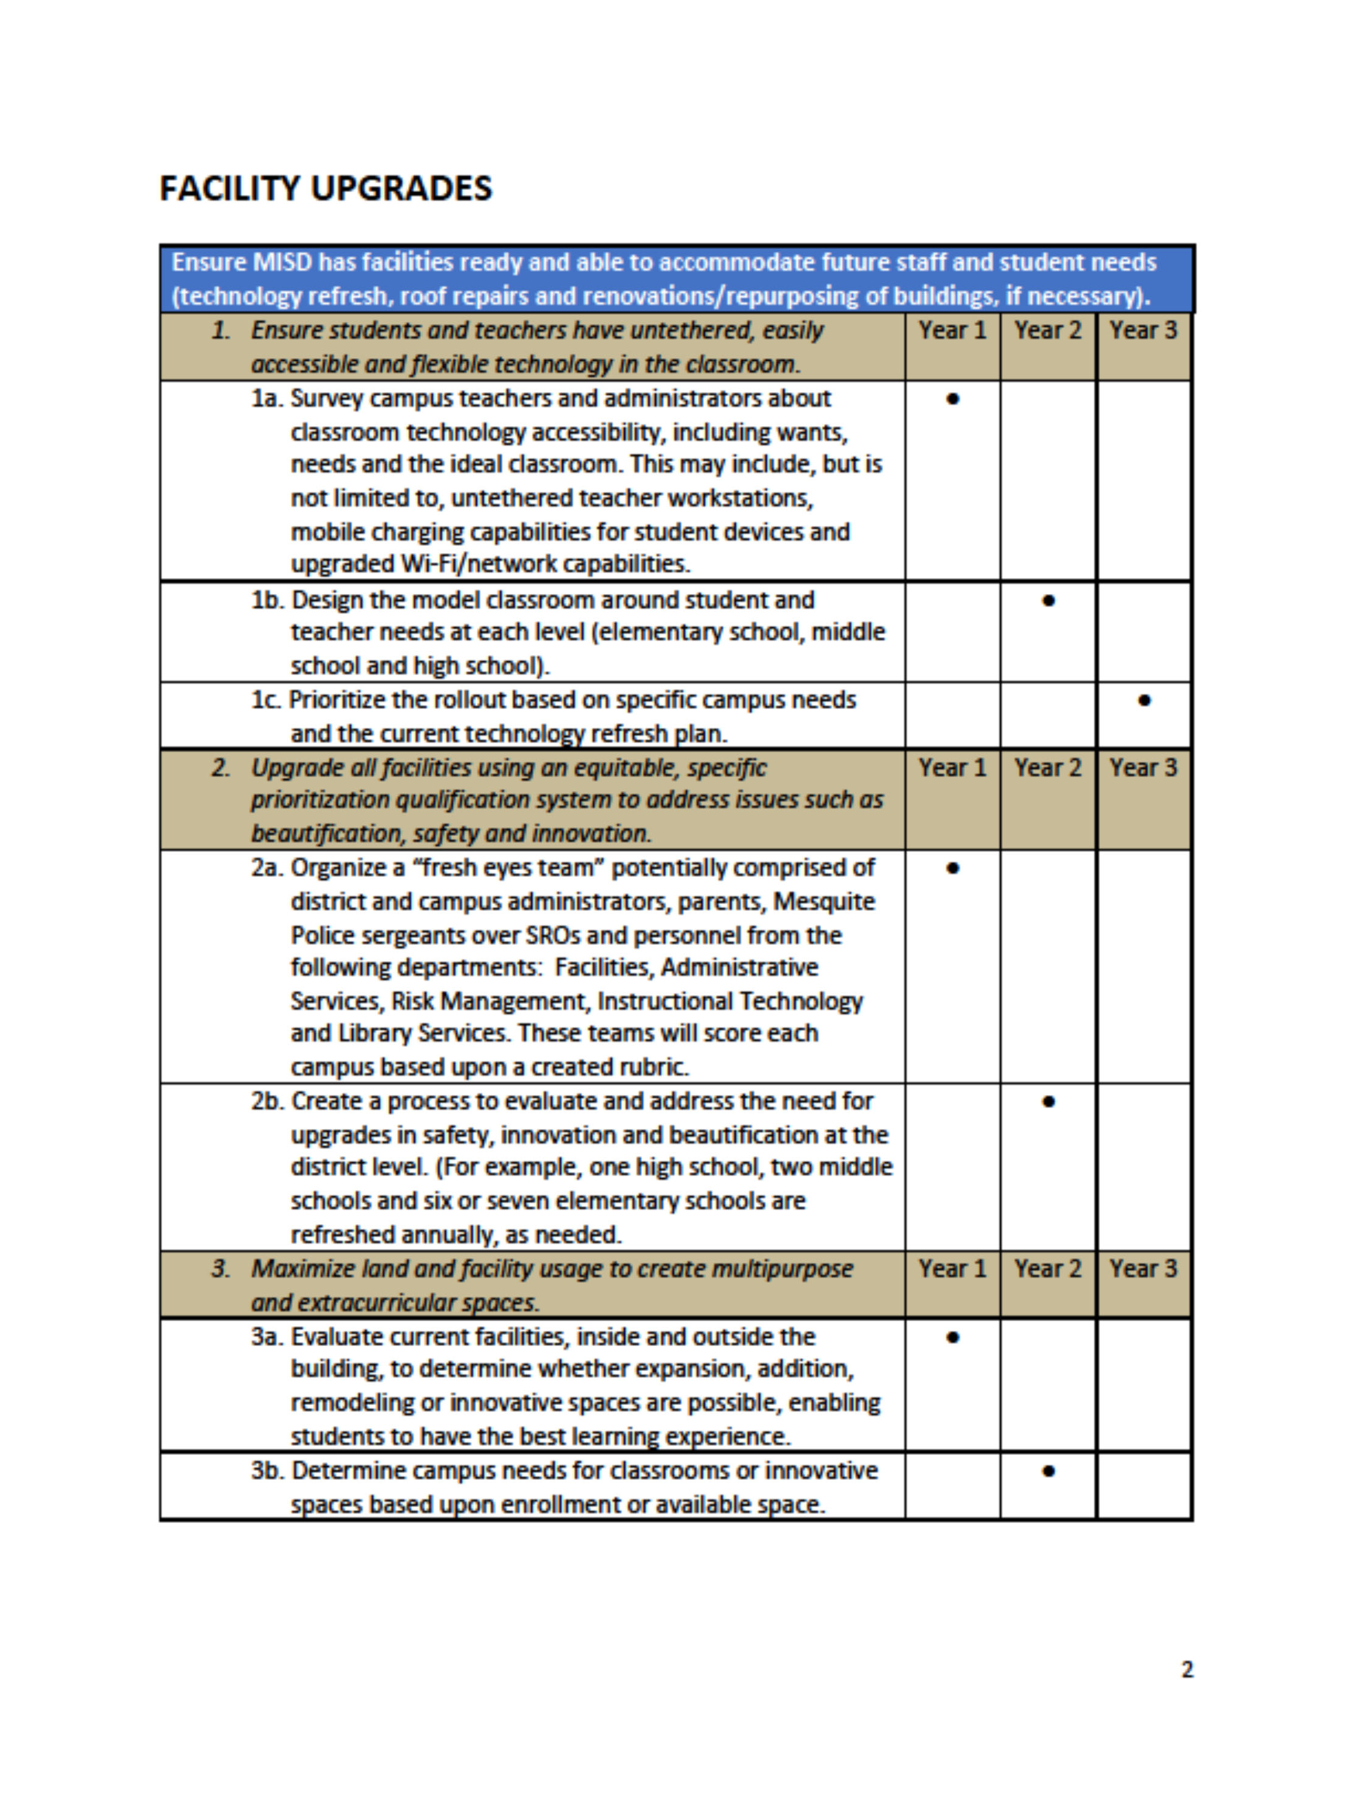

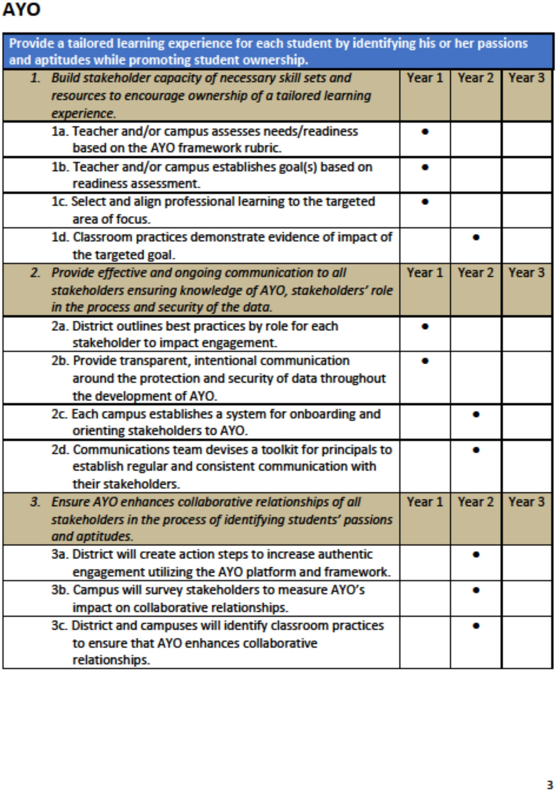

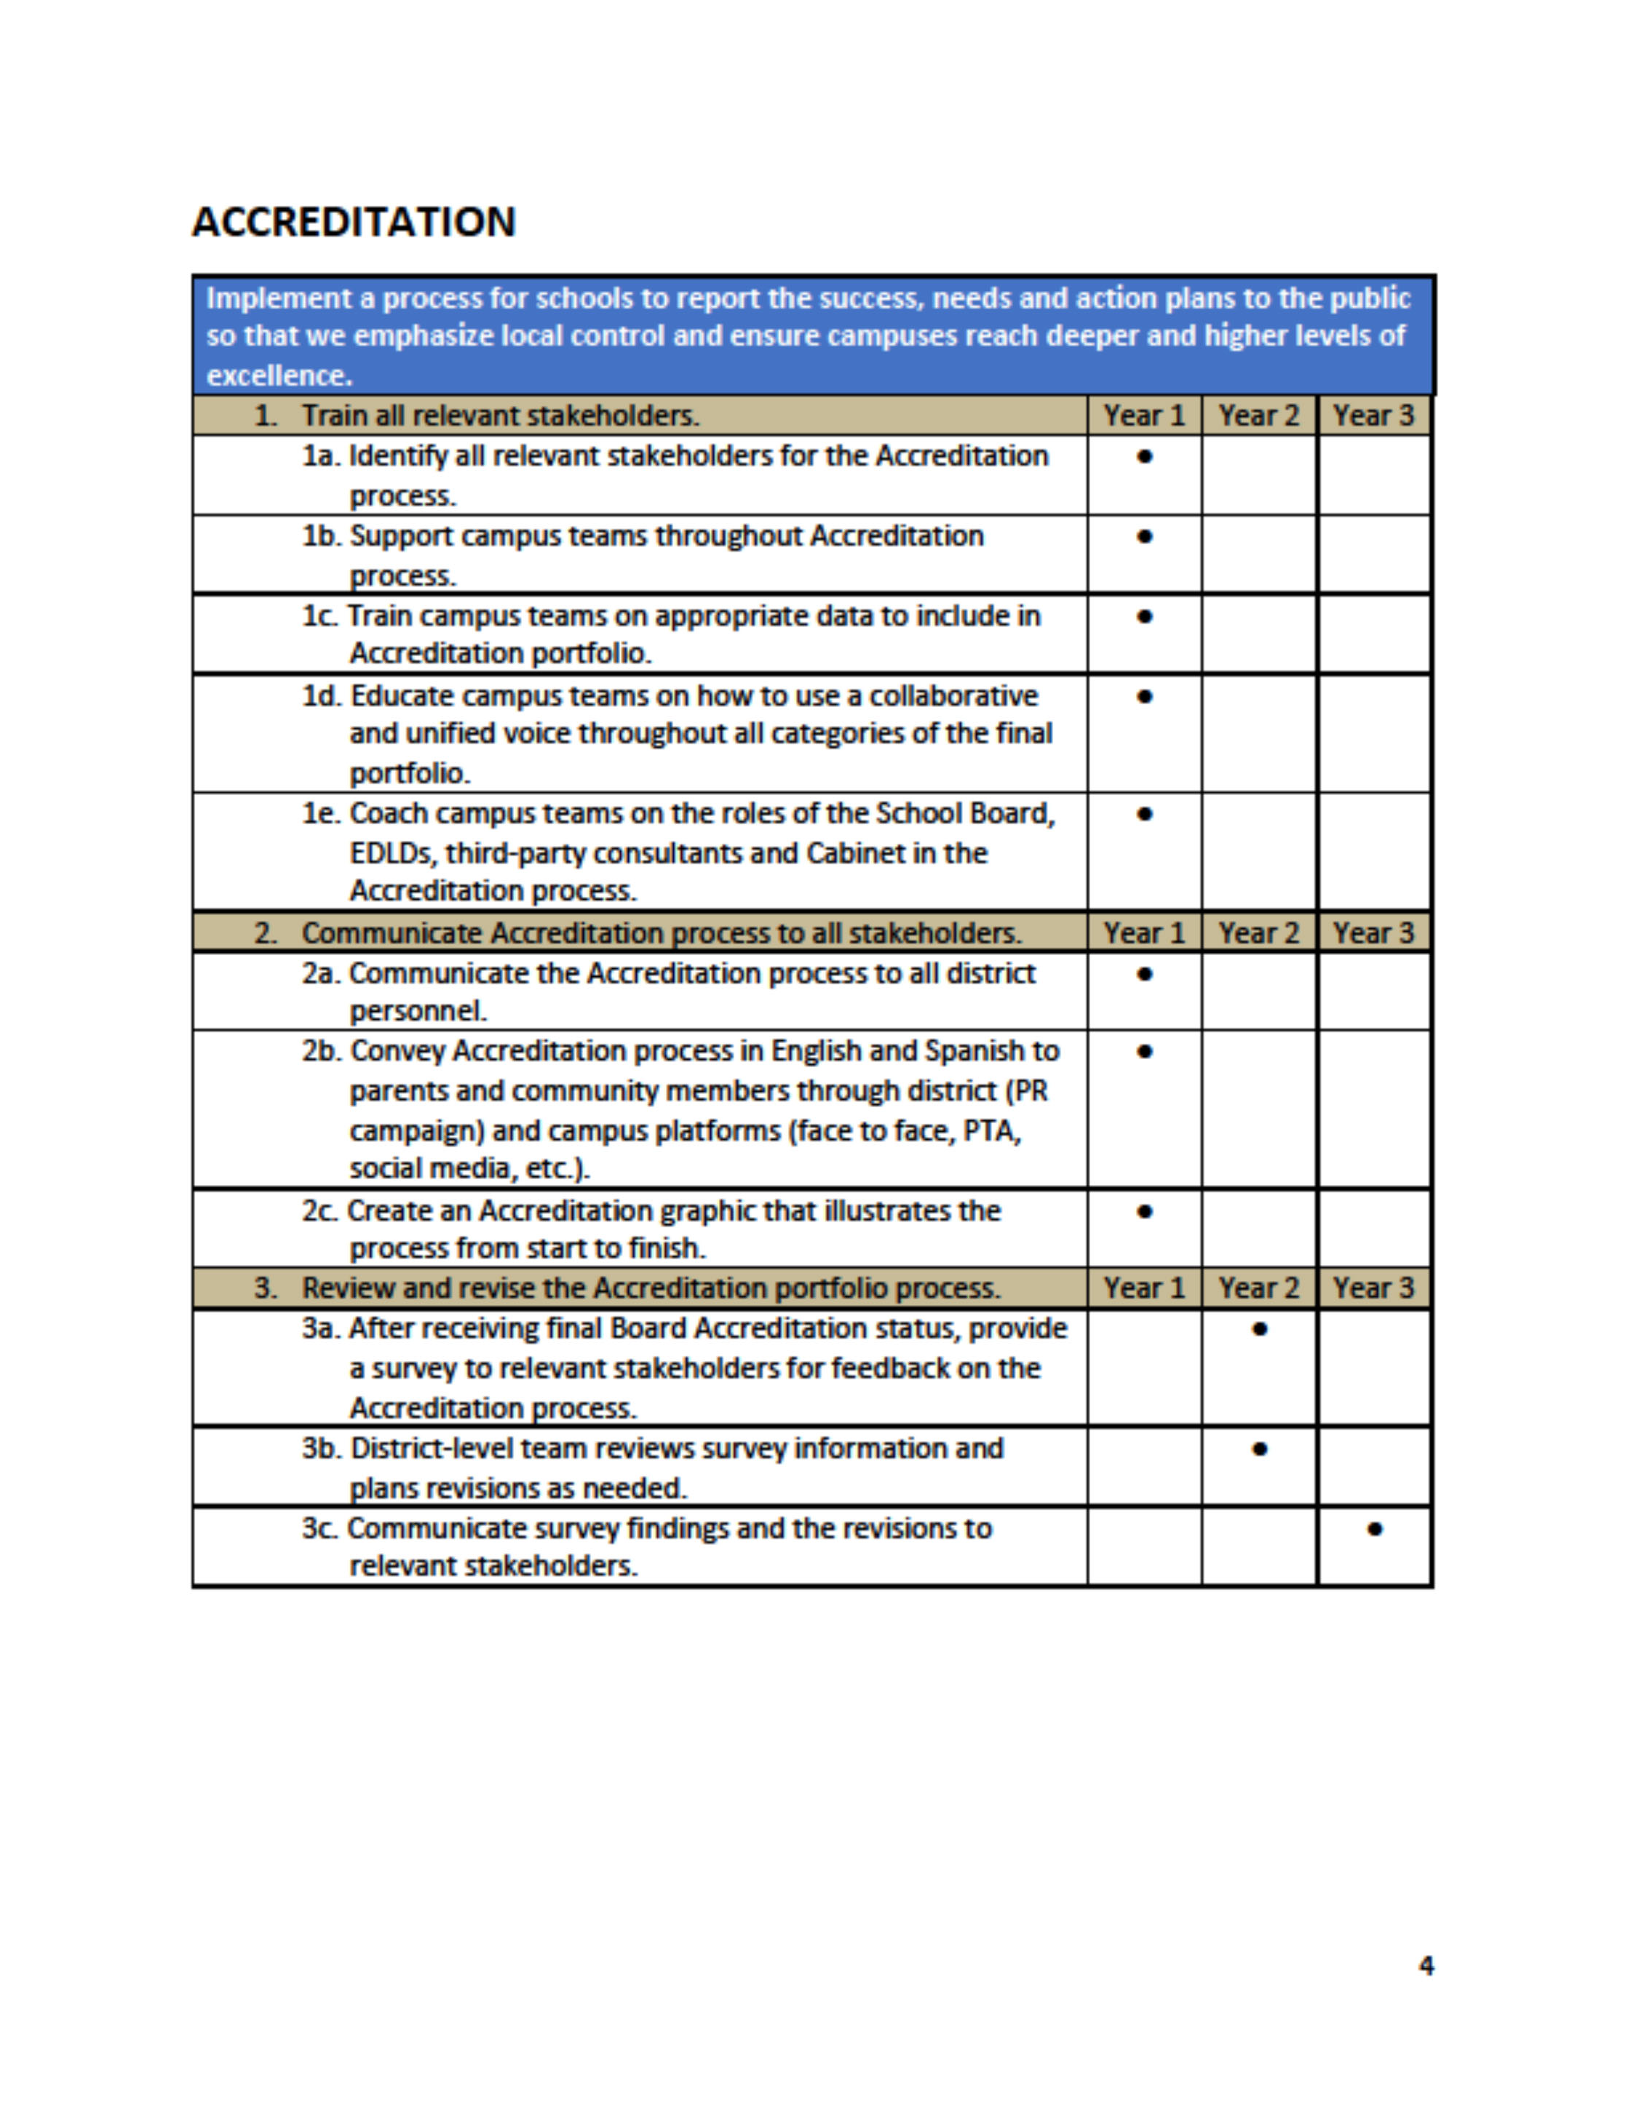

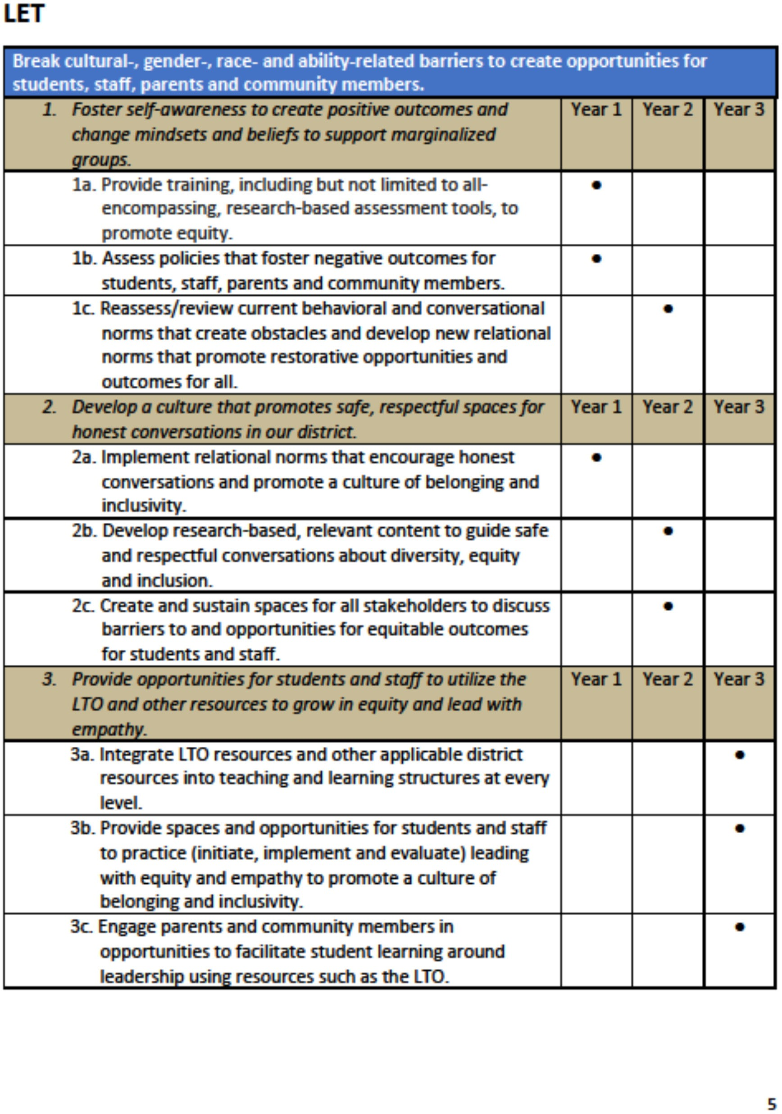

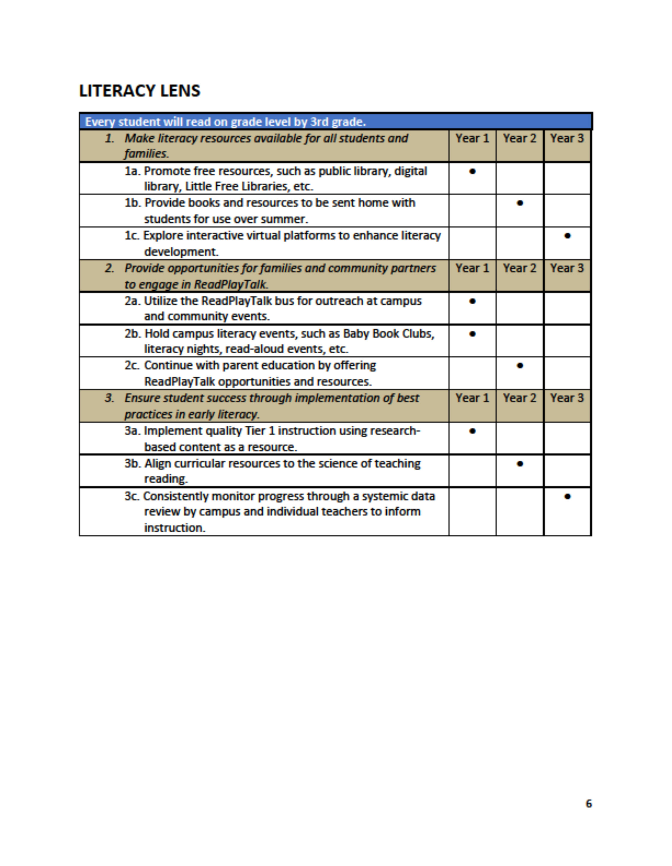

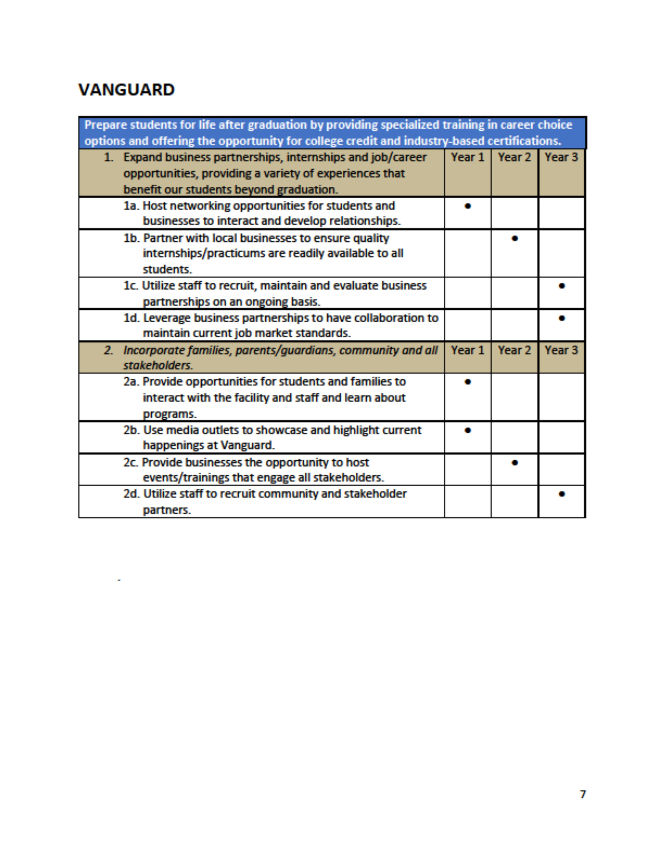

Financial Policies/Basis of Accounting

Financial and budgeting principles and policies adopted by the Texas Education Agency through the Financial Accountability Resource Guide (FASRG) are oﬃcial rules and constitute minimum budgeting, accounting, auditing, and reporting requirements. The Agency’s intent in prescribing these rules is to cause the budgeting and financial accounting and reporting system of independent school districts to conform with generally accepted accounting principles (GAAP) established by the Governmental Ac‐ counting Standards Board (GASB) and the Financial Accounting Standards Board (FASB) for accounting treatments not specified in GASB pronouncements.

A summary of the state mandated principles and policies that Mesquite ISD follows are:

Generally Accepted Accounting Principles (GAAP) – The Mesquite ISD accounting system is kept in accordance with generally accepted accounting principles and presents fairly and with full disclosure the funds and activities and results of financial operations in such a manner to determine and demonstrate compliance with finance‐related legal and contractual provisions. Whenever conflicts exist be‐ tween legal requirements and generally accepted accounting principles, and additional schedules and/ or narrative explanations are attached as necessary to satisfy or report legal compliance responsibilities and accountabilities.

Fund Accounting – The accounting system is organized and operated on a fund basis. All funds of Mesquite ISD are accounted for and included on the end‐of‐year combined balance sheet. A fund is de‐ fined as a fiscal and accounting entity with a self‐balancing set of accounts recording cash and other financial resources, together with all related liabilities and residual equities or balances, and changes therein, which are segregated for the purpose of carrying in specific activities or attaining certain objectives in accordance with special regulations, restrictions, or limitations.

Account Groups – The accounting system provides account groups to account for general capital assets and general long‐term debt of governmental funds. Capital assets and long‐term debt of
fiduciary funds are accounted for through those funds and are excluded from the account groups as detailed in the Account Code section.

Central Accounting – Accounting for funds of the Mesquite Independent School District is on an organization‐wide basis covering all funds and account groups. Governmental and fiduciary fund types are the account responsibility of the District’s business oﬃce.

Capital Assets – Capital assets are accounted for at historical cost. Donated capital assets are recorded at the estimated fair value at the time received. Capital assets include land, buildings, improvements other than buildings, vehicles, machinery, infrastructure, works of art and historical treasures, furniture, and equipment that:

  - Are not consumed as a result of use.
  - Have a useful life of at least seven years and a per unit (or group of similar items) cost of
$5,000 or more.
  - Can be controllable, identified by a permanent or assigned number or label, and be reasonably accounted for through a fiscal inventory system.
  - Groups of like items may be included in the inventory system.

Depreciation ‐ Depreciation of capital assets is over their estimated useful lives unless they are either inexhaustible or are infrastructure assets using the modified approach. Depreciation of capital assets should be reported in the government‐wide statement of activities, and the statement of changes in fiduciary net assets.

Budgetary Basis of Accounting – The budgetary basis of accounting is consistently applied in budgeting, recording, and reporting foundation school program (FSP) revenues in PEIMS information. Under the budgetary basis, earned and material FSP revenues that are collectible beyond 60 days are to be treated consistently for budgeting, recording, and reporting through PEIMS and for tax rollback rate calculation purposes.

Budgetary Control/Encumbrance Accounting – The oﬃcial school District budget of Mesquite ISD, as adopted, is recorded in the general ledger. Revenues and expenditures authorized in the budget are controlled in the accounting records and reported in the financial statements. By State law, only the General Fund, Debt Service Fund and Student Nutrition Fund must be included in the

oﬃcial budget. To control budgeted fund commitments, the accounting system employs encumbrance accounting. Encumbrances are documented by contract, purchase orders, or other evidence showing binding commitments for goods or services.

Appropriations lapse at year end. At that time each outstanding encumbrance is evaluated. An adjustment is made to the fund balance for the value of the outstanding encumbrances in the current year and financial reports.

Uniform Classifications and Terminology – Mesquite ISD uses the fund codes, mandatory account classifications and terminology prescribed in the Texas Education Agency Financial Accounting Resource Guide. General ledger accounts prescribing a double entry system and distribution of related payroll expenses with payroll are uniformly used throughout the budgeting, accounting, and financial reporting system.

Fund Equity and Other Credits – Fund equity is comprised of investments in capital assets (other cred‐ it); contributed capital; net assets; reserved fund balance; unreserved, designated fund balance; and unreserved, undesignated fund balance.

Type of Funds
The following types of funds are used by state and local governments, including Mesquite Independent School District.

Governmental Funds

- The General Fund – to account for all financial resources except those required to be accounted for in another fund. The principal sources of revenue include local property taxes, interest on fund investments, and other operating revenue. Expenditures include all costs necessary for the daily operation of the school and the District.



- Debt Service Funds – to account for the accumulation of resources for, and the payment of, general long‐term debt principal and interest. Debt service funds are required if they are legally mandated and/or if financial resources are being accumulated for principal and interest payment maturing in future years. The primary source of revenue for this fund is local property taxes.

Budgeted funds are used in operation but not included in the legally approved budget by the Board of Trustees are listed below:

Special Revenue Funds – to account for the proceeds of specific revenue sources (other than trust for individuals, private organizations, or other governments or for major capital projects) that are legally restricted to expenditure for specific purposes.

Capital Projects Funds – to account for financial resources to be used for the acquisition or construction of major capital facilities (other than those financed by proprietary funds or in trust funds for individuals, private organizations, or other governments). Capital outlays financed from general obligation bond proceeds should be accounted for through a capital projects fund.

  - Proprietary Funds

- Enterprise Funds – to report any activity for which a fee is charged to external users for goods or services. Activities are required to be reported as enterprise funds if any one of the following criteria is met.

  - The activity is financed with debt that is secured solely by a pledge of the net revenues from fees and charges of the activity.
  - Debt that is secured by a pledge of net revenue from fees and charges and the full faith and credit of a related primary government or component unit – even if that government is not expected to make any payments – is not payable solely from fees and charges of the activity.
  - Laws or regulations require that the activity’s costs of providing services, including capital costs (such as depreciation or debt service), be recovered with fees and charges, rather than with taxes or similar revenues.
  - The pricing policies of the activity establish fees and charges designed to recover its costs, including capital costs (such as depreciation or debt ser‐ vice).

Internal Service Funds – to report any activity that provides goods or services to other funds, departments, or agencies of the primary government and its component units, or to other governments, on a cost‐reimbursement basis.

- Internal service funds should be used only if the reporting government is the predominant participant in the activity. Otherwise, the activity should be reported as an enterprise fund.

  - Fiduciary Funds

- Trust and Agency Funds – to account for assets held by a governmental unit in a trustee capacity or as an agent for individuals, private organizations, other government units, and/or other funds. Trust and agency funds therefore cannot be used to sup‐ port the government’s own programs.

Number of Funds

Mesquite ISD maintains the number of funds necessary to carry on its functions required by law or contract. Funds comply with the properly defined code structures as established by the Texas Education Agency.

Reporting Capital Assets

A clear distinction is made between general capital assets and capital assets of proprietary and fiduciary funds. Capital assets or proprietary funds should be reported in both the government‐wide and fund financial statements. Capital assets of fiduciary funds are reported only in the statement of fiduciary net assets. All other capital assets of the governmental unit are general capital assets. They are not reported as assets in governmental funds but are reported in the governmental activity’s column in the government‐wide statement of net assets.

Reporting of Long‐Term Liabilities

A clear distinction is made between fund long‐term liabilities and general long‐term liabilities. Long‐ term liabilities directly related to and expected to be paid from proprietary funds are reported in the proprietary fund statement of net assets and in the government‐wide statement of net assets.

Long‐term liabilities directly related to and expected to be paid from fiduciary funds are reported in the statement of fiduciary net assets. All other un‐matured general long‐term liabilities of the governmental entity are not reported in governmental funds but should be reported in the governmental activity’s column in the government‐wide statement of net assets.

Accrual Basis of Government Accounting

The modified accrual basis of accounting or accrual basis of accounting, as appropriate, is utilized in measuring financial position and operating results.

  - Governmental fund revenues and expenditures are recognized on the modified accrual basis. Revenues are recognized in the accounting period in which they be‐ come available and measurable. Expenditures are recognized in the accounting period in which the fund liability is incurred, if measurable, except of un‐matured interest on general long‐term debt, which is recognized when due.

  - Proprietary fund statements net assets and revenues, expenses and changes in fund net assets are recognized on the accrual basis. Revenues are recognized in the account period in which they are earned and become measurable; expenses are recognized in the period incurred, if measurable; expenses are recognized in the period incurred, if measurable.

  - Fiduciary funds are reported using the economic resources measurement focus and the accrual basis of accounting, except for the recognition of certain liabilities of defined benefit pension plans and certain post‐employment healthcare plans.

  - Transfers are recognized in the account period in which the interfund receivable and payable arise.

Budgetary Control and Budgetary Reporting

An annual budget is adopted by Mesquite ISD Board of Trustees.

The accounting system provides the basis for appropriate budgetary control.

Budgetary comparison schedules are presented as required with supplementary information for the general fund and for each major special revenue fund that has a legally adopted annual budget. The budgetary comparison schedule is prepared with both the original and the final appropriated budgets for the reporting period as well as actual inflows, outflows, and balances, stated on the government’s budgetary basis.

The budget is considered to be balanced when the sum estimated revenues and other sources equals appropriations and other uses for each fund. Whenever circumstances require the District to adopt a budget that is not balanced, full disclosure of the circumstances surrounding the decision are reported to the Board of Trustees and in District budget documents.

Transfer, Revenue, Expenditure, and Expense Account Classification

Transfers are classified separately from revenues and expenditures or expenses in the basic financial statements.

- Proceeds of general long‐term debt issues are classified separately from revenues and expenditures in the governmental fund financial statements.

- Governmental fund revenues are classified by fund and source. Expenditures are classified by fund and source. Expenditures are classified by fund, function (or pro‐ gram), organization unit, activity, character, and principal classes of objects.

- Proprietary fund revenues are reported by major sources, and expenses are classified in essentially the same manner as those of similar business organizations, functions, or activities.

- The statement of activities presents governmental activities at least at the level of detail required in the governmental fund statement of revenues, expenditures, and changes in fund balance at a minimum by function.

SIGNIFICANT FINANCIAL POLICIES AND PROCEDURES

The following financial policies and procedures of the District significantly influence the development of the annual budget.

Cash Management
The District’s cash management goals are safety, liquidity, and yield. Specifically:
  - Ensure proper collateralization of deposits;
  - Ensure adequate balances to cover cash disbursement needs;
  - Maximize interest earning while, at the same time, maximizing safety and liquidity;
  - Minimize bank charges.

Investment Policies
The Board of Trustees has adopted a written investment policy regarding the investment of its funds as defined in the Public Funds Investment Act of 1995 (and amended by the legislature in 1997). This policy authorizes the District to invest in obligations of the U. S. Treasury, the State of Texas, or certain U. S. Agencies, certificates of deposit, repurchase agreements, commercial paper, bankers’ acceptances, and public funds investment pools as permitted by Chapter 2256, Texas Government Code.

The main goal of the investment program is to ensure its safety, as well as to maximize financial returns within current market conditions in accordance with the District’s investment policy. Assets of the District shall be invested in instruments whose maturities do not exceed one year from the time of purchase. The investment portfolio shall be diversified in terms of investment instruments, maturity scheduling, and financial institutions to reduce risk of loss.

A quarterly and annual investment report is prepared in accordance with the District’s Investment Policies and submitted to the Board. The District’s auditors perform a compliance audit of management controls on investments and adherence to the investment policy as well as a review of the monthly reports sent to the Board.

Debt Administration
Debt Service is a major area of cost due to the District’s building program, which is primarily financed by the sale of general obligation bonds. Under state law, there is no explicit bonded indebtedness limitation, although a tax rate test eﬀectively imposes a limit on the incurrence of debt.

Chapter 45 of the Texas Education Code, as amended, requires a district to demonstrate to the Texas Attorney General that it has the prospective ability to pay debt service on a proposed issue of bonds, together with debt service on other outstanding “new debt” of the district, from a tax levied at a rate of
$0.50 per $100 of assessed valuation before bonds may be issued.

In demonstrating the ability to pay debt service at a rate of $0.50, a district may take into account State allotments which eﬀectively reduce the district’s local share of debt service. Once the prospective ability to pay such tax has been shown and the bonds are issued, a district may levy an unlimited tax to pay debt service.

All principal and interest payments are due February 15th and August 15 of each year. On February 1st of each year, outstanding taxes become delinquent, which permits the collection of a large majority of taxes levied before the long-term debt payments are due.

The District presently carries the highest rating of “AAA” with S&P and “AAA” with Fitch, Inc. However, these ratings are based upon the Permanent School Fund Guarantee provided by the State of Texas.
The district’s current underlying ratings are “AA” by S&P and “AA+” by Fitch.

Fund Balance Levels

Policy CE Local states that the adopted budget shall maintain an annual fund balance in the general operating fund that is equal to at least 22 percent of total operating expenditures, unless the Board declares an emergency by resolution or other Board action.

Fund balance is the excess of assets over liabilities in a governmental fund. The District understands the importance of maintaining an adequate fund balance and strives to develop a balanced budget in each fiscal year. The District defines a balanced budget as one in which anticipated revenues equal or exceed anticipated expenditures thus creating no need to utilize the District’s “savings account,” or fund balance.

The reserved fund balance is that portion of fund balance that is not available for appropriation or that has been legally segregated for specific purposes. The unreserved fund balance is composed of as‐ signed and unassigned portions. The unassigned portion represent that portion of fund balance that is available for budgeting in future periods. Assigned fund balances represent tentative plans for future use of financial resources.

Account Code Structure

Section 44.007 of the Texas Education Code (Code or TEC) requires that a standard school district fiscal accounting system be adopted by each school district. The system must meet at least the minimum requirements prescribed by the State Board of Education and also be subject to review and comment by the state auditor. Additionally, the accounting system must conform to Generally Accepted Ac‐ counting Principles (GAPP). This section further requires that a report be provided at the time that the school district budget is filed, showing financial information suﬃcient to enable the state board of education to monitor the funding process and to determine educational system costs by school district, campus and program.

The Texas Education Code, Section 44.008, requires each school district to have an annual independent audit conducted that meets the minimum requirements of the state board of education, subject to re‐ view and comment by the state auditor. The annual audit must include the performance of certain audit procedures for the purpose of reviewing the accuracy of the fiscal information provided by the district through the Public Education Information Management System (PEIMS). The audit procedures are to be adequate to detect material errors in the school district’s fiscal data to be reported through the PEIMS system for the fiscal period under audit.

A major purpose of the following accounting code structure is to establish the standard school district fiscal accounting system required by law. Although certain codes within the overview may be used at local option, the sequence of the codes within the structure, and the funds and chart of accounts, are to be uniformly used by all school districts in accordance with generally accepted accounting principles.

Basic System Expenditure Code Structure

Fund Code
It is a mandatory three-digit code used for all financial transactions to identify the fund group and specific funds. Within the code, the first digit refers to the fund group and the send and third digits specify the fund.

Basic Expenditure Code Structure (cont.)

Function Code
It is a mandatory two-digit code which identifies the purpose of the transaction. The first digit identifies the major service area and the second digit refers to the specific function within the area.

Object Code
It is a mandatory four-digit code identifying the nature and object of an account, a transaction, or a source. The first digit identifies the type of account or transaction, the second digit identifies the major area and the third and fourth digits provide further sub classifications.

Sub‐Object Code
It is an optional code to provide special accountability for specific programs or areas.

Organization Code
It is a mandatory three-digit code to identify the campus or facility.

Fiscal Year Code
It is a mandatory single digit code to identify the specific fiscal year of the transaction or the project year.

Program Intent Code
It is a mandatory two-digit code to designate transactions or services to specific programs provided to students.

Function Codes

Instruction
This function is used for activities that deal directly with the interaction between teachers and students. Teaching may be provided for students in a school classroom, in another location such as a home or hospital, and in other learning situations. It may also be provided through some other ap‐ proved medium such as television, radio, telephone, telecommunications, multimedia, and correspondence. This function includes expenditures/expenses for direct classroom instruction and other activities that deliver, enhance, or direct the delivery of learning situations to students.

Instructional Resources & Media Services
This function is used for expenditures/expenses that are directly and exclusively used for resource centers, establishing and maintaining libraries, and other major facilities dealing with educational resources and media.

Curriculum Development & Instructional Staﬀ Development
This function is used for expenditures/expenses that are directly and exclusively used to aid instruction‐ al staﬀ in planning, developing, and evaluating the process of providing learning experiences for students. Expenditures and expenses include in‐service training and other staﬀ development for instructional or instructional‐related personnel (Functions 11, 12 and 13) of the school district. This function also includes expenditures and expenses related to research and development activities that investigate, experiment, and/or follow‐through with the development of new or modified instructional methods, techniques, procedures, services, etc.

21 Instructional Leadership
This function is used for expenditures/expenses that are directly used for managing, directing, supervising, and providing leadership for staﬀ who provide general and specific instructional services.

23 School Leadership
This function is used for expenditures/expenses that are used to direct and manage a school campus. They include the activities performed by the principal, assistant principals, and other assistants while they:

- Supervise all operations of the campus.
- Evaluate staﬀ members of the campus.
- Assign duties to staﬀ members maintaining the records of the students on the campus.
- Coordinate school instructional activities with those of the entire school district.

Guidance, Counseling & Evaluation Services
This function is used for expenditures/expenses that are directly and exclusively used for assessing and testing students’ abilities, aptitudes, and interests; counseling students with respect to career and educational opportunities and helping them establish realistic goals. The function includes costs of psycho‐ logical services, identification of individual characteristics, testing, educational counseling, student evaluation and occupational counseling.

Social Work Services
This function is used for expenditures/expenses that are directly and exclusively used for activities such as:
  - Investing and diagnosing student social needs arising out of the home, school, or community.
  - Casework and group work services for the child, parent, or both.
  - Interpreting the social needs of students for other staﬀ members.
  - Promoting modification of the circumstances surrounding the individual student which are related to his or her social needs. (This includes referrals to and interaction with other governmental agencies).

Health Services
This function is used for expenditures/expenses that are directly and exclusively used for providing physical health services which are not direct instruction. This includes activities that provide students with appropriate medical, dental, and nursing services.

Student (Pupil) Transportation
This function is used for expenditures/expenses that are incurred for transporting students to and from school. Expenditures/expenses for regular bus routes to and from school are to be recorded using Pro‐ gram Intent Code 99 (Undistributed), and Organization Code 999 (Undistributed) or Organization Code 998 (Unallocated, Local Option). Expenditures/expenses for transportation specifically and exclusively for purposes of transporting students relating to enhanced program intents such as Career and Technology and Services to Student with Disabilities (Special Education), etc., are to be recorded in Function 34 with the appropriate program intent codes.

Food Services
This function is used for food service operation expenditures/expenses, including the cost of food, labor, and other expenditures/expenses necessary for the preparation, transportation, and storage of food to provide to students and staﬀ. Expenditures/expenses are used directly and exclusively for supervision and maintenance of a food service operation.

Co‐curricular/Extracurricular Activities
This function is used for expenditures/expenses for school‐sponsored activities during or after the school day that are not essential to the delivery of services for Function 11, the Function code 20 series or other Function code 30 series. These activities are generally designed to provide students with experiences such as motivation and the enjoyment and improvement of skills in either a competitive or noncompetitive setting. These activities include student groups such as Future Farmers of America (FFA), National Honor Society, etc. Co‐curricular activities are those activities that are not essential to instruction but enhance the curriculum and include University Interscholastic League competition such as one‐act plays, speech, debate, band, etc. Activities are those that do not enhance the instructional program, including athletics, that normally involve competition between schools (and frequently in‐ volve oﬀsetting gate receipts or fees such as football, baseball, volleyball, track, and tennis). Also, included are related activities (such as pom squad and cheerleading) that exist because of athletics.

41 General Administration
This function is for expenditures that are for purposes of managing or governing the school district as an overall entity. This function covers multiple activities that are not directly and exclusively used for costs applicable to specific functions. General administration is an indirect cost applicable to other expenditure functions of a school district.

Program Intent Code 99 is to be used for all expenditures for Function 41. The organization codes specified in the 700 organization code group are the only organization codes to be used with Function 41 costs and may not be used in any other function, other than specific costs in Function 53 (Data Processing) that relate to the functions of the business oﬃce.

Plant Maintenance & Operations
This function is used for expenditures/expenses for activities to keep the physical plant and grounds open, clean, comfortable and in eﬀective working condition and state of repair. This function is used to record expenditures/expenses for the maintenance and operation of the physical plant and grounds.
This function also includes expenditures/expenses associated with warehousing and receiving services.

Security and Monitoring Services
This function is used for expenditures/expenses that are for activities to keep student and staﬀ surroundings safe, whether in transit to or from school, on a campus or participating in school‐sponsored events at another location.

Data Processing Services
This function is for expenditures/expenses for data processing services, whether in‐house or contract‐ ed. Examples of Function 53 costs are costs for computer facility management, computer processing, systems development, analysis and design, and those interfacing costs associated with general types of technical assistance to data users. Specific types of applications include attendance accounting, grade reporting, financial accounting, and human resources/personnel. Personal Computers (PC’s) that are stand alone are to be charged to the appropriate function. Peripherals including terminals and printers are to be charged to the appropriate function. Costs associated with mainframe, minicomputers and networked or stand‐alone microcomputers that provide services to multiple functions are to be record‐ ed here. For data processing expenditures associated with business oﬃce functions such as accounting and payroll, Organization Code 750 is to be used.

61 Community Services
This function is used for expenditures that are for activities or purposes other than regular public education and adult basic education services. These types of expenditures are used for services or activities relating to the whole community or some segment of the community. This includes providing

resources to non‐public schools, institutions of higher education, and any proprietary types of services incurred for outside entities in the community.

71 Debt Service
This function is used for expenditures that are for the retirement of recurring bond, capital lease principal, and other debt, related debt service fees, and for all debt interest. Note principal for short‐term loans (one year or less in duration) is to be recorded in the liability account 2122, Notes Payable Cur‐ rent Year.

81 Facilities Acquisition & Construction
This function is used by school districts for expenditures that are for acquiring, equipping, and/or making additions to real property and sites, including lease and capital lease transactions.

99 Tax Appraisal and Collection
This function is used to report administrative functions not required to be reported in function 41. The fees for property appraisal are paid from this function.

Mesquite Independent School District Account Code Structure

Revenue Object Codes
Local

5711 Taxes, Current Year Levy 5712 Taxes, Prior Years
5719 Penalties, Interest and Other Tax Revenues 5722 SSA ‐ Local Revenues from Member Districts 5735 Tuition & Fees
5736 Tuition ‐ Regional Day School/Sunnyvale 5737 Summer School
5739 Tuition & Fees
5742 Earnings from Investments 5743 Rental from School Property 5744 Gifts & Bequests
5748 Net Receipts Clearing/Patrol
5749 Miscellaneous/Fines, Wellness & Etc. 5751 Food Services Activity
5752 Athletic Activity Revenue 5753 Extra/Cocurricular Activity 5754 Internal Service Fund 5755 Activity Fund

State
5811 Per Capita/Apportionment
5812 Foundation/Entitlements
5826 Supplemental Pre‐K 5829 Misc. State Programs 5831 TRS On Behalf Benefit
5832 TRS Supplemental Compensation 5869 Other

Federal

5919 Federal Revenues Distributed Other than State or Federal Entities 5921 School Breakfast Program
5922 National School Lunch Program 5923 USDA Donated Commodities

5929 Other Federal Revenue
5931 School Health and Related Service 5932 Medicaid ADM Claiming
5940 Federal Distributed Directly 5949 District Federal Revenues
5952 Federal Revenue from Fiscal AG

Expenditure Object Codes 6100 Payroll Costs
6112 Professional Substitutes 6116 Professional Extra Duty Pay 6117 Career Ladder
6118 Professional Stipends
6119 Professional Salary
6121 Extra Duty/Support 6122 Support Salaries ‐ Sub 6125 Support Salaries
6126 Support Salaries/Hourly
6129 Paraprofessional Personnel
6131 Contract Buyouts
6134 Employee Allowances
6141 Social Security/Medicare 6142 Health & Life Insurance 6143 Workers’ Compensation 6144 TRS On Behalf Benefit
6145 Unemployment Compensation 6146 Teacher Retirement/TRS Care 6147 Sick/Vacation Retirement 6148 Plan Behavior Health
6149 Employee Benefits

6200 Professional & Contracted Services
6211 Legal Services

6212 Audit Services
6213 Tax Appraisal & Collection 6217 Data Processing Service 6219 Professional Service
6221 Staﬀ Tuition Fees 6223 Student Tuition
6239 Education Service Center 6244 Technology Maint/Repairs 6245 Audio Visual Maint/Repairs 6246 Building Maintenance/Repairs
6247 Vehicle Maintenance/Repairs 6249 Contracted Maintenance & Repair 6255 Water
6256 Telephone
6257 Electricity
6258 Gas
6259 Other Utilities
6264 Copier Rental
6265 Equip Rental
6266 Vehicle Rental
6277 Building Rental
6269 Other Rental
6291 Consulting Services
6299 Miscellaneous Contracted Services

6300 Supplies & Materials
6311 Vehicle Fuels
6315 Custodial Supplies
6316 Supplies Buildings
6319 Other Supplies
6321 Textbooks
6325 Reading Materials/Books
6326 Magazines
6329 Reading Material/Other
6334 Testing‐Materials

6341 Food/Food Service
6342 Non‐Food/Food Service 6344 USDA Donated Commodities 6349 Food Service Supplies
6395 Electronics $100‐$5000
6396 Computer Supplies 6397 Furniture Under $5000 6398 Equipment $300‐$5000
6399 General Supplies

6400 Other Operating Costs
6411 Travel/Employees
6412 Travel/Students
6413 Stipends/Non‐Employee
6419 Travel/Non‐Employee
6425 Property Insurance
6426 Liability Insurance
6427 Bonding Insurance
6428 Athletic Insurance
6429 Other Insurance Escrow 6434 Election Expenses
6494 Student Transportation ‐ Buses 6495 Dues
6497 Awards ‐ Graduation 6498 Resource Oﬃcer 6499 Misc. Operating Exp

6500 Debt Service
6511 Bond Principal
6512 Lease Principal 6521 Interest on Bonds 6522 Lease Interest 6599 Debt Service Fees

6600 Capital Equipment
6614 Land Purchase
6624 Building Purchase/Construction
6626 Fees/Buildings
6631 Vehicles>$5000
6635 Electronic Equip>$5000
6637 Furniture>$5000
6639 Equipment>$5,000
6649 Other Equipment<$5,000
6669 Library Books

Budget Policies

The State, the Texas Education Agency (TEA), and each local district formulate legal requirements for school district budgets.

Legal Requirements
Sections 44.002 through 44.006 of the Texas Education Code establish the legal basis for budget development in Texas school districts. The following items summarize the legal requirement from the code.

- The Superintendent is the budget oﬃcer for the District and prepares or causes the budget to be prepared. TEA recommends an interactive approach between the board of trustees and the superintendent be taken to establish the budget process and define related roles and responsibilities.

- The district budget must be prepared by a date set by the State Board of Education, currently August 20.

- The President of the Board of Trustees must call a public meeting of the Board of Trustees, giving ten days public notice in a newspaper, for the adoption of the district budget. Any taxpayer in the district may be present and participate in the meeting.

- No funds may be expended in any manner other than as provided for in the adopted budget. The Board does have the authority to amend the budget or adopt supplementary emergency budgets to cover unforeseen expenditures.

- The budget must be prepared in accordance with GAAP (Generally Accepted Accounting Principles) and state guidelines. The budget is prepared on a modified accrual basis, which is the same basis of accounting used in the district’s audited financial statements.

- The budget must be legally adopted before the adoption of the tax rate.

TEA has developed additional requirements for school district budget preparation as follows:

- The budget must be adopted by the board of trustees, inclusive of amendments, no later than August 31.

- Minutes from district board meetings will be used by TEA to record adoption of any amendments to the budget.

- Budgets for the General Fund, Student Nutrition Fund and the Debt Service Fund must be included in the oﬃcial district budget. These budgets must be prepared and approved at least at the fund and function levels to comply with the state’s legal level of control man‐ dates. A school district must amend the oﬃcial budget before exceeding a functional expenditure category in the total district budget.

- The oﬃcially adopted budget must be filed with TEA through PEIMS (Public Education Information Management System) by the date prescribed in the annual system guidelines. Revenues, other sources, other uses, and fund balances must be reported by fund, object, fiscal year, and amount. Expenditures must be reported by fund, function, object, organization, fiscal year, program intent, and amount.

- The annual financial and compliance report should reflect the amended budget amounts on the schedule comparing budget and actual amounts. The requirement for filing the amended budget with TEA is satisfied when the district files its Annual Financial and Compliance report.

LOCAL DISTRICT REQUIREMENTS ANNUAL OPERATING BUDGET CE (LEGAL)
Authorized Expenditures

The District shall not lend its credit or gratuitously grant public money or things of value in aid of any individual, association, or corporation. Tex. Const. Art. III, Sec. 52; Brazoria County v. Perry, 537 S.W.2nd 89 (Tex. Civ. App. – Houston [1st Dist.] 1976, no writ)

The District shall not grant any extra compensation, fee, or allowance to a public oﬃcer, agent, servant, or contractor after service has been rendered or a contract entered into and performed in whole or in part. Nor shall the District pay or authorize the payment of any claim against the District under any agreement or contract made without authority of law. Tex. Const. Art. III, Sec. 53; Harlingen Indep. Sch. Dist. v. C.H. Page and Bro., 48 S.W.2d 983 (Comm. App.1932)

The state and county available funds disbursed to the District shall be used exclusively for salaries of professional certified staﬀ and for interest on money borrowed on short time to pay such salaries, when salaries become due before school funds for the current year become available. Loans for paying professional certified staﬀ salaries may not be paid out of funds other than those for the current year. Education Code 45.105(b).

Local funds from District taxes, tuition fees, other sources, and state funds not designated for a specific purpose may be used for salaries of any personnel and for purchasing appliances and supplies; for the payment of insurance premiums; for buying school sites; for buying, building, repairing, and renting school buildings, including acquisition of school buildings and sites by leasing through annual payments with an ultimate option to purchase [see CHG]; and for other purposes necessary in the conduct of the public schools to be determined by the Board. Education Code 45.105 (c).

No public funds of the District may be spent in any manner other than as provided for in the budget adopted by the Board. Education Code 44.006(a

Use of District Resources
Except as provided by Education Code 45.109(a‐1) and (a‐w) [see CX], the Board shall not enter into an agreement authorizing the use of District employees, property, or resources for the provision of mate‐ rials or labor for the design, construction, or renovation of improvements to real property not owned or leased by the District. Education Code 11.168

The Board may not use state or local funds or other resources of the District to electioneer for or against any candidate, measure, or political party. Education Code 11.169

Commitment of Current Revenue
A contract for the acquisition, including lease, of real or personal property is a commitment of the District current revenue only, provided the contract contains either or both of the following provisions.

- Retains to the Board the continuing right to terminate the contract at the expiration of each budget period during the term of the contract.

- Is conditioned on a best eﬀorts attempt by the Board to obtain and appropriate funds for payment of the contract. Local Gov’t Code 271.903

Fund Balance
Policy CE Local states that the adopted budget shall maintain an annual fund balance in the general operating fund that is equal to at least 22 percent of total operating expenditures, unless the Board declares an emergency by resolution or other Board action.

Fiscal Year

The Board may determine if the District’s fiscal year begins on July 1 or September 1 of each year. Edu‐ cation Code 44.0011

Budget Preparation
The Superintendent shall prepare, or cause to be prepared, a proposed budget covering all estimated revenue and proposed expenditures of the District for the following fiscal year. Education Code 44.002

Deadlines
The proposed budget shall be prepared on or before a date set by the State Board of Education, currently August 20 (June 19 if the Districts uses a July 1 fiscal year start date). Education Code 44.002(a); 19 TAC 109.1(a), 109.41

The adopted budget must be filed with the Texas Education Agency on or before the date established in the Financial Accountability System Resource Guide. Education Code 44.005; 19 TAC 1091(a)

Public Meeting
After the proposed budget has been prepared, the Board President shall call a Board meeting for the purpose of adopting a budget for the succeeding fiscal year. Any taxpayer of the District may be pre‐ sent and participate in the meeting. Education Code 44.004(a), (f)

The meeting must comply with the notice requirements of the Open Meetings Act. Gov’t Code 551.041, 551.043

Published Notice
The Board President shall also provide for publication of notice of the budget and proposed tax rate meeting in a daily, weekly, or bi‐weekly newspaper published in the District. If no daily, weekly, or bi‐ weekly is published in the District, the President shall provide for publication of notice in at least one newspaper of general circulation in the county in which the District’s central administrative oﬃce is located. The notice shall be published not earlier than the 30th day or later than the tenth day before the date of the hearing.

Form of Notice
The published notice of the public meeting to discuss and adopt the budget and the proposed tax rate must meet the size, format, and content requirements dictated by law.

The notice is not valid if it does not substantially conform to the language and format prescribed by the comptroller.

If the District has not complied with the published notice requirements in the PUBLISHED NOTICE or the FORM OF NOTICE described above, and the failure to comply was not in good faith, a person who owns taxable property in the District is entitled to an injunction restraining the collection of taxes by the District. An action to enjoin the collection of taxes must be filed before the date the District delivers substantially all of its tax bills. Education Code 44.004(b) – (e)

Publication of Notice
Concurrently with the publication of notice of the budget under Education Code 44.004, the District shall post a summary of the proposed budget on the District’s Internet Web site or, if the District has no Internet Web site, in the District’s central administrative oﬃce.

The budget summary must include a comparison to the previous year’s actual spending and information relating to per student and aggregate spending on:
- Instruction;
- Instructional support;
- Central administration;
- District operations;

- Debt service; and
- Any other category designated by the Commissioner.

Education Code 44.0041

Budget Adoption
The Board shall adopt a budget to cover all expenditures for the succeeding fiscal year at the meeting called for that purpose and before the adoption of the tax rate for the tax year in which the fiscal year covered by the budget begins. Education Code 44.004(f) – (g)

Publication of Adopted Budget
On final approval of the budget by the Board, the District shall post on the District’s Internet Web site a copy of the budget adopted by the Board. The District’s Web site must prominently display the electronic link to the adopted budget.

The District shall maintain the adopted budget on the District’s Web site until the third anniversary of the date the budget was adopted.

Education Code 39.084

Budget Amendments
The Board shall have the authority to amend the approved budget or to adopt a supplementary emergency budget to cover necessary unforeseen expenses.

Copies of any amendment or supplementary budget must be prepared and filed in accordance with State Board rules.

Education Code 44.006

Annual Operating Budget CE (Local)

Fiscal Year
The District shall operate on a fiscal year beginning July 1 and ending June 30.

Budget Planning
Budget planning shall be an integral part of overall program planning so that the budget eﬀectively reflects the District’s programs and activities and provides the resources to implement them. In the budget planning process, general educational goals, specific program goals, and alternatives for achieving program goals shall be considered, as well as input from the District and campus level planning and decision‐making committees. Budget planning and evaluation are continuous processes and shall be a part of each month’s activities.

Budget Meeting
The annual public meeting to discuss the proposed budget and tax rate shall be conducted as follows:

- The Board President shall request at the beginning of the meeting that all persons who desire to speak on the proposed budget and/or tax rate sign up on the sheet provided.

- Prior to the beginning of the meeting, the Board may establish time limits for speakers.

- Speakers shall confine their remarks to the appropriation of funds as contained in the pro‐ posed budget and/or the tax rate.

- No oﬃcer or employee of the District shall be required to respond to questions from speakers at the meeting.

Authorized Expenditures
The adopted budget provides authority to expend funds for the purposes indicated and in accordance with state law, Board policy, and the District’s approved purchasing procedures. The expenditure of funds shall be under the direction of the Superintendent or designee who shall ensure that funds are expended in accordance with the adopted budget.

Budget Amendments
The Board shall amend the budget when a change is made increasing any one of the functional spending categories or increasing revenue object accounts and other resources.

Objectives of Budgeting
The objectives of budgeting are outlined by the Texas Education Agency in the Financial Accountability System Resource Guide.

Performance evaluation allows citizens and taxpayers to hold policy makers and administrators ac‐ countable for their actions. Because accountability to citizens often is stated explicitly in state laws and constitutions, it is considered a cornerstone of budgeting and financial reporting. The Governmental Accounting Standards Board (GASB) recognizes its importance with these objectives in its GASB Concepts Statement No. 1 (Section 100.177):

- Financial reporting should provide information to determine whether current‐year revenues were suﬃcient to pay for current‐year services.

- Financial reporting should demonstrate whether resources were obtained and used in accordance with the entity’s legally adopted budget. It should also demonstrate compliance with other finance‐related legal or contractual requirements.

- Financial reporting should provide information to assist users in assessing the service eﬀorts, costs and accomplishments of the governmental entity.

Meeting these objectives requires budget preparation to include several concepts recognizing account‐ ability. Often these concepts have been mandated for state and local public sector budgets.

They include requirements that budget should:

- Be balanced so that current revenues are suﬃcient to pay for current services.

- Be prepared in accordance with all applicable federal, state, and local legal mandates and requirements.
- Provide a basis for the evaluation of a government’s service eﬀorts, costs and accomplishments.

Note: Although the objective of balanced budgets is generally applicable to all school districts to ensure long‐term fiscal health, variations of this objective which are considered appropriate for some school districts over short‐term periods are available. For example, the balanced budget objective may be met through the use of fund balance reserves to pay for current services during certain periods. Such uses of fund balance reserves must be in accordance with applicable state and local fund balance policies.

Budget Development Process
The budgeting process is comprised of five major phases: Planning, Preparation, Adoption, Implementation, and Evaluation.

The budgetary process begins with sound planning. Planning defines the goals and objectives of campuses; the school district develops programs to attain those goals and objectives. Once these pro‐ grams and plans have been established, budgetary resource allocations are made to support them.
Budgetary resource allocations are the preparation phase of budgeting. The allocations cannot be made, however, until plans and programs have been established.

The budget is evaluated for its eﬀectiveness in attaining goals and objectives. Evaluation typically in‐ volves an examination of how funds were expended, what outcomes resulted from the expenditure of funds, and to what degree these outcomes achieved the objectives state during the planning phase.
This evaluation phase is important in determining the following year’s budgetary allocations. In summary, budget preparation is not a one‐time exercise to determine how a school district will allocate funds. Rather, school district budget preparation is part of a continuous cycle of planning and evaluation to achieve district goals.

The budget process emphasizes accountability. As a general rule, the designated campus employee who has been given the authority to initiate expenditure decisions is the one who should budget for the expenditure. The District’s business oﬃce staﬀ prepares preliminary revenue estimates by February of each year. Based on these revenue assumptions, the campuses receive allotments per student diﬀerentiated between secondary and elementary levels. These allotments are multiplied by the projected enrollments to generate a budget sum for each campus. The campus administrator prepares a

detailed budget based on specific goals and objectives. The allotment is designed to cover non‐payroll related expenses.

Staﬃng requests and salary and benefit increases are calculated at the central oﬃce level each year. The review process for net staﬀ is contingent upon projected enrollment growth. Since payroll‐related costs comprise approximately 80% of the District’s operational budget, careful consideration is given to each request for both instructional and non‐instructional positions.

Budgets for non‐campus organizations are determined on a justified need basis. These budgets are reviewed by the respective pyramid head of each area. The Chief Financial Oﬃcer is responsible for compiling all pertinent budget data and projections. This includes estimates of state funding, taxable values, tax rates, and projected utility costs.

Capital improvements are budgeted on a project basis spanning multiple years. Bond proceeds and related interest are accounted for in separate funds for the construction and equipping of school facilities, to purchase school sites, and to renovate or repair existing facilities. The Board of Trustees does not formally adopt the capital project funds on an annual basis.

Each major construction contract is approved based on existing availability of bond proceeds. However, the impact of capital project fund budgets must be considered during the annual budgets for all other funds. Future operating costs (staﬃng, utilities, custodial services, etc.) associated with capital improvements and new facilities must be projected and included in the general fund budget. Repayment of bonds issued for capital projects must be included in the debt service fund projections.

Budget Amendments
Principals and program managers may request the transfer of available budgeted funds. However, any transfer of funds that modifies an expenditure function is approved by the Board of Trustees. At the last meeting of the fiscal year, a formal final amended budget is approved by the Board of Trustees.

Adopted Budget
The oﬃcially adopted district budget, as amended, must be filed with TEA through PEIMS (Public Edu‐ cation Information Management System) by the date prescribed in the annual system guidelines.

Monthly Reporting
The district’s financial statements and investments are presented to the Board of Trustees on a monthly basis.

Annual Audit
The final state of the budget cycle is the approval by the Board of Trustees of the audited financial statements part of which includes budget to actual comparisons.

Budget Timeline

  - Budget Priorities 11‐9‐2020
  - Workshop with Board 12‐14‐2020
  - Campus Allocation & Development Input 1‐31‐2021
  - Comptroller Values (for 2021‐22 state funding) 2‐1‐2021
  - Board Sets Workshop Priorities 3‐8‐2021
  - Board Approves Priorities 3‐8‐2021
  - Preliminary 2021 Values 4‐22‐2021
  - Board Update on Status of Budget Development 4‐12‐2021
  - Final Property Values 7‐2021
  - Board Approves Preliminary Budget 5‐10‐2021
  - Publish Public Notice 6‐3‐2021
  - Amend 2020‐21 Budget 6‐14‐2021
  - Hold Public Meeting 6‐14‐2021
  - Approve 2021‐22 Budget 6‐14‐2021
  - Adopt Tax Rate 9‐13‐2021

Each year the District Cabinet meets to discuss and set the budget priorities including operating, food service, debt service, and the capital projects as approved in the 2018 Bond. A board workshop is held in November/December to discuss the national/state economic outlooks and review priorities. The Board’s Administration discuss and set the priorities at the March workshop/board meeting. The Board is updated
on the budget development in April or May. The fund budget is presented to the Board and adopted in June.

Beginning July 1, 2021, the District changed its fiscal year from September 1 to July 1. Texas districts are permitted by the state to have either a September 1 or July 1 fiscal year. This change will better align the District's fiscal year with the academic year and will add approximately $20M to fund balance since only ten
- months of expenditures are in fiscal year 2021.



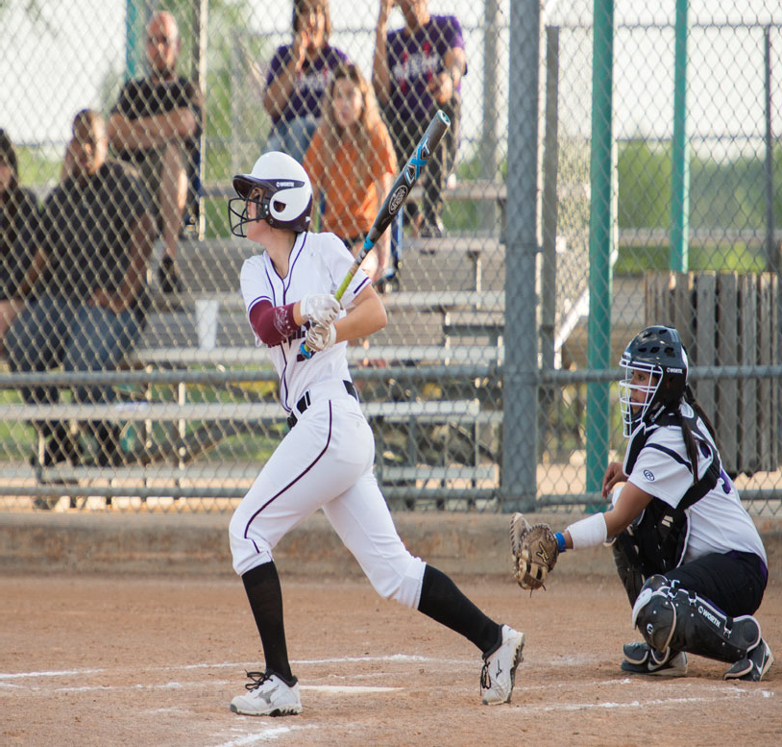
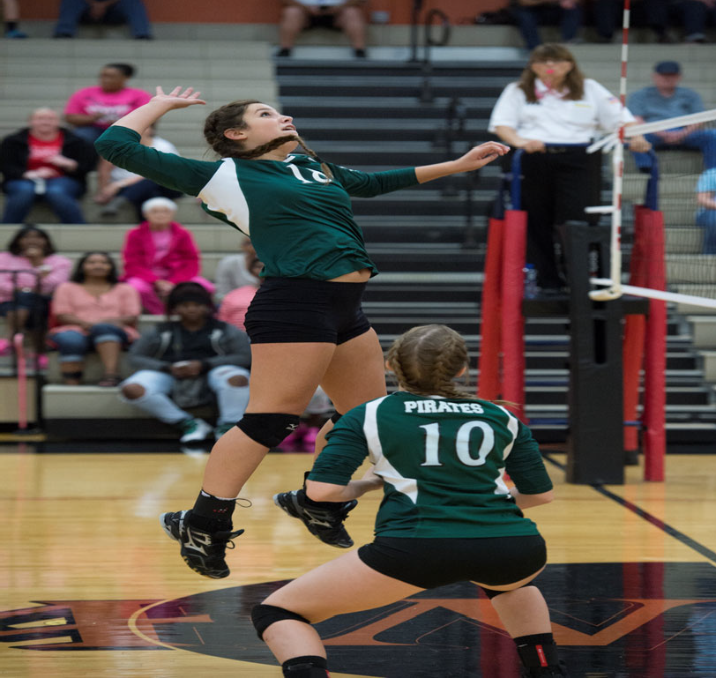
Mesquite Independent School District

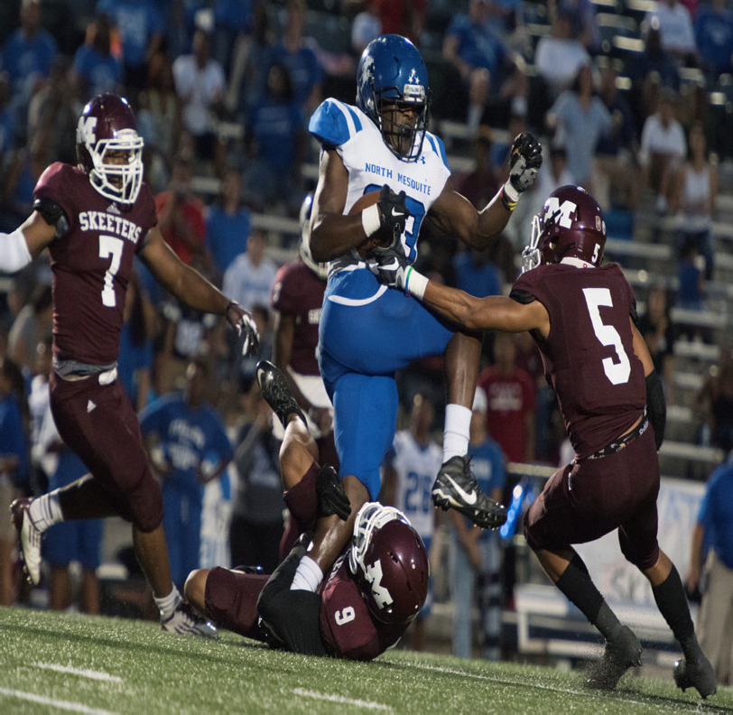 | 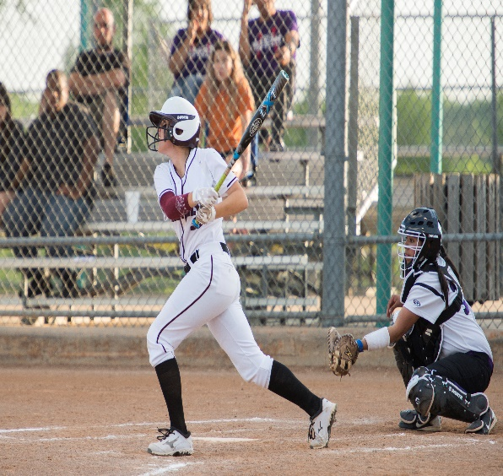  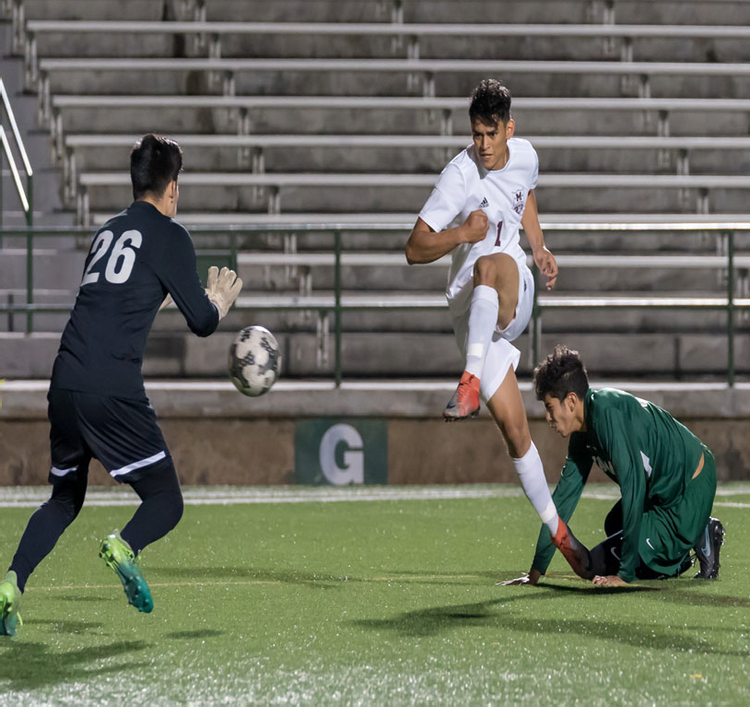
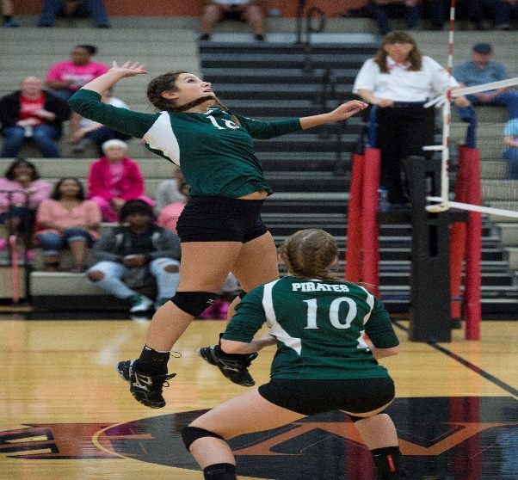

Financial Section

Financial Section 101
Table of Contents 102
Introduction 103
Funding Public Education 104‐105
Property Tax Levies & Collections 106
Comparison of Combined M&O and I&S Tax Rates 107
Long Range Assumptions 108
Budget Administration & Management Process 109‐111
Assumptions & Priorities for the 2021‐22 Budget 112‐113
Financial Section Overview 114
2021‐22 General/Debt Service/Student Nutrition Funds 115
General/Debt Service/Student Nutrition Funds—Revenues by Object 116‐117
General/Debt Service/Student Nutrition Funds—Expenditures by Object 118‐121
General Fund 122
Revenues & Expenditures 123‐124
Revenues by Object 125‐126
Expenditures by Object 127‐130
Student Nutrition Fund 131‐133
Revenues by Object 134
Expenditures by Object 135‐136
Debt Service Fund 137‐139
Revenues by Object 140
Expenditures by Object 141
Bond Debt Service 142
Outstanding Debt 143
Capital Projects Fund Overview 144
Capital Projects—Expenditures by Object 145
2018 Bond Package 146‐150
Internal Service Funds 151
Department Budgets 152
Budget Trends 153
Revenue and Budget 5 Year Estimation 154‐155
Future Budget Years 156
MISD Buildings 157‐160
Defined Benefit Pension Plan 161‐162
OPED Liability 163

Introduction

The Financial Section provides specific fiscal information regarding the various funds of the District. By law, the Board of Trustees must approve annual budgets for the General Fund, Student Nutrition Fund and the Debt Service Fund. These three funds are included in this section.

The Financial Section begins with the Combined Budget Summary of the General Fund, Student Nutrition Fund and Debt Service Fund. After the summary, the remaining section provides the reader with specific information about each of the three funds named above.

In addition to these funds, Capital Project Funds & Internal Service Funds are included as information only. The budget process for the Capital Projects Funds is established at the point in time that the Board approves the sale of authorized bonds for specific projects. The Capital Projects budgets are typically multi‐year budgets encompassing the entire construction period of each separate project.
Separate sub‐funds are created to account for each respective bond sale and unique program codes are used to track specific projects within each sub‐fund. The Internal Service Funds do not have budgets and are actual revenues and expenditures only.

The eﬀect on fund balance as a result of changing the fiscal year from September 1 to July 1 is estimated to increase fund balance $20‐$28M for fiscal year 2021 and the expected net eﬀect on non‐ committed fund balance is expected to remain at or near the current $126M.

Funding Public Education

Where does funding for public education come from?

Overtime, this has drastically changed and continues to change across the nation and within the state of Texas. A survey of state education agencies was conducted by the Editorial Project in Education Re‐ search Center that identified five major approaches to state educational funding:
  - Foundation formulas
  - Equalization methods
  - Local‐eﬀort equalization formulas
  - Flat grant funding
  - Full state funding

States may implement these fiscal mechanisms individually or in combination. For Mesquite ISD, funding is provided by foundation formulas and local‐eﬀort equalization eﬀorts. For most districts across the nation, the foundation formula is the most common method of school funding, employed in 37 states and the District of Columbia. Under this approach, districts are guaranteed a minimum amount of funding and requires districts to raise a local portion of this amount through a state‐mandated tax rate. The diﬀerence between the foundation amount and the district’s contribution determines the amount of state aid needed.

The actual costs to provide educational services are not the same for all students and all schools. Particular categories or students may have extraordinary education needs that require more intensive or diﬀerent (i.e. higher‐cost) services. For example, a cognitively disabled student who requires specialized instruction, transportation, or other services might cost more to educate than the average general education student.

Because of this, Mesquite ISD receives weights and allotments with certain types of students. Across the nation, 46 states receive some sort of weight or adjustment as part of their core school finance formula and each state varies on their amounts.

On the following page is a table for weights Mesquite ISD receives based on student characteristics:

Weights Given Based on Student Characteristics
Program | Description | Weight
Special Education | Funding for students with learning disabilities based on the student placement. | 1.1 ‐ 5.0
Compensatory Education | Additional funding for low‐performing students as determined through the federal free and reduced price lunch program. | 0.225 or 2.75  for pregnant students
Bilingual Education | Additional funding to non‐native English speakers | 0.05—0.15
CTE | Additional funding based on career and vocational skills enrollment in grades 7‐12 | 1.35
Early Education | Funds used to improve reading | 0.1
Dyslexia | Funds to improve support for dyslexic students | 0.10
GT | Gifted Talented | 0.07
CCMR | College, Career, Military Readiness | 5000 Economic Disadvantage  3000 Non‐Economic Disadvantage  2000 Per SPED

Mesquite Independent School District Property Tax Levies & Collections

Fiscal Year | M&O Rate | I&S Rate | Total Tax Rate | Taxable Values | Total Levy | Total Collections | %
2010 | 1.04 | 0.37 | 1.42 | $ 6,467,873,468 | $ 87,516,423 | $ 85,695,026 | 98.17
2011 | 1.04 | 0.37 | 1.42 | $ 6,120,707,473 | $ 86,272,907 | $ 84,461,935 | 98.64
2012 | 1.04 | 0.37 | 1.42 | $ 6,045,576,816 | $ 84,374,630 | $ 82,766,517 | 98.56
2013 | 1.04 | 0.37 | 1.42 | $ 5,875,851,693 | $ 84,516,847 | $ 83,134,933 | 98.65
2014 | 1.04 | 0.36 | 1.41 | $ 5,899,012,680 | $ 88,617,735 | $ 86,607,564 | 98.56
2015 | 1.04 | 0.36 | 1.41 | $ 6,188,134,529 | $ 89,248,544 | $ 87,466,306 | 99.17
2016 | 1.04 | 0.42 | 1.46 | $ 6,862,131,352 | $ 103,000,459 | $ 99,288,582 | 98.66
2017 | 1.04 | 0.42 | 1.46 | $ 7,054,825,858 | $ 107,713,254 | $ 108,857,664 | 98.68
2018 | 1.04 | 0.48 | 1.52 | $ 7,960,549,178 | $ 125,639,017 | $ 123,786,579 | 98.53
2019 | 0.97 | 0.48 | 1.45 | $ 9,271,820,630 | $ 130,792,672 | $ 129,188,293 | 98.77
2020 | 0.9664 | 0.48 | 1.4464 | $ 9,534,547,862 | $ 138,398,388 | $ 140,929,934 | 101.83
2021 | 0.872 | 0.44 | 1.312 | $ 11,172,393,192

Comparison of Tax Rates

The tax rate for 2021‐22 will be 1.312. The tax rate is comprised of two component rates each having separate and state laws governing them—Maintenance and Operations (M&O) tax rate and Debt Service (I&S) tax rate.

Table 24

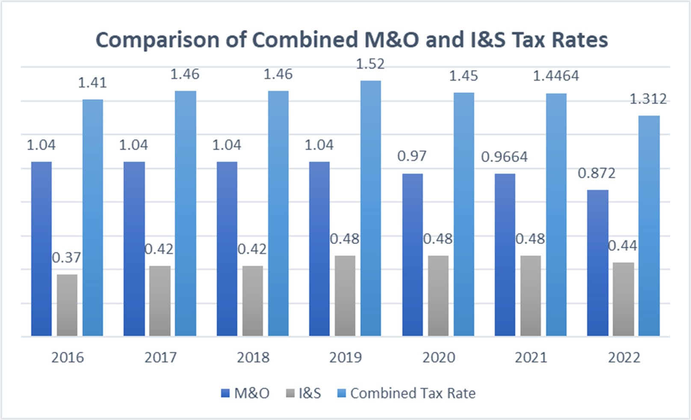

Long‐Range Projection Assumptions

- Enrollment numbers reflect the projections shown in our demographer’s report. The attendance rate of 96% is used to calculate the annual Average Daily Attendance (ADA) number. This number is a major driver in determining the amount of state funding for each fiscal year.

- The Maintenance and Operation (M&O) tax rate is the state compressed rate of 0.822 plus 5 gold pennies for a total M&O rate of $0.8720 per $100 of taxable value. No current plans to hold a Tax Ratification Election (TRE) to increase the rate at this time.

- Budget projections are planned to include an eﬀort to maintain a strong, healthy fund balance reserve of at least 22‐25% of operating expenditures to preserve financial and cash flow stability.

- Vanguard High School opened in 2021 and requires additional staﬃng and operations budgets.

Budget Administration & Management Process
Following the budget adoption, the process of administering and managing the budget begins. The process is ongoing throughout the fiscal year to ensure that accounts do not exceed authorized amounts and that they are used for the intended proper and legal uses.

Expenditure Control and Approval

Mesquite ISD uses a detailed account code called a line item. This code is segmented into fund, function, object, sub‐object, organization, fiscal year, program intent and a local option use code. Organization codes are considered cost centers and have corresponding designated personnel assigned to each. There are exceptions to this rule. If designated personnel has district‐wide responsibility, some costs are allocated to line items with multiple organization codes.

Each designated personnel is authorized to approve expenditures for the funds within their budgets. The District uses the Munis Financial Management system to account for these funds. This system monitors line items to ensure that account balances are not exceeded. Designated personnel may amend their budgets with the same functional level. For instance, supply funds for various grade levels may be redistributed based on the designated personnel’s approval since they are all under the same functional category.

Purchasing

The District’s Purchasing Department is responsible for all formal sealed bids and competitive sealed proposals. All District contracts, except contracts for the purchase of produce valued at $50,000 or more in the aggregate for each 12‐month period, are made by the method that provides the best value for the District:

- Competitive solicitations; quotes and bids.
- Competitive sealed proposals.
- A request for proposals for services other than construction services.
- A catalog purchase as provided by Government Code Chapter 2157, Subchapter B.
- An inter‐local contract.
- The reverse auction procedure as defined by Government Code 2155.062(d).

Requests for Qualifications, Competitive Sealed Proposals and Formal Sealed Bids are advertised per Local Govt. Code 271.025.

Purchase orders are required for purchases of all tangible goods and services. A campus department representative enters a requisition into the accounting system. The account is automatically checked for availability of funds. If funds are available, the requisition is submitted for approval to the denied/re‐routed by Purchasing Department personnel. Requisitions being denied are re‐ turned to the requestor for correction. These items may then be resubmitted for approval once revised. Requests for technology items, computers, peripherals, or software are submitted through Eduphoria and reviewed by the Information Technology staﬀ. If approved, a requisition is entered. Once approved, requisitions are batch updated in the financial software. The funds are encumbered, and accounting is updated to provide necessary budget control during the batch update process. The requisition number changes to a valid purchase order number during this process. Each purchase order is printed at the requestor printer and then mailed, emailed, or faxed to the appropriate vendor based on the vendor setup.

After the goods have been physically received, or services completed, the recipient enters the information acknowledging receipt into the financial accounting system. The Accounts Payable Department receives the invoice and matches it to the correct purchase order number and the correct vendor. The encumbrance is then liquidated at the time of payment.

Credit Cards

Currently, the Superintendent and Cabinet Members have a district level credit card. Departments and campuses can check out cards. A purchase order is required for payment of any charges on credit card statement, receipts are received in the accounting system. These bills are paid on a weekly basis.

Expense Reimbursements

Proper documentation and verification is necessary for expenses such as travel to be reimbursed. Verification includes such things as hotel, parking, cab, shuttle and airfare receipts, conference registration forms and mileage logs detailing dates of travel, destination and number of miles traveled. These transactions are submitted through a check requisition, signed by the requestor and principal or department head, and forwarded to the Business Oﬃce for approval and payment processing.

Budget Amendments

Periodic budget amendments are necessary during the course of the fiscal year to ensure that functional categories maintain a positive balance. Budget amendments are initiated by the Asst. Supt of Business Services. Board approval is required for budget amendments where funds are moved be‐ tween functional categories.

Reporting to the Texas Education Agency

The District submits its annual budget, student attendance information and its end‐of‐year financial status through a system called Public Education Information Management System (PEIMS). Transmission dates are established by TEA. The PEIMS system provides TEA and districts across the state with a wealth of demographic and financial information.

Monthly Financial Report

At each regular monthly Board meeting, the District’s accounting staﬀ prepares a function-by-function report for informational purposes. This report is prepared showing the summary of revenues and expenditures both on a monthly and year‐to‐date basis. These reports also show a percentage of revenues collected and a percentage of budgets expended. In addition to these fund reports, information regarding investments is presented to the Board of Trustees on a quarterly basis.

General Fund Reserve Policy

The board has adopted a 22% to 25% of Budget for the General Fund Reserve.

Internal Controls

Cash Handling Regulation is part of the annual training for all secretaries, principals, club sponsors and anyone else who might handle cash. These requirements are maintained in the district Business Ser‐ vices Handbook.

The district has an Internal Auditor who reports directly to the Board. The auditor will audit many diﬀerent aspects of the district during the school year on a rotating basis.

Assumptions for the 2021‐22 Budget Mesquite Independent School District

Assumptions form the framework of budget development. Four critical factors drive the budget revenue assumptions: the value of the property in the district, the tax rate, the number of students in the average daily attendance and state funding formulas.

Assumptions

- No changes in state funding system

- Local Revenue and Tax Rates
  - Property values ‐ 11.3% increase
  - Maintenance an Operating Tax rate decreases from $0.9664 to $.8720 (includes 5 ‘Gold’ pennies)
  - I&S tax rate estimated to decrease from $0.48 to $0.44 3. Enrollment ‐ 38,225 (ADA ‐ 36,314)
4. Audited Fund Balance ‐ $126,261,007 (8/31/20)

District Priorities for the Maintenance and Operations Budget

- Personnel
  - Vanguard HS $4M
- Secondary ($2.3M)
- Elementary ($0.8M)
- Central Administration $241.5K
- Technology $124K
- Custodial $30K

- Budget Additions
  - Xello (CCMR) $150K
- AED Replacements (2‐year) $40K
- JROTC ‐ Robotics $3K
- Employer‐Paid LTD Insurance $400K
- Website Software (accessibility) $54.2K
- Increase Substitute Pay $250K
- Increase Planetarium Contract $2K
- AYO ($1M) [$1M decrease from prior year]

District Priorities for the Maintenance and Operations Budget continued

- Salaries/Adjustments
  - Pay Adjustments $46.8K
  - Compensation Increase
    - 2.5% compensation increase $7.3M
    - $1,000/$750 one‐time payment $4.85M

- One‐Time Expenditures
  - Bus Seatbelts $1M
- Leadership Coaching $100K

- Capital Projects—Bond Funded
- Information Systems $0
- Construction Services $0
- Operations $210,100
  - Vehicles/Laundry Equipment
- Transportation $799,500
  - 7 Buses/Diagnostic Equipment
- Technical Services $2,960,000
  - Replace Fire Alarm System (WMHS)
  - Security Upgrades
  - Network Upgrades
  - Replace PA systems
  - Replace Generator
- Facilities Management $9,447,700
  - Vehicles (4)
  - Field Rake (2)
  - Security Lights
  - TV Project
  - Ceiling Tile (Pirrung & Shaw)
  - Roofs (Achziger, Shands, Thompson & Smith)
- Athletics $202,000
- Construction Projects $33,898,400
  - Wrap‐up projects (AC New, Wilkinson, McDonald, Kimbrough, Cannaday, & Vanguard)
  - Elementary #34 (GMP $29,188,100)

Mesquite Independent School District Financial Section Overview

This financial section provides fiscal information regarding the various funds of the District. The School Board of Trustees for Mesquite ISD approves annual expenditure budgets for the General fund, Student Nutrition Fund, and Debt Service Fund. These three funds make up the Governmental Funds. All other funds include proprietary funds, fiduciary funds, special revenue funds, and capital project funds.

In this section, a pyramid approach is presented by beginning with a Combined Statement of Revenues and Expenditures for all three Governmental funds together followed by schedules providing financial information for each of the funds.

The District’s budget is organized into the following fund categories:

General Fund
Used to pay for salaries and benefits of District staﬀ, classroom resources, utilities, maintenance, custodial work, grounds upkeep, transportation, etc. Mainly to pay for the general operations of the District’s facilities and staﬀ.

Student Nutrition Fund
Used for the operation of the District’s program to provide meals to the District’s students.

Debt Service Fund
Used to pay the annual principal and interest requirements resulting from the sale of bonds by the District with approval from the District’s voters via a bond election. These bonds are sold to fund the construction of instructional buildings, other facilities, technology needs, and general maintenance projects.

Table 25
Mesquite Independent School District
2021‐22 General/Debt Service/Student Nutrition Funds

Expenditures
General Fund Student Nutrition Fund Debt Service Fund
$ 399,979,697 $ 17,203,598 $ 57,600,000

Revenue
General Fund Student Nutrition Fund Debt Service Fund
$ 387,970,090 $ 19,512,700 $ 57,600,000

Financial Section
Mesquite ISD Oﬃcial Budget 2021‐2022
115

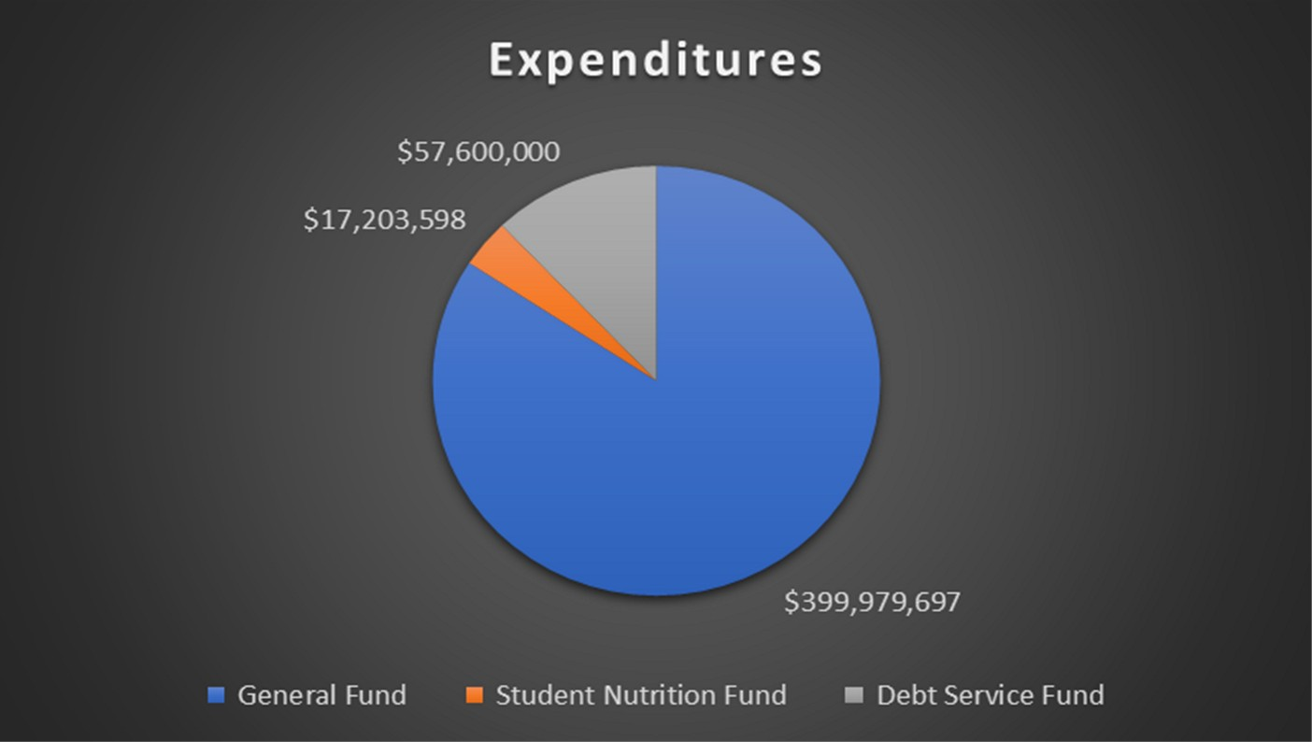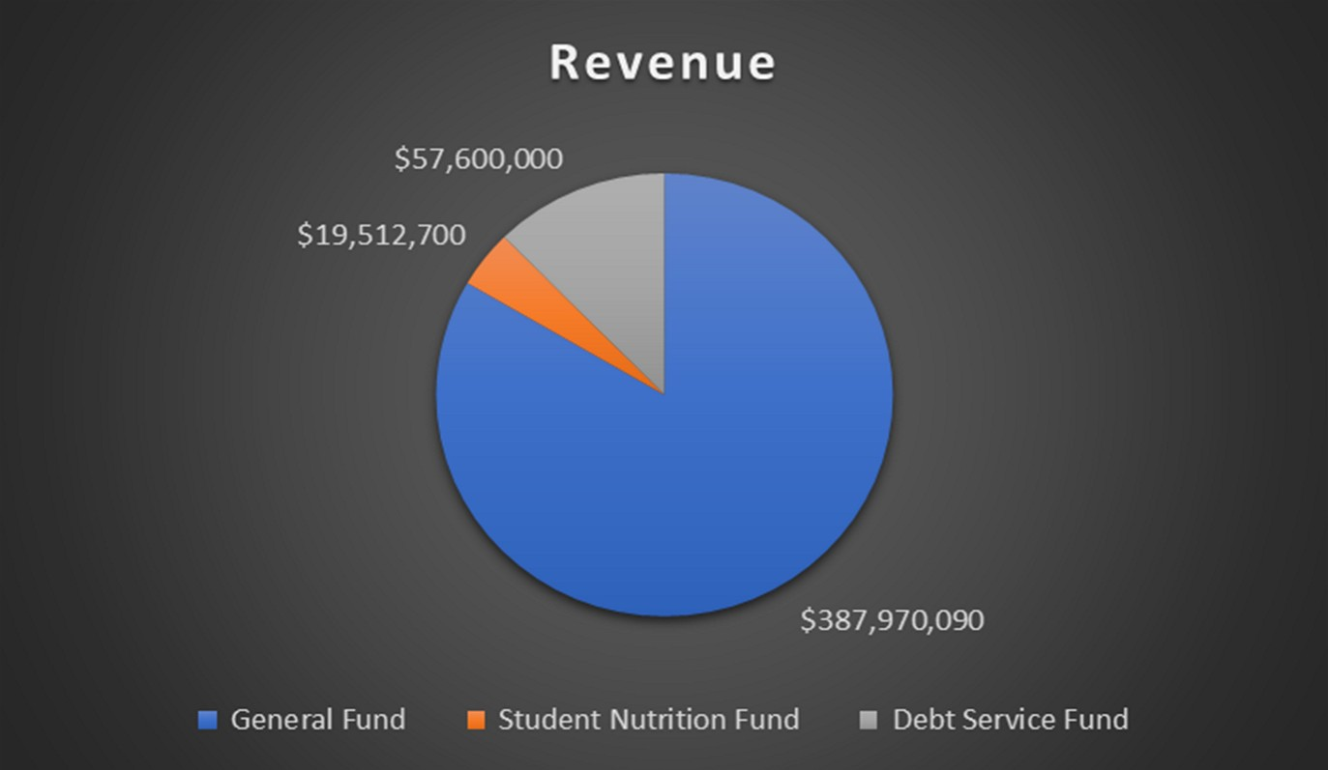

General/Debt Service/Student Nutrition Funds ‐ Revenues by Object

 |  | 2015 AUDITED | 2016 AUDITED |  | 2017 AUDITED |  | 2018 AUDITED |  | 2019 AUDITED 2020 AUDITED |  |  |  | 2021 UNAUDTIED |  | 2022 BUDGET
5711 ‐ TAXES, CURRENT YEAR LEVY | $ | 86,535,995 $ | 87,403,596 $ |  | 99,225,646 | $ | 108,823,339 | $ | 123,658,383 $ 128,935,084 $ |  |  |  | 138,913,794 | $ | 143,050,000
5712 ‐ TAXES PRIOR YEAR | $ 803,309 $ |  | 1,298,062 $ |  | 1,045,083 | $ 948,834 |  | $ 658,793 $ |  |  | 1,461,488 | $ 946,317 |  | $ 1,000,000
5719 ‐ PENALTIES, INTEREST & OTHER TA | $ 940,289 $ |  | 1,129,926 $ |  | 1,167,492 | $ 1,206,083 |  | $ 1,426,439 $ |  |  | 1,450,802 | $ 1,184,581 |  | $ 1,000,000
5721 ‐ LOCAL FROM SALE OF WADA $ ‐ $ ‐ |  |  |  |  |  | $ | ‐ | $ | − $ |  | ‐ | $ | ‐ | $ | ‐
5735 ‐ TUITUION & FEES $ 214,810 $ 186,030 $ |  |  |  |  | 183,180 | $ | 184,212 | $ | 191,535 $ |  | 128,915 | $ | 132,450 | $ | 200,000
5736 ‐ TUITION‐REG DAY SCHOOL/SUNNYVA $ ‐ $ ‐ |  |  |  |  |  | $ ‐ |  | $ ‐ |  | $ 5,725 |  | $ 93,769 |  | $ 75,000
5737 ‐ SUMMER SCHOOL $ 101,834 $ 92,617 $ 100,298 |  |  |  |  |  | $ 70,274 |  | $ 64,780 |  | $ 83,166 |  | $ 58,507 |  | $ 50,000
5738 ‐ OTHER STUDENT TUITION $ ‐ $ ‐ |  |  |  |  |  | $ ‐ |  | $ ‐ |  | $ 405,248 |  | $ 143,197 |  | $ 125,000
5739 ‐ TUITION AND FEES $ 621,258 $ 773,763 $ 17,901 $ 18,275 $ 17,418 $ 13,595 $ 16,405 $ 25,000
5742 ‐ EARNINGS FROM INVESTMENTS | $ 556,0421 $ |  | 1,443,415 | $ 1,737,829 |  | $ 4,040,644 |  | $ 5,161,422 $ |  |  | 4,098,805 | $ 763,553 |  | $ 1,415,000
5743 ‐ RENTAL FROM SCHOOL PROPERTY | $ 473,306 $ |  | 451,147 | $ 603,823 |  | $ 542,237 |  | $ 369,999 $ |  |  | 257,555 | $ 198,251 |  | $ 300,000
5744 ‐ GIFTS & BEQUESTS | $ 174,758 $ |  | 300,210 | $ 163,839 |  | $ 249,274 |  | $ 296,465 $ |  |  | 336,574 | $ 228,623 |  | $ 65,000
5745 ‐ INSURANCE RECOVERY | $ 32,531 $ |  | 26,857 | $ 1,896,755 |  | $ 522,484 |  | $ 726,244 $ |  |  | 161,719 | $ 1,433,759 |  | $ 250,000
5746 ‐ TAX INCREMENT FUND | $ | 60,562 $ | ‐ | $ | ‐ | $ | ‐ | $ | ‐ | $ | ‐ | $ | ‐ | $ | ‐
5748 ‐ NET RECEIPTS CLEARING/PATROL | $ 185,843 $ |  | 194,337 $ |  | 204,557 | $ 196,642 |  | $ 200,561 |  | $ 195,425 |  | $ 191,234 |  | $ 200,000
5749 ‐ MISC/FINES, WELLNESS, & ETC. | $ 1,004,195 $ |  | 1,461,969 $ |  | 1,219,885 | $ 2,495,331 |  | $ 1,099,132 |  | $ 966,460 |  | $ 1,746,813 |  | $ 2,833,000
5751 ‐ FOOD SERVICES ACTIVITY | $ 3,444,883 $ |  | 3,197,861 $ |  | 3,159,059 | $ 3,325,457 |  | $ 3,130,188 |  | $ 2,126,072 |  | $ 1,081,727 |  | $ 2,119,000
5752 ‐ ATHLETIC ACTIVITY REVENUE | $ 758,439 $ |  | 789,016 $ |  | 809,620 | $ 823,156 |  | $ 567,624 |  | $ 701,002 |  | $ 399,391 |  | $ 700,000
5753 ‐ EXTRA/COCURRICULAR ACTIVITY | $ 2,354,979 $ |  | 2,788,412 $ |  | 2,905,256 | $ 2,898,777 |  | $ 3,340,235 $ 2,146,040 $ 1,549,975 $ ‐
5755 ‐ ACTIVITY FUND | $ 112,752 $ |  | 140,187 $ |  | 120,199 | $ 125,260 |  | $ 131,039 $ 71,853 $ 64,726 $ 130,000
5757 ‐ TAXABLE ITEMS SALE $ 424,082 $ 5 |  |  |  | $ 5 |  | $ | ‐ | $ 24,962 |  | $ ‐ |  | $ | ‐ | $ ‐
5761 ‐ SUCESSOR‐IN‐INTEREST CED $ ‐ $ ‐ |  |  |  |  |  | $ | ‐ | $ ‐ |  | $ ‐ |  | $ | ‐ | $ ‐
5769 ‐ COUNTY AVAILABLE | $ | − $ | ‐ |  |  | $ | ‐ | $ | ‐ | $ | ‐ | $ | ‐ | $ | ‐
5811 ‐ PER CAPITA/APPORTIONMENT | $ 9,949,005 $ |  | 6,877,475 $ |  | 5,120,812 | $ 8,011,935 |  | $ 18,653,252 |  | $ 12,090,407 $ 16,568,435 $ 7,365,000
5812 ‐ FOUNDATION/ENTITLEMENTS | $ 224,825,736 $ |  | 241,648,409 $ |  | 34,408,940 | $ 241,130,679 |  | $ 225,197,087 |  | $ 244,910,671 $ 245,249,340 $ 247,999,190
5819 ‐ OTHER FOUNDATION SCHOOL PROGRA $ ‐ $ 432,819 $ ‐ $ ‐ $ ‐
5826 ‐ SUPPLEMENTAL PRE‐K | $ 67,634 $ |  | 69,468 |  |  | $ | ‐ | $ | ‐ | $ | − $ |  | ‐ | $ | ‐
5827 ‐ YEAR ROUND SCHOOL INCENTIVE | $ ‐ $ |  |  | − $ | ‐ | $ | ‐ | $ | ‐ | $ | − $ |  | ‐ | $ | ‐

5829 ‐ MISCELLANEOUS STATE PROGRAMS
$ 21,035,280 $ 23,611,653 $ 22,132,382 $ 24,754,034 $ 24,169,444 $ 20,909,551 $ 17,294,763 $ 10,620,700

Financial Section
Mesquite ISD Oﬃcial Budget 2021‐2022
116

General/Debt Service/Student Nutrition Funds ‐ Revenues by Object (cont.)
Financial Section
Mesquite ISD Oﬃcial Budget 2021‐2022
117

 | 2015 AUDITED |  | 2016 AUDITED |  | 2017 AUDITED |  | 2018 AUDITED |  | 2019 AUDITED |  | 2020 AUDITED |  | 2021 UNAUDITED |  | 2022 BUDGET
5831 ‐ TRS ON‐BEHALF BENEFIT | $ 13,914,380 |  | $ 14,404,913 |  | $ 14,852,191 |  | $ 15,364,250 |  | $ 15,917,167 |  | $ 18,279,319 |  | $ 14,397,218 |  | $ 21,905,900
5836 ‐ REVENUE FROM OTHER TX GOVERNME | $ ‐ |  | $ ‐ |  |  |  | $ ‐ |  | $ ‐ |  | $ ‐ |  | $ ‐ |  | $ ‐
5839 ‐ OTHER STATE AGENCIES | $ 241,490 |  | $ 227,294 |  | $ 178,097 |  | $ 146,059 |  | $ 183,608 |  | $ 1,728,776 |  | $ ‐ |  | $ 1,115,000
5921 ‐ SCHOOL BREAKFAST PROGRAM | $ 2,890,059 |  | $ 3,188,154 |  | $ ,166,768 |  | $ 3,423,909 |  | $ 3,450,297 |  | $ 3,075,166 |  | $ 1,664,133 |  | $ 2,706,000
5922 ‐ NATIONAL SCHOOL LUNCH | $ 12,849,346 |  | $ 13,676,495 |  | $ 13,111,136 |  | $ 14,013,847 |  | $ 3,939,615 |  | $ 10,501,651 |  | $ 7,475,345 |  | $ 11,016,000
5923 ‐ USDA DONATED COMMODITIES | $ 1,263,276 |  | $ 1,590,843 |  | $ 1,692,845 |  | $ 1,717,639 |  | $ 1,675,144 |  | $ 1,699,613 |  | $ 1,841,360 |  | $ 2,143,000
5929 ‐ OTHER FEDERAL REVENUES | $ | ‐ | $ | ‐ | $ | ‐ | $ | ‐ | $ | ‐ | $ | ‐ | $ | 699,476 | $ | ‐
5931 ‐ SCHOOL HEALTH AND RELATED SERV | $ 2,829,209 |  | $ 3,539,646 |  | $ 3,172,021 |  | $ 2,889,561 |  | $ 4,997,323 |  | $ 3,439,995 |  | $ 1,544,116 |  | $ 5,500,000
5932 ‐ MEDICAID ADM CLAIMING | $ 67,328 |  | $ 102,961 |  | $ 58,619 |  | $ 46,877 |  | $ ‐ |  | $ ‐ |  | $ ‐ |  | $ ‐
5949 ‐ DIRECT FEDERAL REVENUE | $ 499,681 |  | $ 462,447 |  | $ 541,995 |  | $ 576,200 |  | $ 515,047 |  | $ 566,768 |  | $ 481,780 |  | $ 550,000
7901 ‐ REFUNDING BOND ISSUANCE | $ 75,874,666 |  | $ 39,160,000 |  | $ 12,803,008 |  | $ 172,334 |  | $ 3,131,150 |  | $ 40,402 |  | $ ‐ |  | $ 150,000
7911 ‐ SALE OF BONDS | $ | ‐ | $ | ‐ | $ | ‐ | $ | ‐ | $ | ‐ | $ | ‐ | $ | ‐ | $ | ‐
7912 ‐ SALE OF PROPERTY | $ 66,789 $ 77,290 $ 34,051 |  |  |  |  |  | $ 172,334 |  | $ 3,131,150 |  | $ 40,402 |  | $ 28,543 |  | $ 150,000
7913 ‐ LEASE‐PURCHASE PROCEEDS | $ | ‐ | $ | ‐ | $ |  |  | ‐ | $ | ‐ | $ | ‐ | $ | ‐ | $ | ‐
7915 ‐ TRANSFER IN | $ 449,3585 |  | $ 432,249 |  | $ 440,115 |  | $ 391,200 |  | $ 391,200 |  | $ 391,200 |  | $ 405,128 |  | $ 475,000
7916 ‐ PREMIUM/DISCOUNT | $ 29,396,644 |  | $ 8,369,934 |  | $ 11,071,275 |  | $ | ‐ | $ | ‐ | $ | ‐ | $ | ‐ | $ | ‐
7949 ‐ OTHER RESOURCES | $ ‐ |  | $ ‐ |  | $ ‐ |  | $ | ‐ | $ | ‐ | $ | ‐ | $ | ‐ | $ | ‐
7989 ‐ OTHER/NON‐REVENUE | $ 647 |  | $ 294 |  | $ 40 |  | $ | ‐ | $ | ‐ | $ | ‐ | $ | ‐ | $ | ‐
7998 ‐ GAIN/LOSS INVESTMENT | $ ‐ |  | $ ‐ |  |  |  |  |  |  |  | $ | ‐ | $ | ‐ | $ | ‐
7999 ‐ RESIDUAL EQUITY TRANSFERS IN | $ ‐ |  | $ ‐ |  |  |  |  |  |  |  | $ | ‐ | $ | ‐ | $ | ‐
Grand Total | $ 495,020,398 |  | $ 459,116,925 |  | $ 47,344,721 |  | $ 439,108,803 |  | $ 453,718,373 |  | $ 461,179,049 |  | $ 458,121,405 |  | $ 465,082,790

General/Debt Service/Student Nutrition Funds ‐ Expenditures by Object
Financial Section
Mesquite ISD Oﬃcial Budget 2021‐2022
118

2015 AUDITED 2016 AUDITED 2017 AUDITED 2018 AUDITED 2019 AUDITED 2020 AUDITED 2021 UNAUDTIED 2022 BUDGET
6112 ‐ PROFESSIONAL SUBSTITUTES | $ 2,173,216 |  | $ 2,219,639 |  | $ 2,228,444 |  | $ 2,358,408 |  | $ 2,510,675 |  | $ 1,781,483 $ |  | 2,246,988 | $ 2,599,101
6116 ‐ PROFESSIONAL EXTRA DUTY PAY | $ 5,007,043 |  | $ 5,157,514 |  | $ 4,997,807 |  | $ 5,094,645 |  | $ 5,184,146 |  | $ 4,563,582 $ |  | 12,074,525 | $ 11,637,453
6117 ‐ CAREER LADDER | $ 165,648 |  | $ 135,072 |  | $ 112,113 |  | $ 85,757 |  | $ 74,222 |  | $ 66,000 $ |  | 43,750 | $ 54,650
6118 ‐ PROFESSIONAL STIPENDS | $ 2,799,974 |  | $ 2,863,103 |  | $ 2,937,504 |  | $ 3,031,402 |  | $ 2,968,796 |  | $ 3,379,983 $ |  | 3,032,026 | $ 2,948,900
6119 ‐ PROFESSIONAL SALARY | $ 169,690,358 |  | $ 178,158,079 |  | $ 179,375,942 |  | $ 190,892,700 |  | $ 190,098,559 |  | $ 193,458,909 $ |  | 170,086,077 | $ 216,926,000
6121 ‐ EXTRA DUTY/SUPPORT | $ 1,766,951 |  | $ 1,935,076 |  | $ 2,286,294 |  | $ 2,316,731 |  | $ 2,659,043 |  | $ 2,992,978 $ |  | 3,024,753 | $ 3,470,152
6122 ‐ SUPPORT SALARIES ‐ SUBS | $ 672,088 |  | $ 820,653 |  | $ 768,560 |  | $ 678,453 |  | $ 617,855 |  | $ 522,442 $ |  | 427,473 | $ 691,203
6125 ‐ SUPPORT SALARIES | $ 35,356,904 |  | $ 37,069,482 |  | $ 39,503,679 |  | $ 41,005,061 |  | $ 41,126,703 |  | $ 42,968,691 $ |  | 36,304,220 | $ 46,574,400
6126 ‐ SUPPORT SALARIES/HOURLY | $ 1,406,933 |  | $ 1,387,646 |  | $ 1,375,573 |  | $ 1,386,551 |  | $ 1,411,899 |  | $ 1,532,309 $ |  | 1,416,612 | $ 1,913,400
6131 ‐ CONTRACT BUYOUTS | $ | ‐ | $ | ‐ |  |  | $ | ‐ | $ | ‐ | $ |  | ‐ | $ ‐
6134 ‐ EMPLOYEE ALLOWANCES | $ 456,652 |  | $ 454,754 |  | $ 293,590 |  | $ 216,329 |  | $ 219,854 |  | $ 219,854 $ |  | 184,580 | $ 257,800
6141 ‐ SOCIAL SECURITY/MEDICARE | $ 2,885,599 |  | $ 3,029,173 |  | $ 3,197,258 |  | $ 3,277,439 |  | $ 3,366,460 |  | $ 3,369,268 $ |  | 3,158,532 | $ 4,034,304
6142 ‐ HEALTH & LIFE INSURANCE | $ 10,975,693 |  | $ 11,138,981 |  | $ 11,354,829 |  | $ 11,396,341 |  | $ 11,045,082 |  | $ 10,965,385 $ |  | 8,981,885 | $ 11,538,740
6143 ‐ WORKERS' COMPENSATION | $ 1,024,911 |  | $ 1,025,233 |  | $ 1,024,371 |  | $ 1,026,542 |  | $ 1,027,866 |  | $ 1,028,814 $ |  | 1,229,950 | $ 1,412,852
6144 ‐ TRS ON‐BEHALF BENEFIT | $ 13,914,380 |  | $ 14,404,913 |  | $ 14,852,191 |  | $ 15,364,250 |  | $ 15,917,167 |  | $ 15,917,167 $ |  | 14,397,218 | $ 21,905,900
6145 ‐ UNEMPLOYMENT COMPENSATION | $ 63,189 |  | $ 80,039 |  | $ 74,864 |  | $ 101,948 |  | $ 41,489 |  | $ 41,489 $ |  | 127,587 | $ 220,300
6146 ‐ TEACHER RETIREMENT/TRS CARE | $ 7,119,852 |  | $ 7,401,076 |  | $ 7,795,915 |  | $ 8,797,244 |  | $ 8,936,002 |  | $ 8,911,735 $ |  | 8,700,652 | $ 11,028,552
6147 ‐ SICK/VACATION RETIREMENT | $ 277,328 |  | $ 881,880 |  | $ 344,559 |  | $ 485,003 |  | $ 322,716 |  | $ 358,946 $ |  | 303,534 | $ 439,360
6148 ‐ PLAN BEHAVIOR HEALTH | $ 110,791 |  | $ 112,459 |  | $ 114,011 |  | $ 114,805 |  | $ 114,919 |  | $ 114,919 $ |  | 95,338 | $ 117,800
6149 ‐ EMPLOYEE BENEFITS | $ 84,276 |  | $ 74,697 |  | $ 75,774 |  | $ 75,213 |  | $ 82,265 |  | $ 82,265 $ |  | 70,779 | $ 477,700
6211 ‐ LEGAL SERVICE | $ 187,373 |  | $ 148,005 |  | $ 176,022 |  | $ 167,753 |  | $ 211,835 |  | $ 211,835 $ |  | 182,011 | $ 258,000
6212 ‐ AUDIT SERVICES | $ 110,000 |  | $ 110,000 |  | $ 142,000 |  | $ 125,000 |  | $ 125,000 |  | $ 125,000 $ |  | 142,500 | $ 120,000
6213 ‐ TAX COLLECTION | $ 655,744 |  | $ 706,235 |  | $ 753,393 |  | $ 759,748 |  | $ 784,840 |  | $ 784,840 $ |  | 782,565 | $ 820,000
6214 ‐ LOBBYING EXPENSE |  |  |  |  |  |  | $ | ‐ | $ | ‐ | $ | − $ | ‐ | $ 7,500
6217 ‐ DATA PROCESSING SERVICE | $ | ‐ | $ | ‐ | $ | ‐ | $ | ‐ | $ | ‐
6219 ‐ PROFESSIONAL SERVICE | $ 50,209 |  | $ 40,000 |  | $ 40,000 |  | $ 40,000 |  | $ 539,193

 | 2015 AUDITED | 2016 AUDITED | 2017 AUDITED | 2018 AUDITED | 2019 AUDITED | 2020 AUDITED | 2021 UNAUDTIED | 2022 BUDGET
6221 ‐ STAFF TUITION FEES | $ 710,552 | $ 656,992 | $ 339,399 | $ 91,951 | $ 91,951 | $ 81,136 | $ 141,402 $ | 325,000
6223 ‐ STUDENT TUITION‐OTHER THAN PUB | $ 266,272 | $ 262,036 | $ 604,557 | $ 766,211 | $ 766,211 | $ 65,576 | $ 189,445 $ | 630,000
6239 ‐ EDUCATION SERVICE CENTER | $ 108,935 | $ 105,023 | $ 122,370 | $ 168,327 | $ 168,327 | $ 126,477 | $ 231,409 $ | 223,850
6244 ‐ TECHNOLOGY MAINT/REPAIRS | $ ‐ | $ 1,159 | $ ‐ | $ ‐ | $ ‐ |  | $ | 1,000
6245 ‐ AUDIO VISUAL MAINT/REPAIRS | $ 7,449 | $ 5,230 | $ 1,445 | $ 5,098 | $ 5,098 | $ 4,192 | $ 3,334 $ | 7,000
6246 ‐ BUILDING MAINTENANCE/REPAIRS | $ 2,004,082 | $ 2,718,974 | $ 1,944,157 | $ 2,656,746 | $ 2,664,959 | $ 2,621,006 | $ 3,828,223 $ | 3,559,200
6247 ‐ VEHICLE MAINTENANCE/REPAIRS | $ 70,303 | $ 38,231 | $ 84,030 | $ 123,927 | $ 123,927 | $ 84,290 | $ 26,246 $ | 56,000
6249 ‐ CONTRACTED MAINT/REPAIR | $ 1,854,003 | $ 2,136,210 | $ 2,398,239 | $ 2,266,326 | $ 2,237,625 | $ 2,909,888 | $ 2,433,362 $ | 3,560,700
6255 ‐ WATER | $ 1,694,384 | $ 2,209,633 | $ 2,149,571 | $ 2,464,137 | $ 2,464,137 | $ 2,271,897 | $ 2,255,903 $ | 3,105,000
6256 ‐ TELEPHONE | $ 983,051 | $ 347,686 | $ 472,419 | $ 450,956 | $ 450,956 | $ 333,964 | $ 193,496 $ | 370,900
6257 ‐ ELECTRICITY | $ 5,468,993 | $ 5,494,409 | $ 5,686,607 | $ 4,924,685 | $ 4,924,685 | $ 4,329,388 | $ 3,361,235 $ | 3,784,100
6258 ‐ GAS | $ 534,070 | $ 404,750 | $ 456,382 | $ 524,861 | $ 524,861 | $ 393,066 | $ 431,062 $ | 643,800
6259 ‐ OTHER UTILITIES | $ 75,016 | $ 721,308 | $ 445,496 | $ 273,578 | $ 273,578 | $ 269,237 | $ 1,868,854 $ | 286,000
6264 ‐ COPIER RENTAL | $ 1,513,675 | $ 1,532,132 | $ 1,215,868 | $ 1,369,324 | $ 1,369,324 | $ 1,483,529 | $ 994,522 $ | 1,568,000
6265 ‐ EQUIP RENTAL | $ 42,817 | $ 16,681 | $ 22,311 | $ 41,940 | $ 41,940 | $ 50,712 | $ 32,212 $ | 87,900
6266 ‐ VEHICLE RENTAL | $ 49,849 | $ 115,589 | $ 116,292 | $ 91,671 | $ 91,671 | $ 90,259 | $ 29,509 $ | 86,500
6267 ‐ BUILDING RENTAL | $ 937,434 | $ 937,434 | $ 937,434 | $ 938,159 | $ 938,159 | $ 938,209 | $ ‐ $ | ‐
6269 ‐ OTHER RENTAL | $ 3,591 | $ 1,270 | $ 4,624 | $ 4,132 | $ 4,132 | $ 25,884 | $ 5,885 $ | 6,000
6291 ‐ CONSULTING SERVICES | $ 13,200 | $ 146,500 | $ 50,000 | $ 259,183 | $ 259,183 | $ 648,979 | $ 883,424 $ | 107,000
6299 ‐ MISC CONTRACTED SERVICE | $ 4,633,112 | $ 5,080,453 | $ 5,416,949 | $ 4,963,073 | $ 4,956,312 | $ 6,140,370 | $ 4,935,103 $ | 5,877,690
6311 ‐ VEHICLE FUELS | $ 647,663 | $ 375,216 | $ 624,808 | $ 724,580 | $ 724,192 | $ 1,022,975 | $ 408,538 $ | 1,265,700
6315 ‐ CUSTODIAL SUPPLIES | $ 885,909 | $ 924,243 | $ 936,662 | $ 1,009,868 | $ 1,009,868 | $ 1,002,836 | $ 1,025,219 $ | 1,206,200
6316 ‐ SUPPLIES BUILDINGS | $ 1,462,465 | $ 1,801,023 | $ 1,451,942 | $ 1,360,573 | $ 1,360,573 | $ 1,527,067 | $ 1,325,845 $ | 3,037,200

6317 ‐ COMPUTER SUPPLIES/M&O
$ ‐ $ ‐ $ ‐ $ ‐ $ ‐ $ ‐

Financial Section
Mesquite ISD Oﬃcial Budget 2021‐2022
119
6319 ‐ OTHER SUPPLIES | $ 1,240,499 |  | $ 1,109,486 |  | $ 980,473 |  | $ 892,302 |  | $ 892,302 |  | $ 1,517,055 |  | $ 1,852,892 |  | $ 1,985,500
6321 ‐ TEXTBOOKS | $ 304,505 |  | $ 145,891 |  | $ 173,186 |  | $ 132,097 |  | $ 132,097 |  | $ 5,072 |  | $ 10,362 |  | $ 292,000
6325 ‐ READING MATERIALS/BOOKS | $ 112,767 |  | $ 174,601 |  | $ 136,523 |  | $ 103,862 |  | $ 103,862 |  | $ 126,136 |  | $ 48,422 |  | $ 48,300
6326 ‐ MAGAZINES | $ 151,455 |  | $ 10,845 |  | $ 26,117 |  | $ 29,797 |  | $ 29,797 |  | $ 11,632 |  | $ 13,530 |  | $ 15,150
6327 ‐ TEXTBOOK (STATE ADOPTED) | $ | ‐ | $ | ‐ | $ | ‐ | $ | ‐ | $ | ‐ | $ | ‐ | $ | ‐ | $ | ‐
6329 ‐ READING MATERIAL/OTHER | $ | 48,997 | $ | 84,435 | $ | 41,389 | $ | 39,911 | $ | 39,911 | $ | 22,531 | $ | 20,234 | $ | 38,950

Financial Section
Mesquite ISD Oﬃcial Budget 2021‐2022
120

 | 2015 AUDITED |  | 2016 AUDITED |  | 2017 AUDITED |  | 2018 AUDITED |  | 2019 AUDITED |  | 2020 AUDITED |  | 2021 UNAUDTIED |  | 2022 BUDGET
6334 ‐ TESTING‐MATERIALS | $ 215,318 |  | $ 171,227 |  | $ 216,830 |  | $ 346,420 |  | $ 346,420 |  | $ 168,389 |  | $ 280,176 |  | $ 443,500
6341 ‐ FOOD/FOOD SERVICE | $ 9,080,744 |  | $ 9,697,225 |  | $ 8,632,745 |  | $ 8,469,470 |  | $ 8,707,429 |  | $ 7,537,348 |  | $ 5,122,490 |  | $ 3,358,200
6342 ‐ NON‐FOOD/FOOD SERVICE | $ 983,582 |  | $ 1,031,191 |  | $ 876,757 |  | $ 930,796 |  | $ 901,210 |  | $ 776,483 |  | $ 551,803 |  | $ 1,119,500
6344 ‐ USDA DONATED COMMODITIES | $ 1,263,276 |  | $ 1,590,843 |  | $ 1,692,845 |  | $ 1,717,639 |  | $ 1,675,603 |  | $ 1,699,952 |  | $ 1,841,268 |  | $ 2,118,398
6349 ‐ FOOD SERVICE SUPPLIES | $ 32,165 |  | $ 174,495 |  | $ 118,367 |  | $ 62,458 |  | $ 738,000 |  | $ 712,951 |  | $ 25,844 |  | $ 102,300
6395 ‐ ELECTRONICS $100‐$5,000 | $ 442,063 |  | $ 543,506 |  | $ 592,104 |  | $ 723,539 |  | $ 1,556,163 |  | $ 1,257,132 |  | $ 726,234 |  | $ 444,500
6396 ‐ COMPUTER SUPPLIES | $ 1,314,871 |  | $ 1,101,759 |  | $ 1,544,036 |  | $ 1,557,766 |  | $ 295,380 |  | $ 322,914 |  | $ 1,158,891 |  | $ 1,710,350
6397 ‐ FURNITURE UNDER $5,000 | $ 255,469 |  | $ 339,294 |  | $ 245,112 |  | $ 293,350 |  | $ 854,270 |  | $ 436,361 |  | $ 200,224 |  | $ 145,800
6398 ‐ EQUIPMENT $300‐$5,000 | $ 276,479 |  | $ 398,901 |  | $ 466,725 |  | $ 894,555 |  | $ 8,218,349 |  | $ 8,022,092 |  | $ 252,704 |  | $ 326,100
6399 ‐ GENERAL SUPPLIES | $ 9,012,097 |  | $ 8,794,451 |  | $ 9,242,910 |  | $ 8,274,158 |  | $ 667,568 |  | $ 8,547,122 |  | $ 8,185,427 |  | $ 13,621,010
6411 ‐ TRAVEL/EMPLOYEE | $ 510,621 |  | $ 593,433 |  | $ 713,272 |  | $ 588,934 |  | $ 1,067,479 |  | $ 1,370,678 |  | $ 83,800 |  | $ 846,155
6412 ‐ TRAVEL/STUDENTS | $ 539,193 |  | $ 756,445 |  | $ 903,435 |  | $ 1,054,022 |  | $ ‐ |  | $ ‐ |  | $ 452,958 |  | $ 837,850
6413 ‐ STIPENDS/NON‐EMPLOYEE | $ | ‐ | $ | ‐ | $ | ‐ | $ | ‐ | $ | 57,472 | $ | ‐ | $ | ‐ | $ | ‐
6419 ‐ TRAVEL/NON‐EMPLOYEE | $ 23,853 |  | $ 38,745 |  | $ 54,617 |  | $ 57,472 |  | $ 950,176 |  | $ 1,349,493 |  | $ 12,632 |  | $ 69,700
6425 ‐ PROPERTY INSURANCE | $ 633,530 |  | $ 649,496 |  | $ 781,873 |  | $ 950,176 |  | $ 124,740 |  | $ 126,858 |  | $ 1,646,987 |  | $ 1,700,500
6426 ‐ LIABILITY INSURANCE | $ 113,879 |  | $ 113,609 |  | $ 122,061 |  | $ 124,740 |  | $ 1,562 |  | $ 2,272 |  | $ 271,470 |  | $ 130,000
6427 ‐ BONDING INSURANCE | $ 1,988 |  | $ 3,053 |  | $ 2,627 |  | $ 1,562 |  | $ 197,539 |  | $ 202,539 |  | $ 1,349 |  | $ 4,000
6428 ‐ ATHLETIC INSURANCE | $ 225,676 |  | $ 228,287 |  | $ 197,539 |  | $ 197,539 |  | $ ‐ |  | $ ‐ |  | $ ‐ |  | $ 210,000
6429 ‐ OTHER INSURANCE ESCROW | $ | ‐ | $ | ‐ | $ | ‐ | $ | ‐ | $ | 60,720 | $ | ‐ | $ | ‐ | $ | ‐
6434 ‐ ELECTION EXPENSES | $ 70,637 |  | $ 41,975 |  | $ | ‐ | $ 60,720 |  | $ 1,833 |  | $ ‐ |  | $ 222,852 |  | $ 230,000
6491 ‐ REQUIRED PUBLIC NOTICES |  |  |  |  |  |  | $ 1,833 |  | $ 1,833 |  | $ 5,920 |  | $ 1,449 |  | $ 21,200
6494 ‐ STUDENT TRANSPORTATION‐BUSES | $ 1,034,129 |  | $ 1,112,246 |  | $ | 1,155,078 | $ 1,336,540 |  | $ 1,336,540 |  | $ 1,198,775 |  | $ 457,286 |  | $ 1,194,200
6495 ‐ DUES | $ 126,065 |  | $ 161,599 |  | $ | 195,075 | $ 181,901 |  | $ 182,993 |  | $ 208,564 |  | $ 179,467 |  | $ 206,950
6497 ‐ AWARDS‐GRADUATION | $ 268,083 |  | $ 268,025 |  | $ | 283,303 | $ 319,345 |  | $ 319,345 |  | $ 307,544 |  | $ 164,505 |  | $ 255,000
6498 ‐ RESOURCE OFFICER | $ 1,078,466 |  | $ 1,114,476 |  | $ | 1,178,242 | $ 1,224,837 |  | $ 1,224,837 |  | $ 1,573,894 |  | $ 1,283,706 |  | $ 1,615,000
6499 ‐ MISC OPERATING EXP | $ 5,119,807 |  | $ 5,332,731 |  | $ | 6,022,967 | $ 6,328,478 |  | $ 6,315,242 |  | $ 5,966,391 |  | $ 1,136,104 |  | $ 1,862,975

General/Debt Service/Student Nutrition Funds ‐ Expenditures by Object (cont.)

5
6511 ‐ BOND PRINCIPAL
6512 ‐ LEASE PRINCIPAL
6521 ‐ INTEREST ON BONDS
6522 ‐ LEASE INTEREST
6599 ‐ DEBT SERVICE FEES
6614 ‐ LAND PURCHASE

2015 AUDITED
$ 29,467,731
$ 1,398,924
$ 14,352,259
$ ‐
$ 1,394,568
$ ‐

2016 AUDITED 2017 AUDITED 2018 AUDITED 2019 AUDITED 2020 AUDITED 2021 UNAUDTIED 2022 BUDGET
$ 27,973,535 $ 29,284,996 $ 26,395,260 $ 28,543,375 $ 24,405,378 $ ‐ $ 19,400,000
$ 1,398,927 $ ‐ $ ‐ $ ‐ $ ‐ $ ‐ $ ‐
$ 18,253,323 $ 19,582,868 $ 25,708,508 $ 34,011,863 $ 35,627,559 $ 16,445,815 $ 37,600,000
$ ‐ $ ‐ $ ‐ $ ‐ $ ‐ $ ‐ $ ‐
$ 871,168 $ 367,038 $ 206,547 $ 197,868 $ 394,629 $ 249,902 $ 600,000
$ ‐ $ 353,163 $ ‐ $ ‐ $ 971,504 $ ‐ $ ‐

6624 ‐ BUILDING PURCHASE/CONSTRUCTION | $ | ‐ | $ 3,657,549 |  |  | $ 7,296,647 |  |  | $ 13,804,610 |  | $ 13,804,610 |  | $ 9,040,991 |  | $ 11,271 |  | $ | ‐
6625 ‐ BUILDING IMPROVEMENT | $ | 13,094,903 | $ 3,376,792 |  |  | $ 992,392 |  |  | $ 9,259,374 |  | $ 9,259,374 |  | $ 2,091,188 |  | $ 84,557 |  | $ | ‐
6626 ‐ FEES/BUILDING | $ 249,954 |  | $ 121,775 |  |  | $ 993,534 |  |  | $ 470,324 |  | $ 470,324 |  | $ 396,193 |  | $ 31,484 |  | $ 1,561,000
6631 ‐ VEHICLE>$5,000 | $ 921,830 |  | $ 711,546 |  |  | $ 1,373,474 |  |  | $ 63,777 |  | $ 34,603 |  | $ 187,758 |  | $ ‐ |  | $ 70,000
6635 ‐ ELECTRONIC EQUIP>$5,000 | $ 4,063,868 |  | $ 7,030,430 |  |  | $ 10,409,625 |  |  | $ 8,393,330 |  | $ 8,405,820 |  | $ 6,060,621 |  | $ 9,738,694 |  | $ 197,000
6637 ‐ FURNITURE>$5,000 | $ 89,029 |  | $ 1,026,427 |  |  | $ 1,673,972 |  |  | $ 808,588 |  | $ 814,368 |  | $ 317,965 |  | $ 168,739 |  | $ 6,448,500
6639 ‐ EQUIPMENT>$5,000 | $ 2,701,899 |  | $ 3,401,699 |  |  | $ 2,612,400 |  |  | $ 2,995,836 |  | $ 4,067,673 |  | $ 3,863,217 |  | $ 941,155 |  | $ 165,000
6644 ‐ FURN<$5,000 | $ | ‐ | $ | ‐ |  | $ |  | ‐ | $ | ‐ | $ | ‐ |  |  | $ 3,506,900
6645 ‐ TECH EQUIP<$5,000 | $ | ‐ | $ | ‐ |  | $ |  | ‐ | $ | ‐ | $ | ‐ | $ | ‐
6649 ‐ OTHER EQUIP<$5,000 | $ | ‐ | $ | ‐ |  | $ | ‐ |  | $ | ‐ | $ | ‐ | $ | ‐
6659 ‐ LEASE PURCHASE | $ | ‐ | $ | ‐ |  | $ | ‐ |  | $ | ‐ | $ | ‐ | $ | ‐
6669 ‐ LIBRARY BOOKS | $ 539,034 |  | $ 414,451 |  |  | $ 378,777 |  |  | $ 401,131 |  | $ 401,131 |  | $ 429,825 $ |  |  | 482,137 | $ 435,000
8911 ‐ TRANSFERS OUT | $ 927,893 |  | $ 733,002 |  |  | $ 1,157,811 |  |  | $ 1,205,456 |  | $ 1,205,456 |  | $ 1,133,884 $ |  |  | 621,522 | $ 1,000,000
8949 ‐ OTHER USES | $ 104,594,785 |  | $ 47,916,562 |  |  | $ 23,625,401 |  |  | $ ‐ |  | $ ‐ |  | $ 14,496,569 $ |  |  | 16,364,219
8989 ‐ MISCELLANEOUS OTHER/NON‐OPERAT | $ | ‐ | $ | ‐ | $ |  | ‐ | $ |  | ‐ | $ | ‐ | $ | ‐
8999 ‐ TRANSFERS OUT | $ | ‐ | $ | ‐ | $ |  | ‐ | $ |  | ‐ | $ | ‐ | $ | ‐

Grand Total
$ 489,198,825
$ 448,055,342 $ 436,004,562 $ 440,885,590 $ 444,204,019 $ 464,756,217 $ 372,119,718 $ 474,783,295

Financial Section
Mesquite ISD Oﬃcial Budget 2021‐2022
121

Mesquite Independent School District General Fund

Revenue

For the 2021‐22 fiscal year, General Fund revenues decreased by $5.3M from the 2020‐21 fiscal year (not including any ESSER funds for COVID‐19). While the property values increased over 20%, local funding remained constant due to HB‐3 compressing districts Maintenance & Operations tax rates based on property value growth. State funding and other local funds decreased.

Expenditures

Approximately 80% ($314,111,600) of the annual operating budget is dedicated to staﬃng and the related salary and benefits costs. To eﬀectively control operating costs of the District, ongoing monitoring must be performed for all staﬃng areas. MISD provided a 2.5% compensation increase to all employees as well as a one‐time payment for all employees at an estimated cost of $4.85M for the 2021‐22 school year.
The most significant change in the 2021‐22 budget is the opening of Vanguard HS. Vanguard HS is MISD’s first ‘choice' campus. The campus will house grades 9‐10 in 2021‐22, 9‐11 in 2022‐23, and 9
‐12 in 2023‐24. The decision was made to staﬀ Vanguard HS as if it housed grades 9‐12 in order to have the proper programs and to help juniors and seniors at the Districts remaining five high schools continue to take the needed courses due to many programs moving from their campus to Vanguard HS. The estimated cost of fully staﬃng Vanguard HS is approximately $4M for the school year.

Fund Balance

The MISD Board of Trustees committed $22M of its $126M 2019‐20 audited fund balance for the following: construction‐$10M, Capital Equipment‐$5M, Self‐Insurance‐$2.5M, and Other‐$4.5M (buses, vehicles, and disaster recovery). The eﬀect on fund balance as a result of changing the fiscal year from September 1 to July 1 is estimated to increase fund balance $20‐$28M and the expected net eﬀect on non‐committed fund balance to remain close to the $126M.

Table 28
Mesquite Independent School District General Fund ‐ Revenues & Expenditures

 | 2018 AUDITED |  | 2019 AUDITED |  | 2020 AUDITED |  | 2021 UNAUDITED |  | 2022 BUDGET
Revenue
Local Revenue | $ 90,177,275 |  | $ 96,682,292 |  | $ 96,941,792 |  | $ 101,203,370 |  | $ 104,090,000
State Revenue | $ 264,513,649 |  | $ 260,207,642 |  | $ 275,692,363 |  | $ 277,559,621 |  | $ 277,280,090
Federal Revenue | $ 3,448,413 |  | $ 5,471,042 |  | $ 3,974,706 |  | $ 2,725,372 |  | $ 6,050,000
Other Sources | $ 563,534 |  | $ 3,522,350 |  | $ 431,602 |  | $ 433,671 |  | $ 550,000
Total Revenue | $ 358,702,871 |  | $ 365,883,325 |  | $ 377,040,463 |  | $ 381,922,034 |  | $ 387,970,090
Expenditures
General | $ 814,256 |  | $ 742,684 |  | $ 7,010,724 |  | $ 621,522 |  | $ 1,000,000
Instruction | $ 210,892,298 |  | $ 209,438,154 |  | $ 211,537,349 |  | $ 199,902,568 |  | $ 244,738,283
Instructional Resource & Media | $ 6,000,597 |  | $ 5,882,019 |  | $ 6,231,567 |  | $ 5,710,879 |  | $ 6,051,440
Curriculum & Staﬀ Dev. | $ 3,482,493 |  | $ 3,701,145 |  | $ 3,829,566 |  | $ 3,387,228 |  | $ 5,432,811
Instructional Leadership | $ 6,953,162 |  | $ 6,677,436 |  | $ 6,889,245 |  | $ 6,493,162 |  | $ 7,680,033
School Administration | $ 18,898,998 |  | $ 19,250,135 |  | $ 19,744,667 |  | $ 16,858,513 |  | $ 21,948,080
Guidance & Counseling | $ 15,099,774 |  | $ 15,162,939 |  | $ 16,426,436 |  | $ 15,106,612 |  | $ 18,731,150
Social Work Services | $ 238,317 |  | $ 215,054 |  | $ 220,715 |  | $ 195,621 |  | $ 259,100
Health Services | $ 3,837,759 |  | $ 3,896,096 |  | $ 3,994,529 |  | $ 3,791,494 |  | $ 4,521,650
Student Transportation | $ 5,317,301 |  | $ 6,599,516 |  | $ 6,623,511 |  | $ 5,340,216 |  | $ 7,322,600
Food Services | $ 1,138,656 |  | $ 1,262,468 |  | $ 1,228,215 |  | $ 1,140,450 |  | $ 1,531,500
CoCurricular/Extra Curricular | $ 9,921,683 |  | $ 11,241,040 |  | $ 9,224,421 |  | $ 7,311,956 |  | $ 9,026,500
General Administration | $ 8,269,954 |  | $ 8,481,423 |  | $ 9,190,688 |  | $ 8,369,318 |  | $ 10,636,900
Plant Maintenance & Operating | $ 33,567,139 |  | $ 34,940,324 |  | $ 35,540,863 |  | $ 33,099,076 |  | $ 38,106,250
Security & Monitoring Services | $ 3,305,098 |  | $ 3,786,211 |  | $ 4,166,518 |  | $ 3,543,564 |  | $ 4,259,450
Data Processing Services | $ 7,101,943 |  | $ 8,220,691 |  | $ 10,569,719 |  | $ 11,032,104 |  | $ 12,988,350
Community Services | $ 261,669 |  | $ 268,666 |  | $ 264,579 |  | $ 213,923 |  | $ 254,650
Debt Services | $ | ‐ | $ | ‐ | $ | ‐ | $ | ‐ | $ | ‐
FAC Acquisition/Construction | $ 27,593,017 |  | $ 15,326,000 |  | $ 13,871,132 |  | $ 1,707,456 |  | $ 4,940,950
Juvenile Justice Alternative | $ 63,762 |  | $ 50,424 |  | $ 23,484 |  | $ 25,488 |  | $ 130,000
Tax Increment Fund | $ 3,627,332 |  | $ 3,216,776 |  | $ 3,183,867 |  | $ ‐ |  | $ ‐
Other Intergovernmental | $ 368,753 |  | $ 406,205 |  | $ 419,493 |  | $ 436,161 |  | $ 420,000
Total Expenditures | $ 366,753,962 |  | $ 358,765,407 |  | $ 370,191,287 |  | $ 324,287,311 |  | $ 399,979,697
Beginning Fund Balance | $ 120,343,707 |  | $ 112,292,616 |  | $ 119,410,534 |  | $ 126,259,710 |  | $ 183,894,433
Ending Fund Balance | $ 112,292,616 |  | $ 119,410,534 |  | $ 126,259,710 |  | $ 183,894,433 |  | $ 171,884,826

Financial Section

Revenue | 2014 AUDITED | 2015 AUDITED | 2016 AUDITED | 2017 AUDITED | 2018 AUDITED | 2019 AUDITED | 2020 UNAUDITED | 2021 BUDGETED | 2022 BUDGETED
Local | $ 67,967,922 | $ 72,058,282 | $ 74,614,814 | $ 81,681,577 $ | 90,177,275 | $ 96,682,292 | $ 96,941,792 | $ 101,203,370 | $ 104,090,000
State | $ 236,927,023 | $ 248,763,500 | $ 263,006,276 | $ 264,460,611 $ | 264,513,649 | $ 260,207,642 | $ 275,692,363 | $ 277,559,621 | $ 277,280,090
Federal | $ 1,607,101 | $ 3,396,217 | $ 4,105,054 | $ 3,720,967 $ | 3,448,413 | $ 5,471,042 | $ 3,974,706 | $ 2,725,372 | $ 6,050,000
Other Sources | $ 4,611,792 | $ 458,636 | $ 468,784 | $ 425,291 $ | 563,534 | $ 3,522,350 | $ 431,602 | $ 433,671 | $ 550,000
Grand Total | $ 311,113,838 | $ 324,676,635 | $ 342,194,928 | $ 350,288,446 $ | 358,702,871 | $ 365,883,325 | $ 377,040,463 | $ 381,922,034 | $ 387,970,090
Expenditures  Payroll Costs | $ 236,713,941 | $ 248,393,226 | $ 260,006,603 | $ 264,278,417 $ | 279,002,861 | $ 279,295,476 | $ 287,275,366 | $ 267,606,222 | $ 329,142,267
Contracted Services | $ 20,482,087 | $ 21,774,000 | $ 23,808,218 | $ 23,475,978 $ | 23,321,836 | $ 23,910,371 | $ 25,779,480 | $ 23,108,091 | $ 25,470,740
Supplies & Materials | $ 14,621,156 | $ 16,224,113 | $ 15,703,504 | $ 16,662,816 $ | 16,184,151 | $ 16,139,044 | $ 16,948,003 | $ 15,194,664 | $ 24,487,760
Other Operating Costs | $ 9,860,075 | $ 9,721,587 | $ 10,390,770 | $ 11,594,810 $ | 12,390,259 | $ 12,948,780 | $ 11,708,475 | $ 6,180,029 | $ 9,106,030
Debt Service Fees $ 1,398,930 $ 1,398,924 $ 1,398,927 $ ‐ $ ‐ $ ‐ $ ‐ $ ‐ $ ‐
Mesquite ISD Oﬃcial Budget 2021‐2022
124

Fixed Assets | $ 21,397,749 | $ 19,349,100 | $ 18,226,689 | $ 25,569,212 $ | 35,040,600 | $ 25,729,052 | $ 21,469,240 | $ 11,576,784 | $ 10,772,900
Other Uses | $ 505,788 | $ 536,693 | $ 341,802 | $ 766,611 $ | 814,256 | $ 742,684 | $ 7,010,724 | $ 621,522 | $ 1,000,000
Grand Total | $ 304,979,726 | $ 317,397,643 | $ 329,876,513 | $ 342,347,844 $ | 366,753,962 | $ 358,765,407 | $ 370,191,287 | $ 324,287,311 | $ 399,979,697

2015 AUDITED 2016 AUDITED 2017 AUDITED 2018 AUDITED 2019 AUDITED 2020 AUDITED 2021 UNAUDITED 2022 BUDGET
Financial Section
5711 ‐ TAXES, CURRENT YEAR LEVY | $ 63,827,998 | $ 64,467,931 | $ 70,681,304 | $ 77,518,020 $ | 84,608,426 | $ 86,253,188 | $ 92,928,605 | $ 96,000,000
5712 ‐ TAXES PRIOR YEAR | $ 593,334 | $ 959,686 | $ 771,877 | $ 690,850 $ | 485,765 | $ 1,138,598 | $ 654,426 | $ 1,000,000
5719 ‐ PENALTIES, INTEREST & OTHER TA | $ 689,215 | $ 847,009 | $ 836,505 | $ 858,335 $ | 973,508 | $ 990,456 | $ 677,592 | $ 1,000,000
5721 ‐ LOCAL FROM SALE OF WADA | $ ‐ | $ ‐
5735 ‐ TUITUION & FEES $ 214,810 $ 186,030 $ 183,180 |  |  |  | $ 184,212 $ | 191,535 | $ 128,915 | $ 132,450 | $ 200,000
5736 ‐ TUITION‐REG DAY SCHOOL/SUNNYVALE $ ‐ $ ‐ |  |  |  | $ ‐ |  | $ 5,725 | $ 93,769 | $ 75,000
5737 ‐ SUMMER SCHOOL $ 101,834 $ 92,617 $ 100,298 |  |  |  | $ 70,274 $ | 64,780 | $ 83,166 | $ 58,507 | $ 50,000
5738 ‐ OTHER STUDENT TUITION $ ‐ $ ‐ |  |  |  |  |  | $ 405,248 | $ 143,197 | $ 125,000

5739 ‐ TUITION AND FEES | $ 621,258 |  | $ 773,763 |  | $ 17,901 |  | $ 18,275 $ |  |  | 17,418 | $ 13,595 |  | $ 16,405 |  | $ 25,000
5742 ‐ EARNINGS FROM INVESTMENTS | $ 428,385 |  | $ 1,135,648 |  | $ 1,278,643 |  | $ 3,053,432 $ |  |  | 3,631,536 | $ 3,199,963 |  | $ 708,879 |  | $ 1,250,000
5743 ‐ RENTAL FROM SCHOOL PROPERTY | $ 473,306 |  | $ 451,147 |  | $ 603,823 |  | $ 542,237 $ |  |  | 369,999 | $ 257,555 |  | $ 198,251 |  | $ 300,000
5744 ‐ GIFTS & BEQUESTS | $ 174,758 |  | $ 300,210 |  | $ 163,839 |  | $ 249,274 $ |  |  | 296,465 | $ 276,574 |  | $ 221,210 |  | $ 5,000
5745 ‐ INSURANCE RECOVERY | $ 32,531 |  | $ 26,857 |  | $ 1,896,755 |  | $ 522,484 $ |  |  | 726,244 | $ 161,719 |  | $ 1,433,759 |  | $ 250,000
5746 ‐ TAX INCREMENT FUND | $ | 60,562 | $ | ‐ | $ | ‐ | $ | − $ |  | ‐ | $ | ‐ | $ | ‐ | $ ‐
5748 ‐ NET RECEIPTS CLEARING/PATROL | $ 185,844 |  | $ 194,337 |  | $ 204,557 |  | $ 196,642 $ |  |  | 200,561 | $ 195,425 |  | $ 191,234 |  | $ 200,000
5749 ‐ MISC/FINES, WELLNESS, & ETC. | $ 1,004,195 |  | $ 1,461,969 |  | $ 1,107,815 |  | $ 2,426,047 $ |  |  | 1,052,656 | $ 912,771 |  | $ 1,730,995 |  | $ 2,780,000
5752 ‐ ATHLETIC ACTIVITY REVENUE | $ 758,439 |  | $ 789,016 |  | $ 809,620 |  | $ 823,156 $ |  |  | 567,624 | $ 701,002 |  |  |  | $ 700,000
5753 ‐ EXTRA/COCURRICULAR ACTIVITY | $ 2,354,979 |  | $ 2,788,412 |  | $ 2,905,256 |  | $ 2,898,777 $ |  |  | 3,340,235 | $ 2,146,040 |  | $ 399,391 |  | $ ‐
5755 ‐ ACTIVITY FUND | $ 112,752 |  | $ 140,187 |  | $ 120,199 |  | $ 125,260 $ |  |  | 130,578 | $ 71,853 |  | $ 1,549,975 |  | $ 130,000
5757 ‐ TAXABLE ITEMS SALE | $ 424,082 |  | $ 5 |  | $ 5 |  | $ ‐ $ 24,962 $ ‐ $ 64,726 $ ‐
5761 ‐ SUCESSOR‐IN‐INTEREST CED | $ | ‐ | $ | ‐ | $ |  |  |  |  |  |  |  |  | ‐ | $ | ‐
5769 ‐ COUNTY AVAILABLE | $ | ‐ | $ | ‐ |  |  |  |  |  |  |  |  |  |  | $ | ‐
5811 ‐ PER CAPITA/APPORTIONMENT | $ 9,949,005 |  | $ 6,877,475 |  | $ 15,120,812 |  | $ 8,011,935 |  | $ 18,653,252 |  | $ 12,090,407 |  |  |  | $ 7,365,000
5812 ‐ FOUNDATION/ENTITLEMENTS | $ 224,825,736 |  | $ 241,648,409 |  | $ 234,408,940 |  | $ 241,130,679 |  | $ 225,197,087 |  | $ 244,910,671 |  | $ 16,568,435 |  | $ 247,999,190
5819 ‐ OTHER FOUNDATION SCHOOL PROGRA |  |  |  |  | $ 432,819 |  |  |  |  |  | $ | ‐ | $ 245,249,340 $ ‐
5826 ‐ SUPPLEMENTAL PRE‐K | $ 67,634 |  | $ 69,468 |  |  |  |  |  |  |  |  |  | $ ‐ $ ‐
5827 ‐ YEAR-ROUND SCHOOL INCENTIVE | $ | ‐ | $ | ‐ | $ | ‐ |  |  |  |  |  | $ ‐
5829 ‐ MISCELLANEOUS STATE PROGRAMS | $ | 6,579 | $ | 6,011 | $ | 78,668 | $ | 6,785 $ |  | 7,317 | $ | 411,965 $ 10,000
$ 19,931
Mesquite ISD Oﬃcial Budget 2021‐2022
125

5831 ‐ TRS ON‐BEHALF BENEFIT
Financial Section
2015 AUDITED
$ 13,914,380
2016 AUDITED 2017 AUDITED 2018 AUDITED 2019 AUDITED 2020 AUDITED 2021 UNAUDITED 2022 BUDGET
$ 1 4,404,912.84 $ 14,852,191 $ 15,364,250 $ 15,917,167 $ 18,279,319 $ 14,397,218 $ 21,905,900

Mesquite ISD Oﬃcial Budget 2021‐2022
126
5836 ‐ REVENUE FROM OTHER TX GOVERNME  5839 ‐ OTHER STATE AGENCIES  5929 ‐ OTHER FEDERAL REVENUES | $ ‐  $ 166  $ ‐ |  | $  $  $ | ‐  ‐  ‐ | $ 699,476 |  |  |  |  |  |  |  |  |  | $  $  $ | ‐  ‐  ‐
5931 ‐ SCHOOL HEALTH AND RELATED SERV | $ | 2,829,209 | $ | 3,539,646 | $ | 3,172,021 | $ | 2,889,561 | $ | 4,997,323 | $ | 3,439,995 | $ | 1,544,116 | $ | 5,500,000
5932 ‐ MEDICAID ADM CLAIMING | $ | 67,328 | $ | 102,961 | $ | 58,619 | $ | 46,877 | $ | ‐ | $ | ‐ | $ | ‐ | $ | ‐
5949 ‐ DIRECT FEDERAL REVENUE | $ 499,681 |  | $ 462,447 |  | $ 490,328 |  | $ 511,976 |  | $ 473,718 |  | $ 534,711 |  | $ 481,780 |  | $ 550,000
7912 ‐ SALE OF PROPERTY | $ 66,789 |  | $ 77,290 |  | $ 34,051 |  | $ 172,334 |  | $ 3,131,150 |  | $ 40,402 |  | $ 28,543 |  | $ 150,000
7913 ‐ LEASE‐PURCHASE PROCEEDS | $ | ‐ | $ | ‐ |  |  |  |  |  |  |  |  |  |  | $ | ‐
7915 ‐ TRANSFER IN | $ | 391,200 | $ | 391,200 | $ | 391,200 | $ | 391,200 | $ | 391,200 | $ | 391,200 | $ | 405,128 | $ | 400,000
7989 ‐ OTHER/NON‐REVENUE | $ 648 |  | $ 294 |  | $ | 40 | $ |  |  |  |  |  |  |  |  | ‐
7998 ‐ GAIN/LOSS INVESTMENT | $ ‐ |  | $ ‐ |  |  |  | $ |  |  |  |  |  |  |  |  | ‐
7999 ‐ RESIDUAL EQUITY TRANSFERS IN | $ ‐ |  | $ ‐ |  |  |  | $ |  |  |  |  |  |  |  |  | ‐
Grand Total | $ | 324,676,637 | $ | 342,194,929 | $ | 350,288,446 | $ | 358,702,871 | $ | 365,883,325 | $ | 377,040,463 | $ | 381,922,034 | $ | 387,970,090

Financial Section
Mesquite ISD Oﬃcial Budget 2021‐2022
127

 | 2015 AUDITED | 2016 AUDITED | 2017 AUDITED | 2018 AUDITED | 2019 AUDITED | 2020 AUDTIED | 2021 UNAUDTIED | 2022 BUDGET
6112 ‐ PROFESSIONAL SUBSTITUTES | $ 2,173,216 | $ 2,219,639 | $ 2,228,444 | $ 2,358,408 | $ 2,510,675 | $ 1,781,483 | $ 2,256,171 | $ 2,599,101
6116 ‐ PROFESSIONAL EXTRA DUTY PAY | $ 4,790,043 | $ 4,938,014 | $ 4,784,307 | $ 4,883,145 | $ 4,978,146 | $ 4,375,582 | $ 11,474,525 | $ 11,028,853
6117 ‐ CAREER LADDER | $ 165,648 | $ 135,072 | $ 112,113 | $ 85,757 | $ 74,222 | $ 66,000 | $ 43,750 | $ 54,650
6118 ‐ PROFESSIONAL STIPENDS | $ 2,791,081 | $ 2,854,401 | $ 2,923,615 | $ 3,029,851 | $ 2,968,796 | $ 3,379,983 | $ 3,032,026 | $ 2,948,900
6119 ‐ PROFESSIONAL SALARY | $ 169,556,273 | $ 177,952,802 | $ 179,143,606 | $ 190,660,101 | $ 189,854,285 | $ 193,157,832 | $ 174,933,470 | $ 216,583,400
6121 ‐ EXTRA DUTY/SUPPORT | $ 1,638,888 | $ 1,778,205 | $ 2,141,399 | $ 2,236,833 | $ 2,513,799 | $ 2,799,810 | $ 2,939,936 | $ 3,270,152
6122 ‐ SUPPORT SALARIES ‐ SUBS | $ 504,936 | $ 545,976 | $ 550,000 | $ 476,820 | $ 476,940 | $ 376,151 | $ 360,083 | $ 691,203
6125 ‐ SUPPORT SALARIES | $ 29,721,250 | $ 30,958,063 | $ 33,272,832 | $ 34,446,014 | $ 34,741,623 | $ 36,568,496 | $ 33,507,406 | $ 39,749,500
6126 ‐ SUPPORT SALARIES/HOURLY | $ 1,403,876 | $ 1,378,478 | $ 1,371,975 | $ 1,364,875 | $ 1,401,679 | $ 1,526,405 | $ 1,390,758 | $ 1,897,000
6131 ‐ CONTRACT BUYOUTS | $ ‐ | $ | ‐ |  |  | $ ‐ | $ ‐ | $ ‐
6134 ‐ EMPLOYEE ALLOWANCES | $ 445,018 | $ 441,817 | $ 284,286 | $ 216,329 | $ 219,854 | $ 210,092 | $ 184,580 | $ 257,800
6141 ‐ SOCIAL SECURITY/MEDICARE | $ 2,804,806 | $ 2,939,433 | $ 3,103,122 | $ 3,184,129 | $ 3,273,745 | $ 3,448,252 | $ 3,085,264 | $ 3,930,404
6142 ‐ HEALTH & LIFE INSURANCE | $ 10,344,226 | $ 10,468,054 | $ 10,665,382 | $ 10,685,422 | $ 10,395,700 | $ 10,140,585 | $ 8,554,394 | $ 10,970,000
6143 ‐ WORKERS' COMPENSATION | $ 995,943 | $ 993,302 | $ 994,170 | $ 997,584 | $ 998,346 | $ 997,149 | $ 1,191,450 | $ 1,370,752
6144 ‐ TRS ON‐BEHALF BENEFIT | $ 13,914,380 | $ 14,404,913 | $ 14,852,191 | $ 15,364,250 | $ 15,917,167 | $ 18,279,054 | $ 15,721,915 | $ 21,905,900
6145 ‐ UNEMPLOYMENT COMPENSATION | $ 63,189 | $ 80,039 | $ 74,864 | $ 101,948 | $ 41,489 | $ 362,497 | $ 127,587 | $ 220,300
6146 ‐ TEACHER RETIREMENT/TRS CARE | $ 6,608,317 | $ 6,851,535 | $ 7,241,769 | $ 8,236,374 | $ 8,411,825 | $ 9,328,603 | $ 8,342,365 | $ 10,669,352
6147 ‐ SICK/VACATION RETIREMENT | $ 277,068 | $ 879,705 | $ 344,559 | $ 485,003 | $ 320,001 | $ 284,381 | $ 294,422 | $ 423,500
6148 ‐ PLAN BEHAVIOR HEALTH | $ 110,791 | $ 112,459 | $ 114,011 | $ 114,805 | $ 114,919 | $ 112,252 | $ 95,338 | $ 117,800
6149 ‐ EMPLOYEE BENEFITS | $ 84,276 | $ 74,697 | $ 75,774 | $ 75,213 | $ 82,265 | $ 80,759 | $ 70,779 | $ 453,700
6211 ‐ LEGAL SERVICE | $ 187,373 | $ 148,005 | $ 176,022 | $ 167,753 | $ 211,835 | $ 330,152 | $ 182,011 | $ 258,000
6212 ‐ AUDIT SERVICES | $ 110,000 | $ 110,000 | $ 142,000 | $ 125,000 | $ 125,000 | $ 150,000 | $ 142,500 | $ 120,000
6213 ‐ TAX COLLECTION | $ 655,744 | $ 706,235 | $ 753,393 | $ 759,748 | $ 784,840 | $ 876,724 | $ 782,565 | $ 820,000
6214 ‐ LOBBYING EXPENSE  6217 ‐ DATA PROCESSING SERVICE | $ ‐ | $ | − $ ‐ | $ ‐ | $ ‐ | $ 7,228  $ ‐ | $ 6,370  $ ‐ | $ 7,500  $ ‐
6219 ‐ PROFESSIONAL SERVICE | $ 50,209 | $ 40,000 | $ 40,000 | $ 40,000 | $ ‐ | $ ‐ | $ ‐ | $ ‐
6221 ‐ STAFF TUITION FEES | $ 710,552 | $ 656,992 | $ 339,399 | $ 91,951 | $ 81,136 | $ 115,962 | $ 141,402 | $ 325,000
6223 ‐ STUDENT TUITION‐OTHER THAN PUB | $ 266,272 | $ 262,036 | $ 604,557 | $ 766,211 | $ 65,576 | $ 171,400 | $ 189,445 | $ 630,000
6239 ‐ EDUCATION SERVICE CENTER | $ 108,815 | $ 105,023 | $ 122,245 | $ 168,327 | $ 126,452 | $ 318,598 | $ 231,409 | $ 223,850
6244 ‐ TECHNOLOGY MAINT/REPAIRS | $ ‐ | $ 1,159 | $ ‐ | $ ‐ | $ 10,826 | $ ‐ | $ ‐ | $ 1,000
6245 ‐ AUDIO VISUAL MAINT/REPAIRS | $ 7,449 | $ 5,230 | $ 1,445 | $ 5,098 | $ 4,192 | $ 1,638 | $ 3,334 | $ 7,000

Financial Section
Mesquite ISD Oﬃcial Budget 2021‐2022
128

2015 AUDITED |  |  | 2016 AUDITED |  | 2017 AUDITED |  | 2018 AUDITED |  | 2019 AUDITED |  | 2020 AUDTIED |  | 2021 UNAUDTIED |  | 2022 BUDGET
6246 ‐ BUILDING MAINTENANCE/REPAIRS | $ 1,998,232 |  | $ 2,713,174 |  | $ 1,946,407 |  | $ 2,656,746 |  | $ 2,619,906 |  | $ 3,937,731 |  | $ 4,728,655 |  | $ 3,559,200
6247 ‐ VEHICLE MAINTENANCE/REPAIRS | $ 68,986 |  | $ 37,828 |  | $ 84,030 |  | $ 123,927 |  | $ 84,290 |  | $ 48,821 |  | $ 26,246 |  | $ 56,000
6249 ‐ CONTRACTED MAINT/REPAIR | $ 1,852,407 |  | $ 2,103,016 |  | $ 2,363,137 |  | $ 2,191,455 |  | $ 2,859,409 |  | $ 3,788,522 |  | $ 2,443,266 |  | $ 3,555,700
6255 ‐ WATER | $ 1,694,384 |  | $ 2,209,633 |  | $ 2,149,571 |  | $ 2,464,137 |  | $ 2,271,897 |  | $ 2,924,901 |  | $ 2,255,903 |  | $ 3,105,000
6256 ‐ TELEPHONE | $ 983,051 |  | $ 347,686 |  | $ 472,419 |  | $ 450,956 |  | $ 333,964 |  | $ 321,590 |  | $ 193,496 |  | $ 370,900
6257 ‐ ELECTRICITY | $ 5,468,993 |  | $ 5,494,409 |  | $ 5,686,607 |  | $ 4,924,685 |  | $ 4,329,388 |  | $ 4,194,974 |  | $ 3,361,235 |  | $ 3,784,100
6258 ‐ GAS | $ 534,070 |  | $ 404,750 |  | $ 456,382 |  | $ 524,861 |  | $ 393,066 |  | $ 308,549 |  | $ 431,062 |  | $ 643,800
6259 ‐ OTHER UTILITIES | $ 75,016 |  | $ 721,308 |  | $ 445,496 |  | $ 273,578 |  | $ 269,237 |  | $ 90,048 |  | $ 1,109,017 |  | $ 286,000
6264 ‐ COPIER RENTAL | $ 1,507,513 |  | $ 1,525,971 |  | $ 1,210,945 |  | $ 1,364,014 |  | $ 1,478,219 |  | $ 1,474,162 |  | $ 980,783 |  | $ 1,562,600
6265 ‐ EQUIP RENTAL | $ 42,817 |  | $ 16,681 |  | $ 22,311 |  | $ 41,940 |  | $ 50,712 |  | $ 78,421 |  | $ 32,212 |  | $ 87,900
6266 ‐ VEHICLE RENTAL | $ 49,849 |  | $ 115,589 |  | $ 116,292 |  | $ 91,671 |  | $ 90,259 |  | $ 123,795 |  | $ 29,509 |  | $ 86,500
6267 ‐ BUILDING RENTAL | $ 937,434 |  | $ 937,434 |  | $ 937,434 |  | $ 938,159 |  | $ 938,209 |  | $ 234,359 |  | $ ‐ |  | $ ‐
6269 ‐ OTHER RENTAL | $ 3,591 |  | $ 1,270 |  | $ 4,624 |  | $ 4,132 |  | $ 25,884 |  | $ 19,991 |  | $ 5,885 |  | $ 6,000
6291 ‐ CONSULTING SERVICES | $ 13,200 |  | $ 146,500 |  | $ 50,000 |  | $ 259,183 |  | $ 648,979 |  | $ 571,602 |  | $ 879,924 |  | $ 107,000
6299 ‐ MISC CONTRACTED SERVICE | $ 4,448,042 |  | $ 4,998,290 |  | $ 5,351,262 |  | $ 4,888,305 |  | $ 6,107,094 |  | $ 5,690,312 |  | $ 4,951,861 |  | $ 5,867,690
6311 ‐ VEHICLE FUELS | $ 644,413 |  | $ 373,325 |  | $ 622,875 |  | $ 722,907 |  | $ 1,022,707 |  | $ 716,546 |  | $ 408,430 |  | $ 1,264,700
6315 ‐ CUSTODIAL SUPPLIES | $ 885,909 |  | $ 924,243 |  | $ 936,662 |  | $ 1,009,868 |  | $ 1,002,836 |  | $ 992,177 |  | $ 1,025,219 |  | $ 1,206,200
6316 ‐ SUPPLIES BUILDINGS | $ 1,462,465 |  | $ 1,801,023 |  | $ 1,451,942 |  | $ 1,360,573 |  | $ 1,524,932 |  | $ 1,226,751 |  | $ 1,324,133 |  | $ 3,037,200
6317 ‐ COMPUTER SUPPLIES/M&O | $ | ‐ | $ | ‐ | $ | ‐ | $ | ‐ | $ | ‐ | $ | ‐ | $ | ‐ | $ ‐
6319 ‐ OTHER SUPPLIES | $ 1,195,745 |  | $ 1,109,486 |  | $ 980,473 |  | $ 892,302 |  | $ 1,517,055 |  | $ 1,827,115 |  | $ 1,840,574 |  | $ 1,980,500
6321 ‐ TEXTBOOKS | $ 304,505 |  | $ 145,891 |  | $ 173,186 |  | $ 132,097 |  | $ 5,072 |  | $ 538 |  | $ 10,362 |  | $ 292,000
6325 ‐ READING MATERIALS/BOOKS | $ 112,652 |  | $ 174,601 |  | $ 136,523 |  | $ 103,862 |  | $ 126,136 |  | $ 336,473 |  | $ 48,422 |  | $ 48,300
6326 ‐ MAGAZINES | $ 151,455 |  | $ 10,845 |  | $ 26,117 |  | $ 29,797 |  | $ 11,632 |  | $ 14,093 |  | $ 13,530 |  | $ 15,150
6327 ‐ TEXTBOOK (STATE ADOPTED) | $ | ‐ | $ | ‐ | $ | ‐ | $ | ‐ | $ | ‐ | $ | ‐ | $ | ‐ | $ | ‐
6329 ‐ READING MATERIAL/OTHER | $ 48,997 |  | $ 84,435 |  | $ 41,389 |  | $ 39,911 |  | $ 22,531 |  | $ 16,858 |  | $ 20,234 |  | $ 38,950
6334 ‐ TESTING‐MATERIALS | $ 215,318 |  | $ 171,227 |  | $ 216,830 |  | $ 346,420 |  | $ 168,389 |  | $ 538,360 |  | $ 280,176 |  | $ 443,500
6341 ‐ FOOD/FOOD SERVICE | $ 81,498 |  | $ 98,015 |  | $ 86,470 |  | $ 81,186 |  | $ 92,568 |  | $ 53,161 |  | $ 42,098 |  | $ 175,000
6342 ‐ NON‐FOOD/FOOD SERVICE | $ 6,423 |  | $ 13,542 |  | $ 7,938 |  | $ 3,408 |  | $ 4,673 |  | $ 3,361 |  | $ 560 |  | $ 10,000
6349 ‐ FOOD SERVICE SUPPLIES | $ 86 |  | $ ‐ |  | $ 4,247 |  | $ 459 |  | $ 339 |  | $ 383 |  | $ 185 |  | $ 800
6395 ‐ ELECTRONICS $100‐$5,000 | $ 427,429 |  | $ 541,953 |  | $ 588,092 |  | $ 715,795 |  | $ 650,630 |  | $ 690,472 |  | $ 508,198 |  | $ 436,500

Mesquite ISD Oﬃcial Budget 2021‐2022
129

2015 AUDITED 2016 AUDITED 2017 AUDITED 2018 AUDITED 2019 AUDITED 2020 AUDTIED 2021 UNAUDTIED 2022 BUDGET
Financial Section
6396 ‐ COMPUTER SUPPLIES | $ 1,309,187 |  | $ 1,075,056 |  | $ 1,538,969 $ |  |  | 1,553,439 | $ 1,249,680 |  | $ 926,733 |  | $ 1,156,522 |  | $ 1,708,350
6397 ‐ FURNITURE UNDER $5,000 | $ 250,571 |  | $ 338,628 |  | $ 243,288 $ |  |  | 293,350 | $ 319,986 |  | $ 445,648 |  | $ 188,006 |  | $ 144,200
6398 ‐ EQUIPMENT $300‐$5,000 | $ 179,493 |  | $ 274,754 |  | $ 433,351 $ |  |  | 794,971 | $ 435,136 |  | $ 689,442 |  | $ 159,529 |  | $ 220,000
6399 ‐ GENERAL SUPPLIES | $ 8,947,968 |  | $ 8,566,482 |  | $ 9,174,465 $ |  |  | 8,103,805 | $ 7,984,743 |  | $ 8,469,894 |  | $ 8,168,487 |  | $ 13,466,410
6411 ‐ TRAVEL/EMPLOYEE | $ 493,730 |  | $ 576,936 |  | $ 704,669 $ |  |  | 578,506 | $ 561,592 |  | $ 360,579 |  | $ 83,531 |  | $ 821,155
6412 ‐ TRAVEL/STUDENTS | $ 539,193 |  | $ 756,445 |  | $ 903,435 $ |  |  | 1,054,022 | $ 1,362,797 |  | $ 844,544 |  | $ 452,958 |  | $ 837,850
6413 ‐ STIPENDS/NON‐EMPLOYEE | $ | ‐ | $ | ‐ | $ | − $ |  | ‐ | $ | ‐ | $ | ‐ | $ | ‐ | $ | ‐
6419 ‐ TRAVEL/NON‐EMPLOYEE | $ 23,853 |  | $ 38,745 |  | $ 54,617 $ |  |  | 57,472 | $ 86,868 |  | $ 23,665 |  | $ 12,632 |  | $ 69,700
6425 ‐ PROPERTY INSURANCE | $ 633,530 |  | $ 649,496 |  | $ 781,873 $ |  |  | 950,176 | $ 1,349,493 |  | $ 1,555,794 |  | $ 1,646,987 |  | $ 1,700,500
6426 ‐ LIABILITY INSURANCE | $ 113,879 |  | $ 113,609 |  | $ 122,061 $ |  |  | 124,740 | $ 126,858 |  | $ 228,942 |  | $ 271,470 |  | $ 130,000
6427 ‐ BONDING INSURANCE | $ 1,988 |  | $ 3,053 |  | $ 2,627 $ |  |  | 1,562 | $ 2,272 |  | $ 3,479 |  | $ 1,349 |  | $ 4,000
6428 ‐ ATHLETIC INSURANCE | $ 225,676 |  | $ 228,287 |  | $ 197,539 $ |  |  | 197,539 | $ 202,539 |  | $ 190,885 |  | $ ‐ |  | $ 210,000
6429 ‐ OTHER INSURANCE ESCROW | $ | ‐ | $ | ‐ | $ | − $ |  | ‐ | $ | ‐ | $ | ‐ | $ | ‐ | $ | ‐
6434 ‐ ELECTION EXPENSES | $ 70,637 |  | $ 41,975 |  | $ | − $ |  | 60,720 | $ 11,700 |  | $ ‐ |  | $ 222,852 |  | $ 230,000
6491 ‐ REQUIRED PUBLIC NOTICES |  |  |  |  |  | $ |  | 1,833 | $ 5,920 |  | $ 4,433 |  | $ 1,449 |  | $ 21,200
6494 ‐ STUDENT TRANSPORTATION‐BUSES | $ 1,034,129 |  | $ 1,112,246 |  | $ | 1,155,078 $ |  | 1,336,540 | $ 1,198,775 |  | $ 904,803 |  | $ 457,286 |  | $ 1,194,200
6495 ‐ DUES | $ 125,095 |  | $ 160,076 |  | $ | 193,855 $ |  | 180,831 | $ 205,603 |  | $ 271,410 |  | $ 176,327 |  | $ 204,450
6497 ‐ AWARDS‐GRADUATION | $ 268,083 |  | $ 268,025 |  | $ | 283,303 $ |  | 319,345 | $ 307,544 |  | $ 303,899 |  | $ 164,505 |  | $ 255,000
6498 ‐ RESOURCE OFFICER | $ 1,078,466 |  | $ 1,114,476 |  | $ | 1,178,242 $ |  | 1,224,837 | $ 1,573,894 |  | $ 1,704,380 |  | $ 1,297,846 |  | $ 1,615,000
6499 ‐ MISC OPERATING EXP | $ 5,113,330 |  | $ 5,327,403 |  | $ | 6,017,511 $ |  | 6,302,137 | $ 5,952,925 |  | $ 5,311,662 |  | $ 1,390,838 |  | $ 1,812,975
6512 ‐ LEASE PRINCIPAL | $ 1,398,924 |  | $ 1,398,927 |  | $ | − $ |  | ‐ | $ ‐ |  | $ ‐ |  | $ ‐
6522 ‐ LEASE INTEREST | $ | ‐ | $ | ‐ | $ | ‐ | $ | ‐ | $ | ‐ | $ | ‐ | $ | ‐ | $ | ‐
6614 ‐ LAND PURCHASE | $ | ‐ | $ | ‐ | $ 353,163 $ |  |  | ‐ | $ 971,504 |  | $ 2,857 |  | $ | ‐
6624 ‐ BUILDING PURCHASE/CONSTRUCTION | $ | ‐ | $ | 3,657,549 | $ 7,296,647 $ |  |  | 13,804,610 | $ 7,833,819 |  | $ 9,040,991 |  | $ | 11,271 | $ | ‐
6625 ‐ BUILDING IMPROVEMENT | $ 13,094,903 |  | $ 3,376,792 |  | $ 992,392 |  | $ 9,259,374 |  | $ 4,445,070 |  | $ 2,091,188 |  | $ 75,472 |  | $ 1,561,000
6626 ‐ FEES/BUILDING | $ 249,954 |  | $ 100,787 |  | $ 993,534 |  | $ 470,324 |  | $ 919,979 |  | $ 396,193 |  | $ 31,484 |  | $ 70,000
6631 ‐ VEHICLE>$5,000 | $ 898,272 |  | $ 613,459 |  | $ 1,373,474 |  | $ 34,603 |  | $ 1,031,179 |  | $ 187,758 |  | $ ‐ |  | $ 133,000
6635 ‐ ELECTRONIC EQUIP>$5,000 | $ 4,042,961 |  | $ 6,952,350 |  | $ 10,409,625 |  | $ 8,364,356 |  | $ 8,523,007 |  | $ 5,886,317 |  | $ 7,506,660 |  | $ 6,430,000
6637 ‐ FURNITURE>$5,000 | $ 65,314 |  | $ 1,026,427 |  | $ 1,673,972 |  | $ 782,691 |  | $ 295,968 |  | $ 305,240 |  | $ 197,181 |  | $ 165,000
6639 ‐ EQUIPMENT>$5,000 | $ 458,661 |  | $ 2,084,873 |  | $ 2,097,626 |  | $ 1,923,510 |  | $ 1,278,700 |  | $ 3,131,987 |  | $ 3,272,579 |  | $ 1,978,900

Financial Section
Mesquite ISD Oﬃcial Budget 2021‐2022
130

 | 2015 AUDITED | 2016 AUDITED |  | 2017 AUDITED |  | 2018 AUDITED | 2019 AUDITED |  | 2020 AUDTIED |  | 2021 UNAUDTIED |  | 2022 BUDGET
6644 ‐ FURN<$5,000 | $ ‐ | $ ‐ | $ | ‐ | $ | ‐ | $ ‐ | $ | ‐ | $ | ‐ | $ | ‐
6645 ‐ TECH EQUIP<$5,000 | $ ‐ | $ ‐ | $ | ‐ | $ | ‐ | $ ‐ | $ | ‐ | $ | ‐ | $ | ‐
6649 ‐ OTHER EQUIP<$5,000 | $ ‐ | $ ‐ | $ | ‐ | $ | ‐ | $ ‐ | $ | ‐ | $ | ‐ | $ | ‐
6659 ‐ LEASE PURCHASE | $ 4,159,462 | $ ‐ | $ | ‐ | $ | ‐ | $ ‐ | $ | ‐ | $ | ‐ | $ | ‐
6669 ‐ LIBRARY BOOKS | $ 265,704 | $ 539,034 | $ 414,451 |  | $ 401,131 |  | $ 429,825 | $ 426,707 |  | $ 482,137 |  | $ 435,000
8911 ‐ TRANSFERS OUT | $ 505,788 | $ 536,693 | $ 341,802 |  | $ 814,256 |  | $ 742,684 | $ 6,651,290 |  | $ 621,522 |  | $ 1,000,000
8949 ‐ |  |  |  |  |  |  |  | $ 359,434 |  | $ ‐
8989 ‐ MISCELLANEOUS OTHER/NON‐ OPERAT | $ ‐ | $ ‐ | $ ‐ |  |  |  |  |  |  |  |  | $ ‐
8999 ‐ TRANSFERS OUT | $ ‐ | $ ‐ | $ ‐ |  |  |  |  |  |  |  |  | $ ‐
Grand Total | $ 317,397,643 | $ 329,876,513 | $ 342,347,844 |  | $ 366,753,962 |  | $ 358,765,407 | $ 370,191,287 |  | $ 324,287,311 |  | $ 399,979,697

Mesquite Independent School District Student Nutrition Fund

The emphasis of the Food Services program is to provide a nutritional meal program that follows the Federal Guidelines. Monthly monitoring of student participation and expenses will allow the operation to stay within the budget.

Revenue
Sales of meals, a’ la carte items and federal reimbursements will provide the necessary funds to meet the budget developed.

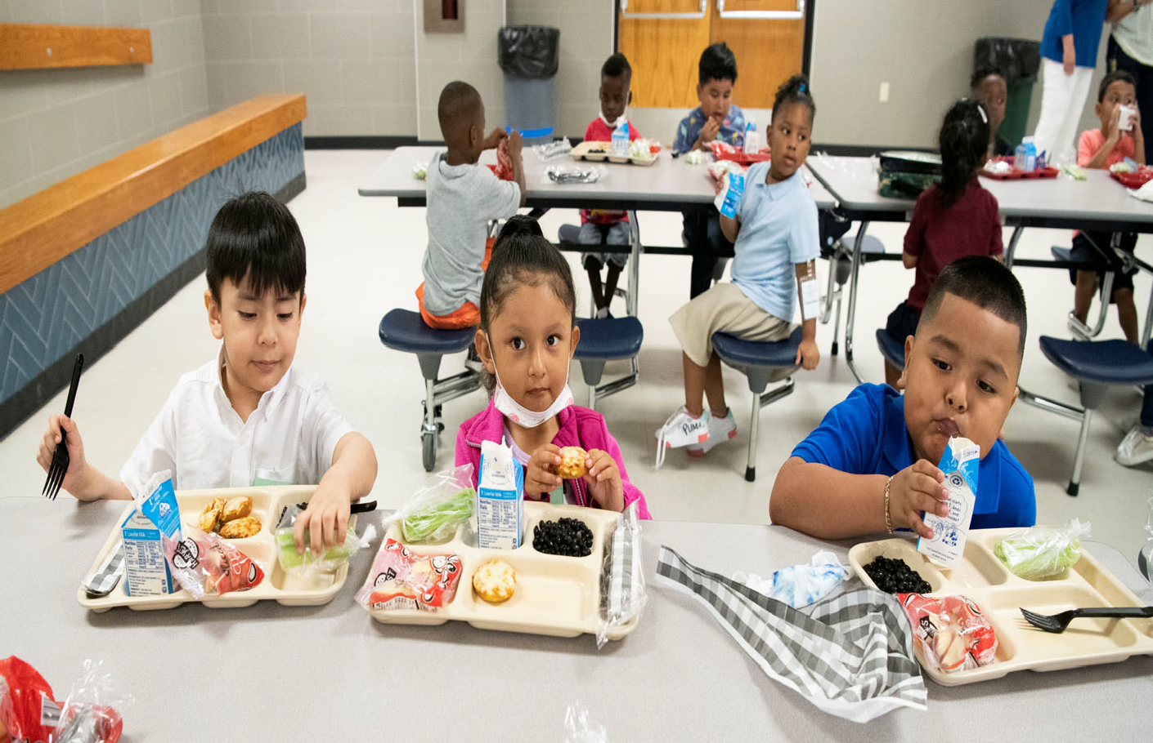

Table 32
Mesquite Independent School District Student Nutrition Fund

 | 2018 AUDITED | 2019 AUDITED | 2020 AUDITED | 2021 UNAUDITED |  | 2022 BUDGET
Local Revenue
Earnings From Investments | $ 91,664 | $ 193,850 | $ 115,455 | $ 38,841 |  | $ 115,000
Gifts & Bequests | $ ‐ | $ ‐ | $ 60,000 | $ 7,413 |  | $ 60,000
Misc/Fines, Wellness, & Etc. | $ 69,285 | $ 46,476 | $ 53,689 | $ 15,818 |  | $ 53,000
Food Services Activity | $ 3,325,457 | $ 3,130,188 | $ 2,126,072 | $ 1,081,727 |  | $ 2,119,000
Extra/Cocurricular Activity | $ ‐ | $ ‐ | $ ‐ | $ ‐ |  | $ ‐
Activity Fund | $ ‐ | $ 462 |  |  |  | $ ‐
Transfer In | $ 64,224 | $ 41,329 | $ 32,058 | $ |  | $ 75,000
Other/Non‐Revenue | $ ‐ | $ ‐ | $ ‐ | $ ‐ |  | $ ‐
Grand Total | $ 3,550,630 | $ 3,412,304 | $ 2,387,274 | $ 1,143,799 |  | $ 2,422,000
State Revenue | 2018 AUDITED | 2019 AUDITED | 2020 AUDITED | 2021 | UNAUDITED | 2022 BUDGET
Miscellaneous State Programs | $ 127,614 | $ 124,976 | $ 121,564 | $ | ‐ | $ 110,700
Other State Agencies | $ 146,059 | $ 183,608 | $ 1,728,776 | $ | ‐ | $ 1,115,000
Grand Total | $ 273,673 | $ 308,584 | $ 1,850,340 | $ | ‐ | $ 1,225,700
Federal Revenue | 2018 AUDITED | 2019 AUDITED | 2020 AUDITED | 2021 UNAUDITED |  | 2022 BUDGET
School Breakfast Program | $ 3,423,909 | $ 3,450,297 | $ 3,075,166 | $ 1,664,133 |  | $ 2,706,000
National School Lunch | $ 14,013,847 | $ 13,939,615 | $ 10,501,651 | $ 7,475,345 |  | $ 11,016,000
USDA Donated Commodities | $ 1,717,639 | $ 1,675,144 | $ 1,699,613 | $ 1,841,360 |  | $ 2,143,000
Other Federal Revenues  Direct Federal Revenue | $ ‐  $ ‐ | $ ‐ | $ ‐ | $ ‐  $ ‐ |  | $ ‐  $ ‐
Grand Total | $ 19,155,395 | $ 19,065,056 | $ 15,276,430 | $ 10,980,838 |  | $ 15,865,000

Table 32 (cont.)

2018 AUDITED 2019 AUDITED 2020 AUDITED 2021 UNAUDITED 2022 BUDGET
Expenditures

Payroll Costs | $ 8,701,961 | $ 8,430,241 | $ 8,469,165 | $ 6,927,615 | $ ‐
Contracted Services | $ 154,950 | $ 127,701 | $ 90,190 | $ 27,947 | $ 420,400
Supplies & Materials | $ 11,378,993 | $ 11,490,337 | $ 10,107,110 | $ 7,683,983 | $ 15,113,698
Other Operating Cost | $ 37,839 | $ 28,724 | $ 24,307 | $ 74,829 | $ 77,500
Fixed Assets | $ 1,156,370 | $ 2,217,303 | $ 918,259 | $ 58,098 | $ 1,592,000
Other Uses | $ 391,200 | $ 391,200 | $ 391,200 | $ ‐ | $ ‐
Grand Total | $ 21,821,313 | $ 22,685,506 | $ 20,000,230 | $ 14,772,472 | $ 17,203,598

Beginning Fund Balance | $ 5,995,589 | $ 7,153,974 | $ 7,254,412 | $ 6,768,226 | $ 4,120,391
Ending Fund Balance | $ 7,153,974 | $ 7,254,412 | $ 6,768,226 | $ 4,120,391 | $ 6,429,493

Table 33
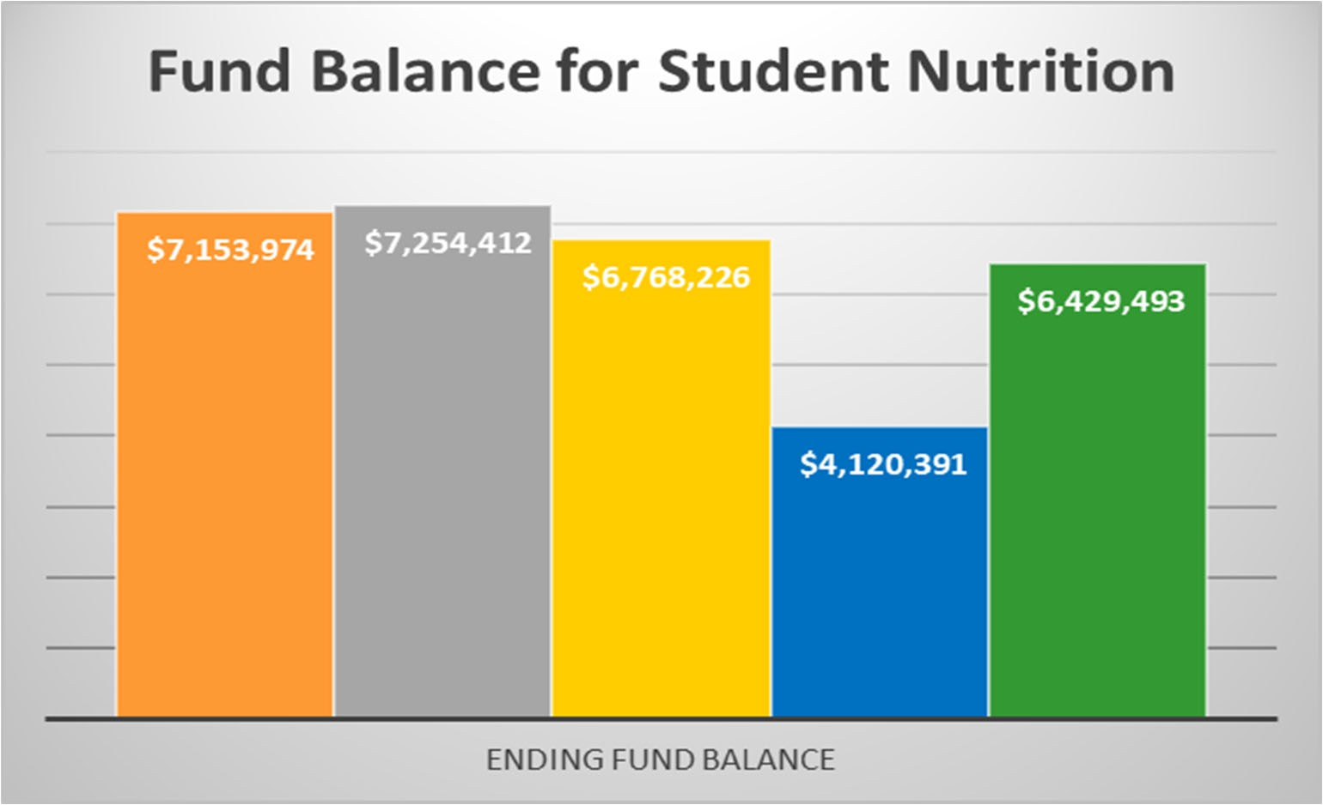
MISD 2020‐21 Financial Unaudited

Financial Section
Mesquite ISD Oﬃcial Budget 2021‐2022

‐
134
 | 2015 AUDITED |  | 2016 AUDITED |  |  | 2017 AUDITED |  | 2018 AUDITED |  | 2019 AUDITED |  | 2020 AUDITED |  | 2021 UNAUDITED | 2022 BUDGET
5742 ‐ EARNINGS FROM INVESTMENTS | $ 16,522 |  | $ 28,671 |  |  | $ 37,207 |  | $ 91,664 |  | $ 193,850 |  | $ 115,455 |  | $ 38,841 | $ 115,000
5744 ‐ GIFTS & BEQUESTS | $ ‐ |  | $ ‐ |  |  | $ ‐ |  |  |  |  |  | $ 60,000 |  | $ 7,413 | $ 60,000
5749 ‐ MISC/FINES, WELLNESS, & ETC. | $ ‐ |  | $ ‐ |  |  | $ 112,067 |  | $ 69,285 |  | $ 46,476 |  | $ 53,689 |  | $ 15,818 | $ 53,000
5751 ‐ FOOD SERVICES ACTIVITY | $ 3,444,883 |  | $ 3,197,861 |  |  | $ 3,159,059 |  | $ 3,325,457 |  | $ 3,130,188 |  | $ 2,126,072 |  | $ 1,081,727 | $ 2,119,000
5753 ‐ EXTRA/COCURRICULAR ACTIVITY | $ ‐ |  | $ ‐ |  |  | $ ‐ |  | $ ‐ |  | $ ‐ |  | $ ‐
5755 ‐ ACTIVITY FUND | $ ‐ |  | $ ‐ |  |  |  |  |  |  | $ 462 |  | $ ‐
5829 ‐ MISCELLANEOUS STATE PROGRAMS | $ 124,672 |  | $ 128,225 |  |  | $ 131,099 |  | $ 127,614 |  | $ 124,976 |  | $ 121,564 |  | $ ‐ | $ 110,700
5839 ‐ OTHER STATE AGENCIES | $ 241,324 |  | $ 227,294 |  |  | $ 178,097 |  | $ 146,059 |  | $ 183,608 |  | $ 1,728,776 |  | $ ‐ | $ 1,115,000
5921 ‐ SCHOOL BREAKFAST PROGRAM | $ 2,890,059 |  | $ 3,188,154 |  |  | $ 3,166,768 |  | $ 3,423,909 |  | $ 3,450,297 |  | $ 3,075,166 |  | $ 1,664,133 | $ 2,706,000
5922 ‐ NATIONAL SCHOOL LUNCH | $ 12,849,346 |  | $ 13,676,495 |  |  | $ 13,111,136 |  | $ 14,013,847 |  | $ 13,939,615 |  | $ 10,501,651 |  | $ 7,475,345 | $ 11,016,000
5923 ‐ USDA DONATED COMMODITIES | $ 1,263,276 |  | $ 1,590,843 |  |  | $ 1,692,845 |  | $ 1,717,639 |  | $ 1,675,144 |  | $ 1,699,613 |  | $ 1,841,360 | $ 2,143,000
5929 ‐ OTHER FEDERAL REVENUES | $ | ‐ | $ | ‐ |  | $ | ‐ | $ | ‐ | $ | ‐ | $ | ‐
5949 ‐ DIRECT FEDERAL REVENUE | $ | − $ |  | − $ 51,667 |  |  |  | $ 64,224 |  | $ 41,329 |  | $ 32,058 $ ‐
7915 ‐ TRANSFER IN | $ 58,158 |  | $ 41,049 |  |  | $ 48,915 |  | $ 75,000
7989 ‐ OTHER/NON‐REVENUE | $ | ‐ | $ |  | $ |  | ‐ | $ | ‐ | $ | ‐ | $ | ‐
Grand Total | $ 20,888,241 |  | $ 22,078,591 |  |  | $ 21,688,860 |  | $ 22,979,699 |  | $ 22,785,944 |  | $ 19,514,044 |  | $ 12,124,637 | $ 19,512,700

6116 ‐ PROFESSIONAL EXTRA DUTY PAY
6118 ‐ PROFESSIONAL STIPENDS
6119 ‐ PROFESSIONAL SALARY
6121 ‐ EXTRA DUTY/SUPPORT
6122 ‐ SUPPORT SALARIES ‐ SUBS
6125 ‐ SUPPORT SALARIES
6126 ‐ SUPPORT SALARIES/HOURLY
6134 ‐ EMPLOYEE ALLOWANCES
6141 ‐ SOCIAL SECURITY/MEDICARE
6142 ‐ HEALTH & LIFE INSURANCE
6143 ‐ WORKERS' COMPENSATION
6144 ‐ TRS ON‐BEHALF BENEFIT
6145 ‐ UNEMPLOYMENT COMPENSATION
6146 ‐ TEACHER RETIREMENT/TRS CARE
6147 ‐ SICK/VACATION RETIREMENT
135
6149 ‐ EMPLOYEE BENEFITS
6219 ‐ PROFESSIONAL SERVICE
6239 ‐ EDUCATION SERVICE CENTER
6246 ‐ BUILDING MAINTENANCE/REPAIRS
6247 ‐ VEHICLE MAINTENANCE/REPAIRS
6249 ‐ CONTRACTED MAINT/REPAIR
2015 AUDITED
$ 217,000
$ 8,893
$ 134,084
$ 128,063
$ 167,152
$ 5,635,654
$ 3,057
$ 11,635
$ 80,793
$ 631,466
$ 28,968
$ ‐
$ ‐
$ 511,535
$ 260
$ ‐
$ ‐
$ 120
$ 5,850
$ 1,316
$ 1,596
2016 AUDITED 2017 AUDITED 2018 AUDITED 2019 AUDITED 2020 AUDITED 2021 UNAUDITED 2022 BUDGET
$ 219,500 $ 213,500 $ 211,500 $ 206,000 $ 188,000 $ 600,000
$ 8,702 $ 13,889 $ 1,551 $ ‐ $ ‐ $ ‐
$ 205,277 $ 232,336 $ 232,598 $ 244,274 $ 301,077 $ 206,010
$ 156,871 $ 144,895 $ 79,898 $ 145,243 $ 193,168 $ 84,817
$ 274,677 $ 218,561 $ 201,633 $ 140,915 $ 146,291 $ 67,390
$ 6,111,419 $ 6,230,847 $ 6,559,047 $ 6,385,079 $ 6,400,194 $ 5,052,627
$ 9,168 $ 3,598 $ 21,676 $ 10,220 $ 5,904 $ 9,974
$ 12,937 $ 9,304
$ 89,740 $ 94,136 $ ‐ $ ‐ $ ‐ $ ‐
$ 670,927 $ 689,447 $ 93,310 $ 92,715 $ 95,522 $ 73,270
$ 31,931 $ 30,201 $ 710,919 $ 649,382 $ 569,684 $ 427,624
$ ‐ $ 28,957 $ 29,521 $ 30,469 $ 38,500
$ ‐ $ ‐ $ ‐ $ ‐ $ ‐
$ 549,541 $ 554,146 $ 560,871 $ 524,177 $ 499,909 $ 358,292
$ 2,175 $ 2,715 $ 38,945 $ 9,112
$ ‐ $ ‐ $ ‐ $ ‐ $ ‐
$ ‐ $ ‐
$ ‐ $ 125 $ 25.00 $ ‐
$ 5,800 $ 2,250 $ 8,213 $ 1,100 $ ‐
$ 403 $ ‐ $ ‐ $ ‐ $ ‐ $ ‐
$ 33,194 $ 35,102 $ 74,871 $ 46,170 $ 50,479 $ 2,650 $ 5,000

6256 ‐ TELEPHONE | $ ‐ | $ ‐ $ ‐
6257 ‐ |  |  |  |  |  |  |  | $ 400,000
6264 ‐ COPIER RENTAL | $ 6,161 | $ 6,161 | $ 4,923 | $ 5,310 | $ 5,310 | $ 5,310 | $ 13,735 | $ 5,400
6266 ‐ VEHICLE RENTAL | $ ‐ | $ ‐ |  |  |  |  | $ ‐
6299 ‐ MISC CONTRACTED SERVICE | $ 185,070 | $ 82,162 | $ 65,688 | $ 74,768 | $ 68,007 | $ 33,276 | $ 11,562 | $ 10,000
6311 ‐ VEHICLE FUELS | $ 3,250 | $ 1,891 | $ 1,934 | $ 1,672 | $ 1,285 | $ 268 | $ 108 | $ 1,000
6316 ‐ SUPPLIES BUILDINGS  6319 ‐ OTHER SUPPLIES | $ 44,754 | $ ‐ | $ ‐ |  |  | $ 2,135.26 | $ ‐ | $ 5,000
6325 ‐ READING MATERIALS/BOOKS  6326 ‐ MAGAZINES | $ 115  $ ‐ | $ ‐  $ ‐ |  |  |  |  | $ ‐  $ ‐
6341 ‐ FOOD/FOOD SERVICE | $ 8,999,245 | $ 9,599,210 | $ 8,546,274 | $ 8,388,285 | $ 8,626,243 | $ 7,444,780 | $ 5,080,392 | $ 11,479,800
Financial Section
Mesquite ISD Oﬃcial Budget 2021‐2022

136
Financial Section
Mesquite ISD Oﬃcial Budget 2021‐2022

 | 2015 AUDITED |  | 2016 AUDITED |  | 2017 AUDITED 2018 AUDITED |  |  |  | 2019 AUDITED |  | 2020 AUDITED |  | 2021 UNAUDITED |  | 2022 BUDGET
6342 ‐ NON‐FOOD/FOOD SERVICE | $ 977,158.15 |  | $ 1,017,649.59 |  | $ 868,819.53 $ 927,388 |  |  |  | $ 897,802 |  | $ 771,810 |  | $ 551,243 |  | $ 1,095,000
6344 ‐ USDA DONATED COMMODITIES | $ 1,263,276.24 |  | $ 1,590,842.63 |  | $ 1,692,845.00 $ 1,717,639 |  |  |  | $ 1,675,144 |  | $ 1,699,613 |  | $ 1,841,268 |  | $ 2,140,600
6349 ‐ FOOD SERVICE SUPPLIES | $ 32,079.59 |  | $ 174,494.96 |  | $ 114,119.79 $ 61,999 |  |  |  | $ 22,205 |  | $ 62,321 |  | $ 25,659 |  | $ 101,500
6395 ‐ ELECTRONICS $100‐$5,000 | $ 14,634.13 |  | $ 1,553.39 |  | $ 4,012.45 $ 7,744 |  |  |  | $ 2,724 |  | $ 7,452 |  | $ 48,343 |  | $ 26,500
6396 ‐ COMPUTER SUPPLIES | $ 5,684.56 |  | $ 26,703.38 |  | $ 5,066.77 $ 4,327 |  |  |  | $ 2,030 |  | $ 2,928 |  | $ 3,182 |  | $ 2,000
6397 ‐ FURNITURE UNDER $5,000 | $ 4,897.27 |  | $ 666.00 |  | $ 1,823.06 |  |  |  | $ 59,299 |  | $ 1,225 |  | $ 276 |  | $ 1,600
6398 ‐ EQUIPMENT $300‐$5,000 | $ 96,986.02 |  | $ 124,147.77 |  | $ 33,374.27 $ 99,585 |  |  |  | $ 114,544 |  | $ 37,349 |  | $ 70,147 |  | $ 105,698
6399 ‐ GENERAL SUPPLIES | $ 64,128.71 |  | $ 227,968.70 |  | $ 68,445.51 $ 170,353 |  |  |  | $ 89,062 |  | $ 77,228 |  | $ 63,365 |  | $ 155,000
6411 ‐ TRAVEL/EMPLOYEE | $ 16,891.09 |  | $ 16,497.47 |  | $ 8,602.91 $ 10,428 |  |  |  | $ 13,458 |  | $ 7,881 |  | $ 269 |  | $ 25,000
6495 ‐ DUES | $ 970.00 |  | $ 1,523.00 |  | $ 1,220.00 $ 1,070 |  |  |  | $ 2,162 |  | $ 2,961 |  | $ 270 |  | $ 2,500
6499 ‐ MISC OPERATING EXP  6625 ‐ BUILDING IMPROVEMENT  6626 ‐ FEES/BUILDING | $ 6,477.07  $ ‐ |  | $ 5,327.92  $ ‐  $ 20,988.61 |  | $ 5,455.44 $ 26,341 |  |  |  | $ 13,105 |  | $ 13,466 |  | $ 74,290  $ ‐  $ ‐ |  | $ 50,000
6631 ‐ VEHICLE>$5,000 | $ 23,557.68 |  | $ 98,086.36 |  | $ ‐ $ 29,174 |  |  |  |  |  |  |  |  |  | $ 64,000
6635 ‐ ELECTRONIC EQUIP>$5,000 | $ 20,906.99 |  | $ 78,079.35 |  | $ ‐ $ 28,974 |  |  |  | $ 41,464 |  | $ 174,304 |  | $ 21,206
6637 ‐ FURNITURE>$5,000 | $ | 23,714.19 | $ | ‐ | $ | ‐ | $ | 25,897 | $ | 31,677 | $ | 12,725 | $ | ‐ | $ | ‐
6639 ‐ EQUIPMENT>$5,000  6645 ‐ TECH EQUIP<$5,000  6649 ‐ OTHER EQUIP<$5,000  8911 ‐ TRANSFERS OUT | $ 2,243,238.32  $ ‐  $ ‐  $ 391,200.00 |  | $ 1,316,825.35  $ ‐  $ ‐  $ 391,200.00 |  | $ 514,773.99 $  $ 391,200.00 $ |  |  | 1,072,326  391,200 | $ 2,144,162  $ 391,200 |  | $ 731,230  $ 391,200 |  | $  $  $  $ | 36,892  ‐  ‐  ‐ | $ 1,528,000  $ ‐
Grand Total | $ 21,991,839.89 |  | $ 23,164,240.34 |  | $ 20,796,414.32 $ |  |  | 21,821,313 | $ 22,685,506 |  | $ 20,000,230 |  | $ | 14,772,472 | $ 17,203,598

Mesquite Independent School District Debt Service Fund

Over the past 10 years and in the near future, the District has and will continue to have a need to con‐ duct bond sales. A school district is authorized to issue bonds and levy taxes for payment of bonds subject to voter approval of a proposition submitted to the voters under Texas Education Code (TEX)
45.003 (b)(1). A debt service fund is a government fund, with budgetary control, that must be used to account for general long‐term debt principal and interest for debt issues and other long‐term debts for which a tax has been dedicated. A separate bank account must be kept for this fund and a separate tax rate is assessed to fund the debt payments based on the scheduled maturities. The debt tax rate (or Interest and Sinking – I&S tax rate) is approved by the Board of Trustees annually and is calculated based on the scheduled debt requirements and the taxable property values certified by the DAC.

TEC 45.003(1), as amended, requires a district to demonstrate to the Texas Attorney General that it has the prospective ability to pay debt service on a proposed issue of bonds, together with debt service on other outstanding “new debt” of the district, from a tax levied at a rate of $0.50 per $100 of assessed valuation before bonds may be issued.

Once the prospective ability to pay such tax has been shown and the bonds are issued, a district may levy a tax to pay the annual debt service. Mesquite ISD is presently taxing at $0.48 per $100 of taxable value for the Interest and Sinking fund.

The District was rated by S & P Global with a rating of AA/Stable and by Fitch Ratings as AA+.

Revenue

The primary source of revenue for the debt service fund is an ad valorem tax raised from levying the Interest and Sinking (I&S) tax rate. The district is presently taxing at $0.48 per $100 of taxable value. The state laws governing debt tax rates limit a school district to a maximum tax rate of $0.50, thus leaving the District with $0.02 per $100 taxable available for future bond sales.

Other sources of revenue are state funds provided as part of the Existing Debt Allotment (EDA) pro‐ gram and the Instructional Facilities (IFA) program, along with investment earnings from fund cash balances.

The EDA is provided for existing debt issued by school districts to produce a guaranteed yield in State and local revenue per student for each cent of debt service tax levy. In general, a district’s bonds are eligible for the allotment if, during the previous State biennium, the district (1) made payments on such bonds or (2) levied and collected taxes for the payment of principal and interest on such bonds.

The IFA guarantees each school district a specified dollar amount per student in state and local funds for each cent of tax eﬀort to pay principal and interest on eligible bond used to construct, acquire, renovate, or improve instructional facilities. To receive an IFA, a school district must apply to the Commissioner of Education before issuing the bonds to be paid with State assistance. These funds are allocated to school districts based upon property wealth per student. Districts with the lowest amounts will receive funding first.

Expenditures

The expenditures from the Debt Service fund consist mainly of the semi‐annual principal and interest requirements from existing bond debt. Currently, these payments total approximately $62,000,000.

Current Debt Levels and legal Debt Limits

The State limits the District to issuing debt in an amount in which the levy of the I & S tax rate in a maximum amount of $0.50, along with State IFA and/or EDA funds, is suﬃcient to cover maximum annual debt service at the time of issuance of the bonds.

Debt Levels on Current and Future Budgets

The current outstanding debt plus anticipated debt to be issued associated with the District’s authorized but unissued voter authority is projected to be services with a maximum I & S tax rate of $0.48.

Table 36
Mesquite Independent School District Debt Service Fund

2018 AUDITED 2019 AUDITED 2020 AUDITED 2021 UNAUDITED 2022 BUDGET

Local Revenue
Taxes, Current Year Levy | $ 31,305,319 |  | $ 39,049,957 |  | $ 42,681,897 |  | $ 45,985,189 |  | $ 47,050,000
Taxes Prior Year | $ 257,984 |  | $ 173,028 |  | $ 322,890 |  | $ 291,891 |  | $ ‐
Penalties, Interest & Other TA | $ 347,748 |  | $ 452,931 |  | $ 460,346 |  | $ 506,989 |  | $ ‐
Earnings From Investments | $ 895,547 |  | $ 1,336,037 |  | $ 783,387 |  | $ 15,833 |  | $ 50,000
Grand Total | $ 32,806,598 |  | $ 41,011,953 |  | $ 44,248,520 |  | $ 46,799,902 |  | $ 47,100,000
State Revenue  Misc. State Programs | $ 24,619,635 |  | $ 24,037,151 |  | $ 20,376,022 |  | $ 17,274,832 |  | $ 10,500,000
Grand Total | $ 24,619,635 |  | $ 24,037,151 |  | $ 20,376,022 |  | $ 17,274,832 |  | $ 10,500,000
Expenditures
Bond Principal | $ 26,395,260 |  | $ 28,778,582 |  | $ 24,405,378 |  | $ ‐ |  | $ 19,400,000
Interest on Bonds | $ 25,708,508 |  | $ 33,776,656 |  | $ 35,627,559 |  | $ 16,445,815 |  | $ 37,600,000
Debt Service Fees | $ 206,547 |  | $ 197,868 |  | $ 394,629 |  | $ 249,902 |  | $ 600,000
Grand Total | $ 52,310,315 |  | $ 62,753,106 |  | $ 60,427,565 |  | $ 16,695,716 |  | $ 57,600,000
Other Financing Sources
Refunding Bond Issuance | $ | ‐ | $ | ‐ | $ | (11,940,000) | $ | (14,780,000) | $ | ‐
Sale of Bonds | $ | ‐ | $ ‐ |  | $ | ‐ | $ | ‐ | $ ‐
Transfer In | $ | ‐ | $ ‐ |  | $ | ‐ | $ | ‐ | $ ‐
Premium/Discount | $ | ‐ | $ ‐ |  | $ (2,001,805) |  | $ (1,633,143) |  | $ ‐
Other Resources | $ | ‐ | $ ‐ |  | $ ‐ |  | $ ‐ |  | $ ‐
Other Uses | $ | ‐ | $ ‐ |  | $ 14,137,135 |  | $ 16,364,219 |  | $ ‐
Grand Total | $ | ‐ | $ ‐ |  | $ 195,330 |  | $ (48,924) |  | $ ‐
Beginning Fund Balance | $ 17,088,628 |  | $ 22,204,546 |  | $ 24,500,544 |  | $ 28,892,851 |  | $ 76,222,945
Ending Fund Balance | $ 22,204,546 |  | $ 24,500,544 |  | $ 28,892,851 |  | $ 76,222,945 |  | $ 76,222,945

5829 ‐ MISCELLANEOUS STATE PROGRAMS
7901 ‐ REFUNDING BOND ISSUANCE

$ 20,904,029.00
$ 75,874,666.05
‐
‐
 | 2015 AUDITED |  | 2016 AUDITED |  | 2017 AUDITED | 2018 AUDITED | 2019 AUDITED |  |  | 2020 AUDTIED |  | 2021 UNAUDITED | 2022 BUDGET
5711 ‐ TAXES, CURRENT YEAR LEVY | $ 22,707,997.09 |  | $ 22,935,664.97 |  | $ 28,544,340.42 | $ 31,305,319 | $ 39,049,957 |  |  | $ 42,681,897 |  | $ 45,985,189 | $ 47,050,000
5712 ‐ TAXES PRIOR YEAR | $ 209,975.09 |  | $ 338,376.41 |  | $ 273,206.57 | $ 257,984 | $ 173,028 |  |  | $ 322,890 |  | $ 291,891 | $ ‐
5719 ‐ PENALTIES, INTEREST & OTHER TA | $ 251,073.58 |  | $ 282,916.58 |  | $ 330,987.39 | $ 347,748 | $ 452,931 |  |  | $ 460,346 |  | $ 506,989 | $ ‐
5742 ‐ EARNINGS FROM INVESTMENTS | $ 111,135.28 |  | $ 279,096.42 |  | $ 421,979.11 | $ 895,547 | $ 1,336,037 |  |  | $ 783,387 |  | $ 15,833 | $ 50,000
5746 ‐ TAX INCREMENT FUND | $ | ‐ | $ | ‐ | $ ‐ | $ |  | $ | ‐ | $ | ‐
5749 ‐ MISC/FINES, WELLNESS, & ETC. | $ | ‐ | $ | ‐ | $ 3.70 | $ |  | $ | ‐ | $ | ‐
5812 ‐ FOUNDATION/ENTITLEMENTS | $ | ‐ | $ | ‐ | $ ‐ | $ |  | $ | ‐ | $ | ‐

‐
$ 23,477,417.00 $ 21,922,615.00 $ 24,619,635 $ 24,037,151 $ 20,376,022 $ 17,274,832
$ 39,160,000.00 $ 12,803,007.85 $ ‐ $ ‐ $ ‐

$ 10,500,000

140
Financial Section
Mesquite ISD Oﬃcial Budget 2021‐2022
7911 ‐ SALE OF BONDS | $ | ‐ | $ | ‐ | $ | ‐ | $ | ‐ | $ | ‐ | $ | ‐
7915 ‐ TRANSFER IN | $ | ‐ | $ | ‐ | $ | ‐ | $ | ‐ | $ | ‐ | $ | ‐
7916 ‐ PREMIUM/DISCOUNT | $ | 29,396,644.45 | $ | 8,369,934.00 | $ | 11,071,275.15 | $ | ‐ | $ | ‐ | $ | ‐
7949 ‐ OTHER RESOURCES | $ | ‐ | $ | ‐ | $ | ‐ | $ | ‐ | $ | ‐ | $ | ‐
Grand Total | $ 149,55,520.54 |  | $ 94,843,405.38 |  | $ 75,367,415.19 |  | $ 57,426,233 | $ 65,049,104 |  |  | $ 64,624,542 |  | $ 64,074,734 | $ 57,600,000

2015 AUDITED
2016 AUDITED 2017 AUDITED 2018 AUDITED 2019 AUDITED 2020 AUDTIED 2021 UNAUDITED
2022 BUDGET

141
Financial Section
Mesquite ISD Oﬃcial Budget 2021‐2022
6511 ‐ BOND PRINCIPAL $ |  | 29,467,730.60 | $ 27,973,534.85 |  | $ 29,284,996.20 |  | $ 26,395,260 |  | $ 28,543,375 |  | $ 24,405,378 $ |  | ‐ | $ 19,400,000
6521 ‐ INTEREST ON BONDS $ |  | 14,352,258.87 | $ 18,253,323.17 |  | $ 19,582,867.51 |  | $ 25,708,508 |  | $ 34,011,863 |  | $ 35,627,559 $ |  | 16,445,815 | $ 37,600,000
6599 ‐ DEBT SERVICE FEES $ |  | 1,394,568.21 | $ 871,168.37 |  | $ 367,038.13 |  | $ 206,547 |  | $ 197,868 |  | $ 394,629 $ |  | 249,902 | $ 600,000
8949 ‐ OTHER USES | $ 104,594,784.91 |  | $ | 47,916,562.32 | $ | 23,625,401.36 | $ | ‐ | $ | ‐ | $ | 14,137,135 $ | 16,364,219 | $ | ‐
Grand Total | $ 149,809,342.59 |  | $ | 95,014,588.71 | $ | 72,860,303.20 | $ | 52,310,315 | $ | 62,753,106 | $ | 74,564,700 $ | 33,059,935 | $ | 57,600,000



Table 39

BOND DEBT SERVICE
Mesquite ISD
All Outstanding Debt As of FYE 6/30/2021

Compounded
Period Ending Principal Interest Interest Debt Service

6/30/2022 | $ 23,431,113.40 | $ 31,943,785.96 | $ 5,723,886.60 | $ 61,098,785.96
6/30/2023 | 19,153,707.20 | 31,007,949.96 | 5,806,292.80 | 55,967,949.96
6/30/2024 | 19,729,980.20 | 30,151,214.11 | 5,840,019.80 | 55,721,214.11
6/30/2025 | 25,770,329.00 | 30,128,034.01 | ‐ | 55,898,363.01
6/30/2026 | 26,935,000.00 | 28,099,150.86 | ‐ | 55,034,150.86
6/30/2027 | 27,475,000.00 | 26,895,929.76 | ‐ | 54,370,929.76
6/30/2028 | 27,667,396.35 | 25,725,315.36 | 907,603.65 | 54,300,315.36
6/30/2029 | 28,705,201.85 | 24,580,840.81 | 969,798.15 | 54,255,840.81
6/30/2030 | 27,798,810.60 | 23,427,107.51 | 1,031,189.40 | 52,257,107.51
6/30/2031 | 28,417,674.90 | 22,262,318.76 | 1,087,325.10 | 51,767,318.76
6/30/2032 | 30,275,175.40 | 21,060,318.76 | 1,139,824.60 | 52,475,318.76
6/30/2033 | 31,520,000.00 | 19,772,781.26 | ‐ | 51,292,781.26
6/30/2034 | 31,980,000.00 | 18,365,506.26 | ‐ | 50,345,506.26
6/30/2035 | 33,075,000.00 | 16,903,981.26 | ‐ | 49,978,981.26
6/30/2036 | 34,525,000.00 | 15,410,131.26 | ‐ | 49,935,131.26
6/30/2037 | 33,370,000.00 | 13,926,709.38 | ‐ | 47,296,709.38
6/30/2038 | 34,795,000.00 | 12,473,475.00 | ‐ | 47,268,475.00
6/30/2039 | 36,275,000.00 | 10,949,375.00 | ‐ | 47,224,375.00
6/30/2040 | 37,840,000.00 | 9,349,506.25 | ‐ | 47,189,506.25
6/30/2041 | 38,265,000.00 | 7,671,700.00 | ‐ | 45,936,700.00
6/30/2042 | 37,990,000.00 | 5,961,375.00 | ‐ | 43,951,375.00
6/30/2043 | 33,800,000.00 | 4,370,475.00 | ‐ | 38,170,475.00
6/30/2044 | 19,725,000.00 | 3,201,125.00 | ‐ | 22,926,125.00
6/30/2045 | 20,580,000.00 | 2,325,775.00 | ‐ | 22,905,775.00
6/30/2046 | 14,280,000.00 | 1,555,850.00 | ‐ | 15,835,850.00
6/30/2047 | 7,820,000.00 | 1,037,500.00 | ‐ | 8,857,500.00
6/30/2048 | 8,215,000.00 | 636,625.00 | ‐ | 8,851,625.00
6/30/2049 | 8,625,000.00 215,625.00 ‐ 8,840,625.00
$ 748,039,388.90 |  | $ 439,409,481.53 | $ 22,505,940.10 | $ 1,209,954,810.53

Financial Section
142
Mesquite ISD Oﬃcial Budget 2021‐2022

Table 40
Financial Section
143
Mesquite ISD Oﬃcial Budget 2021‐2022

Mesquite ISD
Capital Improvement Program Impact on Tax Rate (Outstanding Debt Only)

As of June 30, 2021
Fiscal  Year End | Taxable Assessed  Valuation | Growth  Rate | Principal | Interest | Interest | Total P+I | Total P+I | Less: Estimated  IFA/EDA | Less  Estimated  IFA/EDA | Net Debt  Service | Net  Debt  Service | Estimated I&S Tax  Rate
2022 | $ 11,172,393,192 |  | $ 23,431,113 | $ 37,667,673 | $ 37,667,673 | $ 61,098,786 | $ 61,098,786 | $ 12,661,862 | $ 12,661,862 | $ 48,436,924 | $ 48,436,924 | $ 0.4400
2023 | 11,395,841,056 | 2.0% | 19,153,707 | 36,814,243 | 36,814,243 | 55,967,950 | 55,967,950 | 10,457,814 | 10,457,814 | 45,510,136 | 45,510,136 | 0.4075
2024 | 11,623,757,877 | 2.0% | 19,729,980 | 35,991,234 | 35,991,234 | 55,721,214 | 55,721,214 | 9,655,793 | 9,655,793 | 46,065,421 | 46,065,421 | 0.4044
2025 | 11,856,233,034 | 2.0% | 25,770,329 | 30,128,034 | 30,128,034 | 55,898,363 | 55,898,363 | 8,837,399 | 8,837,399 | 47,060,964 | 47,060,964 | 0.4050
2026 | 11,856,233,034 | 0.0% | 26,935,000 | 28,099,151 | 28,099,151 | 55,034,151 | 55,034,151 | 7,739,128 | 7,739,128 | 47,295,023 | 47,295,023 | 0.4070
2027 | 11,856,233,034 | 0.0% | 27,475,000 | 26,895,930 | 26,895,930 | 54,370,930 | 54,370,930 | 7,739,128 | 7,739,128 | 46,631,801 | 46,631,801 | 0.4013
2028 | 11,856,233,034 | 0.0% | 27,667,396 | 26,632,919 | 26,632,919 | 54,300,315 | 54,300,315 | 7,739,128 | 7,739,128 | 46,561,187 | 46,561,187 | 0.4007
2029 | 11,856,233,034 | 0.0% | 28,705,202 | 25,550,639 | 25,550,639 | 54,255,841 | 54,255,841 | 7,739,128 | 7,739,128 | 46,516,713 | 46,516,713 | 0.4003
2030 | 11,856,233,034 | 0.0% | 27,798,811 | 24,458,297 | 24,458,297 | 52,257,108 | 52,257,108 | 7,739,128 | 7,739,128 | 44,517,979 | 44,517,979 | 0.3831
2031 | 11,856,233,034 | 0.0% | 28,417,675 | 23,349,644 | 23,349,644 | 51,767,319 | 51,767,319 | 7,739,128 | 7,739,128 | 44,028,190 | 44,028,190 | 0.3789
2032 | 11,856,233,034 | 0.0% | 30,275,175 | 22,200,143 | 22,200,143 | 52,475,319 | 52,475,319 | 7,739,128 | 7,739,128 | 44,736,190 | 44,736,190 | 0.3850
2033 | 11,856,233,034 | 0.0% | 31,520,000 | 19,772,781 | 19,772,781 | 51,292,781 | 51,292,781 | 7,418,097 | 7,418,097 | 43,874,685 | 43,874,685 | 0.3776
2034 | 11,856,233,034 | 0.0% | 31,980,000 | 18,365,506 | 18,365,506 | 50,345,506 | 50,345,506 | 7,418,097 | 7,418,097 | 42,927,410 | 42,927,410 | 0.3695
2035 | 11,856,233,034 | 0.0% | 33,075,000 | 16,903,981 | 16,903,981 | 49,978,981 | 49,978,981 | 7,418,097 | 7,418,097 | 42,560,885 | 42,560,885 | 0.3663
2036 | 11,856,233,034 | 0.0% | 34,525,000 | 15,410,131 | 15,410,131 | 49,935,131 | 49,935,131 | 7,418,097 | 7,418,097 | 42,517,035 | 42,517,035 | 0.3659
2037 | 11,856,233,034 | 0.0% | 33,370,000 | 13,926,709 | 13,926,709 | 47,296,709 | 47,296,709 | 7,418,097 | 7,418,097 | 39,878,613 | 39,878,613 | 0.3432
2038 | 11,856,233,034 | 0.0% | 34,795,000 | 12,473,475 | 12,473,475 | 47,268,475 | 47,268,475 | 7,418,097 | 7,418,097 | 39,850,378 | 39,850,378 | 0.3430
2039 | 11,856,233,034 | 0.0% | 36,275,000 | 10,949,375 | 10,949,375 | 47,224,375 | 47,224,375 | 7,418,097 | 7,418,097 | 39,806,278 | 39,806,278 | 0.3426
2040 | 11,856,233,034 | 0.0% | 37,840,000 | 9,349,506 | 9,349,506 | 47,189,506 | 47,189,506 | 7,418,097 | 7,418,097 | 39,771,410 | 39,771,410 | 0.3423
2041 | 11,856,233,034 | 0.0% | 38,265,000 | 7,671,700 | 7,671,700 | 45,936,700 | 45,936,700 | 7,418,097 | 7,418,097 | 38,518,603 | 38,518,603 | 0.3315
2042 | 11,856,233,034 | 0.0% | 37,990,000 | 5,961,375 | 5,961,375 | 43,951,375 | 43,951,375 | 6,671,343 | 6,671,343 | 37,280,032 | 37,280,032 | 0.3209
2043 | 11,856,233,034 | 0.0% | 33,800,000 | 4,370,475 | 4,370,475 | 38,170,475 | 38,170,475 | 4,004,086 | 4,004,086 | 34,166,389 | 34,166,389 | 0.2941
2044 | 11,856,233,034 | 0.0% | 19,725,000 | 3,201,125 | 3,201,125 | 22,926,125 | 22,926,125 | 4,003,821 | 4,003,821 | 18,922,304 | 18,922,304 | 0.1629
2045 | 11,856,233,034 | 0.0% | 20,580,000 | 2,325,775 | 2,325,775 | 22,905,775 | 22,905,775 | 2,770,391 | 2,770,391 | 20,135,384 | 20,135,384 | 0.1733
2046 | 11,856,233,034 | 0.0% | 14,280,000 | 1,555,850 | 1,555,850 | 15,835,850 | 15,835,850 | 1,552,127 | 1,552,127 | 14,283,723 | 14,283,723 | 0.1229
2047 | 11,856,233,034 | 0.0% | 7,820,000 | 1,037,500 | 1,037,500 | 8,857,500 | 8,857,500 | 1,552,813 | 1,552,813 | 7,304,687 | 7,304,687 | 0.0629
2048 | 11,856,233,034 | 0.0% | 8,215,000 | 636,625 | 636,625 | 8,851,625 | 8,851,625 | 1,552,684 | 1,552,684 | 7,298,941 | 7,298,941 | 0.0628
2049 | 11,856,233,034 | 0.0% | 8,625,000 | 215,625 | 215,625 | 8,840,625 | 8,840,625 | 1,552,479 | 1,552,479 | 7,288,146 | 7,288,146 | 0.0627
 |  |  | $ 748,039,389 | $ 461,915,422 | $ 461,915,422 | $ 1,209,954,811 | $ 1,209,954,811 | $ 186,209,379 | $ 186,209,379 | $ 1,023,745,432 | $ 1,023,745,432

NOTE: Taxable assessed valuations, IFA/EDA amounts, net debt service and I&S tax rates are projected and subject to change. "Interest" column includes interest plus compound interest on the capital appreciation bonds.

Mesquite Independent School District Capital Projects Fund Overview

Capital Projects Funds are used to account for the proceeds of General Obligation bonds, related interest earnings, expenditures of these fund for the construction and equipping of school facilities, to purchased school land sites, purchase school buses, purchase technology, purchase large equipment, purchase trucks and renovations or repair of existing facilities. Projects are determined and prioritized through School Board and staﬀ review along with input from the community. Enrollment and program additions / changes are major considerations in identifying and prioritizing District needs. Once all high‐priority projects are identified, a bond election is held to obtain the community’s approval / authorization for the District to see bonds to fund the projects’ construction.

Capital projects are defined as a project that is distinguishable from other tasks or work being per‐ formed, has a schedule with a definitive beginning and ending, does not occur routinely, and results in a capital improvement or acquisition.

The capital project budgets are prepared on a project basis. Each major construction contract is approved based on existing availability of bond proceeds and/or authorized but not yet sold bonds. However, the impact of the Capital Projects Fund’s projects must be considered when developing the annual budgets for all other funds. Future operating costs (staﬃng, utilities, etc.) must be projected and included in future budgets.

Repayment of bonds issued to fund these capital projects must be included in the Debt Service Fund projections.

The bond authorization election was approved by voters in May 2015 for a new total of
$280,000,000. This bond package addressed enrollment growth with 4 new elementary schools, 1 new middle school, 5 new middle school additions, 3 high school additions, new roofs, athletic improvements, buses, and new equipment.

The most recent bond authorization election was approved by voters in May 2018 for a new total of
$325,000,000. This bond package addressed the enrollment growth and the need to get rid of portables with 1 new elementary, 1 new middle school, 1 choice high school, several additions, new roofs, athletic improvements, buses and new technology infrastructure.

Financial Section
144
Mesquite ISD Oﬃcial Budget 2021‐2022

Table 41
Mesquite Independent School District Capital Projects‐ Expenditures by Object

2018 AUDITED 2019 AUDITED 2020 AUDTIED 2021 UNAUDITED 2022 BUDGET

PAYROLL COSTS  CONTRACTED SERVICES | $ ‐ | $ ‐ | $ ‐  $ ‐ | $ ‐  $ 495 | $ 2,000  $ ‐
SUPPLIES & MATERIALS | $ 348,948 | $ 346,000 | $ 326,549 | $ 563,329 | $ ‐
OTHER OPERATING COST | $ ‐ | $ ‐ | $ ‐ | $ ‐ | $ ‐
DEBT SERVICE FEES | $ 928,440 | $ ‐ | $ 1,441,377 | $ ‐ | $ ‐
FIXED ASSETS | $ 103,488,796 | $ 60,559,183 | $ 130,074,175 | $ 61,371,748 | $ 37,340,800
OTHER USES | $ ‐ | $ ‐ | $ ‐ | $ ‐ | $ ‐
Grand Total | $ 104,766,184 | $ 60,905,183 | $ 131,842,101 | $ 61,935,572 | $ 37,342,800

145

146
Financial Section
Mesquite ISD Oﬃcial Budget 2021‐2022
Bond Package 2018  $325,000,000 | Start Date | End Date | Item | Total Cost | 2018  Construction  Bond Program | 2018  Construction  Bond Program | 2018  Construction  Bond Program | 2018  Construction  Bond Program | 2018  Construction  Bond Program
 | 4/2019 | 6/2023 |  |  | 2018‐2019 | 2019‐2020 | 2020‐2021 | 2021‐2022 | 2022‐2023
Price of Project |  |  | $ 60,305,658.00
Woolley Middle School | 4/1/19 | 7/31/20 | Architect/Engineer | $ 3,472,279.00 | $ 2,140,279.00 | $ 1,323,000.00 | $ 72,000.00
 |  |  | GMP | $ 48,917,079.00 | $ 16,305,500.00 | $ 32,611,380.00 | $ 4,000,000.00
 |  |  | Misc. Cost | $ 4,247,520.00 | $ 4,000,000.00 | $ 247,520.00 | $ ‐
 |  |  | MISD Furniture | $ 3,668,781.00 |  | $ 3,668,781.00 | $ ‐
Price of Project |  |  | $ 10,984,797.00
Porter Elementary | 6/11/19 | 8/6/20 | Architect/Engineer | $ 902,150.00 | $ 251,064.00 | $ 246,552.00 | $ 40,000.00
 |  |  | Construction Manager | $ 9,404,426.00 | $ 1,850,000.00 | $ 6,269,616.00 | $ 1,436,000.00
 |  |  | Misc. Cost | $ 208,000.00 | $ 50,000.00 | $ 104,000.00 | $ ‐
 |  |  | MISD Furniture | $ 470,220.00 | $ ‐ | $ 470,220.00 | $ ‐
Price of Project |  |  | $ 10,477,293.00
Vanston MS Gym & Add | 6/13/19 | 9/8/20 | Architect/Engineer | $ 668,247.00 | $ 429,408.00 | $ 184,392.00 | $ 36,000.00
 |  |  | GMP | $ 8,997,660.00 | $ 2,538,460.00 | $ 5,998,440.00 | $ 1,205,200.00
 |  |  | Misc. Cost | $ 136,561.00 | $ 25,000.00 | $ 102,420.00 | $ ‐
 |  |  | MISD Furniture | $ 674,825.00 | $ ‐ | $ 674,825.00 | $ ‐
Price of Project |  |  | $ 6,875,082.00
Terry MS Gym | 7/15/19 | 8/10/20 | Architect/Engineer | $ 524,985.00 | $ 204,600.00 | $ 349,992.00 | $ 24,000.00
 |  |  | GMP | $ 5,907,065.00 | $ 99,999.00 | $ 4,725,660.00 | $ 1,796,000.00
 |  |  | Misc. Cost | $ ‐ | $ ‐ | $ ‐ | $ ‐
 |  |  | MISD Furniture | $ 443,032.00 | $ ‐ | $ 443,032.00 | $ ‐

147
Financial Section
Mesquite ISD Oﬃcial Budget 2021‐2022
Bond Package 2018  $325,000,000 | Start Date | End Date | Item | Total Cost | 2018  Construction Bond Program | 2018  Construction Bond Program | 2018  Construction Bond Program | 2018  Construction Bond Program | 2018  Construction Bond Program
 |  |  |  |  | 2018‐2019 | 2019‐2020 | 2020‐2021 | 2021‐2022 | 2022‐2023
Price of Project |  |  | $ 6,576,047.00
Berry MS Gym | 7/15/19 | 8/13/20 | Architect/Engineer | $ 496,958.00 | $ 204,600.00 | $ 331,308.00 | $ 22,200.00
 |  |  | GMP | $ 5,654,965.00 | $ 99,999.00 | $ 4,523,976.00 | $ 1,652,000.00
 |  |  | Misc. Cost | $ ‐ | $ ‐ | $ ‐ | $ ‐
 |  |  | MISD Furniture | $ 424,124.00 | $ ‐ | $ 424,124.00 | $ ‐
Price of Project |  |  | $ 6,836,706.00
Agnew MS Gym | 7/15/19 | 7/16/19 | Architect/Engineer | $ 515,828.00 | $ 204,600.00 | $ 343,896.00 | $ 22,000.00
 |  |  | GMP | $ 5,879,886.00 | $ 99,999.00 | $ 4,703,916.00 | $ 1,572,000.00
 |  |  | Misc. Cost | $ ‐ | $ ‐ | $ ‐ | $ ‐
 |  |  | MISD Furniture | $ 440,992.00 | $ ‐ | $ 440,992.00 | $ ‐
Price of Project |  |  | $ 89,751,081.00
Vanguard HS | 10/14/1  9 | 6/14/21 | Architect/Engineer | $ 4,437,961.00 | $ 1,937,500.00 | $ 1,976,064.00 | $ 695,000.00
 |  |  | GMP | $ 70,577,600.00 | $ | $ 49,492,428.00 | $ 40,800,000.00
 |  |  | Misc. Cost | $ 620,000.00 | $ ‐ | $ 73,155.00 | $ 528,000.00
 |  |  | MISD Furniture | $ 14,115,520.00 | $ ‐ | $ ‐ | $ 14,115,520.00
Price of Project |  |  | $ 12,170,960.00
A. C. New | 4/17/20 | 9/30/21 | Architect/Engineer | $741,511.00 | $ ‐ | $ 593,208.00 | $ 216,000.00
(Gym, Classrooms, Café) |  |  | GMP | $10,487,860.00 | $ ‐ | $ 1,747,974.00 | $ 7,646,700.00
 |  |  | Misc. Cost | $155,000.00 | $ ‐ | $ 116,250.00 | $ 38,750.00
 |  |  | MISD Furniture | $786,590.00 | $ ‐ | $ ‐ | $ 788,588.00

148
Financial Section
Mesquite ISD Oﬃcial Budget 2021‐2022
Bond Package 2018  $325,000,000 | Start Date | End Date | Item | Total Cost | 2018  Construction Bond Program | 2018  Construction Bond Program | 2018  Construction Bond Program | 2018  Construction Bond Program | 2018  Construction Bond Program
 |  |  |  |  | 2018‐2019 | 2019‐2020 | 2020‐2021 | 2021‐2022 | 2022‐2023
Price of Project |  |  | $ 7,277,136.00
Wilkinson Gym | 7/21/20 | 7/1/21 | Architect/Engineer | $ 459,056.00 |  | $ 306,000.00 | $ 192,000.00
 |  |  | GMP | $ 6,142,400.00 |  | $ 1,083,951.00 | $ 4,800,000.00
 |  |  | Misc. Cost | $ 215,000.00 |  | $ 107,500.00 | $ 107,500.00
 |  |  | MISD Furniture | $ 460,680.00 |  | $ ‐ | $ 460,680.00
Price of Project |  |  | $ 7,277,136.00
McDonald Gym | 7/20/20 | 7/6/21 | Architect/Engineer | $459,056.00 |  | $ 306,000.00 | $ 192,000.00
 |  |  | GMP | $6,142,400.00 |  | $ 10,839,951.00 | $ 4,800,00.00
 |  |  | Misc. Cost | $215,000.00 |  | $ 107,500.00 | $ 107,500.00
 |  |  | MISD Furniture | $460,680.00 |  | $ ‐ | $ 460,680.00
Price of Project |  |  | $ 7,277,136.00
KMS Gym | 6/29/20 | 6/28/21 | Architect/Engineer | $ 459,056.00 |  | $ 306,000.00 | $ 192,000.00
 |  |  | GMP | $6,142,400.00 |  | $ 1,083,951.00 | $ 4,800,00.00
 |  |  | Misc. Cost | $215,000.00 |  | $ 107,500.00 | $ 107,500.00
 |  |  | MISD Furniture | $460,680.00 |  | $ ‐ | $ 460,680.00
Price of Project |  |  | $ 36,500,000.00
Elementary 34 | 3/15/22 | 6/1/23 | Architect/Engineer
 |  |  | GMP
 |  |  | Misc. Cost
 |  |  | MISD Furniture

149
Financial Section
Mesquite ISD Oﬃcial Budget 2021‐2022

Bond Package 2018  $325,000,000 | Start Date | End Date | Item | Total Cost | 2018  Construction  Bond Program | 2018  Construction  Bond Program | 2018  Construction  Bond Program | 2018  Construction  Bond Program | 2018  Construction  Bond Program
 |  |  |  |  | 2018‐2019 | 2019‐2020 | 2020‐2021 | 2021‐2022 | 2022‐2023
Price of Project |  |  | $ 8,904,681.00
Cannaday | 5/14/20 | 9/30/21 | Architect/Engineer | $ 552,000.00 |  | $ 384,000.00 | $ 168,000.00
 |  |  | GMP | $ 8,147,000.00 |  | $ 1,475,288.00 | $ 6,084,000.00
 |  |  | Misc. Cost | $ 215,000.00 |  | $ 161,250.00 | $ 53,750.00
 |  |  | MISD Furniture | $ 567,756.00 |  | $ ‐ | $ 567,756.00
Price of Project |  |  | $ 4,000,000.00
H. S. Auditoriums | F‐2020 | F‐2022 | Architect/Engineer |  |  | $ 3,000,000.00
 |  |  | GMP
 |  |  | Misc. Cost
 |  |  | MISD Furniture
Price of Project |  |  | $ 23,000,000.00
Roofs | F‐2018 | F‐2024 | Architect/Engineer
 |  |  | GMP
 |  |  | Misc. Cost |  | $ 1,848,200.00 | $ 3,542,078.00 | $ 2,219,544.00 | $ 3,667,878.00 | $ 5 ,371,067.00
 |  |  | MISD Furniture
Price of Project |  |  | $ 17,500,000.00
 |  |  | Architect/Engineer
Capital Projects | F‐2018 | F‐2024 | GMP
HVAC, Buses, Trucks, Equipment |  |  | Misc. Cost |  | $ 3,087,300.00 | $ 3,500,000.00 | $ 3,500,000.00 | $ 3,500,000.00 | $ 3,500,000.00
 |  |  | MISD Furniture

150
Financial Section
Mesquite ISD Oﬃcial Budget 2021‐2022

Bond Package 2018  $325,000,000 | Start Date | End Date | Item | Total Cost | 2018  Construction  Bond Program | 2018  Construction Bond  Program | 2018  Construction  Bond Program | 2018  Construction  Bond Program | 2018  Construction  Bond Program
 |  |  |  |  | 2018‐2019 | 2019‐2020 | 2020‐2021 | 2021‐2022 | 2022‐2023
Price of Project |  |  | $ 5,000,000.00
Technology Infrastructure | F‐2018 | F‐2024 | Architect/Engineer
 |  |  | GMP
 |  |  | Misc. Cost |  | $ 896,000.00 | $ 1,000,000.00 | $ 1,000,000.00 | $ 1,000,000.00 | $ 1,000,000.00
 |  |  | MISD Furniture
Price of Project |  |  | $ 5,000,000.00
Resurface Tracks & Tennis Courts Repairs to Athletics Facility Lighting on Tennis Courts | F‐2018 | F‐2024 | Architect/Engineer
 |  |  | GMP
 |  |  | Misc. Cost |  | $ 886,000.00 | $ 1,000,000.00 | $ 1,000,000.00 | $ 1,000,000.00 | $ 1,000,000.00
 |  |  | MISD Furniture
Price of Project |  |  | $ 3,000,000.00
Turf Fields | F‐2018 | F‐2020 | Architect/Engineer
 |  |  | GMP
 |  |  | Misc. Cost |  | $ 2,000,000.00 | $ 1,000,000.00
 |  |  | MISD Furniture
Total |  |  | $ 328,713,713.00 |  | $ 39,168,508.00 | $ 141,711,090.00 | $ 107,979,348.00 | $ 9,167,878.00 | $ 10,871,067.00

Mesquite Independent School District Internal Service Funds
Financial Section
Mesquite ISD Oﬃcial Budget 2021‐2022
151

 |  | Employee Health Center Fund |  |  | Workers Compensation Fund
 | 2019 AUDITED | 2020 AUDITED | 2021 UNAUDITED | 2019 AUDITED | 2020 AUDITED | 2021 UNAUDITED
Revenue
Charges for services | $ 3,725,105 | $ 3,654,953 | $ 3,148,558 | $ 1,100,000 | $ 1,100,000 | $ 1,329,148
Earnings | $ 7,248 | $ 1,447 | $ 37 | $ 159 | $ 158 | $ ‐
Grand Total | $ 3,732,353 | $ 3,656,400 | $ 3,148,595 | $ 1,100,159 | $ 1,100,158 | $ 1,329,148
Expenditures
Personal services | $ 1,286,152 | $ 1,374,728 | $ 1,209,410 | $ 236,486 | $ 251,194 | $ 216,864
Professional and contractual services | $ 87,661 | $ 61,791 | $ 45,400 | $ 15,221 | $ 13,913 | $ 14,040
Supplies and materials | $ 2,986,890 | $ 2,728,529 | $ 2,324,738 | $ 10,396 | $ 9,694 | $ 5,169
Insurance claims and expenses | $ 33,608 | $ 40,600 | $ 40,987 | $ 1,198,568 | $ 948,058 | $ 558,876
Other operating costs | $ 4,156 | $ 3,409 | $ 13,100 | $ 16,721 | $ 12,930 | $ 12,930
Grand Total | $ 4,398,467 | $ 4,209,057 | $ 3,633,635 | $ 1,477,392 | $ 1,235,789 | $ 807,879
Loss before transfers | $ (666,114) | $ (552,657) | $ (485,040) | $ (377,233) | $ (135,631) | $ 521,269
Transfers in | $ 261,985 | $ 311,998 | $ 588,573 | $ ‐ | $ ‐ | $ ‐
Change in net position | $ (404,129) | $ (240,659) | $ 103,533 | $ (377,233) | $ (135,631) | $ 521,269
Net position‐beginning | $ 827,885 | $ 423,756 | $ 183,097 | $ 1,629,014 | $ 1,251,781 | $ 1,116,150
Net position ‐ending | $ 423,756 | $ 183,097 | $ 286,630 | $ 1,251,781 | $ 1,116,150 | $ 1,637,419

Table 43 Department Budgets
Non‐Campus Dept. | 2018 AUDITED | 2019 AUDITED | 2020 AUDITED | 2021 UNAUDITED | 2022 BUDGET
699‐Summer School | $ 109,446 | $ 117,969 | $ 163,332 | $ 44,204 | $ 184,550
701‐Superintendent Oﬃce | $ 736,184 | $ 660,471 | $ 692,063 | $ 617,940 | $ 815,200
702‐Board Members | $ 193,210 | $ 181,274 | $ 127,815 | $ 320,580 | $ 382,400
703‐Tax Costs | $ 759,748 | $ 784,840 | $ 876,724 | $ 782,565 | $ 820,000
710‐General Administration | $ 680,740 | $ 643,305 | $ 1,212,208 | $ 829,223 | $ 942,200
711‐Asst. Supt.‐Plan & Innovation | $ 790,762 | $ 217 | $ 342,995 | $ 288,972 | $ 374,900
712‐Asst. Supt.‐Admin Services | $ 275,610 | $ 273,359 | $ 286,825 | $ 233,881 | $ 295,300
732‐Governmental Aﬀairs | $ 159,501 | $ 463,092 | $ 2,480,523 | $ 781,788 | $ 1,794,400
733‐Asst. Supt.‐Business Services | $ 1,756,348 | $ 2,302,979 | $ 1,952,806 | $ 1,904,563 | $ 2,627,500
734‐Asst. Supt.‐Personnel | $ 1,857,830 | $ 1,916,899 | $ 1,898,510 | $ 1,705,104 | $ 2,177,100
735‐Fixed Assets | $ 172,913 | $ 169,717 | $ 155,180 | $ 135,185 | $ 161,600
736‐Purchasing | $ 332,639 | $ 345,121 | $ 340,384 | $ 326,607 | $ 535,900
740‐Information Systems | $ 1,694,129 | $ 1,736,210 | $ 1,739,766 | $ 1,578,976 | $ 2,093,600
741‐Technical Services | $ 3,751,062 | $ ‐ | $ 11,319 | $ 8,125 | $ 100
743‐Service Center | $ 37,110 | $ 33,520 | $ 29,721 | $ (549,598) | $ 34,800
744‐Instsructional Technology | $ 954,520 | $ 529 | $ ‐ | $ ‐ | $ ‐
746‐Communications | $ 828,400 | $ 759,260 | $ 732,355 | $ 699,543 | $ 1,044,900
800‐General Administration | $ 1,670,319 | $ 1,043,124 | $ 1,182,651 | $ 961,384 | $ ‐
840‐Middle School Game Workers | $ 172,036 | $ 172,544 | $ 61,105 | $ 3,377 | $ 89,800
871‐Special Education | $ 5,930,426 | $ 5,346,501 | $ 6,006,106 | $ 5,153,638 | $ 6,713,650
872‐Deaf Ed | $ 1,971 | $ 1,333 | $ 1,022 | $ 1,720 | $ ‐
885‐Exec Dir‐Leadership‐Lloyd | $ 16,448 | $ 3,991 | $ 1,001 | $ 2,128 | $ 5,000
886‐Exec Dir‐Leadership‐Carpenter | $ 4,696 | $ 3,153 | $ 4,315 | $ 2,461 | $ 5,000
887‐Exec Dir‐Leadership‐Feinglas | $ 7,666 | $ 6,110 | $ 5,367 | $ 1,910 | $ 5,200
888‐Exec Dir‐Leadership‐Hammett | $ 6,451 | $ (9,714) | $ 3,013 | $ 2,405 | $ 5,000
889‐Exec Dir‐Leadership‐McAda | $ 755,420 | $ 725,221 | $ 698,677 | $ 596,881 | $ 1,054,000
890‐Deputy Superintendent | $ 5,458,442 | $ 4,731,980 | $ 4,391,018 | $ 1,485,131 | $ 3,329,100
892‐Title I Oﬃce | $ 18,109 | $ 8,373 | $ 10,964 | $ 6,214 | $ 8,000
893‐Asst. Supt‐Instructional Serv | $ 2,822,450 | $ 3,924,382 | $ 4,048,031 | $ 5,876,764 | $ 8,591,917
894‐Advanced Academics Coord. | $ 517,910 | $ 567,342 | $ 638,110 | $ 445,384 | $ 766,000
895‐Fine Arts Director | $ 512,674 | $ 508,963 | $ 549,869 | $ 378,133 | $ 575,750
896‐ROTC Oﬃce | $ 212,436 | $ 203,602 | $ 231,400 | $ 184,936 | $ 248,900
897‐CTE Director | $ 516,335 | $ 769,293 | $ 587,685 | $ 1,208,336 | $ 2,695,000
898‐Student Services | $ 2,659,190 | $ 2,543,271 | $ 2,898,197 | $ 3,714,484 | $ 5,628,600
900‐General Administration | $ 25,006,668 | $ 5,362,961 | $ 27,439,706 | $ 8,941,415 | $ ‐
905‐Administration Bldg. | $ 392,862 | $ 6,900,247 | $ 8,664,345 | $ 317,798 | $ 487,200
907‐Athletic Oﬃce | $ 703,491 | $ 661,902 | $ 636,435 | $ 552,315 | $ 824,700
909‐Exec. Dir ‐ Construction | $ 393,125 | $ 465,200 | $ 490,803 | $ 362,845 | $ 697,800
910‐Exec. Dir. ‐ Facilities Mgmt. | $ 11,891,608 | $ 2,233,756 | $ 12,820,124 | $ 1,937,593 | $ 13,985,200
912‐Energy Management | $ ‐ | $ 17,265 | $ 15,910 | $ ‐ | $ ‐
915‐Transportation | $ 5,301,980 | $ 6,572,431 | $ 6,559,906 | $ 4,720,735 | $ 7,136,550
920‐EMS | $ 479,880 | $ 471,457 | $ 503,205 | $ 479,464 | $ 417,300
921‐Planetarium | $ 205,317 | $ 191,418 | $ 383,224 | $ 346,646 | $ 379,050
922‐Radio Station | $ 403,766 | $ 329,702 | $ 329,866 | $ 272,901 | $ 349,000
923‐Tower | $ 150,716 | $ 158,084 | $ 205,298 | $ 143,330 | $ 237,400
925‐Library Services | $ 1,020,536 | $ 1,000,739 | $ 1,007,052 | $ 965,821 | $ 1,054,100
931‐LA Berry Support Complex | $ 1,086,345 | $ 1,224,643 | $ 1,229,458 | $ 976,576 | $ 1,419,600
940‐Student Support Center | $ 146,265 | $ 117,753 | $ 120,516 | $ 94,072 | $ 106,800
944‐Technology Excellence Center | $ 367,528 | $ 294,052 | $ 151,147 | $ 95,054 | $ 91,500
948‐Professional Dev. Ctr. | $ 1,429,449 | $ 1,422,983 | $ 568,027 | $ 4,631 | $ 7,000
950‐School Patrol | $ 404,814 | $ 410,354 | $ 436,369 | $ 409,967 | $ 529,000
976‐Catering | $ 292,219 | $ 323,791 | $ 285,488 | $ 202,279 | $ 455,500
990‐Stadiums | $ 732,781 | $ 1,164,823 | $ 2,625,902 | $ 694,798 | $ 1,903,600
999‐Print Shop | $ 116,441 | $ 142,548 | $ 145,678 | $ 88,818 | $ 37,948,400

Mesquite Independent School District Budget Trends
The projected budgets for the next 5 years show there are many changes in store for MISD. The Demographer predicts a relatively flat growth rate for the next year or two then MISD will experience enrollment growth as new housing becomes available. While MISD has experienced a decline in enrollment from 17‐18 through 20‐21, it appears the 21‐22 enrollment is beginning level with 20‐21 (when you add in the virtual students). MISD is experiencing an unprecedented amount of residential, townhomes, and apartment growth.

The District’s first choice high school opens in 2021‐22. MISD’s brand new Vanguard High
School oﬀers students a comprehensive career focus and non‐traditional learning environment. Stu‐ dents can choose from 16 diﬀerent programs of study and earn multiple industry certifications, as well as dual credit. The campus will house grades 9‐10 in 2021‐22, 9‐11 in 2022‐23, and 9‐12 in 2023‐24. The decision was made to staﬀ Vanguard HS as if it housed grades 9‐12 in order to have the proper pro‐ grams and to help juniors and seniors at the Districts remaining five high schools continue to take the needed courses due to many programs moving from their campus to Vanguard HS. Vanguard HS will help reduce the size of the other five high schools while providing a diﬀerent type of educational opportunity for students.

The Student Nutrition Fund shows a consistent source or revenue except for the decrease experienced in 2020‐21 due to schools being closed in March until the end of the school year due to COVID‐19. As of August 2021, 80.5% of students are identified as being on the Federal Lunch Program. The fund balance will be used to replace aging equipment and cover losses due to school closure from COVID‐19.

The Debt Service Fund will continue to pay the District bonded indebtedness. Due to the change in the fiscal year the debt service fund balance will incur a significant increase in 2020‐21. All approved bonds from the 2018 Bond have been sold.

Table 44
Financial Section
154
Mesquite ISD Oﬃcial Budget 2021‐2022
Mesquite Independent School District Revenue and Budget 5 Year Estimations

Property Growth Prediction |  |  | 10% |  | 10% |  | 4% |  | 4% |  | 4% |  | 4% |  | 4% |  | 4% |  | 4%
Student Enrollment | 2016‐2017 |  | 2017‐2018 |  | 2018‐2019 |  | 2019‐2020 |  | 2020‐2021 |  | 2021‐2022 |  | 2022‐2023 |  | 2023‐2024 |  | 2024‐25 |  | 2025‐26
Growth Factor Projected‐Demographer (Low) | 40,886 |  | 40,923 |  | 40,888 |  | 40,965 |  | 40,996 |  | 37,816 |  | 37,640 |  | 37,248 |  | 37,005 |  | 36,957
Growth Factor Projected‐Demographer (Moderate) | 40,886 |  | 40,923 |  | 41,053 |  | 41,249 |  | 41,401 |  | 38,152 |  | 38,190 |  | 37,976 |  | 37,864 |  | 37,963
Growth Factor Used for Revenue Planning |  |  | 269 |  | 0 |  | 125 |  | 100 |  | ‐268 |  | 38 |  | ‐213 |  | ‐112 |  | 99
Refined ADA‐Formula | 38,786 |  | 38,530 |  | 38,530 |  | 38,655 |  | 38,755 |  | 36,696 |  | 36,734 |  | 36,521 |  | 36,409 |  | 36,508
Summary of Total State/Local M&O | Audited |  | Audited |  | Audited |  | Audited |  | Budgeted |  | Budgeted |  | Budgeted |  | Budgeted |  | Budgeted |  | Budgeted
Revenue | Revenue |  | Revenue |  | Revenue |  | Revenue |  | Revenue |  | Revenue |  | Revenue |  | Revenue |  | Revenue |  | Revenue
 | 2016‐2017 |  | 2017‐2018 |  | 2018‐2019 |  | 2019‐2020 |  | 2020‐2021 |  | 2021‐2022 |  | 2022‐2023 |  | 2023‐2024 |  | 2024‐25 |  | 2025‐26
State Revenue | $ 264,460,611 |  | $ 264,513,649 |  | $ 260,207,642 |  | $ 275,692,362 |  | $ 283,775,600 |  | $ 277,280,090 |  | $ 275,280,090 |  | $ 273,903,690 |  | $ 271,507,032 |  | $ 271,846,416
Local Revenue | $ 81,681,577 |  | $ 90,177,275 |  | $ 96,682,294 |  | $ 96,941,793 |  | $ 102,936,700 |  | $ 104,090,000 |  | $ 105,727,556 |  | $ 107,334,131 |  | $ 108,730,789 |  | $ 108,791,405
Federal Revenue | $ 3,720,967 |  | $ 3,448,413 |  | $ 5,471,041 |  | $ 3,974,706 |  | $ 6,050,000 |  | $ 6,050,000 |  | $ 6,050,000 |  | $ 6,050,000 |  | $ 6,050,000 |  | $ 6,050,000
Other Sources | $ 425,291 |  | $ 563,534 |  | $ 2,779,666 |  | $ ‐ |  | $ 550,000 |  | $ 550,000 |  | $ 550,000 |  | $ 550,000 |  | $ 550,000 |  | $ 550,000
Total M&O Revenue | $ | 350,288,446 | $ | 358,702,871 | $ | 365,140,643 | $ | 376,608,861 | $ | 393,312,300 | $ | 387,970,090 | $ | 387,607,646 | $ | 387,837,821 | $ | 386,837,821 | $ | 387,237,821
 |  | Audited |  | Audited |  | Audited |  | Audited |  | Budgeted |  | Budgeted |  | Budgeted |  | Budgeted |  | Budgeted |  | Budgeted
 |  | Expenditures |  | Expenditures |  | Expenditures |  | Expenditures |  | Expenditures |  | Expenditures |  | Expenditures |  | Expenditures |  | Revenue |  | Revenue
 |  | 2016‐2017 |  | 2017‐2018 |  | 2018‐2019 |  | 2019‐2020 |  | 2020‐2021 |  | 2021‐2022 |  | 2022‐2023 |  | 2023‐2024 |  | 2024‐25 |  | 2025‐26
Expenditures
General | $ 766,611 |  | $ 814,256 |  | $ |  |  | 6,579,122 | $ 1,000,000 |  | $ 1,000,000 |  | $ 600,000 |  | $ 600,000 |  | $ 600,000 |  | $ 600,000
Instruction | $ 203,626,505 |  | $ 210,892,298 |  | $ 209,440,357 $ |  |  | 211,559,530 | $ 234,546,500 |  | $ 244,738,283 |  | $ 245,764,147 |  | $ 245,764,147 |  | $ 245,764,147 |  | $ 245,764,147
Instructional Resources | $ 5,808,045 |  | $ 6,000,597 |  | $ 5,882,019 $ |  |  | 6,208,669 | $ 6,601,550 |  | $ 6,051,440 |  | $ 6,495,950 |  | $ 6,495,950 |  | $ 6,495,950 |  | $ 6,495,950
Staﬀ Development | $ 3,434,673 |  | $ 3,482,493 |  | $ 3,701,139 $ |  |  | 3,829,566 | $ 5,895,850 |  | $ 5,432,811 |  | $ 5,005,000 |  | $ 5,005,000 |  | $ 5,005,000 |  | $ 5,005,000
Instructional Leadership | $ 6,031,666 |  | $ 6,953,162 |  | $ 6,677,436 $ |  |  | 6,889,245 | $ 8,040,600 |  | $ 7,680,033 |  | $ 7,200,000 |  | $ 7,200,000 |  | $ 7,200,000 |  | $ 7,200,000
School Administration | $ 17,824,237 |  | $ 18,898,998 |  | $ 19,250,145 $ |  |  | 19,745,382 | $ 21,033,450 |  | $ 21,948,080 |  | $ 21,300,000 |  | $ 21,000,000 |  | $ 21,000,000 |  | $ 21,000,000
Guidance & Counseling Services | $ 13,958,037 |  | $ 15,099,774 |  | $ 15,162,952 $ |  |  | 16,426,443 | $ 18,504,900 |  | $ 18,731,150 |  | $ 17,000,000 |  | $ 17,000,000 |  | $ 17,000,000 |  | $ 17,000,000
Social Work Services | $ 217,139 |  | $ 238,317 |  | $ 215,053 $ |  |  | 220,715 | $ 221,500 |  | $ 259,100 |  | $ 220,000 |  | $ 220,000 |  | $ 220,000 |  | $ 220,000
Health Services | $ 3,633,255 |  | $ 3,837,759 |  | $ 3,896,097 $ |  |  | 3,994,527 | $ 4,265,800 |  | $ 4,521,650 |  | $ 4,405,000 |  | $ 4,405,000 |  | $ 4,405,000 |  | $ 4,405,000
Transportation Services | $ 5,533,277 |  | $ 5,317,301 |  | $ 6,599,519 $ |  |  | 6,623,511 | $ 7,683,200 |  | $ 7,322,600 |  | $ 6,850,000 |  | $ 6,850,000 |  | $ 6,850,000 |  | $ 6,850,000
Food Service | $ 1,220,182 |  | $ 1,138,656 |  | $ 1,262,470 $ |  |  | 1,228,214 | $ 1,433,700 |  | $ 1,531,500 |  | $ 1,600,000 |  | $ 1,600,000 |  | $ 1,600,000 |  | $ 1,600,000
Extra Curricular Services | $ 9,705,576 |  | $ 9,921,683 |  | $ 11,241,059 $ |  |  | 9,224,421 | $ 10,075,000 |  | $ 9,026,500 |  | $ 9,250,000 |  | $ 9,250,000 |  | $ 9,250,000 |  | $ 9,250,000
General Administration | $ 7,907,330 |  | $ 8,269,954 |  | $ 8,481,425 $ |  |  | 9,190,689 | $ 9,765,800 |  | $ 10,636,900 |  | $ 9,600,000 |  | $ 9,600,000 |  | $ 9,600,000 |  | $ 9,600,000

Table 44 (cont.)
Financial Section
155
Mesquite ISD Oﬃcial Budget 2021‐2022

 | Audited Expenditures | Audited Expenditures | Audited Expenditures | Audited Expenditures | Budgeted Expenditures | Budgeted Expenditures | Budgeted Expenditures | Budgeted Expenditures | Budgeted Revenue | Budgeted Revenue
 | 2016‐2017 | 2017‐2018 | 2018‐2019 | 2019‐2020 | 2020‐2021 | 2021‐2022 | 2022‐2023 | 2023‐2024 | 2024‐25 | 2025‐26
Expenditures
Maintenance | $ 33,739,387 | $ 33,567,139 | $ 34,940,328 | $ 35,540,859 | $ 37,700,950 | $ 38,106,250 | $ 38,000,000 | $ 38,000,000 | $ 38,000,000 | $ 38,000,000
Security | $ 3,408,242 | $ 3,305,098 | $ 3,786,216 | $ 4,166,516 | $ 4,026,400 | $ 4,259,450 | $ 3,850,000 | $ 3,850,000 | $ 3,850,000 | $ 3,850,000
Data Processing | $ 8,230,436 | $ 7,101,943 | $ 8,220,692 | $ 10,569,718 | $ 11,947,000 | $ 12,988,350 | $ 12,000,000 | $ 12,000,000 | $ 12,000,000 | $ 12,000,000
Community Services | $ 112,286 | $ 261,669 | $ 268,672 | $ 264,579 | $ 284,700 | $ 254,650 | $ 279,600 | $ 279,600 | $ 279,600 | $ 279,600
Juvenile Justice Alternative | $ 85,308 | $ 63,762 | $ 15,325,998 | $ 13,871,130 | $ 4,895,200 | $ 130,000 | $ 130,000 | $ 130,000 | $ 130,000 | $ 130,000
Tax Increment Zones | $ 3,416,856 | $ 3,627,332 | $ 50,424 | $ 23,484 | $ 130,000 | $ ‐
FAC Acquisition/Construction | $ 13,343,955 | $ 27,593,017 | $ 3,216,624 | $ 3,183,867 | $ 3,600,000 | $ 4,940,950 | $ 5,000,000 | $ 5,000,000 | $ 5,000,000 | $ 5,000,000
Intergovernmental Charges | $ 344,842 | $ 368,753 | $ 406,205 | $ 419,493 | $ 420,000 | $ 420,000 | $ 430,000 | $ 430,000 | $ 430,000 | $ 430,000

TOTAL EXPENDITURES | $ 342,347,846 | $ 366,753,962 | $ 358,024,830 | $ 369,759,680 | $ 392,072,100 | $ 399,979,697 | $ 394,979,697 | $ 394,679,697 | $ 394,679,697 | $ 394,679,697

Current Fund Balance $ 112,402,842 $ 120,343,442 $ 112,296,013 $ 119,411,826 $ 126,261,007 $ 127,501,207 $ 115,491,600 $ 108,119,549 $ 101,277,673 $ 93,435,796

Revenues ‐ Expenditures | $ 7,940,600 | $ (8,051,091) | $ 7,115,813 $ | 6,849,181 | $ 1,240,200 | $ (12,009,607) | $ (7,372,051) | $ (6,841,876) | $ (7,841,876) | $ (7,441,876)
Predicted Fund Balance | $ 120,343,442 | $ 112,292,351 | $ 119,411,826 $ | 126,261,007 | $ 127,501,207 | $ 115,491,600 | $ 108,119,549 | $ 101,277,673 | $ 93,435,796 | $ 85,993,921
Board Policy ‐ 22% Fund Balance | $ 75,316,526 | $ 80,685,872 | $ 80,330,941 $ | 82,853,949 | $ 86,528,706 | $ 85,353,420 | $ 85,273,682 | $ 85,324,321 | $ 85,104,321 | $ 85,192,321

MISD Internal Data
Black is audited and red is unaudited/forecast budget

Future Budget Years

General Fund | 2021‐2022 | 2022‐2023 | 2023‐2024 | 2024‐2025 | 2025‐2026
Revenues | $ 387,970,090 | $ 387,607,646 | $ 387,837,821 | $ 386,837,821 | $ 387,237,821
Expenditures | $ 399,979,697 | $ 394,979,697 | $ 394,979,697 | $ 394,979,697 | $ 394,979,697
Net | $ (12,009,607) | $ (7,372,051) | $ (7,141,876) | $ (8,141,876) | $ (7,741,876)
Beginning Fund Balance | $ 151,000,000 | $ 138,990,393 | $ 131,618,342 | $ 124,476,466 | $ 116,334,590
Ending Fund Balance | $ 138,990,393 | $ 131,618,342 | $ 124,476,466 | $ 116,334,590 | $ 108,592,714
Debt Service Fund
Revenues | $ 57,600,000 | $ 56,600,000 | $ 56,000,000 | $ 56,000,000 | $ 55,000,000
Expenditures | $ 61,100,000 | $ 56,600,000 | $ 56,000,000 | $ 56,000,000 | $ 55,050,000
Net | $ (3,500,000) | $ ‐ | $ ‐ | $ ‐ | $ (50,000)
Beginning Fund Balance | $ 59,162,208 | $ 62,662,208 | $ 62,662,208 | $ 62,662,208 | $ 62,662,208
Ending Fund Balance | $ 62,662,208 | $ 62,662,208 | $ 62,662,208 | $ 62,662,208 | $ 62,712,208
Student Nutrition Fund
Revenues | $ 19,512,700 | $ 24,000,000 | $ 24,250,000 | $ 24,700,000 | $ 25,000,000
Expenditures | $ 17,203,598 | $ 24,000,000 | $ 24,250,000 | $ 24,700,000 | $ 25,000,000
Net | $ 2,309,102 | $ ‐ | $ ‐ | $ ‐ | $ | ‐
Beginning Fund Balance | $ 6,768,227 | $ 9,077,329 | $ 9,077,329 | $ 9,077,329 | $ 9,077,329
Ending Fund Balance | $ 9,077,329 | $ 9,077,329 | $ 9,077,329 | $ 9,077,329 | $ 9,077,329
Capital Projects Fund
Revenues | $ 3,000,000 | $ 125,000 | $ 50,000
Expenditures | $ 37,342,800 | $ 49,750,000 | $ 17,174,366
Net | $ (34,342,800) | $ (49,625,000) | $ (17,124,366)
Beginning Fund Balance | $ 173,753,366 | $ 139,410,566 | $ 17,124,366
Ending Fund Balance | $ 139,410,566 | $ 89,785,566 | $ ‐
*The District has sold its last authorized amount and the remainder of the Capital Projects Funds will be expended on bond projects.

Buildings

ELEMENTARY CAMPUSES | INITIAL YEARS  OF SERVICE | BUILDING  SQ.FT. | NUMBER OF  PORTABLE  CLASSROOM | PORTABLE  SQ.FT. | TOTAL BUILDING/  PORTABLE SQ.FT.
Achziger | 2009 | 87,545 | 3 | 2,688 | 90,233
Austin | 1989 | 55,197 | 0 | 0 | 55,197
Beasley | 1981 | 48,341 | 0 | 0 | 48,341
Black | 1953 | 82,301 | 0 | 0 | 82,301
Cannaday | 1988 | 72,912 | 0 | 0 | 72,912
Florence | 1965 | 96,415 | 0 | 0 | 96,415
Floyd | 1972 | 87,993 | 0 | 0 | 87,993
Galloway | 1963 | 80,361 | 0 | 0 | 80,361
Gentry | 2003 | 79,000 | 0 | 0 | 79,000
Gray | 1999 | 67,350 | 0 | 0 | 67,350
Hanby | 1962 | 109,472 | 0 | 0 | 109,472
Henrie | 2015 | 114,848 | 0 | 0 | 114,848
Hodges | 1964 | 75,185 | 0 | 0 | 75,185
Kimball | 1985 | 42,191 | 5 | 4,480 | 46,671
Lawrence | 1967 | 45,329 | 4 | 3,264 | 48,593
Mackey | 2004 | 79,000 | 0 | 0 | 79,000
McKenzie | 1980 | 64,898 | 0 | 0 | 64,898
McWhorter | 1960 | 84,000 | 2 | 1,792 | 85,792
Moss | 1992 | 55,632 | 0 | 0 | 55,632
Motley | 1962 | 42,395 | 5 | 4,352 | 46,747

ELEMENTARY CAMPUSES | INITIAL YEARS  OF SERVICE | BUILDING  SQ. FT. |  | NUMBER OF  PORTABLE  CLASSROOM |  | PORTABLE  SQ. FT. |  | TOTAL BUILDING/  PORTABLE SQ. FT.
Pirrung | 1987 | 58,205 |  | 0 |  | 0 |  | 58,205
Porter | 1979 | 57,367 |  | 0 |  | 0 |  | 57,367
Price | 1981 | 49,675 |  | 0 |  | 0 |  | 49,675
Range | 1962 | 96,115 |  | 0 |  | 0 |  | 96,115
Rugel | 1965 | 62,209 |  | 0 |  | 0 |  | 62,209
Rutherford | 1965 | 97,472 |  | 0 |  | 0 |  | 97,472
Seabourn | 1966 | 92,115 |  | 0 |  | 0 |  | 92,115
Shands | 1964 | 83,970 |  | 0 |  | 0 |  | 83,970
Shaw | 1983 | 65,497 |  | 0 |  | 0 |  | 65,497
Smith | 1998 | 67,350 |  | 0 |  | 0 |  | 67,350
Thompson | 1995 | 69,600 |  | 0 |  | 0 |  | 69,600
Tisinger | 1958 | 94,736 |  | 0 |  | 0 |  | 94,736
Tosch | 1966 | 83,970 |  | 0 |  | 0 |  | 83,970
Total Elementary (33) |  | 2,448,646 |  | 19 |  | 16,576 |  | 2,465,222
SECONDARY CAMPUSES
Agnew Middle School | 1958 | 203,979 |  | 0 |  | 0 |  | 203,979
Berry Middle School | 1997 | 161,102 |  | 6 |  | 5,376 |  | 166,478
Frasier Middle School | 2018 | 193,000 |  | 0 |  | 0 |  | 193,000
Kimbrough Middle School | 1993 | 183,937 |  | 0 |  | 0 |  | 183,937
McDonald Middle School | 1972 | 153,363 |  | 0 |  | 0 |  | 153,363

SECONDARY CAMPUSES | INITIAL YEARS  OF SERVICE | BUILDING  SQ. FT. |  | NUMBER OF  PORTABLE  CLASSROOM |  | PORTABLE  SQ. FT. |  | TOTAL BUILDING/  PORTABLE SQ. FT.
New Middle School | 1987 | 154,835 |  | 0 |  | 0 |  | 154,835
Terry Middle School | 2006 | 153,658 |  | 27 |  | 23,800 |  | 177,458
Vanston Middle School | 1959 | 165,287 |  | 0 |  | 0 |  | 165,287
Wilkinson Middle School | 1961 | 167,840 |  | 0 |  | 0 |  | 167,840
Woolley Middle School | 2020 | 193,000 |  | 0 |  | 0 |  | 193,000
Horn High School | 2000 | 450,374 |  | 3 |  | 3,232 |  | 453,606
Mesquite High School | 1963 | 364,026 |  | 17 |  | 14,833 |  | 378,859
Area Vocational School (MHS) |  | 21,320 |  | 0 |  | 0 |  | 21,320
North Mesquite High School | 1969 | 347,868 |  | 20 |  | 18,576 |  | 366,444
Industrial Technology Bldg (NMHS) |  | 18,834 |  | 0 |  | 0 |  | 18,834
Poteet High School | 1986 | 317,062 |  | 11 |  | 10,624 |  | 327,686
Vanguard High School | 2021 | 261,178 |  | 0 |  | 0 |  | 261,178
West Mesquite High School | 1976 | 355,296 |  | 1 |  | 768 |  | 356,064
Total Secondary (16) |  | 3,865,959 |  | 85 |  | 77,209 |  | 3,943,168

ALTERNATIVE CAMPUSES
Mesquite Academy | 1995 | 44,956 |  | 0 |  | 0 |  | 44,956
Learning Center | 2004 | 32,111 |  | 0 |  | 0 |  | 32,111
Total Alternative (2) |  | 77,067 |  | 0 |  | 0 |  | 77,067

Total Instructional (51) 6,391,672 104 93,785 6,485,457

SUPPORT BUILDINGS | INITIAL YEARS  OF SERVICE | BUILDING  SQ. FT. | NUMBER OF  PORTABLE  CLASSROOM | PORTABLE  SQ. FT. | TOTAL BUILDING/  PORTABLE SQ. FT.
Administration & PDC | 2016 | 110,662 |  |  | 110,662
Administration Annex | 1972 | 16,700 |  |  | 16,700
Athletics | 1967 | 5,651 |  |  | 5,651
Berry Support Complex | 1977 | 65,915 |  |  | 65,915
Communications Tower | 1992 | 2,211 |  |  | 2,211
Florence Annex | 2005 | 2,000 |  |  | 2,000
Food Services | 1961 | 6,308 |  |  | 6,308

Lawson Warehouse  Maintenance #2 | 1970 | 12,000 |  |  | 12,000
Learning Center - Parent Engagement/Teacher Store/Clothes Closet | 2004 | 6,000 |  |  | 6,000

Maintenance #1 201 E. Lawson | 1970 | 10,464 |  |  |  |  |  | 10,464
Maintenance #3 Carpenter Shop | 1958 | 8,400 |  |  |  |  |  | 8,400
Maintenance #4 Grounds Bldg. | 2012 | 3,814 |  |  |  |  |  | 3,814
MEHC Clinic | 2007 | 4,400 |  | 1 |  | 704 |  | 5,104
Russell Planetarium | 1977 | 7,588 |  |  |  |  |  | 7,588
Safe Landing |  | 1,472 |  |  |  |  |  | 1,472
Service Center | 1993 | 84,436 |  | 5 |  | 3,200 |  | 87,636
Service Center Annex | 2005 | 9,100 |  |  |  |  |  | 9,100
Student Support Center | 2000 | 28,600 |  |  |  |  |  | 28,600
Technology Excellence Center | 2013 | 23,142 |  |  |  |  |  | 23,142
Transportation Center | 1987 | 17,614 |  | 1 |  | 1,792 |  | 19,406
Total Support Buildings (20) |  | 426,477 |  | 7 |  | 5,696 |  | 432,173

Total District (70) 6,818,149 111 99,481 6,917,630

Defined Benefit Pension Plan

Plan Description

The District participates in a cost‐sharing multiple‐employer defined benefit pension that has a special funding situation. The plan is administered by the Teacher Retirement System of Texas. TRS’s defined benefit pension plan is established and administered in accordance with the Texas Constitution, Article XVI, Section 67 and Texas Government Code, Title 8, Subtitle C. The pension trust fund is a qualified pension trust under Section 401(a) of the Internal Revenue Code. The Texas Legislature establishes benefits and contribution rates within the guidelines of the Texas Constitution. The pension’s Board of Trustees does not have the authority to establish or amend benefit terms.

All employees of public, state‐supported education institutions in Texas who are employed for one‐ half or more of the standard workload and who are not exempted from membership under Texas Government Code, Title 8, Section 822.002 are covered by the system.

Contributions

Contribution requirements are established or amended pursuant to Article 16, section 67 of the Texas Constitution which requires the Texas legislature to establish a member contribution rate of not less than 6% of the member’s annual compensation and a state contribution rate of not less than 6% and not more than 10% of the aggregate annual compensation paid to members of the system during the fiscal year. Texas Government Code section 821.006 prohibits benefit improvements, if as a result of the particular action, the time required to amortize TRS’ unfunded actuarial liabilities would be increased to a period that exceeds 31 years, or, if the amortization period already exceeds 31 years, the period would be increased by such action.

Employee contribution rates are set in state statute, Texas Government Code 825.402. Senate Bill 1458 of the 83rd Texas Legislature amended Texas Government Code 825.402 for member contributions and established employee contribution rates for fiscal years 2014 thru 2017. The 83rd Texas Legislature, General Appropriations Act established the employer contribution rates for fiscal years 2014 and 2015. The 84th Texas Legislature, General Appropriations Act (GAA) established the employer contribution rates for Plan fiscal years 2015 and 2016

Defined Benefit Pension Plan (cont.)

Contribution Rates
2020  Member | 8.0%
Non‐Employer Contributing Entity | 6.8%
Employers | 6.8%
2020‐21 Employer Contributions | $8,273,696
2020‐21 Member Contributions | $20,653,783
2020‐21 NECE On‐behalf Contributions | $11,634,809
Retiree Health Plan

The MISD contributes to the Texas Public School Retired Employees Group Insurance Program (TRS‐ Care), a cost‐sharing multiple‐employer defined benefit postemployment health care plan administered by the Teacher Retirement System of Texas. TRS‐Care Retired Plan provides health care cover‐ age for certain persons (and their dependents) who retired under the Teacher Retirement System of Texas. The statutory authority for the program is Texas Insurance Code, Chapter 1575. Section 1575.052 grants the TRS Board of Trustees the authority to establish and amend basic and optional group insurance coverage for participants.

Contribution requirements are not actuarially determined but are legally established each biennium by the Texas Legislature. The contribution rates set by the 85th Legislature are:

Members Retirement Contribution | 8.0%
Member TRS Care Contribution | .65%
Reporting Entity TRS—Care Contribution | .75%
State Contribution | 7.75%
Federal TRS ‐ Care | 1.25%



OPEB Liability

As of 8/31/20

The District reported a liability of $142,841,285 for its proportionate share of the TRS net pension liability as of August 31, 2020 (the most recent data available due to the District’s fiscal year
change). This liability reflects a reduction for State pension support provided to the District. The amount recognized by the District as its proportionate share of the net pension liability, the related State support, and the total portion of the net pension liability that was associated with the District were as follows:

District’s proportionate share of the collective net pension liability $ 142,841,285

State’s proportionate share that is associated with District $ 189,804,118

Total $ 332,645,403

At August 31, 2019 the employer’s proportion of the collective net pension liability was .02363832% which was an increase of .00064591% from its proportion measured as of August 2018 (Annual Financial Report, 2020).

For the fiscal year ended August 31, 2020, the District recognized pension expense of $42,683,334 and revenue of $27,145,275 for support provided by the State (Annual Financial Report, 2020).



Mesquite Independent School District

Informational Section

Informational Section 164
Table of Contents 165‐166
Taxable Value Information 167
Assessed Value History 2000‐2022 168
Taxable Value History and Future Projections 169
Property Tax Levies & Collections 170
Top Ten Taxpayers 2021 171
Tax Rate Impact to District’s Taxpayers 172
Taxable Values & Tax Rate History 173‐174
Student & Enrollment By Campus 175
Student Enrollment & Projected Student Enrollment 176
Student Enrollment by Campus 177‐178
Enrollment 179
Staﬃng 180
Debt Service Fund 181‐182
Principal Outstanding 183
Bond Debt Service 184
Capital Improvement Program Impact on Tax Rate (Outstanding Debt Only) 185
Dropout Rate 186
2021 Accountability 187
MISD 2020‐21 Accomplishments 188‐192
Graduation Rates 193
ISIP‐Early Reading 194
Free/Reduced Lunch Numbers 195
Campus Budget and Performance Information
Achziger Elementary School 196
Austin Elementary School 197
Beasley Elementary School 198
Black Elementary School 199
Cannaday Elementary School 200
Florence Elementary School 201
Floyd Elementary School 202
Galloway Elementary School 203
Gentry Elementary School 204
Gray Elementary School 205
Hanby Elementary School 206
Henrie Elementary School 207
Hodges Elementary School 208
Kimball Elementary School 209
Lawrence Elementary School 210
Mackey Elementary School 211
McKenzie Elementary School 212
McWhorter Elementary School 213
Moss Elementary School 214

Informational Section (cont.)
Motley Elementary School 215
Pirrung Elementary School 216
Porter Elementary School 217
Price Elementary School 218
Range Elementary School 219
Rugel Elementary School 220
Rutherford Elementary School. 221
Seabourn Elementary School 222
Shands Elementary School 223
Shaw Elementary School 224
Smith Elementary School 225
Thompson Elementary School 226
Tisinger Elementary School 227
Tosch Elementary School 228
Agnew Middle School 229
Berry Middle School 230
Fraiser Middle School 231
Kimbrough Middle School 232
McDonald Middle School 233
New Middle School 234
Terry Middle School 235
Vanston Middle School 236
Wilkinson Middle School 237
Woolley Middle School 238
Horn High School 239
Mesquite High School 240
North Mesquite High School 241
Poteet High School 242
Vanguard High School 243
West Mesquite High School 244
Mesquite Academy 245
Learning Center 246
Athletics 247
Glossary of Terms 248‐257

Taxable Value Information

On January 1 each year the property values are rendered for appraisal. The appraisal process is con‐ ducted by the Dallas Central Appraisal District (DCAD). Properties are required to be appraised at 100% market value. A 10% annual appraisal cap increase has been implemented by the Texas State Legislature.

The DCAD submits preliminary values to the school district by April 30. These values are usually a conservative estimate of the ultimate certified values that come by July 25. The preliminary values are good estimates upon which to base the tax levies for the operating and debt service budgets. Once the certified values are received by the District, the tax rate adoption and budgeting process can be completed for the new fiscal year. For example, the 2021 tax year is used to develop the 2021‐22 budget.

The tables on the following pages depict the increasing growth rate of property values.

Mesquite Independent School District Assessed Value History
2000‐2022

Tax Year as of Jan. 1 Total Assessed Value Assessed Value of New Construction
2000‐2001 | $ 4,626,978,196 | $ 157,387,000
2001‐2002 | $ 4,984,958,356 | $ 146,854,000
2002‐2003 | $ 5,562,556,711 | $ 190,125,000
2003‐2004 | $ 5,872,033,385 | $ 156,783,000
2004‐2005 | $ 5,293,286,904 | $ 216,662,000
2005‐2006 | $ 6,193,034,206 | $ 121,051,000
2006‐2007 | $ 6,417,581,830 | $ 143, 711,000
2007‐2008 | $ 6,758,783,540 | $ 170,066,000
2008‐2009 | $ 6,821,420,639 | $ 106,366,000
2009‐2010 | $ 6,467,873,468 | $ 50,469,000
2010‐2011 | $ 6,120,707,473 | $ 38,998,000
2011‐2012 | $ 6,045,576,816 | $ 43,939,772
2012‐2013 | $ 5,875,851,693 | $ 28,938,000
2013‐2014 | $ 5,899,012,680 | $ 26,744,000
2014‐2015 | $ 6,188,134,529 | $ 23,848,000
2015‐2016 | $ 6,862,131,352 | $ 27,863,177
2016‐2017 | $ 7,054,825,858 | $ 51,746,880
2017‐2018 | $ 7,960,549,178 | $ 121,003,577
2018‐2019 | $ 8,558,184,886 | $ 94,176,575
2019‐2020 | $ 9,271,820,630 | $ 142,419,254
2020‐2021 | $ 9,534,547,862 | $ 214,763,752
2021‐2022 | $ 11,172,393,192
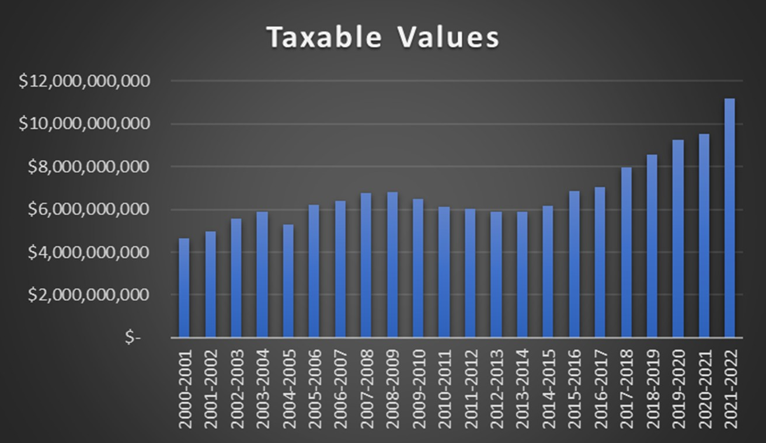

Taxable Value History and Future Projections

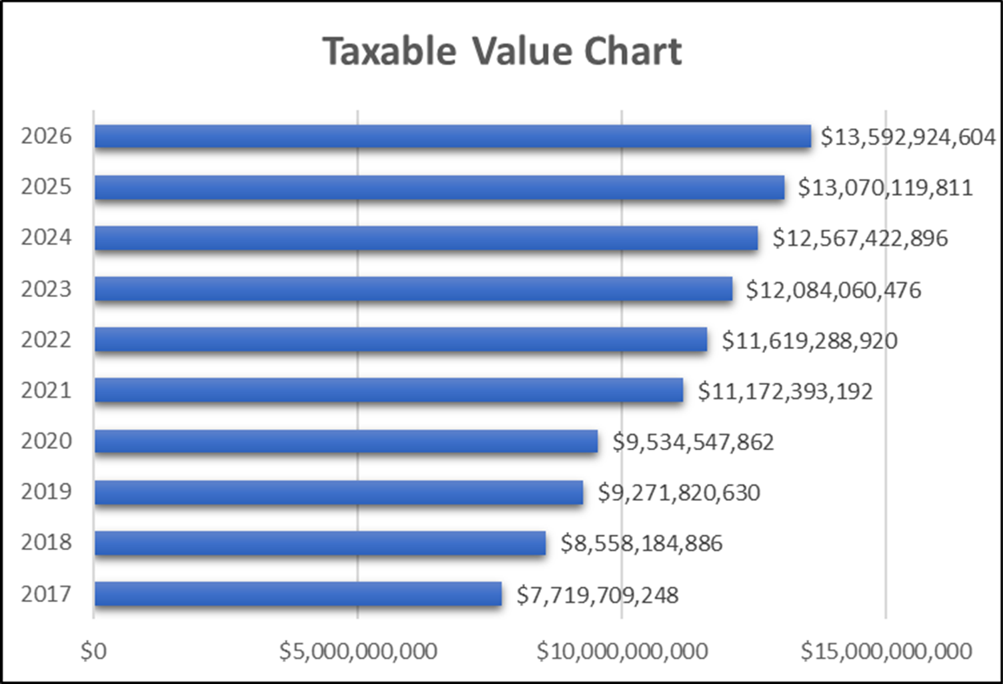

- Predictions are based on a 4% growth

Property Tax Levies & Collections

Fiscal  Year | M&O  Rate | I&S  Rate | Total Tax  Rate | Taxable Values | Total Levy | Total Collections | %
2010 | 1.04 | 0.37 | 1.42 | $ 6,467,873,468 | $ 87,516,423 | $ 85,695,026 | 98.17
2011 | 1.04 | 0.37 | 1.42 | $ 6,120,707,473 | $ 86,272,907 | $ 84,461,935 | 98.64
2012 | 1.04 | 0.37 | 1.42 | $ 6,045,576,816 | $ 84,374,630 | $ 82,766,517 | 98.56
2013 | 1.04 | 0.37 | 1.42 | $ 5,875,851,693 | $ 84,516,847 | $ 83,134,933 | 98.65
2014 | 1.04 | 0.36 | 1.41 | $ 5,899,012,680 | $ 88,617,735 | $ 86,607,564 | 98.56
2015 | 1.04 | 0.36 | 1.41 | $ 6,188,134,529 | $ 89,248,544 | $ 87,466,306 | 99.17
2016 | 1.04 | 0.42 | 1.46 | $ 6,862,131,352 | $ 103,000,459 | $ 99,288,582 | 98.66
2017 | 1.04 | 0.42 | 1.46 | $ 7,054,825,858 | $ 107,713,254 | $ 108,857,664 | 98.68
2018 | 1.04 | 0.48 | 1.52 | $ 7,960,549,178 | $ 125,639,017 | $ 123,786,579 | 98.53
2019 | 0.97 | 0.48 | 1.45 | $ 9,271,820,630 | $ 130,792,672 | $ 129,188,293 | 98.77
2020 | 0.9664 | 0.48 | 1.4464 | $ 9,534,547,862 | $ 138,398,388 | $ 140,929,934 | 101.83
2021 | 0.872 | 0.44 | 1.312 | $ 11,172,393,192

Property taxes are calculated on 100% of market values less appropriate exemptions. Taxes are calculated on each $100 of taxable value.

It is important to note that taxes collected for the 2021‐22 school year are taxes that are billed in October for tax year 2021. They are not due until February 1 without penalty.

2021 Top Ten Taxpayers

Item | Principal Taxpayer | Type of Property | 2021 Valuation
1 | Town East Mall | Shopping Mall | $ 131,750,000
2 | Oncor Electric Delivery | Utilities | $ 63,464,040
3 | Bottling Group, Inc. | Bottling Company | $ 53,049,721
4 | Ashley Furniture Ind | Furniture Manufacturer | $ 41,289,710
5 | Market East Associates LLC | Retail | $ 40,921,370
6 | SPI Mission Ranch LLC | Apartment Complex | $ 35,500,000
7 | S2 Camelot LLC | Apartment Complex | $ 35,238,460
8 | Miskin LLC | Apartment Complex | $ 31,750,000
9 | Atmos Energy Mid Texas | Gas | $ 30,203,940
10 | SCI Mesquite Fund 1 LLC | Apartment Complex | $ 29,000,000

The yearly impact of the M&O tax rate and the Debt Service (Interest & Sinking or I&S) tax rate for the District’s taxpayers is shown in Table 8. The numbers show the eﬀect of the total tax rate along with the increases in property values over the past several years. The table uses the average home value in the District over the past 8 years to reflect the tax increase trend.

Table 51
Tax Rate Impact to District’s Taxpayers

 | 2017‐18 | 2018‐19 | 2019‐20 | 2020‐21 | 2021‐22
Assessed/Market Value of a Home | $ 128,823 | $ 146,319 | $ 147,608 | $ 169,135 | $ 173,364
Average Taxable Value | $ 99,152 | $ 113,294 | $ 115,607 | $ 138,608 | $ 143,468
Total Property Tax Rate | $ 1.46 | $ 1.52 | $ 1.45 | $ 1.4464 | $ 1.312
Property Tax Due | $ 1,447.62 | $ 1,722.06 | $ 1,676.30 | $ 2,004.83 | $ 1,882.30
Increase in Taxes | $ 193.76 | $ 274.44 | $ (45.76) | $ 328.53 | $ (122.53)
Property Tax Percent Increase from Prior Year | 15.5% | 19.0% | ‐2.7% | 19.6 % | ‐6.1%

This schedule shows the trends in property values and tax rates. Each year the Dallas Central Appraisal District appraises property based on market conditions such as sales in the surrounding areas. The above schedules show how market conditions have aﬀected the assessed value through 2021‐22 based on the overall appraisal value trends in the District. As shown above, the average value of a residence in the District continues to rise annually.

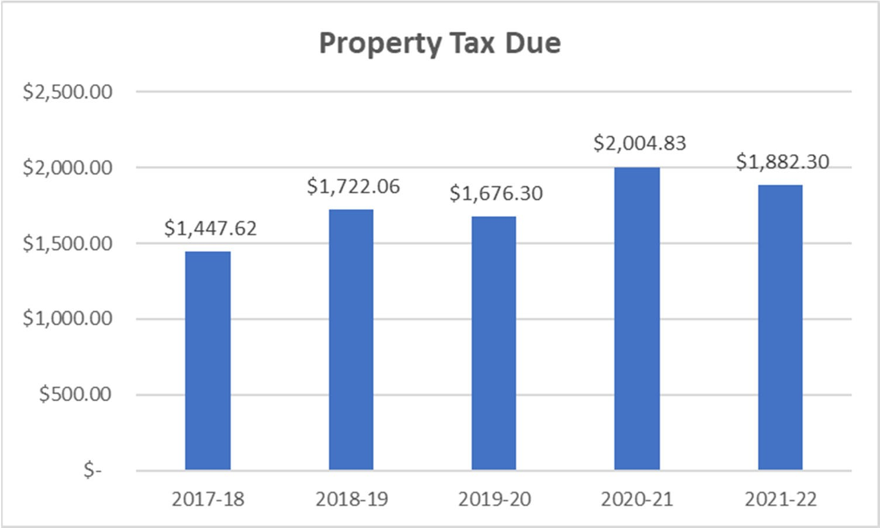

Mesquite Independent School District Taxable Values and Tax Rate
The appraisal process is conducted by the Dallas County Appraisal District (DCAD). Properties are re‐ quired to be appraised at 100% of market value as of January 1. A ten percent appraisal cap controls runaway property value growth. The DCAD submits preliminary values to the school district by May 1. These values are usually a conservative estimate of the final certified values that are provided by July 25th. The preliminary values are good estimates upon which to base the tax levies for the operating and debt service budgets. Once the certified values are received by the district, the tax rate adoption and budgeting process can be completed for the new fiscal year. The tax year 2021 value we use for the 2021‐22 budget.

Table 52
Taxable Value Projections
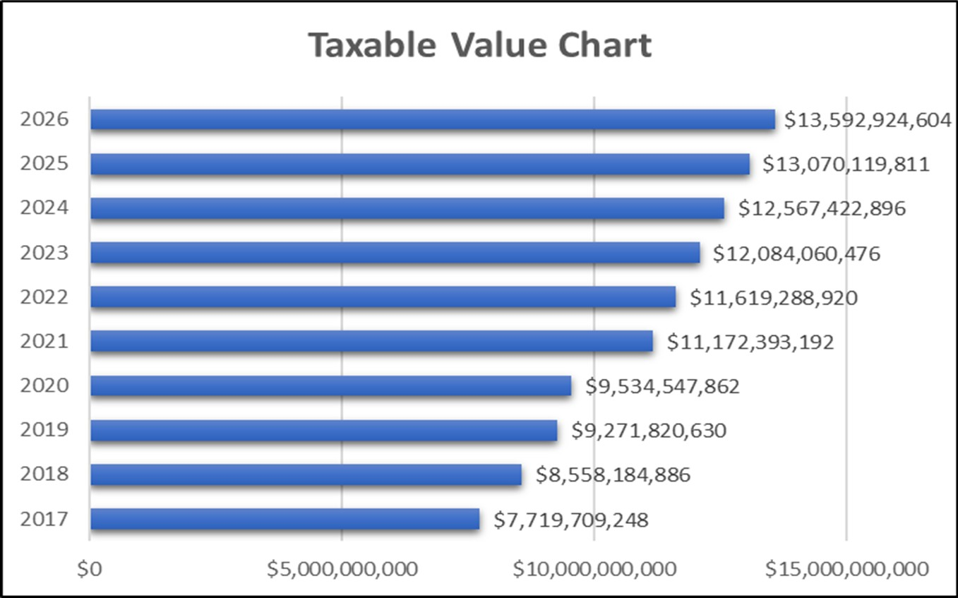
Dallas County Appraisal District

For budget purposes, the tax levy is computed from the New Taxable Value at a 99% collection rate. The actual taxes to be collected on the Freeze Taxable Values are added back. The Freeze Taxable Value is the property values of citizens over 65 years old. When a taxpayer on a homesteaded property turns 65, the taxes are frozen and can only increase if the home is enlarged. The combination of the Net Taxable Value levy on Frozen Values the Total Levy for the year.

The Maintenance and Operations tax rate supports the major educational and operational programs of the District for such expenses as staﬀ salaries, utilities, supplies, materials, equipment, etc. The M&O rate for 2021‐22 is $ 0.8720.

The Debt Service rate tax rate supports payments of principal and interest for the debt authorized by the voters. The total amount of debt service payable each year less any state aid is divided by the taxable property values to determine the rate. For the 2021‐22, the debt service rate is $0.44 which is a four cent decrease from the 202‐21 year.

Table 53
Tax Rate History
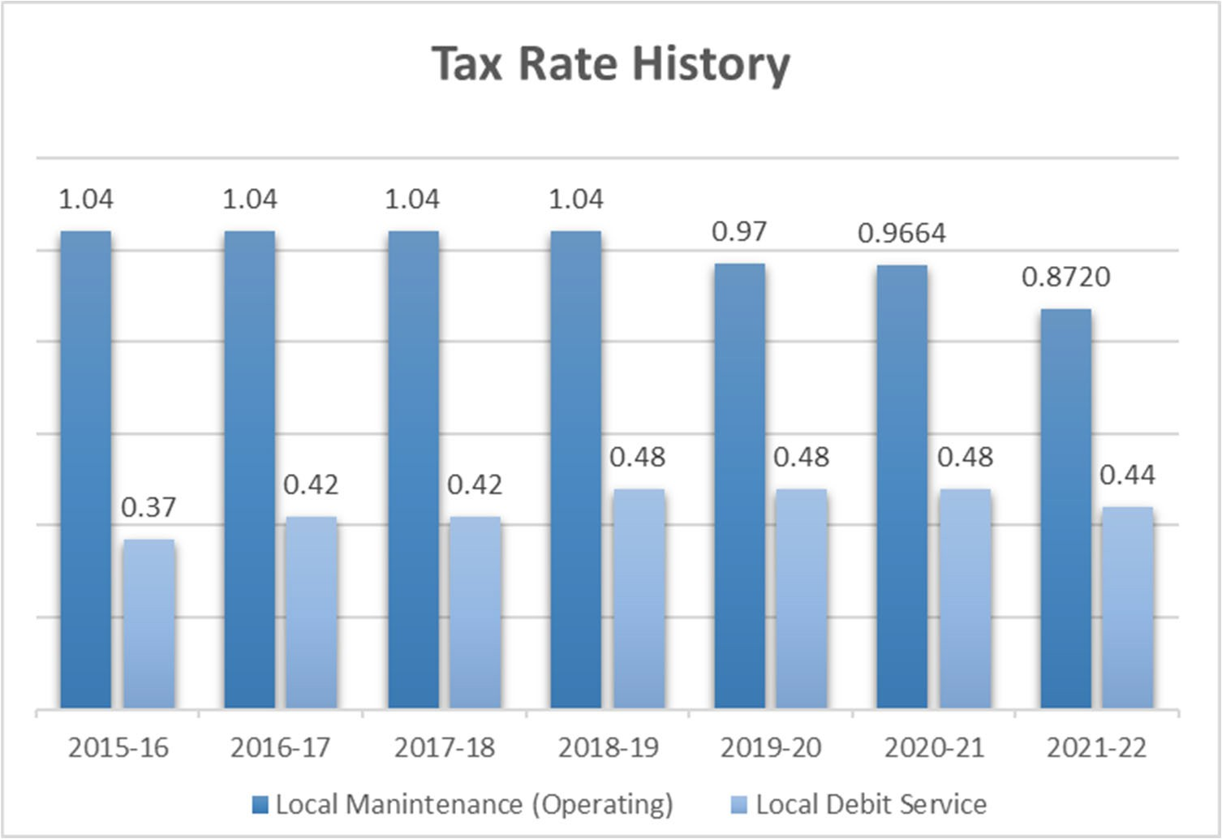

Mesquite Independent School District Student & Enrollment By Campus

Over the past 10 years, Mesquite ISD has experienced significant increases in the student population. Total PK‐12 enrollment rose from 37,205 in 2009‐2010 to 41,016 in 2017‐2018. Starting with the school year 2016‐2017 you can see the enrollment stabilizing.

District enrollment projections are produced using demographic data specific to Mesquite ISD. The district’s demographer reviews overall population and household growth trends, the cohort survival rates for each grade level, and how the local birth rate relates to incoming kindergarten enrollment. Additionally, GIS analysis of enrolled student data and quarterly housing surveys are used to deter‐ mine student yields per single‐family home and apartment unit, the rate of new home construction per subdivision, and the impact that current and future residential developments will have on district enrollment. Presently in 2021‐22, the decrease in birthrate is reflected in Kindergarten through Second grades, particularly Pre‐K due to COVID. This is causing a decrease in enrollment in those grades. However, as subdivisions begin to build homes and apartments the district expects to experience annual growth beginning in school year 2022‐2023.

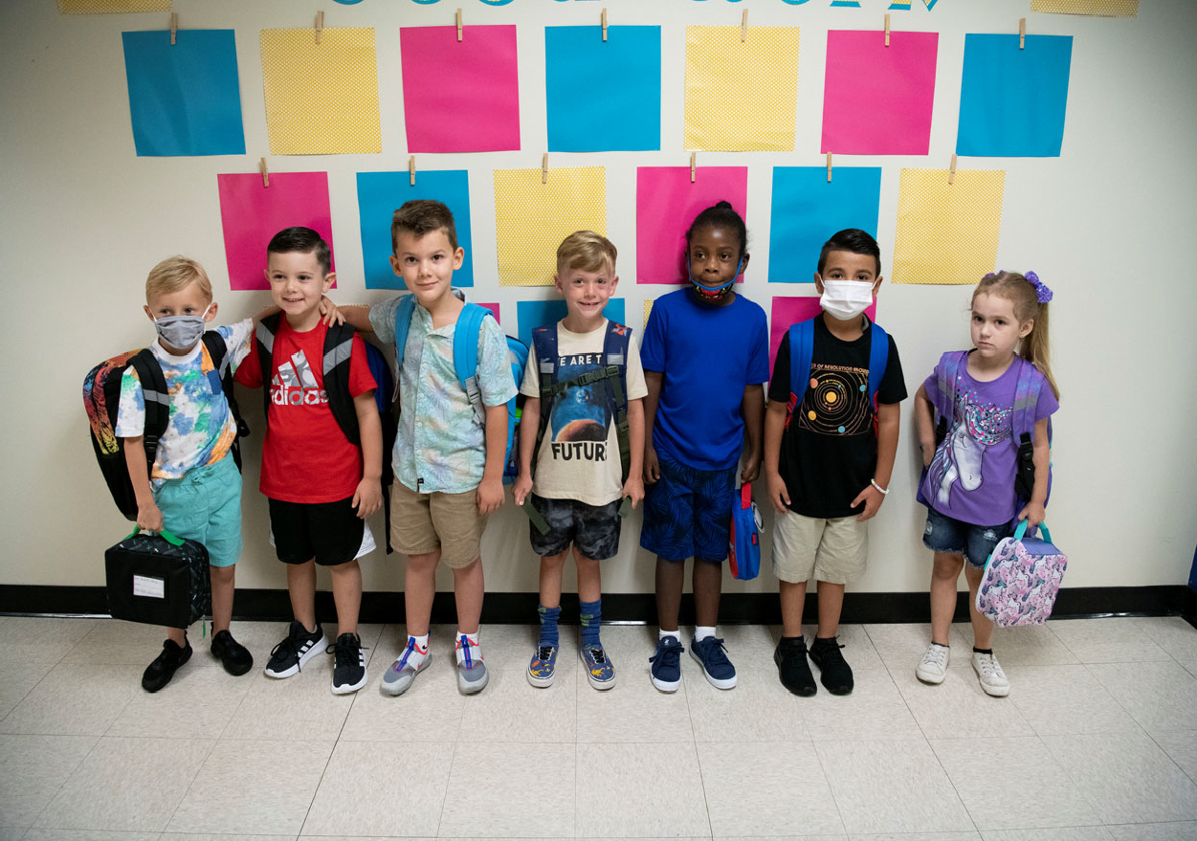

Mesquite Independent School District Table 54
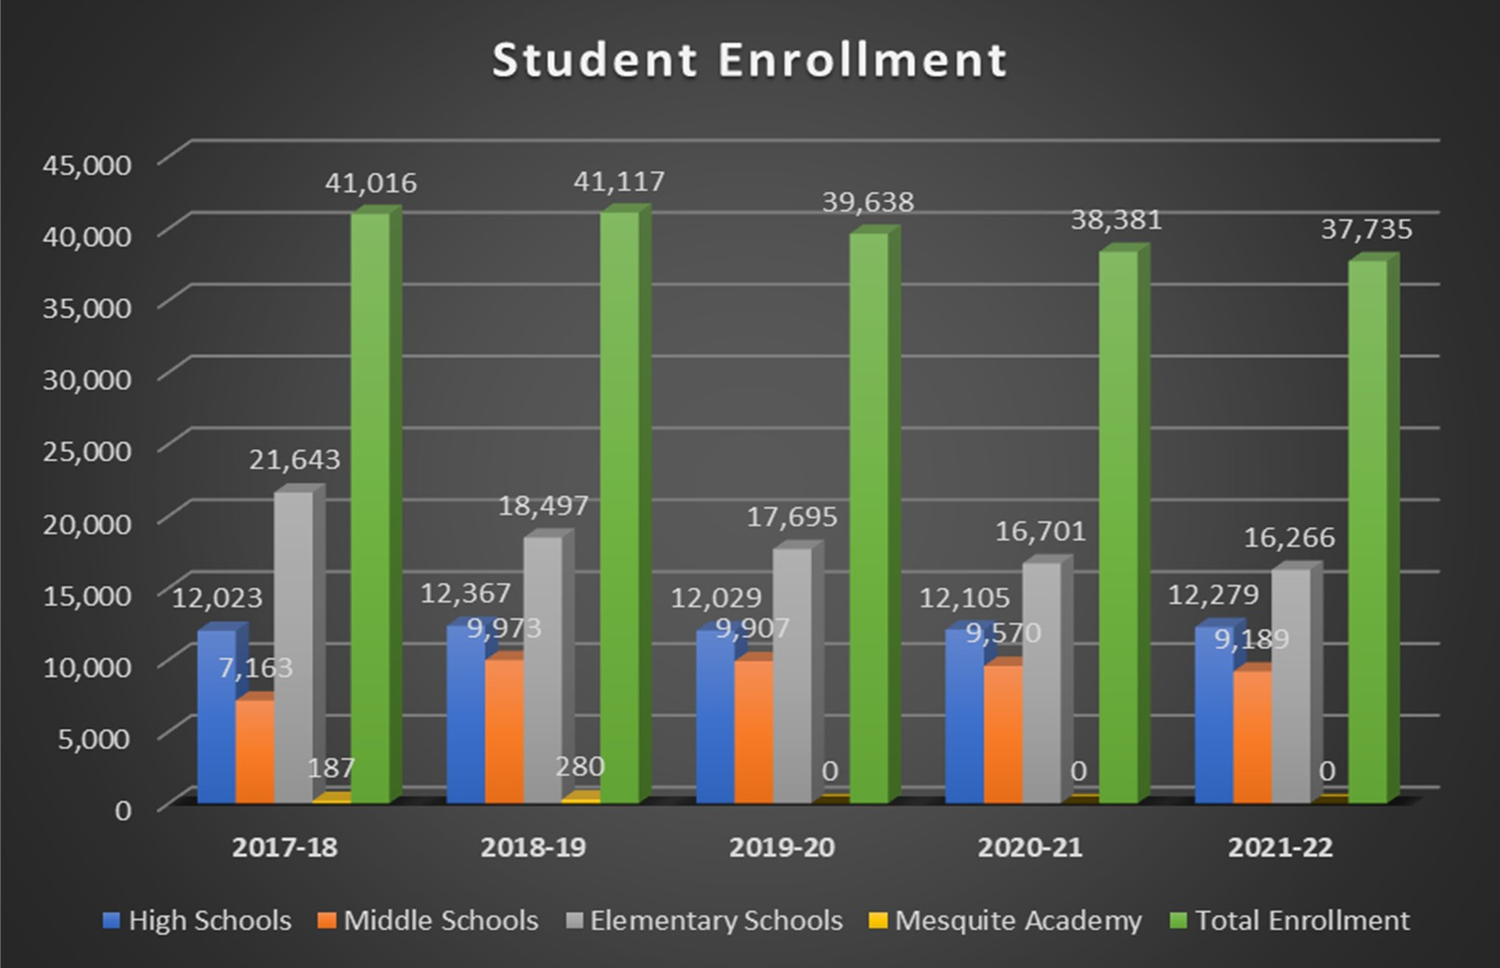
Student Enrollment
Student Information System (as of September 3, 2021)

Table 55
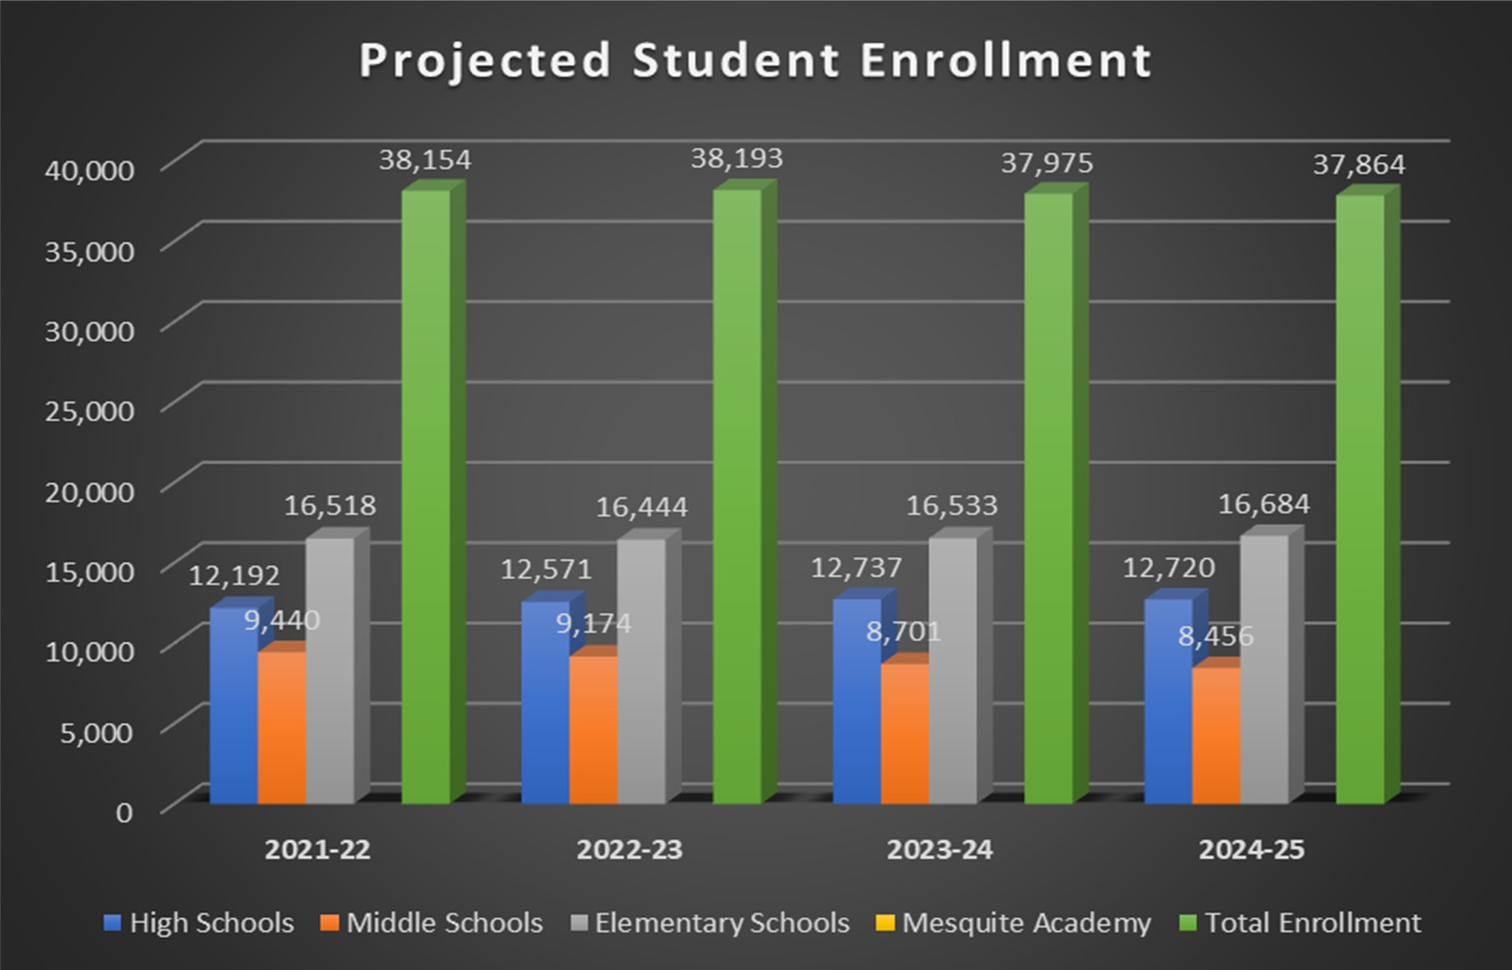
Projected Student Enrollment
District Demographic Report ‐ 2021

Table 56
Informational Section
Mesquite ISD Oﬃcial Budget 2021‐2022
177
Mesquite ISD Student Enrollment by Campus

Campus | Actual  2017‐18 | Actual  2018‐19 | Actual  2019‐20 | Actual  2020‐21 | Current Year  2021‐22 | Projected  2021‐22 | Projected  2022‐23 | Projected  2023‐24 | Projected  2024‐25
Mesquite High School | 2,904 | 2,829 | 2,625 | 2,561 | 2345 | 2,574 | 2,660 | 2,724 | 2,648
North Mesquite High School | 2,808 | 2,864 | 2,522 | 2,415 | 2169 | 2,346 | 2,358 | 2,358 | 2,328
West Mesquite High School | 2,077 | 2,137 | 2,162 | 2,280 | 2223 | 2,422 | 2,549 | 2,545 | 2,490
Poteet High School | 1,848 | 1,853 | 1,822 | 1,750 | 1651 | 1,730 | 1,729 | 1,687 | 1,700
Horn High School | 2,386 | 2,684 | 2,898 | 3,099 | 3089 | 3,120 | 3,275 | 3,423 | 3,554
Vanguard High School | 0 | 0 | 0 | 0 | 802
Agnew Middle School | 831 | 1,280 | 1,228 | 1,227 | 1153 | 1,147 | 1,114 | 1019 | 1066
Vanston Middle School | 805 | 969 | 923 | 847 | 856 | 878 | 837 | 798 | 714
Wilkinson Middle School | 974 | 926 | 790 | 797 | 724 | 768 | 733 | 659 | 633
McDonald Middle School | 1,002 | 909 | 908 | 923 | 840 | 876 | 829 | 798 | 798
New Middle School | 926 | 931 | 935 | 831 | 797 | 852 | 800 | 737 | 697
Kimbrough Middle School | 825 | 1,222 | 1,357 | 1,260 | 1188 | 1,243 | 1,249 | 1,232 | 1,167
Berry Middle School | 904 | 1,116 | 1,103 | 613 | 601 | 636 | 635 | 699 | 704
Terry Middle School | 896 | 1,440 | 1,463 | 1,039 | 1056 | 1,061 | 1,015 | 916 | 869
Fraiser Middle School | 0 | 1,180 | 1,200 | 1,126 | 1087 | 1,076 | 1,001 | 929 | 877
Woolley Middle School | 0 | 0 | 0 | 907 | 887 | 903 | 961 | 914 | 931
Black Elementary School | 639 | 606 | 656 | 626 | 634 | 621 | 610 | 622 | 617
Florence Elementary School | 654 | 543 | 548 | 467 | 482 | 458 | 450 | 441 | 428
Galloway Elementary School | 732 | 489 | 461 | 420 | 418 | 394 | 382 | 374 | 374
Hanby Elementary School | 929 | 835 | 838 | 740 | 689 | 749 | 740 | 750 | 757
Hodges Elementary School | 767 | 610 | 545 | 514 | 512 | 498 | 500 | 491 | 489
McWhorter Elementary School | 870 | 719 | 633 | 549 | 496 | 516 | 481 | 477 | 477
Motley Elementary School | 455 | 370 | 338 | 276 | 250 | 253 | 243 | 241 | 250
Range Elementary School | 763 | 653 | 601 | 580 | 572 | 571 | 562 | 553 | 532
Rugel Elementary School | 458 | 355 | 355 | 321 | 293 | 302 | 308 | 308 | 305
Rutherford Elementary School | 474 | 645 | 659 | 648 | 657 | 659 | 658 | 652 | 631
Shands Elementary School | 825 | 655 | 629 | 622 | 544 | 596 | 600 | 582 | 580
Tisinger Elementary School | 824 | 819 | 660 | 631 | 648 | 614 | 624 | 621 | 621
Tosch Elementary School | 872 | 658 | 594 | 617 | 585 | 626 | 621 | 626 | 644
Seabourn Elementary School | 724 | 700 | 661 | 578 | 608 | 594 | 592 | 600 | 606
Lawrence Elementary School | 440 | 368 | 334 | 283 | 261 | 255 | 248 | 243 | 254
Floyd Elementary School | 798 | 579 | 604 | 455 | 428 | 452 | 466 | 480 | 477
Porter Elementary School | 605 | 427 | 421 | 389 | 374 | 368 | 375 | 356 | 354

Table 56 (cont.)
Informational Section
Mesquite ISD Oﬃcial Budget 2021‐2022
178

Mesquite ISD Student Enrollment by Campus (cont.)

Campus | Actual 2017‐18 | Actual 2018‐19 | Actual 2019‐20 | Actual 2020‐21 | Current Year 2021‐22 | Projected 2021‐22 | Projected 2022‐23 | Projected 2023‐24 | Projected 2024‐25
McKenzie Elementary School | 538 | 493 | 454 | 414 | 390 | 415 | 412 | 401 | 403
Beasley Elementary School | 467 | 378 | 374 | 359 | 369 | 355 | 341 | 345 | 346
Price Elementary School | 451 | 359 | 348 | 299 | 311 | 298 | 298 | 304 | 312
Shaw Elementary School | 884 | 582 | 577 | 555 | 514 | 548 | 533 | 537 | 530
Kimball Elementary School | 242 | 192 | 188 | 211 | 214 | 224 | 225 | 247 | 252
Pirrung Elementary School | 434 | 438 | 392 | 396 | 388 | 392 | 383 | 377 | 375
Cannaday Elementary School | 564 | 575 | 590 | 582 | 570 | 580 | 569 | 563 | 574
Austin Elementary School | 471 | 471 | 390 | 343 | 323 | 345 | 345 | 349 | 358
Moss Elementary School | 434 | 391 | 380 | 323 | 317 | 322 | 316 | 318 | 311
Thompson Elementary School | 565 | 529 | 523 | 566 | 566 | 571 | 563 | 557 | 562
Gray Elementary School | 634 | 512 | 450 | 431 | 412 | 431 | 431 | 436 | 450
Smith Elementary School | 494 | 425 | 437 | 545 | 541 | 564 | 583 | 594 | 613
Gentry Elementary School | 916 | 654 | 617 | 624 | 595 | 613 | 633 | 667 | 722
Mackey Elementary School | 788 | 678 | 615 | 650 | 663 | 639 | 633 | 644 | 649
Achziger Elementary School | 971 | 854 | 912 | 827 | 816 | 847 | 903 | 963 | 1,015
Henrie Elementary School | 961 | 935 | 911 | 860 | 826 | 848 | 816 | 814 | 816
Mesquite Academy | 187 | 280 | * | * | *
JJAEP |  |  | 7 | 5 | 1 | 4 | 4 | 4 | 4
TOTAL | 41,016 | 41,117 | 39,638 | 38,381 | 37,735 | 38,154 | 38,193 | 37,975 | 37,864

* Student enrollment included in high school count.
District Demographic Report‐2021

Table 57
Mesquite Independent School District Enrollment
Campus | Enrollment 20‐21 | Enrollment 21‐22
Achziger | 827 | 816
Austin | 343 | 323
Beasley | 359 | 369
Black | 626 | 634
Cannaday | 582 | 570
Florence | 467 | 482
Floyd | 455 | 428
Galloway | 420 | 418
Gentry | 624 | 595
Gray | 431 | 412
Hanby | 740 | 689
Henrie | 860 | 826
Hodges | 514 | 512
Kimball | 211 | 214
Lawrence | 283 | 261
Mackey | 650 | 663
McKenzie | 414 | 390
McWhorter | 549 | 496
Moss | 323 | 317
Motley | 276 | 250
Pirrung | 396 | 388
Porter | 389 | 374
Price | 299 | 311
Range | 580 | 572
Rugel | 321 | 293
Rutherford | 648 | 657

Campus | Enrollment 20‐21 | Enrollment 21‐22
Seabourn | 578 | 608
Shands | 622 | 544
Shaw | 555 | 514
Smith | 545 | 541
Thompson | 566 | 566
Tisinger | 631 | 648
Tosch | 617 | 585
Agnew MS | 1,227 | 1153
Berry MS | 613 | 601
Fraiser MS | 1,126 | 1087
Kimbrough MS | 1,260 | 1188
McDonald MS | 923 | 840
New MS | 831 | 797
Terry MS | 1,039 | 1056
Vanston MS | 847 | 856
Wilkinson MS | 797 | 724
Woolley MS | 907 | 887
Horn HS | 3,099 | 3089
Mesquite HS | 2,561 | 2345
North Mesquite HS | 2,415 | 2169
Poteet HS | 1,750 | 1651
Vanguard HS | 0 | 802
West Mesquite HS | 2,280 | 2223

Staﬃng

The data below shows the 5‐year history of the Districts staﬃng by employee group, student enrollment and teaching and total staﬀ‐to‐student ratios. Starting in the 2019‐20 school year there were increases in the professional support, school leadership, and central administration categories due to the following three factors: 1) the Texas state legislature passed HB‐3 which increased funding for Texas school districts, 2) HB‐3 added three new allotments (Dyslexia, Early Childhood Allotment, and College, Career and Military Readiness Allotment), and 3) MISD added teachers, professional supports, school leadership, and central administration positions to focus on building and enhancing leadership development throughout the district.

The teaching staﬀ and total staﬀ‐to‐student ratios have decreased over the past two‐years mainly due to a tempo‐ rary drop in enrollment due to the COVID‐19 pandemic in the 2020‐21 school year, coupled with the additional positions which have been provided to help Mesquite ISD meet its goals as stated in the ‘Strategic Roadmap’.

Table 58
Mesquite Independent School District Staﬃng History
School Years  Teachers  (Classroom, Interventionists, Special Programs) | 17‐18  2,738 | 18‐19  2,748 | 19‐20  2,751 | 20‐21  2,789 | 21‐22  2,870
Professional Support | 532 | 546 | 566 | 585 | 591
(Directors, Counselors, Librarians, Campus Oﬃce Staﬀ, Central Oﬃce Staﬀ)
School Leadership | 132 | 133 | 141 | 145 | 148
(Principals, Asst. Principals)
Central Administration | 11 | 9 | 28 | 30 | 32
(Superintendent, Asst. Superintendents, Cabinet‐Level Positions)
Paraprofessional | 802 | 807 | 810 | 837 | 842
Auxiliary | 1,156 | 1,138 | 1,135 | 1,101 | 1,122
Total Staﬀ | 5,371 | 5.381 | 5,431 | 5,489 | 5,605
Student Enrollment (as of September 3, 2021**) | 41,025 | 41,022 | 39,638 | 38,381 | 37,735*
Staﬃng Ratios
MISD | 15.1 | 15.1 | 15.1 | NA | NA
Teaching Staﬀ | 14.98 | 14.93 | 14.41 | 13.76 | 13.15
Total Staﬀ | 7.64 | 7.62 | 7.30 | 6.99 | 6.73
State | 7.57 | 7.57 | 7.46 | NA | NA
*Does not include 466 students who have opted for virtual learning for the first 9‐weeks of the 2021‐22 school year.
**For years 2017‐18 through 2020‐21 the enrollment was based on the District ‘Snapshot Date’ which is the last Friday of October. However, due to MISD changing its fiscal year from September 1 to July 1 the enrollment is as of the first Friday in September for 2021‐22. TAPR

Debt Service Fund

Over the past 10 years and in the near future, the District has and will continue to have a need to con‐ duct bond sales. `A school district is authorized to issue bonds and levy taxes for payment of bonds subject to voter approval of a proposition submitted to the voters under Texas Education Code (TEX)
  - (b)(1). A debt service fund is a government fund, with budgetary control, that must be used to account for general long‐term debt principal and interest for debt issues and other long‐term debts for which a tax has been dedicated. A separate bank account must be kept for this fund and a separate tax rate is assessed to fund the debt payments based on the scheduled maturities. The debt tax rate (or Interest and Sinking – I&S tax rate) is approved by the Board of Trustees annually and is calculated based on the scheduled debt requirements and the taxable property values certified by the DAC.

TEC 45.003(1), as amended, requires a district to demonstrate to the Texas Attorney General that it has the prospective ability to pay debt service on a proposed issue of bonds, together with debt service on other outstanding “new debt” of the district, from a tax levied at a rate of $0.50 per $100 of assessed valuation before bonds may be issued.

Once the prospective ability to pay such tax has been shown and the bonds are issued, a district may levy a tax to pay the annual debt service. Mesquite ISD is presently taxing at $0.44 per $100 of taxable value for the Interest and Sinking fund.

The District was rated by S & P Global with a rating of AA/Stable and by Fitch Ratings as AA+.

Revenue

The primary source of revenue for the debt service fund is an ad valorem tax raised from levying the Interest and Sinking (I&S) tax rate. The district is presently taxing at $0.44 per $100 of taxable value. The state laws governing debt tax rates limit a school district to a maximum tax rate of $0.50, thus leaving the District with $0.02 per $100 taxable available for future bond sales.

Other sources of revenue are state funds provided as part of the Existing Debt Allotment (EDA) pro‐ gram and the Instructional Facilities (IFA) program, along with investment earnings from fund cash balances.

The EDA is provided for existing debt issued by school districts to produce a guaranteed yield in State and local revenue per student for each cent of debt service tax levy. In general, a district’s bonds are eligible for the allotment if, during the previous State biennium, the district (1) made payments on such bonds or (2) levied and collected taxes for the payment of principal and interest on such bonds.

The IFA guarantees each school district a specified dollar amount per student in state and local funds for each cent of tax eﬀort to pay principal and interest on eligible bond used to construct, acquire, ren‐ ovate, or improve instructional facilities. To receive an IFA, a school district must apply to the Commissioner of Education before issuing the bonds to be paid with State assistance. These funds are allocated to school districts based upon property wealth per student. Districts with the lowest amounts will receive funding first.

Expenditures

The expenditures from the Debt Service fund consist mainly of the semi‐annual principal and interest requirements from existing bond debt. Currently, these payments total approximately $62,000,000.

Mesquite Independent School District Principal Outstanding as of June 30, 2021

Principal
Series Description Outstanding

Unlimited Tax School Building Bonds, Series 2020A | 3rd Bond Sale for 2018 Bond | $ 81,190,000.00
Unlimited Tax Refunding Bonds, Series 2020B | Bond Refunding | 6,260,000.00
Unlimited Tax Refunding Bonds, Series 2020C | Bond Refunding | 5,680,000.00
Unlimited Tax Refunding Bonds, Taxable Series 2020D | Bond Refunding | 14,780,000.00
Unlimited Tax School Building Bonds, Series 2019 | 2nd 2018 Bond Sale | 84,740,000.00
Unlimited Tax School Building Bonds, Series 2018 | 1st 2018 Bond Sale | 112,040,000.00
Unlimited Tax Refunding Bonds, Series 2017A | Bond Refunding | 12,017,231.80
Unlimited Tax School Building Bonds, Series 2017B | 3rd Bond Sale for 2015 Bond | 80,635,000.00
Unlimited Tax Refunding Bonds, Series 2016A | Bond Refunding | 15,965,000.00
Unlimited Tax Refunding Bonds, Series 2016B | Bond Refunding | 22,270,000.00
Unlimited Tax School Building Bonds, Series 2016C | 2nd Bond Sale for 2015 Bond | 90,470,000.00
Unlimited Tax School Building Bonds, Series 2015A | 1st 2015 Bond Sale | 22,050,000.00
Unlimited Tax Refunding Bonds, Series 2015B | Bond Refunding | 16,640,000.00
Unlimited Tax Refunding Bonds, Series 2015C | Bond Refunding | 26,437,898.00
Unlimited Tax Refunding Bonds, Series 2015D | Bond Refunding | 18,885,000.00
Unlimited Tax School Building Bonds, Series 2015E | 1st Bond Sale for 2015 Bond | 68,460,000.00
Unlimited Tax School Building Bonds, Series 2014A | 1st 2014 Bond Sale | 17,345,000.00
Unlimited Tax Refunding Bonds, Series 2014B | Bond Refunding | 9,920,000.00
Unlimited Tax Refunding Bonds, Series 2013 | Bond Refunding | 8,610,000.00
Unlimited Tax Refunding Bonds, Series 2012 | Bond Refunding | 9,844,259.10
Variable Rate School Building Unlimited Tax Bonds, Series 2003A |  | 23,800,000.00
 |  | $ 748,039,388.90

BOND DEBT SERVICE
Mesquite ISD
All Outstanding Debt As of FYE 6/30/2021

Compounded
Period Ending Principal Interest Interest Debt Service

6/30/2022 | $ 23,431,113.40 | $ 31,943,785.96 | $ 5,723,886.60 | $ 61,098,785.96
6/30/2023 | 19,153,707.20 | 31,007,949.96 | 5,806,292.80 | 55,967,949.96
6/30/2024 | 19,729,980.20 | 30,151,214.11 | 5,840,019.80 | 55,721,214.11
6/30/2025 | 25,770,329.00 | 30,128,034.01 | ‐ | 55,898,363.01
6/30/2026 | 26,935,000.00 | 28,099,150.86 | ‐ | 55,034,150.86
6/30/2027 | 27,475,000.00 | 26,895,929.76 | ‐ | 54,370,929.76
6/30/2028 | 27,667,396.35 | 25,725,315.36 | 907,603.65 | 54,300,315.36
6/30/2029 | 28,705,201.85 | 24,580,840.81 | 969,798.15 | 54,255,840.81
6/30/2030 | 27,798,810.60 | 23,427,107.51 | 1,031,189.40 | 52,257,107.51
6/30/2031 | 28,417,674.90 | 22,262,318.76 | 1,087,325.10 | 51,767,318.76
6/30/2032 | 30,275,175.40 | 21,060,318.76 | 1,139,824.60 | 52,475,318.76
6/30/2033 | 31,520,000.00 | 19,772,781.26 | ‐ | 51,292,781.26
6/30/2034 | 31,980,000.00 | 18,365,506.26 | ‐ | 50,345,506.26
6/30/2035 | 33,075,000.00 | 16,903,981.26 | ‐ | 49,978,981.26
6/30/2036 | 34,525,000.00 | 15,410,131.26 | ‐ | 49,935,131.26
6/30/2037 | 33,370,000.00 | 13,926,709.38 | ‐ | 47,296,709.38
6/30/2038 | 34,795,000.00 | 12,473,475.00 | ‐ | 47,268,475.00
6/30/2039 | 36,275,000.00 | 10,949,375.00 | ‐ | 47,224,375.00
6/30/2040 | 37,840,000.00 | 9,349,506.25 | ‐ | 47,189,506.25
6/30/2041 | 38,265,000.00 | 7,671,700.00 | ‐ | 45,936,700.00
6/30/2042 | 37,990,000.00 | 5,961,375.00 | ‐ | 43,951,375.00
6/30/2043 | 33,800,000.00 | 4,370,475.00 | ‐ | 38,170,475.00
6/30/2044 | 19,725,000.00 | 3,201,125.00 | ‐ | 22,926,125.00
6/30/2045 | 20,580,000.00 | 2,325,775.00 | ‐ | 22,905,775.00
6/30/2046 | 14,280,000.00 | 1,555,850.00 | ‐ | 15,835,850.00
6/30/2047 | 7,820,000.00 | 1,037,500.00 | ‐ | 8,857,500.00
6/30/2048 | 8,215,000.00 | 636,625.00 | ‐ | 8,851,625.00
6/30/2049 | 8,625,000.00 215,625.00 ‐ 8,840,625.00
$ 748,039,388.90 |  | $ 439,409,481.53 | $ 22,505,940.10 | $ 1,209,954,810.53

Table 61
Informational Section
185
Mesquite ISD Oﬃcial Budget 2021‐2022

Mesquite ISD
Capital Improvement Program Impact on Tax Rate (Outstanding Debt Only)

As of June 30, 2021
Fiscal  Year End | Taxable Assessed  Valuation | Growth  Rate | Principal | Interest | Interest | Total P+I | Total P+I | Less: Estimated  IFA/EDA | Less  Estimated  IFA/EDA | Net Debt  Service | Net  Debt  Service | Estimated I&S Tax  Rate
2022 | $ 11,172,393,192 |  | $ 23,431,113 | $ 37,667,673 | $ 37,667,673 | $ 61,098,786 | $ 61,098,786 | $ 12,661,862 | $ 12,661,862 | $ 48,436,924 | $ 48,436,924 | $ 0.4400
2023 | 11,395,841,056 | 2.0% | 19,153,707 | 36,814,243 | 36,814,243 | 55,967,950 | 55,967,950 | 10,457,814 | 10,457,814 | 45,510,136 | 45,510,136 | 0.4075
2024 | 11,623,757,877 | 2.0% | 19,729,980 | 35,991,234 | 35,991,234 | 55,721,214 | 55,721,214 | 9,655,793 | 9,655,793 | 46,065,421 | 46,065,421 | 0.4044
2025 | 11,856,233,034 | 2.0% | 25,770,329 | 30,128,034 | 30,128,034 | 55,898,363 | 55,898,363 | 8,837,399 | 8,837,399 | 47,060,964 | 47,060,964 | 0.4050
2026 | 11,856,233,034 | 0.0% | 26,935,000 | 28,099,151 | 28,099,151 | 55,034,151 | 55,034,151 | 7,739,128 | 7,739,128 | 47,295,023 | 47,295,023 | 0.4070
2027 | 11,856,233,034 | 0.0% | 27,475,000 | 26,895,930 | 26,895,930 | 54,370,930 | 54,370,930 | 7,739,128 | 7,739,128 | 46,631,801 | 46,631,801 | 0.4013
2028 | 11,856,233,034 | 0.0% | 27,667,396 | 26,632,919 | 26,632,919 | 54,300,315 | 54,300,315 | 7,739,128 | 7,739,128 | 46,561,187 | 46,561,187 | 0.4007
2029 | 11,856,233,034 | 0.0% | 28,705,202 | 25,550,639 | 25,550,639 | 54,255,841 | 54,255,841 | 7,739,128 | 7,739,128 | 46,516,713 | 46,516,713 | 0.4003
2030 | 11,856,233,034 | 0.0% | 27,798,811 | 24,458,297 | 24,458,297 | 52,257,108 | 52,257,108 | 7,739,128 | 7,739,128 | 44,517,979 | 44,517,979 | 0.3831
2031 | 11,856,233,034 | 0.0% | 28,417,675 | 23,349,644 | 23,349,644 | 51,767,319 | 51,767,319 | 7,739,128 | 7,739,128 | 44,028,190 | 44,028,190 | 0.3789
2032 | 11,856,233,034 | 0.0% | 30,275,175 | 22,200,143 | 22,200,143 | 52,475,319 | 52,475,319 | 7,739,128 | 7,739,128 | 44,736,190 | 44,736,190 | 0.3850
2033 | 11,856,233,034 | 0.0% | 31,520,000 | 19,772,781 | 19,772,781 | 51,292,781 | 51,292,781 | 7,418,097 | 7,418,097 | 43,874,685 | 43,874,685 | 0.3776
2034 | 11,856,233,034 | 0.0% | 31,980,000 | 18,365,506 | 18,365,506 | 50,345,506 | 50,345,506 | 7,418,097 | 7,418,097 | 42,927,410 | 42,927,410 | 0.3695
2035 | 11,856,233,034 | 0.0% | 33,075,000 | 16,903,981 | 16,903,981 | 49,978,981 | 49,978,981 | 7,418,097 | 7,418,097 | 42,560,885 | 42,560,885 | 0.3663
2036 | 11,856,233,034 | 0.0% | 34,525,000 | 15,410,131 | 15,410,131 | 49,935,131 | 49,935,131 | 7,418,097 | 7,418,097 | 42,517,035 | 42,517,035 | 0.3659
2037 | 11,856,233,034 | 0.0% | 33,370,000 | 13,926,709 | 13,926,709 | 47,296,709 | 47,296,709 | 7,418,097 | 7,418,097 | 39,878,613 | 39,878,613 | 0.3432
2038 | 11,856,233,034 | 0.0% | 34,795,000 | 12,473,475 | 12,473,475 | 47,268,475 | 47,268,475 | 7,418,097 | 7,418,097 | 39,850,378 | 39,850,378 | 0.3430
2039 | 11,856,233,034 | 0.0% | 36,275,000 | 10,949,375 | 10,949,375 | 47,224,375 | 47,224,375 | 7,418,097 | 7,418,097 | 39,806,278 | 39,806,278 | 0.3426
2040 | 11,856,233,034 | 0.0% | 37,840,000 | 9,349,506 | 9,349,506 | 47,189,506 | 47,189,506 | 7,418,097 | 7,418,097 | 39,771,410 | 39,771,410 | 0.3423
2041 | 11,856,233,034 | 0.0% | 38,265,000 | 7,671,700 | 7,671,700 | 45,936,700 | 45,936,700 | 7,418,097 | 7,418,097 | 38,518,603 | 38,518,603 | 0.3315
2042 | 11,856,233,034 | 0.0% | 37,990,000 | 5,961,375 | 5,961,375 | 43,951,375 | 43,951,375 | 6,671,343 | 6,671,343 | 37,280,032 | 37,280,032 | 0.3209
2043 | 11,856,233,034 | 0.0% | 33,800,000 | 4,370,475 | 4,370,475 | 38,170,475 | 38,170,475 | 4,004,086 | 4,004,086 | 34,166,389 | 34,166,389 | 0.2941
2044 | 11,856,233,034 | 0.0% | 19,725,000 | 3,201,125 | 3,201,125 | 22,926,125 | 22,926,125 | 4,003,821 | 4,003,821 | 18,922,304 | 18,922,304 | 0.1629
2045 | 11,856,233,034 | 0.0% | 20,580,000 | 2,325,775 | 2,325,775 | 22,905,775 | 22,905,775 | 2,770,391 | 2,770,391 | 20,135,384 | 20,135,384 | 0.1733
2046 | 11,856,233,034 | 0.0% | 14,280,000 | 1,555,850 | 1,555,850 | 15,835,850 | 15,835,850 | 1,552,127 | 1,552,127 | 14,283,723 | 14,283,723 | 0.1229
2047 | 11,856,233,034 | 0.0% | 7,820,000 | 1,037,500 | 1,037,500 | 8,857,500 | 8,857,500 | 1,552,813 | 1,552,813 | 7,304,687 | 7,304,687 | 0.0629
2048 | 11,856,233,034 | 0.0% | 8,215,000 | 636,625 | 636,625 | 8,851,625 | 8,851,625 | 1,552,684 | 1,552,684 | 7,298,941 | 7,298,941 | 0.0628
2049 | 11,856,233,034 | 0.0% | 8,625,000 | 215,625 | 215,625 | 8,840,625 | 8,840,625 | 1,552,479 | 1,552,479 | 7,288,146 | 7,288,146 | 0.0627
 |  |  | $ 748,039,389 | $ 461,915,422 | $ 461,915,422 | $ 1,209,954,811 | $ 1,209,954,811 | $ 186,209,379 | $ 186,209,379 | $ 1,023,745,432 | $ 1,023,745,432

NOTE: Taxable assessed valuations, IFA/EDA amounts, net debt service and I&S tax rates are projected and subject to change. "Interest" column includes interest plus compound interest on

Table 62
Mesquite Independent School District Dropout Rate

All Secondary: Grades 7 – 12
School Year | State Annual Dropout Rate | District
School Year | State Annual Dropout Rate | Annual Dropout Rate | Total Dropouts | At‐Risk Students | Non At‐Risk Students
2019 – 2020 | 1.2% | 0.6% | 116 | 73 | 43
2018—2019 | 1.4% | 0.8% | 148 | 96 | 52
2017—2018 | 1.4% | 1.1% | 207 | 139 | 68
2016 – 2017 | 1.4% | 1.2% | 227 | 153 | 74
2015 – 2016 | 1.4% | 1.4% | 272 | 182 | 90
2014 – 2015 | 1.5% | 1.5% | 289 | 153 | 136
2013 – 2014 | 1.6% | 1.3% | 254 | 136 | 118
2012 – 2013 | 1.6% | 1.2% | 219 | 107 | 112

High School: Grades 9 – 12
School Year | State Annual Dropout Rate | District
School Year | State Annual Dropout Rate | Annual Dropout  Rate | Total Dropouts
2019 – 2020 | 1.6% | 0.8% | 105
2018—2019 | 1.9% | 1.0% | 125
2017—2018 | 1.9% | 1.4% | 181
2016 – 2017 | 1.9% | 1.7% | Not Reported
2015 – 2016 | 2.0% | 2.0% | 252
2014 – 2015 | 2.1% | 2.1% | 264
2013 – 2014 | 2.2% | 1.9% | 229
2012 – 2013 | 2.2% | 1.6% | 196

Middle School: Grades 7 – 8
School Year | State Annual Dropout Rate | District
School Year | State Annual Dropout Rate | Annual Dropout  Rate | Total Dropouts
2019 – 2020 | 0.5% | 0.2% | 11
2018—2019 | 0.4% | 0.3% | 23
2017—2018 | 0.4% | 0.4% | 26
2016 – 2017 | 0.3% | 0.2% | Not Reported
2015 – 2016 | 0.4% | 0.3% | 20
2014 – 2015 | 0.3% | 0.4% | 25
2013 – 2014 | 0.5% | 0.4% | 25
2012 – 2013 | 0.4% | 0.4% | 23

2021 Accountability Ratings

The STAAR test was administered in 2021 for the first time since 2019. However, due to COVID, new accountability ratings were not given. All campuses retained their “Not Rated” status and 2019 ratings remain in eﬀect. The district retained an 87‐B. All campuses retained their 2019 overall ratings.

Table 63
2019 Accountability Ratings
CAMPUS | OVERALL PERFORMANCE  GRADE
Elementary Schools
Achziger | C
Austin | B
Beasley | B
Black | C
Cannaday | C
Florence | B
Floyd | C
Galloway | B
Gentry | B
Gray | B
Hanby | B
Henrie | B
Hodges | C
Kimball | A
Lawrence | B
Mackey | B
McKenzie | B
McWhorter | C
Moss | B
Motley | A
Pirrung | B
Porter | A
Price | C
Range | C
Rugel | B

CAMPUS | OVERALL PERFORMANCE GRADE
Rutherford | B
Seabourn | C
Shands | B
Shaw | C
Smith | B
Thompson | C
Tisinger | C
Tosch | C
Middle Schools
Agnew | C
Berry | B
Frasier | C
Kimbrough | C
McDonald | C
New | C
Terry | C
Vanston | C
Wilkinson | A
High Schools
HHS | B
MHS | B
NMHS | B
PHS | B
WMHS | B
Mesquite Academy | Not Rated
Texas Education Agency‐District TAPER Report

Mesquite Independent School District 2020‐2021 Accomplishments

Fine Arts Accolades
    - Mesquite ISD was once again named as one of the "Best Communities for Music Education" by the NAMM Foundation.
    - All 5 High School Marching Bands Earned 1st Division Ratings
    - 60 Ensembles received earned a UIL Sweepstakes Award
    - 107 Medals earned at Regional VASE Competition.
    - 4 high school received Medals at State VASE
    - Jr. VASE – 65 middle school art students participated receiving 75 medals, including 3 platinum
    - Over 1000 students earned some sort of individual award or recognition (all city, all region, solo & ensemble, ... ).
    - 228 students earned a position in one of the TMEA All Region Ensembles
    - MISD had 3 students earn a position in the Texas All State Band.
    - MHS & PHS One Act Plays Advanced to Bi‐District
    - 24 Students received All‐Star Cast or Crew Recognition at UIL One Act Play Competition
    - Poteet HS Musical, “You’re A Good Man Charlie Brown” was nominated for Best Costume Design by the Dallas Summer Musicals High School Theatre Awards

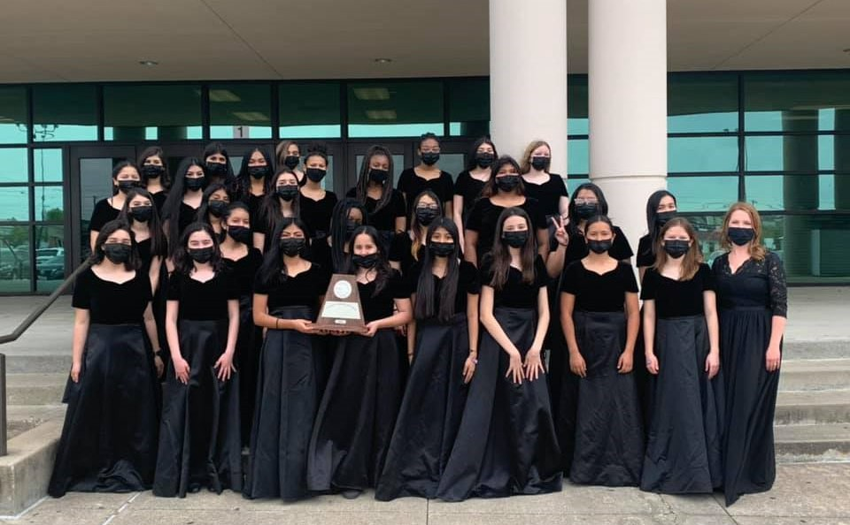

Career & Technical Education Excellence

      - Career & Technical Education students earned 1073 industry certifications and licenses in the 2020‐2021 school year.
      - Students in Health Science, Automotive, Child Guidance and Ready, Set, Teach! courses earned a total of 1719 dual credit hours.
      - CTE added guaranteed teaching contracts to the Child Guidance Program for Pre‐K.
      - The CTE department piloted a new module for Agnew middle school in the Career Investigations class giving students “hands on” experience in 15 diﬀerent types of career areas.
      - Mesquite HS, West and Poteet all named a CTE teacher as their secondary teacher of the year.
      - Mesquite HS’s CTE teacher was named secondary teacher of the year for the district.
      - Began the process of ASE certification for our automotive teachers and students.
      - Beginning with this year’s 9th grade class, we put in place 26 Programs of Study designed to ensure our students are prepared for in‐demand, high‐skill, high‐wage careers in Texas.
      - Continued working with WRA, purchasing and the dean on design, construction, equipment and staﬃng for the CTE portion of Vanguard HS.
      - 136 of the 558 students that participated at the regional level of our Career & Technical Stu‐ dent Organizations (CTSOs), advanced to the state level.
      - CTE had 24 students competing in CTSOs selected to represent us nationally.



Mesquite Education Foundation
      - The Education Foundation funded ten Innovation Grants and seventeen Campus Grants totaling $162,919.53 for the 2021‐2022 school year.
      - Since 2004, the Education Foundation has funded $3 million in grants across the district.
      - In the fall of 2020, the Foundation’s Virtually Amazing Santa Color 5K Run & Walk netted approximately $50,000, after pivoting to a completely virtual event. The Walk A Mile in My Show Video Blog project, used to promote the 5K and highlight the impact of the pandemic on MISD stake‐ holders, accumulated more than 40,000 views on Facebook.
      - Net proceeds from the Foundation’s Show of Appreciation Virtual Comedy Special, Auction and Lunch reached approximately $150,000 in net proceeds. This was the substitute event since the 15th Annual Lone Star Legacy Gala and Concert was cancelled.
      - Employees of MISD contributed more than $125,000 to the Foundation through monthly pledges and one‐time gifts through the annual Employee Giving Campaign.
      - Despite many challenges and changes, the Foundation met or exceeded all budget projections for the 2020‐2021 school year. The Foundation’s annual budget was modified during the pan‐ demic in anticipation of a 25% reduction in fundraising.

ReadPlayTalk
      - Unfortunately, both of ReadPlayTalk’s primary events were cancelled due to the COVID‐19 pan‐ demic. Hopefully, The ReadPlayTalk Festival and The ReadPlayTalk Fair will both resume during the 2021‐2022 school year.
      - The bi‐monthly story times at Town East Mall have moved to Facebook Live. These virtual story
times have proven to be successful, reaching between 300‐500 people each episode.
      - The ReadPlayTalk Bus is completed and made several stops during the summer of 2021. Four events were help at public parks across the Mesquite and Balch Springs region where families were invited to experience The ReadPlayTalk Bus. Mesquite ISD Council of PTAs, Child Care Group, and the public libraries from Mesquite and Balch Springs were also present at these events, as they handed out books, giveaways, and information about their programs.
      - LENA Start launched in the spring of 2021. Mesquite ISD received a launch funds grant that covered most of the expenses of the program for the first two years. There have been 29 families that have participated in the spring and summer sessions of LENA Start. The district is planning to reach 50 families total in 2021 and 100 families in 2022.

Academic Achievements
        - NMHS Beyond Blue DI team advanced to Global Finals and won 3rd place!
        - We received a grant from DI and four of our DI teams participated in additional challenges in the ImagineXperience.
        - We had 4 QuestBridge Finalists and 2 of them matched for scholarships.
        - Based on PSAT Scores, we had two National Merit finalists, two National Hispanic Recognition Program Award recipients, one National African American Recognition Program recipient, and one National Rural and Small-Town Recognition Program recipient

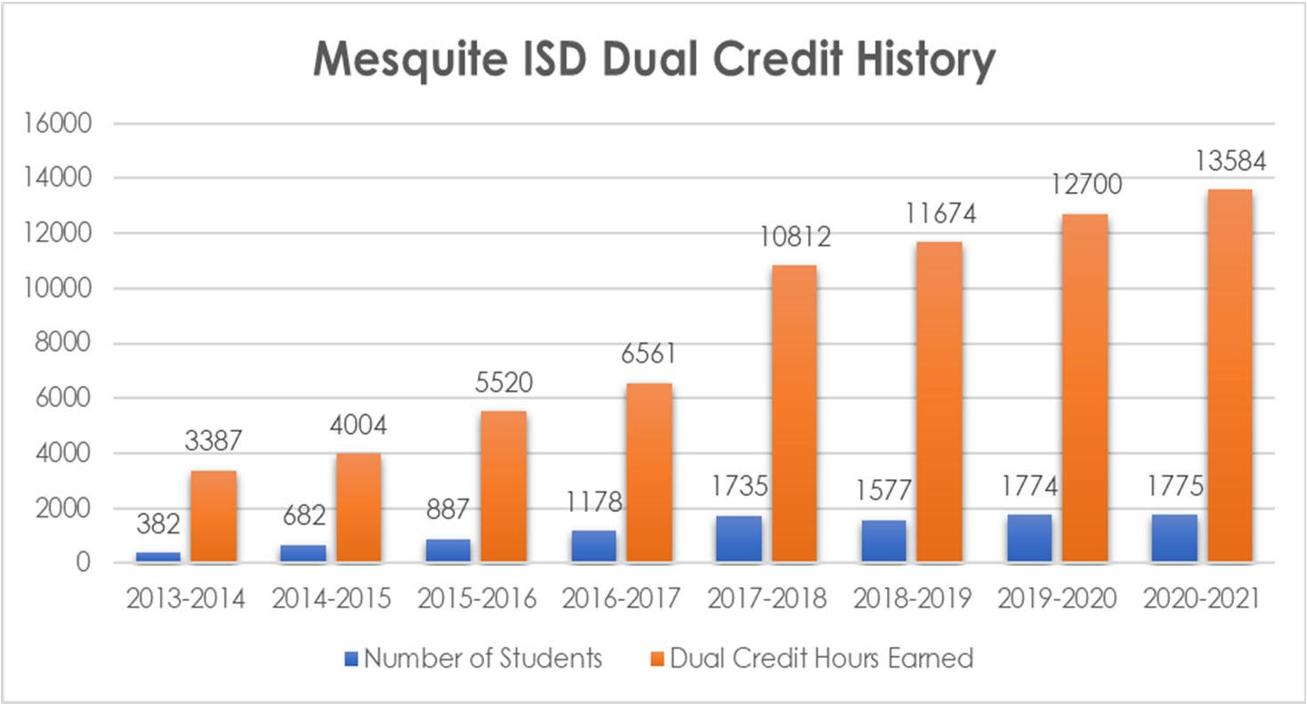

        - We had in‐person elementary Camp Invention STEM camp, and it was as maximum capacity; we had our first in‐person middle school Invention Project STEM camp, and it was a great success.

Athletics

- On Average 5,000‐ 5,500 students participate annually in MISD Athletics.
- MISD Athletics had 70 athletes receive scholarships last year for the 20‐21 school year.
- MISD has 326 Coaches and 14 Licensed Athletic Trainers serving MISD athletes.
- MISD has an athletic oﬃce staﬀ of 6 full‐time and 4 part‐time employees serving our district.
- MISD Athletics is considered to be a leader in the development of student‐athlete safety protocols (Concussion Return to Play Policy‐Lightning Policy‐Heat Policy‐Drug Testing Policy)
- MISD Coaches are trained yearly with an 8-hour Coaches Staﬀ Development Training and are required to comply with having over 10 trainings or certifications to meet district, state, and UIL requirements.
- MISD is one of only a handful of school districts to employee a full time Athletic Director of Strength and Nutrition who is certified by the National Strength Coaches Association.
- High School Athletics oﬀers Football, Volleyball, Tennis, Cross Country, Basketball, Track, Golf, Baseball, Softball, Swim and Soccer.
- Middle School Athletics oﬀers Football, Volleyball, Tennis, Basketball, Track, Non‐Competitive Golf and is looking to pilot Middle School Soccer in the future.
- MISD Athletics now oﬀers 6th Grade Pre Athletics PE in order to introduce Athletics to 6th graders.
- MISD Athletics hosts over 400 Varsity Events alone District Wide in Mesquite.
- MISD Athletic Department hosts over 2,000 athletics events each year in Mesquite at over 25 diﬀerent Venues within Mesquite. (7th Grade through Varsity)
- MISD has 7 former athletes playing professional sports.
- MISD Athletics had 65 varsity athletes recognized as academic All State by the THSCA and TGCA.
- MISD Athletics aligns with the Districts Core Values by implementing community service and character development initiatives at each of our campuses athletic programs.

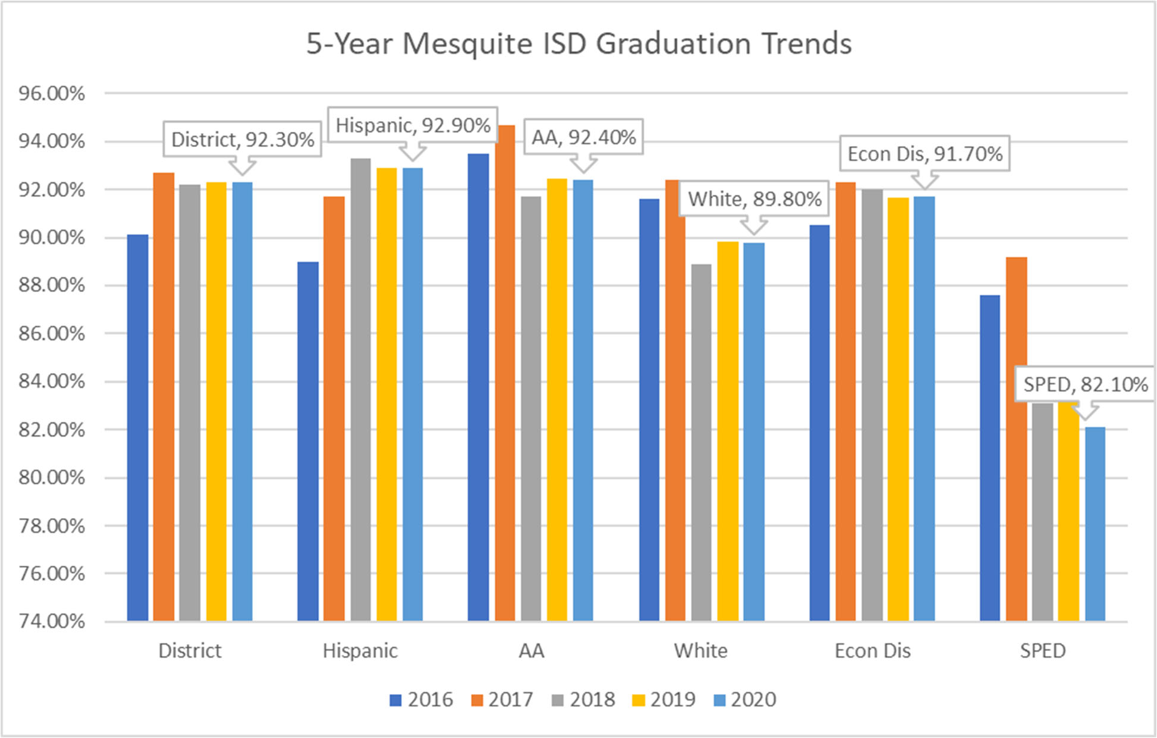
Graduation Rates Table 64

Texas Education Agency‐District TAPER Report

Mesquite ISD maintains one of the highest graduation rates for districts that are similar in demographic makeup and size. Graduation rates remain consistently above the region and the state rates.

ISIP‐Early Reading (ISIP‐ER)

ISIP‐Early Reading (ISIP‐ER)
ISIP‐ER is a computer‐based assessment that requires no teacher testing or manual scoring. Teachers monitor students as they test on the computer. This diagnostic assessment is nationally normed, child‐ friendly, and oﬀers immediate access to student data for the teacher. While being assessed, students begin with the test oﬀered to all children in their grade. ISIP‐ER then oﬀers more diﬃcult test items when a student answers correctly and less diﬃcult items when an incorrect response is recorded. This gives the teacher a true picture of the early reading skills that each student has mastered. Intervention lessons are then recommended based upon each child’s individual needs.

Tier 1 students are on track and performing at or above grade level. Tier 2 are at some risk and may be in need of intervention in one or more of the areas tested on a subtest. Tier 3 students are at risk, are performing seriously below grade level, and are in need of intensive intervention. During the school year, the goal is to move students at Tiers 2 and 3 up to Tier 1. Teachers must also continue to monitor students at Tier 1 making sure to build their reading skills suﬃciently throughout the year.
The 2020‐21 school year was the final year for the district to use ISIP‐ER. The state has recommended that districts use an assessment to measure early reading ability that is on the Commissioner’s list of tools. For the 2021‐22 school year, the district will be using a digital version of one of the recommend‐ ed tools.

Table 65
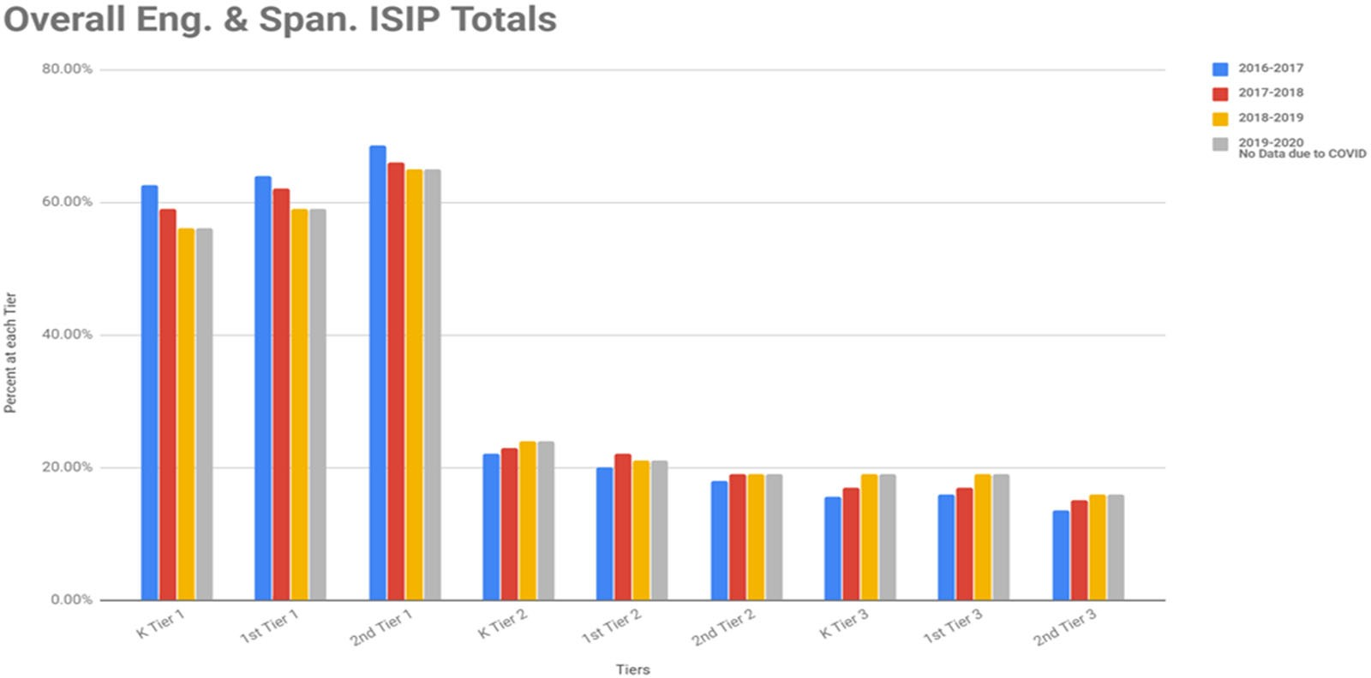

Table 66
Mesquite Independent School District Free/Reduced Lunch Numbers

SY | Enrollment | Free | Reduced | Other | Total F&R | Percent
2012‐2013 | 39,127 | 24,197 | 3,212 | 41 | 27,409 | 70.05%
2013‐2014 | 39,912 | 24,784 | 3,255 | 98 | 28,039 | 70.25%
2014‐2015 | 40,296 | 25,819 | 3,683 | 31 | 29,502 | 73.21%
2015‐2016 | 40,827 | 26,848 | 3,716 | 67 | 30,564 | 74.86%
2016‐2017 | 41,038 | 26,553 | 4,165 | 61 | 30,718 | 74.85%
2017‐2018 | 41,029 | 26,195 | 4,320 | 61 | 30,515 | 74.37%
2018‐2019 | 40,379 | 27,658 | 3,711 | 86 | 31,369 | 77.69%
2019‐2020 | 39,856 | 26,657 | 4,363 | 77 | 31,020 | 77.83%
2020‐2021 | 38,517 | 25,909 | 3,783 | 29 | 29,692 | 77.09%

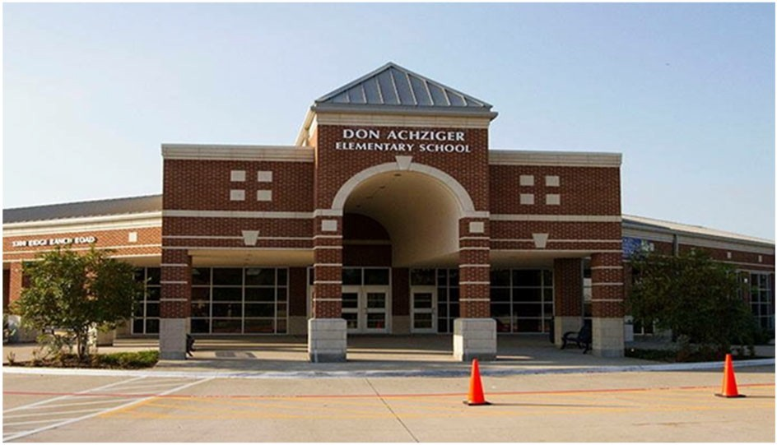Don Achziger Elementary School

Robin Cathcart, Principal

Excellence Always
 | 2017‐2018 | 2018‐2019 | 2019‐2020 | 2020‐2021 | 2021‐2022
Enrollment | 971 | 854 | 912 | 827 | 816
Student/Teacher Ratio | 18.7 | 16.4 | 16.7 | 16.2
Staﬀ FTE's
Professional | 66.9 | 64 | 66.5 | 63.9
Teachers | 51.9 | 52 | 54.5 | 50.9
Professional Support | 12 | 10 | 9 | 10
Campus Administration | 3 | 2 | 3 | 3
Support
Educational Aides | 17 | 17 | 17 | 16.8
Total | 83.9 | 81 | 83.5 | 80.7
Expenditures | 2018 AUDITED | 2019 AUDITED | 2020 AUDITED | 2021 UNAUDITED | 2022 BUDGET
Payroll Costs | $ 4,716,704 | $ 4,314,103 | $ 4,609,338 | $ 3,769,173 | $ 4,597,750
Contracted Services | $ 130,762 | $ 128,935 | $ 120,857 | $ 132,674 | $ 152,500
Supplies and Materials | $ 110,673 | $ 92,759 | $ 135,041 | $ 88,609 | $ 100,400
Other Operating Costs | $ 33,956 | $ 32,603 | $ 22,947 | $ 12,342 | $ 18,500
Fixed Assets | $ 10,305 | $ 312,293 | $ 4,486 | $ 7,900 | $ ‐
Grand Total | $ 5,002,400 | $ 4,880,693 | $ 4,892,668 | $ 4,010,698 | $ 4,869,150
Expenditures by Intent
 | 2018 AUDITED | 2019 AUDITED | 2020 AUDITED | 2021 UNAUDITED | 2022 BUDGET
Basic | $ 3,112,245 | $ 3,089,273 | $ 2,442,229 | $ 2,197,673 | $ 2,692,200
Gifted | $ 646 | $ 243 | $ 611 | $ 468 | $ 650
Special Education | $ 593,305 | $ 559,271 | $ 669,938 | $ 507,717 | $ 546,200
Compensatory | $ 67,495 | $ 64,421 | $ 70,023 | $ 46,301 | $ 59,250
Bilingual | $ 301,272 | $ 270,111 | $ 302,266 | $ 224,590 | $ 295,300
SCE to Title I | $ ‐ | $ 62,508 | $ 402 | $ 52,833 | $ 65,650
Pre‐Kindergarten | $ 17,115 | $ 17,156 | $ 18,147 | $ 35,226 | $ 43,600
Pre‐Kindergarten‐Comp Ed | $ 61,073 | $ 123,124 | $ 102,392 | $ 71,356 | $ 96,600
Pre‐Kindergarten Bilingual Ed |  |  | $ 449,616 | $ 78,886 | $ 98,250
Dyslexia |  |  |  | $ 52,652 | $ 64,800
Other Instructional Area | $ 849,250 | $ 694,587 | $ 837,044 | $ 742,995 | $ 906,650
Grand Total | $ 5,002,400 | $ 4,880,693 | $ 4,892,668 | $ 4,010,698 | $ 4,869,150
Per Student Cost | $ 5,152 | $ 5,715 | $ 5,365 | $ 4,850 | $ 5,967
Assessment Results | 2018 STAAR | 2019 STAAR | 2020 STAAR | 2021 STAAR | 2021 STAAR
Reading | 76% | 80% | NA | NA
Mathematics | 78% | 76% | NA | NA
Writing | 63% | 50% | NA | NA
Science | 86% | 76% | NA | NA

**Information obtained from the TEA PEIMS Standard Report and Munis Accounting

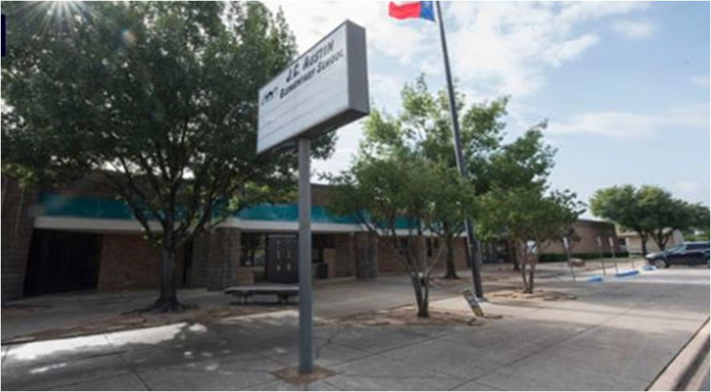
J. C. Austin Elementary School
Dr. Jonathan Royle, Principal

 | 2017‐2018 | 2018‐2019 | 2019‐2020 | 2020‐2021 | 2021‐2022
Enrollment | 471 | 471 | 390 | 343 | 323
Student/Teacher Ratio  Staﬀ FTE's Professional | 16.8  35.1 | 18.6  31.6 | 15.4  31.8 | 12.8  34.2
Teachers | 28.1 | 25.3 | 25.4 | 26.9
Professional Support | 5 | 4.3 | 4.4 | 5.3
Campus Administration  Support  Educational Aides | 2  7 | 2  5 | 2  5 | 2  5
Total | 42.1 | 36.6 | 36.8 | 39.2
Expenditures | 2018 AUDITED | 2019 AUDITED | 2020 AUDITED | 2021 UNAUDITED | 2022 BUDGET
Payroll Costs | $ 2,649,769 | $ 2,191,624 | $ 2,302,634 | $ 1,987,085 | $ 2,367,350
Contracted Services | $ 97,717 | $ 106,864 | $ 109,430 | $ 85,687 | $ 93,400
Supplies and Materials | $ 70,148 | $ 55,790 | $ 48,120 | $ 46,146 | $ 48,900
Other Operating Costs | $ 17,220 | $ 16,782 | $ 14,626 | $ 7,931 | $ 12,400
Fixed Assets | $ 97,745 | $ 56,949 | $ 1,252 | $ 265 | $ 25,000
Grand Total | $ 2,932,599 | $ 2,428,009 | $ 2,476,063 | $ 2,127,114 | $ 2,547,050
Expenditures by Intent | 2018 AUDITED | 2019 AUDITED | 2020 AUDITED | 2021 UNAUDITED | 2022 BUDGET
Basic | $ 1,669,079 | $ 1,388,408 | $ 1,191,381 | $ 1,144,214 | $ 1,317,100
Gifted | $ 155 | $ ‐ | $ ‐ | $ ‐ | $ 650
Special Education | $ 196,027 | $ 79,546 | $ 160,939 | $ 107,996 | $ 134,300
Bilingual | $ 143,094 | $ 145,812 | $ 154,086 | $ 130,602 | $ 160,750
SCE to Support Title I | $ 62,380 | $ 66,925 | $ 59,821 | $ 78,897 | $ 87,000
Pre‐Kindergarten | $ 56,559 | $ 61,492 | $ 64,160 | $ 27,462 | $ 33,850
Pre‐Kindergarten‐Comp Ed | $ 20,013 | $ 17,068 | $ 17,837 | $ 14,512 | $ 18,400
Other Instructional Area |  |  | $ 120,357 | $ 26,599 | $ 33,250
 | $ 785,290 | $ 668,758 | $ 707,482 | $ 596,831 | $ 761,750
Grand Total | $ 2,932,599 | $ 2,428,009 | $ 2,476,063 | $ 2,127,114 $ 2,547,050
Per Student Cost | $ 6,226 | $ 5,155 | $ 6,349 | $ 6,201 $ 7,886
Assessment Results | 2018 STAAR | 2019 STAAR | 2020 STAAR | 2021 STAAR | 2022 STAAR
Reading | 72% | 83% | NA | NA
Mathematics | 82% | 81% | NA | NA
Writing | 73% | 68% | NA | NA
Science | 83% | 78% | NA | NA

**Information obtained from the TEA PEIMS Standard Report and Munis Accounting

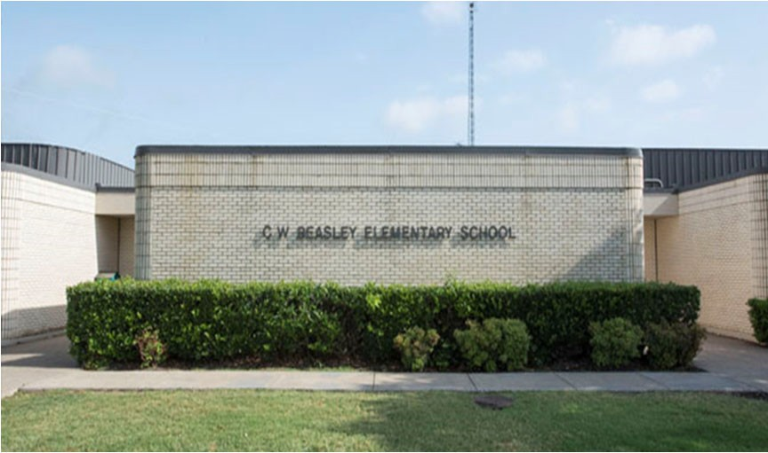C.W. Beasley Elementary School

Kelly McCollom, Principal

Our Vision is "Beasley Pride: Creating students that em‐ body positive atti tude, responsibility, integrity, dedication and excellence in all they do!"

 | 2017‐2018 |  | 2018‐2019 |  | 2019‐2020 |  | 2020‐2021 |  | 2021‐2022
Enrollment | 467 |  | 388 |  | 374 |  | 359 |  | 369
Student/Teacher Ratio Staﬀ FTE's  Professional | 17.6  34.3 |  | 14.5  34.4 |  | 14.5  31.8 |  | 13.4  34.5
Teachers | 26.5 |  | 26.7 |  | 25.8 |  | 26.7
Professional Support | 5.8 |  | 5.7 |  | 4 |  | 5.8
Campus Administration Support  Educational Aides | 2  8.8 |  | 2  8.9 |  | 2  7 |  | 2  7
Total | 46.1 |  | 43.3 |  | 38.8 |  | 41.5
Expenditures | 2018 AUDITED |  | 2019 AUDITED |  | 2020 AUDITED |  | 2021 UNAUDITED |  | 2022 BUDGET
Payroll Costs | $ 2,643,453 |  | $ 2,495,641 |  | $ 2,430,994 |  | $ 2,216,896 |  | $ 2,856,600
Contracted Services | $ 82,705 |  | $ 87,690 |  | $ 67,153 |  | $ 52,429 |  | $ 61,000
Supplies and Materials | $ 51,835 |  | $ 49,332 |  | $ 59,570 |  | $ 46,225 |  | $ 48,750
Other Operating Costs | $ 25,369 |  | $ 24,606 |  | $ 18,382 |  | $ 10,362 |  | $ 12,600
Fixed Assets | $ 961 |  | $ 57,225 |  | $ 4,486 |  | $ 265 |  | $ ‐
Grand Total | $ | 2,804,324 | $ | 2,714,495 | $ | 2,580,585 | $ | 2,326,177 | $ | 2,978,950
Expenditures by Intent | 2018 AUDITED |  | 2019 AUDITED |  | 2020 AUDITED |  | 2021 UNAUDITED |  | 2022 BUDGET
Basic | $ 1,676,310 |  | $ 1,598,736 |  | $ 1,249,007 |  | $ 1,283,542 |  | $ 1,576,500
Gifted | $ 551 |  | $ 62 |  | $ ‐ |  | $ ‐ |  | $ 650
Special Education Compensatory  Bilingual | $ 345,172  $ ‐  $ 59,743 |  | $ 340,677  $ 61,267 |  | $ 275,031  $ 65,327 |  | $ 316,049  $ 55,416 |  | $ 386,300  $ ‐  $ 68,450
SCE to Support Title I Pre‐Kindergarten Pre‐kindergarten ‐ Comp Ed  Early Education Allotment | $ 57,138 |  | $ 59,107 |  | $ 68,737  $ ‐  $ ‐  $ 206,059 |  | $ 74,294  $ ‐  $ ‐  $ ‐ |  | $ 190,800  $ ‐  $ ‐  $ 36,100
Dyslexia |  |  |  |  | $ 69,230 |  | $ 59,930 |  | $ 74,450
Other Instructional Area | $ 665,411 |  | $ 654,646 |  | $ 647,194 |  | $ 536,946 |  | $ 645,700
Grand Total | $ 2,804,324 |  | $ 2,714,495 |  | $ 2,580,585 |  | $ 2,326,177 |  | $ 2,978,950
Per Student Cost | $ 6,005 |  | $ 6,996 |  | $ 6,900 |  | $ 6,480 |  | $ 8,073
Assessment Results | 2018 STAAR |  | 2019 STAAR |  | 2020 STAAR |  | 2021 STAAR |  | 2022 STAAR
Reading | 72% |  | 75% |  | NA |  | NA
Mathematics | 77% |  | 76% |  | NA |  | NA
Writing | 52% |  | 52% |  | NA |  | NA
Science | 87% |  | 66% |  | NA |  | NA

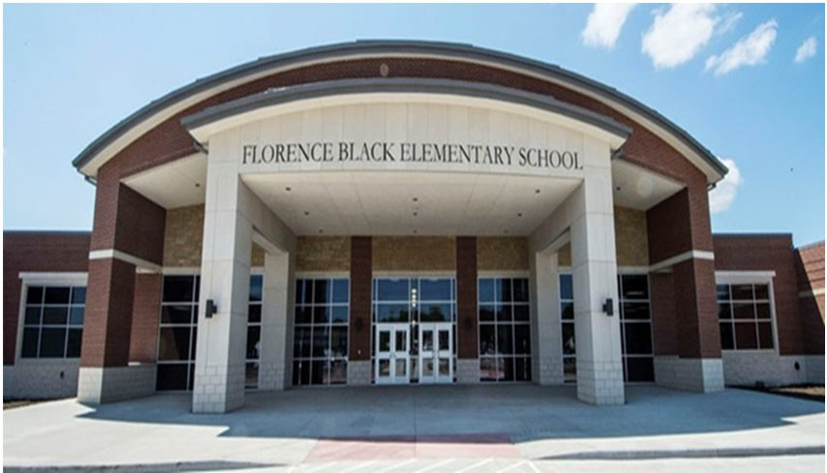Florence Black Elementary
Darla Franklin, Principal

The Tradition of Excellence Begins Here!
Dream It! Believe It! Achieve It!

 | 2017‐2018 | 2018‐2019 | 2019‐2020 | 2020‐2021 | 2021‐2022
Enrollment | 639 | 652 | 656 | 626 | 634
Student/Teacher Ratio  Staﬀ FTE's  Professional | 18.6  44 | 16.4  48.5 | 17.1  47 | 15.6  49.1
Teachers | 34.4 | 39.7 | 38.2 | 40.1
Professional Support | 7.6 | 6.8 | 6.8 | 7
Campus Administration  Support  Educational Aides | 2  8 | 2  9.6 | 2  9.7 | 2  11
Total | 52 | 58.1 | 56.7 | 60.1
Expenditures | 2018 AUDITED | 2019 AUDITED | 2020 AUDITED | 2021 UNAUDITED | 2022 BUDGET
Payroll Costs | $ 3,216,926 | $ 3,325,031 | $ 3,300,235 | $ 3,007,336 | $ 3,723,750
Contracted Services | $ 178,494 | $ 106,800 | $ 112,175 | $ 93,690 | $ 105,400
Supplies and Materials | $ 68,623 | $ 68,749 | $ 81,826 | $ 53,890 | $ 75,000
Other Operating Costs | $ 26,115 | $ 29,454 | $ 19,448 | $ 13,088 | $ 18,500
Fixed Assets | $ 152,479 | $ 105,211 | $ 4,486 | $ 28,409 | $ ‐
Grand Total | $ 3,642,636 | $ 3,635,244 | $ 3,518,171 | $ 3,196,414 | $ 3,922,650
Expenditures by Intent | 2018 AUDITED | 2019 AUDITED | 2020 AUDITED | 2021 UNAUDITED | 2022 BUDGET
Basic | $ 2,180,895 | $ 2,203,980 | $ 1,850,830 | $ 1,816,037 | $ 2,232,900
Gifted | $ 650 | $ 133 | $ ‐ | $ ‐ | $ 650
Special Education | $ 409,447 | $ 392,851 | $ 411,346 | $ 350,204 | $ 434,300
Compensatory | $ ‐ |  |  |  | $ ‐
Bilingual | $ 71,128 | $ 73,684 | $ 67,419 | $ 56,061 | $ 62,250
SCE to Support Title I | $ 103,822 | $ 138,579 | $ 142,148 | $ 180,112 | $ 225,200
Pre‐Kindergarten | $ 61,054 | $ 62,299 | $ 69,087 | $ 30,109 | $ 36,950
Pre‐Kindergarten ‐ Comp Ed | $ 19,556 | $ 20,055 | $ 19,939 | $ 32,249 | $ 40,100
Pre‐Kindergarten ‐ Bilingual Ed |  |  | $ ‐ | $ 25,934 | $ 30,900
Early Educational Allotment |  |  | $ 194,923 | $ 54,117 | $ 67,250
Other Instructional Area | $ 796,085 | $ 743,663 | $ 762,478 | $ 651,590 | $ 792,150
Grand Total | $ 3,642,636 | $ 3,635,244 | $ 3,518,171 | $ 3,196,414 | $ 3,922,650
Per Student Cost | $ 5,701 | $ 5,576 | $ 5,363 | $ 5,106 | $ 6,187
Assessment Results | 2018 STAAR | 2019 STAAR | 2020 STAAR | 2021 STAAR | 2022 STAAR
Reading | 73% | 78% | NA | NA
Mathematics | 75% | 79% | NA | NA
Writing | 57% | 61% | NA | NA
Science | 62% | 71% | NA | NA

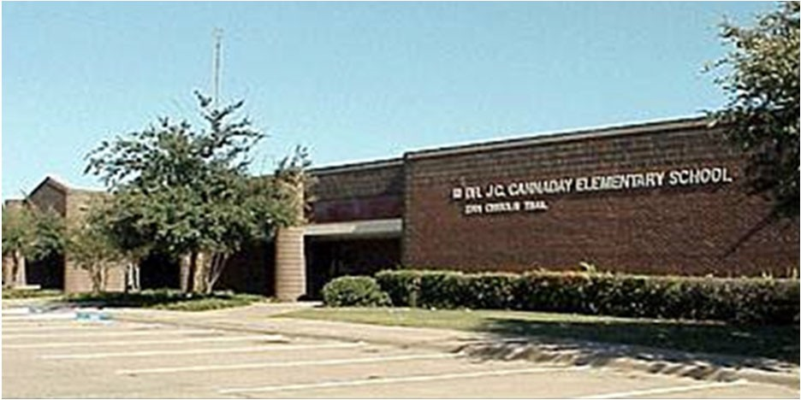
J.C. Cannaday Elementary School
Dr. Lauren Chism, Principal
Add Value to Every Child Every Day

Enrollment | 2017‐2018  564 | 2018‐2019  575 | 2019‐2020  590 | 2020‐2021  582 | 2021‐2022  570
Student/Teacher Ratio  Staﬀ FTE's Professional | 14.8  36.9 | 15.5  45.1 | 15.0  47.3 | 14.2  49.3
Teachers | 38.1 | 37.2 | 39.3 | 40.9
Professional Support | 6.8 | 5.9 | 6 | 6.4
Campus Administration  Support  Educational Aides | 2  10 | 2  11 | 2  12 | 2  14
Total | 46.9 | 56 | 59.3 | 63.3
Expenditures | 2018 AUDITED | 2019 AUDITED | 2020 AUDITED | 2021 AUDITED | 2022 BUDGET
Payroll Costs | $ 2,912,355 | $ 3,240,111 | $ 3,465,370 | $ 3,116,444 | $ 3,820,900
Contracted Services | $ 105,350 | $ 89,948 | $ 102,887 | $ 81,888 | $ 91,700
Supplies and Materials | $ 71,672 | $ 80,960 | $ 114,255 | $ 71,317 | $ 119,800
Other Operating Costs | $ 23,414 | $ 27,309 | $ 17,683 | $ 10,618 | $ 15,700
Fixed Assets $ 16,261 |  | $ 205,541 | $ 7,720 | $ 9,951 | $ ‐
Grand Total $ 3,129,051 |  | $ 3,643,869 | $ 3,707,915 | $ 3,290,218 | $ 4,048,100
Expenditures by Intent | 2018 AUDITED | 2019 AUDITED | 2020 AUDITED | 2021 AUDITED | 2022 BUDGET
Basic | $ 1,741,290 | $ 2,274,697 | $ 1,924,988 | $ 1,787,465 | $ 2,137,900
Gifted | $ 259 | $ 117 | $ ‐ | $ ‐ | $ 650
Special Education | $ 439,613 | $ 401,383 | $ 427,552 | $ 395,296 | $ 495,500
Bilingual | $ 62,438 | $ 67,407 | $ 72,257 | $ 60,128 | $ 74,850
SCE to Support Title I | $ 264,449 | $ 258,329 | $ 319,497 | $ 267,690 | $ 347,800
Pre‐Kindergarten |  |  | $ ‐ | $ 27,009 | $ 35,450
Pre‐Kindergarten ‐ Comp Ed |  |  | $ ‐ | $ 33,708 | $ 42,800
Pre‐Kindergarten ‐ Bilingual Ed |  |  | $ ‐ | $ 29,696 | $ 36,300
Early Education Allotment |  |  | $ 293,350 | $ 55,995 | $ 70,800
Dyslexia |  |  |  | $ 50,593 | $ 62,300
Other Instructional Area | $ 621,003 | $ 641,936 | $ 670,271 | $ 582,639 | $ 743,750
Grand Total | $ 3,129,051 | $ 3,643,869 | $ 3,707,915 | $ 3,290,218 | $ 4,048,100
Per Student Cost | $ 5,548 | $ 6,337 | $ 6,285 | $ 5,653 | $ 7,102
Assessment Results | 2018 STAAR | 2019 STAAR | 2020 STAAR | 2021 STAAR | 2022 STAAR
Reading | 67% | 70% | NA | NA
Mathematics | 77% | 73% | NA | NA
Writing | 59% | 67% | NA | NA
Science | 73% | 64% | NA | NA

**Information obtained from the TEA PEIMS Standard Report and Munis Accounting

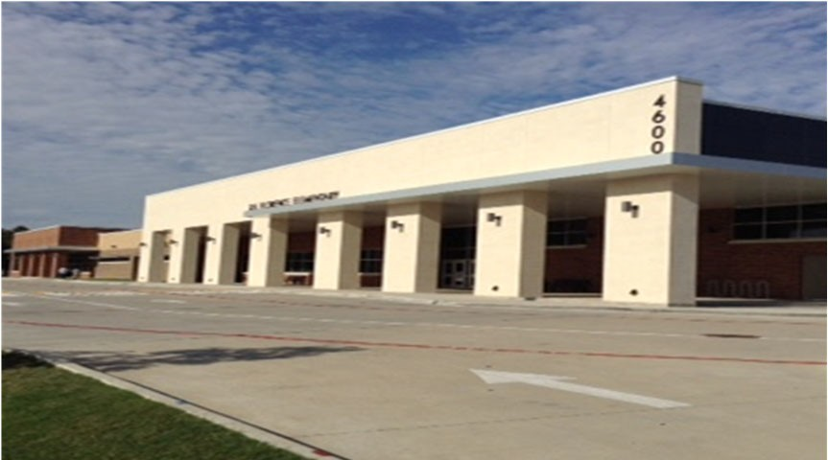J. H. Florence Elementary School

Maria Franco, Principal

“We are Florence STRONG: Not only do we teach for academic suc‐ cess, but our students are taught to be the best they can be every day by showing respect, understanding how to work as a team, be‐ ing responsible, owning up when necessary, being able to negotiate resolutions, and giving back to their respective community."

 | 2017‐2018 | 2018‐2019 | 2019‐2020 | 2020‐2021 | 2021‐2022
Enrollment | 654 | 579 | 548 | 467 | 482
Student/Teacher Ratio Staﬀ FTE's  Professional | 17.5  48.1 | 14.4  51 | 14  51 | 12.7  47.8
Teachers | 37.3 | 40.2 | 39.2 | 36.9
Professional Support | 8.8 | 8.8 | 9.8 | 8.9
Campus Administration Support  Educational Aides | 2  21.9 | 2  18.7 | 2  20.6 | 2  20.1
Total | 70 | 69.7 | 71.6 | 67.9
Expenditures | 2018 AUDITED | 2019 AUDITED | 2020 AUDITED | 2021 UNAUDITED | 2022 BUDGET
Payroll Costs | $ 3,194,745 | $ 3,011,537 | $ 3,141,002 | $ 2,440,928 | $ 3,022,550
Contracted Services | $ 100,715 | $ 100,919 | $ 103,920 | $ 76,676 | $ 91,800
Supplies and Materials | $ 98,732 | $ 75,061 | $ 75,657 | $ 56,295 | $ 69,400
Other Operating Costs | $ 21,518 | $ 27,314 | $ 23,260 | $ 10,331 | $ 15,400
Fixed Assets | $ 2,176 | $ 77,755 | $ 19,568 | $ 26,695 | $ ‐
Grand Total | $ 3,417,886 | $ 3,292,586 | $ 3,363,407 | $ 2,610,925 | $ 3,199,150
Expenditures by Intent | 2018 AUDITED | 2019 AUDITED | 2020 AUDITED | 2021 UNAUDITED | 2022 BUDGET
Basic | $ 1,914,873 | $ 1,741,403 | $ 1,562,227 | $ 1,174,283 | $ 1,406,100
Gifted | $ 214 | $ 207,737 | $ 211,272 | $ 184,262 | $ 226,700
Special Education Compensatory  Bilingual | $ 441,509  $ 62,460 | $ 301,483  $ 63,457 | $ 349,366  $ 64,971 | $ 262,606  $ 54,633 | $ 343,900  $ ‐  $ 70,450
SCE to Support Title I | $ 138,991 | $ 134,909 | $ 168,143 | $ 122,303 | $ 165,600
Pre‐Kindergarten | $ 59,215 | $ 57,761 | $ 58,376 | $ 28,773 | $ 37,250
Prekindergarten‐Comp Ed | $ 43,398 | $ 44,434 | $ 46,352 | $ 32,406 | $ 40,100
Prekindergarten‐Bilingual Ed | $ 61,039 | $ 57,463 | $ 48,494 | $ 60,174 | $ 72,850
Early Education Allotment |  |  | $ 65,105 | $ 29,645 | $ 36,900
Dyslexia |  |  | $ 65,740 | $ 71,963 | $ 96,400
Other Instructional Area | $ 696,188 | $ 683,940 | $ 723,363 | $ 589,877 | $ 702,900
Grand Total | $ 3,417,886 | $ 3,292,586 | $ 3,363,407 | $ 2,610,925 | $ 3,199,150
Per Student Cost | $ 5,226 | $ 5,687 | $ 6,138 | $ 5,591 | $ 6,637
Assessment Results | 2018 STAAR | 2019 STAAR | 2020 STAAR | 2021 STAAR | 2022 STAAR
Reading | 71% | 70% | NA | NA
Mathematics | 86% | 73% | NA | NA
Writing | 72% | 67% | NA | NA
Science | 77% | 64% | NA | NA

**Information obtained from the TEA PEIMS Standard Report and Munis Accounting

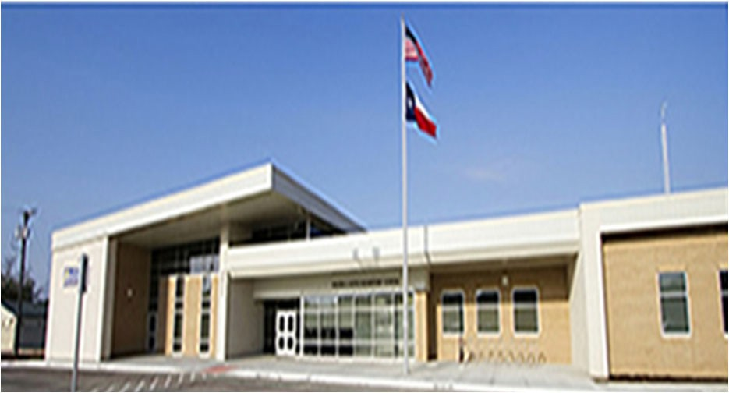Walter E. Floyd Elementary School

Christina Alvarez, Principal

Every Child, Every Need, Every Day!

 | 2017‐2018 | 2018‐2019 | 2019‐2020 | 2020‐2021 | 2021‐2022
Enrollment | 798 | 567 | 604 | 455 | 428
Student/Teacher Ratio Staﬀ FTE's  Professional | 18.6  52.7 | 15.5  45.3 | 16.4  44.3 | 12.7  44.9
Teachers | 42.9 | 36.5 | 36.8 | 35.9
Professional Support | 7.8 | 6.8 | 6 | 7
Campus Administration  Support  Educational Aides | 2  11 | 2  8.8 | 1.5  9 | 2  10
Total | 63.7 | 54.1 | 53.3 | 54.9
Expenditures
 | 2018 AUDITED | 2019 AUDITED | 2020 AUDITED | 2021 UNAUDITED | 2022 BUDGET
Payroll Costs | $ 4,147,466 | $ 3,092,705 | $ 3,213,143 | $ 2,750,603 | $ 3,095,950
Contracted Services | $ 119,601 | $ 92,239 | $ 97,904 | $ 76,997 | $ 94,000
Supplies and Materials | $ 97,256 | $ 73,814 | $ 147,704 | $ 77,420 | $ 67,000
Other Operating Costs | $ 46,011 | $ 43,914 | $ 31,638 | $ 18,436 | $ 12,800
Fixed Assets | $ 154,421 | $ 101,818 | $ 93,665 | $ 904 | $ ‐
Grand Total | $ 4,564,754 | $ 3,404,490 | $ 3,584,054 | $ 2,924,359 | $ 3,269,750
Expenditures by Intent
2018 AUDITED |  | 2019 AUDITED | 2020 AUDITED 2021 UNAUDITED 2022 BUDGET
Basic | $ 3,082,298 | $ 2,129,604 | $ 1,617,845 | $ 1,491,860 | $ 1,842,894
Gifted | $ 251 | $ ‐ | $ ‐ | $ 693 | $ 650
Special Education | $ 352,122 | $ 272,394 | $ 301,511 | $ 256,061 | $ 318,500
Bilingual | $ 65,406 | $ 64,053 | $ 67,944 | $ 59,130 | $ 71,950
SCE to Support Title I | $ 264,403 | $ 182,854 | $ 253,468 | $ 210,646 | $ 243,500
Pre‐Kindergarten | $ ‐ | $ ‐ | $ 7,900 | $ 2,203 | $ ‐
Pre‐Kindergarten ‐ Comp Ed | $ 20,933 | $ 21,343 | $ 23,465 | $ 37,737 | $ 46,600
Pre‐Kindergarten ‐ Bilingual Ed | $ 61,888 | $ 63,301 | $ 66,412 | $ 30,436 | $ 35,700
Early Education Allotment |  |  | $ 478,070 | $ 234,860 | $ 14,300
Other Instructional Area | $ 717,453 | $ 670,941 | $ 767,439 | $ 600,734 | $ 696,950
Grand Total | $ 4,564,754 | $ 3,404,490 | $ 3,584,054 | $ 2,924,359 | $ 3,269,750
Per Student Cost | $ 5,720 | $ 6,004 | $ 5,934 | $ 6,427 | $ 7,640
Assessment Results | 2018 STAAR | 2019 STAAR | 2020 STAAR | 2021 STAAR | 2022 STAAR
Reading | 57% | 63% | NA | NA
Mathematics | 63% | 67% | NA | NA
Writing | 40% | 54% | NA | NA
Science | 49% | 59% | NA | NA

**Information obtained from the TEA PEIMS Standard Report and Munis Accounting

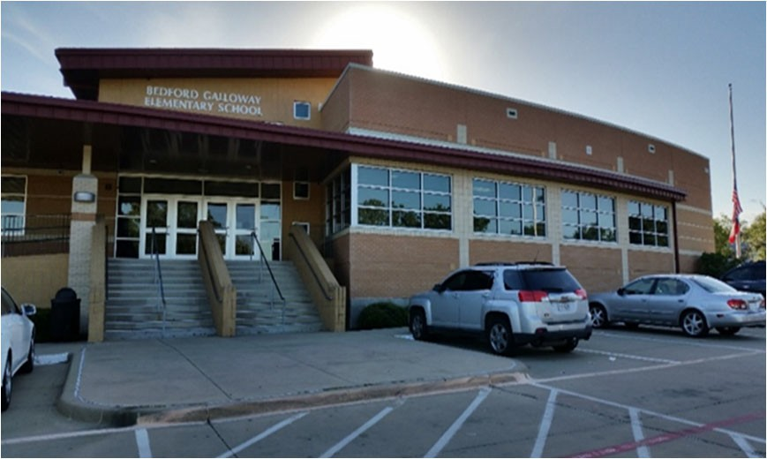April Sarpy, Principal

To provide every child the opportunity to achieve his/her fullest potential in a collaborative and nurturing learning environment.

 | 2017‐2018 | 2018‐2019 | 2019‐2020 | 2020‐2021 | 2021‐2022
Enrollment | 732 | 502 | 461 | 420 | 418
Student/Teacher Ratio Staﬀ FTE's  Professional | 19.5  46.4 | 13.8  44.4 | 14  41 | 13.8  39.4
Teachers | 37.6 | 36.4 | 33 | 31.4
Professional Support | 6.8 | 6 | 6 | 6
Campus Administration Support  Educational Aides | 2  13.3 | 2  8 | 2  8.8 | 2  10
Total | 59.7 | 52.4 | 49.8 | 49.4
Expenditures
 | 2018 AUDITED | 2019 AUDITED | 2020 AUDITED | 2021 UNAUDITED | 2022 BUDGET
Payroll Costs | $ 3,643,264 | $ 3,125,917 | $ 3,011,525 | $ 2,527,075 | $ 2,976,450
Contracted Services | $ 100,098 | $ 90,830 | $ 86,718 | $ 95,676 | $ 90,500
Supplies and Materials | $ 107,466 | $ 75,908 | $ 92,608 | $ 58,890 | $ 62,400
Other Operating Costs | $ 35,422 | $ 33,331 | $ 19,415 | $ 13,209 | $ 12,900
Fixed Assets | $ 162,891 | $ 640,224 | $ 10,769 | $ 265 | $ ‐
Grand Total | $ 4,049,142 | $ 3,966,210 | $ 3,221,034 | $ 2,695,115 | $ 3,142,250
Expenditures by Intent | 2018 AUDITED | 2019 AUDITED | 2020 AUDITED | 2021 UNAUDITED | 2022 BUDGET
Basic | $ 2,665,778 | $ 2,078,885 | $ 1,621,485 | $ 1,432,818 | $ 1,681,590
Gifted | $ ‐ | $ ‐ | $ ‐ | $ 800 | $ 650
Special Education | $ 276,956 | $ 373,079 | $ 396,953 | $ 341,533 | $ 370,300
Bilingual | $ 69,864 | $ 70,255 | $ 70,791 | $ 60,629 | $ 74,950
SCE to Support Title I | $ 205,559 | $ 131,299 | $ 187,924 | $ 131,284 | $ 148,000
Pre‐Kindergarten | $ ‐ | $ ‐ | $ ‐ | $ 29,631 | $ 35,900
Prekindergarten‐Comp Ed | $ 21,128 | $ 21,546 | $ 22,918 | $ 34,930 | $ 45,200
Prekindergarten‐Bilingual Ed | $ 65,366 | $ 65,861 | $ 68,779 | $ 29,662 | $ 36,650
Early Education Allotment |  |  | $ 190,757 | $ 57,942 | $ 71,950
Other Instructional Area | $ 744,490 | $ 1,225,285 | $ 661,427 | $ 575,887 | $ 678,350
Grand Total | $ 4,049,142 | $ 3,966,210 | $ 3,221,034 | $ 2,695,115 | $ 3,142,250
Per Student Cost | $ 5,532 | $ 7,901 | $ 6,987 | $ 6,417 | $ 7,517
Assessment Results | 2018 STAAR | 2019 STAAR | 2020 STAAR | 2021 STAAR | 2022 STAAR
Reading | 66% | 73% | NA | NA
Mathematics | 81% | 81% | NA | NA
Writing | 50% | 67% | NA | NA
Science | 72% | 74% | NA | NA

**Information obtained from the TEA PEIMS Standard Report and Munis Accounting

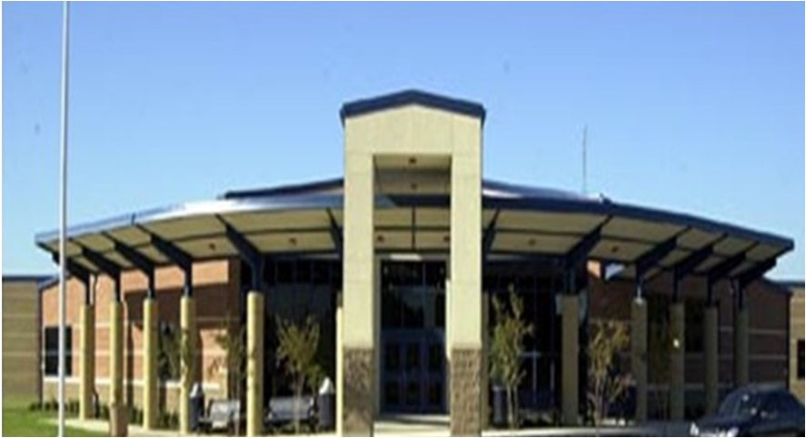Rashunda Price, Principal

Connect, Inspire, TEACH AND LEAD BIG!

 | 2017‐2018 | 2018‐2019 | 2019‐2020 | 2020‐2021 | 2021‐2022
Enrollment | 916 | 654 | 617 | 624 | 595
Student/Teacher Ratio | 21.8 | 15.8 | 15.4 | 15.8
Staﬀ FTE's
Professional | 51 | 48.4 | 48 | 48.4
Teachers | 42.1 | 41.5 | 40 | 39.4
Professional Support | 7.2 | 4.9 | 6 | 7
Campus Administration | 2 | 2 | 2 | 2
Support
Educational Aides | 13 | 11.9 | 11 | 14
Total | 64.3 | 60.3 | 59 | 62.4
Expenditures
 | 2018 AUDITED | 2019 AUDITED | 2020 AUDITED | 2021 UNAUDITED | 2022 BUDGET
Payroll Costs | $ 4,331,846 | $ 3,688,193 | $ 3,657,314 | $ 3,169,491 | $ 4,071,700
Contracted Services | $ 134,324 | $ 110,670 | $ 120,517 | $ 95,555 | $ 127,900
Supplies and Materials | $ 82,004 | $ 78,918 | $ 98,289 | $ 67,755 | $ 71,800
Other Operating Costs | $ 35,364 | $ 37,308 | $ 30,670 | $ 20,263 | $ 25,200
Fixed Assets | $ 172,372 | $ 93,024 | $ 4,203 | $ 18,431 | $ ‐
Grand Total | $ 4,755,911 | $ 4,008,112 | $ 3,910,993 | $ 3,371,496 | $ 4,296,600
Expenditures by Intent
2018 AUDITED 2019 AUDITED 2020 AUDITED 2021 UNAUDITED 2022 BUDGET
Basic | $ 3,157,835 | $ 2,535,333 | $ 2,010,238 | $ 1,902,961 | $ 2,388,100
Gifted | $ 140 | $ ‐ | $ 56 | $ ‐ | $ 650
Special Education | $ 453,979 | $ 449,213 | $ 479,536 | $ 424,025 | $ 525,700
Compensatory | $ ‐ |  |  |  | $ ‐
Bilingual | $ 63,411 | $ 64,248 | $ 68,037 | $ 57,943 | $ 73,150
SCE to Title I | $ 205,076 | $ 146,946 | $ 115,744 | $ 121,383 | $ 237,500
Pre‐Kindergarten |  |  | $ ‐ | $ 24,665 | $ 31,200
Pre‐Kindergarten‐Comp Ed | $ 22,167 | $ 22,418 | $ 23,106 | $ 36,390 | $ 45,100
Pre‐Kindergarten Bilingual Ed | $ 66,657 | $ 30,407 | $ 70,902 | $ 51,093 | $ 62,700
Early Education Allotment |  |  | $ 320,560 | $ 29,102 | $ 36,200
Dyslexia |  |  | $ 70,054 | $ 60,197 | $ 74,200
Other Instructional Area | $ 786,645 | $ 759,548 | $ 752,760 | $ 663,738 | $ 822,100
Grand Total | $ 4,755,911 | $ 4,008,112 | $ 3,910,993 | $ 3,371,496 | $ 4,296,600
Per Student Cost | $ 5,192 | $ 6,129 | $ 6,339 | $ 5,403 | $ 7,221
Assessment Results | 2018 STAAR | 2019 STAAR | 2020 STAAR | 2021 STAAR | 2022 STAAR
Reading | 78% | 81% | NA | NA
Mathematics | 87% | 85% | NA | NA
Writing | 63% | 67% | NA | NA
Science | 79% | 90% | NA | NA

**Information obtained from the TEA PEIMS Standard Report and Munis Accounting

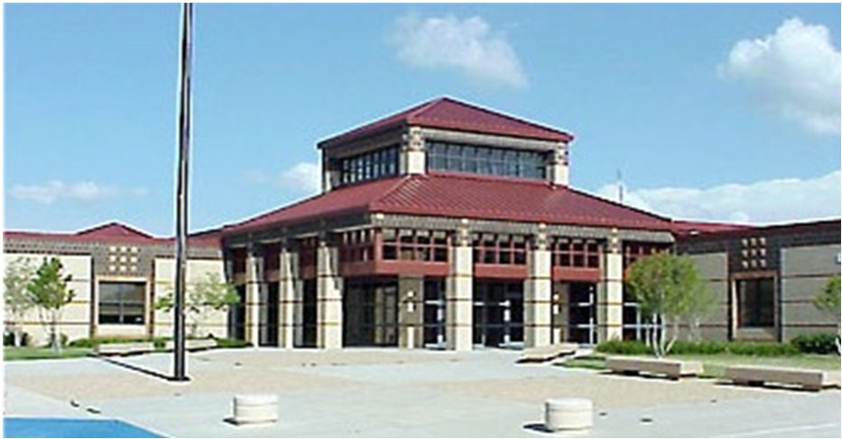W. O. Gray Elementary School

Keshia LaVergue, Principal

Excellence for All
 | 2017‐2018 | 2018‐2019 | 2019‐2020 | 2020‐2021 | 2021‐2022
Enrollment | 634 | 512 | 450 | 431 | 412
Student/Teacher Ratio  Staﬀ FTE's  Professional | 16.8  46.6 | 15.0  42.1 | 14.8  38.4 | 14.2  38.4
Teachers | 37.8 | 34.1 | 30.4 | 30.4
Professional Support | 6.8 | 6 | 6 | 6
Campus Administration  Support  Educational Aides | 2  14 | 2  10.6 | 2  11 | 2  10.9
Total | 60.6 | 52.7 | 49.4 | 49.3
Expenditures | 2018 AUDITED | 2019 AUDITED | 2020 AUDITED | 2021 UNAUDITED | 2022 BUDGET
Payroll Costs | $ 3,097,419 | $ 2,782,063 | $ 2,613,657 | $ 2,232,318 | $ 2,667,950
Contracted Services | $ 116,698 | $ 109,140 | $ 95,916 | $ 68,094 | $ 83,700
Supplies and Materials | $ 91,556 | $ 81,812 | $ 80,471 | $ 70,926 | $ 62,500
Other Operating Costs | $ 27,459 | $ 29,950 | $ 21,120 | $ 13,485 | $ 13,700
Fixed Assets | $ 167,412 | $ 81,127 | $ 22,395 | $ 765 | $ ‐
Grand Total | $ 3,500,543 | $ 3,084,092 | $ 2,833,558 | $ 2,385,589 | $ 2,827,850
Expenditures by Intent
2018 AUDITED |  | 2019 AUDITED | 2020 AUDITED 2021 UNAUDITED 2022 BUDGET
Basic | $ 2,281,247 | $ 1,927,021 | $ 1,498,402 | $ 1,249,132 | $ 1,477,100
Gifted | $ ‐ | $ ‐ | $ ‐ | $ ‐ | $ 650
Special Education | $ 146,486 | $ 109,923 | $ 107,833 | $ 183,215 | $ 226,300
Bilingual | $ 64,460 | $ 61,774 | $ 64,065 | $ 56,147 | $ 70,350
SCE to Support Title I | $ 148,580 | $ 140,962 | $ 217,329 | $ 161,151 | $ 197,500
Pre‐Kindergarten | $ 65,170 | $ 65,764 | $ 67,605 | $ 29,329 | $ 35,850
Pre‐Kindergarten Comp Ed | $ 39,378 | $ 34,002 | $ 38,365 | $ 31,998 | $ 40,500
Pre‐Kindergarten Bilingual | $ 63,030 | $ 63,690 | $ 41,588 | $ 28,482 | $ 35,750
Early Education Allotment |  |  | $ 116,168 | $ 59,273 | $ 70,300
Other Instructional Area | $ 692,192 | $ 680,956 | $ 682,202 | $ 586,862 | $ 673,550
Grand Total | $ 3,500,543 | $ 3,084,092 | $ 2,833,558 | $ 2,385,589 | $ 2,827,850
Per Student Cost | $ 5,521 | $ 6,024 | $ 6,297 | $ 5,535 | $ 6,864
Assessment Results | 2018 STAAR | 2019 STAAR | 2020 STAAR | 2021 STAAR | 2022 STAAR
Reading | 71% | 80% | NA | NA
Mathematics | 82% | 85% | NA | NA
Writing | 56% | 68% | NA | NA
Science | 80% | 69% | NA | NA

**Information obtained from the TEA PEIMS Standard Report and Munis Accounting

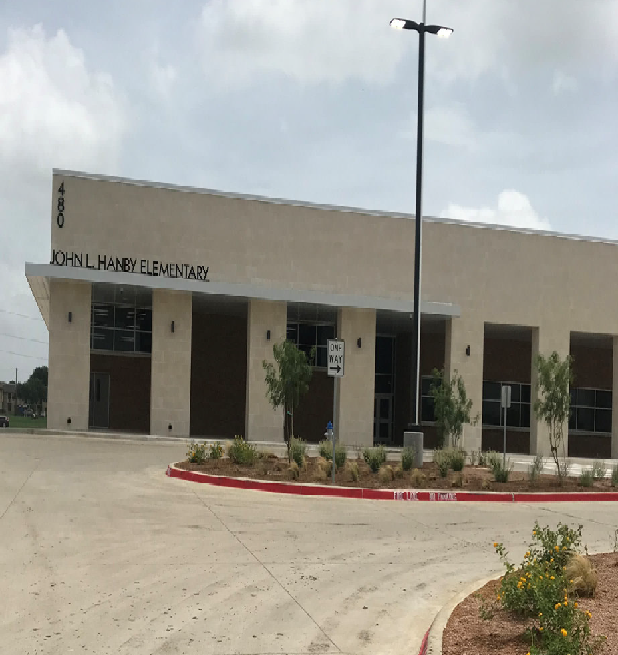Jessica Eaton, Principal

Excellence Always!
 | 2017‐2018 | 2018‐2019 | 2019‐2020 | 2020‐2021 | 2021‐2022
Enrollment | 929 | 850 | 838 | 740 | 689
Student/Teacher Ratio Staﬀ FTE's  Professional | 18.6  62.4 | 16.7  59.8 | 16.8  58.3 | 14.7  59.3
Teachers | 50 | 50.8 | 49.8 | 50.3
Professional Support | 9.4 | 7 | 7 | 7
Campus Administration Support  Educational Aides | 3  16 | 2  15.8 | 1.5  14.2 | 2  13.1
Total | 78.4 | 75.6 | 72.5 | 72.4
Expenditures | 2018 AUDITED | 2019 AUDITED | 2020 AUDITED | 2021 UNAUDITED | 2022 BUDGET
Payroll Costs | $ 4,582,999 | $ 4,135,754 | $ 4,185,041 | $ 3,572,176 | $ 4,377,313
Contracted Services | $ 146,697 | $ 109,625 | $ 157,755 | $ 91,781 | $ 112,200
Supplies and Materials | $ 185,001 | $ 122,854 | $ 124,987 | $ 87,005 | $ 106,544
Other Operating Costs | $ 39,060 | $ 56,288 | $ 32,484 | $ 22,078 | $ 11,300
Fixed Assets | $ 123,258 | $ 149,769 | $ 4,536 | $ 265 | $ ‐
Grand Total | $ 5,077,015 | $ 4,574,290 | $ 4,504,804 | $ 3,773,304 | $ 4,607,357
Expenditures by Intent | 2018 AUDITED | 2019 AUDITIED | 2020 AUDITED | 2021 UNAUDITED | 2022 BUDGET
Basic | $ 3,120,631 | $ 2,905,559 | $ 2,433,549 | $ 2,213,104 | $ 2,684,744
Gifted | $ 731 | $ ‐ | $ ‐ | $ ‐ | $ 650
Special Education | $ 503,436 | $ 498,395 | $ 487,698 | $ 337,500 | $ 417,000
Bilingual | $ 86,983 | $ 64,657 | $ 69,668 | $ 60,185 | $ 75,050
SCE to Support Title I | $ 169,159 | $ 156,399 | $ 274,286 | $ 256,274 | $ 330,863
Pre‐Kindergarten | $ 49,205 | $ 67,092 | $ 71,979 | $ 55,231 | $ 69,350
Prekindergarten‐Comp Ed | $ 42,858 | $ 43,638 | $ 45,489 | $ 47,526 | $ 56,300
Prekindergarten‐Bilingual Ed | $ 66,263 | $ 66,729 | $ 70,336 | $ 28,820 | $ 35,650
Early Education Allotment |  |  | $ 259,915 | $ 87,021 | $ 103,200
Dyslexia |  |  |  | $ 51,636 | $ 60,500
Other Instructional Area | $ 1,037,750 | $ 771,822 | $ 791,883 | $ 636,007 | $ 774,050
Grand Total | $ 5,077,015 | $ 4,574,290 | $ 4,504,804 | $ 3,773,304 | $ 4,607,357
Per Student Cost | $ 5,465 | $ 5,382 | $ 5,376 | $ 5,099 | $ 6,687
Assessment Results | 2018 STAAR | 2019 STAAR | 2020 STAAR | 2021 STAAR | 2022 STAAR
Reading | 72% | 74% | NA | NA
Mathematics | 78% | 79% | NA | NA
Writing | 54% | 58% | NA | NA
Science | 73% | 72% | NA | NA

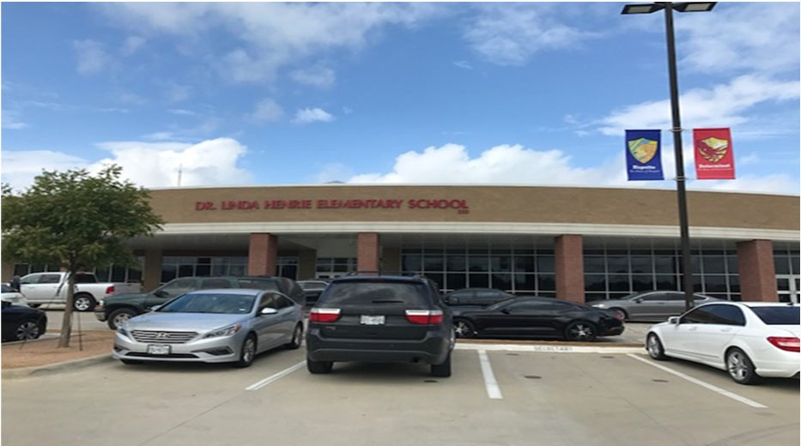
Liz Felton, Principal
The faculty and staﬀ of Henrie Elementary are committed to the
development of the total child, not only through a strong academ‐ ic program, but also with emphasis on the nurturing and building of each child's self‐esteem.

Enrollment | 2017‐2018  961 | 2018‐2019  935 | 2019‐2020  911 | 2020‐2021  860 | 2021‐2022  826
Student/Teacher Ratio Staﬀ FTE's  Professional | 17.9  65.2 | 16.0  68.1 | 15.8  68.8 | 15.5  65
Teachers | 53.4 | 58.3 | 57.8 | 55.6
Professional Support | 8.8 | 7.8 | 8 | 6.4
Campus Administration Support  Educational Aides | 3  14.7 | 2  13.7 | 3  14.3 | 3  17.8
Total | 79.9 | 81.8 | 83.1 | 82.8
Expenditures | 2018 AUDITED | 2019 AUDITED | 2020 AUDITED | 2021 UNAUDITED | 2022 BUDGET
Payroll Costs | $ 4,597,250 | $ 4,524,426 | $ 4,755,292 | $ 3,816,795 | $ 4,860,200
Contracted Services | $ 149,605 | $ 141,258 | $ 109,503 | $ 103,553 | $ 116,300
Supplies and Materials | $ 113,189 | $ 140,164 | $ 182,725 | $ 101,029 | $ 124,300
Other Operating Costs | $ 37,889 | $ 41,296 | $ 28,321 | $ 14,003 | $ 28,000
Fixed Assets | $ 3,651 | $ 126,927 | $ 10,954 | $ 26,695 | $ ‐
Grand Total | $ 4,901,585 | $ 4,974,071 | $ 5,086,796 | $ 4,062,076 | $ 5,128,800
Expenditures by Intent | 2018 AUDITED | 2019 AUDITED | 2020 AUDITED | 2021 UNAUDITED | 2022 BUDGET
Basic | $ 3,301,289 | $ 3,070,504 | $ 2,812,526 | $ 2,184,346 | $ 2,652,850
Gifted | $ 653 | $ 237,199 | $ 251,457 | $ 217,179 | $ 261,950
Special Education | $ 312,582 | $ 325,891 | $ 367,809 | $ 320,085 | $ 406,500
Compensatory | $ ‐ |  |  |  | $ ‐
Bilingual | $ 66,775 | $ 41,557 | $ 69,382 | $ 62,801 | $ 153,350
SCE to Support Title I | $ 268,087 | $ 260,470 | $ 313,688 | $ 239,062 | $ 368,900
Pre‐Kindergarten |  |  | $ ‐ | $ 10,567 | $ 18,600
Pre‐Kindergarten‐Comp Ed | $ 16,890 | $ 34,964 | $ 36,664 | $ 63,462 | $ 78,300
Pre‐Kindergarten‐Bilingual Ed | $ 59,576 | $ 129,701 | $ 141,036 | $ 118,763 | $ 149,000
Early Education Allotment |  |  | $ 242,019 | $ 124,824 | $ 158,100
Other Instructional Area | $ 875,734 | $ 873,786 | $ 852,214 | $ 720,986 | $ 881,250
Grand Total | $ 4,901,585 | $ 4,974,071 | $ 5,086,796 | $ 4,062,076 | $ 5,128,800
Per Student Cost | $ 5,101 | $ 5,320 | $ 5,583 | $ 4,723 | $ 6,209
Assessment Results | 2018 STAAR | 2019 STAAR | 2020 STAAR | 2021 STAAR | 2022 STAAR
Reading | 83% | 88% | NA | NA
Mathematics | 89% | 88% | NA | NA
Writing | 74% | 76% | NA | NA
Science | 88% | 82% | NA | NA

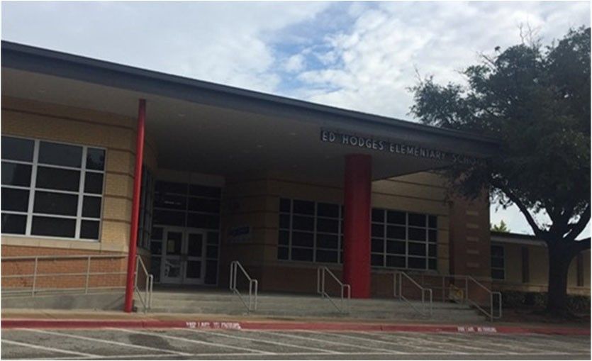Ed Hodges Elementary School
Dr. Kim Broadway, Principal

As a devoted and resolute community of lifelong learners, the mission of Hodges Elementary is to create an empowering, uplifting environ‐ ment where life‐changing experiences develop resilient ad passionate students who grow into person of integrity and are prepared to make choices, solve problems, take risks, and produce change in our world.

 | 2017‐2018 |  | 2018‐2019 |  | 2019‐2020 |  | 2020‐2021 |  | 2021‐2022
Enrollment | 767 |  | 595 |  | 545 |  | 514 |  | 512
Student/Teacher Ratio Staﬀ FTE's  Professional | 18.08  52.2 |  | 14.9  48.5 |  | 14.6  46.3 |  | 14.3  45
Teachers | 42.4 |  | 39.9 |  | 37.3 |  | 36
Professional Support | 7.8 |  | 6.6 |  | 7 |  | 7
Campus Administration Support  Educational Aides | 2  12 |  | 2  9 |  | 2  8 |  | 2  10
Total | 64.2 |  | 57.5 |  | 54.3 |  | 55
Expenditures | 2018 AUDITED |  | 2019 AUDITED |  | 2020 AUDITED |  | 2021 UNAUDITED |  | 2022 BUDGET
Payroll Costs | $ 3,885,275 |  | $ 3,429,688 |  | $ 3,444,537 |  | $ 2,884,433 |  | $ 3,566,650
Contracted Services | $ 135,307 |  | $ 110,675 |  | $ 101,499 |  | $ 89,120 |  | $ 114,800
Supplies and Materials | $ 110,753 |  | $ 83,568 |  | $ 85,218 |  | $ 73,356 |  | $ 69,300
Other Operating Costs | $ 48,147 |  | $ 44,459 |  | $ 33,174 |  | $ 19,425 |  | $ 13,600
Fixed Assets | $ 8,731 |  | $ 265,474 |  | $ 1,252 |  | $ 14,067 |  | $ ‐
Grand Total $ 4,188,213 |  |  | $ 3,933,864 |  | $ 3,665,680 |  | $ 3,080,401 |  | $ 3,764,350
Expenditures by Program Intent | 2018 AUDITED |  | 2019 AUDITED |  | 2020 AUDITED |  | 2021 UNAUDITED |  | 2022 BUDGET
Basic | $ 2,610,098 |  | $ 2,461,677 |  | $ 1,919,104 |  | $ 1,656,635 |  | $ 2,039,600
Gifted | $ 200 |  | $ 464 |  | $ ‐ |  | $ ‐ |  | $ 650
Special Education Compensatory  Bilingual | $ 327,751  $ 66,705 |  | $ 261,972  $ ‐  $ 67,490 |  | $ 225,331  $ 70,785 |  | $ 238,597  $ 58,801 |  | $ 293,200  $ ‐  $ 75,550
SCE to Support Title I | $ 228,297 |  | $ 212,576 |  | $ 219,653 |  | $ 203,266 |  | $ 235,100
Pre‐Kindergarten | $ 63,468 |  | $ 64,616 |  | $ ‐ |  | $ 25,912 |  | $ 32,900
Prekindergarten‐Comp Ed | $ 39,014 |  | $ 38,289 |  | $ 22,050 |  | $ 32,586 |  | $ 42,500
Prekindergarten‐Bilingual Ed | $ 63,245 |  | $ 64,461 |  | $ 67,779 |  | $ 55,416 |  | $ 68,550
Early Education Allotment |  |  |  |  | $ 298,103 |  | $ 81,090 |  | $ 98,850
Dyslexia |  |  |  |  | $ 72,209 |  | $ 62,340 |  | $ 77,400
Other Instructional Area | $ 789,434 |  | $ 762,319 |  | $ 770,667 |  | $ 665,758 |  | $ 800,050
Grand Total | $ 4,188,213 |  | $ 3,933,864 |  | $ 3,665,680 |  | $ 3,080,401 |  | $ 3,764,350
Per Student Cost $ |  | 5,461 | $ | 6,612 | $ | 6,726 | $ | 5,993 | $ | 7,352
Assessment Results | 2018 STAAR |  | 2019 STAAR |  | 2020 STAAR |  | 2021 STAAR |  | 2022 STAAR
Reading | 66% |  | 61% |  | NA |  | NA
Mathematics | 76% |  | 71% |  | NA |  | NA
Writing | 60% |  | 46% |  | NA |  | NA
Science | 79% |  | 66% |  | NA |  | NA

**Information obtained from the TEA PEIMS Standard Report and Munis Accounting

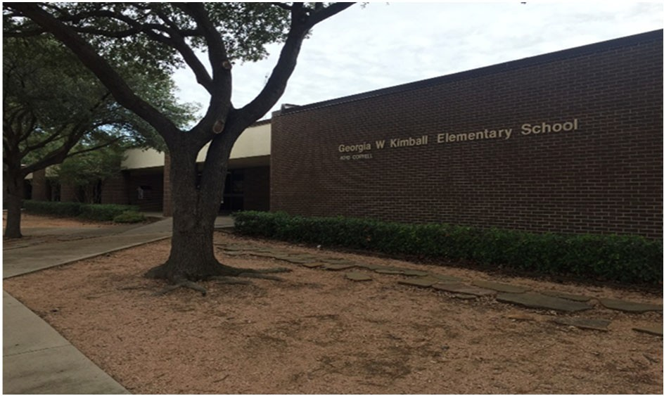Georgia W. Kimball Elementary School

Stacy Sheﬃeld, Principal

Georgia W. Kimball Elementary is a collaborative, driven and in‐ cludible learning community where we inspire students to em‐ brace challenges. Through our partnership with parents we de‐ velop productive, creative and responsible students who can demonstrate compassion toward others and become responsible citizens who are lifelong leaners.

 | 2017‐2018 | 2018‐2019 | 2019‐2020 | 2020‐2021 | 2021‐2022
Enrollment | 242 | 192 | 188 | 211 | 214
Student/Teacher Ratio  Staﬀ FTE's  Professional | 14.7  21.9 | 11.2  22 | 11  21.9 | 12.1  22.4
Teachers | 16.5 | 17.2 | 17.1 | 17.4
Professional Support | 4.4 | 3.8 | 3.8 | 4
Campus Administration  Support  Educational Aides | 1  5 | 1  6 | 1  6 | 1  8
Total | 26.9 | 28 | 27.9 | 30.4
Expenditures | 2018 AUDITED | 2019 AUDITED | 2020 AUDITED | 2021 UNAUDITED | 2022 BUDGET
Payroll Costs | $ 1,786,928 | $ 1,668,156 | $ 1,673,303 | $ 1,464,408 | $ 1,919,350
Contracted Services | $ 77,567 | $ 60,022 | $ 61,672 | $ 51,522 | $ 61,300
Supplies and Materials | $ 38,119 | $ 34,133 | $ 53,771 | $ 32,398 | $ 35,350
Other Operating Costs | $ 20,035 | $ 19,985 | $ 13,158 | $ 8,550 | $ 12,700
Fixed Assets | $ 2,349 | $ 33,269 | $ 4,486 | $ 7,313 | $ ‐
Grand Total | $ 1,924,999 | $ 1,815,566 | $ 1,806,390 | $ 1,564,191 | $ 2,028,700
Expenditures by Intent | 2018 AUDITED | 2019 AUDITED | 2020 AUDITED | 2021 UNAUDITED | 2022 BUDGET
Basic | $ 1,068,528 | $ 912,242 | $ 770,238 | $ 624,371 | $ 856,400
Gifted | $ 254 | $ 337 | $ 335 | $ 161 | $ 650
Special Education | $ 196,656 | $ 251,534 | $ 239,386 | $ 273,106 | $ 338,900
Bilingual | $ 58,690 | $ 60,738 | $ 65,956 | $ 56,734 | $ 70,450
SCE to Support Title I | $ 29,001 | $ 34,247 | $ 29,065 | $ 23,882 | $ 47,100
Pre‐Kindergarten |  |  | $ ‐ | $ 681 | $ ‐
Pre‐Kindergarten ‐ Comp Ed |  |  | $ ‐ | $ 14,688 | $ 18,600
Early Education Allotment |  |  | $ 85,577 | $ ‐ | $ ‐
Dyslexia |  |  | $ 38,273 | $ 58,611 | $ 72,400
Other Instructional Area | $ 571,872 | $ 556,468 | $ 577,560 | $ 511,956 | $ 624,200
Grand Total | $ 1,924,999 | $ 1,815,566 | $ 1,806,390 | $ 1,564,191 | $ 2,028,700
Per Student Cost | $ 7,955 | $ 9,456 | $ 9,608 | $ 7,413 | $ 9,480
Assessment Results | 2018 STAAR | 2019 STAAR | 2020 STAAR | 2021 STAAR | 2022 STAAR
Reading | 84% | 88% | NA | NA
Mathematics | 93% | 92% | NA | NA
Writing | 62% | 78% | NA | NA
Science | 89% | 90% | NA | NA

**Information obtained from the TEA PEIMS Standard Report and Munis Accounting

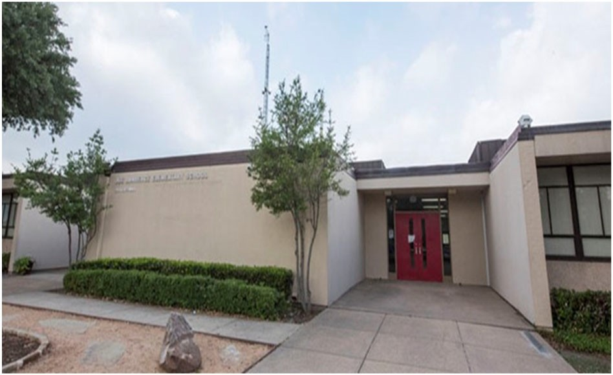J. H. Lawrence Elementary School

Dr. RoShanda Jenkins, Principal

"Every Child, Every Day"
2017‐2018
2018‐2019
2019‐2020
2020‐2021
2021‐2022
Enrollment 440 355 334 283 261
Student/Teacher Ratio 15.2 12.7 14 12.2
Staﬀ FTE's
Professional 47.8 36.9 32.8 31.2
Teachers 28.9 27.9 23.8 23.2
Professional Support 7.9 7 7 6
Campus Administration 11 2 2 2
Support
Educational Aides 11 12 12 9
Total 58.8 48.9 44.8 40.2
Expenditures
2018 AUDITED 2019 AUDITED 2020 AUDITED 2021 UNAUDITED 2022 BUDGET
Payroll Costs $ 2,842,626 $ 2,632,417 $ 2,432,930 $ 1,943,820 $ 2,460,150
Contracted Services $ 115,076 $ 75,007 $ 66,563 $ 65,126 $ 75,300
Supplies and Materials $ 61,540 $ 55,557 $ 46,982 $ 39,607 $ 43,700
Other Operating Costs $ 25,105 $ 24,114 $ 21,249 $ 16,439 $ 13,700
Fixed Assets $ 17,887 $ 774,917 $ 1,252 $ 265 $ ‐

Grand Total $ 3,062,235 $ 3,562,011 $ 2,568,976 $ 2,065,257 $ 2,592,850
Expenditures by Intent
2018 AUDITED 2019 AUDITED 2020 AUDITED 2021 UNAUDITED 2022 BUDGET

Basic $ 1,678,314 $ 1,535,970 $ 1,102,699 $ 1,083,593 $ 1,337,628
Gifted $ ‐ $ ‐ $ ‐ $ ‐ $ 650
Special Education $ 431,870 $ 342,758 $ 345,748 $ 186,584 $ 237,400
Bilingual $ 57,562 $ 58,039 $ 68,696 $ 59,442 $ 73,050
SCE to Support Title I $ 95,853 $ 120,919 $ 142,031 $ 115,626 $ 160,400
Pre‐Kindergarten $ 60,890 $ 62,092 $ ‐ $ ‐ $ 600
Pre‐Kindergarten Comp Ed $ 20,263 $ 20,806 $ ‐ $ ‐ $ ‐
Early Education Allotment $ 177,963 $ ‐ $ ‐
Dyslexia $ 64,356 $ 55,495 $ 68,400
Other Instruction Area $ 717,482 $ 1,421,428 $ 667,484 $ 564,516 $ 715,250

Grand Total $ 3,062,235 $ 3,562,011 $ 2,568,976 $ 2,065,257 $ 2,592,850

Per Student Cost $ 6,960 $ 10,034 $ 7,692 $ 7,298 $ 9,934
Assessment Results
2018 STAAR
2019 STAAR
2020 STAAR
2021 STAAR
2022 STAAR
Reading 75% 82% NA NA
Mathematics 83% 85% NA NA
Writing 68% 64% NA NA
Science 76% 85% NA NA

**Information obtained from the TEA PEIMS Standard Report and Munis Accounting

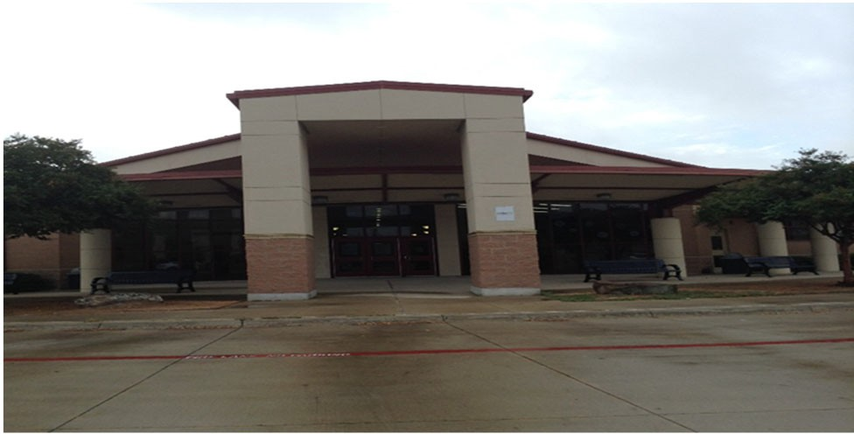Sue Ann Mackey Elementary School

Lynne Noe, Principal

Changing the world one child at a time.

 | 2017‐2018 | 2018‐2019 | 2019‐2020 | 2020‐2021 | 2021‐2022
Enrollment | 788 | 678 | 615 | 650 | 663
Student/Teacher Ratio | 19.4 | 16.7 | 14.4 | 15.5
Staﬀ FTE's
Professional | 50.5 | 49.4 | 51.7 | 51
Teachers | 40.7 | 40.7 | 42.7 | 42
Professional Support | 7.8 | 6.7 | 7 | 7
Campus Administration | 2 | 2 | 2 | 2
Support
Educational Aides | 11 | 8 | 8 | 11
Total | 61.5 | 57.4 | 59.7 | 62
Expenditures | 2018 AUDITED | 2019 AUDITED | 2020 AUDITED | 2021 UNAUDITED | 2022 BUDGET
Payroll Costs | $ 3,768,217 | $ 3,562,275 | $ 3,736,739 | $ 3,238,586 | $ 4,038,700
Contracted Services | $ 125,746 | $ 124,506 | $ 136,032 | $ 103,179 | $ 125,800
Supplies and Materials | $ 75,037 | $ 67,597 | $ 100,972 | $ 61,392 | $ 85,700
Other Operating Costs | $ 26,981 | $ 34,736 | $ 21,392 | $ 14,244 | $ 14,600
Fixed Assets | $ 184,681 | $ 171,714 | $ 7,720 | $ 265 | $ ‐
Grand Total | $ 4,180,663 | $ 3,960,829 | $ 4,002,855 | $ 3,417,666 | $ 4,264,800
Expenditures by Intent
2018 AUDITED |  | 2019 AUDITED | 2020 AUDITED 2021 UNAUDITED 2022 BUDGET
Basic | $ 2,974,178 | $ 2,688,259 | $ 2,212,846 | $ 2,068,544 | $ 2,610,050
Gifted | $ 142 | $ ‐ | $ ‐ | $ ‐ | $ 650
Special Education | $ 224,880 | $ 265,907 | $ 287,207 | $ 259,450 | $ 320,800
Bilingual | $ 66,751 | $ 58,654 | $ 64,608 | $ 60,540 | $ 6,550
SCE to Support Title I | $ 201,270 | $ 155,686 | $ 235,432 | $ 198,746 | $ 305,800
Pre‐Kindergarten |  |  | $ ‐ | $ 28,395 | $ 34,950
Pre‐Kindergarten ‐ Comp Ed |  |  | $ ‐ | $ 30,248 | $ 36,800
Pre‐Kindergarten ‐ Bilingual Ed |  |  | $ ‐ | $ 31,428 | $ 38,450
Early Education Allotment |  |  | $ 395,850 | $ 58,046 | $ 71,700
Dyslexia |  |  | $ 68,285 | $ 58,909 | $ 72,600
Other Instructional Area | $ 713,443 | $ 792,322 | $ 738,627 | $ 623,359 | $ 766,450
Grand Total | $ 4,180,663 | $ 3,960,829 | $ 4,002,855 | $ 3,417,666 | $ 4,264,800
Per Student Cost | $ 5,305 | $ 5,842 | $ 6,509 | $ 5,258 | $ 6,433
Assessment Results | 2018 STAAR | 2019 STAAR | 2020 STAAR | 2021 STAAR | 2022 STAAR
Reading | 61% | 75% | NA | NA
Mathematics | 72% | 78% | NA | NA
Writing | 48% | 64% | NA | NA
Science | 51% | 77% | NA | NA

**Information obtained from the TEA PEIMS Standard Report and Munis Accounting

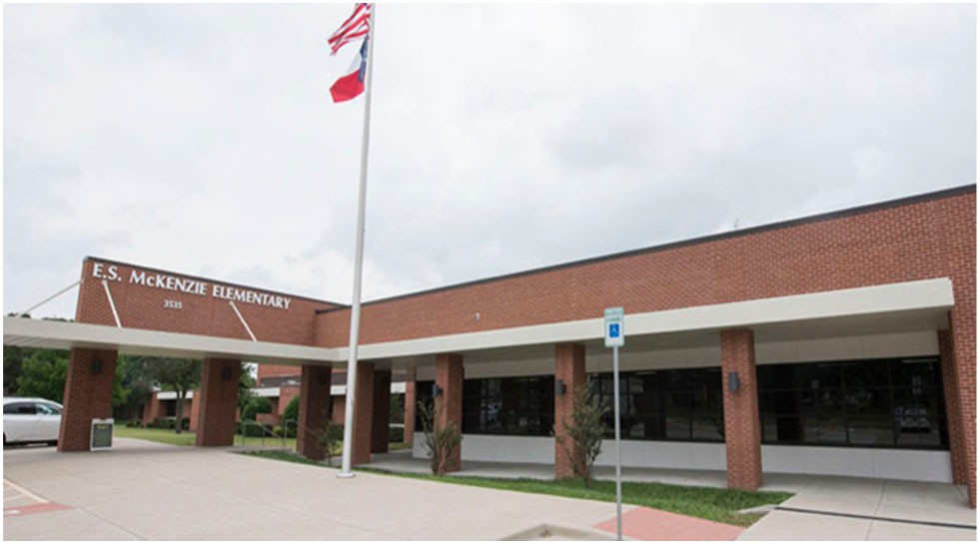E. S. McKenzie Elementary School

Suzanne Langston, Principal

Our Mission at McKenzie Elementary is to foster an inviting cli‐ mate that involves students, families, staﬀ, and the community as key contributors to educational success. Through innovative practices, we are on a quest to be constantly improving. Together we work to find success in EACH one, SOME way, EVERY day!

2017‐2018
2018‐2019
2019‐2020
2020‐2021
2021‐2022
Enrollment 538 475 454 414 390
Student/Teacher Ratio 15.6 14.8 14.5 12.9
Staﬀ FTE's
Professional 43.2 40 39 39.6
Teachers 34.4 32.2 31.4 32
Professional Support 6.8 5.8 5.6 5.6
Campus Administration 2 2 2 2
Support
Educational Aides 8 7 7 9
Total 51.2 47 46 48.6
Expenditures
2018 AUDITED
2019 AUDITED
2020 AUDITED 2021 UNAUDITED 2022 BUDGET
Payroll Costs $ 2,804,764 $ 2,712,757 $ 2,740,722 $ 2,475,431 $ 3,015,350
Contracted Services $ 80,127 $ 79,051 $ 81,675 $ 70,857 $ 83,700
Supplies and Materials $ 69,451 $ 59,452 $ 68,735 $ 53,901 $ 58,350
Other Operating Costs $ 24,835 $ 25,717 $ 15,970 $ 9,988 $ 13,400
Fixed Assets $ 539,033 $ 230,037 $ 10,151 $ 14,948 $ ‐

Grand Total $ 3,518,210 $ 3,107,013 $ 2,917,254 $ 2,625,127 $ 3,170,800
2020 AUDITED 2021 UNAUDITED 2022 BUDGET
2019 AUDTIED
2018 AUDITED
Expenditures by Intent
Basic $ 2,000,663 $ 2,096,109 $ 1,632,983 $ 1,634,147 $ 1,930,000
Gifted $ ‐ $ ‐ $ ‐ $ ‐ $ 650
Special Education $ 108,567 $ 88,816 $ 148,747 $ 180,742 $ 218,400
Bilingual $ 77,608 $ 81,567 $ 69,456 $ 58,118 $ 73,650
SCE to Support Title I $ 145,284 $ 140,122 $ 141,754 $ 136,053 $ 166,800
Pre‐Kindergarten $ ‐ $ 4,198 $ 46,600
Pre‐Kindergarten ‐ Comp Ed $ ‐ $ 17,148 $ 21,600
Early Education Allotment $ 270,568 $ 49,734 $ 73,000
Other Instructional Area $ 1,186,089 $ 700,400 $ 653,747 $ 544,988 $ 640,100

Grand Total $ 3,518,210 $ 3,107,013 $ 2,917,254 $ 2,625,127 $ 3,170,800

Per Student Cost $ 6,539 $ 6,541 $ 6,426 $ 6,341 $ 8,130
Assessment Results
2018 STAAR
2019 STAAR
2020 STAAR
2021 STAAR
2022 STAAR
Reading 72% 76% NA NA
Mathematics 78% 83% NA NA
Writing 52% 61% NA NA
Science 70% 83% NA NA

**Information obtained from the TEA PEIMS Standard Report and Munis Accounting

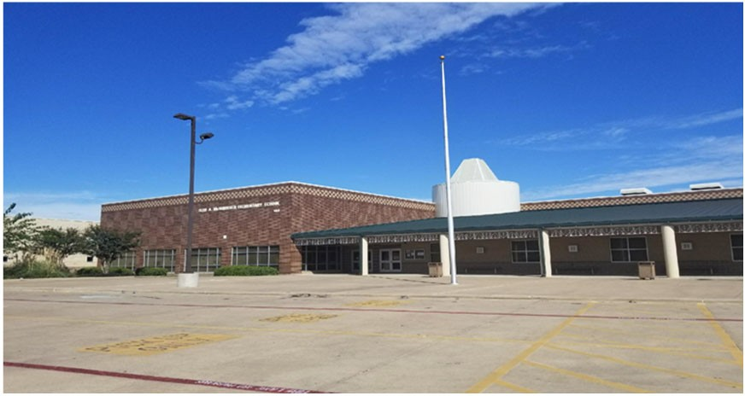Fred A. McWhorter Elementary School

Tammi Froning, Principal

Going the distance for success!

 | 2017‐2018 | 2018‐2019 | 2019‐2020 | 2020‐2021 | 2021‐2022
Enrollment | 870 | 722 | 633 | 549 | 496
Student/Teacher Ratio | 18.8 | 16.5 | 14.7 | 14.5
Staﬀ FTE's  Professional | 58.6 | 52.7 | 52.2 | 46.8
Teachers | 46.2 | 43.7 | 43.2 | 37.8
Professional Support | 9.4 | 7 | 7 | 7
Campus Administration  Support  Educational Aides | 3  14.5 | 2  12 | 2  11 | 2  12
Total | 73.1 | 64.7 | 63.2 | 58.8
Expenditures | 2018 AUDITED | 2019 AUDITED | 2020 AUDITED | 2021 UNAUDITED | 2022 BUDGET
Payroll Costs | $ 4,527,905 | $ 3,768,116 | $ 3,654,430 | $ 3,001,803 | $ 3,620,150
Contracted Services | $ 165,993 | $ 136,301 | $ 141,503 | $ 115,040 | $ 162,300
Supplies and Materials | $ 81,200 | $ 75,719 | $ 79,296 | $ 62,164 | $ 72,350
Other Operating Costs | $ 30,301 | $ 24,555 | $ 17,891 | $ 11,788 | $ 17,100
Fixed Assets | $ 11,916 | $ 235,602 | $ 26,879 | $ 265 | $ ‐
Grand Total | $ 4,817,315 | $ 4,240,292 | $ 3,919,999 | $ 3,191,059 | $ 3,871,900
Expenditures by Intent
 | 2018 AUDITED | 2019 AUDITED | 2020 AUDITED | 2021 UNAUDITED | 2022 BUDGET
Basic | $ 3,066,338 | $ 2,710,564 | $ 2,093,434 | $ 1,713,756 | $ 2,058,300
Gifted | $ 619 | $ 585 | $ 307 | $ ‐ | $ 650
Special Education | $ 542,220 | $ 425,687 | $ 414,449 | $ 354,611 | $ 432,200
Bilingual | $ 64,662 | $ 78,048 | $ 74,201 | $ 59,966 | $ 71,850
SCE to Support Title I | $ 146,611 | $ 130,596 | $ 209,876 | $ 194,059 | $ 228,000
Pre‐Kindergarten | $ 74,865 | $ 68,320 | $ 66,096 | $ 30,454 | $ 37,200
Pre‐Kindergarten‐Comp Ed | $ 39,800 | $ 40,711 | $ 43,606 | $ 37,337 | $ 46,300
Pre‐Kindergarten‐Bilingual Ed | $ 62,643 | $ 63,783 | $ 67,183 | $ 29,213 | $ 35,650
Early Education Allotment |  |  | $ 123,190 | $ 58,226 | $ 72,450
Dyslexia |  |  | $ 74,749 | $ 57,880 | $ 71,500
Other Instructional Area | $ 819,557 | $ 721,998 | $ 752,908 | $ 655,558 | $ 817,800
Grand Total | $ 4,817,315 | $ 4,240,292 | $ 3,919,999 | $ 3,191,059 | $ 3,871,900
Per Student Cost | $ 5,537 | $ 5,873 | $ 6,193 | $ 5,812 | $ 7.806
Assessment Results | 2018 STAAR | 2019 STAAR | 2020 STAAR | 2021 STAAR | 2022 STAAR
Reading | 62% | 71% | NA | NA
Mathematics | 69% | 73% | NA | NA
Writing | 43% | 63% | NA | NA
Science | 60% | 62% | NA | NA

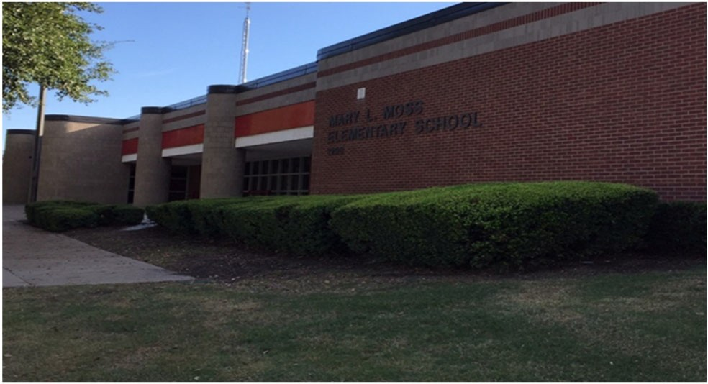Mary L. Moss Elementary School
Michael Pierotti , Principal

All day, Every day, Moss PRIDE.

 | 2017‐2018 | 2018‐2019 | 2019‐2020 | 2020‐2021 | 2021‐2022
Enrollment | 434 | 391 | 380 | 323 | 317
Student/Teacher Ratio  Staﬀ FTE's | 18.9 | 15 | 14.7 | 12.7
Professional | 30.8 | 33.6 | 33.8 | 34
Teachers | 23 | 26 | 25.8 | 25.5
Professional Support | 5.8 | 5.6 | 6 | 6.5
Campus Administration  Support  Educational Aides | 2  4 | 2  7 | 2  6.9 | 2  5.9
Total | 34.8 | 40.6 | 40.7 | 39.9
Expenditures | 2018 AUDITED | 2019 AUDITED | 2020 AUDITED | 2021 UNAUDITED | 2022 BUDGET
Payroll Costs | $ 2,599,724 | $ 2,469,682 | $ 2,533,873 | $ 2,143,727 | $ 2,557,650
Contracted Services | $ 91,107 | $ 89,116 | $ 153,974 | $ 81,184 | $ 72,900
Supplies and Materials | $ 61,407 | $ 49,721 | $ 38,240 | $ 42,414 | $ 48,600
Other Operating Costs | $ 18,240 | $ 19,745 | $ 14,354 | $ 12,749 | $ 13,000
Fixed Assets | $ 4,342 | $ 58,467 | $ 11,418 | $ 23,151 | $ ‐
Grand Total | $ 2,774,819 | $ 2,686,731 | $ 2,751,859 | $ 2,303,224 | $ 2,692,150
Expenditures by Intent
2018 AUDITED |  | 2019 AUDITED | 2020 AUDITED 2021 UNAUDITED 2022 BUDGET
Basic | $ 1,743,351 | $ 1,483,690 | $ 1,130,747 | $ 1,194,629 | $ 1,365,700
Gifted | $ 633 | $ 640 | $ 645 | $ 649 | $ 650
Special Education | $ 215,207 | $ 296,389 | $ 325,544 | $ 299,834 | $ 342,500
Bilingual | $ 75,205 | $ 81,584 | $ 68,690 | $ 58,190 | $ 71,950
SCE to Support Title I | $ 100,353 | $ 108,968 | $ 93,685 | $ 84,164 | $ 81,700
Pre‐Kindergarten | $ ‐ | $ 62,190 | $ 65,878 | $ 28,557 | $ 35,150
Pre‐Kindergarten‐Comp Ed | $ ‐ | $ 18,157 | $ 18,955 | $ 19,121 | $ 24,200
Early Education Allotment |  |  | $ 251,726 | $ 27,667 | $ 34,550
Dyslexia |  |  | $ 67,824 | $ 58,475 | $ 72,100
Other Instructional Area | $ 640,071 | $ 635,113 | $ 728,165 | $ 531,938 | $ 663,650
Grand Total | $ 2,774,819 | $ 2,686,731 | $ 2,751,859 | $ 2,303,224 | $ 2,692,150
Per Student Cost | $ 6,394 | $ 6,871 | $ 7,412 | $ 8,863 | $ 8,493
Assessment Results | 2018 STAAR | 2019 STAAR | 2020 STAAR | 2021 STAAR | 2022 STAAR
Reading | 79% | 76% | NA | NA
Mathematics | 82% | 82% | NA | NA
Writing | 60% | 66% | NA | NA
Science | 85% | 75% | NA | NA

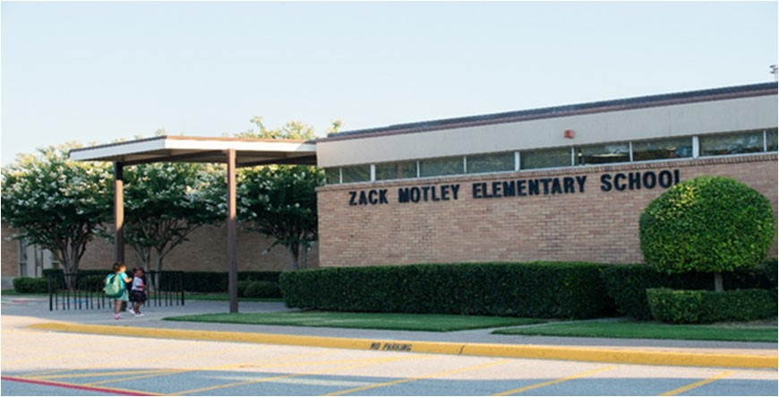Zach Motley Elementary School
Dr. Shawna Delamar, Principal

We will work hard to grow every student every day. At Motley we are a family dedicated and passionate about serving stu‐ dents and their families.

 | 2017‐2018 | 2018‐2019 | 2019‐2020 | 2020‐2021 | 2021‐2022
Enrollment | 455 | 343 | 338 | 276 | 250
Student/Teacher Ratio Staﬀ FTE's  Professional | 17.6  34.5 | 14.5  31.2 | 15.7  28.9 | 12.6  29.3
Teachers | 25.9 | 23.6 | 21.5 | 21.9
Professional Support | 6.6 | 5.6 | 5.4 | 5.4
Campus Administration Support  Educational Aides | 2  10.5 | 2  8 | 2  8 | 2  7
Total | 45 | 39.2 | 36.9 | 36.3
Expenditures | 2018 AUDITED | 2019 AUDITED | 2020 AUDITED | 2021 UNAUDITED | 2022 BUDGET
Payroll Costs | $ 2,674,584 | $ 2,290,056 | $ 2,250,077 | $ 1,957,778 | $ 2,349,350
Contracted Services | $ 86,765 | $ 66,221 | $ 72,079 | $ 60,817 | $ 70,300
Supplies and Materials | $ 59,702 | $ 46,931 | $ 64,956 | $ 45,944 | $ 39,200
Other Operating Costs | $ 32,359 | $ 26,852 | $ 23,571 | $ 15,256 | $ 13,400
Fixed Assets | $ 113,826 | $ 55,843 | $ 1,252 | $ 890 | $ ‐
Grand Total | $ 2,967,236 | $ 2,485,903 | $ 2,411,935 | $ 2,080,685 | $ 2,472,250
Expenditures by Intent | 2018 AUDITED | 2019 AUDITED | 2020 AUDITED | 2021 UNAUDITED | 2022 BUDGET
Basic | $ 1,661,721 | $ 1,353,758 | $ 955,007 | $ 997,862 | $ 1,161,400
Gifted | $ 451 | $ 439 | $ 655 | $ 649 | $ 650
Special Education  Compensatory Bilingual | $ 236,056  $ ‐  $ 148,467 | $ 176,175  $ 86,367 | $ 185,168  $ 90,365 | $ 159,216  $ 77,502 | $ 196,100  $ ‐  $ 95,650
SCE to Support Title I | $ 115,429 | $ 124,012 | $ 84,776 | $ 110,622 | $ 119,400
Pre‐Kindergarten | $ 62,828 | $ 63,742 | $ 67,252 | $ 29,489 | $ 36,000
Pre‐Kindergarten‐Comp Ed | $ 34,823 | $ 32,050 | $ 35,320 | $ 29,824 | $ 37,200
Pre‐Kindergarten‐Bilingual Ed | $ 60,160 | $ 60,027 | $ 64,119 | $ 27,590 | $ 34,050
Early Education Allotment |  |  | $ 244,198 | $ 55,686 | $ 68,350
Dyslexia |  |  | $ 70,296 | $ 60,507 | $ 74,700
Other Instructional Area | $ 647,299 | $ 589,334 | $ 614,779 | $ 531,739 | $ 648,750
Grand Total | $ 2,967,236 | $ 2,485,903 | $ 2,411,935 | $ 2,080,685 | $ 2,472,250
Per Student Cost | $ 6,521 | $ 7,248 | $ 7,135 | $ 7,539 | $ 9,889
Assessment Results | 2018 STAAR | 2019 STAAR | 2020 STAAR | 2021 STAAR | 2022 STAAR
Reading | 76% | 84% | NA | NA
Mathematics | 84% | 85% | NA | NA
Writing | 66% | 73% | NA | NA
Science | 87% | 83% | NA | NA

**Information obtained from the TEA PEIMS Standard Report and Munis Accounting

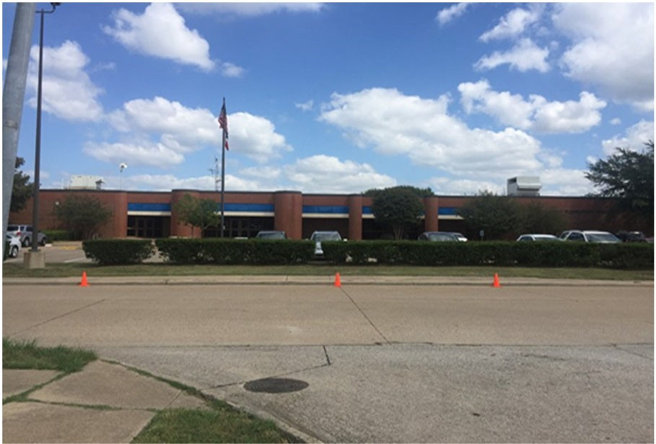Dr. Joey Pirrung Elementary School

Paige Brison, Principal

The mission of Pirrung Elementary is to empower students to excel and become confident, productive citizens as they dis‐ cover their own purposes and transform the lives of others with integrity and kindness.

 | 2017‐2018 | 2018‐2019 | 2019‐2020 | 2020‐2021 | 2021‐2022
Enrollment | 434 | 438 | 392 | 396 | 388
Student/Teacher Ratio | 16.9 | 16.5 | 15.5 | 15
Staﬀ FTE's  Professional | 33.7 | 33.5 | 32.3 | 35.4
Teachers | 25.7 | 26.5 | 25.3 | 26.4
Professional Support | 6 | 5 | 5 | 7
Campus Administration | 2 | 2 | 2 | 2
Support
Educational Aides | 6 | 7.9 | 7 | 10
Total | 39.7 | 41.4 | 39.3 | 45.4
Expenditures
 | 2018 AUDITED | 2019 AUDITED | 2020 AUDITED | 2021 UNAUDITED | 2022 BUDGET
Payroll Costs | $ 2,415,779 | $ 2,340,085 | $ 2,205,517 | $ 2,149,441 | $ 2,731,050
Contracted Services | $ 111,051 | $ 74,406 | $ 72,809 | $ 68,408 | $ 80,200
Supplies and Materials | $ 50,621 | $ 60,571 | $ 64,640 | $ 65,093 | $ 48,970
Other Operating Costs | $ 19,790 | $ 24,460 | $ 14,404 | $ 12,466 | $ 15,630
Fixed Assets | $ 16,630 | $ 646,966 | $ 10,640 | $ 265 | $ ‐
Grand Total | $ 2,613,871 | $ 3,146,488 | $ 2,368,010 | $ 2,295,674 | $ 2,875,850
Expenditures by Intent
2018 AUDITED |  | 2019 AUDITED | 2020 AUDITED 2021 UNAUDITED 2022 BUDGET
Basic | $ 1,573,519 | $ 1,511,433 | $ 1,107,747 | $ 1,196,524 | $ 1,537,270
Gifted | $ ‐ | $ ‐ | $ ‐ | $ 648 | $ 650
Special Education | $ 215,923 | $ 243,320 | $ 263,850 | $ 331,719 | $ 409,100
Bilingual | $ 82,011 | $ 65,419 | $ 69,393 | $ 56,829 | $ 72,550
SCE to Support Title I | $ 69,601 | $ 101,383 | $ 67,783 | $ 86,434 | $ 88,500
Pre‐Kindergarten | $ ‐ | $ ‐ | $ ‐ | $ 29,263 | $ 35,700
Pre‐Kindergarten ‐ Comp Ed |  |  | $ ‐ | $ 14,657 | $ 18,400
Early Education Allotment |  |  | $ 201,294 | $ 28,728 | $ 35,600
Other Instructional Area | $ 672,816 | $ 1,224,933 | $ 657,944 | $ 550,871 | $ 678,080
Grand Total | $ 2,613,871 | $ 3,146,488 | $ 2,368,010 | $ 2,295,674 | $ 2,875,850
Per Student Cost | $ 6,023 | $ 7,184 | $ 6,041 | $ 5,797 | $ 7,412
Assessment Results | 2018 STAAR | 2019 STAAR | 2020 STAAR | 2021 STAAR | 2022 STAAR
Reading | 76% | 80% | NA | NA
Mathematics | 69% | 77% | NA | NA
Writing | 52% | 49% | NA | NA
Science | 60% | 70% | NA | NA

**Information obtained from the TEA PEIMS Standard Report and Munis Accounting

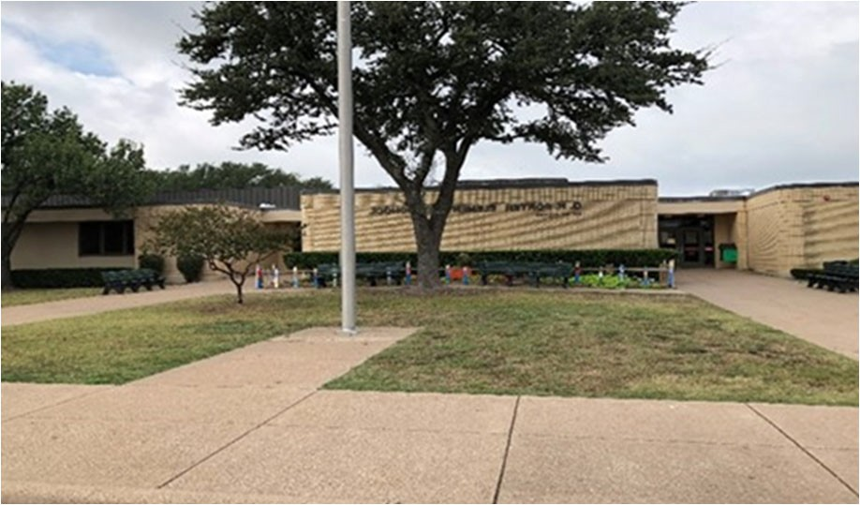G.R. Porter Elementary School

LeeAnn Englert, Principal

Porter will be a unified campus with high expectations for criti‐ cal thinking, creativity, and problem solving. Providing a nurtur‐ ing, respectful environment based on supportive relationships between teachers, students and parents that encourage every child to be the best they can be.

 | 2017‐2018 | 2018‐2019 | 2019‐2020 | 2020‐2021 | 2021‐2022
Enrollment | 605 | 442 | 421 | 389 | 374
Student/Teacher Ratio | 19.3 | 15.3 | 14.3 | 13.8
Staﬀ FTE's  Professional | 39.9 | 36.3 | 35.4 | 35.6
Teachers | 31.3 | 28.9 | 29.4 | 28.2
Professional Support | 6.6 | 5.4 | 4 | 5.4
Campus Administration Support  Educational Aides | 2  8 | 2  5.9 | 2  6 | 2  7
Total | 47.9 | 42.2 | 41.4 | 42.6
Expenditures | 2018 AUDITED | 2019 AUDITED | 2020 AUDITED | 2021 UNAUDITED | 2022 BUDGET
Payroll Costs | $ 3,152,589 | $ 2,616,569 | $ 2,629,410 | $ 2,146,649 | $ 2,523,050
Contracted Services | $ 84,172 | $ 74,556 | $ 82,021 | $ 64,141 | $ 84,600
Supplies and Materials | $ 71,594 | $ 62,686 | $ 87,818 | $ 59,200 | $ 100,000
Other Operating Costs | $ 21,310 | $ 22,611 | $ 17,569 | $ 10,858 | $ 15,100
Fixed Assets | $ 1,079 | $ 67,503 | $ 63,097 | $ 109,116 | $ 50,000
Grand Total | $ 3,330,744 | $ 2,843,926 | $ 2,879,916 | $ 2,389,965 | $ 2,772,750
Expenditures by Intent | 2018 AUDITED | 2019 AUDITED | 2020 AUDITED | 2021 UNAUDITED | 2022 BUDGET
Basic | $ 2,148,729 | $ 1,744,231 | $ 1,536,827 | $ 1,425,645 | $ 1,559,056
Gifted | $ ‐ | $ ‐ | $ ‐ | $ ‐ | $ 650
Special Education | $ 175,650 | $ 150,312 | $ 116,820 | $ 96,846 | $ 121,400
Bilingual | $ 71,564 | $ 70,975 | $ 74,272 | $ 63,190 | $ 6,350
SCE to Support Title I | $ 191,560 | $ 140,396 | $ 112,398 | $ 140,536 | $ 192,200
Pre‐Kindergarten |  |  | $ ‐ | $ ‐ | $ ‐
Pre‐Kindergarten‐Comp Ed | $ 20,559 | $ 25,638 | $ 25,087 | $ 14,068 | $ 17,100
Pre‐Kindergarten‐Bilingual | $ 60,021 | $ 60,489 | $ 64,409 | $ 27,726 | $ 34,050
Early Education Allotment |  |  | $ 169,424 | $ 28,328 | $ 33,450
Dyslexia |  |  | $ 69,737 | $ ‐ | $ ‐
Other Instructional Area | $ 662,661 | $ 651,886 | $ 710,941 | $ 593,626 | $ 809,150
Grand Total | $ 3,330,744 | $ 2,843,926 | $ 2,879,916 | $ 2,389,965 | $ 2,772,750
Per Student Cost | $ 5,505 | $ 6,434 | $ 6,841 | $ 6,144 | $ 7,414
Assessment Results | 2018 STAAR | 2019 STAAR | 2020 STAAR | 2021 STAAR | 2022 STAAR
Reading | 78% | 87% | NA | NA
Mathematics | 91% | 93% | NA | NA
Writing | 68% | 70% | NA | NA
Science | 76% | 84% | NA | NA

**Information obtained from the TEA PEIMS Standard Report and Munis Accounting

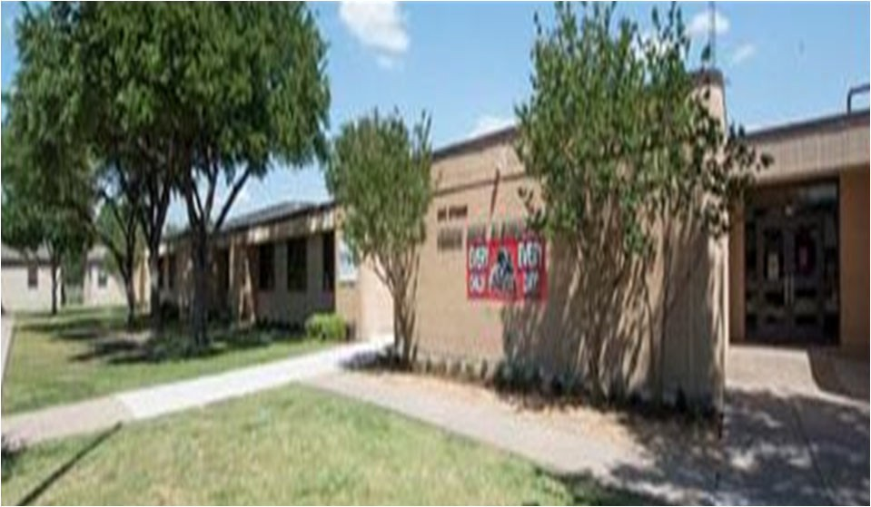Vernon Price Elementary School

Ashley Goodwin, Principal

Excellence Always!

 | 2017‐2018 |  | 2018‐2019 |  | 2019‐2020 |  | 2020‐2021 |  | 2021‐2022
Enrollment | 451 |  | 379 |  | 348 |  | 299 |  | 311
Student/Teacher Ratio  Staﬀ FTE's  Professional | 18.8  31.6 |  | 15.4  32.6 |  | 16.1  29.6 |  | 13.7  29.8
Teachers | 24 |  | 24.6 |  | 21.6 |  | 21.8
Professional Support | 5.6 |  | 6 |  | 6 |  | 6
Campus Administration  Support  Educational Aides | 2  8 |  | 2  8 |  | 2  8 |  | 2  8
Total | 39.6 |  | 40.6 |  | 37.6 |  | 37.8
Expenditures
 | 2018 AUDITED |  | 2019 AUDITED |  | 2020 AUDITED |  | 2021 UNAUDITED |  | 2022 BUDGET
Payroll Costs | $ 2,574,715 |  | $ 2,262,071 |  | $ 2,172,286 |  | $ 1,860,801 |  | $ 2,285,550
Contracted Services | $ 68,366 |  | $ 66,315 |  | $ 62,072 |  | $ 50,351 |  | $ 61,000
Supplies and Materials | $ 46,424 |  | $ 36,937 |  | $ 39,132 |  | $ 36,506 |  | $ 39,350
Other Operating Costs | $ 20,090 |  | $ 20,910 |  | $ 19,396 |  | $ 12,475 |  | $ 13,600
Fixed Assets | $ 489,269 |  | $ 80,926 |  | $ 50,752 |  | $ 265 |  | $ ‐
Grand Total | $ 3,198,863 |  | $ 2,467,159 |  | $ 2,343,639 |  | $ 1,960,397 |  | $ 2,399,500
Expenditures by Intent | 2018 AUDITED |  | 2019 AUDITED |  | 2020 AUDITED |  | 2021 UNAUDITED |  | 2022 BUDGET
Basic | $ 1,624,565 |  | $ 1,298,587 |  | $ 986,337 |  | $ 888,676 |  | $ 1,086,900
Gifted | $ | ‐ | $ | ‐ | $ | ‐ | $ | ‐ | $ | 650
Special Education | $ 229,540 |  | $ 312,861 |  | $ 387,827 |  | $ 332,500 |  | $ 405,500
Bilingual | $ 64,622 |  | $ 38,107 |  | $ 76,641 |  | $ 64,909 |  | $ 80,450
SCE to Support Title I | $ 100,465 |  | $ 103,754 |  | $ 67,470 |  | $ 82,981 |  | $ 97,700
Pre‐Kindergarten | $ 60,377 |  | $ 61,206 |  | $ 65,525 |  | $ 27,873 |  | $ 34,550
Pre‐Kindergarten ‐ Comp Ed | $ 16,454 |  | $ 20,524 |  | $ 21,631 |  | $ 15,192 |  | $ 20,300
Early Education Allotment |  |  |  |  | $ 118,285 |  | $ 28,642 |  | $ 33,950
Other Instructional Area | $ 1,102,842 |  | $ 632,119 |  | $ 619,924 |  | $ 519,625 |  | $ 639,500
Grand Total | $ 3,198,863 |  | $ 2,467,159 |  | $ 2,343,639 |  | $ 1,960,397 |  | $ 2,399,500
Per Student Cost | $ 7,093 |  | $ 6,510 |  | $ 6,734 |  | $ 6,557 |  | $ 7,715
Assessment Results | 2018 STAAR |  | 2019 STAAR |  | 2020 STAAR |  | 2021 STAAR |  | 2021 STAAR
Reading | 60% |  | 63% |  | NA |  | NA
Mathematics | 73% |  | 76% |  | NA |  | NA
Writing | 31% |  | 50% |  | NA |  | NA
Science | 68% |  | 75% |  | NA |  | NA

**Information obtained from the TEA PEIMS Standard Report and Munis Accounting

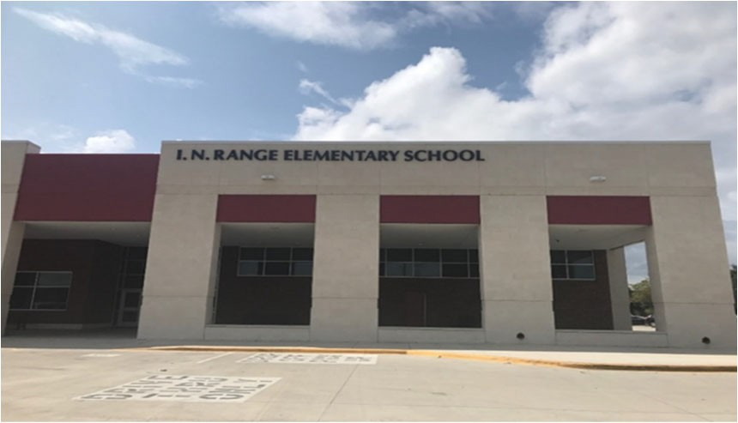I. N. Range Elementary School

Kelly Locke, Principal

To develop and grow all students academically, socially, and emo‐ tionally in order to foster a life‐long desire to learn.
 | 2017‐2018 | 2018‐2019 | 2019‐2020 | 2020‐2021 | 2021‐2022
Enrollment | 763 | 613 | 601 | 580 | 572
Student/Teacher Ratio  Staﬀ FTE's Professional | 18.5  49.6 | 15.4  47.1 | 15.4  46.5 | 15.1  46.1
Teachers | 41.2 | 39.7 | 38.9 | 38.5
Professional Support | 6.4 | 5.4 | 5.6 | 5.6
Campus Administration  Support  Educational Aides | 2  11.3 | 2  10.9 | 2  10 | 2  7
Total | 60.9 | 58 | 56.5 | 53.1
Expenditures | 2018 AUDITED | 2019 AUDITED | 2020 AUDITED | 2021 UNAUDITED | 2022 BUDGET
Payroll Costs | $ 3,887,840 | $ 3,468,498 | $ 3,420,583 | $ 2,878,229 | $ 3,592,150
Contracted Services | $ 130,148 | $ 137,984 | $ 236,747 | $ 79,464 | $ 95,000
Supplies and Materials | $ 76,035 | $ 92,826 | $ 120,944 | $ 76,550 | $ 76,300
Other Operating Costs | $ 33,681 | $ 37,700 | $ 29,948 | $ 24,642 | $ 17,600
Fixed Assets | $ 2,174 | $ 94,696 | $ 7,720 | $ 265 | $ ‐
Grand Total | $ 4,129,879 | $ 3,831,704 | $ 3,815,941 | $ 3,059,150 | $ 3,781,050
Expenditures by Intent
2018 AUDITED |  | 2019 AUDITED | 2020 AUDITED 2021 UNAUDITED 2022 BUDGET
Basic | $ 2,772,373 | $ 2,521,430 | $ 2,049,252 | $ 1,824,457 | $ 2,226,338
Gifted | $ 646 | $ ‐ | $ ‐ | $ ‐ | $ 650
Special Education | $ 356,484 | $ 360,439 | $ 356,937 | $ 146,577 | $ 186,800
Bilingual | $ 64,924 | $ 65,479 | $ 68,446 | $ 58,223 | $ 72,150
SCE to Support Title I | $ 159,600 | $ 159,492 | $ 158,612 | $ 198,437 | $ 258,600
Pre‐Kindergarten |  |  | $ ‐ | $ 61,378 | $ 76,300
Pre‐Kindergarten ‐ Comp Ed |  |  | $ ‐ | $ 25,474 | $ 28,500
Pre‐Kindergarten ‐ Bilingual Ed |  |  | $ ‐ | $ 29,903 | $ 35,800
Early Education Allotment |  |  | $ 273,985 | $ 88,450 | $ 110,900
Dyslexia |  |  | $ 66,634 | $ 100,557 | $ 140,500
Other Instructional Area | $ 775,852 | $ 724,865 | $ 842,074 | $ 525,694 | $ 645,550
Grand Total | $ 4,129,879 | $ 3,831,704 | $ 3,815,941 | $ 3,059,150 | $ 3,781,050
Per Student Cost | $ 5,412 | $ 6,251 | $ 6,349 | $ 5,274 | $ 6,610
Assessment Results | 2018 STAAR | 2019 STAAR | 2020 STAAR | 2021 STAAR | 2022 STAAR
Reading | 73% | 72% | NA | NA
Mathematics | 83% | 73% | NA | NA
Writing | 58% | 70% | NA | NA
Science | 75% | 72% | NA | NA

**Information obtained from the TEA PEIMS Standard Report and Munis Accounting

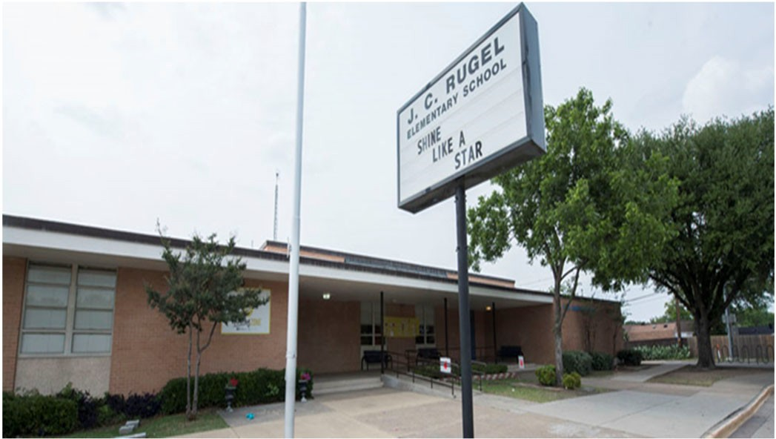J. C. Rugel Elementary School

Dr. Amanda Walker, Principal

Rugel All In.
 | 2017‐2018 | 2018‐2019 | 2019‐2020 | 2020‐2021 | 2021‐2022
Enrollment | 458 | 369 | 355 | 321 | 293
Student/Teacher Ratio Staﬀ FTE's  Professional | 14  41.4 | 13.9  33.3 | 14  31.4 | 13.5  31.4
Teachers | 32.8 | 26.5 | 25.4 | 23.7
Professional Support | 6.6 | 4.8 | 4 | 5.7
Campus Administration  Support  Educational Aides | 2  7 | 2  8 | 2  9 | 2  8
Total | 48.4 | 41.3 | 40.4 | 39.4
Expenditures | 2018 AUDITED | 2019 AUDITED | 2020 AUDITED | 2021 UNAUDITED | 2022 BUDGET
Payroll Costs | $ 3,170,906 | $ 2,364,752 | $ 2,392,309 | $ 2,096,631 | $ 2,557,950
Contracted Services | $ 130,462 | $ 163,030 | $ 74,861 | $ 70,854 | $ 76,600
Supplies and Materials | $ 70,293 | $ 57,477 | $ 64,181 | $ 50,253 | $ 45,600
Other Operating Costs | $ 25,039 | $ 21,518 | $ 16,351 | $ 11,070 | $ 13,300
Fixed Assets | $ 701,428 | $ 88,064 | $ 9,868 | $ 265 | $ ‐
Grand Total | $ 4,098,128 | $ 2,694,841 | $ 2,557,571 | $ 2,229,073 | $ 2,693,450
Expenditures by Intent
2018 AUDITED |  | 2019 AUDITED | 2020 AUDITED 2021 UNAUDITED 2022 BUDGET
Basic | $ 1,843,204 | $ 1,468,842 | $ 1,177,386 | $ 1,139,950 | $ 1,349,194
Gifted | $ 450,192 | $ 3,050 | $ 201 | $ ‐ | $ 650
Special Education | $ 374,533 | $ 356,604 | $ 324,693 | $ 310,775 | $ 384,100
Bilingual | $ 63,524 | $ 64,496 | $ 68,136 | $ 57,857 | $ 71,950
SCE to Support Title I | $ 91,290 | $ 78,262 | $ 67,653 | $ 88,745 | $ 119,500
Pre‐Kindergarten |  |  | $ ‐ | $ 167 | $ ‐
Pre‐Kindergarten ‐ Comp Ed |  |  | $ ‐ | $ 1,794 | $ 3,300
Early Education Allotment |  |  | $ 202,445 | $ ‐ | $ ‐
Dyslexia |  |  | $ 80,630 | $ 69,714 | $ 85,800
Other Instructional Area | $ 1,275,385 | $ 723,588 | $ 636,426 | $ 560,071 | $ 679,250
Grand Total | $ 4,098,128 | $ 2,694,841 | $ 2,557,571 | $ 2,229,073 | $ 2,693,450
Per Student Cost | $ 8,948 | $ 7,303 | $ 7,204 | $ 6,944 | $ 9,193
Assessment Results | 2018 STAAR | 2019 STAAR | 2020 STAAR | 2021 STAAR | 2022 STAAR
Reading | 61% | 66% | NA | NA
Mathematics | 69% | 77% | NA | NA
Writing | 47% | 51% | NA | NA
Science | 67% | 66% | NA | NA

**Information obtained from the TEA PEIMS Standard Report and Munis Accounting

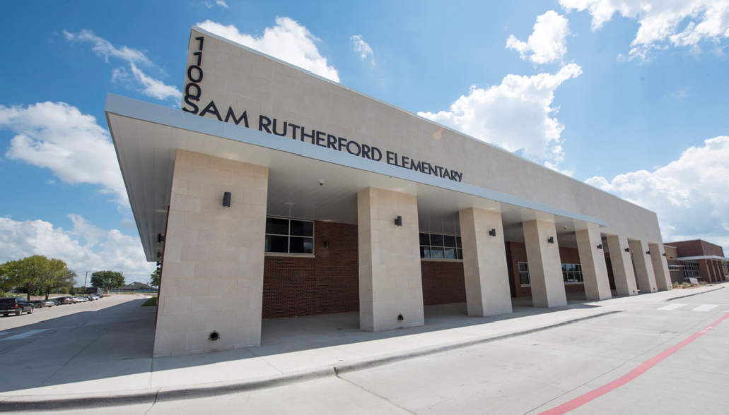Sam Rutherford Elementary School

Dr. Holly Grubbs, Principal

Where the Best Begins
 | 2017‐2018 | 2018‐2019 | 2019‐2020 | 2020‐2021 | 2021‐2022
Enrollment | 474 | 687 | 659 | 648 | 657
Student/Teacher Ratio  Staﬀ FTE's  Professional | 16.3  36.4 | 16.8  48.4 | 15.3  50.3 | 14.6  53.5
Teachers | 29 | 41 | 43 | 44.5
Professional Support | 5.4 | 5.4 | 5.3 | 7
Campus Administration  Support  Educational Aides | 2  5 | 2  5 | 2  10 | 2  14.7
Total | 41.4 | 53.4 | 60.3 | 68.2
Expenditures
 | 2018 AUDITED | 2019 AUDITED | 2020 AUDITED | 2021 UNAUDITED | 2022 BUDGET
Payroll Costs | $ 2,644,782 | $ 3,615,861 | $ 3,825,540 | $ 3,371,949 | $ 4,183,350
Contracted Services | $ 84,373 | $ 72,503 | $ 82,032 | $ 86,796 | $ 105,300
Supplies and Materials | $ 165,977 | $ 117,295 | $ 100,385 | $ 98,339 | $ 86,150
Other Operating Costs | $ 22,737 | $ 31,114 | $ 22,995 | $ 13,042 | $ 17,600
Fixed Assets | $ 139,959 | $ 113,189 | $ 6,346 | $ 265 | $ ‐
Grand Total | $ 3,057,827 | $ 3,949,963 | $ 4,037,298 | $ 3,570,391 | $ 4,392,400
Expenditures by Intent | 2018 AUDITED | 2019 AUDITED | 2020 AUDITED | 2021 UNAUDITED | 2022 BUDGET
Basic | $ 1,702,426 | $ 2,597,089 | $ 2,337,610 | $ 2,024,820 | $ 2,550,200
Gifted | $ 657 | $ 538 | $ 382 | $ 641 | $ 650
Special Education  Compensatory  Bilingual | $ 203,848  $ ‐  $ 84,131 | $ 336,859  $ 68,532 | $ 337,153  $ 74,419 | $ 436,144  $ 60,766 | $ 542,800  $ ‐  $ 5,150
SCE to Support Title I | $ 112,408 | $ 145,907 | $ 151,124 | $ 207,316 | $ 246,200
Pre‐Kindergarten | $ 49,148 | $ 66,664 | $ 73,986 | $ 32,098 | $ 39,400
Pre‐Kindergarten ‐ Comp Ed | $ 17,182 | $ 17,838 | $ 18,511 | $ 31,064 | $ 38,400
Pre‐Kindergarten ‐ Bilingual Ed |  |  | $ ‐ | $ 32,094 | $ 39,300
Early Education Allotment |  |  | $ 263,352 | $ 62,265 | $ 77,000
Dyslexia |  |  | $ 66,939 | $ 58,969 | $ 72,700
Other Instructional Area | $ 888,027 | $ 716,536 | $ 713,820 | $ 624,214 | $ 780,600
Grand Total | $ 3,057,827 | $ 3,949,963 | $ 4,037,298 | $ 3,570,391 | $ 4,392,400
Per Student Cost | $ 6,451 | $ 5,750 | $ 6,126 | $ 5,510 | $ 6,585
Assessment Results | 2018 STAAR | 2019 STAAR | 2020 STAAR | 2021 STAAR | 2022 STAAR
Reading | 67% | 76% | NA | NA
Mathematics | 75% | 74% | NA | NA
Writing | 46% | 64% | NA | NA
Science | 87% | 87% | NA | NA

**Information obtained from the TEA PEIMS Standard Report and Munis Accounting

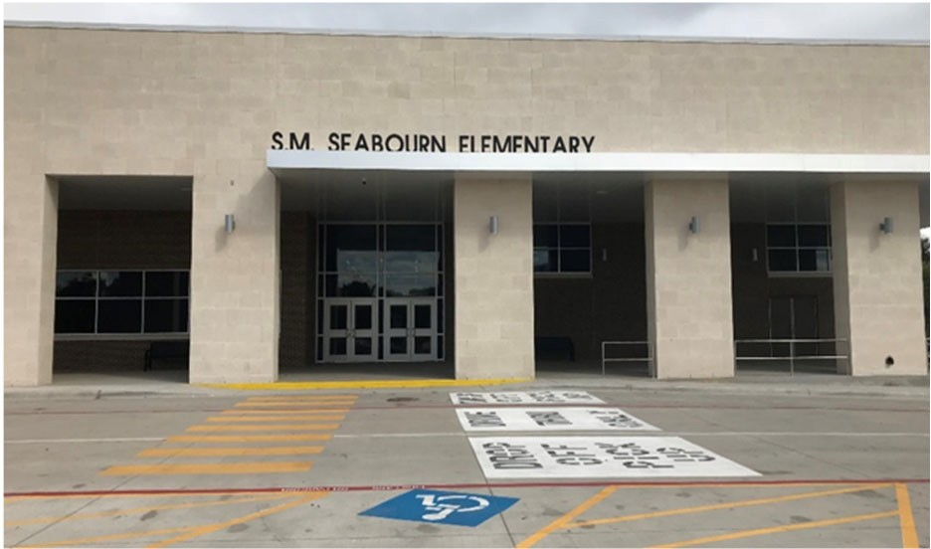S.M. Seabourn Elementary School

Renea Kern, Principal

Seabourn PRIDE ‐
Excellence Always
2017‐2018
2018‐2019
2019‐2020
2020‐2021
2021‐2022
Enrollment 724 680 661 578 608
Student/Teacher Ratio 19.5 17.1 17.8 14.8
Staﬀ FTE's
Professional 46 48.7 46.2 48.4
Teachers 37.2 39.7 37.2 39.1
Professional Support 6.8 7 7 7.3
Campus Administration 2 2 2 2
Support
Educational Aides 13 12.8 12 12
Total 59 61.5 58.2 60.4
Expenditures
2018 AUDITED 2019 AUDITED 2020 AUDITED 2021 UNAUDITED 2022 BUDGET
Payroll Costs $ 3,246,584 $ 3,108,780 $ 3,166,850 $ 2,836,658 $ 3,449,800
Contracted Services $ 107,165 $ 100,485 $ 125,452 $ 77,806 $ 85,600
Supplies and Materials $ 80,382 $ 77,981 $ 74,888 $ 53,712 $ 84,950
Other Operating Costs $ 24,924 $ 32,716 $ 20,626 $ 12,714 $ 13,300
Fixed Assets $ 641 $ 84,873 $ 1,252 $ 265 $ ‐

Grand Total $ 3,459,696 $ 3,404,835 $ 3,389,068 $ 2,981,155 $ 3,633,650
Expenditures by Intent
2018 AUDITED 2019 AUDITED 2020 AUDITED 2021 UNAUDITED 2022 BUDGET

Basic $ 1,925,164 $ 1,860,850 $ 1,512,233 $ 1,582,779 $ 1,950,596
Gifted $ ‐ $ ‐ $ ‐ $ ‐ $ 650
Special Education $ 363,086 $ 375,687 $ 405,323 $ 309,804 $ 377,900
Bilingual $ 63,426 $ 64,162 $ 66,796 $ 56,733 $ 73,650
SCE to Support Title I $ 138,099 $ 158,507 $ 158,494 $ 197,361 $ 217,200
Pre‐Kindergarten $ 66,881 $ 67,691 $ 67,997 $ 30,433 $ 38,150
Pre‐Kindergarten‐Comp Ed $ 67,706 $ 54,800 $ 56,804 $ 48,316 $ 59,800
Pre‐Kindergarten‐Bilingual Ed $ 111,389 $ 131,482 $ 143,460 $ 61,168 $ 76,500
Early Education Allotment $ 239,895 $ 93,054 $ 112,250
Other Instruction Area $ 723,945 $ 691,657 $ 738,065 $ 601,507 $ 727,850

Grand Total $ 3,459,696 $ 3,404,835 $ 3,389,068 $ 2,981,155 $ 3,633,650

Per Student Cost $ 4,779 $ 5,007 $ 5,127 $ 5,158 $ 5,976
Assessment Results
2018 STAAR
2019 STAAR
2020 STAAR
2021 STAAR
2022 STAAR
Reading 70% 75% NA NA
Mathematics 77% 75% NA NA
Writing 53% 51% NA NA
Science 85% 78% NA NA

**Information obtained from the TEA PEIMS Standard Report and Munis Accounting

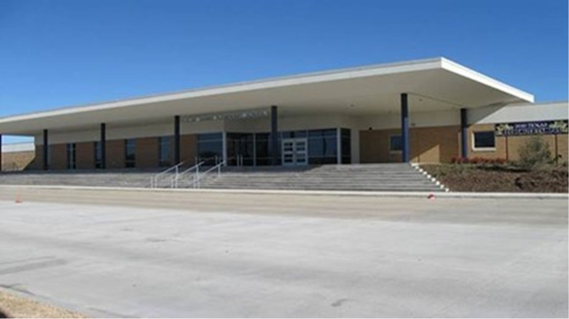Brandi Lewis, Principal

Expect Excellence No Excuses

 | 2017‐2018 |  | 2018‐2019 |  | 2019‐2020 |  | 2020‐2021 |  | 2021‐2022
Enrollment | 825 |  | 664 |  | 629 |  | 622 |  | 544
Student/Teacher Ratio | 19.3 |  | 16.8 |  | 15.6 |  | 14.9
Staﬀ FTE's
Professional | 52.6 |  | 48.5 |  | 49.4 |  | 51.2
Teachers | 42.7 |  | 39.5 |  | 40.4 |  | 41.7
Professional Support | 7.9 |  | 7 |  | 7 |  | 7.5
Campus Administration | 2 |  | 2 |  | 2 |  | 2
Support
Educational Aides | 10.9 |  | 8.9 |  | 8.9 |  | 12.7
Total | 63.5 |  | 57.4 |  | 58.3 |  | 63.9
Expenditures
 | 2018 AUDITED |  | 2019 AUDITED |  | 2020 AUDITED |  | 2021 UNAUDITED |  | 2022 BUDGET
Payroll Costs | $ 4,244,039 |  | $ 3,462,934 |  | $ 3,625,380 |  | $ 3,152,634 |  | $ 3,760,450
Contracted Services | $ 157,919 |  | $ 100,853 |  | $ 106,540 |  | $ 82,998 |  | $ 95,100
Supplies and Materials | $ 76,201 |  | $ 77,648 |  | $ 110,755 |  | $ 60,085 |  | $ 77,250
Other Operating Costs | $ 38,258 |  | $ 32,074 |  | $ 25,494 |  | $ 10,922 |  | $ 16,100
Fixed Assets | $ 188,761 |  | $ 99,810 |  | $ 21,912 |  | $ 265 |  | $ ‐
Grand Total | $ 4,705,178 |  | $ 3,773,318 |  | $ 3,890,080 |  | $ 3,306,903 |  | $ 3,948,900
Expenditures by Intent
 | 2018 AUDITED |  | 2019 AUDITED |  | 2020 AUDITED |  | 2021 UNAUDITED |  | 2022 BUDGET
Basic | $ 3,254,142 |  | $ 2,463,183 |  | $ 2,057,566 |  | $ 2,054,511 |  | $ 2,526,652
Gifted | $ | ‐ | $ | ‐ | $ | ‐ | $ | ‐ | $ 650
Career & Technology | $ | ‐ | $ | ‐ | $ | ‐ | $ | ‐ | $ ‐
Special Education | $ 387,440 |  | $ 353,750 |  | $ 401,160 |  | $ 397,758 |  | $ 420,500
Bilingual | $ 65,242 |  | $ 64,999 |  | $ 66,213 |  | $ 56,617 |  | $ 5,950
SCE to Support Title I | $ 253,367 |  | $ 183,456 |  | $ 283,260 |  | $ 164,319 |  | $ 207,200
Pre‐Kindergarten |  |  |  |  | $ ‐ |  | $ ‐ |  | $ 600
Pre‐Kindergarten ‐ Comp Ed |  |  |  |  | $ ‐ |  | $ 32,755 |  | $ 38,700
Pre‐Kindergarten ‐ Bilingual Ed |  |  |  |  | $ ‐ |  | $ ‐ |  | $ 600
Early Education Allotment |  |  |  |  | $ 332,273 |  | $ ‐ |  | $ ‐
Other Instructional Area | $ 744,987 |  | $ 707,931 |  | $ 749,608 |  | $ 600,944 |  | $ 749,100
Grand Total | $ 4,705,178 |  | $ 3,773,318 |  | $ 3,890,080 |  | $ 3,306,903 |  | $ 3,948,900
Per Student Cost | $ 5,703 |  | $ 5,683 |  | $ 6,185 |  | $ 5,317 |  | $ 7,259
Assessment Results | 2018 STAAR |  | 2019 STAAR |  | 2020 STAAR |  | 2021 STAAR |  | 2022 STAAR
Reading | 68% |  | 78% |  | NA |  | NA
Mathematics | 83% |  | 82% |  | NA |  | NA
Writing | 60% |  | 57% |  | NA |  | NA
Science | 69% |  | 78% |  | NA |  | NA

**Information obtained from the TEA PEIMS Standard Report and Munis Accounting

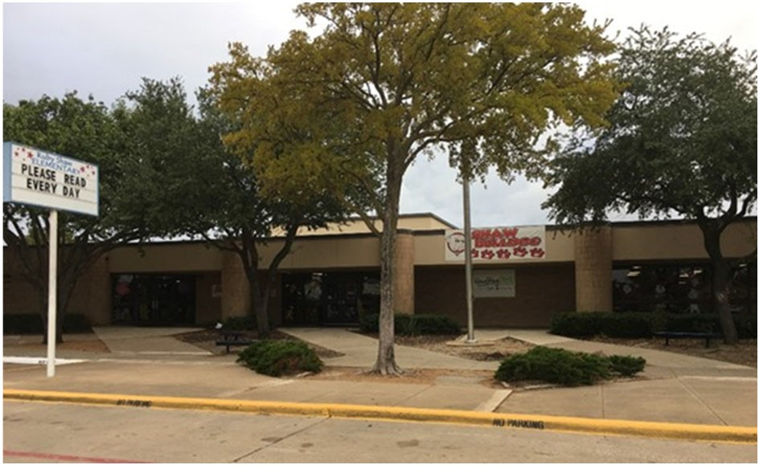Kim Dumaine Banuelos, Principal

The Shaw Bulldog vision is to create and nurture a family of learners where every person is encouraged and empowered to become his or her best.

 | 2017‐2018 |  | 2018‐2019 |  | 2019‐2020 |  | 2020‐2021 |  | 2021‐2022
Enrollment | 884 |  | 505 |  | 577 |  | 555 |  | 514
Student/Teacher Ratio  Staﬀ FTE's  Professional | 21.8  51.6 |  | 13.4  43.7 |  | 15.8  45.6 |  | 14.2  48.1
Teachers | 40.6 |  | 34.7 |  | 36.6 |  | 39.1
Professional Support | 9 |  | 7 |  | 7 |  | 7
Campus Administration  Support  Educational Aides | 2  11 |  | 2  9.9 |  | 2  11 |  | 2  8
Total | 62.6 |  | 53.6 |  | 56.6 |  | 56.1
Expenditures | 2018 AUDITED |  | 2019 AUDITED |  | 2020 AUDITED |  | 2021 UNAUDITED |  | 2022 BUDGET
Payroll Costs | $ 4,118,666 |  | $ 3,181,016 |  | $ 3,209,545 |  | $ 2,757,234 |  | $ 3,283,650
Contracted Services | $ 129,207 |  | $ 111,685 |  | $ 118,578 |  | $ 83,824 |  | $ 101,200
Supplies and Materials | $ 110,780 |  | $ 67,571 |  | $ 71,270 |  | $ 77,058 |  | $ 63,300
Other Operating Costs | $ 41,812 |  | $ 35,727 |  | $ 27,184 |  | $ 16,847 |  | $ 18,700
Fixed Assets | $ 1,885 |  | $ 79,110 |  | $ 4,203 |  | $ 265 |  | $ ‐
Grand Total | $ 4,402,349 |  | $ 3,475,110 |  | $ 3,430,781 |  | $ 2,935,228 |  | $ 3,466,850
Expenditures by Intent
 | 2018 AUDITED |  | 2019 AUDITED |  | 2020 AUDITED |  | 2021 UNAUDITED |  | 2022 BUDGET
Basic | $ 2,957,867 |  | $ 2,040,417 |  | $ 1,663,522 |  | $ 1,763,714 |  | $ 2,025,800
Gifted | $ | ‐ | $ | ‐ | $ | ‐ | $ | ‐ | $ | 650
Special Education | $ 422,946 |  | $ 457,940 |  | $ 385,285 |  | $ 222,718 |  | $ 276,100
Bilingual | $ 72,690 |  | $ 72,684 |  | $ 76,482 |  | $ 65,535 |  | $ 82,850
SCE to Support Title I | $ 244,503 |  | $ 231,036 |  | $ 256,189 |  | $ 161,121 |  | $ 196,400
Pre‐Kindergarten |  |  |  |  | $ ‐ |  | $ 606 |  | $ ‐
Pre‐Kindergarten ‐ Comp Ed |  |  |  |  | $ ‐ |  | $ 12,510 |  | $ 14,400
Early Education Allotment |  |  |  |  | $ 254,449 |  | $ ‐ |  | $ ‐
Dyslexia |  |  |  |  | $ 68,671 |  | $ 114,130 |  | $ 140,500
Other Instructional Area | $ 704,342 |  | $ 673,033 |  | $ 726,184 |  | $ 594,893 |  | $ 730,150
Grand Total | $ 4,402,349 |  | $ 3,475,110 |  | $ 3,430,781 |  | $ 2,935,228 |  | $ 3,466,850
Per Student Cost | $ 4,980 |  | $ 6,881 |  | $ 5,946 |  | $ 5,289 |  | $ 6,745
Assessment Results | 2018 STAAR |  | 2019 STAAR |  | 2020 STAAR |  | 2021 STAAR |  | 2022 STAAR
Reading | 67% |  | 74% |  | NA |  | NA
Mathematics | 71% |  | 83% |  | NA |  | NA
Writing | 57% |  | 57% |  | NA |  | NA
Science | 65% |  | 76% |  | NA |  | NA

**Information obtained from the TEA PEIMS Standard Report and Munis Accounting

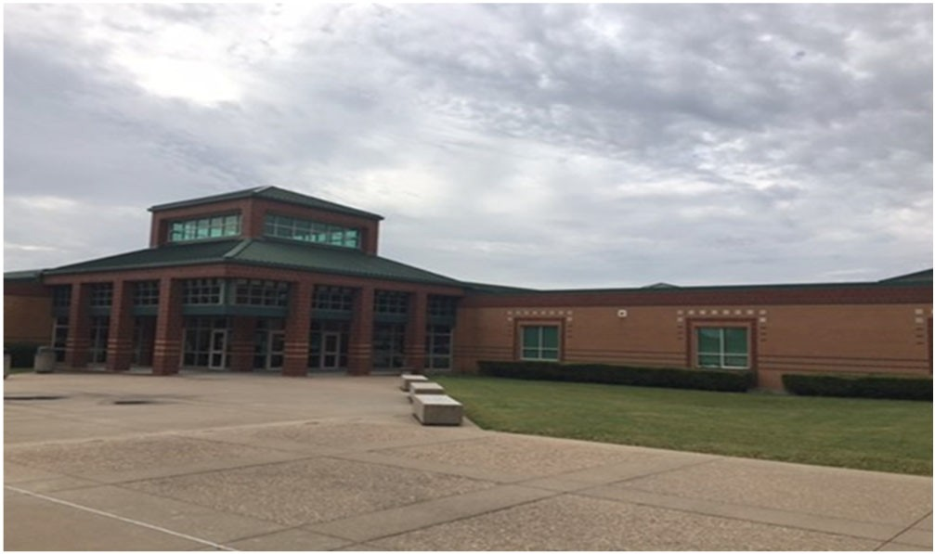B. J. Smith Elementary School

Stacy Bennett, Principal

A family that innovatively invests in their school and community.

 | 2017‐2018 | 2018‐2019 | 2019‐2020 | 2020‐2021 |  | 2021‐2022
Enrollment | 494 | 425 | 437 | 545 |  | 541
Student/Teacher Ratio  Staﬀ FTE's  Professional | 16.1  37.4 | 14.3  37.7 | 14.9  37.4 | 14.7  45.5
Teachers | 30.6 | 29.7 | 29.4 | 37.2
Professional Support | 4.8 | 6 | 6 | 6.3
Campus Administration  Support  Educational Aides | 2  12 | 2  10.9 | 2  10.8 | 2  12
Total | 49.4 | 48.6 | 48.2 | 57.5
Expenditures
 | 2018 AUDITED | 2019 AUDITED | 2020 AUDITED | 2021 UNAUDITED |  | 2022 BUDGET
Payroll Costs | $ 2,543,221 | $ 2,418,664 | $ 2,534,279 | $ 2,548,172 |  | $ 3,119,500
Contracted Services | $ 91,392 | $ 100,066 | $ 92,486 | $ 87,936 |  | $ 83,600
Supplies and Materials | $ 75,613 | $ 55,553 | $ 86,010 | $ 69,113 |  | $ 70,750
Other Operating Costs | $ 22,753 | $ 25,690 | $ 26,768 | $ 11,567 |  | $ 13,800
Fixed Assets | $ 5,746 | $ 71,730 | $ 4,745 | $ 265 |  | $ ‐
Grand Total | $ 2,738,726 | $ 2,671,703 | $ 2,744,288 | $ 2,717,053 |  | $ 3,287,650
Expenditures by Intent
 | 2018 AUDITED | 2019 AUDITED | 2020 AUDITED | 2021 UNAUDITED |  | 2022 BUDGET
Basic | $ 1,583,502 | $ 1,583,518 | $ 1,342,972 | $ 1,551,528 |  | $ 1,889,500
Gifted | $ 390 | $ 131 | $ ‐ | $ 411 |  | $ 650
Special Education | $ 260,022 | $ 228,241 | $ 276,918 | $ 247,231 |  | $ 286,000
Bilingual | $ 52,944 | $ 61,708 | $ 65,386 | $ 51,800 |  | $ 63,350
SCE to Support Title I | $ 63,876 | $ 67,246 | $ 73,608 | $ 141,268 |  | $ 171,800
Pre‐Kindergarten | $ 103,263 | $ 61,327 | $ 69,049 | $ 29,917 |  | $ 37,650
Pre‐Kindergarten‐Comp Ed | $ 37,758 | $ 16,664 | $ 18,434 | $ 37,664 |  | $ 46,500
Pre‐Kindergarten‐Bilingual Ed |  |  | $ ‐ | $ 26,164 |  | $ 31,950
Early Education Allotment | $ 189,401 |  |  | $ 56,448 |  | $ 68,150
Dyslexia |  |  | $ 65,995 | $ | ‐ | $ | ‐
Other Instructional Area | $ 636,971 | $ 652,869 | $ 642,525 | $ | 574,622 | $ | 692,100
Grand Total | $ 2,738,726 | $ 2,671,703 | $ 2,744,288 | $ | 2,717,053 | $ | 3,287,650
Per Student Cost | $ 5,544 | $ 6,286 | $ 6,280 | $ | 4,985 | $ | 6,077
Assessment Results | 2018 STAAR | 2019 STAAR | 2020 STAAR |  | 2021 STAAR |  | 2022 STAAR
Reading | 77% | 84% | NA |  | NA
Mathematics | 69% | 76% | NA |  | NA
Writing | 47% | 67% | NA |  | NA
Science | 80% | 87% | NA |  | NA

**Information obtained from the TEA PEIMS Standard Report and Munis Accounting

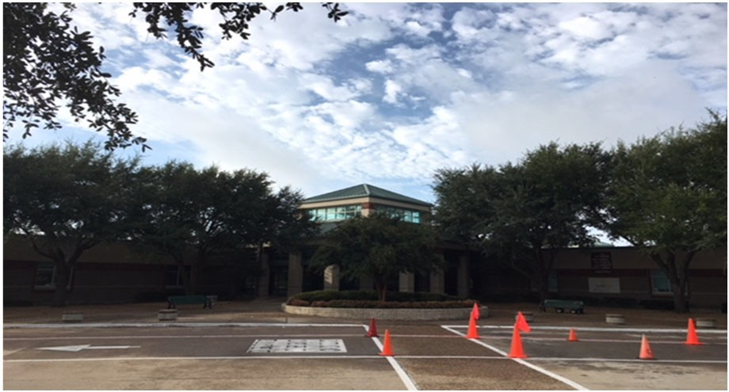Jay R. Thompson Elementary School

Bridgett Mitchell, Principal

Our mission is to ensure the academic and social‐emotional growth of ALL students every day.
 | 2017‐2018 | 2018‐2019 | 2019‐2020 | 2020‐2021 | 2021‐2022
Enrollment | 565 | 529 | 523 | 566 | 566
Student/Teacher Ratio | 17.1 | 16.1 | 16.9 | 16.4
Staﬀ FTE's Professional | 40.8 | 40.4 | 38.9 | 41.5
Teachers | 33 | 32.9 | 30.9 | 34.5
Professional Support | 5.8 | 5.5 | 6 | 5
Campus Administration  Support  Educational Aides | 2  8 | 2  6.9 | 2  8 | 2  8
Total | 48.8 | 47.3 | 46.9 | 49.5
Expenditures | 2018 AUDITED | 2019 AUDITED | 2020 AUDITED | 2021 UNAUDITED | 2022 BUDGET
Payroll Costs | $ 2,931,926 | $ 2,852,745 | $ 2,849,188 | $ 2,586,357 | $ 3,282,200
Contracted Services | $ 118,747 | $ 96,869 | $ 109,170 | $ 108,683 | $ 102,200
Supplies and Materials | $ 57,650 | $ 64,411 | $ 87,737 | $ 60,656 | $ 67,300
Other Operating Costs | $ 28,487 | $ 28,814 | $ 21,647 | $ 13,790 | $ 20,100
Fixed Assets $ 133,966 |  | $ 79,561 | $ 4,486 | $ 265 | $ ‐
Grand Total $ 3,270,776 |  | $ 3,122,400 | $ 3,072,229 | $ 2,769,751 | $ 3,471,800
Expenditures by Intent | 2018 AUDITED | 2019 AUDITED | 2020 AUDITED | 2021 UNAUDITED | 2022 BUDGET
Basic | $ 1,981,672 | $ 1,930,036 | $ 1,535,067 | $ 1,503,052 | $ 1,871,500
Gifted | $ 84 | $ ‐ | $ 84 | $ 84 | $ 650
Special Education | $ 280,429 | $ 315,197 | $ 344,196 | $ 344,462 | $ 392,900
Bilingual | $ 63,608 | $ 64,831 | $ 65,298 | $ 57,956 | $ 71,650
SCE to Support Title I | $ 103,701 | $ 72,411 | $ 100,214 | $ 69,967 | $ 91,300
Pre‐Kindergarten | $ 43,602 | $ 59,678 | $ 63,554 | $ 55,322 | $ 68,600
Pre‐Kindergarten Comp Ed | $ 17,462 | $ 16,723 | $ 17,415 | $ 31,466 | $ 38,200
Early Education Allotment |  |  | $ 195,647 | $ 55,444 | $ 68,000
Dyslexia |  |  | $ 68,810 | $ 59,317 | $ 73,100
Other Instructional Area | $ 780,219 | $ 663,522 | $ 681,944 | $ 592,682 | $ 795,900
Grand Total | $ 3,270,776 | $ 3,122,400 | $ 3,072,229 | $ 2,769,751 | $ 3,471,800
Per Student Cost | $ 5,789 | $ 5,902 | $ 5,874 | $ 4,894 | $ 6,134
Assessment Results | 2018 STAAR | 2019 STAAR | 2020 STAAR | 2021 STAAR | 2022 STAAR
Reading | 69% | 71% | NA | NA
Mathematics | 74% | 69% | NA | NA
Writing | 54% | 52% | NA | NA
Science | 61% | 69% | NA | NA

**Information obtained from the TEA PEIMS Standard Report and Munis Accounting

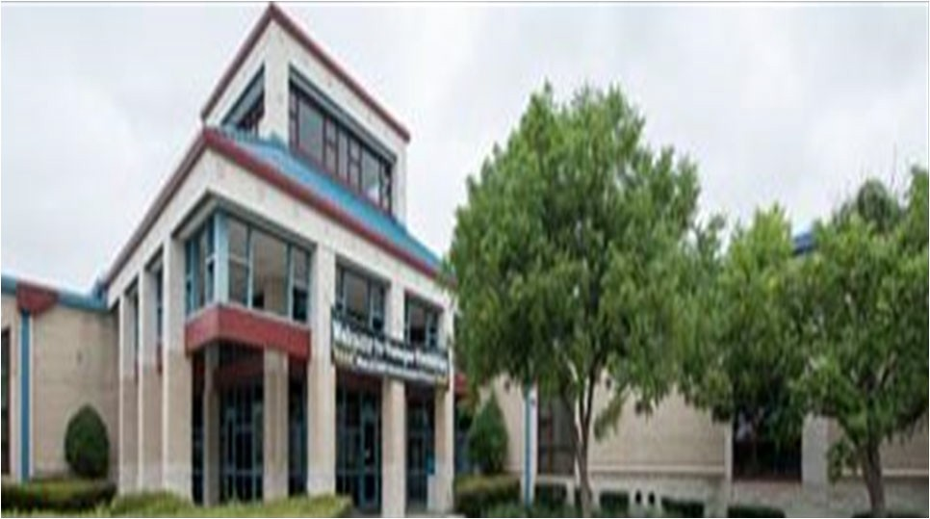Ben Tisinger Elementary School

Amanda Relf, Principal

Where We Inspire A LOVE for Learning in ALL Students

 | 2017‐2018 | 2018‐2019 | 2019‐2020 | 2020‐2021 | 2021‐2022
Enrollment | 824 | 770 | 660 | 631 | 648
Student/Teacher Ratio  Staﬀ FTE's  Professional | 17  58.4 | 16.1  55.9 | 15.9  50.5 | 15.4  50.9
Teachers | 48.4 | 47.9 | 41.5 | 41.1
Professional Support | 8 | 6 | 7 | 7.8
Campus Administration  Support  Educational Aides | 2  12 | 2  12 | 2  10.9 | 2  10.9
Total | 70.4 | 67.9 | 61.4 | 61.8
Expenditures | 2018 AUDITED | 2019 AUDITED | 2020 AUDITED | 2021 UNAUDITED | 2022 BUDGET
Payroll Costs | $ 3,770,165 | $ 3,797,528 | $ 3,511,891 | $ 3,013,425 | $ 3,770,150
Contracted Services | $ 117,337 | $ 149,956 | $ 132,594 | $ 87,970 | $ 102,500
Supplies and Materials | $ 76,754 | $ 96,980 | $ 90,813 | $ 62,012 | $ 86,250
Other Operating Costs | $ 29,859 | $ 32,752 | $ 20,014 | $ 17,500 | $ 14,200
Fixed Assets | $ 144,053 | $ 112,643 | $ 4,486 | $ 265 | $ ‐
Grand Total | $ 4,138,167 | $ 4,189,859 | $ 3,759,798 | $ 3,181,172 | $ 3,973,100
Expenditures by Intent
 | 2018 AUDITED | 2019 AUDITED | 2020 AUDITED | 2021 UNAUDITED | 2022 BUDGET
Basic | $ 2,699,946 | $ 2,765,237 | $ 2,014,569 | $ 1,869,217 | $ 2,325,686
Gifted | $ ‐ | $ ‐ | $ ‐ | $ ‐ | $ 650
Special Education | $ 398,165 | $ 392,837 | $ 376,001 | $ 302,928 | $ 371,000
Bilingual | $ 45,458 | $ 30,769 | $ 34,153 | $ 29,019 | $ 109,050
SCE to Support Title I | $ 212,514 | $ 207,828 | $ 256,574 | $ 241,439 | $ 236,200
Pre‐Kindergarten | $ 60,339 | $ 61,019 | $ 70,641 | $ 56,359 | $ 71,000
Pre‐Kindergarten Comp Ed | $ 25,720 | $ 26,262 | $ 27,690 | $ 40,400 | $ 79,800
Pre‐Kindergarten Bilingual Ed |  |  |  | $ ‐ | $ ‐
Early Education Allotment |  |  | $ 272,719 | $ 56,096 | $ 69,800
Other Instruction Area | $ 696,026 | $ 705,906 | $ 707,451 | $ 585,715 | $ 711,100
Grand Total | $ 4,138,167 | $ 4,189,859 | $ 3,759,798 | $ 3,181,172 | $ 3,973,100
Per Student Cost | $ 5,022 | $ 5,441 | $ 5,697 | $ 5,041 | $ 6,131
Assessment Results | 2018 STAAR | 2019 STAAR | 2020 STAAR | 2021 STAAR | 2022 STAAR
Reading | 59% | 68% | NA | NA
Mathematics | 71% | 77% | NA | NA
Writing | 36% | 46% | NA | NA
Science | 67% | 69% | NA | NA

**Information obtained from the TEA PEIMS Standard Report and Munis Accounting

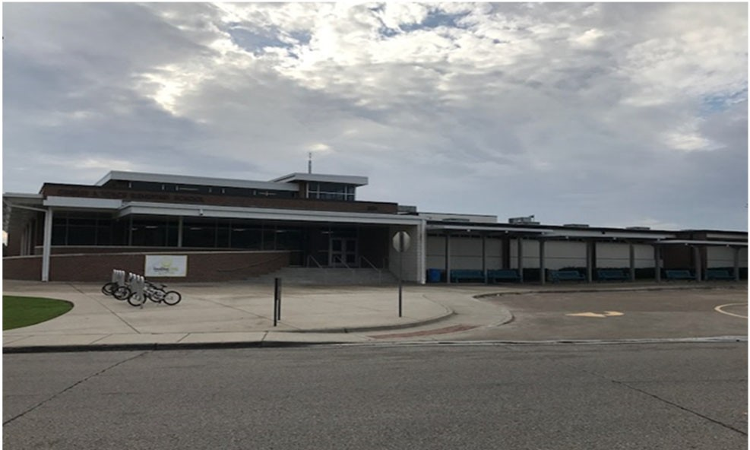Charles A. Tosch Elementary School

Amy Childress, Principal

Excellence Always
 | 2017‐2018 | 2018‐2019 | 2019‐2020 | 2020‐2021 | 2021‐2022
Enrollment | 872 | 664 | 594 | 617 | 585
Student/Teacher Ratio  Staﬀ FTE's Professional | 22  51.6 | 17.3  47 | 15.8  46.7 | 15.0  49.8
Teachers | 39.6 | 38.3 | 37.7 | 41.2
Professional Support | 9 | 6.7 | 7 | 6.6
Campus Administration  Support  Educational Aides | 3  11 | 2  10 | 2  13 | 2  14.9
Total | 62.6 | 57 | 59.7 | 64.7
Expenditures | 2018 AUDITED | 2019 AUDITED | 2020 AUDITED | 2021 UNAUDITED | 2022 BUDGET
Payroll Costs | $ 4,158,250 | $ 3,188,518 | $ 3,225,745 | $ 3,025,930 | $ 3,836,700
Contracted Services | $ 148,176 | $ 125,994 | $ 125,851 | $ 110,512 | $ 116,900
Supplies and Materials | $ 96,262 | $ 80,848 | $ 112,974 | $ 81,648 | $ 78,900
Other Operating Costs | $ 32,561 | $ 24,926 | $ 18,894 | $ 13,981 | $ 15,200
Fixed Assets | $ 1,200,606 | $ 201,435 | $ 122,506 | $ 6,138 | $ ‐
Grand Total | $ 5,635,854 | $ 3,621,721 | $ 3,605,971 | $ 3,238,208 | $ 4,047,700
Expenditures by Program Intent | 2018 AUDITED | 2019 AUDITED | 2020 AUDITED | 2021 UNAUDITED | 2022 BUDGET
Basic | $ 2,957,359 | $ 2,203,650 | $ 1,899,857 | $ 1,736,040 | $ 2,081,238
Gifted | $ 570 | $ ‐ | $ 318 | $ 760 | $ 650
Special Education | $ 305,794 | $ 191,132 | $ 303,368 | $ 318,373 | $ 357,500
Bilingual | $ 95,919 | $ 160,069 | $ 169,027 | $ 143,027 | $ 249,050
SCE to Support Title I | $ 229,306 | $ 169,680 | $ 178,401 | $ 144,058 | $ 250,300
Pre‐Kindergarten | $ 61,683 | $ 61,825 | $ 63,910 | $ 57,387 | $ 70,700
Pre‐Kindergarten Comp Ed | $ 21,256 | $ 21,690 | $ 22,421 | $ 57,114 | $ 65,800
Pre– Kindergarten‐Bilingual Ed | $ 26 | $ 686 | $ 886 | $ 52,935 | $ 75,300
Early Education Allotment |  |  | $ 219,372 | $ 100,672 | $ 129,500
Other Instruction Area | $ 1,963,942 | $ 812,989 | $ 748,409 | $ 627,841 | $ 768,700
Grand Total | $ 5,635,854 | $ 3,621,721 | $ 3,605,971 | $ 3,238,208 | $ 4,047,700
Per Student Cost | $ 6,463 | $ 5,454 | $ 6,071 | $ 5,248 | $ 6,919
Assessment Results | 2018 STAAR | 2019 STAAR | 2020 STAAR | 2021 STAAR | 2022 STAAR
Reading | 74% | 72% | NA | NA
Mathematics | 77% | 74% | NA | NA
Writing | 51% | 59% | NA | NA
Science | 83% | 72% | NA | NA

**Information obtained from the TEA PEIMS Standard Report and Munis Accounting

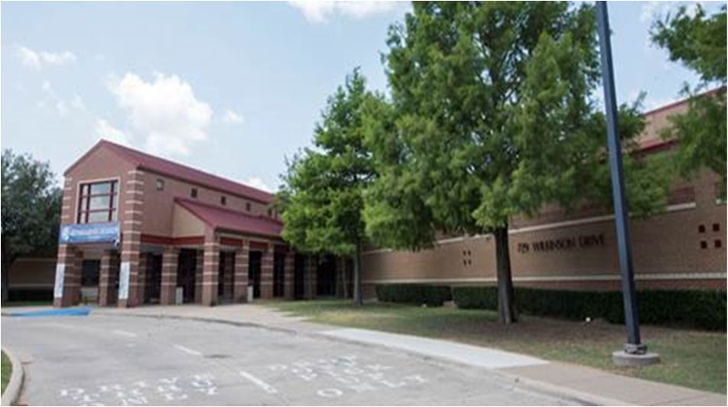Frank B. Agnew Middle School

TJ Reed, Principal

Our mission at Agnew Middle School is to cultivate an innovative learning experience while empower‐ ing our students to make their hope a reality.

 | 2017‐2018 | 2018‐2019 | 2019‐2020 | 2020‐2021 | 2021‐2022
Enrollment | 831 | 1231 | 1228 | 1227 | 1153
Student/Teacher Ratio Staﬀ FTE's  Professional | 9.3  101.6 | 16.5  88.2 | 16.4  90.3 | 16.6  89.3
Teachers | 89.4 | 74.8 | 74.9 | 73.9
Professional Support | 9.2 | 9.4 | 11.4 | 11.4
Campus Administration Support  Educational Aides | 4  7 | 4  5 | 4  6 | 4  5
Total | 109.6 | 93.2 | 96.3 | 94.3
Expenditures | 2018 AUDITED | 2019 AUDITED | 2020 AUDITED | 2021 UNAUDITED | 2022 BUDGET
Payroll Costs | $ 4,414,238 | $ 5,765,103 | $ 5,961,667 | $ 5,089,125 | $ 6,606,050
Contracted Services | $ 205,404 | $ 222,528 | $ 191,706 | $ 182,258 | $ 219,550
Supplies and Materials | $ 205,429 | $ 178,227 | $ 203,275 | $ 216,488 | $ 202,900
Other Operating Costs | $ 128,401 | $ 145,359 | $ 138,677 | $ 84,956 | $ 123,500
Fixed Assets | $ 10,072,624 | $ 678,609 | $ 48,066 | $ 122,089 | $ ‐
Grand Total | $ 15,026,096 | $ 6,989,827 | $ 6,543,391 | $ 5,694,916 | $ 7,152,000
Expenditures by Intent | 2018 AUDITED | 2019 AUDITED | 2020 AUDITED | 2021 UNAUDITED | 2022 BUDGET
Basic | $ 2,853,813 | $ 4,012,785 | $ 3,864,716 | $ 3,588,194 | $ 4,310,200
Gifted | $ 70,454 | $ 40,828 | $ 66,305 | $ 49,802 | $ 65,500
Career & Technology | $ ‐ |  | $ 90,452 | $ 92,058 | $ 118,000
Special Education | $ 514,948 | $ 553,528 | $ 625,488 | $ 438,478 | $ 546,300
Compensatory | $ 20,228 | $ ‐ |  |  | $ ‐
Bilingual | $ 65,407 | $ 60,047 | $ ‐ | $ 2,901 | $ 6,050
SCE to Support Title 1 | $ 138,191 | $ 194,772 | $ 424,000 | $ 313,846 | $ 470,700
Athletics | $ 101,974 | $ 110,929 | $ 122,742 | $ 106,499 | $ 122,100
Other Instructional Areas | $ 11,261,081 | $ 2,016,937 | $ 1,349,688 | $ 1,103,139 | $ 1,513,150
Grand Total | $ 15,026,096 | $ 6,989,827 | $ 6,543,391 | $ 5,694,916 | $ 7,152,000
Per Student Cost | $ 18,082 | $ 5,678 | $ 5,528 | $ 4,641 | $ 6,203
Assessment Results | 2018 STAAR | 2019 STAAR | 2020 STAAR | 2021 STAAR | 2022 STAAR
Reading | 70% | 66% | NA | NA
Mathematics | 80% | 77% | NA | NA
Writing | 54% | 60% | NA | NA
Social Studies | 55% | 51% | NA | NA
Science | 67% | 80% | NA | NA

**Information obtained from the TEA PEIMS Standard Report and Munis Accounting
The 2018 year a wing was added from 199. This is what added to the high expenditure per student.

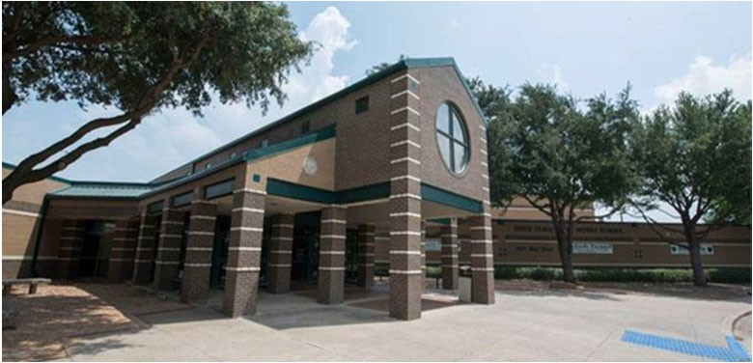Judge Frank Berry Middle School

Angela Wiggins, Principal

Love First: We believe in creating a loving culture of community and value built on positive relationships, servant leadership, and mutual respect.
Standards Focused: We believe that beginning with the end in mind includes: setti ng high expectations and achievable goals, getti ng to know our students through engaging and creative activities, delivering TEKS‐focused, diﬀerentiated instruction, and preparing students to be lifelong learners.
Bear PRIDE: WE believe unity, consistency, and a culture of honor exemplifies Bear PRIDE.
 | 2017‐2018 | 2018‐2019 | 2019‐2020 | 2020‐2021 | 2021‐2022
Enrollment | 904 | 1112 | 1103 | 613 | 601
Student/Teacher Ratio Staﬀ FTE's  Professional | 14.3  73.4 | 16  74.9 | 16.5  79 | 14.2  52
Teachers | 63 | 69.6 | 67 | 43.1
Professional Support | 6.4 | 6.3 | 8 | 5.9
Campus Administration Support  Educational Aides | 4  8.8 | 4  10 | 4  7.9 | 3  5
Total | 82.2 | 89.9 | 86.9 | 57
Expenditures | 2018 AUDITED | 2019 AUDITED | 2020 AUDITED | 2021 UNAUDITED | 2022 BUDGET
Payroll Costs | $ 4,549,389 | $ 5,387,070 | $ 5,300,881 | $ 3,205,842 | $ 3,994,700
Contracted Services | $ 251,845 | $ 215,230 | $ 193,388 | $ 220,816 | $ 271,150
Supplies and Materials | $ 164,673 | $ 180,646 | $ 190,033 | $ 148,585 | $ 153,950
Other Operating Costs | $ 147,807 | $ 132,873 | $ 113,739 | $ 78,327 | $ 115,100
Fixed Assets | $ 30,063 | $ 1,350 | $ 32,794 | $ 132,444 | $ ‐
Grand Total | $ 5,143,778 | $ 5,917,169 | $ 5,830,835 | $ 3,786,014 | $ 4,534,900
Expenditures by Intent
2018 AUDITED |  | 2019 AUDITED | 2020 AUDITED 2021 UNAUDITED 2022 BUDGET
Basic | $ 2,987,748 | $ 3,510,270 | $ 3,202,840 | $ 1,909,245 | $ 2,186,000
Gifted | $ 65,737 | $ 140,525 | $ 169,745 | $ 125,536 | $ 154,800
Career & Technology |  |  | $ 74,991 | $ 71,299 | $ 89,200
Special Education | $ 407,820 | $ 560,159 | $ 686,766 | $ 309,227 | $ 401,600
Compensatory | $ 201,760 | $ ‐ |  |  | $ ‐
Bilingual | $ 63,835 | $ 68,719 | $ 61,435 | $ ‐ | $ 1,250
SCE to Support Title 1 | $ ‐ | $ 216,458 | $ 260,623 | $ 242,503 | $ 290,400
Athletics | $ 105,100 | $ 101,097 | $ 126,914 | $ 101,701 | $ 116,100
Other Instructional Areas | $ 1,311,779 | $ 1,319,941 | $ 1,247,521 | $ 1,026,502 | $ 1,295,550
Grand Total | $ 5,143,778 | $ 5,917,169 | $ 5,830,835 | $ 3,786,014 | $ 4,534,900
Per Student Cost | $ 5,690 | $ 5,321 | $ 5,286 | $ 5,530 | $ 7,546
Assessment Results | 2018 STAAR | 2019 STAAR | 2020 STAAR | 2021 STAAR | 2022 STAAR
Reading | 67% | 75% | NA | NA
Mathematics | 77% | 83% | NA | NA
Writing | 61% | 70% | NA | NA
Social Studies | 64% | 69% | NA | NA
Science | 72% | 87% | NA | NA

**Information obtained from the TEA PEIMS Standard Report and Munis Accounting

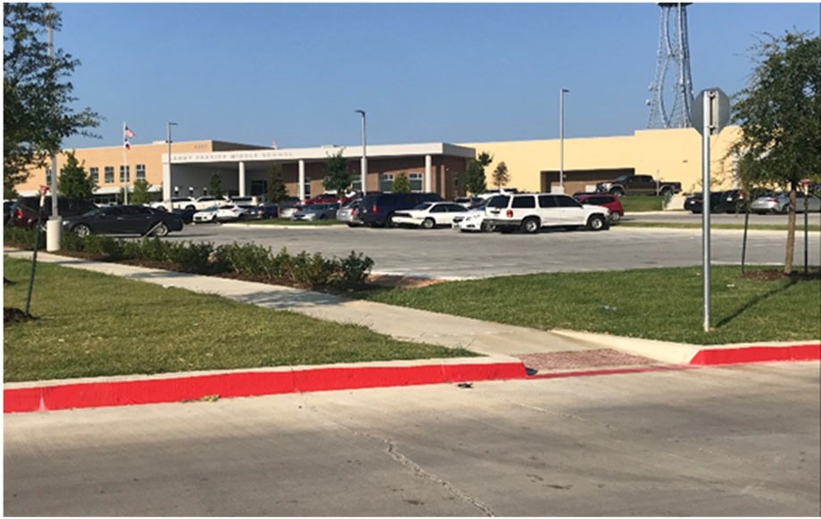Lanny Frasier Middle School

Kristi Morse, Principal

 | 2017‐2018 | 2018‐2019 | 2019‐2020 | 2020‐2021 | 2021‐2022
Enrollment |  | 1225 | 1200 | 1126 | 1087
Student/Teacher Ratio  Staﬀ FTE's  Professional |  | 17.7  82.9 | 16.4  88.8 | 15.4  88.8
Teachers |  | 69.5 | 73.1 | 73
Professional Support |  | 9.4 | 11.7 | 11.5
Campus Administration  Support  Educational Aides |  | 4  8.9 | 4  7.8 | 4  9
Total |  | 91.8 | 96.6 | 97.5
Expenditures
 | 2018 AUDITED | 2019 AUDITED | 2020 AUDITED | 2021 UNAUDITED | 2022 BUDGET
Payroll Costs | $ 122,326 | $ 5,716,744 | $ 5,974,674 | $ 5,310,137 | $ 6,491,200
Contracted Services | $ 26,434 | $ 214,809 | $ 207,743 | $ 140,787 | $ 218,300
Supplies and Materials | $ 676,781 | $ 269,980 | $ 158,240 | $ 142,766 | $ 179,250
Other Operating Costs | $ 5,883 | $ 132,694 | $ 113,906 | $ 84,130 | $ 127,100
Fixed Assets | $ 1,149,075 | $ 62,918 | $ 33,882 | $ 2,069 | $ ‐
Grand Total | $ 1,980,499 | $ 6,397,146 | $ 6,488,444 | $ 5,679,890 | $ 7,015,850
Expenditures by Intent | 2018 AUDITED | 2019 AUDITED | 2020 AUDITED | 2021 UNAUDITED | 2022 BUDGET
Basic | $ 11,726 | $ 3,642,937 | $ 3,594,636 | $ 3,214,675 | $ 3,843,850
Gifted | $ ‐ | $ ‐ | $ ‐ | $ ‐ | $ 1,000
Career & Technology | $ ‐ | $ ‐ | $ 98,128 | $ 74,178 | $ 88,200
Special Education | $ (253) | $ 966,852 | $ 1,010,015 | $ 885,191 | $ 1,090,500
Compensatory | $ ‐ $ ‐
Bilingual | $ ‐ | $ 63,782 | $ 65,336 | $ 55,526 | $ 68,950
SCE to Support Title 1 | $ ‐ | $ 192,135 | $ 321,273 | $ 311,073 | $ 413,000
Athletics | $ 1,200 | $ 101,479 | $ 123,299 | $ 111,288 | $ 117,700
Other Instructional Areas | $ 1,967,825 | $ 1,429,961 | $ 1,275,757 | $ 1,027,959 | $ 1,392,650
Grand Total | $ 1,980,499 | $ 6,397,146 | $ 6,488,444 | $ 5,679,890 | $ 7,015,850
Per Student Cost |  | $ 5,222 | $ 5,407 | $ 5,044 | $ 6,454
Assessment Results | 2018 STAAR | 2019 STAAR | 2020 STAAR | 2021 STAAR | 2022 STAAR
Reading |  | 65% | NA | NA
Mathematics |  | 73% | NA | NA
Writing |  | 68% | NA | NA
Social Studies |  | 54% | NA | NA
Science |  | 78% | NA | NA

**Information obtained from the TEA PEIMS Standard Report and Munis Accounting

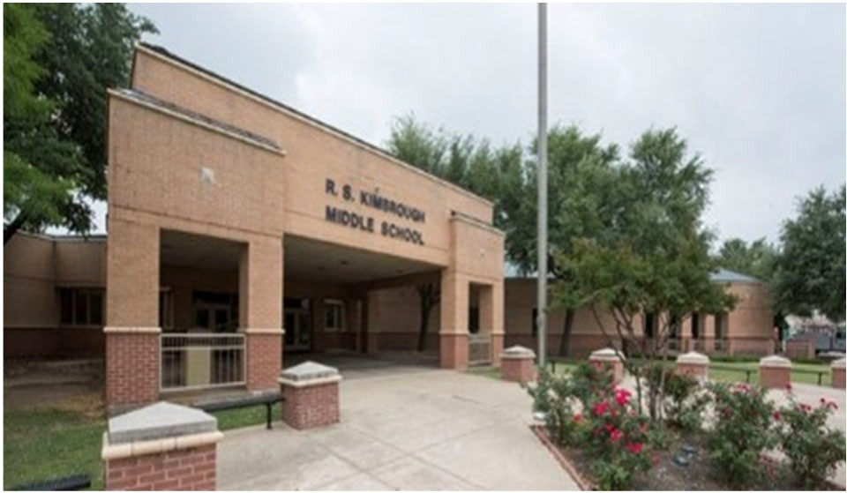R.B. Kimbrough Middle School

Chris Brott, Principal

EVERY student EVERY day
 | 2017‐2018 |  | 2018‐2019 | 2019‐2020 | 2020‐2021 | 2021‐2022
Enrollment | 825 |  | 1342 | 1357 | 1260 | 1188
Student/Teacher Ratio  Staﬀ FTE's  Professional | 12.5  77.6 |  | 18  89 | 17.3  94.6 | 16.3  92.4
Teachers | 66.2 |  | 74.6 | 78.6 | 77.4
Professional Support | 7.4 |  | 9.4 | 12 | 11
Campus Administration  Support  Educational Aides | 4  7.6 |  | 5  7 | 4  8 | 4  9.7
Total | 85.2 |  | 96 | 102.6 | 102.1
Expenditures | 2018 AUDITED |  | 2019 AUDITED | 2020 AUDITED | 2021 UNAUDITED | 2022 BUDGET
Payroll Costs | $ 4,535,481 |  | $ 5,948,195 | $ 6,463,157 | $ 5,451,017 | $ 6,676,200
Contracted Services | $ 251,389 |  | $ 244,185 | $ 215,777 | $ 170,569 | $ 183,950
Supplies and Materials | $ 174,168 |  | $ 211,912 | $ 172,442 | $ 193,556 | $ 209,050
Other Operating Costs | $ 142,716 |  | $ 137,546 | $ 120,042 | $ 89,615 | $ 135,350
Fixed Assets | $ 5,339,419 |  | $ 1,283,699 | $ 23,459 | $ 157,533 | $ ‐
Grand Total | $ 10,443,173 |  | $ 7,825,538 | $ 6,994,876 | $ 6,062,291 | $ 7,204,550
Expenditures by Program Intent
2018 AUDITED |  |  | 2019 AUDITED | 2020 AUDITED 2021 UNAUDITED 2022 BUDGET
Basic | $ 2,819,943 |  | $ 3,831,188 | $ 3,849,565 | $ 3,505,407 | $ 3,985,600
Gifted | $ 181,194 |  | $ 164,494 | $ 191,010 | $ 217,142 | $ 266,600
Career & Technology |  |  |  | $ 61,363 | $ 81,315 | $ 84,900
Special Education | $ 647,443 |  | $ 801,895 | $ 989,752 | $ 808,483 | $ 1,001,200
Compensatory | $ 53,308 |  | $ 75 |  |  | $ ‐
Bilingual | $ 59,836 |  | $ 60,808 | $ 61,738 | $ 52,327 | $ 63,950
SCE to Support Title 1 | $ | ‐ | $ 234,370 | $ 376,502 | $ 274,628 | $ 343,500
Athletics | $ | 104,915 | $ 101,214 | $ 127,892 | $ 110,566 | $ 125,000
Other Instructional Areas | $ | 6,576,533 | $ 2,631,494 | $ 1,337,055 | $ 1,012,423 | $ 1,333,800
Grand Total | $ | 10,443,173 | $ 7,825,538 | $ 6,994,876 | $ 6,062,291 | $ 7,204,550
Per Student Cost | $ | 12,658 | $ 5,831 | $ 5,155 | $ 4,811 | $ 6,064
Assessment Results |  | 2018 STAAR | 2019 STAAR | 2020 STAAR | 2021 STAAR | 2022 STAAR
Reading |  | 74% | 71% | NA | NA
Mathematics |  | 78% | 83% | NA | NA
Writing |  | 70% | 68% | NA | NA
Social Studies |  | 68% | 62% | NA | NA
Science |  | 75% | 81% | NA | NA

**Information obtained from the TEA PEIMS Standard Report and Munis Accounting The 2018 school year 199 funds were used to build a wing.

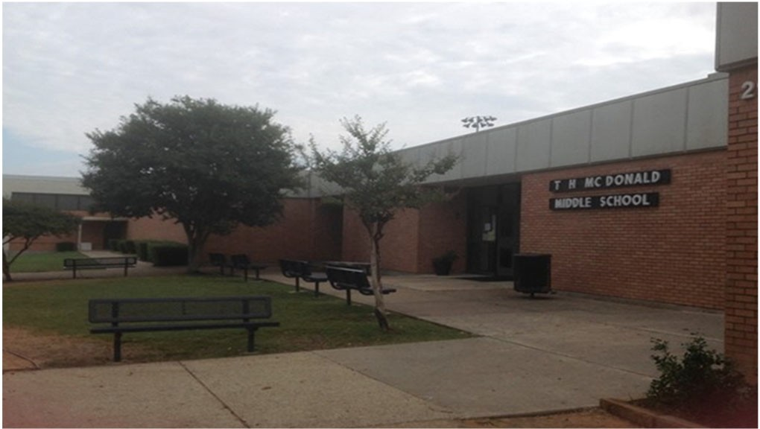T. H. McDonald Middle School

Jordan Simmons, Principal

Believe in all students
 | 2017‐2018 | 2018‐2019 | 2019‐2020 | 2020‐2021 | 2021‐2022
Enrollment | 1002 | 883 | 908 | 923 | 840
Student/Teacher Ratio | 17.9 | 16.2 | 16.6 | 16.2
Staﬀ FTE's
Professional | 67.3 | 66.7 | 68.1 | 70.2
Teachers | 56 | 54.5 | 54.8 | 56.9
Professional Support | 8.3 | 9.2 | 10.3 | 10.2
Campus Administration | 3 | 3 | 3 | 3.1
Support
Educational Aides | 5 | 5 | 5 | 9
Total | 72.3 | 71.7 | 73.1 | 79.2
Expenditures
 | 2018 AUDITED | 2019 AUDITED | 2020 AUDITED | 2021 UNAUDITED | 2022 BUDGET
Payroll Costs | $ 5,212,187 | $ 4,501,909 | $ 4,624,538 | $ 4,165,577 | $ 5,209,600
Contracted Services | $ 214,113 | $ 191,294 | $ 173,627 | $ 162,158 | $ 193,800
Supplies and Materials | $ 195,910 | $ 166,059 | $ 166,098 | $ 143,694 | $ 173,300
Other Operating Costs | $ 128,709 | $ 134,217 | $ 121,602 | $ 79,325 | $ 132,250
Fixed Assets | $ 2,222,996 | $ 475,038 | $ 49,424 | $ 49,438 | $ ‐
Grand Total | $ 7,973,914 | $ 5,468,516 | $ 5,135,289 | $ 4,600,192 | $ 5,708,950
Expenditures by Intent
2018 AUDITED |  | 2019 AUDITED | 2020 AUDITED 2021 UNAUDITED 2022 BUDGET
Basic | $ 3,670,329 | $ 2,999,687 | $ 2,854,464 | $ 2,597,588 | $ 3,074,900
Gifted | $ 53,347 | $ 30,200 | $ 45,159 | $ 36,792 | $ 46,600
Career & Technology |  |  | $ 108,234 | $ 75,483 | $ 93,600
Special Education | $ 631,656 | $ 507,483 | $ 568,121 | $ 580,733 | $ 713,500
Compensatory | $ 379 |  |  |  | $ ‐
Bilingual | $ 9,894 | $ 9,549 | $ 86 | $ ‐ | $ 250
SCE to Support Title I | $ 157,981 | $ 229,250 | $ 263,775 | $ 237,684 | $ 396,400
Athletics | $ 107,640 | $ 94,668 | $ 114,675 | $ 108,895 | $ 125,200
Other Instructional | $ 3,342,688 | $ 1,597,679 | $ 1,180,775 | $ 963,016 | $ 1,258,500
Grand Total | $ 7,973,914 | $ 5,468,516 | $ 5,135,289 | $ 4,600,192 | $ 5,708,950
Per Student Cost | $ 7,958 | $ 6,193 | $ 5,656 | $ 4,984 | $ 6,796
Assessment Results | 2018 STAAR | 2019 STAAR | 2020 STAAR | 2021 STAAR | 2022 STAAR
Reading | 69% | 68% | NA | NA
Mathematics | 78% | 81% | NA | NA
Writing | 60% | 61% | NA | NA
Social Studies | 55% | 58% | NA | NA
Science | 70% | 77% | NA | NA

**Information obtained from the TEA PEIMS Standard Report and Munis Accounting

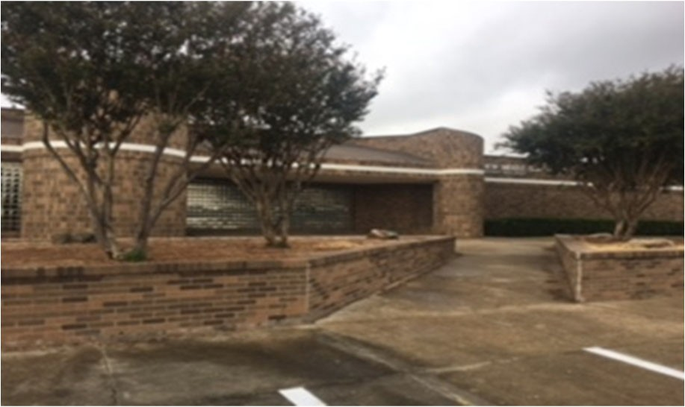A.C. New Middle School

Regina Jackson, Principal

Knights boldly learn and work together to grow as a fami‐
ly!
 | 2017‐2018 | 2018‐2019 | 2019‐2020 | 2020‐2021 | 2021‐2022
Enrollment | 926 | 910 | 935 | 831 | 797
Student/Teacher Ratio Staﬀ FTE's  Professional | 16.5  65.2 | 13.1  69.7 | 15.7  70.2 | 14.1  69.6
Teachers | 56 | 60.3 | 59.5 | 59.1
Professional Support | 6.2 | 6.4 | 7.7 | 7.5
Campus Administration Support  Educational Aides | 3  5 | 3  5 | 3  7 | 3  7
Total | 70.2 | 74.7 | 77.2 | 76.6
Expenditures By Character | 2018 AUDITED | 2019 AUDITED | 2020 AUDITED | 2021 UNAUDITED | 2022 BUDGET
Payroll Costs | $ 4,833,279 | $ 4,568,547 | $ 4,730,067 | $ 4,126,214 | $ 5,063,100
Contracted Services | $ 215,436 | $ 183,642 | $ 198,748 | $ 147,385 | $ 179,850
Supplies and Materials | $ 161,123 | $ 191,632 | $ 169,299 | $ 169,388 | $ 184,350
Other Operating Costs | $ 122,295 | $ 118,146 | $ 98,255 | $ 72,908 | $ 102,700
Fixed Assets | $ 615,951 | $ 50,355 | $ 194,619 | $ 10,523 | $ ‐
Grand Total | $ 5,948,084 | $ 5,112,322 | $ 5,390,988 | $ 4,526,417 | $ 5,530,000
Expenditures by Program Intent
 | 2018 AUDITED | 2019 AUDITED | 2020 AUDITED | 2021 UNAUDITED | 2022 BUDGET
Basic | $ 3,237,251 | $ 2,883,646 | $ 3,035,675 | $ 2,475,480 | $ 2,873,700
Gifted | $ 60,809 | $ 51,424 | $ 44,766 | $ 9,779 | $ 13,000
Career & Technology |  |  | $ 85,174 | $ 91,622 | $ 114,400
Special Education | $ 552,982 | $ 535,414 | $ 551,983 | $ 481,184 | $ 607,100
Compensatory |  | $ 26 |  |  | $ ‐
Bilingual | $ 17 | $ 63,118 | $ 71,877 | $ 60,207 | $ 75,450
SCE to Support Title I | $ 245,875 | $ 298,361 | $ 311,778 | $ 296,256 | $ 457,500
Dyslexia |  |  |  | $ 58,104 | $ 71,000
Athletics | $ 104,847 | $ 98,853 | $ 121,010 | $ 102,336 | $ 115,900
Other Instructional | $ 1,746,303 | $ 1,181,481 | $ 1,168,725 | $ 951,449 | $ 1,201,950
Grand Total | $ 5,948,084 | $ 5,112,322 | $ 5,390,988 | $ 4,526,417 | $ 5,530,000
Per Student Cost | $ 6,423 | $ 5,618 | $ 5,766 | $ 5,447 | $ 6,939
Assessment Results | 2018 STAAR | 2019 STAAR | 2020 STAAR | 2021 STAAR | 2022 STAAR
Reading | 69% | 63% | NA | NA
Mathematics | 81% | 75% | NA | NA
Writing | 55% | 55% | NA | NA
Social Studies | 53% | 57% | NA | NA
Science | 74% | 76% | NA | NA

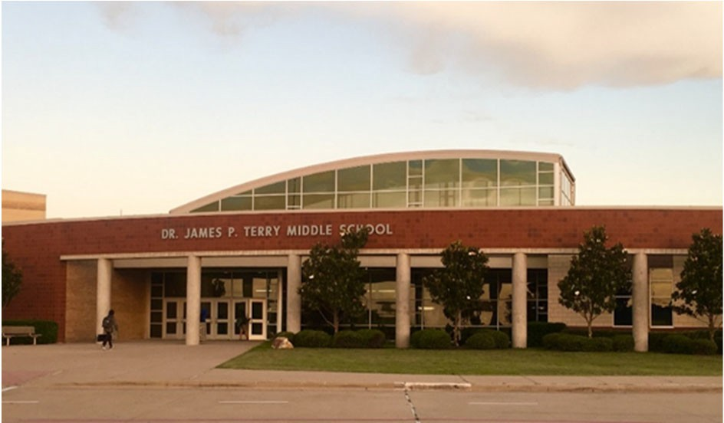Dr. James P. Terry Middle School
Kelley Prewitt, Principal

At Terry M.S. we believe in a respectful, collaborative, and student
‐centered environment where teachers build relationships with students and peers, and students are empowered to think inde‐ pendently. Their accomplishments are celebrated all while pro‐ moting a culture of positive behavior.
 | 2017‐2018 | 2018‐2019 | 2019‐2020 | 2020‐2021 | 2021‐2022
Enrollment | 896 | 1425 | 1463 | 1039 | 1056
Student/Teacher Ratio Staﬀ FTE's  Professional | 12  84.7 | 16.6  96.4 | 17.5  98.1 | 15.4  81
Teachers | 74.5 | 86 | 83.5 | 67.5
Professional Support | 6.2 | 7.4 | 10.6 | 9.5
Campus Administration Support  Educational Aides | 4  8.7 | 3  8.8 | 4  8.9 | 4  7.8
Total | 93.4 | 105.2 | 107 | 88.8
Expenditures | 2018 AUDITED | 2019 AUDITED | 2020 AUDITED | 2021 UNAUDITED | 2022 BUDGET
Payroll Costs | $ 4,443,200 | $ 6,648,852 | $ 6,720,318 | $ 5,036,664 | $ 5,894,800
Contracted Services | $ 266,888 | $ 265,385 | $ 369,561 | $ 183,099 | $ 270,850
Supplies and Materials | $ 189,633 | $ 209,260 | $ 199,359 | $ 117,127 | $ 172,950
Other Operating Costs | $ 124,837 | $ 141,558 | $ 118,904 | $ 90,055 | $ 131,350
Fixed Assets | $ 123,207 | $ 14,477 | $ 194,814 | $ 77,374 | $ ‐
Grand Total | $ 5,147,765 | $ 7,279,531 | $ 7,602,956 | $ 5,504,319 | $ 6,469,950
Expenditures by Intent
2018 AUDITED |  | 2019 AUDITED | 2020 AUDITED 202 UNAUDITED 2022 BUDGET
Basic | $ 3,013,303 | $ 4,591,491 | $ 4,433,425 | $ 3,167,706 | $ 3,582,700
Gifted | $ 65,703 | $ 61,419 | $ 55,181 | $ 37,409 | $ 47,500
Career & Technology |  |  | $ 100,324 | $ 72,468 | $ 90,200
Special Education | $ 640,093 | $ 863,533 | $ 910,315 | $ 681,771 | $ 844,800
Compensatory | $ 9,011 | $ ‐ |  |  | $ ‐
Bilingual | $ ‐ | $ 113,290 | $ 123,213 | $ 55,881 | $ 69,650
SCE to Support Title 1 | $ ‐ | $ 160,470 | $ 368,924 | $ 293,880 | $ 357,900
Dyslexia |  |  |  | $ 62,042 | $ 74,000
Athletics | $ 97,982 | $ 99,527 | $ 127,883 | $ 105,223 | $ 117,100
Other Instructional Areas | $ 1,321,673 | $ 1,389,801 | $ 1,483,690 | $ 1,027,939 | $ 1,286,100
Grand Total | $ 5,147,765 | $ 7,279,531 | $ 7,602,956 | $ 5,504,319 | $ 6,469,950
Per Student Cost | $ 5,745 | $ 5,108 | $ 5,197 | $ 5,298 | $ 6,127
Assessment Results | 2018 STAAR | 2019 STAAR | 2020 STAAR | 2021 STAAR | 2022 STAAR
Reading | 74% | 65% | NA | NA
Mathematics | 78% | 73% | NA | NA
Writing | 75% | 62% | NA | NA
Social Studies | 76% | 63% | NA | NA
Science | 82% | 74% | NA | NA

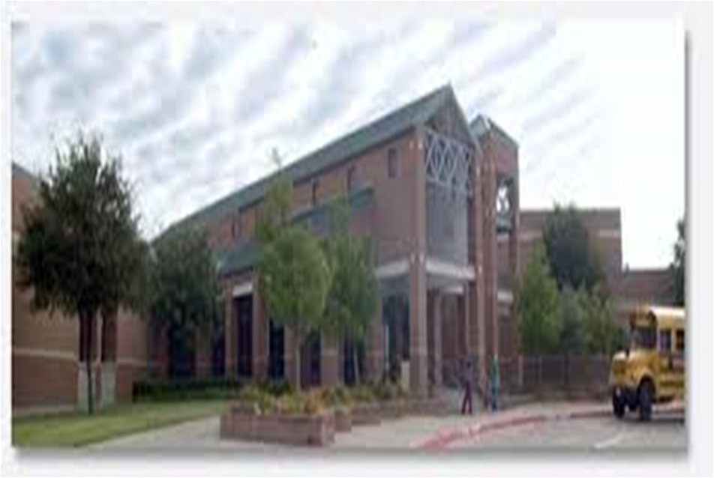
Ed F. Vanston Middle School
Melissa Smith, Principal

To establish an educational environment that produces productive members of society who are creative, innovative, and global think‐ ers. To utilize strategies that promote innovation through problem solving, collaboration and critical thinking. To provide a positive learning environment that empowers our students to succeed aca‐ demically, as well as acquiring skills necessary to succeed in the 21st century.

Enrollment | 2017‐2018  805 | 2018‐2019  913 | 2019‐2020  923 | 2020‐2021  847 | 2021‐2022  856
Student/Teacher Ratio Staﬀ FTE's  Professional | 13.3  70.8 | 15.3  71.2 | 15  73.2 | 73.2
Teachers | 60.3 | 59.8 | 61.7 | 60.2
Professional Support | 7.5 | 8.4 | 8.5 | 10
Campus Administration Support  Educational Aides | 3  8 | 3  9 | 3  10 | 3  9.6
Total | 78.8 | 80.2 | 83.2 | 82.8
Expenditures | 2018 AUDITED | 2019 AUDITED | 2020 AUDITED | 2021 UNAUDITED | 2022 BUDGET
Payroll Costs | $ 4,409,129 | $ 4,753,161 | $ 4,836,808 | $ 4,300,747 | $ 5,385,900
Contracted Services | $ 204,699 | $ 191,231 | $ 191,240 | $ 168,690 | $ 199,200
Supplies and Materials | $ 168,601 | $ 170,985 | $ 173,851 | $ 125,454 | $ 167,350
Other Operating Costs | $ 136,068 | $ 147,096 | $ 119,845 | $ 76,895 | $ 132,200
Fixed Assets | $ 101,923 | $ 31,379 | $ 192,080 | $ ‐ | $ ‐
Grand Total | $ 5,020,419 | $ 5,293,852 | $ 5,513,823 | $ 4,671,786 | $ 5,884,650
Expenditures by Intent | 2018 AUDITED | 2019 AUDITED | 2020 AUDITED | 2021 UNAUDITED | 2022 BUDGET
Basic | $ 2,699,503 | $ 3,032,627 | $ 3,017,314 | $ 2,545,521 | $ 3,169,100
Gifted | $ 41,326 | $ 35,698 | $ 56,999 | $ 39,774 | $ 48,800
Career & Technology | $ ‐ | $ ‐ | $ 86,435 | $ 75,302 | $ 86,500
Special Education | $ 672,258 | $ 636,329 | $ 738,816 | $ 640,356 | $ 796,000
Bilingual | $ 49,030 | $ 64,734 | $ 68,261 | $ 61,032 | $ 75,650
SCE to Support Title I | $ 214,555 | $ 210,416 | $ 242,207 | $ 239,528 | $ 326,600
Athletics | $ 108,152 | $ 92,894 | $ 126,761 | $ 102,327 | $ 115,300
Other Instructional | $ 1,235,595 | $ 1,221,154 | $ 1,177,031 | $ 967,946 | $ 1,266,700
Grand Total | $ 5,020,419 | $ 5,293,852 | $ 5,513,823 | $ 4,671,786 | $ 5,884,650
Per Student Cost | $ 6,237 | $ 5,798 | $ 5,974 | $ 5,516 | $ 6,875
Assessment Results | 2018 STAAR | 2019 STAAR | 2020 STAAR | 2021 STAAR | 2022 STAAR
Reading | 68% | 65% | NA | NA
Mathematics | 79% | 80% | NA | NA
Writing | 55% | 63% | NA | NA
Social Studies | 43% | 48% | NA | NA
Science | 80% | 77% | NA | NA

**Information obtained from the TEA PEIMS Standard Report and Munis Accounting

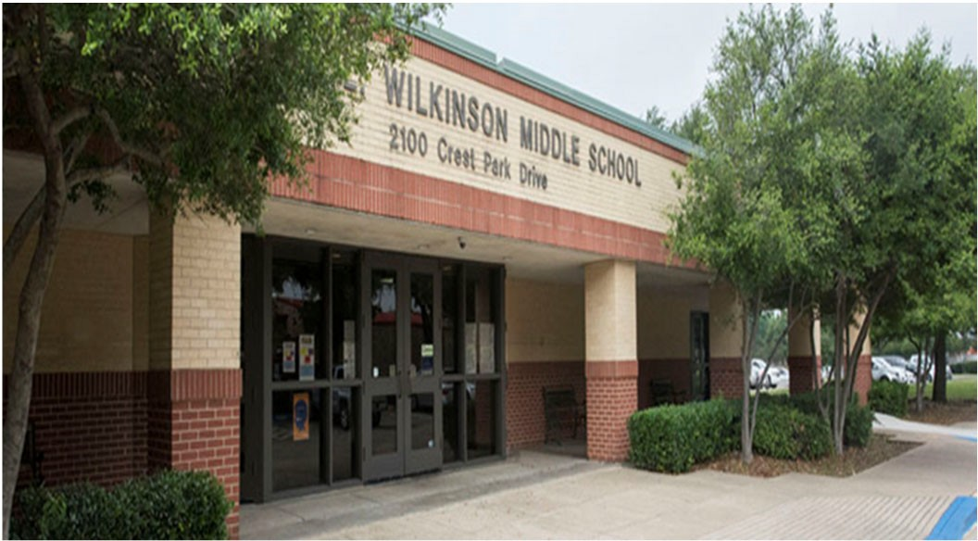Walter L. Wilkinson Middle School

Tomika Johnson, Principal

Wilkinson Vision‐Catch Greatness
 |  | 2017‐2018 | 2018‐2019 | 2019‐2020 | 2020‐2021 | 2021‐2022
Enrollment |  | 974 | 776 | 790 | 797 | 724
Student/Teacher Ratio |  | 16.1 | 13 | 14 | 13.7
Staﬀ FTE's
Professional |  | 69.2 | 69 | 66.9 | 68.2
Teachers |  | 60.5 | 59.8 | 56.6 | 58.3
Professional Support |  | 5.7 | 6.2 | 7.3 | 6.9
Campus Administration |  | 3 | 3 | 3 | 3
Support
Educational Aides | 9.9 |  | 9 | 9.6 | 8.7
Total | 79.1 |  | 78 | 76.5 | 76.9
Expenditures By Character
 | 2018 AUDITED |  | 2019 AUDITED | 2020 AUDITED | 2021 UNAUDITED | 2022 BUDGET
Payroll Costs | $ 4,835,694 |  | $ 4,547,022 | $ 4,601,515 | $ 3,916,562 | $ 4,880,400
Contracted Services | $ 268,666 |  | $ 252,691 | $ 222,485 | $ 168,419 | $ 195,050
Supplies and Materials | $ 168,519 |  | $ 162,198 | $ 154,134 | $ 148,289 | $ 171,250
Other Operating Costs | $ 133,375 |  | $ 136,813 | $ 121,916 | $ 92,620 | $ 120,250
Fixed Assets | $ 37,853 |  | $ 7,082 | $ 169,413 | $ 6,095 | $ ‐
Grand Total | $ 5,444,107 |  | $ 5,105,805 | $ 5,269,463 | $ 4,331,985 | $ 5,366,950
Expenditures by Program Intent
 | 2018 AUDITED |  | 2019 AUDITED | 2020 AUDITED | 2021 UNAUDITED | 2022 BUDGET
Basic | $ 3,231,839 |  | $ 2,821,827 | $ 2,770,902 | $ 2,368,581 | $ 2,861,950
Gifted | $ 95,908 |  | $ 84,832 | $ 84,230 | $ 48,358 | $ 60,400
Career & Technology |  |  |  | $ 89,316 | $ 71,757 | $ 89,700
Special Education | $ 436,761 |  | $ 490,764 | $ 622,284 | $ 478,588 | $ 616,200
Compensatory |  |  |  |  |  | $ ‐
Bilingual | $ 93,731 |  | $ 125,714 | $ 105,659 | $ 70,424 | $ 87,850
SCE to Support Title I | $ 212,398 |  | $ 211,586 | $ 249,457 | $ 211,331 | $ 278,100
Athletics | $ 95,103 |  | $ 92,711 | $ 120,914 | $ 101,349 | $ 117,700
Other Instructional | $ 1,278,367 |  | $ 1,278,370 | $ 1,226,702 | $ 981,597 | $ 1,255,050
Grand Total | $ 5,444,107 |  | $ 5,105,805 | $ 5,269,463 | $ 4,331,985 | $ 5,366,950
Per Student Cost | $ 5,589 |  | $ 6,580 | $ 6,670 | $ 5,435 | $ 7,413
Assessment Results | 2018 STAAR |  | 2019 STAAR | 2020 STAAR | 2021 STAAR | 2022 STAAR
Reading | 71% |  | 72% | NA | NA
Mathematics | 84% |  | 90% | NA | NA
Writing | 65% |  | 72% | NA | NA
Social Studies | 65% |  | 69% | NA | NA
Science | 90% |  | 92% | NA | NA

**Information obtained from the TEA PEIMS Standard Report and Munis Accounting

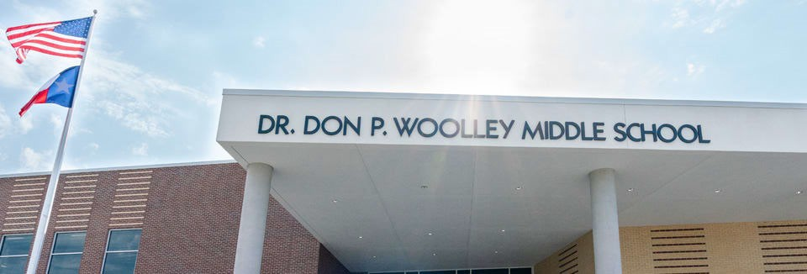Woolley Middle School

Ashly Cochran, Principal

 | 2017‐2018 | 2018‐2019 | 2019‐2020 | 2020‐2021 | 2021‐2022
Enrollment |  |  |  | 907 | 887
Student/Teacher Ratio  Staﬀ FTE's  Professional |  |  |  | 18.1  62.8
Teachers |  |  |  | 50.2
Professional Support |  |  |  | 9.6
Campus Administration  Support  Educational Aides |  |  |  | 3  7
Total |  |  |  | 69.8
Expenditures
 | 2018 AUDITED | 2019 AUDITED | 2020 AUDITED | 2021 UNAUDITED | 2022 BUDGET
Payroll Costs |  |  | $ 135,101 | $ 3,879,361 | $ 4,960,454
Contracted Services |  |  | $ 2,530 | $ 127,347 | $ 175,350
Supplies and Materials |  |  | $ 635,623 | $ 210,683 | $ 316,600
Other Operating Costs |  |  | $ 5,403 | $ 66,649 | $ 126,400
Fixed Assets |  |  | $ 808,303 | $ 399,974 | $ ‐
Grand Total |  |  | $ 1,586,960 | $ 4,684,015 | $ 5,578,804
Expenditures by Intent
 | 2018 AUDITED | 2019 AUDITED | 2020 AUDITED | 2021 UNAUDITED | 2022 BUDGET
Basic |  |  | $ 17,280 | $ 2,315,177 | $ 2,949,850
Gifted |  |  | $ ‐ | $ ‐ | $ 1,000
Career & Technology |  |  | $ 2,105 | $ 83,192 | $ 97,200
Special Education |  |  | $ ‐ | $ 492,231 | $ 615,300
Bilingual |  |  | $ ‐ | $ 54,674 | $ 67,850
SCE to Support Title 1 |  |  | $ 1,813 | $ 226,895 | $ 371,954
Athletics |  |  | $ 1,435 | $ 92,016 | $ 124,600
Other Instructional Areas |  |  | $ 1,564,327 | $ 1,419,830 | $ 1,351,050
Grand Total |  |  | $ 1,586,960 | $ 4,684,015 | $ 5,578,804

Per Student Cost |  |  |  | $ 5,164 | $ 6,290
Assessment Results | 2018 STAAR | 2019 STAAR | 2020 STAAR | 2021 STAAR | 2022 STAAR
Reading NA
Mathematics NA
Writing NA
Social Studies NA
Science NA

**Information obtained from the TEA PEIMS Standard Report and Munis Accounting

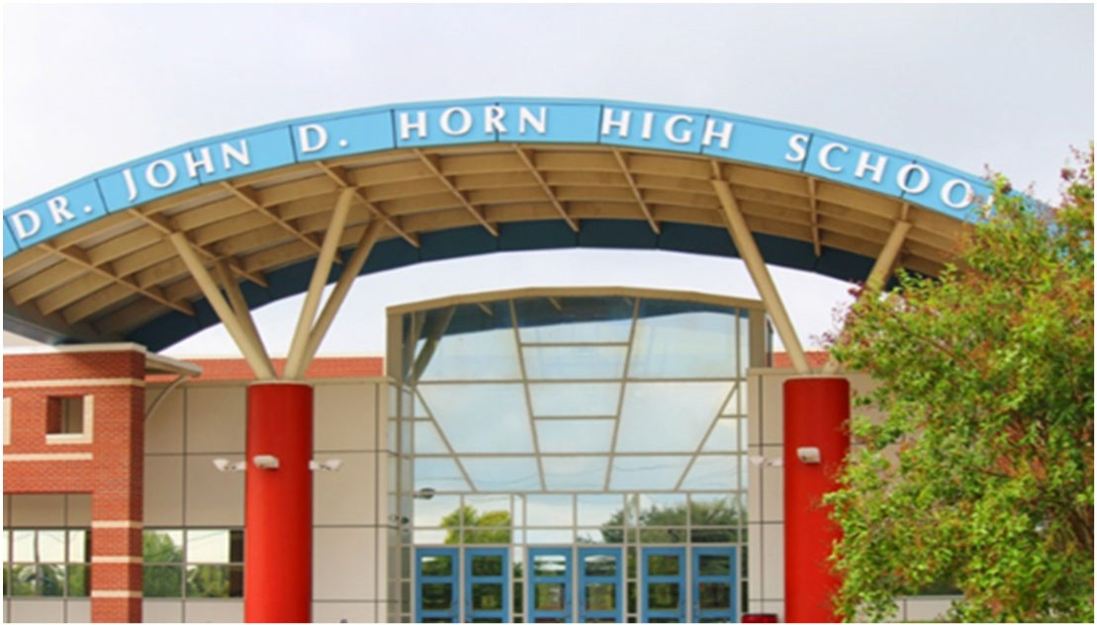Dr. John D. Horn High School

Deedra Brown, Principal

Our mission is to enable all students at Dr. John D. Horn High to become lifelong learners and to acquire the atti tudes, values, and ethics needed to be coop‐ erative and productive citizens of a free society. We will strive to create a school community of empower‐ ment, leadership, and continuous learning that oﬀers success for all students.
 | 2017‐2018 |  | 2018‐2019 |  | 2019‐2020 |  | 2020‐2021 |  | 2021‐2022
Enrollment | 2386 |  | 2620 |  | 2898 |  | 3099 |  | 3089
Student/Teacher Ratio  Staﬀ FTE's  Professional | 15  184 |  | 16.4  189.5 |  | 16.9  201.2 |  | 16.6  218.5
Teachers | 160 |  | 159.7 |  | 171.1 |  | 186.8
Professional Support | 17 |  | 21.3 |  | 21.4 |  | 23.2
Campus Administration  Support  Educational Aides | 7  12 |  | 8.5  14.8 |  | 8.7  14.7 |  | 8.5  16
Total | 196 |  | 204.3 |  | 215.9 |  | 234.5
Expenditures By Character | 2018 AUDITED |  | 2019 AUDITED |  | 2020 AUDITED |  | 2021 UNAUDITED |  | 2022 BUDGET
Payroll Costs | $ 13,199,748 |  | $ 13,946,851 |  | $ 15,053,516 |  | $ 14,066,242 |  | $ 17,642,750
Contracted Services | $ 627,057 |  | $ 778,674 |  | $ 607,874 |  | $ 451,379 |  | $ 460,150
Supplies and Materials | $ 704,991 |  | $ 886,312 |  | $ 708,246 |  | $ 476,705 |  | $ 686,400
Other Operating Costs | $ 635,488 |  | $ 717,955 |  | $ 616,644 |  | $ 396,335 |  | $ 530,100
Fixed Assets | $ 725,512 |  | $ 715,455 |  | $ 481,919 |  | $ 105,681 |  | $ ‐
Grand Total | $ | 15,892,795 | $ | 17,045,247 | $ | 17,468,199 | $ | 15,496,343 | $ | 19,319,400
Expenditures by Program Intent  2018 AUDITED 2019 AUDITED |  |  |  |  | 2020 AUDITED |  | 2021 UNAUDITED |  | 2022 BUDGET
General | $ | ‐ |  |  |  |  |  |  | $ | ‐
Basic | $ | 7,053,692 | $ 7,293,626 |  | $ 8,746,314 |  | $ 8,266,559 |  | $ | 10,556,550
Gifted | $ | 158,156 | $ 191,399 |  | $ 217,850 |  | $ 177,232 |  | $ | 221,000
Career & Technology | $ | 2,115,908 | $ 2,071,040 |  | $ 2,468,205 |  | $ 1,935,454 |  | $ | 2,142,000
Special Education | $ | 1,344,541 | $ 1,482,863 |  | $ 1,599,340 |  | $ 1,414,897 |  | $ | 1,767,300
Compensatory | $ | 402,781 | $ (26) |  |  |  |  |  | $ | ‐
Bilingual | $ | 69,309 | $ ‐ |  | $ ‐ |  | $ 688 |  | $ | 2,250
SCE to Support Title I | $ | ‐ | $ 421,707 |  | $ 327,737 |  | $ 241,240 |  | $ | 376,300
High School Allotment | $ | 524,073 | $ 1,120,391 |  | $ ‐ |  | $ 1,085 |  | $ | 100
College Career & Mil Readiness |  |  |  |  | $ 137,177 |  | $ 47,230 |  | $ | 69,900
Athletics | $ | 1,128,232 | $ 1,237,792 |  | $ 974,632 |  | $ 868,225 |  | $ | 844,850
Other Instructional | $ | 3,096,104 | $ 3,226,455 |  | $ 2,996,943 |  | $ 2,543,733 |  | $ | 3,339,150
Grand Total | $ | 15,892,795 | $ 17,045,247 |  | $ 17,468,199 |  | $ 15,496,343 |  | $ | 19,319,400
Per Student Cost | $ | 6,661 | $ 6,506 |  | $ 6,028 |  | $ 5,000 |  | $ | 6,254
Assessment Results |  | 2018 STAAR | 2019 STAAR |  | 2020 STAAR |  | 2021 STAAR |  |  | 2022 STAAR
Reading |  | 65% | 65% |  | NA |  | NA
Mathematics |  | 82% | 88% |  | NA |  | NA
Social Studies |  | 89% | 90% |  | NA |  | NA
Science |  | 93% | 93% |  | NA |  | NA

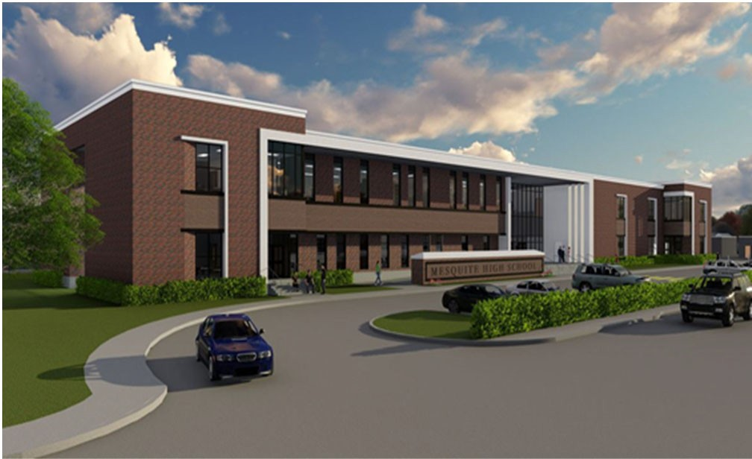Mesquite High School

Abram Joseph, Principal

The Skeeter community invests in the growth of our students, empowering them to reach their full potential and impact the future.

 | 2017‐2018 | 2018‐2019 | 2019‐2020 | 2020‐2021 | 2021‐2022
Enrollment | 2904 | 2650 | 2625 | 2561 | 2345
Student/Teacher Ratio | 16.3 | 14.9 | 13.9 | 13.8
Staﬀ FTE's
Professional | 202.7 | 208.1 | 223.7 | 219.9
Teachers | 177.9 | 178.1 | 188.9 | 186.3
Professional Support | 16.8 | 21.5 | 25.3 | 24.5
Campus Administration  Support | 8 | 8.5 | 9.5 | 9.1
Educational Aides | 19 | 21.7 | 19.4 | 20.6
Total | 221.7 | 229.8 | 243.1 | 240.5
 | 2018 AUDITED | 2019 AUDITED | 2020 AUDITED | 2021 UNAUDITED | 2022 BUDGET
Payroll Costs | $ 15,369,936 | $ 15,198,754 | $ 15,574,173 | $ 13,365,454 | $ 15,757,300
Contracted Services | $ 818,271 | $ 767,893 | $ 820,665 | $ 656,201 | $ 733,300
Supplies and Materials | $ 922,845 | $ 980,985 | $ 888,580 | $ 600,796 | $ 532,100
Other Operating Costs | $ 660,539 | $ 750,595 | $ 569,640 | $ 364,719 | $ 536,750
Fixed Assets | $ 976,721 | $ 1,050,266 | $ 463,846 | $ 433,207 | $ 100,000
Grand Total | $ 18,748,312 | $ 18,748,492 | $ 18,316,903 | $ 15,420,376 | $ 17,659,450
 | 2018 AUDITED | 2019 AUDITED | 2020 AUDITED | 2021 UNAUDITED | 2022 BUDGET
Basic | $ 7,948,281 | $ 6,958,842 | $ 7,960,386 | $ 7,315,963 | $ 8,764,600
Gifted | $ 160,267 | $ 135,459 | $ 36,807 | $ ‐ | $ 3,000
Career & Technology | $ 2,931,900 | $ 3,049,395 | $ 3,250,230 | $ 2,431,767 | $ 2,308,800
Special Education | $ 1,624,919 | $ 1,782,706 | $ 1,809,211 | $ 1,410,792 | $ 1,767,500
Compensatory | $ 656,953 | $ ‐ | $ ‐ |  | $ ‐
Bilingual | $ 81,043 | $ 82,048 | $ 86,444 | $ 47 | $ 2,350
SCE to Support Title I | $ ‐ | $ 598,771 | $ 623,601 | $ 476,055 | $ 492,800
High School Allotment | $ 796,433 | $ 994,475 | $ ‐ | $ 2,172 | $ 1,600
College Career & Mil Readiness |  |  | $ 53,418 | $ 55,935 | $ 400
Athletics | $ 1,098,450 | $ 1,155,814 | $ 980,832 | $ 719,003 | $ 871,450
Other Instructional | $ 3,450,068 | $ 3,990,984 | $ 3,515,974 | $ 3,008,643 | $ 3,446,950
Grand Total | $ 18,748,312 | $ 18,748,492 | $ 18,316,903 | $ 15,420,376 | $ 17,659,450
Per Student Cost | $ 6,456 | $ 7,075 | $ 6,978 | $ 6,021 | $ 7,531
Assessment Results | 2018 STAAR | 2019 STAAR | 2020 STAAR | 2021 STAAR | 2022 STAAR
Reading | 61% | 63% | NA | NA
Mathematics | 75% | 88% | NA | NA
Social Studies | 85% | 88% | NA | NA
Science | 90% | 89% | NA | NA

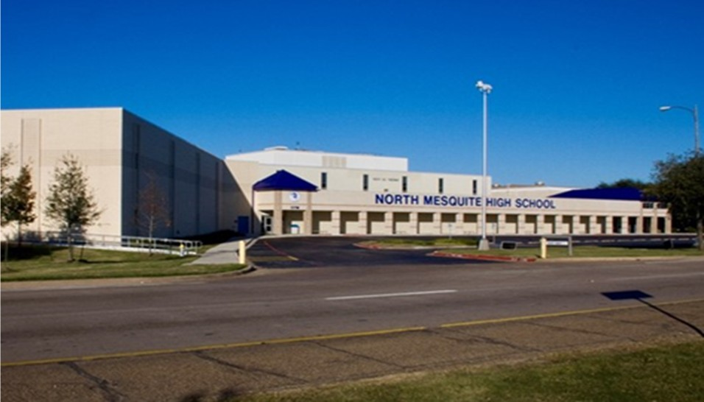North Mesquite High School
Kenneth Washington, Principal

Dream…Believe…Achieve!
 | 2017‐2018 |  | 2018‐2019 | 2019‐2020 | 2020‐2021 | 2021‐2022
Enrollment | 2808 |  | 2611 | 2522 | 2415 | 2169
Student/Teacher Ratio | 15.9 |  | 14.6 | 14.7 | 14.5
Staﬀ FTE's
Professional | 203.1 |  | 209.7 | 202.5 | 200.8
Teachers | 176.6 |  | 178.4 | 171.2 | 166.4
Professional Support | 17.4 |  | 21.8 | 22 | 25.2
Campus Administration | 9.1 |  | 9.5 | 9.3 | 9.2
Support
Educational Aides | 20.9 |  | 19.9 | 21 | 18.7
Total | 224 |  | 229.6 | 223.5 | 219.5
 | 2018 AUDITED |  | 2019 AUDITED | 2020 AUDITED | 2021 UNAUDITED | 2022 BUDGET
Payroll Costs | $ 14,943,000 |  | $ 14,673,750 | $ 14,377,240 | $ 12,661,965 | $ 14,210,400
Contracted Services | $ 732,825 |  | $ 705,742 | $ 682,193 | $ 545,565 | $ 625,350
Supplies and Materials | $ 814,666 |  | $ 851,835 | $ 807,835 | $ 537,592 | $ 525,550
Other Operating Costs | $ 680,561 |  | $ 670,910 | $ 540,612 | $ 353,095 | $ 536,400
Fixed Assets | $ 2,865,417 |  | $ 2,245,059 | $ 1,462,587 | $ 204,034 | $ ‐
Grand Total | $ 20,036,469 |  | $ 19,147,295 | $ 17,870,466 | $ 14,302,252 | $ 15,897,700
 | 2018 AUDITED |  | 2019 AUDITED | 2020 AUDITED | 2021 UNAUDITED | 2022 BUDGET
Basic | $ 8,374,657 |  | $ 7,741,045 | $ 8,160,407 | $ 7,407,418 | $ 8,227,800
Gifted | $ 179,059 |  | $ 172,654 | $ 183,154 | $ 181,255 | $ 229,500
Career & Technology | $ 2,494,029 |  | $ 2,366,056 | $ 2,259,136 | $ 1 ,684,956 | $ 1,607,100
Special Education | $ 1,185,464 |  | $ 1,231,081 | $ 1,219,950 | $ 906,209 | $ 1,110,100
Compensatory | $ 441,646 |  | $ 135 |  |  | $ ‐
Bilingual | $ 74,350 |  | $ 137,978 | $ 115,942 | $ 95,708 | $ 115,450
SCE to Support Title I | $ | ‐ | $ 383,030 | $ 437,157 | $ 375,922 | $ 448,000
High School Allotment | $ | 875,779 | $ 853,677 | $ ‐ | $ 4,664 | $ 8,600
College Career & Mil Readiness |  |  |  | $ 91,810 | $ 54,022 | $ 66,300
Athletics | $ | 934,552 | $ 1,004,890 | $ 850,755 | $ 789,701 | $ 883,250
Other Instructional | $ | 5,476,933 | $ 5,256,748 | $ 4,552,156 | $ 2,802,396 | $ 3,201,600
Grand Total | $ | 20,036,469 | $ 19,147,295 | $ 17,870,466 | $ 14,302,252 | $ 15,897,700
Per Student Cost | $ 7,135 |  | $ 7,333 | $ 7,086 | $ 5922 | $ 7,330
Assessment Results | 2018 STAAR |  | 2019 STAAR | 2020 STAAR | 2021 STAAR | 2022 STAAR
Reading | 59% |  | 64% | NA | NA
Mathematics | 76% |  | 90% | NA | NA
Social Studies | 82% |  | 89% | NA | NA
Science | 85% |  | 90% | NA | NA  NA
Serves Grades 9th‐12th
**Information obtained from the TEA PEIMS Standard Report and Munis Accounting

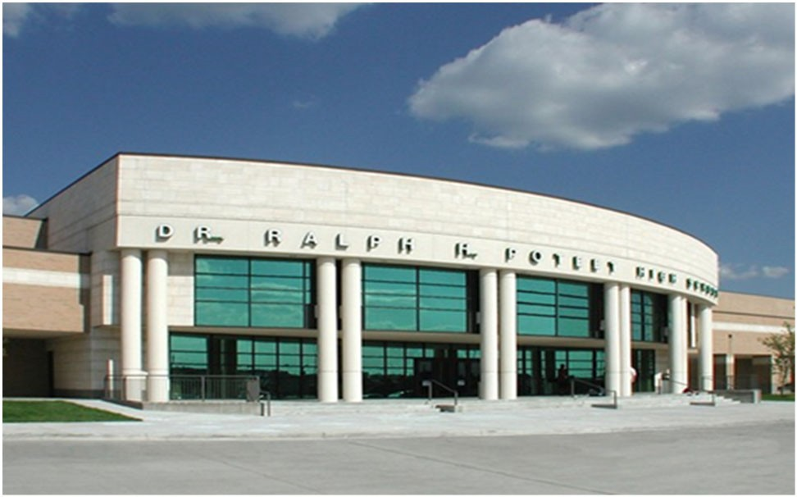Ralph H. Poteet High School

Kelly Long, Principal

Respect the past, Honor the future, and take Pride in today.

 | 2017‐2018 | 2018‐2019 | 2019‐2020 | 2020‐2021 | 2021‐2022
Enrollment | 1848 | 1794 | 1822 | 1750 | 1651
Student/Teacher Ratio  Staﬀ FTE's Professional | 15.8  134.3 | 15.6  134.5 | 16  133.1 | 15.3  133.2
Teachers | 117 | 115.3 | 114 | 114.1
Professional Support | 11.3 | 12.9 | 12.8 | 11.8
Campus Administration  Support | 6 | 6.3 | 6.3 | 7.3
Educational Aides | 12 | 12 | 11 | 10
Total | 146.3 | 146.5 | 144.1 | 143.2
Expenditures | 2018 AUDITED | 2019 AUDITED | 2020 AUDITED | 2021 UNAUDITED | 2022 BUDGET
Payroll Costs | $ 10,271,665 | $ 10,270,160 | $ 10,016,580 | $ 8,817,180 | $ 10,801,250
Contracted Services | $ 630,418 | $ 586,274 | $ 565,070 | $ 430,251 | $ 432,100
Supplies and Materials | $ 775,011 | $ 868,851 | $ 801,709 | $ 593,730 | $ 453,280
Other Operating Costs | $ 596,125 | $ 599,735 | $ 530,310 | $ 355,595 | $ 494,050
Fixed Assets | $ 716,571 | $ 234,512 | $ 456,054 | $ 226,972 | $ ‐
Grand Total | $ 12,989,791 | $ 12,559,532 | $ 12,369,723 | $ 10,423,729 | $ 12,180,680
Expenditures by Intent | 2018 AUDITED | 2019 AUDITED | 2020 AUDITED | 2021 UNAUDITED | 2022 BUDGET
Basic | $ 5,410,069 | $ 5,037,219 | $ 5,655,297 | $ 4,849,895 | $ 6,022,380
Gifted | $ 235,807 | $ 254,829 | $ 224,289 | $ 171,671 | $ 225,300
Career & Technology | $ 2,023,300 | $ 1,849,565 | $ 1,773,008 | $ 1,506,321 | $ 1,482,200
Special Education | $ 932,437 | $ 943,294 | $ 966,155 | $ 778,006 | $ 950,900
Compensatory | $ 262,723 | $ 418 |  |  | $ ‐
Bilingual | $ 28,956 | $ 54,657 | $ ‐ | $ ‐ | $ 750
SCE to Support Title I | $ ‐ | $ 288,655 | $ 289,387 | $ 188,304 | $ 238,300
High School Allotment | $ 556,508 | $ 599,666 | $ ‐ | $ 1,745 | $ 1,700
College Career & Mil Readiness |  |  | $ 62,302 | $ 63,481 | $ 78,200
Athletics | $ 980,119 | $ 1,087,737 | $ 992,697 | $ 792,157 | $ 799,150
Other Instructional | $ 2,559,872 | $ 2,443,491 | $ 2,406,588 | $ 2,072,151 | $ 2,381,800
Grand Total | $ 12,989,791 | $ 12,559,532 | $ 12,369,723 | $ 10,423,729 | $ 12,180,680
Per Student Cost | $ 7,029 | $ 7,001 | $ 6,789 | $ 5,956 | $ 7,378
Assessment Results | 2018 STAAR | 2019 STAAR | 2020 STAAR | 2021 STAAR | 2022 STAAR
 |  |  | NA | NA
Reading | 68% | 69% | NA | NA
Mathematics | 74% | 88% | NA | NA
Social Studies | 92% | 86% | NA | NA
Science | 93% | 90% | NA | NA

Serves Grades 9th‐12th
**Information obtained from the TEA PEIMS Standard Report and Munis Accounting


Vanguard High School

Clinton Elasser, Principal

An Innovative Education Experience
Designed to engage students more deeply in chosen areas for either technology, engineering, health science or construction science, Vanguard High School will aﬀord students time to engage in more project‐based work.

2017‐2018 2018‐2019 2019‐2020 2020‐2021 2021‐2022
Enrollment 802
Student/Teacher Ratio Staﬀ FTE's
Professional Teachers
Professional Support Campus Administration
Support
Educational Aides
Total
Expenditures By Character | 2018 AUDITED | 2019 AUDITED | 2020 AUDITED | 2021 UNAUDITED | 2022 BUDGET
Payroll Costs |  | $ ‐ | $ 23,280 | $ 198,512 | $ 7,010,750
Contracted Services |  |  | $ ‐ | $ 20,427 | $ 476,800
Supplies and Materials |  |  | $ ‐ | $ 248,207 | $ 1,362,400
Other Operating Costs |  |  | $ ‐ | $ 517 | $ 26,400
Fixed Assets |  |  | $ ‐ | $ 257,366 | $ 800,000
Grand Total |  | $ ‐ | $ 23,280 | $ 725,029 | $ 9,676,350
Expenditures by Intent | 2018 AUDITED | 2019 AUDITED | 2020 AUDITED | 2021 UNAUDITED | 2022 BUDGET
Basic |  |  |  | $ 186 | $ 2,433,200
Career & Technology |  |  |  | $ ‐ | $ 3,276,900
Special Education |  |  |  | $ ‐ | $ ‐
Bilingual |  |  |  | $ ‐ | $ ‐
SCE to Support Title I |  |  |  | $ ‐ | $ 186,450
Other Instructional |  | $ ‐ | $ 23,280 | $ 724,843 | $ 3,779,800
Grand Total |  | $ ‐ | $ 23,280 | $ 725,029 | $ 9,676,350
Per Student Cost |  |  |  |  | $ 12,065
Assessment Results | 2018 STAAR | 2019 STAAR | 2020 STAAR | 2021 STAAR | 2022 STAAR
Reading Mathematics Social Studies
Science

Serves Grades 9th‐12th
**Information obtained from the TEA PEIMS Standard Report and Munis Accounting

West Mesquite High School  Karen Morris, Principal  The mission of West Mesquite High School is to educate and empower our students by providing them an innovative learning environment which will prepare them to become contributing mem‐ bers of a global society. |  | 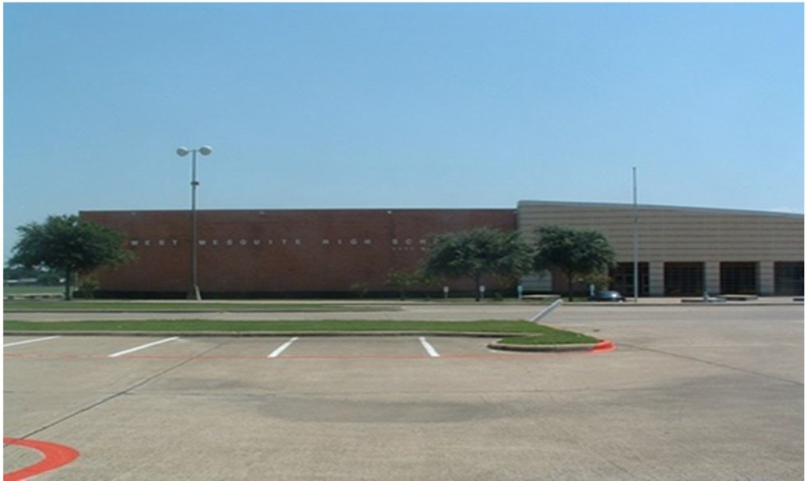
2017‐2018 | 2018‐2019 | 2019‐2020 | 2020‐2021 | 2021‐2022
Enrollment | 2077 | 2114 | 2162 | 2280 | 2223
Student/Teacher Ratio Staﬀ FTE's  Professional | 15.4  157.1 | 15.2  160.4 | 15.2  165.8 | 15.2  177.7
Teachers | 135.3 | 139.4 | 141.9 | 150.2
Professional Support | 14.5 | 14.9 | 16.8 | 20.4
Campus Administration Support  Educational Aides | 7.3  11.8 | 6.1  10.5 | 7.1  11 | 7.1  11.9
Total | 168.9 | 170.9 | 176.8 | 189.6
Expenditures By Character | 2018 AUDITED | 2019 AUDITED | 2020 AUDITED | 2021 UNAUDITED | 2022 BUDGET
Payroll Costs | $ 11,819,222 | $ 11,429,987 | $ 12,141,696 | $ 11,063,016 | $ 13,786,200
Contracted Services | $ 629,520 | $ 558,178 | $ 589,174 | $ 420,324 | $ 472,800
Supplies and Materials | $ 855,760 | $ 789,765 | $ 1,021,473 | $ 575,321 | $ 507,200
Other Operating Costs | $ 471,937 | $ 560,313 | $ 507,544 | $ 369,096 | $ 501,300
Fixed Assets | $ 658,173 | $ 766,866 | $ 305,868 | $ 187,227 | $ ‐
Grand Total | $ 14,434,611 | $ 14,105,110 | $ 14,565,756 | $ 12,614,985 | $ 15,267,500
Expenditures by Intent | 2018 AUDITED | 2019 AUDITED | 2020 AUDITED | 2021 UNAUDITED | 2022 BUDGET
Basic | $ 6,392,422 | $ 5,861,710 | $ 6,891,549 | $ 6,838,156 | $ 8,551,450
Gifted | $ 141,633 | $ 78,231 | $ 80,459 | $ 68,269 | $ 84,700
Career & Technology | $ 2,390,791 | $ 2,292,286 | $ 2,551,831 | $ 1,768,889 | $ 1,738,400
Special Education  Compensatory | $ 951,275 | $ 935,980  $ ‐ | $ 1,097,342 | $ 736,910 | $ 865,200  $ ‐
Bilingual | $ 60,014 | $ 65,320 | $ 43 | $ 59 | $ 350
SCE to Support Title I | $ 446,081 | $ 408,949 | $ 414,125 | $ 336,602 | $ 422,500
High School Allotment | $ 668,892 | $ 762,633 | $ ‐ | $ 49,674 | $ 61,500
College Career & Mil Readiness |  |  | $ 147,418 | $ 39,790 | $ 41,000
Athletics | $ 823,314 | $ 868,397 | $ 849,617 | $ 718,073 | $ 779,850
Other Instructional | $ 2,560,191 | $ 2,831,604 | $ 2,533,373 | $ 2,058,562 | $ 2,722,550
Grand Total | $ 14,434,611 | $ 14,105,110 | $ 14,565,756 | $ 12,614,985 | $ 15,267,500
Per Student Cost | $ 6,446 | $ 6,672 | $ 6,737 | $ 5,533 | $ 6,868
Assessment Results | 2018 STAAR | 2019 STAAR | 2020 STAAR | 2021 STAAR | 2022 STAAR
Reading | 59% | 60% | NA | NA
Mathematics | 71% | 86% | NA | NA
Social Studies | 80% | 85% | NA | NA
Science | 87% | 88% | NA | NA

Serves Grades 9th‐12th
**Information obtained from the TEA PEIMS Standard Report and Munis Accounting

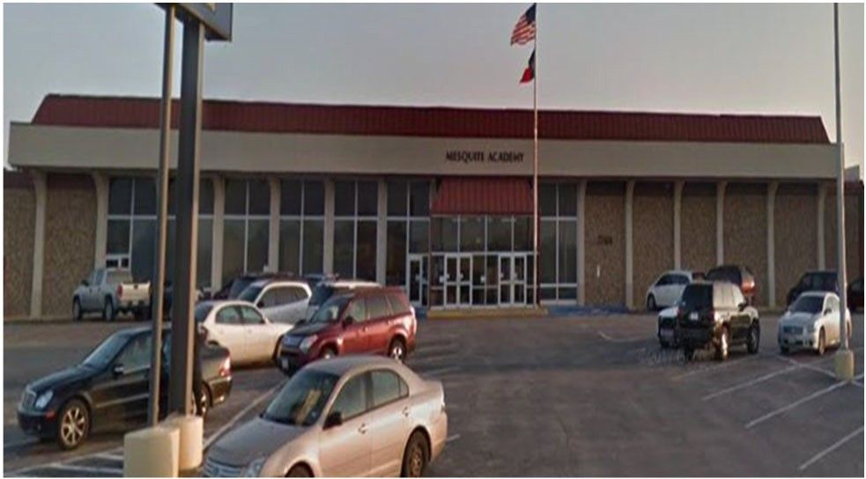Mesquite Academy

Jeﬀ Johnson, Principal

DREAM IT! BELIEVE IT!
Excellence Always!
Graduate!

2017‐2018 |  | 2018‐2019 2019‐2020 2020‐2021 2021‐2022
Enrollment 187 |  | 280 Included in Campus Included in Campus Included in Campus  Count Count Count
Student/Teacher Ratio 4  Staﬀ FTE's  Professional 62.4 |  | 3.8  60.4
Teachers | 46.2 | 47.4
Professional Support | 12.2 | 10
Campus Administration | 4 | 3
Support
Educational Aides 15 14
Total 77.4 74.4

Expenditures
2018 AUDITED 2019 AUDITED 2020 AUDITED 2021 UNAUDITED 2022 BUDGET
Payroll Costs | $ 2,089,794 |  | $ 2,483,770 |  | $ 2,659,355 |  | $ 2,154,893 |  | $ 2,707,700
Contracted Services | $ 41,727 |  | $ 49,698 |  | $ 62,157 |  | $ 45,904 |  | $ 60,600
Supplies and Materials | $ 51,931 |  | $ 51,355 |  | $ 51,777 |  | $ 61,352 |  | $ 48,300
Other Operating Costs | $ 18,690 |  | $ 73,815 |  | $ 89,844 |  | $ 61,279 |  | $ 79,950
Fixed Assets $ 56,849 |  |  | $ 36,480 |  | $ 56,842 |  | $ 36,086 |  | $ ‐
Grand Total $ 2,258,992 |  |  | $ 2,695,119 |  | $ 2,919,975 |  | $ 2,359,514 |  | $ 2,896,550
Expenditures by Intent
2018 AUDITED 2019 AUDITED 2020 AUDITED 2021 UNAUDITED 2022 BUDGET
Basic |  |  |  |  |  |  |  |  | $ | ‐
Career & Technology | $ 233,240 |  | $ 234,589 |  | $ | ‐ | $ | 74 | $ | ‐
Special Education | $ 79,361 |  | $ 86,430 |  | $ 150,794 $ 149,226 $ 184,700
Bilingual | $ ‐ |  | $ ‐ |  | $ 269 |  | $ 12 |  | $ 250
Nondisciplinary AEP Basic | $ 1,776,683 |  | $ 2,207,451 |  | $ 2,588,471 |  | $ 2,055,677 |  | $ 2,524,600
Nondisciplinary AEP Supplies | $ | ‐ | $ ‐ |  | $ | ‐ | $ | ‐ | $ | ‐
Disciplinary AEP Basic |  |  | $ 696 |  | $ | ‐ | $ | ‐ | $ | ‐
SCE to Support Title 1 |  |  |  |  |  |  | $ | ‐ | $ | ‐
Other Instruction Area $ 169,708 |  |  | $ 165,953 |  | $ 180,441 |  | $ 154,525 |  | $ 187,000
Grand Total $ 2,258,992 |  |  | $ 2,695,119 |  | $ 2,919,975 |  | $ 2,359,514 |  | $ 2,896,550
Per Student Cost | $ | 12,080 | $ | 9,625 | ‐ |  | − ‐
Assessment Results | 2018 STAAR |  | 2019 STAAR |  | 2020 STAAR |  | 2021 STAAR |  | 2022 STAAR
Reading | 20%
Mathematics  Writing  Science | 50%  33%
Social Studies | 61%

**Information obtained from the TEA PEIMS Standard Report and Munis Accounting

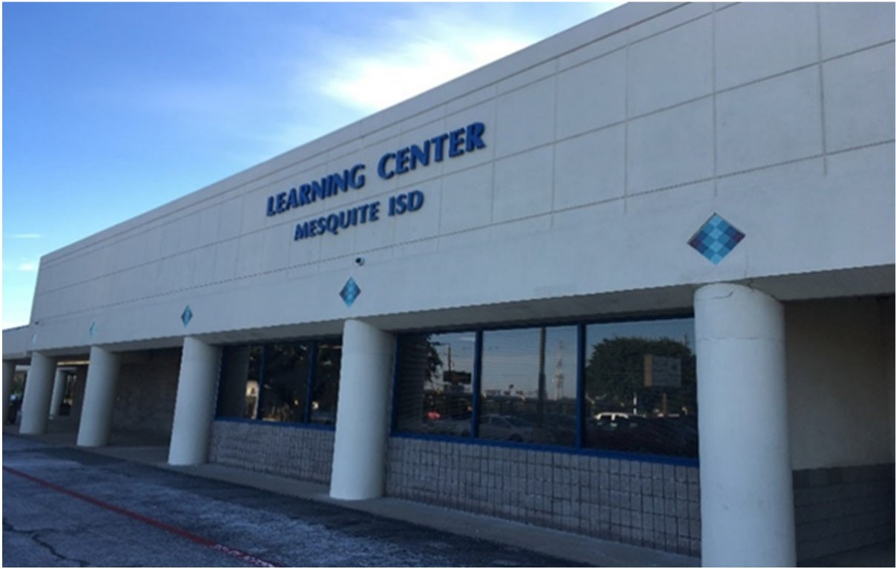The Learning Center

Dr. Valerie Nelson, Principal

Safety‐Relationships‐Engagement

Expenditures
2018 AUDITED |  | 2019 AUDITED | 2020 AUDITED | 2021 UNAUDITED | 2022 BUDGET
Payroll Costs $ 2,950,448 |  | $ 2,481,968 | $ 2,271,223 | $ 1,948,316 | $ 2,469,300
Contracted Services $ 51,197 |  | $ 44,891 | $ 49,283 | $ 49,103 | $ 52,900
Supplies and Materials $ 38,103 |  | $ 25,395 | $ 33,323 | $ 15,666 | $ 39,500
Other Operating Costs $ 3,346 |  | $ 54,632 | $ 72,243 | $ 52,478 | $ 69,600
Fixed Assets $ 279 |  | $ 5,692 | $ 46,886 | $ 77,441 | $ ‐
Grand Total $ 3,043,372 |  | $ 2,612,579 | $ 2,472,957 | $ 2,143,004 | $ 2,631,300
Expenditures by Intent
2018 AUDITED |  | 2019 AUDITED | 2020 AUDITED | 2021 UNAUDITED | 2022 BUDGET
Basic $ (278) |  | $ 1,827 | $ ‐ | $ ‐ | $ ‐
Career & Technology $ 1,203 |  | $ 3,392 | $ 636 | $ 82 | $ ‐
Special Education $ 216,351 |  | $ 223,237 | $ 316,079 | $ 272,151 | $ 335,700
Bilingual $ ‐ |  | $ ‐ | $ ‐ | $ ‐ | $ ‐
Nondisplinary AEP Basic |  | $ 535 | $ ‐ | $ ‐ | $ ‐
Disciplinary AEP Basic | $ 2,717,946 | $ 2,280,832 | $ 2,016,276 | $ 1,751,372 $ 2,142,500
SCE to Support Title 1  Other Instruction Area | $ 108,150 | $ 102,755 | $ 139,966 | $ ‐ $ ‐  $ 119,399 $ 153,100
Grand Total $ 3,043,372 $ 2,612,579 $ 2,472,957 $ 2,143,004 $ 2,631,300

**Disciplinary Placements

Athletics

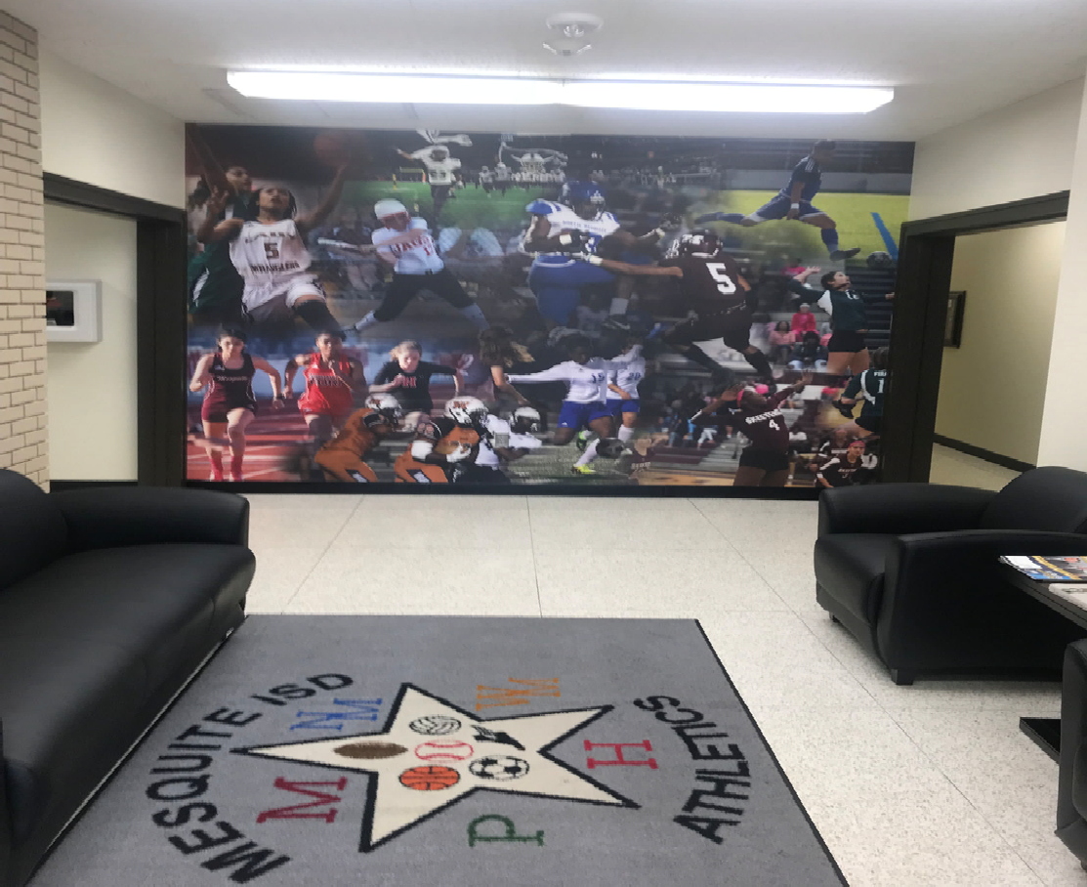Kody Groves, Athletic Director

 | 2018 AUDITED | 2019 AUDITED | 2020 AUDITED | 2021 UNAUDITED | 2022 BUDGET
Payroll Costs | $ 650,962 | $ 619,506 | $ 594,063 | $ 502,088 | $ 770,300
Contracted Services | $ 10,642 | $ 10,260 | $ 10,694 | $ 9,097 | $ 16,200
Supplies & Materials | $ 21,732 | $ 13,229 | $ 19,886 | $ 36,835 | $ 25,700
Other Operating Cost | $ 15,133 | $ 18,907 | $ 11,792 | $ 4,295 | $ 12,500
Fixed Assets | $ 5,021 |  |  |  | $ ‐
Total | $ 703,491 | $ 661,902 | $ 636,435 | $ 552,315 | $ 824,700

GLOSSARY
This glossary contains definitions of terms used in this guide and such additional terms as seems necessary to common understanding concerning financial accounting procedures for schools. Several terms which are not primarily financial accounting terms have been included because of their significance for school financial accounting.

Account – A descriptive heading under which are recorded financial transactions that are similar in terms of a given frame of reference, such as purpose, object, or source.

Accounting System – The total structure of records and procedures which discover, record, classify, and report information on the financial position and operations of a school district or any of its funds, balanced account groups and organizational components.

Accrual Basis – The basis of accounting, under which revenues are recorded when levies are made, and expenditures are recorded as soon as they result in liabilities, regardless of when the revenue is actually received, or the payment is actually made. See also Estimated Revenue and Expenditures.

Accrue – To record revenues when earned or when levies are made, and to record expenditures as soon they result in liabilities, regardless of when the revenue is actually received, or the payment is actually made. Sometimes, the term is used in a restricted sense to denote the recording of revenue earned but not yet due, such as accrued interest on investments and the recording of expenditures which result in liabilities that are payable in another accounting period, such as accrued interest on bonds. Also see Estimated Revenues and Expenditures.

ACT – represents American College Testing.

ADA – Average Daily Attendance is based on the number of days of instruction in the school year. The aggregate days attendance is divided by the number of days of instruction to compute average daily attendance. ADA is used in the formula to distribute funding to Texas public school districts.

Administration – Those activities which have as their purpose the general regulation, direction, and control of the aﬀairs of the local education agency that are system‐wide and not confined to one school, subject, or narrow phase of school activity.

Ad Valorem Tax – The primary source of local funding for school districts levied against the local tax base. Ad Valorem means according to the value.

AEIS – represents Academic Excellence Indicator System. A system of indicators established by the Legislature and adopted by the State Board of Education to help determine the quality of learning on a campus and in a school district. The indicators include passing rates on the state assessment tests, attendance, graduation rates, dropout rates, and scores on college entrance exams. The state will assess district and school performance compared with state‐level standards. AEIS is the foundation for a school district’s accountability rating.
Allocation – A part of a lump‐sum appropriation which is designated for expenditure by specific organization units and/or for specific purposes, activities, or objects.

Appropriation – An authorization granted by a legislative body to make expenditures and to incur obligations for specific purposes. An appropriation is usually limited in amount and as to the time when it may be expended.

Assessed Valuation – A valuation set upon real estate or other property by the County Appraisal District to be used as a basis for levying taxes.

Audit – A comprehensive review of the manner in which the government’s resources were actually utilized. A certified public accountant issues an opinion over the presentation of financial statements, tests the controls over the safekeeping of assets and makes recommendations for improvements for where necessary.

Board of Education (School Board of Trustees) – The elected or appointed body which has been created according to State law and vested with responsibilities for school boards, governing boards, boards of directors, school committees, school trustees, etc. This definition relates to the general term and covers State boards, intermediate administrative unit boards, and local basic administrative unit boards.

Bond – A written promise, generally under seal, to pay a specific sum of money called the face value, at a fixed time in the future called the date of maturity, and carrying interest at a fixed rate, usually payable periodically. The diﬀerence between a note and a bond is that the latter usually runs for a longer period of time and requires greater legal formality. See also Surety Bond.

Bonded Debt – The part of the school district debt which is covered by outstanding bonds of the district. Sometimes called “Funded Debt”.

Bonds Authorized and Unissued – Bonds which have been legally authorized but not issued and which can be issued and sold without further authorization. Bonds Issued – Bond sold.

Budget – A plan of financial operation embodying an estimate of proposed expenditures for a given period or purpose and the proposed means of financing them. The budget usually consists of three parts. The first part contains a message from the budget‐making authority together with a summary of the proposed expenditures and the means of financing them. The second part is composed of drafts of the appropriation, revenue, and borrowing measures necessary to put the budget into eﬀect. The third part consists of schedules supporting the summary. These schedules show in detail the proposed expenditures and means of financing them together with information as to past years’ actual revenues and expenditures and other data used in making the estimates.
Budgetary Control – The control management of the business aﬀairs of the school district in accordance with an approved budget with a responsibility to keep expenditures within the authorized amounts.

Capital Budget – A plan of proposed capital outlays and the means of financing them for the current fiscal period. It is usually a part of the current budget. If a Capital Program is in operation, it will be the first year thereof. A Capital Program is sometimes referred to as a Capital Budget.

Capital Outlays – A plan for capital expenditures to be incurred each year over a fixed period of years to meet capital needs arising from the long-term work program or otherwise. It sets forth each project or other contemplated expenditure in which the local education agency is to have a part and specifies the full resources estimated to be available to finance the projected expenditures.

Capital Projects Fund – A governmental fund type with budgetary control established to account for projects that are financed by the proceeds from bond issues, or for capital projects otherwise mandated to be so accounted for in this fund.

Classification, Function – As applied to expenditures, this term has reference to an activity or service aimed at accomplishing a certain purpose or end, for example, Instructional, School Leadership, Nursing.

Classification, Object – As applied to e3xpenditures, this term has reference to an article or service received, for example, payroll costs, purchased and contracted service, materials, and supplies.

CPA – represents Certified Public Accountant.

Coding – A system of numbering, or otherwise designating, accounts, entries, invoices, vouchers, etc., in such a manner that the symbol used quickly reveals certain required information.

Debt Limit – The maximum amount of gross or net debt which is legally permitted.

Debt Service Fund – A governmental fund with budgetary control that accounts for expenditures for the retirement of debt and expenditures for interest on debt, except principal and interest of current loans. See also Cur‐rent Loans.

Encumbrance Accounting – A System or procedure which involves giving recognition in the accounting budgetary expenditure control records for the issuance of purchase orders, statements, or other commitments chargeable to an appropriation in advance of any liability or payment.
Encumbrance – Any commitment of funds against an appropriation. It may be in the form of a purchase order or a contract. Encumbrance accounting is formally integrated into the accounting system for expenditure control purposes. An encumbrance diﬀers from an account payable as follows: an ac‐ count payable represents a legal liability to pay and results from the goods and/or services requested in a purchase order or contract having been delivered to the District. Until such time as the goods and/ or services are delivered, the commitment is referred to as an encumbrance.

Equipment – Moveable items used for school operation that are of a non‐expendable and mechanical nature, i.e. perform an operation. Typewriters, projectors, vacuum cleaners, accounting machines, computers, lathes, clocks, machinery, and vehicles, etc., are classified as equipment. (Heating and air conditioning systems, lighting fixtures and similar items permanently fixed to or within a building, are considered as part of the building.)

Estimated Revenue – When the accounts are kept on an accrual basis, this term designates the amount of revenue estimated to accrue during a given period regardless of whether or not it will be collected during the period.

Existing Debt Allotment (EDA) Program – In 1999, the Legislature added Subchapter B to Chapter 46 of the Texas Education Code (TEC) to create the Existing Debt Allotment (EDA) program. The EDA provides tax rate equalization for local debt service taxes, operates without applications, and has no award cycles. Each school district is guaranteed a specified amount per student in state and local funds for each cent of tax eﬀort to pay the principal of and interest on eligible bonds. Only general obligation bonds are eligible for the program. Payments demonstrating eligibility for the EDA must appear on the debt service schedule contained in the final oﬃcial statement or bond order.

Expenditures – This grouping includes total charges incurred, whether paid or unpaid, for current expense, capital outlay, and debt service. (Transfers between funds, encumbrances, exchanges of cash for other current assets such as the purchase stores and investment of cash in U.S. Bonds, payments of cash in settlement of liabilities already accounted as expenditures, and the repayment of the principal of current loans are not considered as expenditures.)

Expense – Charges incurred, whether paid or unpaid, for operation, maintenance, and interest, and other charges which are presumed to benefit the current fiscal period. Legal provisions sometimes make it necessary to treat as expense charges whose benefits extend over future periods.

Fiscal Period – Any period at the end of which a local education agency determines its financial position and the results of its operations. The period may be a month, a quarter, or a year, depending upon the scope of operations and requirements for managerial control and reporting.

Fiscal Year – A twelve‐month period of time to which the annual budget applies and at the end of which a local education agency determines its financial position and the results of its operations. The District’s fiscal year is September 1 through August 31.

Fixed Assets – Assets of a long‐term character which are intended to continue to be held or used, such as land, buildings, machinery, furniture and other equipment.

Foundation School Program (FSP) – A program for the financial support of a basic instructional pro‐ gram for all Texas schoolchildren. Money to support the program comes from the Permanent School Fund, Available School Fund, Foundation School Fund, state general revenue, and local property taxes. The state establishes a foundation level and sets, for each district, a calculated contribution level called the local fund assignment (LFA). The greater a district’s property wealth, the higher the LFA. State aid makes up the diﬀerence between the LFA and the foundation level. (See also “Local Fund Assignment”) Currently, the FSP described in the Texas Education Code consists of three parts or tiers. The first pro‐ vides funding for a basic program. The second tier provides a guaranteed‐yield system so that school districts have substantially equal access to revenue suﬃcient to support an accredited program. The third tier equalizes debt service requirements for existing facilities debt.

FTE – Full‐Time Equivalent measures the extent to which one individual or student occupies a full‐time position or provides instruction, e.g., a person who works four hours a day or a student that attends a half of a day represents a .5 FTE. When FTE counts are included in reports they represent the aggregate of all FTE percentages, e.g., if one teacher provides four hours of instruction and four other provide one hour, together they represent one FTE.

Fund – An independent fiscal and accounting entity with a self‐balancing set of accounts recording cash and/or other resources, together with all related liabilities, obligations, reserves, and equities which are segregated for the purpose of carrying on in accordance with special regulations, restrictions, or limitations.

Fund Balance – The excess of assets of a fund over its liabilities and reserves. During the fiscal year prior to closing, it represents the excess of the fund’s assets and estimated revenues for the period over its liabilities, reserves and appropriations of the period during the fiscal year prior to closing.

Gift – Money received from a philanthropic foundation, private individual, or private organization for which no repayment or special service to the contributor is expected.

Grant – A contribution by one governmental unit to another. The contribution is usually made to aid in the support of specified function (for example, job training), but it is sometimes also for general purposes.

Guarantee Yield – A school finance plan in which the state specifies a revenue yield that it will guaran‐ tee in terms of revenue per student per penny of local tax eﬀort. The districts adopt tax rates and levy taxes. The state makes up the diﬀerence between what each district levies locally per student and the guarantee yield per student. High wealth districts may raise all of their guaranteed‐yield revenue from local tax sources. In Texas, this is commonly known as Tier Two in the Foundation School Program.

Improvements ‐ Buildings, other structures, and other attachments or annexations to land which are intended to remain so attached or annexed, such as sidewalks, trees, drives, tunnels, drains, and sewers.

Independent School District (ISD) – The Texas Constitution permits the state Legislature to create school districts. Each district operates its schools and taxes property within the district to support, in part, the schools. The term independent refers to the fact that the school district is not a part of city or county government and has independent budgeting and taxing authority. ISD’s are governed by locally elected boards of trustees.

Individuals with Disabilities Education Act (IDEA) – The purpose of the Individuals with Disabilities Education Act (IDEA) are to: (1) ensure that all children with disabilities have available to them a free ap‐ propriate public education which emphasizes special education and related services designed to meet their unique needs; (2) ensure that the rights of children with disabilities and their parents or guardians are protected; (3) assist States, localities, educational service agencies and Federal agencies to provide for the education of all children with disabilities; and (4) assess and ensure the eﬀectiveness of eﬀorts to educate children with disabilities.

Instruction – The activities dealing directly with the teaching of students or improving the quality of teaching.

Instructional Facilities Allotment (IFA) – Granted by House Bill 4 in 1997, this program provides a guar‐ anteed level ($35) of state and local funds per student per penny of tax eﬀort applicable to debt service on eligible bonds. However, there is a limit on funding for each biennium so the District must apply for funding. The applications are ranked based on relative property wealth and funs are awarded up to the dollar limit available.

Inventory – A detailed list of record showing quantities, descriptions, values, units of measure, and unit prices of property on hand.

Levy – To impose taxes or special assessments. (Noun) The total of taxes special assessments imposed by governmental unit.

Liability – An obligation, based on a past transaction, to convey assets or perform services in the future.

M&O Tax Rate – The tax rate calculated to provide the revenues needed to cover Maintenance & Operations (M&O). M&O includes such things as salaries, utilities, and day‐to‐day operations.

Modified Accrual Accounting – A basis of accounting in which expenditures are accrued when incurred and revenues are accounted for when they become measurable and available.

National School Lunch Program (NSLP) – A federally‐assisted meal program operation in more than 101,000 public and non‐profit private schools across the nation. The program was established under the National School Lunch Act, signed by President Harry Truman in 1946.

PEIMS ‐ represents Public Education Information Management System.

Personnel, Administration – Personnel on the school payroll who are primarily engaged in activities which have as their purpose the general regulation, direction, and control of the aﬀairs of the school district that are system‐wide and not confined to one school, subject, or narrow phase of school activity: for example, superintendent of schools, business manager and accountant.
Personnel, Full‐Time – School employees who occupy positions the duties of which require them to be on the job on school days, throughout the school year, at least the number of hours the schools in the system are in session.

Program – A group of related activates performed by one or more organizational units for the purpose of accomplishing a function or project for which the District is responsible.

Program Budget – A budget wherein expenditures are based primarily on program on work and secondarily on character and object. A program budget is a traditional type of budget between the traditional character and object budget on the one hand, the performance budget on the other.

Refined ADA – Refined Average Daily Attendance is based on the number of days of instruction in the school year. The aggregate eligible days attendance is divided by the number of days of instruction to compute the re‐fined average daily attendance. See also ADA.

Refunding Bonds – Bonds issued to pay oﬀ bonds already outstanding.

Revenue – The yield of taxes, tuition, interest earnings, and other monetary resources that the District collects and receives into the treasury for public use. For those revenues which are recorded on the accrual basis, this term designates additions to assets which (a) do not increase any liability; (b) do not represent the recovery of an expenditure; (c) do not represent contributions of fund capital in enterprise and internal service funds. The same definition applies to those cases where revenue is recorded on the modified accrual or cash basis, except those additions would be partially or entirely to cash. See Receipts, Revenues.

Rollback Tax Rate – A tax rate that exceeds the rollback tax rate will automatically trigger an election to limit school taxes on a date not less than 30 days or more than 90 days after the tax rate is adopted. If the election to limit school taxes is successful, the tax rate the district may impose for the current year is limited to the calculated rollback tax rate.

Salary – The total amount regularly paid or stipulated to be paid to an individual, before deductions, for personal services rendered while on the payroll of the school district. Payments for sabbatical leave are also considered as salary.

SAT – represents Standardized Achievement Tests.

School – A division of the school system consisting of a group of pupils composed of one or more teachers to give instruction of a defined type and housed in a school plant of one or more buildings. More than one school may be housed in one school plant, as is the case when the elementary and secondary programs are housed in the same school plant.

School, Elementary – A school classified as elementary by State and local practice and composed of any span of grades not above grade five. In this District this term includes kindergartens and pre‐ kindergartens if they are under the control of the local board of education.

School, Middle – A separately organized secondary school intermediate between elementary, intermediate, and senior high school. In this District middle schools include grades six through eight.

School Secondary – A secondary school comprises any span of grades beginning with the next grade following the elementary school and ending with grade 12, including middle schools, the diﬀerent types of high schools, and alternative high schools.

Special Revenue Funds – A governmental fund type with budgetary control, used to account for the proceeds of specific revenue sources, other than expendable trusts or for major capital projects, that are legally restricted to expenditures for specified purposes.

Tax Base – The total value of all real, personal, and mineral property in the District as of January 1st of each year, as certified by the County Appraisal Board. The tax base represents net value after all ex‐ emptions.

Taxes – Compulsory charges levied by a governmental unit of the purpose of financing service per‐ formed for the common benefit. The term includes licenses and permits. It does not include special assessments.

Tax Rate – Total tax rate is set by the Board of Trustees and is made up of two components: maintenance and operating and debt service rates. It is the amount levied for each $100 of assessed valuation.

Tax Roll – The oﬃcial list showing the amount of taxes levied against each taxpayer of property.

TEA – represents Texas Education Agency. It is the administrative and regulatory unit for the Texas public education system managed by the commissioner of education. TEA is responsible for implementing public education policies as established by the Legislature, State board of Education, and commissioner of education.

Teacher Retirement System (TRS) – TRS delivers retirement and related benefits authorized by law for members and their beneficiaries.

Unassigned Fund Balance – For budget purposes, the unassigned fund balance is that portion of fund equity that is currently available for allocation.

WADA – To treat school districts fairly in funding, a Weighted Average Daily Attendance (WADA) is used to measure the extent students are participating in special programs. The concept of WADA in eﬀect converts all a school district’s students with their diﬀerent weights to a calculated number of regular students required to raise the same amount of revenue. The greater the number of students eligible for special entitlements, the greater a school district’s WADA will be.

