\\

OAK GROVE SCHOOL DISTRICT

Slip, Trip, and Fall Prevention Guide

Oak Grove School District

Slip, Trip, and Fall Prevention Guide

CONTENTS PAGE

1.0 PURPOSE .............................................................................................................................................. 1

2.0 APPLICATION OF THIS GUIDANCE DOCUMENT ........................................................................ 1

3.0 RESPONSIBILITIES ............................................................................................................................ 2

3.1 Supervisors ..................................................................................................................................... 2

3.2 Employees....................................................................................................................................... 2

3.3 Principals and Managers ................................................................................................................. 3

3.4 Oak Grove School District Safety Committee…………... ............................................................. 3

4.0 HAZARD IDENTIFICATION/ INSPECTION..................................................................................... 4

4.1 Slip, Trip, & Fall Hazards.............................................................................................................. 4

4.1.1 Higher Risk Areas .............................................................................................................. 4

4.2 Inspections ...................................................................................................................................... 5

5.0 HAZARD CONTROL MEASURES ..................................................................................................... 5

5.1 General Housekeeping Procedures / Safe Work Practices .............................................................. 5

5.2 Floor Mats and Other Floor Treatments ......................................................................................... 6

5.3 Slip-Resistant Footwear .................................................................................................................. 7

5.4 Floor Maintenance Procedures .......................................................................................................

6.0 TRAINING ............................................................................................................................................. 8

6.1 General Housekeeping / Safe Work Practices ................................................................................ 7

6.2 Floor Maintenance Procedures ....................................................................................................... 7

6.3 Recordkeeping ................................................................................................................................ 7

APPENDICES

Appendix – A: Sample of an Inspection Form

Appendix – B: Design Guidelines

Appendix – C: Product Recommendations

1.0 PURPOSE

Oak Grove School District makes all reasonable efforts to:

a) Protect the health and safety of Oak Grove School District staff and students.

b) Provide safe work practices for staff and students.

c) Provide information to staff and students about health and safety hazards.

d) Identify and correct health and safety hazard and encourage staff and students to report hazards.

e) Provide information and safeguards for those on site and in the surrounding community regarding environmental hazards arising from operations at Oak Grove School District.1

To fulfill this District’s policy and to comply with the Cal/OSHA Standard (California Code of Regulations, Title 8, Section 3203 & 3273), this Slip, Trip and Fall Prevention Guide has been developed to minimize injury, illness, or death associated from slip, trip and fall related
incidents. Procedures include worksite evaluations, elimination of slip, trip and fall hazards, and employee training.

Requirements outlined in this document are mandatory by regulation where the word "shall" is used and are advisory in nature where the word "should" is used.

2.0 APPLICATION OF THIS GUIDANCE DOCUMENT

The objectives of the Slip, Trip and Fall Prevention Guide are to provide direction on:

a) Identifying working environments where slip, trip and fall hazards are most likely to occur.

b) Eliminating identified slip, trip and fall hazards.

c) Training Oak Grove School District employees who will be working in environments where slip, trip and fall hazards are likely to arise during a typical work shift.

3.0 RESPONSIBILITIES

The responsibilities listed below supplement the core responsibilities outlined in Oak Grove School District’s Injury and Illness Prevention Plan (IIPP). The IIPP plan is on the Oak Grove School District’s website/M&O/Safety folder/

3.1 Supervisors

Supervisors are responsible for the following:

a) Identifying work locations that are high risk areas.

b) Ensuring periodic workplace inspection is conducted to identify slip/ trip/ fall hazards.

c) Properly addressing slip, trip and fall hazards promptly and consulting with the Oak Grove School District’s Safety Committee if a slip, trip and/or fall hazard cannot be abated.

d) Ensuring appropriate training is provided for all employees who will be working in higher risk areas where slip, trip and fall hazards are prevalent.

e) Evaluating employees’ compliance with safe work practices.

f) Where routine or occasional floor cleaning is performed by departmental staff, creating a floor maintenance procedure and ensuring that personnel properly and consistently follow floor maintenance procedures.

g) Promptly reporting all employee injuries to Human Resources by completing and submitting the appropriate forms (e.g., DWC Form 1, 5020 Form). For clarification of reporting requirements or unusual circumstances, call Sylvia Alvarez.

3.2 Employees

Employees who work in a higher risk area are responsible for the following:

a) Adhering to the recommended housekeeping practices & other safe work practices to prevent slip, trip and fall related incidents. This includes cleaning up spills immediately, marking spills and wet areas, mopping or sweeping debris from floors, and removing obstacles from walkways, and keeping areas free from clutter.

b) Following all safety practices as listed in the District’s Injury and Illness
Prevention Program, including but not limited to:

1) Reporting potential hazards to the supervisor immediately.

2) Reporting accidents to the supervisor immediately.

3.3 Principals and M&O managers

Principals and M&O managers are responsible for the following:

a) Assisting in the identification and elimination of slip, trip and fall hazards found in common/shared areas. Inspections for identifying slip, trip and fall hazards are recommended:
- At least annually, ideally prior to a wet season.
- Before, during, and/or after construction and renovation activities in situations where building occupants and the general public may be affected.

b) As appropriate, assisting with the removal of facilities-related slip, trip and fall hazards.

c) Consulting with Oak Grove School District’s Safety Committee for assistance in addressing slip, trip and fall hazards as appropriate.

3.4 Oak Grove School District Safety Committee

The Oak Grove School District’s Safety Committee is responsible for the following:
a) Developing, implementing, and maintaining the Slip, Trip and Fall Prevention Guide. b) Assisting departments in evaluating areas where slip, trip and fall hazards are
prevalent and providing suggestions to help abate noted deficiencies.

c) Making available training for employees who work in areas where slip, trip and fall hazards are prevalent.

d) Analyzing and reporting trends in injury and/or incidence rates related to slip, trip and fall hazards, using data reported to the Safety Committee monthly.

4.0 HAZARD IDENTIFICATION/ INSPECTION

4.1 Slip, Trip, & Fall Hazards

Common slip, trip and fall hazards result from:

a) Wet or contaminated floors (e.g. grease, liquids, ice, oil, dust fine powders, etc.).

Contaminant | Source
Rain water | • Transmitted internally from open external doors or from the feet, coats or umbrellas of pedestrians  • Building leaks
Water, other fluids | • From spills, plumbing leaks, cleaning, refrigerators
Floor cleaning products | • Resulting from failure to follow appropriate cleaning protocol
Body fluids | • Blood, vomit
Condensation | • Variations in temperature
Dusts | • Natural or from stored materials
Debris | • Bags, paper, food residues, soil, cardboard boxes

b) Uneven walking surfaces, holes, changes in level, broken or loose floor tiles, defective or wrinkled carpet or uneven steps/thresholds.

c) Mats or rugs not laying flat on the floor.

d) Obstructions and accumulation of objects in walkways (e.g. hoses, cords, cables, debris, etc.).

e) Unguarded platforms, walkways, and work areas 30 inches above ground. f) Inadequate illumination

4.1.1 Higher Risk Areas

For purposes of this Guide, an area where slip, trip, or fall hazards may likely arise during a typical work shift, is considered a “higher risk area”. Examples of higher risk areas include:

a) Kitchens – wet floor
b) Locker rooms – wet floor
c) Elevated locations

4.2 Inspections

Inspections to identify slip, trip and fall hazards are recommended at least annually, ideally prior to the wet season. For higher risk areas, a formal inspection is recommended at least on a quarterly basis; more frequently depending on the likelihood for changing conditions. For building common areas, recommend the building manager conduct inspections.

Recommended inspections should minimally include evaluation of the following:

a) Condition of floors, carpets, and steps b) Floor maintenance protocol
c) Housekeeping practices d) Lighting levels
e) Presence and condition of guardrails/ handrails at elevated work surfaces.

5.0 HAZARD CONTROL MEASURES

5.1 General Housekeeping Procedures / Safe Work Practices

The following housekeeping procedures and safe work practices must be followed to prevent accidents associated with slip, trip and fall hazards:

a) General Safety
• Avoid running or walking too fast, especially in higher risk areas.
• Avoid carrying items that will obstruct one’s view of their walking pathway.
• Avoid walking through potential slip, trip and fall hazards.
• Use extra caution when traveling both outdoors and indoors during/ following wet weather.

b) General Housekeeping Procedures

• Clean up spills immediately. For greasy liquids, use suitable cleaning agent.
• Do not leave floors wet after cleaning – clean them to a completely dry finish if possible. If "clean-to-dry" is not possible, then use barriers and "wet floor" warning signs to keep people off the wet area.
• Use cleaning methods that do not spread the problem. Small spills are often better dealt with using a paper towel instead of a mop that wets a larger area of floor.
• Do not use cardboard to soak up spills.

c) Slip Hazards

• Floors, platforms, and walkways shall be maintained in good repair, and reasonably free of oil, grease, or water. Mats, grates, or other methods that provide equivalent protection shall be used on areas where operation requires walking on slippery surfaces.
• Slip-resistant floor coatings should be used in areas that are likely to get wet or subject to frequent spills.
• Slip hazards must be identified and removed promptly.
• Warning signs or other equally effective means (barricades) should be used as a warning system in areas where a slip hazard is present.

d) Trip Hazards

• Platforms and walkways shall be free of obstructions & dangerous projections
(e.g. extension cords, power cables, hoses, carts, boxes, debris).
• Position equipment to avoid cables crossing pedestrian routes; use cable covers securely fix to surfaces, or consider use of cordless tools.
• Surfaces in poor repair (i.e. holes, surface upheaval, and broken tiles) shall be repaired or guarded by readily visible barricades, rails or other equally effective means.
• Ensure floor mats and rugs are securely fixed and do not have curling edges. e) Fall Hazards
1) Elevated Locations

Guardrails shall be provided on all open sides of unenclosed elevated locations. Example of elevated locations include: balconies, runway ramps, or working surfaces that are more than 30 inches above the floor, ground, or other working areas of a building.

For Roofs: Guardrails shall be provided at locations where there is routine need for an employee to approach within 6 feet of the edge of the roof. Where such roof access is needed no more than 4 times a year, safety belts, lanyards, or an approved fall protection system may be used in lieu of guardrails.

2) Stairways:

Stairways shall have handrails or stair rails on each side.

3) Ladder Use:

When a ladder is used, the employee shall follow safe ladder practices. Ladder safety training is conducted annually with M&O Oak Grove School District employees.

Department specific training may be arranged upon request. Contact M&O Management for more details.

4) Elevating Work Platforms & Aerial Devices (e.g. scissor lift, mast-climbing work platform):

Only employees who have been trained, and approved by the supervisor shall operate elevating work platforms and aerial devices. NOTE: Aerial device and elevating work platforms are vehicle-mounted or self-propelled device designed to elevate a platform/ individual in a substantially vertical axis.

5.2 Floor Mats and Other Floor Treatments

Where work processes are expected to create wet floor surfaces, such surfaces shall be protected against slipping by using mats, grates, cleats, or other methods that provide equivalent
protection.

Where wet processes take place, drainage shall be maintained and false floors, platforms, mats, or other dry standing places provided.

a) Floor mats

1) Floor mats shall be placed in building entrances and higher risk areas where walking-working surfaces may encounter wetness or other slippery conditions. Examples of these areas include:
• Areas adjacent to food counters and food preparation areas
• Cooking areas
• Dishwashing areas
• Frying stations

2) The design of floor mats should have the following features:
• Slip resistant surface on both top and bottom sides.
• Beveled edges, flat edges or similar design to help reduce the likelihood of workers tripping on the mat’s edges.
• Slots or similar design to help promote drainage and prevent accumulation of water & grease.
• Antibacterial treatment or similar design to help prevent the growth of mold and mildew.

3) Floor mats should not be installed and used in a way where the mat itself becomes a slip or trip hazard.

b) Other Methods

Where wet processes are used drainage shall be maintained and false floors, platforms, mats, or other dry standing places provided.

5.3 Slip-Resistant Footwear

Employees who work in potentially slippery higher risk areas must wear slip-resistant footwear. When selecting slip-resistant footwear, the following should be considered:

a) Level of slip-resistance (i.e. Polyurethane and microcellular urethane soles are more slip-resistant compared to nitrite and styrene rubber).

b) Tread design, tread hardness, and shape of sole and heel. (i.e. High elastic soles with raised-tread and cross-hatch patterns are more slip-resistant compared to rough and flat soles. Tread patterns should cover the whole sole and heel area.)

c) Proper support and comfort.

NOTE: The use of slip-resistant footwear alone is not adequate in preventing slip-related accidents. General housekeeping procedures, safe work practices, and matting/ floor treatments (as necessary) must be used.

5.4 Floor Maintenance Procedures

A floor maintenance procedure must exist where routine or occasional floor cleaning is performed by departmental staff. Recommend consulting with floor cleaner product manufacturer for guidance on suggested cleaning procedures. The following should be considered when developing a floor maintenance procedure:

a) The type of floor finish products used, including slip-resistant polymer finishes, strippers, degreasers and general cleaners.

b) Proper application methods for products, including proper dilution and time schedules for each component or process.

c) Proper warning system used during floor maintenance operation to alert building occupants of the presence of potential slip, trip and fall hazards.

d) Documentation of products used, including Safety Data Sheets, and specifications regarding the slip-resistance level of the product.

e) Periodic review of maintenance program, especially after a report of an employee
“near miss” or actual accident.

6.0 TRAINING

For employees working in higher risk areas, training shall be provided to ensure employees are in compliance with safe work practices. Department-specific trainings may be arranged upon request-- contact James Moreno at 408-674-1265.

6.1 General Housekeeping / Safe Work Practices

All employees who may be required to work in a higher risk area shall be trained on the following:

• Recognition of potential hazards associated with working in a higher risk area.
• The use of control measures to prevent slip, trip and fall related accidents.

The frequency of training provided to the employees is to be determined by the supervisor, M&O manager, and Oak Grove School District Safety Committee.

6.2 Floor Maintenance Procedures

Where departmental staff are assigned to perform routine or occasional floor maintenance, recommend training be provided on established floor maintenance procedures. When new products and/or equipment are used, recommend the departmental staff receives adequate re- training for proper usage.

6.3 Recordkeeping

Supervisors shall keep records of health and safety training received by employees for at least
two year.

All questions and concerns should be directed to James Moreno, Manager of M&O, at 408-674-1265.

The Slip, Trip and Fall Prevention Guide was approved by the Oak Grove School District Safety Committee. The plan was reviewed and updated on August 2016, August 2017, August 2018 and June 2019.
APPENDICES

Appendix A: INSPECTION FORM

Slip, Trip and Fall Hazards –Inspection form
Building: |  | Floor: | Area/ Room#: |  |  |  |  |  | Higher Risk Area  Yes □ No □
Building ID Number: |  | Supervisor:
Floor Condition |  |  |  | YES |  | NO | N/A | COMMENTS
1. | Floor is kept free from slip hazards such as food or liquid spills, and other debris.
2. | Walkway is kept free from trip hazards such as torn carpets, electrical cords, fallen articles, broken tiles, etc.
3. | Carpet/rugs are in good condition & secured to the floor.
4. | Floors are properly designed to allow for good drainage.
5. | Floors drains are not plugged/ allow adequate drainage.
6. | Floor mats are in good condition, free of grease, and used appropriately (i.e. mat is not a trip hazard).
7. | Floor mats have beveled edges, and where appropriate, are grease resistant and promote drainage.
Others |  |  |  | YES |  | NO | N/A | COMMENTS
1. | Portable signs, and equipment used for spills cleanup are available for use.
2. | Slip-resistant footwear is worn by employee.
3. | Illumination is adequate.
4. | Stepladders are in good condition and have non-skid feet.
Building perimeter / Stairways/Special Areas |  |  |  | YES |  | NO | N/A | COMMENTS
1. | Sidewalks & ramps are free of defects (e.g. cracks, breaks, holes).
2. | Sidewalks & ramps do not show signs of surface upheaval or unevenness.
3. | Stairway’s surface and nosing (leading edge of stair tread) are free of defects  (e.g. broken steps, cracks).
4. | Handrail is present and secured at stairways & ramps.
5. | Guardrails are present and secured on working surfaces that are more than 30 inches above floor or other working areas (Exception: loading dock).
6. | Restroom floors free from defects and properly maintained. No evidence of plumbing leaks.
7. | Other:
Other Comments/ Notes
Inspected by: |  |  |  |  | Date:

Appendix B: DESIGN GUIDELINES B-1: Guardrails
Per Cal/OSHA 8 CCR 3209 - 3210, the design of guardrails shall comply with the following standards:

a) Guardrails shall be provided on all open sides of unenclosed elevated work areas such as roof openings, platforms, ramps, or any other working location that are more than 30 inches above the floor, ground, or other working areas of a building. Exception: Platforms, ramps, runways, or other working level constructed prior to January 1, 1967, that are less than 4 feet above floor, ground, or other working level, are not required to have guardrails.

b) A standard guardrail shall consist of a top rail, a midrail or an equivalent protection and posts.

c) The distance between the floor and the upper surface of the top rail shall be within the range of 42 inches to 45 inches.

d) The top rail shall be smooth-surfaced through the length of the railing.

e) The midrail shall be approximately halfway between the top rail and the floor, ground or other surface it is attached to. NOTE: Local building regulations may require 9- inch spacing of midrails.

f) The mounting of guardrails shall be such that the top rail is capable of withstanding a downward load of 20 pounds per linear foot applied either horizontally or vertically.

B-2: Handrails

Per Cal/OSHA 8 CCR 3214, the design of handrails shall comply with the following standards:

a) Stairways shall have handrails or stair rails on each side. Every stairway required to be more than 88 inches in width shall be provided with at least one intermediate stair rail for each 88 inches of required width. EXCEPTION:

1) Stairways less than 44 inches in width may have one handrail unless the other side of the stairway is open. In that case, the open side shall have a handrail.

2) Stairways with less than four risers are not required to have a handrail.

3) Stairways giving access to portable work stands less than 30 inches high are not required to have a handrail.

b) The upper surface of handrails shall be placed no less than 34 inches or more than 38 inches above the nosing of treads and landings.

c) Handrails shall be continuous the full length of the stairs.

d) Handrails shall be designed to prevent falls by providing a grasping surface to the user.

e) In handrails projecting from a wall, the space between the wall and the handrail shall
be at least 1 ½ inches.

f) The mounting of handrails shall be such that the completed structure is capable of withstanding a load of at least 200 pounds applied in any direction at any point on the rail.

B-3: Stairways

Per Cal/OSHA 8 CCR 3231, the designs of stairways shall comply with the following standards:

a) Stairways that serve an occupant load of more than 50 shall have a width no less than
44 inches.

b) The run shall not be less than 10 inches as measured horizontally between the vertical planes of the furthermost projection of adjacent treads. The largest tread run within any flight of stairs shall not exceed the smallest by more than 3/8 inch. The greatest riser height within any flight of stairs shall not exceed the smallest by more than 3/8 inch.

c) Treads of stairways shall be slip-resistant.

d) Headroom clearance of stairway shall be no less than 6 feet 6 inches. Such clearance is determined by measuring the vertical distance between a plane parallel and tangent to the stairway tread nosing, to the soffit above at all points.

B-4: Ramps

Per Cal/OSHA 8 CCR 3232, the designs of ramps shall comply with the following standards:

a) Surface of ramps shall be roughened or shall be of non-slip materials.

b) Ramps that serves any exit way, provides handicap access or is in the path of travel shall not have a slope that exceeds 1-foot rise to 12 feet of horizontal run. Exception: Existing ramps shall not exceed 1-foot rise to 8 feet of horizontal run.

c) Ramps with slopes exceeding 1-foot rise to 15 feet of horizontal run shall have handrails or stair rails as required for stairways.

d) Ramps more than 30 inches above the adjacent ground or floor are to be provided with guardrails (per Cal/OSHA 8 CCR 3210).

B-5: Loading Dock

For loading docks equipped with a dock lift, the following requirements apply:

a) Posts, stanchions & chain rails or other guardrails which will provide equivalent protection when the dock lift is not in active use shall be installed to prevent accidental falls from the dock level down to the lowered dock lift.

b) Posts, stanchions & chain rails or other guardrails which will provide equivalent protection, should be located at least 3 feet from the edges of the dock lift.

c) Dock levelers/dock plates shall be rated to support the load expected.

d) Awareness training regarding recognition of potential hazards associated with working in an elevated area must be provided for employees working at loading docks.

B-6: Lighting

Working areas, stairways, aisles, passageways, work benches and machines shall be provided with either natural or artificial illumination which is adequate and suitable to provide a reasonably safe place of employment.

Minimum levels of illumination for safety

Hazards  requiring visual detection | Slight |  | High
Normal Activity  Level | Low | High | Low | High
Areas | Offices, locker rooms, storage yards | Loading areas,  warehouses, corridors, washrooms | Elevators, stairways, assembly area | Engine rooms, processing area, machine shop
Foot-candles | 0.5 | 1.0 | 2.0 | 5.0

Appendix C: Sample Products for Slip/ Trip/ Fall Prevention

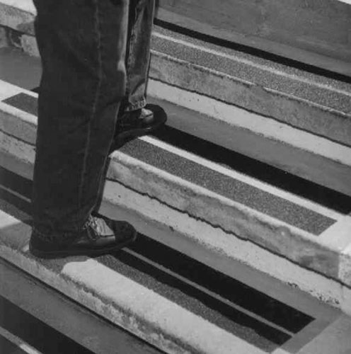
Anti-Slip Tapes & Strips:

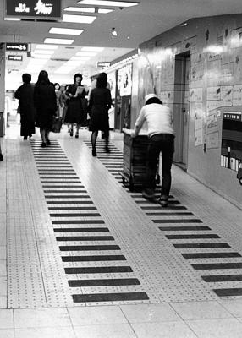

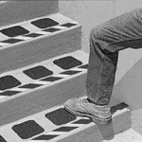

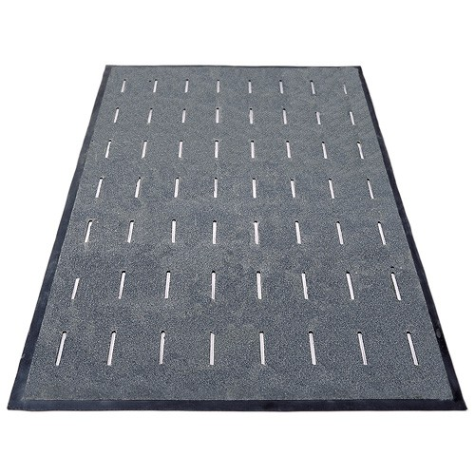
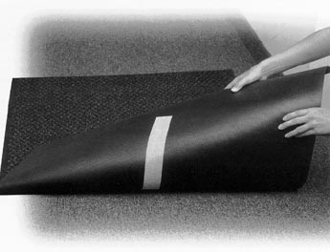
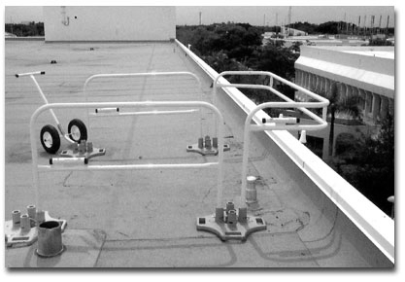
Floor Mats:
Floor Mat Tape:
Portable Safety Rail for Fall
Protection:

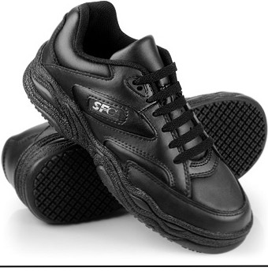
Slip- Resistant Shoes:

