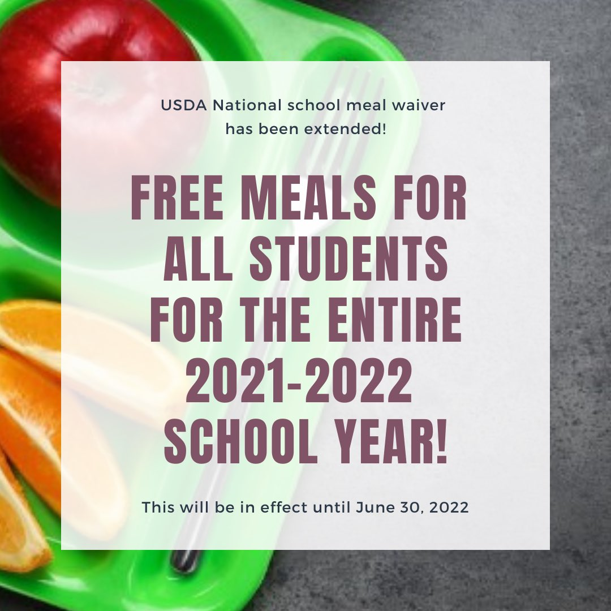

**School Nutrition**

**Parent Guide**

**2021-2022**

**YOU MAY BE ELIGIBLE**

Although school meals are available at no cost to students this school year, applying for meal benefits is still very important!

By applying for meal benefits you may be eligible for the following:

* P-EBT Funding
* Free or reduced fees for sports
* Reduced registration fees for AP, SAT and/or AP Tests
* Discounted rates on college application fees

Your application affects funding in many areas!

* School Funding
* Internet & Technology
* Access to grants
* Resources for classrooms, teachers & children

Applications are available on the district’s

website wcsdk12.org

under the Food Service tab

**2021-2022 School Year Meal Prices**

First Breakfast K-12 FREE

First Lunch K-12 FREE

Packed Lunch Power Pack* FREE

There is still additional cost for A la Carte items.

A la carte items include but are not limited to;

snacks, bottled water, 2nd Breakfast, 2nd Lunches, extras and doubles.

Second Breakfast K-12 $2.25

Second Lunch K-5 $3.00

Second Lunch 6-12 $3.25

A la carte items are priced accordingly.

**Packed Lunch Power Pack\***

If your child prefers to bring their favorite lunch from home, try our FREE fresh add on items to go with your packed lunch.

*Students must take all three to be free*





Healthcare provider notes and Food Allergy Action Plans must be updated annually with your school nurse.

**Student Lunch Account**

All students are issued a personal lunch account number or code when they enter Washingtonville CSD.

We encourage you to work with your student to memorize this number. Students will use this code

throughout their time in the district to identify themselves at the register. The use of this number

speeds up service for all students and gives them more time to enjoy their lunch.

Although we will be accepting cash and issuing change this year, we continue to encourage students to

use their lunch account as much as possible. If you have not done so please go to MySchoolBucks.com

and create an account. Funds can be deposited on-line via the website, by using the MySchooBucks app

or in the cafeteria with a cash payment or check made payable to “WCSD Lunch Fund”.

Please remember students are not permitted to charge negative on their lunch fund accounts.

