Welcome to Civics and Government!
Teacher: I began teaching at Susquehanna Township High School in 2017. I received my bachelor’s degree in history in 2004 and have worked in education across the country. I live in Carlisle PA with my wife and two children and enjoy spending time outside whenever I can.
Course Overview: The course will investigate the constitutional underpinnings, formal structure and politics of government in the United States at all levels. Emphasis will be placed on the federal government and its role in the international political system and comparative economic systems with an in-depth examination of the U.S. Congress, the Presidency, and the Supreme Court. Discussion of current political issues and a variety of experiences will supplement this program.
Units of Study will include:
-Foundations of American Government
-The Constitution
-Political Behavior: Government by the People
-Legislative Branch
-Executive Branch
-Judiciary
-State and Local Government

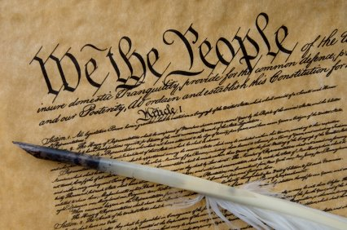

Classroom Expectations: All school-wide policies/procedures will be enforced in the classroom. Mr. Sell’s classroom expectations include the following:
- Respect yourself, others, and the Teacher at all times – Raise your hand to speak and respect the opinions, ideas, and beliefs of others. Be willing to work cooperatively with others and learn new things!
- Come to class prepared and ready to complete work as assigned
- Follow all Classroom Procedures and School Policies
- Electronic Devices/Cell Phones should not be used in class unless directed to by the teacher
- No Food or Drink in class with the exception of water in a clear bottle.
- All Assignments will be distributed and collected through Teams.
Grading/Assessment: Units of study will include the following types of assignments and assessments. They are weighted according to the following structure.
Assessments (tests, quizzes, projects, essays): 70%
Classwork: 20%
Homework: 10%
Mid-TERM and FINAL EXAM: Both the midterm and the final exam will be cumulative and each will count as 10% of the overall course grade.

Late Work: All work is due by the due date. Students may submit late work with a 10% deduction for every day it is late. If you have not turned in an assignment after five school days you will receive a zero for the assignment.
Absences: Students that are absent from class for an excused reason may make up work that they missed. It is the student’s responsibility to inquire with Mr. Sell about the work that was missed. Students will have the same amount of time to make up the work as was originally given for the assignment (i.e. if students have two days to complete an assignment when originally assigned, then the student has two days to complete the work following their return to class).
Materials:
Textbook –
Composition Notebook – will be distributed first week of classes, bring to class EVERY day
Notebook/Binder – MEAD Five Star Notebook highly recommended , works best to stay organized!
Pen/Pencil – A highlighter is also recommended
Technology – Bring your 1:1 device to class everyday – we will be using technology!
Academic Honesty: Plagiarism/Cheating is regarded as a serious academic offense and goes against the core value of integrity. Any suspicion of plagiarism or cheating will be investigated by the teacher. Please see the attached academic Integrity form for more information on this policy.
Class Teams and OneNote: In order to provide students and parents access to assignments or materials out of the classroom, a classroom Notebook and Teams can be accessed through Microsoft O365.
Communication: Communication between the teacher, students, and parent/guardian is of paramount importance to ensure overall success. Parent/Guardian questions, concerns, or request for conference should be directed to Mr. Sell jsell@hannasd.org
Extra Help: If you need help, please reach out, we can set up an appointment during my office hours.

* Finally, considering the current situation with COVID-19 you will need to be flexible, the format of instruction may change due to constraints that are unavoidable, in other words, this syllabus is subject to change.
cut here
Please Cut/Tear this bottom signature slip and return to Mr. Port by September 5th
Civics and Government
Student Name:
I have read and understand Mr. Port’s class expectations and information. Any further questions can be directed to Mr. Port at jport@hannasd.org.
Student: Date:
Parent/Guardian Date:

