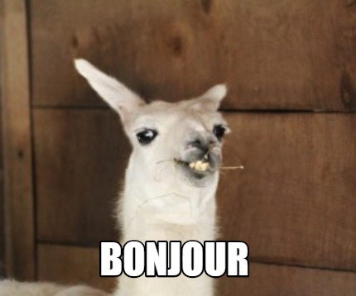
Summer Review:
In Preparation for French 2!!

Salut tout le monde!

I am so excited to see you all in French 2! But, in preparation for that, it is important we keep up with French. Learning a language takes continued practice -- you either “use it or you lose it,” as the saying goes.

This review packet is meant to give you practice listening and reading in French. Of course I want you to be able to enjoy your summer, so these assignments are meant to be interesting and will hopefully inspire you to explore francophone culture more in your free time. (Check out this YouTube playlist if you want some awesome French summer jams)

I recommend you space out these assignments over the entire summer. Not only will it save you stress later on, it will also be the most efficient for your learning and retention of the language. I think spending about 30 minutes per week on these assignments will keep you on track.

Like in class, do not use Google Translate. Take your time with this material, use wordreference if/when you need a dictionary, and you will be prepared come the 2021-2022 school year!

If you have questions throughout the summer, you can email me (fishera@ndnj.org). I will be available on a limited basis, so give me a week to respond.

Passez un bon été et à bientôt!,
M. Fisher

Assignment #1: Radio France International

Listen to this short podcast and answer the following questions. Please be prepared to hand in your responses. Either complete the assignment on a google doc or on a piece of paper.

Here is a helpful list of vocabulary:
Originaire de = originate from
L’architecture = architecture
Une église = a church

- Quel âge a-t-il ? David Angelo a :
□ 32 ans. □ 33 ans. □ 34 ans.

- D’où vient-il ?
□ Il vient d’Angleterre. □ Il vient du Soudan.

- Quelle est sa profession ?
□ professeur d’anglais □ traducteur anglais-français □ professeur de musique □ musicien

- Il aime :
□ l’architecture parisienne. □ les expositions parisiennes. □ la musique à l’opéra. □ la musique dans les églises.

Assignment #2: Reading

Read this story and answer the attached questions. Like assignment #1, please complete this activity either on a google doc or on a separate piece of paper.

Assignment #3: Writing

Write a response to the following questions. Like the above assignments, use a google doc or a separate piece of paper.

Don’t use google. We will be reviewing these at the start of the school year so just do your best.

- Comment tu t’appelles?
- Qu’est-ce que tu aimes? Qu’est-ce que tu n’aimes pas? Qu’est-ce que tu détestes?
- Est-ce que tu as des frères ou des soeurs? Combien? Ils s’appellent comment?
- Tu es comment? (use 2 physical adjectives to describe yourself and 2 adjectives to describe your personality)

Optional: Duolingo
If you would like to practice more and review some basic vocabulary, signing up for duolingo is a great way to do that.

Optional: Grammar
While my class is not hyper focused on grammar, the more you review and read, the more prepared you will be to communicate. Linked below are some grammar games you can play to review some of the concepts you may not feel as strong about. These are not mandatory, but you might find them fun and to be a good review!

The verb etre
Present tense verb games
Preposition games
Possessive adjectives game 1
Adjective games

*Note* The above games are for college level French courses, so it may be a challenge and take a moment to figure out the answers. But don’t give up! Each game comes with a document at the bottom to explain the concept in both French and in English.

