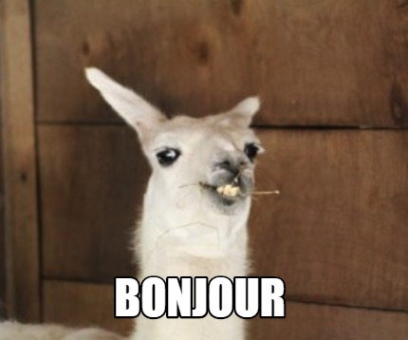
Summer Review:
In Preparation for French 3!!

Salut tout le monde!

I am so excited to see you all in French 3! But, in preparation for that, it is important we keep up with French. Learning a language takes continued practice -- you either “use it or you lose it,” as the saying goes.

This review packet is meant to give you practice listening and reading in French. Of course I want you to be able to enjoy your summer, so these assignments are meant to be interesting and will hopefully inspire you to explore francophone culture more in your free time. (Check out this YouTube playlist if you want some awesome French summer jams)

I recommend you space out these assignments over the entire summer. Not only will it save you stress later on, it will also be the most efficient for your learning and retention of the language. I think spending about 30 minutes per week on these assignments will keep you on track.

Like in class, do not use Google Translate. Take your time with this material, use wordreference if/when you need a dictionary, and you will be prepared come the 2021-2022 school year!

If you have questions throughout the summer, you can email me (fishera@ndnj.org). I will be available on a limited basis, so give me a week to respond.

Passez un bon été et à bientôt!,
M. Fisher

Assignment #1: Radio France International

Listen to this short podcast and answer these questions.

Vocabulaire:
Prendre l’air - get some air
À l'extérieur/intérieur - outside/inside
Bouquiner - to read (to have your head in a book)

Please be prepared to hand in your responses. Either complete the assignment on a google doc or on a piece of paper.

Assignment #2: Reading

Read 1 of the 3 articles from this document. There is a story about Japanese fashion in Cameroon, a poem written by a teacher from Morocco, and a story about “zooming” and speaking in French.

When you read the article, complete 2 of the activities listed on this Google Slide. You may choose any 2 to complete. Like assignment #1, please complete those activities either on a google doc or on a separate piece of paper.

Assignment #3: EasyFrench

Choose and watch 1 video from this YouTube playlist. After you watch the video, write a paragraph where you answer the following questions (5-7 sentences total, not including the vocabulary portion). Please include the link of the video you watch. Like the above assignments, use a google doc or a separate piece of paper.

Your responses should be in French. Do not use google translate. We will be reviewing this when we get back so do the best that you can.

- Qu’est-ce que vous pensez de la vidéo? Est-ce que vous l’aimez? Est-ce que vous ne l’aimez pas? Pourquoi?
- Quels sont les gens (the people) dans la vidéo? Ils sont comment? Décrivez-les (Describe them. Use adjectives, describe what they are wearing, talk about what they seem like).
- Quels sont 3 nouveaux mots de vocabulaire? Définissez-les en anglais. (define them in English)

Optional: Duolingo
If you would like to practice more and review some basic vocabulary, signing up for duolingo is a great way to do that.

Optional: Grammar
While my class is not hyper focused on grammar, the more you review and read, the more prepared you will be to communicate. Linked below are some grammar games you can play to review some of the concepts you may not feel as strong about. These are not mandatory, but you might find them fun and to be a good review!

Present tense verb games
Passe compose verb games
To review negation
To review forming questions
Demonstrative adjective game 1
Demonstrative adjective game 2

*Note* The above games are for college level French courses, so it may be a challenge and take a moment to figure out the answers. But don’t give up! Each game comes with a document at the bottom to explain the concept in both French and in English.
