English Grade 11 Honors
Summer Reading Assignment

Required texts: McBride’s “ The Color of Water” and Ford’s “ Hotel on the Corner of Bitter and Sweet”

The Color of Water
By James McBride

Background about the book:
“As a boy in Brooklyn’s Red Hook projects, James McBride knew his mother was different. But when he asked about it, she’d simply say, “I’m light-skinned.” Later he wondered if he was different, too, and asked his mother if he was black or white. “You’re a human being,” she snapped. “Educate yourself or you’ll be a nobody!” And when James asked what color God was, she said, “God is the color of water.”…As an adult, McBride finally persuaded his mother to tell her story — the story of a rabbi’s daughter, born in Poland and raised in the South, who fled to Harlem, married a black man, founded a Baptist church, and put twelve children through college. The Color of Water is James McBride’s tribute to his remarkable, eccentric, determined mother — and an eloquent exploration of what family really means.”

Assignment:

- Read the book.

- Complete the Dialectical journal that follows this page. Instructions are included at the top of each section

- Watch the video created by Shante Crawford for background on The Color of Water. You can stop viewing at 4:36. The URL is https://www.youtube.com/watch?v=EgPofpWShpM

- Be prepared to discuss and/or write about the book using the dialectical journal on the first day of class.

Name _______________________

Dialectical Journal Color of Water, Chapters 1-3
Directions: Tell what you learned about the character based on the quotation.

Quotation From the Text | Page Number | Response
“ There were too many rules to  follow, too many forbiddens  and ‘you can’ts’ and ‘you  mustn’ts,’ but does anyone have  time to say they love you? Not  in my family we didn’t.” | 2
“…I didn’t want my friends  seeing my white mother out  there riding a bicycle. She was  already while, that was bad  enough…” | 8
“As a boy, I always thought my  mother was strange. She never  cared to socialize with our  neighbors.” | 9
“What’s money if your mind is  empty?” | 9
“Matters involving race and  identity she ignored” | 9
“Me and Mommy alone. It was  the first time I remember ever  being alone with my mother.” | 11
“…I noticed that Mommy stood  apart from the other mothers  rarely speaking to them…She’d  quickly grasp my hand as I  stepped off the bus, ignoring the  stares of the black women…” | 12
“Who am I? I ain’t nobody! I  can’t be telling the world this!” | 17
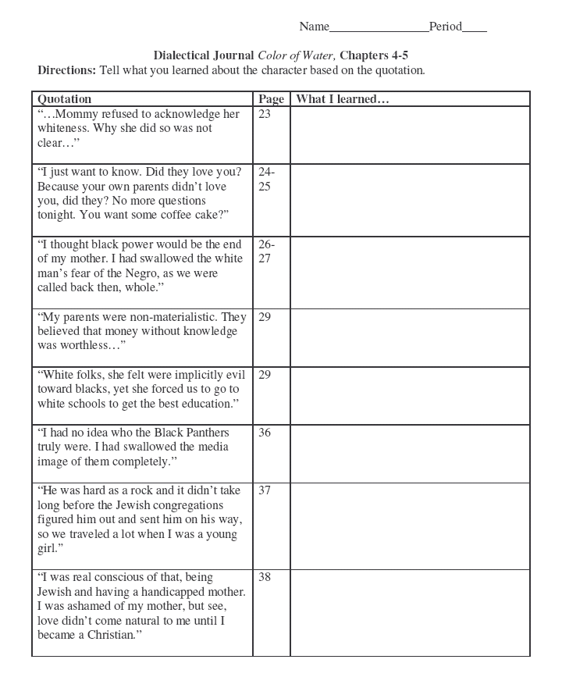
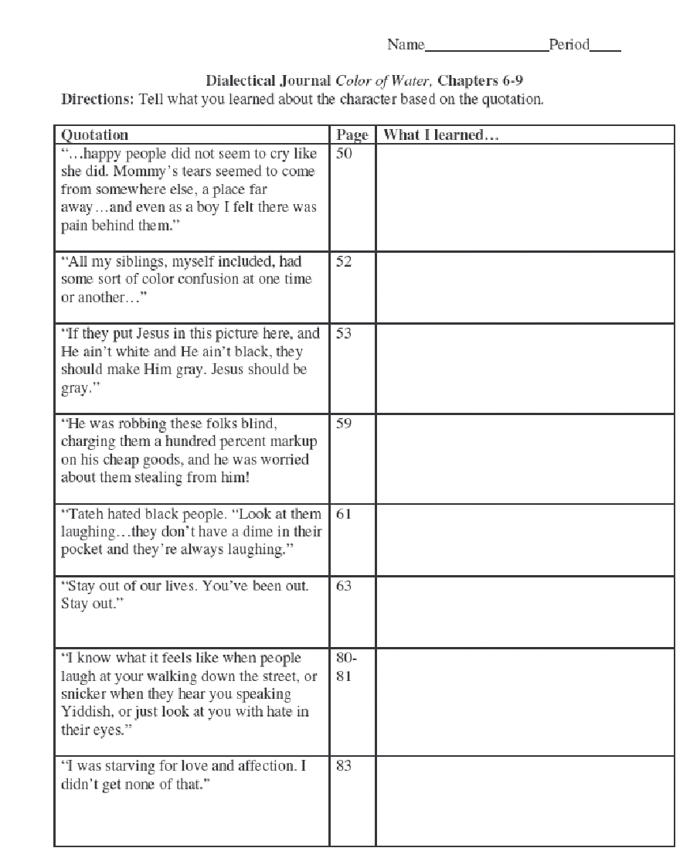
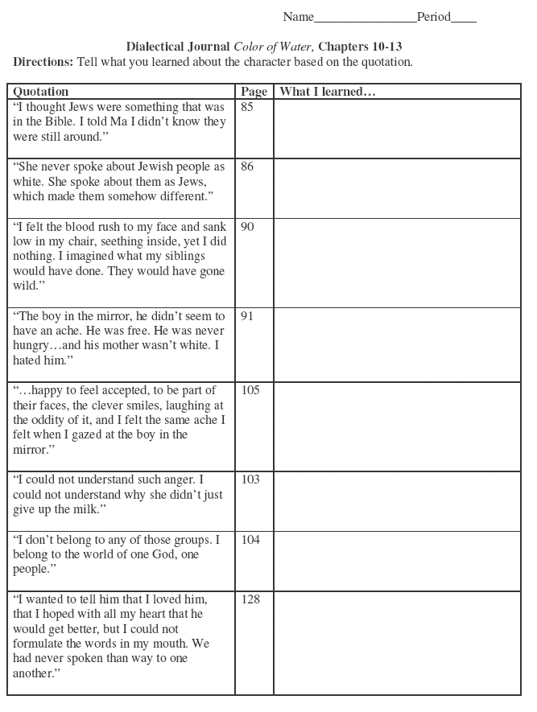
Your Turn: Find quotes throughout the assigned chapters, that you find interesting or important to the areas of conflict, figurative language and tone/mood. List them below and explain what you learned about that character. Please note that the areas are separated, but encompass all the chapters from 14-25.

Dialectical Journal Color of Water, Chapters 14-25
Directions: Tell what you learned about any conflicts based in these chapters.
Quotations | Page | What I learned

Dialectical Journal Color of Water, Chapters 14-25
Directions: Tell what you learned about use of figurative language in these chapters.
Quotations | Page | What I learned…

Dialectical Journal Color of Water, Chapters 14-25
Directions: Tell what you learned about the mood/tone based in these chapters.
Quotations | Page | What I learned…

Required Text II:
Read ‘Hotel on the Corner of Bitter and Sweet’, by Jamie Ford. Annotate the text and bring it with you on the first day of class.

- Download and read From Citizen to Enemy: The Tragedy of Japanese Internment at
http://www.gilderlehrman.org/history-by-era/world-war-ii/essays/from-citizen-enemy-tragedy-japanese-internment
- Watch a minimum of one video online on the Japanese Internment in WWII. A good example is
http://www.history.com/topics/world-war-ii/japanese-american-relocation/videos/japanese-internment-in-america

The class will discuss each work and the importance of the additional references in class during the first week. At the conclusion of the first week, an essay on each book will be written and submitted to Turnitin.com. Each essay will be written on a separate day.

