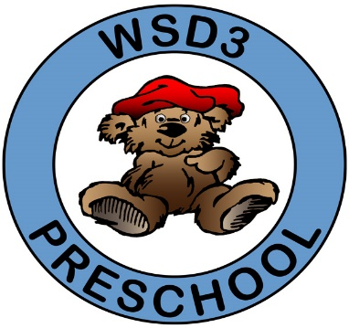
Widefield School District 3
Preschool Program
Supply List

Since students will not be sharing supplies, they will need the following items for their individual use. Please put your child’s name on each item.
Pencil box
Crayons (box of 8 or 16)
Washable markers
4 glue sticks
Child-size scissors (metal blades, blunt-tip, NOT plastic-guard safety scissors)
Watercolor paints
Sidewalk chalk (small box)
Full-sized backpack
Full change of clothes (top, bottoms, underwear, socks, extra face mask)
Water-bottle (to travel between home and school daily)
Face Mask (to travel between home and school daily), if this is still a requirement at the time your child enrolls.

Note: If you cannot supply your child with these items, please let your child’s teacher know so we can help!

Additional Donation Request List
2021-2022

Can you help? The following is a list of supplies that are regularly used in the preschool classrooms. Donations are not required, but very much appreciated! Thank you for any supplies you can provide!

AM Classes PM Classes
Gallon size Ziploc bags Sandwich size Ziploc bags
Diaper wipes 2 boxes of Kleenex
Play-doh Play-doh
Sticky-back Velcro dots Sticky-back magnet dots
Thin, nontoxic dry-erase markers Thick, nontoxic dry-erase markers

Note: Teachers may request some additional items at the time of parent conferences and throughout the school year as needed.

