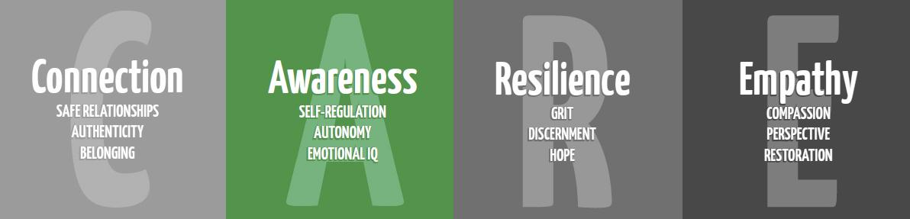
Career Lesson
Lesson Title: What Careers Interest You?
Objective: To relate interests, strengths, experiences to careers
Grade: 4-5
Time: 25-30 minutes
Materials: See activity below
1. Talk about higher education/college, for example: it’s not too early to start because higher education begins now; setting goals and forming good work habits (school/homework) because these skills are important when selecting a career; (These are also important to choosing a career based on 3 important criteria 1)your interests (likes), 2)your strengths (what you are good at), 3)your experiences (what have you done & like don’t like).
2. Pass out the sheet paper and tell students to stay on Side 1 and write their names. Ask the students to read descriptions for the six boxes on Side 1. As they read if the statement relates/sounds like them they need to circle it. Tally how many they circle in each box and write the number in the box. When they finish, tell them to circle the top three areas in the order that best describes them. (I always read box 1 to them to help them get started).
3. Have students turn over to Side 2. The careers in each box on Side 2 correspond to the statements on each box on Side 1. Remind students that this is just a small snapshot of how they see themselves right now and this may change. I have students read the careers in each box on Side 2 and I may point out or ask students to identify the strengths needed in that job cluster.
4. Students may choose to share their tops if they would like.
5. Review how the 3 criteria’s (interests, strengths, experiences) are important when selecting a career and summarize.
Name______________________________
Side 1
Area 1
Like to work in groups
Can influence other people
Like reading
Not afraid to talk in front of the class
Have a lot of friends
Very important to make money this summer
Like to dress up
Know the latest gossip at school

Area 2
Care a lot about who becomes president
Really like virtual reality
Like working with numbers
Science is one of your favorite subjects
Your room is clean
Like the internet
Good with details
Prefer casual clothes

Area 3
Like to teach others how to do things
Gets along well with others
You want to make the world a better place
Love to go to parties
People describe you as friendly
Talk on the phone a lot
Like being on a team
Like to wear popular clothes

Area 4
At football games, you like watching people
Like art, music and writing
Don’t have to wear popular clothes
Others may describe you as being emotional
Others may describe you as being expressive
Like different types of music
Movies with morals to them interest you
Science Fiction doesn’t interest very much

Area 5
Enjoy word problems and riddles
Like math and science
Fashion isn’t important to you
Like to learn new things
Don’t have to agree with others
Like Science Fiction
Ask ‘Why?’ a lot
Interested in other planets
Area 6
Like action movies
Enjoy fixing things
Like rock and roll or country music
Rather wear jeans than dress-up
Like athletics
Enjoy pets
Like to camp and fish
People describe you as practical

Side 2
Area 1
Apartment Manager
Auto Dealer
Building Contractor
Demonstrator
Importer/Exporter
Lawyer
Lobbyist
Personnel Manager
Salesperson

Area 2
Bank Teller
Bookkeeper
Business Machine Operator
Accountant
Credit Manager
Homemaker
Library Assistant
Secretary
Photographer

Area 3
Coach
Hairdresser
Speech Therapist
Religious Leader
Teacher
Librarian
Nurse
Physical Therapist
Recreation Worker
Bus Driver

Area 4
Actor/Actress
Architect
Artist
Dancer
Fashion Designer
Interior Decorator
Jewelry Designer
Journalist/Reporter
Musician
Photographer

Area 5
Airline Pilot
Historian
Chemist Cook
Computer Programmer
Instrument Repairer
Marine Biologist
Pharmacist
Doctor
Physicist
Zoologist

Area 6
Carpenter
Electrician
Mechanic
Police Officer
Tailor
Truck Driver
Coach
Psychologist
Grounds Keeper

