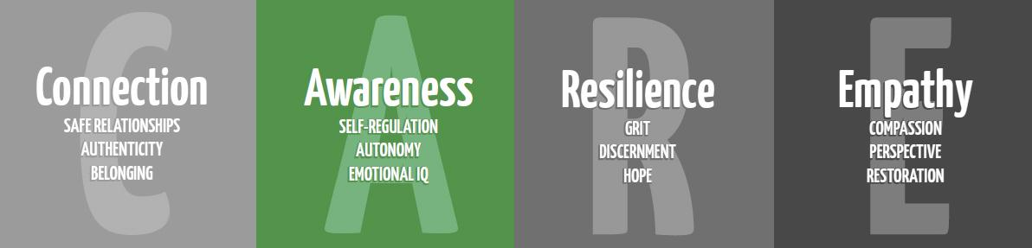

Careers for 2nd Grade

Purpose: To educate students on the 16 different clusters of careers and promote future minded thinking.

Materials:
Foldable template for each student (below) & Counselor made example foldable
My First Resume (below)
*Ideally, classes need to explore careers online before the lesson. (https://xello.world/en/ or https://www.bls.gov/k12/students/ )

Time:
Approximately 30 minutes

Focus:
Ask kids what is a job? What is a career?
A job is an activity to earn money. A career is the pursuit of a long-term goal, and can be made up of many jobs. Careers require different kinds of training, skills, and education.

Lesson:
Pass out a foldable to each student. Discuss how obtaining a career is a journey. All trips need planning, so we are going to plan for our future! The first step towards a career is knowing what you like, what you’re good at, and what experiences you have. Discuss each one and have students write their likes, talents, and experiences in the foldable. Model this using your own foldable! Have kids brainstorm what jobs they could do based on their likes, talents, and experiences. They can discuss the jobs they learned about in their online exploration. Have each student pick his/her ‘dream job’ and write what it is in the last part of the foldable. Each student can draw a picture of himself doing his dream job.

Closure:
Talk about planning for a dream job. What education, training, and skills are needed? Tell students a resume is a short summary of a person’s work experience and qualifications to help someone get a dream job. Fill out the My First Resume page as a class for a career (can give students copies to fill out later individually).

Extension:
Students research what it takes to get their dream job and write about it on the back of the foldable, or make a collage about their dream job.

Your Name

Address

City State Zip

Telephone

Position Sought:
(A job you might want to have)
A
resume is a short summary of a
person’s work experience and qualifications.
You can create your first resume by filling in
the blanks.

Abilities and Talents: (list positive character traits and things you are good at. For example: good listener, reliable, computer skills, good in math, great speller)






Achievements and Awards: (list awards you have received and when. For example; Honor Roll for 4th Grade, Perfect Attendance 2nd Grade, Scouting Award 2004, Citizenship Award.)




Work Experience: (list jobs you had or currently have. For example: dog walker, babysitter, plant waterer, salesperson at school store. These do not have to be jobs you receive pay for.)




Education: 
Grade Name of School
References: (list people who will say good things about you)


Retrieved from Texas Workforce Commission Career Activity Book https://lmci.state.tx.us/shared/PDFs/CareerActivitiesBook.pdf

What would my dream job be?
What experience do I have?
What are my interests?
What am I good at?

