The Brain Song
(to the tune of B-I-N-G-O)
I have a brain in my head and it is for THINKING Helps me make good choices
Helps me pay attention Helps me know what to do My brain is for THINKING

I have a brain in my head and it is for FEELING Sometimes I feel happy
Sometimes I feel angry Sometimes I feel sad
My brain is for FEELING

I have a brain in my head and it is for REMEMBERING Helps me learn new things
Keeps all my memories
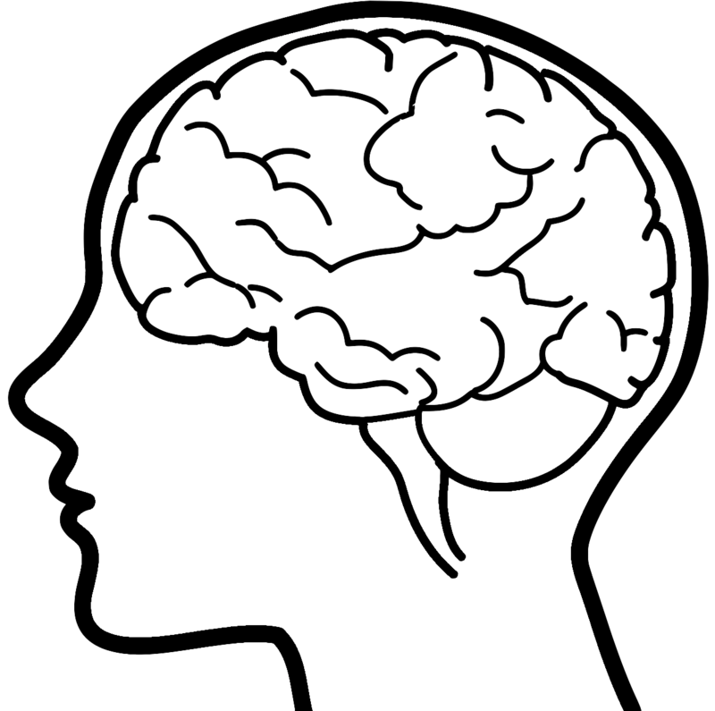
Helps me so I don’t forget My brain is for REMEMBERING

