Self-awareness/SEL

5th Grade

Purpose: To teach self-regulation (SEL), help students identify where they feel emotions in their bodies, and how to handle settle their glitter.

Materials:
Brain Poster: https://docs.google.com/presentation/d/1kMORCbVZK8_0095eilZHtJnklmhNxPyjpJMM2z55uwY/copy
Glitter jar
Emotions and the Brain Video https://www.youtube.com/watch?v=WBM_LqkS4r4
OR Why Do We Lose Control of Our Emotions? Video https://www.youtube.com/watch?v=3bKuoH8CkFc
Self-Control task cards from TPT (read through them and pick grade level appropriate cards)
https://www.teacherspayteachers.com/Product/Self-Control-Task-Cards-2981195
OR make your own role play/reflection cards
Elementary #OneYou video https://www.youtube.com/watch?v=lPIMPLYrKqQ
And one of the following options:
OPTION 1: Emoji handout (with #oneyou questions on back)
OPTION 2: Pieces of Me handout (with #oneyou questions on back)

Additional resources:
Brain Song: https://docs.google.com/presentation/d/1xhXc5aoUpg_LWz-SZ3-xppr5x7fC_vhOlBwlWthQ_iY/copy
Feelings Poster https://resources.finalsite.net/files/v1617985556/mesquiteisdorg/m7j9nawjtrmcymo6atb6/ResourceFeelingsPoster-Eng-Span.pptx
OR Feelings Picture Wall https://www.teacherspayteachers.com/Product/Emotions-and-Feelings-Vocabulary-Word-Wall-Cards-plus-Write-and-Wipe-Version-3657974
Stop Think Settle Your Glitter: https://resources.finalsite.net/files/v1617993729/mesquiteisdorg/yrzlkxrqqmcdqiqefybr/Resource-Stop-Think-SettleYourGlitter.docx
Brain Song: https://docs.google.com/presentation/d/1xhXc5aoUpg_LWz-SZ3-xppr5x7fC_vhOlBwlWthQ_iY/copy
Extension activities and parent handouts available for download from: https://www.mesquiteisd.org/resources-services/counseling-services/guidanceprogram/counseling-program/social-emotional-learning
Slides with Visuals: https://docs.google.com/presentation/d/1RA-hVhUPY0vcAvLw4oQqNgv0kNjZkEH_uHcpHBTHsfw/copy

Time:
Approximately 45 minutes

Focus:
Show the students broken pieces of tile. Then show them a mosaic (It can be a picture of a mosaic or an actual mosaic. Pick one that shows a picture, not just a colorful pattern). Talk about how individually, the pieces are unique and different, but it’s when they come together that they create something beautiful. The whole is more than the sum of the parts. We’re going to talk about the pieces that make up us.

Lesson:
Tell students that their brain is responsible for everything about them: thinking, feeling, doing, hearing, seeing, touching, smelling, tasting. Review with students the brain hand and “flipping your lid”. Tell students there is only one you, and you’ve got to take care of you. Talk about “big feelings” and “settling your glitter”. Use the glitter jar for a quick object lesson. (Show students a glitter jar with different size glitter. Shake it up and ask them what they see. This is what are brain is like when we are sad, mad, scared. It’s hard to see through all the glitter, and it’s hard for us to think and make good choices. Point out the different size glitter. Those are like the different sizes of our emotions. Notice some glitter settles faster than others. We have to work harder to calm ourselves down with big emotions.)

Watch either the “Emotions and the Brain” video, or the “Why Do We Lose Control of Our Emotions” video.

Pass out the Pieces of Me or Emoji handout (use whichever version best suits your group of kiddos).
Tell students that we can catch ourselves before our glitter gets stirred up through self-awareness. Self-awareness is noticing your physical sensations, feelings, habits, behaviors, and thoughts. It’s knowing yourself inside & out, and especially being HONEST with yourself. Use the inside out shirt as an analogy about knowing ourselves. Guide students through one of the following:

Pieces of Me handout
Say: like we talked about at the beginning of the lesson when we looked at the mosaic, we are more than our pieces. It’s important to know our pieces, so we can be the person we want to be. Our thoughts, feelings, and actions are pieces that make up us. We have to be aware of ourselves to control ourselves and make good choices to have the life we want to have.

Guide students in completing the handout and model by filling out your own handout on a document camera. Ask students what they think self-awareness is; guide them in answering (self-awareness is knowing ourselves). Point to the brain graphic. One of the first steps in knowing ourselves is paying attention to our thoughts and how we think about ourselves. Are you kind to yourself? Do you tell yourself mean things? Think about a negative thought, a mean thought, you think about yourself and write it on the page near the brain. Now I want you to find a way to turn that into a growth mindset or something positive. Model for students your own example (for example: negative: I’m so fat. Growth: I can grow stronger, and I am worthwhile no matter how I look.)
-Point to the heart. Our feelings are another important piece of us. Think about a time you felt happy and write or draw a picture next to the emoji. Guide students in doing this for each emoji.
-Point at the hand on the left. Our behaviors, our actions are another important piece of us. It’s the piece of us that people can see, and they make inferences about us (they decide what they think about us) based on our behaviors. Think about what you do when you feel angry. There might be warning signs in your body (feeling hot, headache, etc.) that let you know you’re feeling that way. These are important clues in controlling yourself and helping to calm your brain and body before you flip your lid. Guide students on writing in this section for each emotion. Do these actions match up with the person you want to be and the life you want to have?
-Point to the hand on the right. Our habits, another piece of our actions, can tell us a lot about ourselves. Think about things you do a lot. Play video games? Ride your bike? Shop? Watch Tik Tok videos? Your habits are like food for your brain. Are what you’re feeding your brain healthy things? Do these actions match up with the person you want to be and the life you want to have?
-Point to the feet. Think about and then write down places you go a lot. School? The store? The park? Someone’s house? These are all clues to what/who are important to you. This is another important piece of you.
We are more than our thoughts, feelings, and actions. However, these things all influence who we are. As you get older, you get more control and freedom to make choices. When you make choices, ask yourself, is this the kind of person I want to be? Is this the kind of life I want? You are in control of you.

Emoji handout
We have to be aware of ourselves to control ourselves and make good choices to have the life we want to have. Discuss each emotion and recognizing their warning signs of each (feeling hot, clenched fists, stomach ache, headache, etc.). Next, guide students through what coping skills are and have students write down the coping skill that helps them through those feelings listed. (Deep breathing, walks, punch a pillow, etc.)

Group Discussion (for either option)
Share with students that we are going to talk through some situations that they may or may not have experienced by working with their group using task cards. Explain to students that some of these situations they may not have experienced yet, but hopefully as we talk through some of these, it will help them to know what to do and to be more confident if they find themselves in any of these.

Pass out task cards for each group to work through at their tables. Set a timer for 15 minutes, and have students work through as many cards as they can. Set expectations that everyone participates and not just one person controls the cards.

Task card examples, if you choose to make your own:
Role play: Talk to a friend who has flipped his/her lid. What would you say to him/her?
Draw it: Sketch what it looks like to have self-control in class.
Turn and Talk: What kind of self-control do you need in PE?
Define it: What is an I statement?

Closure:
Collect the task cards and remind students that they need to know themselves for many reasons. In middle school, knowing themselves will help them to pick classes that they are happy with, which will affect high school, which affects the rest of their lives.

Show the #oneyou video. Following the video, discuss that there is only “one you”, you can’t be replaced, and that taking care of your brain is as important as taking care of any other part of their body. We want their brain to be happy and healthy so that they can have their best life.

Extension:
Send home parent brain infographic.
Share Dr. Arnold Beisser’s description of the Paradoxical Theory of Change: “Change occurs when you become what you are, not when you try to become what you are not.” Being you is how you become a better you, not trying to be someone else. #oneyou

Have students take some time on their own to reflect and answer the #oneyou questions about themselves on the back of the handout. Can offer an incentive for students showing you they completed them the next time you come in for guidance.

OR Show students the Feelings Poster or the Feelings Picture Wall that you are going to leave for them in the classroom. Explain to them that this is something their teacher is going to use to continue to talk about some of the feelings we talk about today. The teacher may want to hang it up and refer to it daily as a poster or you can cut it apart and have the teacher add one feeling at a time as they discuss until they are all up. The teacher can reinforce belly breathing and the glitter jar as they discuss each feeling with the class.
OR Review and give teacher a copy of the “Stop Think Settle Your Glitter” paper to hang in their room.

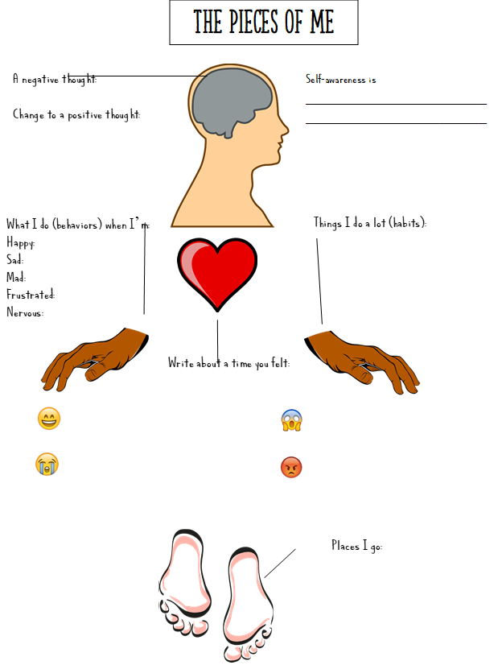
- Some things I do well are ___________________________________________________ ________________________________________________________________________
#oneyou

- Some things I can improve are _______________________________________________ ________________________________________________________________________
- Some things I enjoy doing are _______________________________________________ ________________________________________________________________________
- Some things I dislike doing are ______________________________________________ ________________________________________________________________________
- Some things/people who are important to me are _________________________________ ________________________________________________________________________
Places and/or situations I might need help: | Things I can do to help myself:

Other things for me to think about:
What does how I talk to people say about me?

What is my body language and tone of voice when I talk to others?

Do I make wise word choices when I speak to others?

Do I feel confident when I talk about myself to others?
Questions adapted from ME! Lessons for Teaching Self-Awareness & Self-Advocacy
http://www.ou.edu/education/centers-and-partnerships/zarrow/transition-education-materials/me-lessons-for-teaching-self-awareness-and-self-advocacy.html

Self-awareness is _____________________________________________

Sad
Annoyed

Worried

Confused
Frustrated

Scared
Angry

Nervous
#oneyou

- Some things I do well are ___________________________________________________ ________________________________________________________________________
- Some things I can improve are _______________________________________________ ________________________________________________________________________
- Some things I enjoy doing are _______________________________________________ ________________________________________________________________________
- Some things I dislike doing are ______________________________________________ ________________________________________________________________________
- Some things/people who are important to me are _________________________________ ________________________________________________________________________
Places and/or situations I might need help: | Things I can do to help myself:

Other things for me to think about:
What does how I talk to people say about me?

What is my body language and tone of voice when I talk to others?

Do I make wise word choices when I speak to others?

Do I feel confident when I talk about myself to others?
Questions adapted from ME! Lessons for Teaching Self-Awareness & Self-Advocacy
http://www.ou.edu/education/centers-and-partnerships/zarrow/transition-education-materials/me-lessons-for-teaching-self-awareness-and-self-advocacy.html

