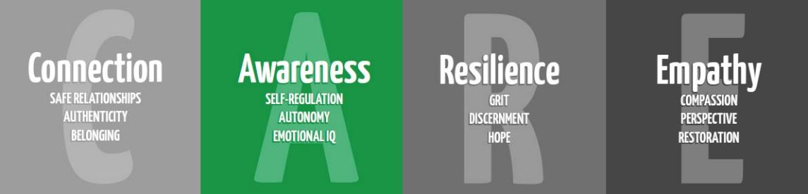

Self-Regulation
for 5th

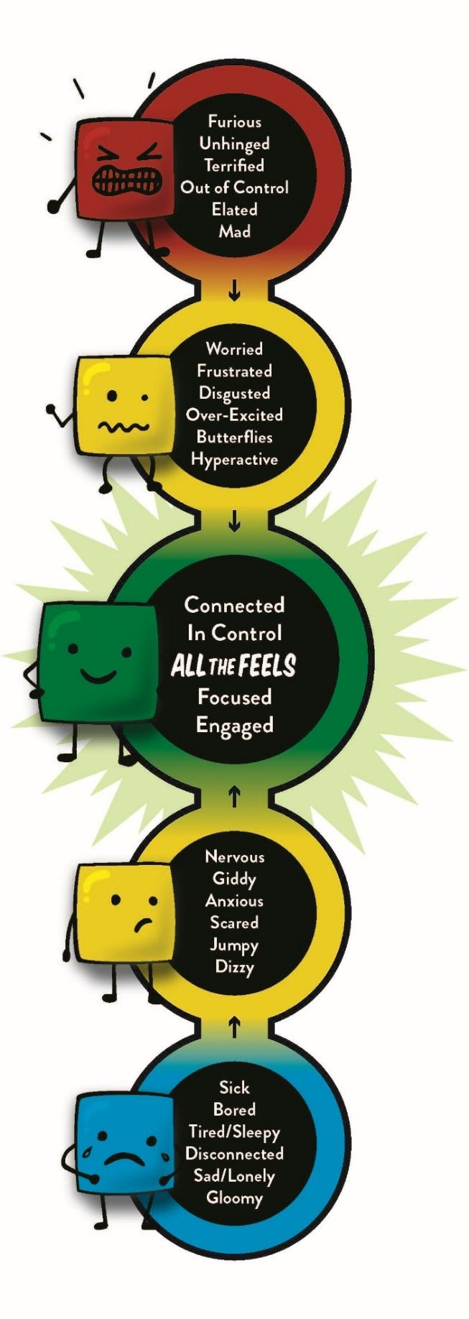
Purpose: To educate students on how to calm down when the have big, or little, feelings. To scaffold SEL language from elementary to secondary

Materials:
Empty bleach bottle
Box Breathing and Star Breathing techniques (below_
Identifying Stress Handout (below)
Get to Green fillable cards (below- print front/back)
Tangled Ball of Emotions (below)
Crayons
Ted Talk-Overcoming Obstacles https://www.youtube.com/watch?v=2MGMvEnoD6U
Or use this Google Slides to present https://docs.google.com/presentation/d/1xLWzNR7eEVUbjd5mLNHmDjJkqfkV2wPsB75Ao9DK_KI/edit?usp=sharing
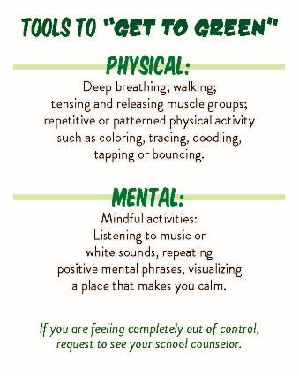
Time:
Approximately 30 minutes

Focus:
Bring in an empty bleach container and ask students what it is and what they know about bleach. Bleach takes out all of the color of everything. Ask them what they know about the word stress, what it means and what it looks like for them. Stress would be like pouring bleach on your brain, it washes away your logical reasoning and heightens your emotions, making it hard to concentrate.

Lesson:
Give students the “Identifying Stress” handout and talk through or model identifying stressors in their life. Allow students to have a few minutes to identify the stressors in their life. Tell students that when we say “Settle Your Glitter”, it’s another way of saying to find a way to calm your brain and your body. Moving forward as they reach middle school and high school, “Get to Green” is a phrase they are going to hear frequently in their building and from their counselors. Show students the Get to Green graphic and talk through each level. Your calm can from within or an outside source. Review with students the meaning of coping skills. Review with students about breathing and counting. We have been referring to this as Belly Breathing, but the older we get, we may feel we need something a little more age appropriate. Introduce Box Breathing and Star Breathing. Have students practice each with you a few times.
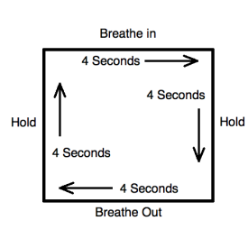
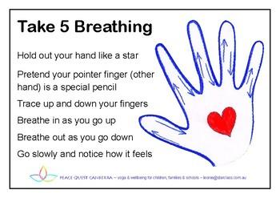

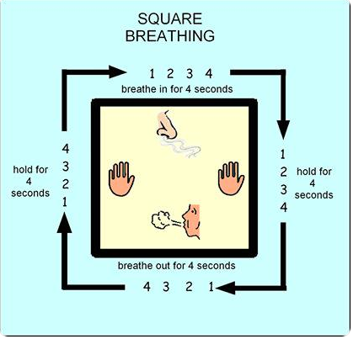

Give students the Get to Green cards. Discuss other coping skills that may work for them to manage some of these stressors and give them the opportunity to fill their card in.

Share the TED Talk: Overcoming Obstacles- https://www.youtube.com/watch?v=2MGMvEnoD6U

Closure:
Tell students: We use many different strategies to cope with stress and motivate ourselves. Another coping skill many people love is through art. The first step to Getting to Green is awareness of what’s going on inside of us. We can feel many emotions at once and sometimes not even recognize that there is more than one emotion present. I’m going to pass out a paper and it may seem overwhelming or confusing when you first look at it. This is exactly how you might feel when you start reflecting on your own emotions. Get out a few different colors and we’re going to process through this sheet together. This activity is designed to help you unravel the tangled ball of emotions (see pic below). Let’s look at the page together. Are there any words that jump out at you? (Let students share.) Are there any words that are confusing or that you don’t recognize? (Let students share and clarify the words.) Be ready to talk through a couple of professional examples to model for kids how you connect with the Tangled Ball of Emotions. Examples: Color in excited and talk about something you’re excited and looking forward to. Color in drained and talk about what has been draining to you recently. You may want to do a few more with them. Leave students with the page to finish on their own time.
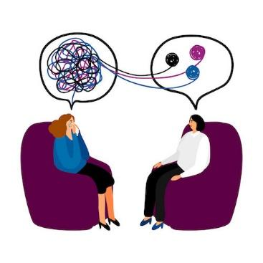

Identifying things that bring me stress
In each space, add something in your life, either at home or at school that brings stress to your life.

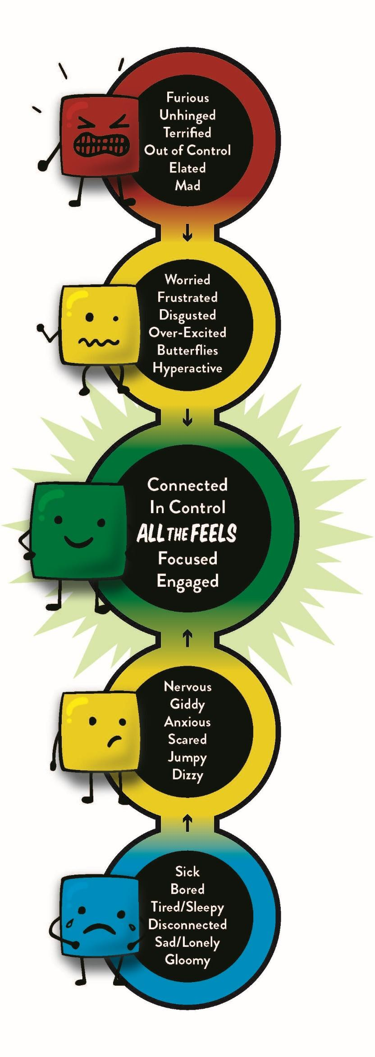

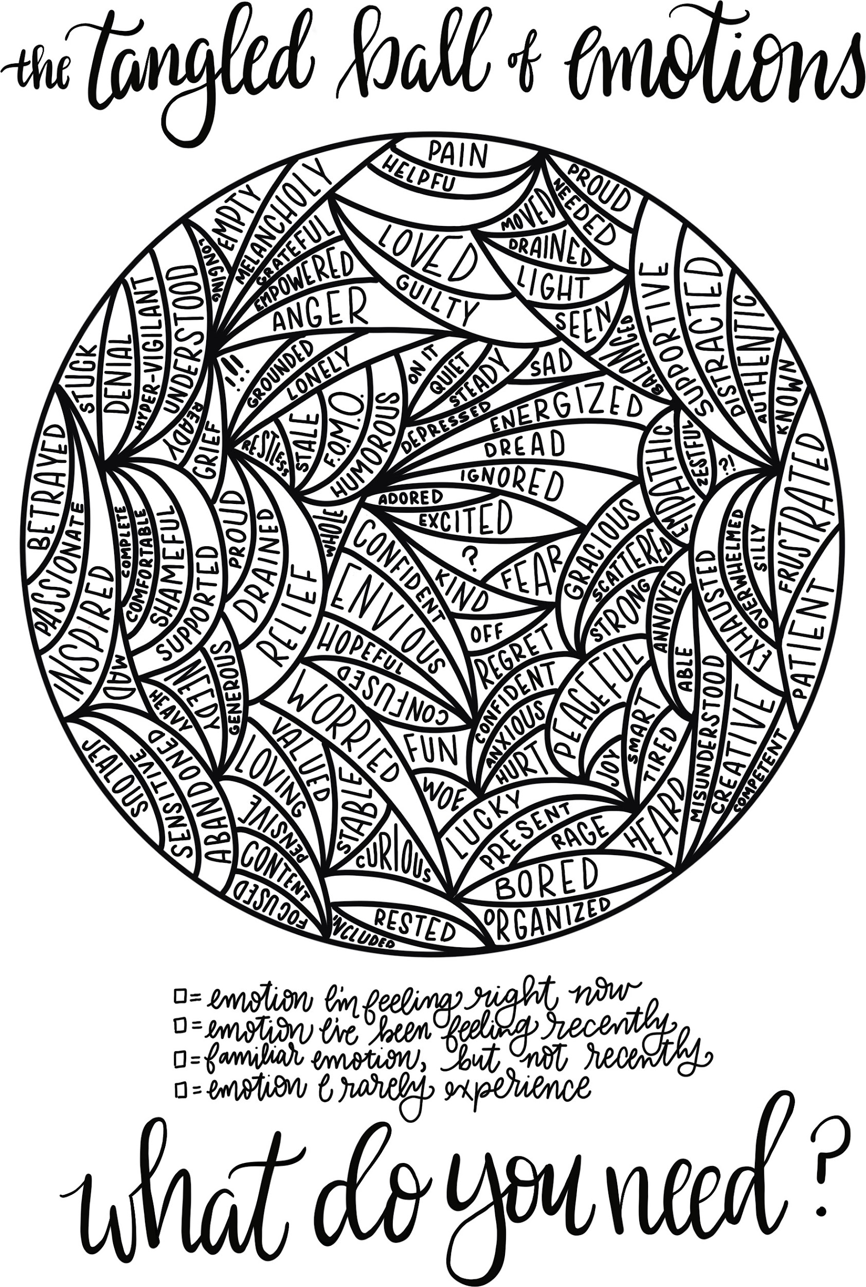

Emotion I’m feeling right now. Emotion I’ve been feeling recently. Familiar emotion, but not recently. Emotion I rarely experience.

